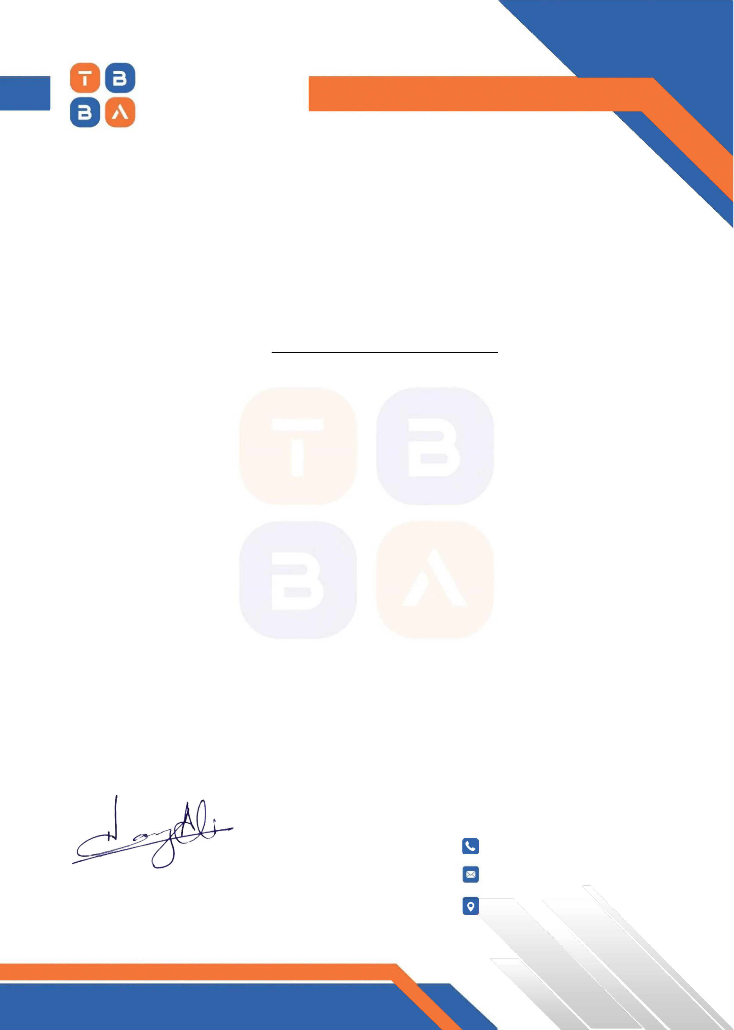

**THE BIZBUZZ**

**AGENCY**

|  |  |  |  |  |  |  |  |  |
| --- | --- | --- | --- | --- | --- | --- | --- | --- |
| WHERE | IDEAS | START | BUZZING | D | ate: | 21`-0 | 8 | -2024 |
| The Branch Manager | |

Meezan Bank

Gulberg Greens, Islamabad

**Subject: Request for Account Opening**

Dear Branch Manager,

It is to clarify that **Mr. Abdul Basit S/O Rashid Qureshi** Having **CNIC# 61101-8593618-7** is

employee of **The BizBuzz Agency** as a n **Web Development** having salary of **50,000/Month**

It is requested to you to please open his account in you bank and facilitate him with your services.

Yours sincerely,

HAMZA ALI KHAN

CEO

|  |  |  |  |
| --- | --- | --- | --- |
| +92 | 321 | 955 | 7301 |

hamza@thebizbuzzagency@gmail.com

|  |  |  |
| --- | --- | --- |
| Office# 202 , | 2 nd | Floor, The Real Arcade, |

Gulberg Greens Islamabad.