Style Guidelines for Final Year Project ReportsGrey Matter Abnormalities Detection in Dementia Patients using Deep Learning on ADNI Images

Final Year Project Proposal

Session 2023-2024

A 4th Year Student

A project submitted in partial fulfillment of the

COMSATS University Degree

of

BSc. (Hons.)BS in Computer Science / Software Engineering (CUI)



Department of Computer Science

COMSATS University Islamabad, Lahore Campus

10 March 2023

**Project Registration**

|  |  |  |  |  |  |  |  |
| --- | --- | --- | --- | --- | --- | --- | --- |
| Project ID (for office use) | | |  | | | | |
| Type of project | | | [ ] Traditional [ ] Industrial [ ] Continuing | | | | |
| Nature of project | | | [ ] **D**evelopment [ ] **R**esearch [ ] **R**&**D** | | | | |
| Area of specialization | | |  | | | | |
| **Project Group Members** | | | | | | | |
| Sr.# | Reg. # | Student Name | | CGPA | Email ID | Phone # | Signature |
| (i) | Group Leader  SP20-BSE-044 | ABDUL KARIM | | 3.5 | Sp20-bse-044@cuilahore.edu.pk | +923070116551 |  |
| (ii) | SP20-BSE-032 | NOUMAN AHMAD | | 2.9 | Sp20-bse-032@cuilahore.edu.pk | +923070017130 |  |
| (iii) | SP20-BSE-098 | SEHAR AKHTAR | | 2.7 | Sp20-bse-098@cuilahore.edu.pk | +923134632446 |  |
| **Declaration:** FYP group members have cleared all prerequisites courses For FYP-I as per their degree requirements.  For BS(Computer Science)  (CSC241 Object Oriented Programming, CSC291 Software Engineering Concepts, CSC371 Database Systems-I, HUM102 Report Writing Skills)  For BS(Software Engineering)  (CSC241 Object Oriented Programming, CSE291 Introduction to Software Engineering , CSC371 Database Systems-I , HUM102 Report Writing Skills) | | | | | | | |

# Plagiarism Free Certificate

This is to certify that, I am Abdul Karim S/D/o Muhammad Akram, group leader of FYP under registration no CIIT/SP20-BSE-044/LHR at Computer Science Department, COMSATS Institute of Information Technology, Lahore. I declare that my FYP proposal is checked by my supervisor and the similarity index is _____% that is less than 20%, an acceptable limit by HEC. The report is attached herewith as Appendix A.

Date: ____________ Name of Group Leader: Abdul Karim Signature: _____________

Name of Supervisor: _____________________ Co-Supervisor (if any):____________________

Designation: _____________________ Designation: _____________________

Signature: _____________________ Signature: _____________________

**Project Abstract :**

Dementia most frequently results from Alzheimer's disease. The seventh most common cause of death in the United States of America right now is Alzheimer's disease. It is the most typical cause of dementia among senior citizens. Alzheimer’s detection at an early stage is a big problem for medical practitioners as there is no biomarker for the diagnosis of this disease. There is no cure for Alzheimer, but its effect can be reduced by the early detection of this disease. Using cutting-edge techniques for the analysis, interpretation, processing, and display of pictures has been made easier by the field of medical imaging. One of the advanced image processing methods is magnetic resonance imaging (M.R.I.), which provides high-resolution brain pictures for diagnostics purposes. While identifying Alzheimer's, the ADNI dataset photos are taken into account. A hybrid enhancement technique and modified optimum curvelet thresholding are used for the image pre-processing. Equalization of the octagonal histogram using extending in black and white. Pooling on various scales in the image, the white matter is extracted using residual autoencoder architecture. For classification, the K-nearest neighbors algorithm (KNN), Extreme Learning Machine (ELM), and Support Vector Machine (SVM) are employed. According to SVM, the overall accuracy for categorizing AD is 98.21% for the ADNI dataset. The user inputs their MRI pictures of the brain, and our machine algorithm mentioned above then processes the picture. Basically, an image processing algorithm is used here. The processed image is then compared with the ADNI dataset. So, our system predicts the results of whether dementia is detected based on learning that it had incurred from the ADNI dataset.

# Introduction

A loss of memory, language, thought processes, and other cognitive faculties severe enough to affect day-to-day functioning is referred to as dementia. The most frequent cause of dementia is Alzheimer's disease. In the United States of America, Alzheimer's disease is currently the seventh most common cause of death. Among elderly adults, it is the most frequent cause of dementia. Alzheimer's symptoms become noticeable once the patient has reached the age of 60 or more. It may be apparent in the patient whose age is between 35 and 50 because of the genetic mutation. Alzheimer’s takes many years to develop and effect a healthy brain. The patient is first diagnosed with moderate cognitive impairment (MCI) that may develop into Alzheimer’s. The patient who has been diagnosed with MCI might not develop Alzheimer’s but in some cases, the MCI is converted into Alzheimer’s.

Head injuries, chemical exposure, genetic predisposition, and environmental factors can all contribute to Alzheimer's disease. Memory loss, cognitive issues, communication and recognition issues, mood disorders, and behavioral issues are some of the common signs and symptoms of Alzheimer's disease. This sickness has a bad prognosis and can advance at different speeds depending on the patient. Alzheimer's disease currently has no known cure, and drug studies to treat it have a high failure rate. Methods for the early detection of Alzheimer's disease are currently being developed by researchers.

Due to the prevalence of dementia among patients. There is a need for a highly sophisticated system that can detect the early stage of the illness so that the patient gets the appropriate treatment. Magnetic resonance imaging stands out among various methodologies for detecting dementia due to its clear and accurate depiction of various brain tissues without the aid of ionizing radiation. Magnetic resonance imaging is also cost-effective for the patient. These images are helpful in detecting MCI, frontotemporal dementia, and other types of dementia by considering the link between the beginning of cognitive deficits and MRI anomalies.

The [Support Vector Machine](https://www.sciencedirect.com/topics/engineering/support-vector-machine)(SVM), artificial neural networks(ANN), and deep learning are the most common classification methods. Whereas ANN provides a locally optimal solution, SVM provides an optimal solution worldwide. High-quality magnetic resonance images are required to detect the disease. Image processing is used to scan the images. Using image processing alone will yield longer scanning and coverage time. These issues can be overcome by using artificial intelligence along with image processing. The medical images and neural networks are combined to give accurate results. Rician noises, a type of multiplicative noise, can contaminate MRI pictures. The examination of the spatial and transform domains form the basis of numerous denoising techniques. Frequency, wavelet, and curvelet techniques are used to analyze the transform domain. The Wiener, CVT, BM4D, wavelet-based, and curvelet transforms are the techniques applied in the transform domain. White matter is linked to Alzheimer's, and MRI white matter can be used to forecast the disease.

The work focuses on creating an Alzheimer’s diagnosis system with computer assistance. MRI brain pictures are used as the analysis's input. It is advised to use a curvelet transform with an adjustable threshold based on the subband approach to remove noise from photographs. In order to enhance the white matter of the image, the denoised image is next subjected to a hybrid histogram equalization technique (Octagon histogram equalization with black and white Stretching). White matter is segmented using a multi-scale pooling residual autoencoder architecture. The characteristics are extracted from the segmented result. The classification is then completed by a number of classifiers, including SVM, ELM (Extreme Learning Machine), and KNN (K-nearest Neighbor). Compared to other classifiers, SVM demonstrates a higher classification accuracy.

# Success Criterion

Once the user uploads the MRI images. The denoising technique is applied in order to eradicate the Rician noise present in the MRI. As Rician noise affects MRI pictures, the first task is to denoise the image. The Rician noise in the image is eliminated using modified optimum Curvelet thresholding. After noise removal, a hybrid method is employed to improve the image. Then these MRI pictures are compared with ADNI database that is classified according to the specified algorithm so that the result could be displayed. The result tells whether the patient had been diagnosed with dementia or not. A high number of patients with Alzheimer's symptoms will benefit from this treatment. The publicly available datasets ADNI and Kaggle were used to obtain the MRI data for the project.

# Related work

The following is the research work we have gone through in order to depict the real understanding of our project.

|  |  |  |  |  |  |  |
| --- | --- | --- | --- | --- | --- | --- |
| **Author** | **Year** | **Models** | **Dataset** | **Evaluation** | **accuracyy** | **Critic** |
| Emre Altinkaya, Kemal Polat, Burhan Barakli | 2020 | Convolutional Neural Networks(CNN), Deep Neural Networks(DNN), Deep Automatic Encoders (DA), and Deep Boltzmann Machines(DBM) are the models being used. | MRI images dataset that uses super-resolution technique is used to convert low-resolution MRI to high-resolution images for accurate results. | In [1] author proposed the super-resolution method is used for producing high-resolution MRI. The pre-processing of the data set is done through the super-resolution method and then CNN, DNN, DA, or DBM methods are used to classify the dataset and perform prognosis. | The DNN model provides 99.2%, the CNN model provides 99.9%, the DA model provides 91.95%, and the DBM model provides 95.35% accuracy. | There is no method for denoising for eliminating Rician noises that are present in the MRI images that will result in an inaccurate prognosis. |
| [Helcy D. Alon](https://ieeexplore.ieee.org/author/37088850669), [Michael Angelo D. Ligayo](https://ieeexplore.ieee.org/author/37088565243), [Maribel A. Misola](https://ieeexplore.ieee.org/author/37088915373), [Allan A. Sandoval](https://ieeexplore.ieee.org/author/37088915232), [Marites V. Fontanilla](https://ieeexplore.ieee.org/author/37088919011) | 2020 | The YOLO v3 algorithm has been used to directly perform the prognosis directly using MRI images. | The dataset comprises MRI images. The datasets are annotated using the LabelImg tool and the Pascal VOC format to classify the images as non-demented and mildly-demented. | In [2] author proposed the method in which the dataset that is MRI images are annotated using Pascal VOC format and Labellmg tool. This will categorize the images into non-demented and demented. Then yolo v3 algorithm is used to directly predict based on MRI images using the annotated dataset and information gained through MRI image analysis. | The system has a validation accuracy of 98.8207%, a training accuracy of 98.617%, and a mean average precision of 96.17%. Using images from MRI scans, the model's accuracy is evaluated, and it recorded 80% testing accuracy. | There is no method for denoising for eliminating Rician noises that are present in the MRI images that will result in an inaccurate prognosis. |
| [Nitsa J. Herzog](https://sciprofiles.com/profile/1431723),  [George D. Magoulas](https://sciprofiles.com/profile/197171) | 2021 | Convolutional neural networks with supervised machine learning network models are used. | Initiative for Neuroimaging in Alzheimer's Disease the ADNI database is utilised as dataset. | In [3] author proposed that supervised machine learning algorithms and convolutional neural network models are used to perform prognosis based on the ADNI database. | The Supervised machine learning algorithms give an accuracy of 92.5% and convolutional neural network models give 75.0% accuracy. | There is no method for denoising for eliminating Rician noises that are present in the MRI images that will result in an inaccurate prognosis. |
| [Arshad Hashmi](https://sciprofiles.com/profile/2455768),  [Omar Barukab](https://sciprofiles.com/profile/1019525) | 2023 | Deep Reinforcement System improvedalgorithm is used for the classification of the dataset. | Biomarker identification using the Open Access Series of Imaging Studies (OASIS) database. | In [4] author proposed that Particularly in the sphere of medicine, image processing has gained popularity. In contrast to earlier techniques, DL actually saves time and enhances performance. Deep learning performs admirably when processing multi-layer images, unlike conventional methods, which can only handle single-layer images. The key feature of deep learning is the ability to self-discover the variables that need to be manually entered, enabling it to process photos in a single pass. This work intends to develop software for deep learning-based dementia classification in MRI data. | The Deep Reinforcement system increased F-score by 9–10%, recall by 13%, precision by 9%, and trial accuracy by 6%. | There is no method for denoising for eliminating Rician noises that are present in the MRI images that will result in an inaccurate prognosis. |
| Badiea Abdulkarem Mohammed, Ebrahim Mohammed Senan, Taha H. Rassem, Nasrin M. Makbol ,Adwan Alownie Alanazi ,Zeyad Ghaleb Al-Mekhlafi ,Tariq S. Almurayziq and Fuad A. Ghaleb | 2021 | Alex Net and SVM-based machine learning, ResNet-50 models, and produced the result. | OASIS Dataset  MRI Alzheimer’s Dataset | In [5]author proposed the evaluation of Multi-Method Analysis of Medical Data and MRI Images Based on Deep Learning and Hybrid Approaches for Early Detection of Dementia and Alzheimer's Disease was conducted using several measures such as F1 score, accuracy, sensitivity, specificity, and precision. | The system was tested using the ADNI and OASIS datasets, and it showed 73.4% accuracy for the ADNI dataset and 69.9% accuracy for the OASIS dataset. | it is important to note that the dataset used was relatively small |
| Murugan S, Venkatesan C, Sumithra MG, Gao XZ, Elakkiya B, Akila M, Manoharan S | 2021 | DEMNET model | ADNI Dataset | In [6] author proposed following pre-processing of the dataset and normalization, the photos loaded into a CNN, which extracts distinguishing features to spot the area damaged by Alzheimer's. The CNN model was created from the ground up to categorise the stages of dementia and find AD in our work. | With the same model parameters in the ADNI dataset, the DEMNET model gets an accuracy of 84.83%, AUC of 95.62%, and Cohen's kappa score of 0.81. | the model only considers images from a single modality, i.e., MRI, which might not be sufficient for diagnosing Alzheimer's and Dementia accurately. |
| M. Menagadevi, S. Mangai, Nirmala Madian, D. Thiyagarajan | 2022 | SVM Model | Kaggle  dataset | In [7] author proposed a new approach for automated Alzheimer's disease prediction employing a support vector machine and deep residual autoencoder algorithm. The proposed method aims to extract meaningful features from brain images using the autoencoder, and then classify the extracted features using the SVM algorithm. | The accuracy is 99.77% | The scope was very limited. |
| Amini S, Zhang L, Hao B, Gupta A, Song M, Karjadi C, Lin H, Kolachalama VB, Au R, Paschalidis IC | 2021 | A composite logistic regression model is used. | CDT  dataset | In [8] author proposed the method seems to be a promising and effective approach for detecting dementia employing illustrations from the clock drawing test. The study conducted a comprehensive analysis using a sizable dataset made up of healthy people and those with mild cognitive impairment or dementia. | The accuracy is 91.9% and 94.6% | the study only relied on one specific type of test, the Clock Drawing Test, which may not be comprehensive enough to accurately diagnose dementia on its own. |

# Project Rationale

The purpose of the dementia detection system project is to develop a system that can correctly detect the initial symptoms such as MCI (Moderate Cognitive Impairment) which leads towards the most prevalent kind is Alzheimer's disease of the of dementia in people. Dementia is a devastating condition that affects cognitive functions such as memory, language, and reasoning, and it can have a deep effect on the life of the people and their families. The motivation behind this project is the increasing occurrence of dementia in aging populations and the urgent need to detect and treat the condition as early as possible. According to the World Alzheimer Report (2019), By 2050, there will be three times as many people living with dementia as there are today. Early detection can help people access treatment easily which can better their life and slow down the progress of the disease. I am interested in this project because I think that technology can make a real difference in the lives of people facing dementia. By developing a reliable and precise dementia detection system, we can help people to find those who are at risk of developing the condition and provide them the early detection of the disease. Through my research and development in this project, I hope to learn more about the basic reasons for dementia, the specific cognitive functions that are affected, and the most efficient methods for detecting and treating the condition.

## Aims and Objectives

The main objective of a dementia detection system project is to create a system that can accurately detect the presence of dementia in people.

1. One of the important objectives of a dementia detection system project is to detect the symptoms of dementia in people as soon as possible. Early detection can help to earlier treatments, which can slow the progress of the disease.
2. Another important objective of a dementia detection system project is to develop a system that is accurate in identifying the presence of dementia. This requires the use of consistent and effective measures, as well as deep data analysis techniques.
3. A third objective of a dementia detection system project is to create a system that is simple and user-friendly which help people to identify their diseases at home without need to visit the healthcare centre.

## Scope of the Project

The scope of the dementia detection system project includes:

Developing a system that uses artificial intelligence and machine learning to detect dementia signs at an early stage and providing a user-friendly system to people and doctors so they can interact with system easily. The user can interact with system and easily detect that they are suffering or not with dementia by providing their MRI report to the system. Different medical tests are conducted to check the system's precision and effectiveness in detecting dementia signs.

# Proposed Methodology and Architecture

The proposed methodology and architecture of the system for detecting Alzheimer's disease using an automated prediction system involves the use of a deep residual autoencoder and support vector machine algorithms. The system is designed to examine the structural and functional MRI data of the brain to recognize patterns and changes that are indicative of Alzheimer's disease.

The architecture of the system includes the following steps:

Data pre-processing: To get rid of noise and artefacts, the raw MRI data is first processed.

Feature Extraction: The most important properties are extracted from the pre-processed MRI data using the deep residual autoencoder.

Features selection: The features that are extracted are chosen depending on their applicability in the diagnosis of Alzheimer's disease.

Classification: The selected features are categorized as either suggestive or non-indicative of Alzheimer's disease using the support vector machine.

Prediction: Classification outcomes are used to predict possibility of a patient having Alzheimer's disease.

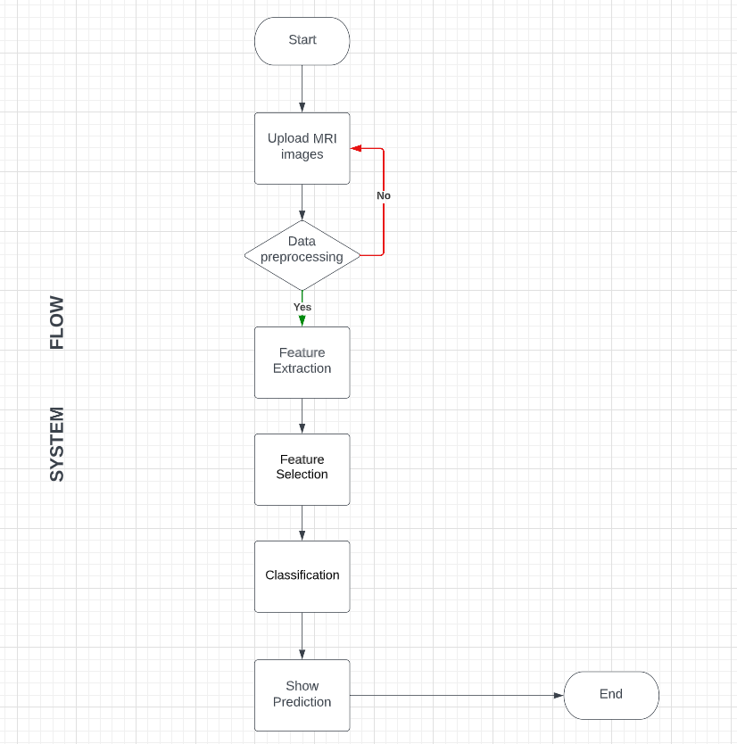

# Individual Tasks

The expected individual work list and a rough schedule are shown below. (Requirement engineering,Project plan, Design,Development,testing,Deployment,)

|  |  |  |
| --- | --- | --- |
| **Team Member** | **Activity** | **Tentative Date** |
| Nouman Ahmad,Abdul Karim | Requirement Engineering | 20/03/2023 |
| Abdul Karim,Nouman Ahmad,Sehar Akthar | Design | 25/04/2023 |
| Nouman Ahmad,Sehar Akhtar | Interface Design | 15/05/2023 |
| Abdul Karim,Nouman Ahmad,Sehar Akthar | Project plan (FYP-1 report) | 15/06/2023 |
| Abdul Karim | Implementation | 26/07/2023 |
| Nouman Ahmad, Abdul Karim | Testing | 16/11/2023 |
| Sehar Akthar | Deployment | 20/09/2023 |
| Abdul Karim | Training | 10/10/2023 |

# Gantt Chart

According to specific tasks listed in the preceding section, the Gantt chart is as follows:

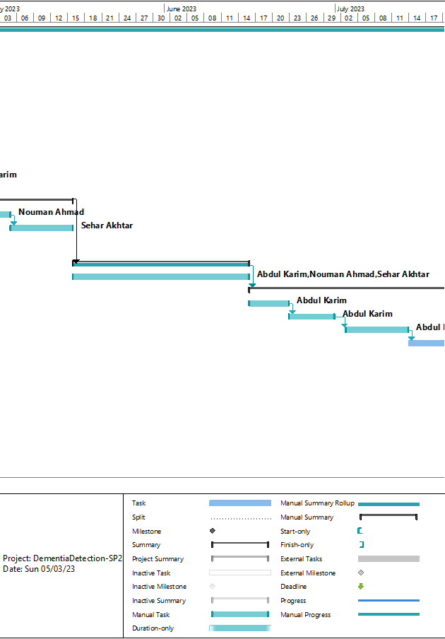

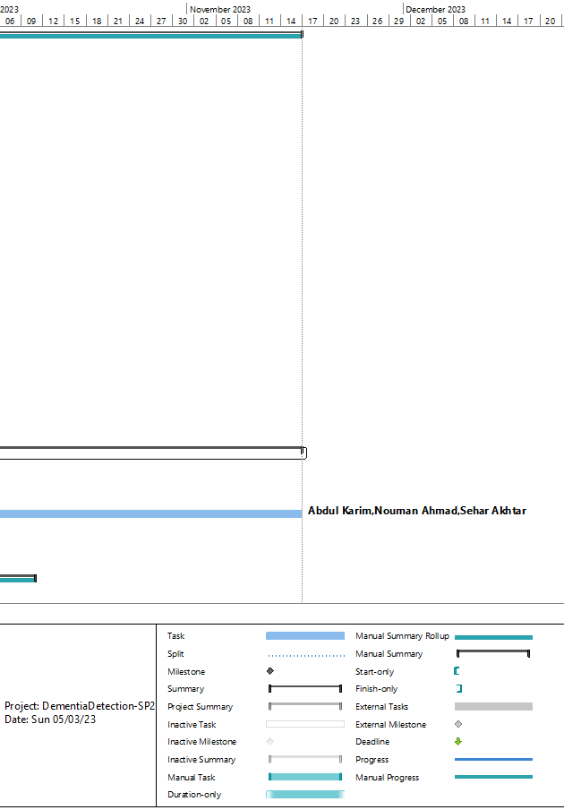

# Tools and Technologies

The ADNI database are used as the dataset. The dataset includes different MRI images that are used to predict the results. As Rician noise affects MRI pictures, the first task is to denoise the image. The Rician noise in the image is eliminated using modified optimum Curvelet thresholding. After noise removal, a hybrid method is used to enhance the image. This whole denoising procedure is termed as the data pre-processing. The important features such as the features that are necessary to distinguish between a healthy and Alzheimer brain are extracted from the dataset using deep residual autoencoder. Our system uses opencv and skimage for the image processing that is: Python picture pattern analysis using OpenCV, a machine learning package built using C++ on the backend. Skimage, also referred to as Scikit-Image, is a machine learning tool created for preprocessing images to look for hidden patterns. This procedure can be termed as the feature extraction. So, some important features are selected among all the extracted features according to their relevance for the prognosis of the Alzheimer disease that is the major cause of Dementia. This procedure can be termed as the Feature selection. The next step is to apply classification on the selected features. The classification will yield two outputs Dementia or No dementia. The classification can be done using S.V.M and K.N.N or other machine algorithm based on its accuracy. The next step is to test the system as a whole and do integration, system and module testing to verify results according to the test cases provided The final step is the deployment step, A web application or mobile application can be created to provide the interface to interact with the system.

# References

|  |  |
| --- | --- |
| [1] | E. Altinkay, K. Polat and B. Barakli, “Detection of Alzheimer’s disease and dementia states based on deep learning from MRI images: a comprehensive review.,” *Journal of the Institute of Electronics and Computer,* vol. 1, no. 1, pp. 39-53, 2020. |
| [2] | H. Alon , M. Ligayo, M. Misola, A. Sandoval and M. Fontanilla , “Eye-Zheimer: A Deep Transfer Learning Approach of Dementia Detection and Classification from NeuroImaging,” *IEEE 7th International Conference on Engineering Technologies and Applied Sciences (ICETAS),* pp. 1-4, 2020. |
| [3] | N. Herzog and G. Magoulas , “Brain asymmetry detection and machine learning classification for diagnosis of early dementia,” *Sensors ,* vol. 21, no. 3, p. 778, 2021. |
| [4] | A. Hashmi and O. Barukab , “Dementia Classification Using Deep Reinforcement Learning for Early Diagnosis,” *Applied Sciences, 13(3),* vol. 13, no. 3, p. 1464, 2023. |
| [5] | B. Mohammed , E. Senan , T. Rassem , N. Makbol, A. Alanazi, Z. Al-Mekhlafi , T. Almurayziq and F. Ghaleb , “Multi-method analysis of medical records and MRI images for early diagnosis of dementia and Alzheimer’s disease based on deep learning and hybrid methods,” *Electronics 10,* vol. 10, no. 22, p. 2860, 2021. |
| [6] | S. Murugan, C. Venkatesan , M. Sumithra, X. Gao, B. Elakkiya , M. Akila and S. Manoharan , “DEMNET: a deep learning model for early diagnosis of Alzheimer diseases and dementia from MR images,” *IEEE Access,* vol. 9, pp. 90319-90329, 2021. |
| [7] | M. Menagadevi , S. Mangai , N. Madian and D. Thiyagarajan , “Automated prediction system for Alzheimer detection based on deep residual autoencoder and support vector machine,” *Optik ,* vol. 272, p. 170212, 2023. |
| [8] | S. Amini , L. Zhang , B. Hao, A. Gupta , M. Song , C. Karjadi , H. Lin, V. Kolachalama , R. Au and I. Paschalidis , “An artificial intelligence-assisted method for dementia detection using images from the clock drawing test,” *Journal of Alzheimer's Disease,* vol. 83, no. 2, pp. 581-589, 2021. |