Software Requirements and
Design Document
for
CareerBridge
Prepared by
Abdul Moeed (24I-0720)
Naveen Aamir (24I-0744)
Hamna Bilal (24I-0794)
Section: CS - 4A
Instructor: Ms Afia Zafar
May 2026

Table of Contents

1. Introduction

1.1 Purpose
This document describes the software requirements and design for CareerBridge version 1.0. We wrote this document to clearly define what our system does, how it is structured, and what decisions we made during development. It covers the full scope of the application including the job seeker module, the company module, the admin module, and the AI matching engine.

1.2 Product Scope
CareerBridge is a desktop based job portal application built for the Pakistani job market. We designed it to connect job seekers with companies that offer internships and jobs. The platform pulls real job listings from Rozee.pk RSS feeds and jobdataapi.com so that users always see fresh and authentic opportunities. Companies can post verified offerings, manage applications and view analytics about their candidates. Job seekers can build profiles, compare themselves against job requirements using AI powered match scoring, and filter opportunities based on location, role, experience, CGPA and stipend.
We built this project as part of our Software Design and Architecture course to demonstrate layered architecture, OOP principles, design patterns, and integration between UI, business logic and database layers.

1.3 Title
CareerBridge: An AI Powered Job Portal for Connecting Job Seekers and Companies in Pakistan.
The title reflects exactly what our system does. It bridges the gap between job seekers and employers by providing intelligent matching, real time job feeds, and structured application management all in one desktop application.

1.4 Objectives
We set out to achieve the following goals through this project:
- Provide job seekers with job and internship listings from verified sources like Rozee.pk and jobdataapi.com.
- Let job seekers filter opportunities based on location, skills, CGPA, role, experience and stipend.
- Enable profile to job matching and AI powered recommendations for job seekers.
- Allow approved companies to post job offerings and internships through a dedicated dashboard.
- Give companies the ability to rank applicants using weighted scoring based on skills, CV quality, education and experience.
- Provide an admin panel for managing company approvals, user accounts and trending skill analytics.
- Build the system using proper layered architecture with clear separation between UI, business logic and database.
- Apply GRASP and GoF design patterns throughout the codebase.

1.5 Problem Statement
Finding relevant internships and entry level jobs in Pakistan is a real struggle for students and fresh graduates. Job listings are scattered across many websites, most of them are outdated, and there is no way to know how well you match a particular role. Students end up applying blindly to dozens of positions without any guidance on whether they are a good fit.
On the other side, companies also face problems. They receive large numbers of applications but have no efficient way to filter and rank candidates. They waste time going through unqualified applicants manually. There is no centralized system where they can see analytics about their candidate pool or get AI based rankings.
We decided to build CareerBridge to solve both these problems in one platform. By combining live job feeds from real sources, AI based match scoring and skill gap analysis, and structured dashboards for both job seekers and companies, our system addresses the core pain points on both sides. We felt this was a feasible project because we could use existing RSS feeds and APIs for job data, JavaFX for the desktop interface, and custom ML models for the matching logic.S

2. Overall Description

2.1 Product Perspective
CareerBridge is a new, self contained desktop application. We did not base it on any existing system. We built it from scratch as a standalone product that integrates with external job data sources.
The system has three main actors: Job Seekers who browse and apply for jobs, Companies who post offerings and review candidates, and Admins who manage the platform. Each actor has their own dedicated dashboard. The application connects to a MySQL database for persistent storage and fetches real time job data from Rozee.pk and jobdataapi.com.
We organized the system into clearly separated layers. The UI layer handles all the JavaFX screens. The Business Logic layer contains the controllers, services, domain models and interfaces. The Data Access layer handles all database operations through DAO classes. And we have a Utility layer for shared infrastructure like database connectivity, session management and external data fetching.

2.2 Product Functions
Here is a high level summary of what our system does:
- Authentication: User registration and login with role based access control. Passwords are hashed using SHA-256.
- Company Management: Admin approval workflow for companies. Only approved companies can access the platform.
- Job Posting: Companies can create, manage and close job offerings through their dashboard.
- Job Browsing and Filtering: Job seekers can browse all offerings and filter by location, role, CGPA, stipend and experience.
- Job Applications: Job seekers can apply for jobs with duplicate prevention. They can also view their application history.
- Profile Management: Job seekers can build profiles with education, CGPA, skills, experience and CV upload with text extraction.
- AI Matching: The system ranks offerings for seekers and ranks applicants for companies using weighted scoring and OLS regression.
- Job Feed Integration: Automated fetching from Rozee.pk RSS feeds and jobdataapi.com with deduplication.
- Trending Skills: Extraction of trending skills from job descriptions with frequency analysis.
- Analytics: Company dashboard shows average CGPA, total applicants and match score distribution charts.
- User Management: Admin can view all users and deactivate accounts.

2.3 List of Use Cases
ID | Use Case Name | Actor(s) | Description
UC-01 | User Registration | Job Seeker, Company | A new user fills out the registration form with name, email, password and role. If the role is Company, additional company fields appear. The system creates the account.
UC-02 | User Login | Job Seeker, Company, Admin | User enters email and password. The system validates credentials, hashes the password, checks it against the database, and redirects to the correct dashboard.
UC-03 | Company Approval | Admin | Admin views pending company registrations. Admin can approve or reject each company. Only approved companies can log in and post offerings.
UC-04 | Post Job Offering | Company | Company fills out the offering form with title, role, location, description, required CGPA, experience, stipend and type. The system saves it to the database.
UC-05 | Browse and Filter Jobs | Job Seeker | Job seeker views all available offerings. They can filter by location, role, CGPA, stipend and experience. The FilterService applies the criteria and returns matching results.
UC-06 | Apply for Job | Job Seeker | Job seeker selects an offering and clicks apply. The system checks for duplicate applications and if none exist, creates a new application record.
UC-07 | View My Applications | Job Seeker | Job seeker views all their submitted applications with status, company name and application date.
UC-08 | Manage Profile | Job Seeker | Job seeker creates or updates their profile with education, CGPA, skills, experience and CV upload. The system extracts text from the CV for matching.
UC-09 | Rank Applicants | Company | Company views applicants for a specific offering. The ApplicantRanker computes weighted scores based on skills, CV, education and experience, then sorts them.
UC-10 | View Analytics | Company | Company views analytics for their offerings including average CGPA of applicants, total applications and match score distribution chart.
UC-11 | AI Job Recommendations | Job Seeker | The system uses AIMatchingService and OfferingRanker to rank offerings based on the seeker profile and shows match scores.
UC-12 | Refresh Job Feed | System, Admin | The system fetches jobs from Rozee RSS and JobDataAPI, deduplicates them, and saves new offerings to the database.
UC-13 | Trending Skills | Admin, Job Seeker | TrendingSkillService extracts skill keywords from all job descriptions, counts frequencies and displays the most in demand skills.
UC-14 | Deactivate User | Admin | Admin can deactivate any user account from the admin dashboard. The deactivated user can no longer log in.
UC-15 | Close Offering | Company | Company can close an active offering so it no longer appears to job seekers and no new applications are accepted.

2.4 Extended Use Cases
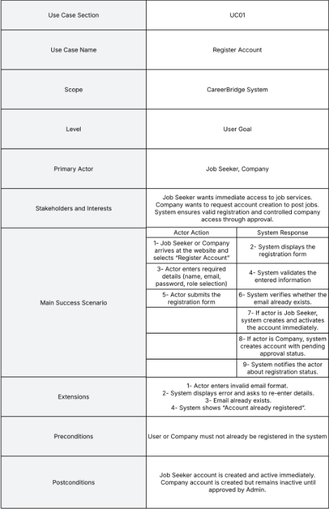

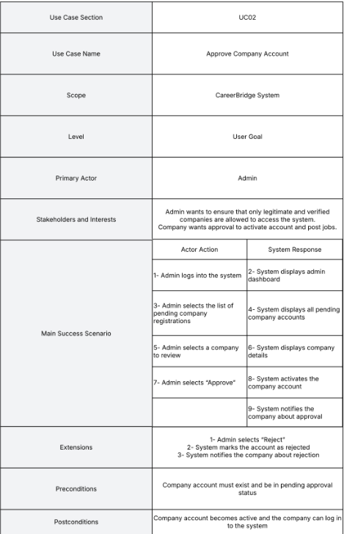

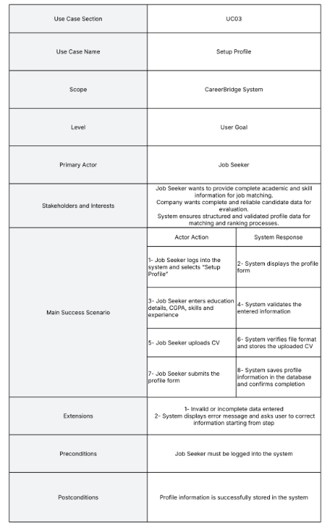

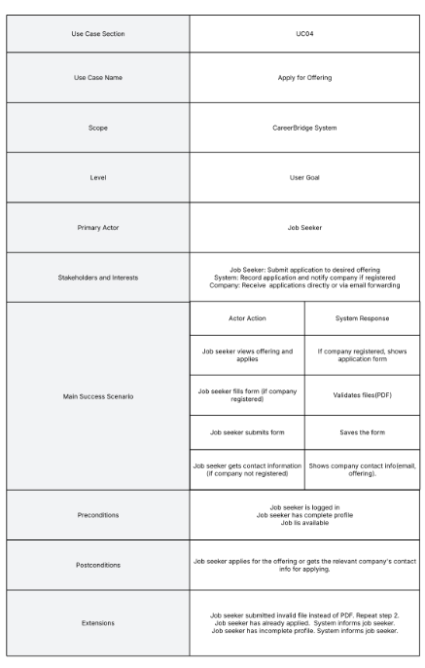
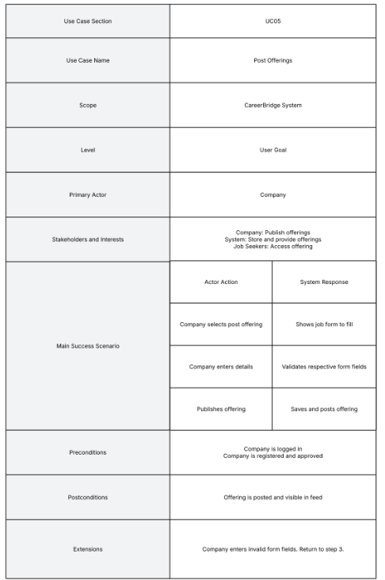

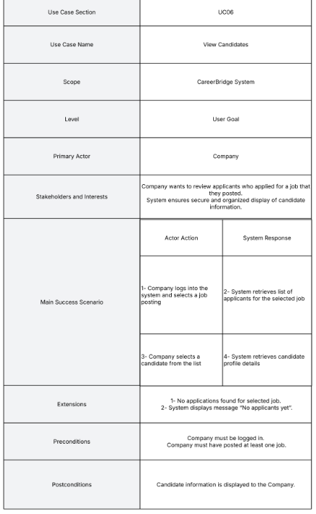
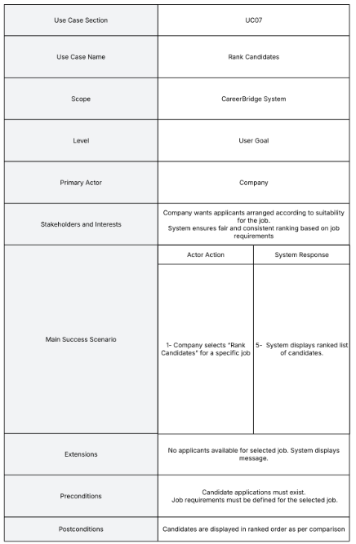

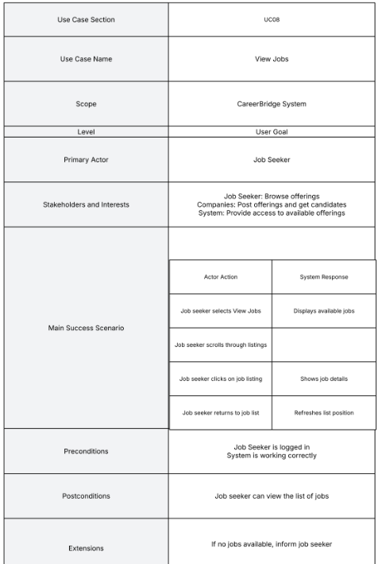

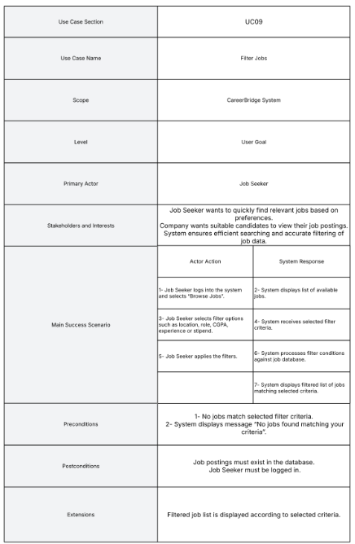

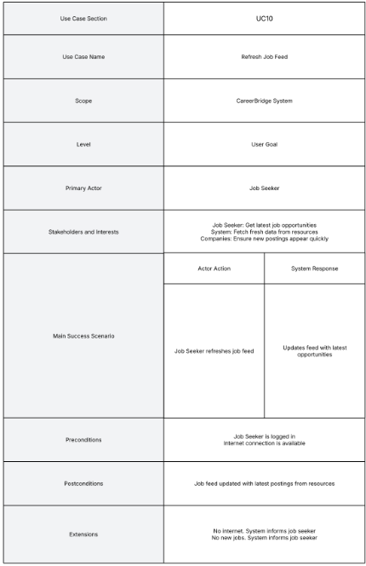

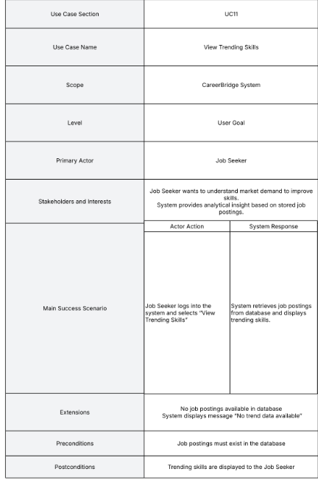

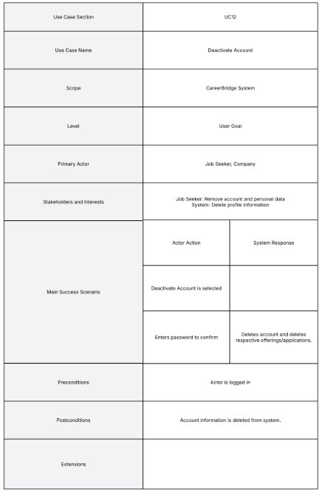

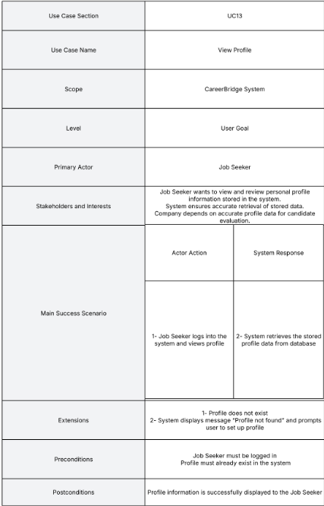

2.5 Use Case Diagram
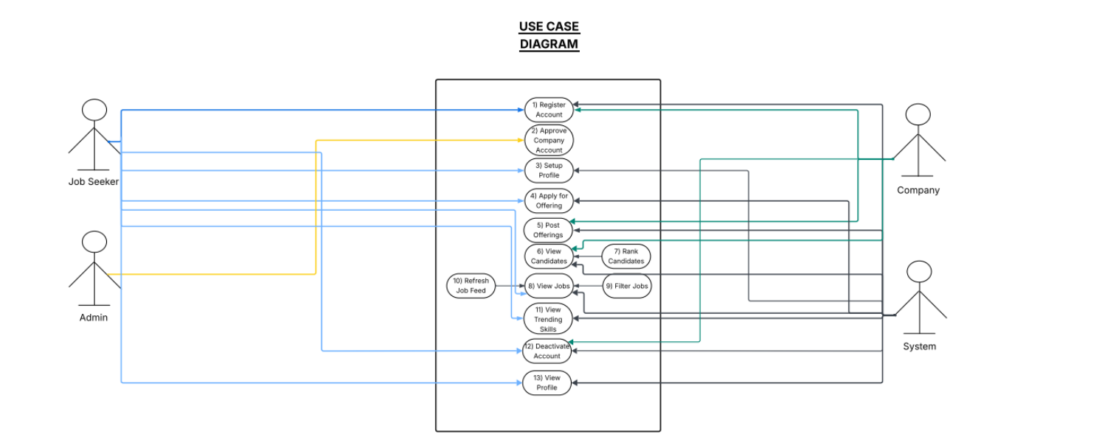

3. Other Nonfunctional Requirements

3.1 Performance Requirements
We designed the system with the following performance goals in mind:
- The login process should complete within 2 seconds including password hashing and database lookup.
- Job listing retrieval and display should take no more than 3 seconds for up to 1000 offerings.
- Filtering operations should feel instant to the user and complete within 1 second.
- AI match score computation should complete within 5 seconds for a batch of up to 100 offerings.
- Applicant ranking for a single offering should complete within 3 seconds for up to 200 applicants.
- External job feed fetching is expected to take longer (up to 15 seconds) due to network latency, so we run it on demand rather than automatically on startup.

3.2 Safety Requirements
We made sure that the system prevents accidental data loss or harm in the following ways:
- All database operations use try catch blocks so that a failed query does not crash the application.
- Duplicate application checking prevents a seeker from accidentally applying to the same job twice.
- Company approval gating ensures that unapproved companies cannot access the system or post fake listings.
- The admin cannot delete users permanently. We only deactivate accounts so data is preserved.
- CV file uploads are stored locally and the system only reads them. It does not modify or delete uploaded files.

3.3 Security Requirements
Security was important to us and we addressed it in these ways:
- All passwords are hashed using SHA-256 before being stored in the database. We never store plain text passwords.
- Session management is handled through SessionManager (Singleton) which tracks the logged in user and provides authentication checks.
- Role based access control ensures that job seekers, companies and admins can only access their own dashboards and features.
- All database queries use JDBC PreparedStatements which protect against SQL injection attacks.
- Company accounts require admin approval before they can access the platform, preventing unauthorized company registrations.
- Input validation is performed at both the UI layer (required fields, format checks) and the controller layer (business rule validation).

3.4 Software Quality Attributes
We prioritized the following quality attributes:
- Maintainability: The layered architecture with clear separation between UI, business logic and data access makes it easy to modify one layer without affecting others.
- Reusability: Interfaces like IFeedFetchable, IRankable and IFilterable allow us to swap implementations without changing the calling code. FilterPanel is a reusable UI component.
- Reliability: Exception handling throughout the DAO layer ensures the application does not crash on database errors. Duplicate checks prevent data inconsistency.
- Usability: Consistent dark theme with cyan and gold accents across all screens. Role specific dashboards show only relevant features. Filter panel provides intuitive controls.
- Extensibility: The IFeedFetchable interface makes it easy to add new job sources. AbstractDatasetLoader uses Template Method pattern so we can add new dataset formats by just writing a new subclass.
- Testability: Business logic is separated from UI, so controllers and services can be tested independently of the JavaFX screens.

3.5 Business Rules
We established the following rules for how the system operates:
- Only users with an approved company account can post job offerings. Pending or rejected companies cannot.
- A job seeker can only apply once per offering. The system prevents duplicate applications.
- Admin is the only role that can approve or reject company registrations.
- Admin is the only role that can deactivate user accounts.
- Companies can only view applicants for their own offerings, not for other companies.
- A closed offering does not accept new applications.
- Job feed refresh is triggered to pull a new loaded dataset from the computer.
- Trending skills are recomputed whenever the job feed is refreshed.

3.6 Operating Environment
We built and tested CareerBridge in the following environment:
- Operating System: Windows 10 or Windows 11.
- Java Runtime: Java 17 or later with JavaFX support.
- Database: MySQL 8.0 or later running locally.
- Build Tool: Standard Java compilation (no Maven or Gradle required for the base project).
- External Dependencies: Apache PDFBox for CV text extraction from PDF files.
- Network: Internet connection required for fetching job feeds from Rozee.pk RSS and jobdataapi.com.
- Hardware: Any modern PC with at least 4GB RAM and 500MB free disk space.

3.7 User Interfaces
Our application has three main dashboards and several supporting screens, all built with JavaFX:
- LoginScreen: Simple form with email and password fields, a login button and a link to the registration screen. Shows error messages for invalid credentials.
- RegisterScreen: Form with name, email, password, confirm password and role selector. Shows additional company fields when Company role is selected.
- JobSeekerDashboard: Main screen with a job list on the left, filter panel on the right with fields for location, role, CGPA, stipend and experience. Shows trending skills in a sidebar and match score progress bars.
- CompanyDashboard: Shows posted offerings in a table, applicants for selected offering, and analytics panel with bar charts for match score distribution.
- AdminDashboard: Tabbed interface with pending companies table, all users table and trending skills chart.
- ProfileSetupScreen: Form for education, CGPA, location, skills, experience and CV file upload button.
- PostOfferingScreen: Form for title, role, location, description, CGPA, experience, stipend and offering type dropdown.
- MyApplicationsScreen: List of submitted applications with status badges and total count.
All screens follow a consistent dark theme with background colors around #111111 and #0A1929, cyan (#00d4ff) accent for interactive elements and gold (#FFD700) for highlights.

4. Domain Model
The domain model shows the key business entities in our system and how they relate to each other. The main entities are User (with subtypes Admin, Company and JobSeeker), Profile, Offering, Application, TrendingSkill, JobFeed and FilterCandidate.
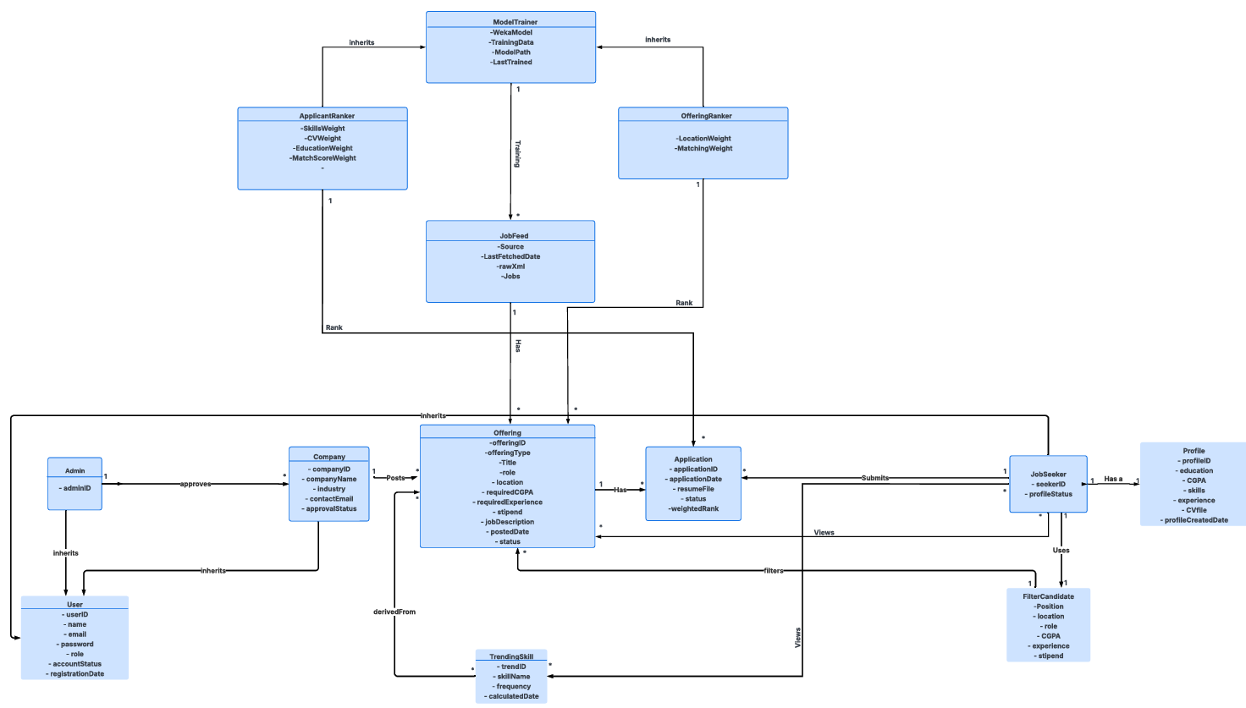

5. System Sequence Diagram
System sequence diagrams show the interaction between an actor and the system as a black box. We created SSDs for our main use cases to show what messages the actor sends and what responses the system returns.

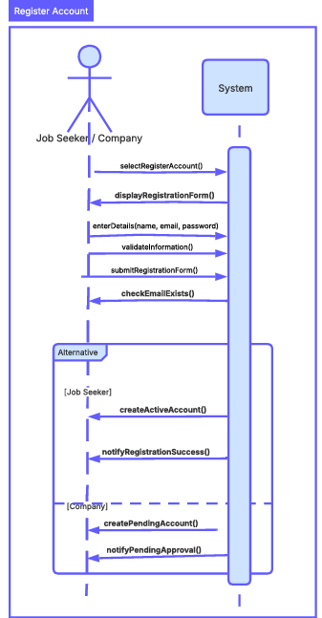

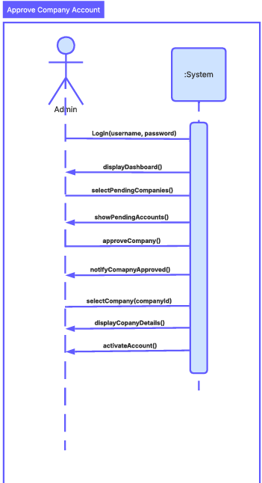

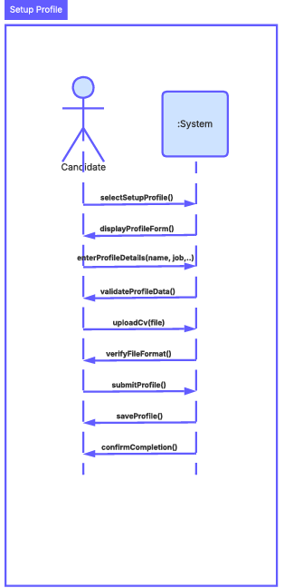

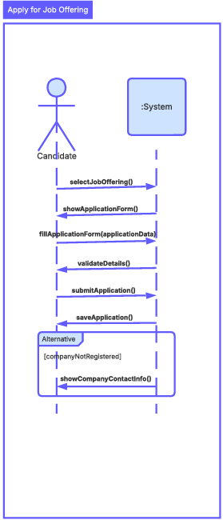

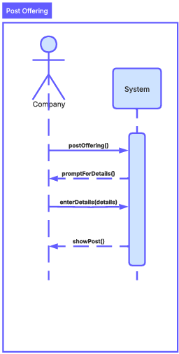

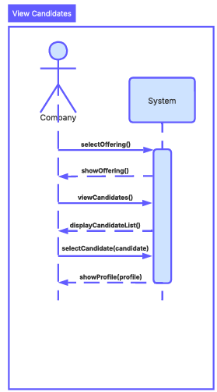

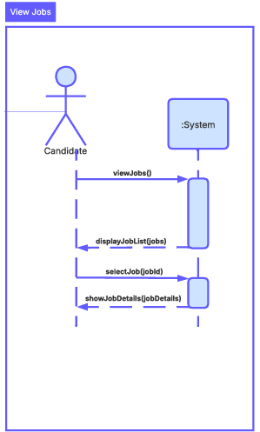

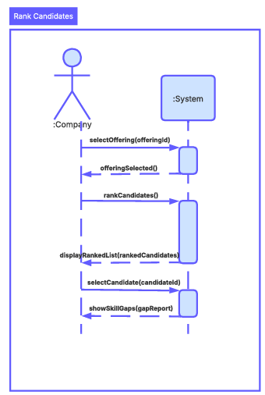

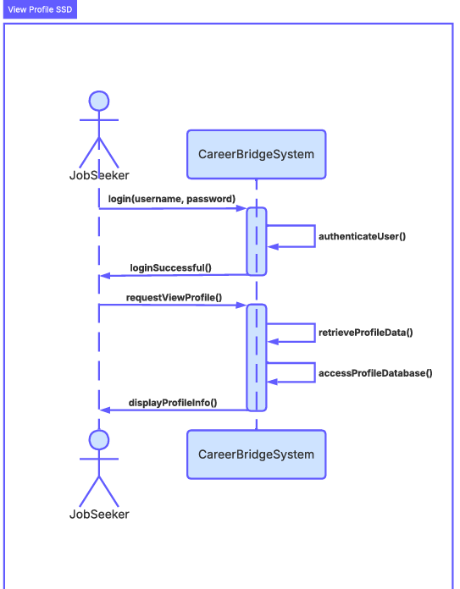

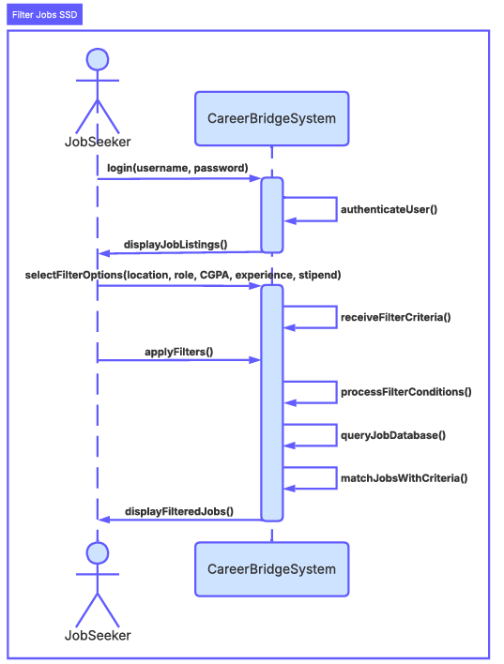

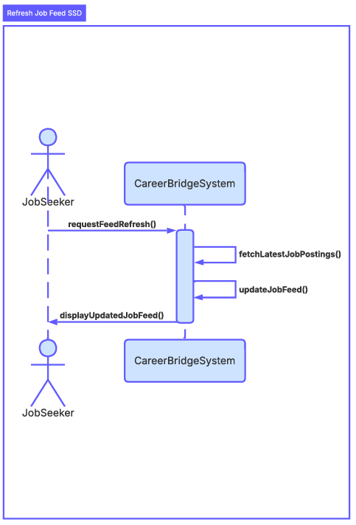

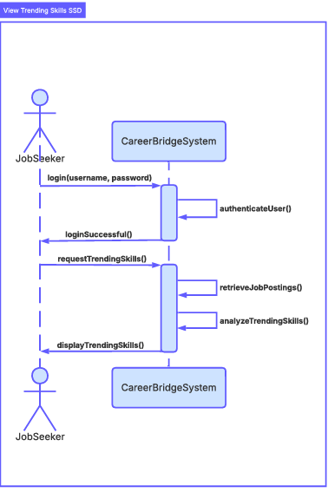

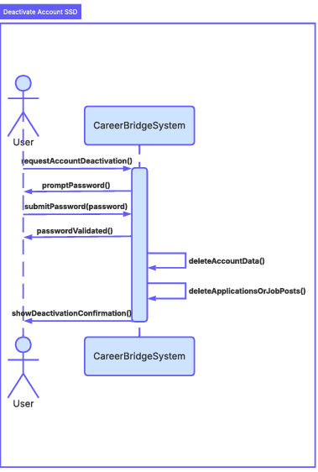

6. Sequence Diagram
Our detailed sequence diagrams show the internal interactions between objects for each use case. They show how the UI screen calls the controller, the controller calls the service or DAO, and the DAO interacts with the database. We created sequence diagrams for login, apply for job, post offering, rank applicants and refresh job feed.
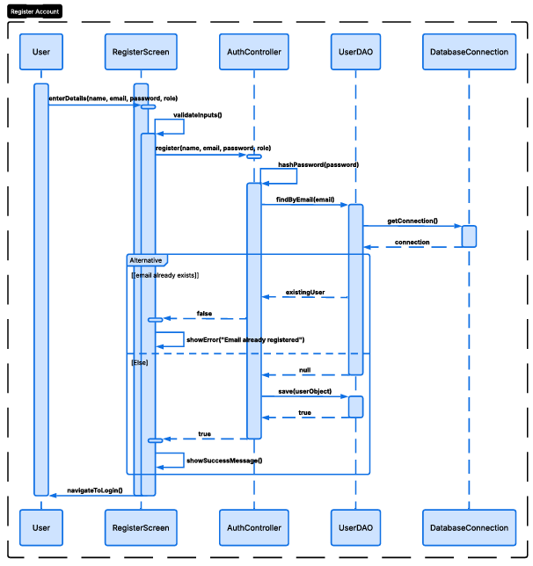

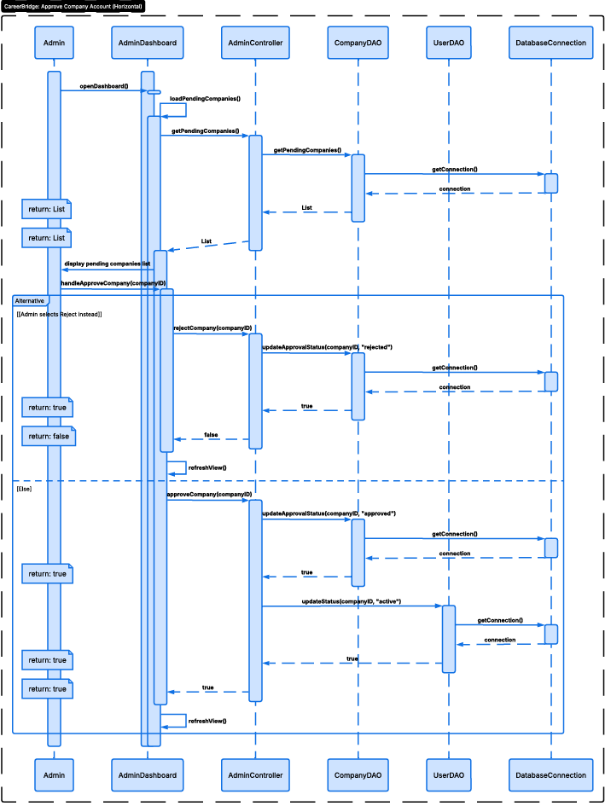

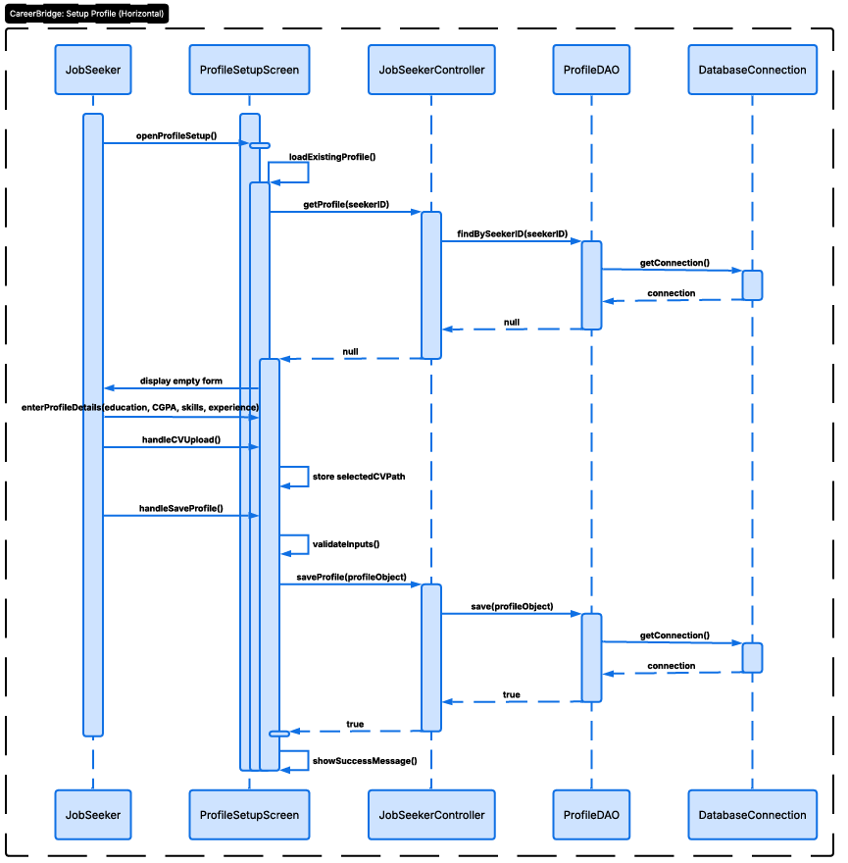

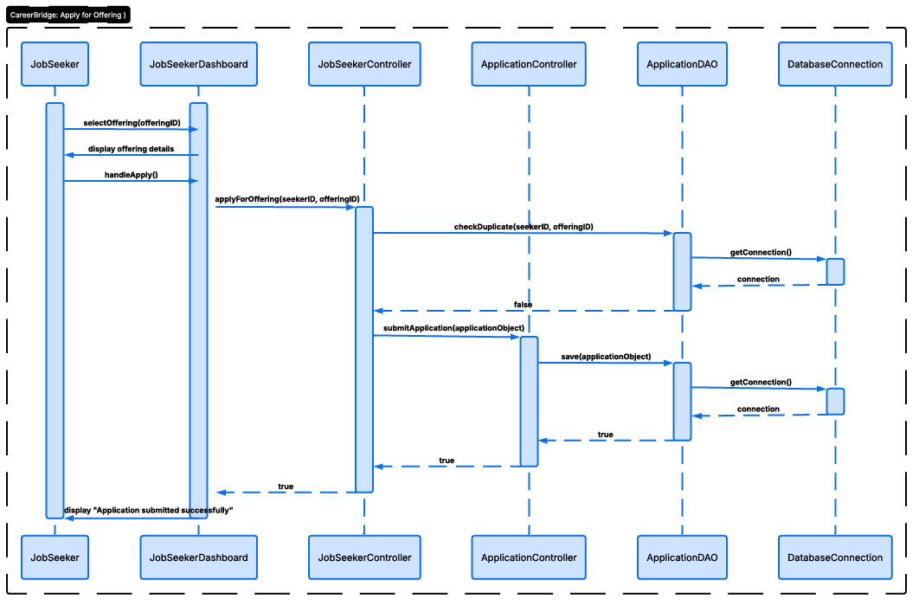

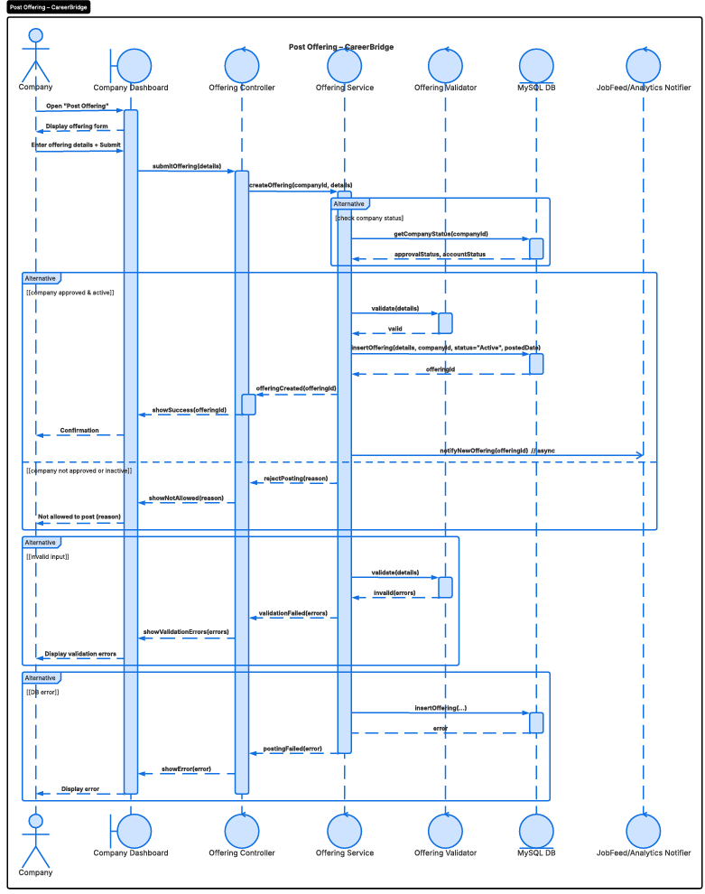

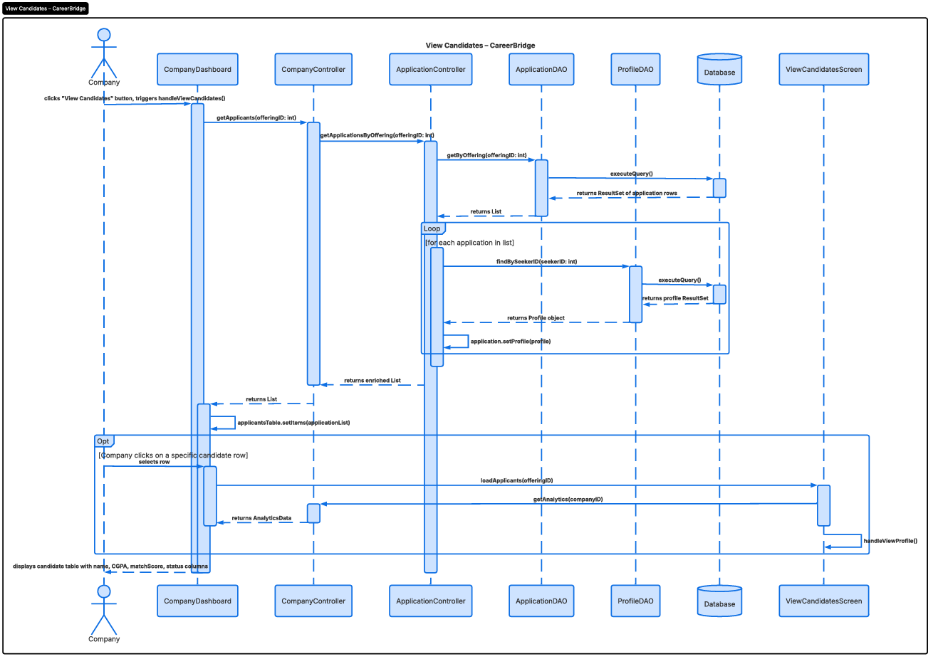

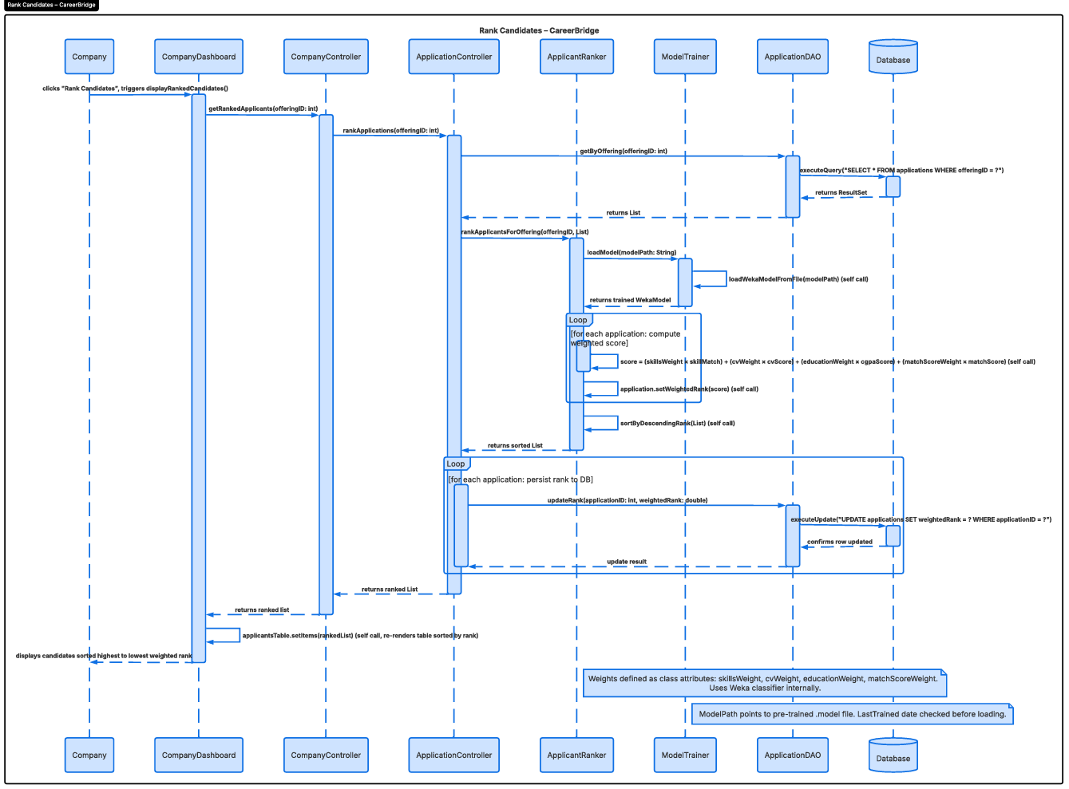

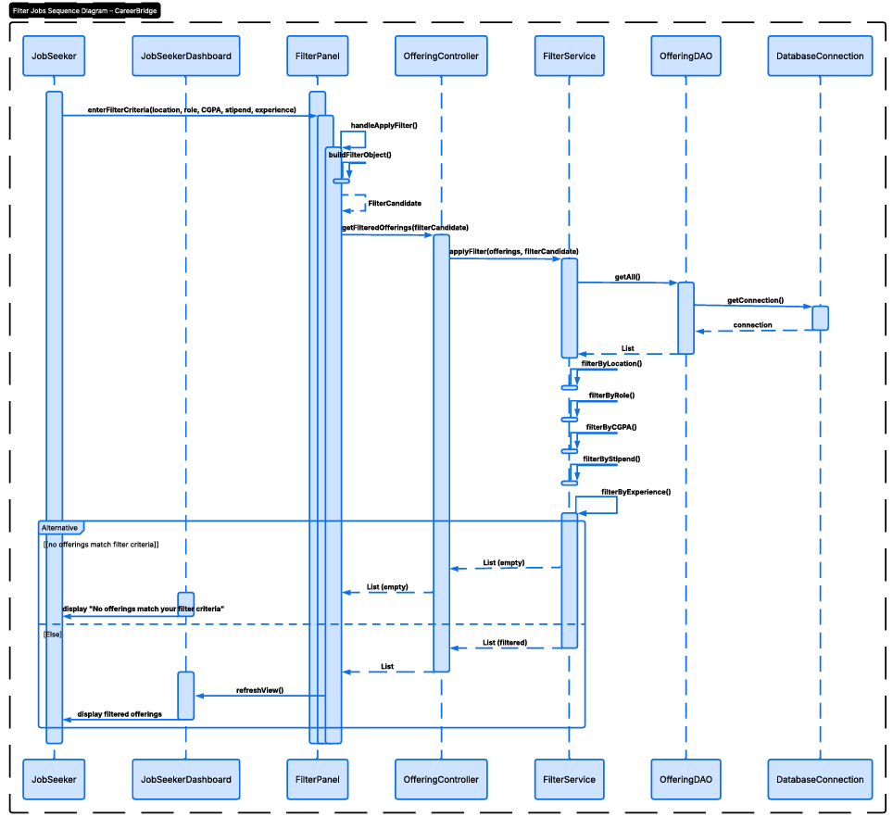

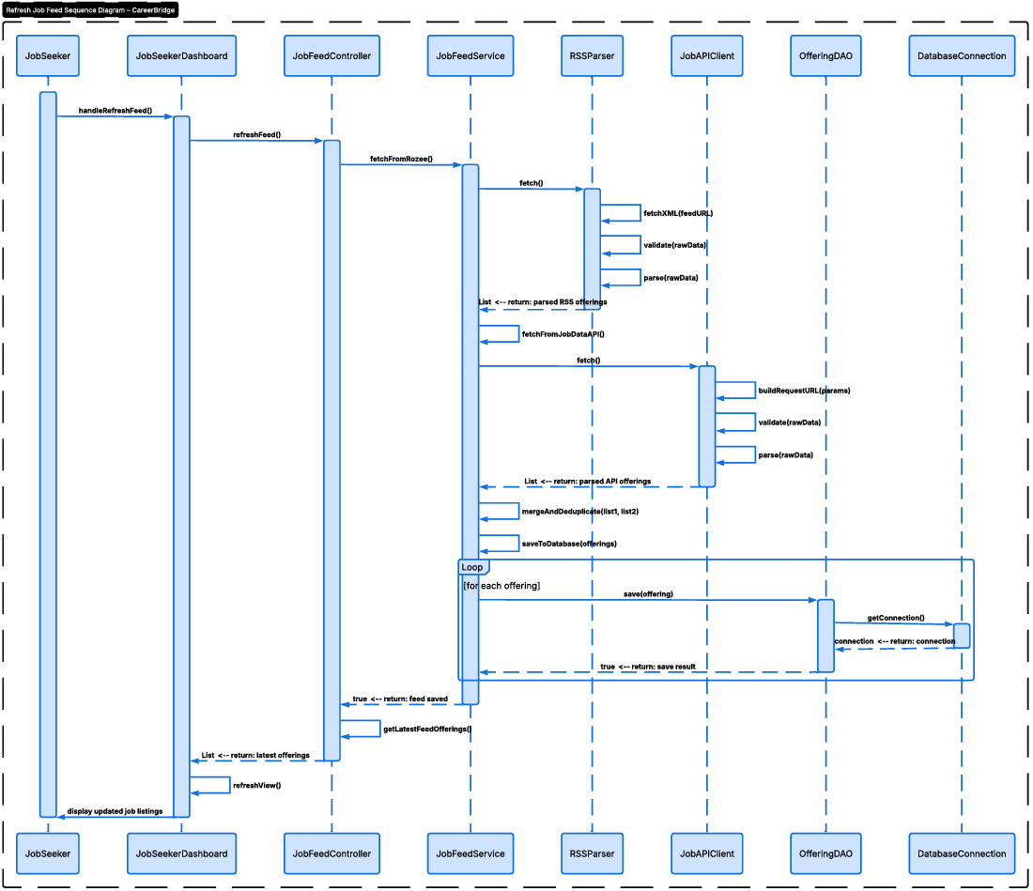

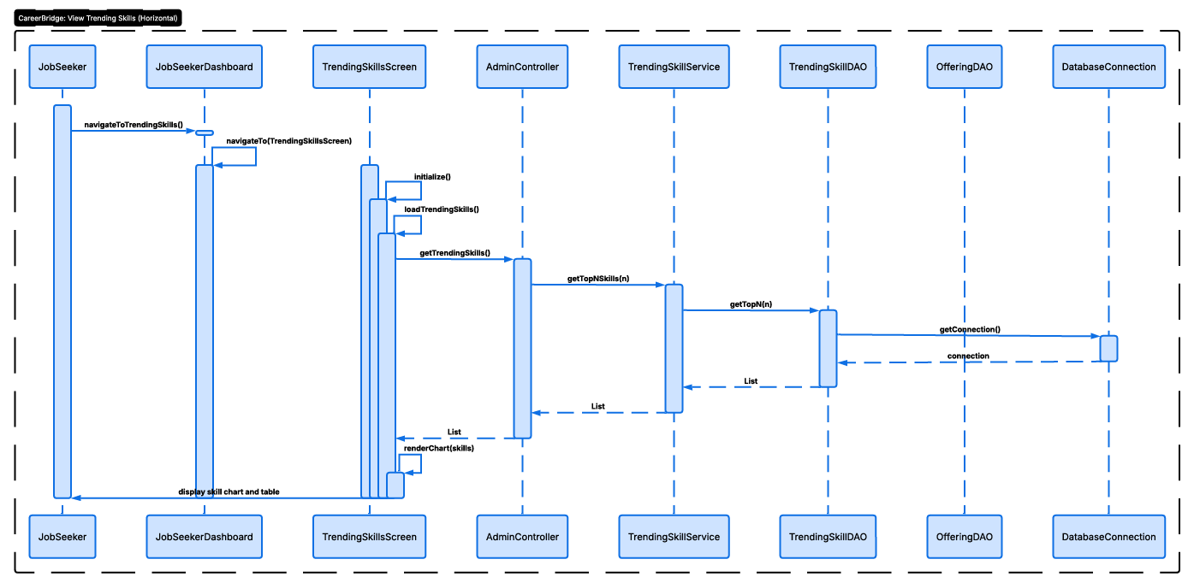

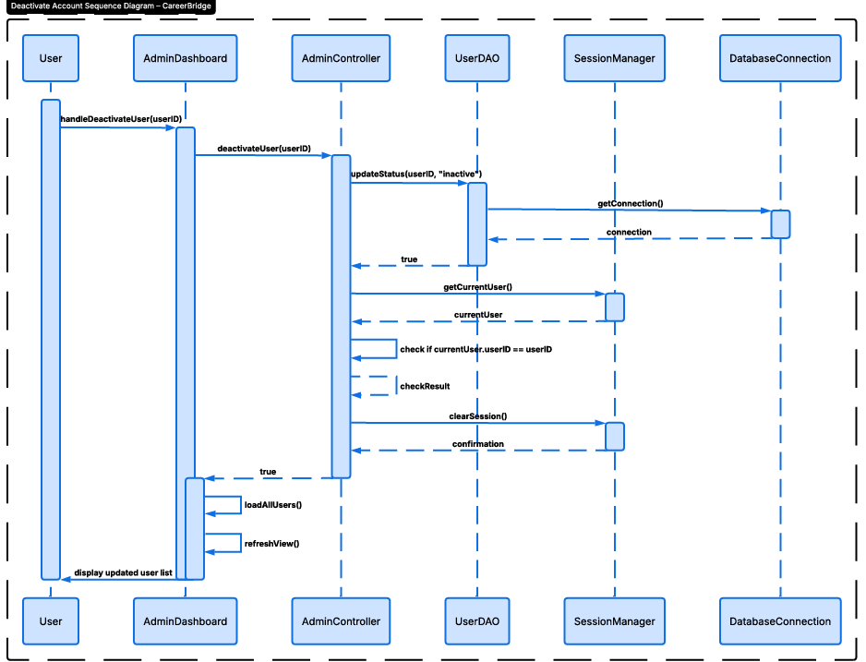

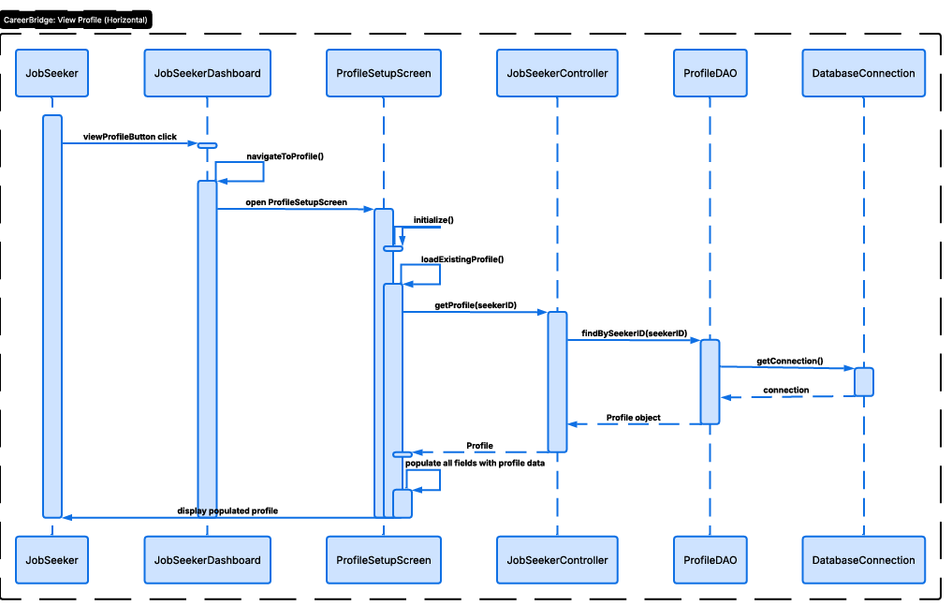

7. Class Diagram
Our class diagram shows all classes organized by layer with their attributes, methods and relationships.
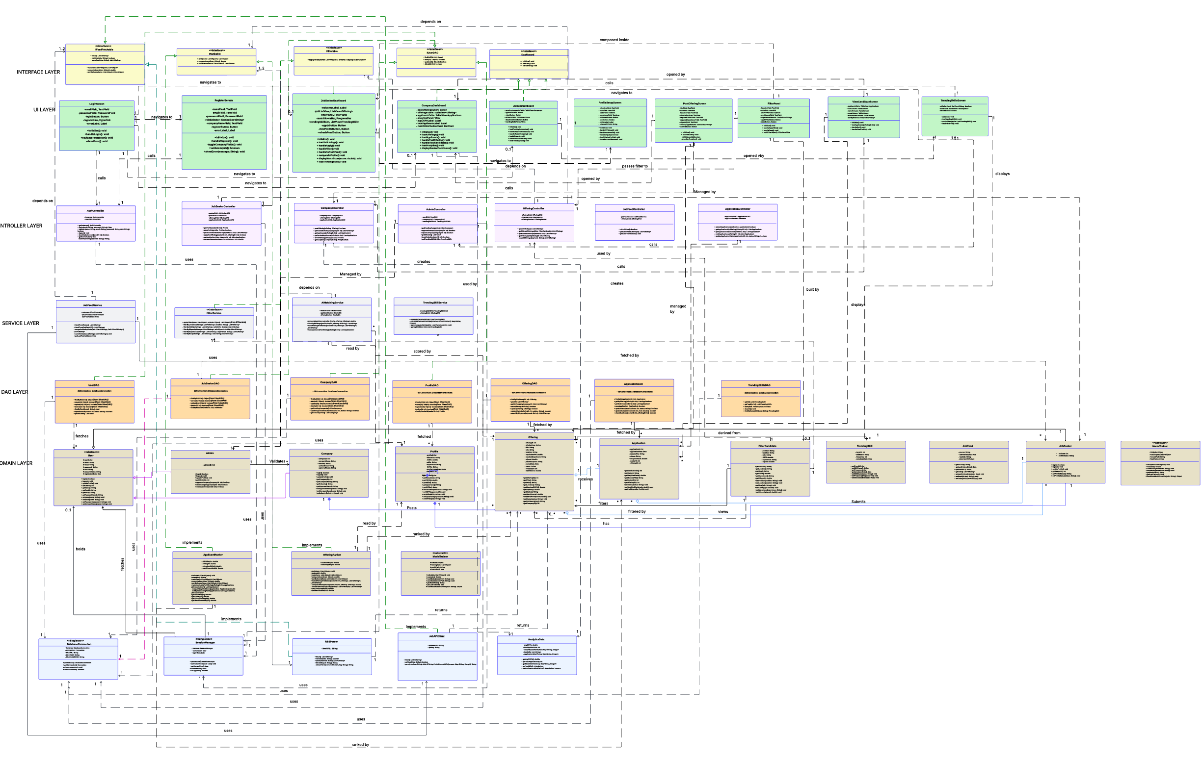

8. Package Diagram
Our package diagram shows the six packages in our system and their dependencies:
- ui: Contains all 9 JavaFX screens. Depends on the controller package.
- controller: Contains 7 controllers. Depends on service, dao and domain packages.
- service: Contains 6 service classes. Depends on dao and domain packages.
- domain: Contains 13 domain model classes. This is the core package with no outward dependencies.
- dao: Contains 7 DAO classes. Depends on domain and utility packages.
- utility: Contains 11 utility classes. Depends on domain package for SessionManager.
- interfaces: Contains 5 interface definitions. Referenced by domain, service, controller and UI packages.
The dependency flow goes from UI to Controller to Service to DAO to Database. No lower layer depends on a higher layer. This is the standard layered architecture pattern.
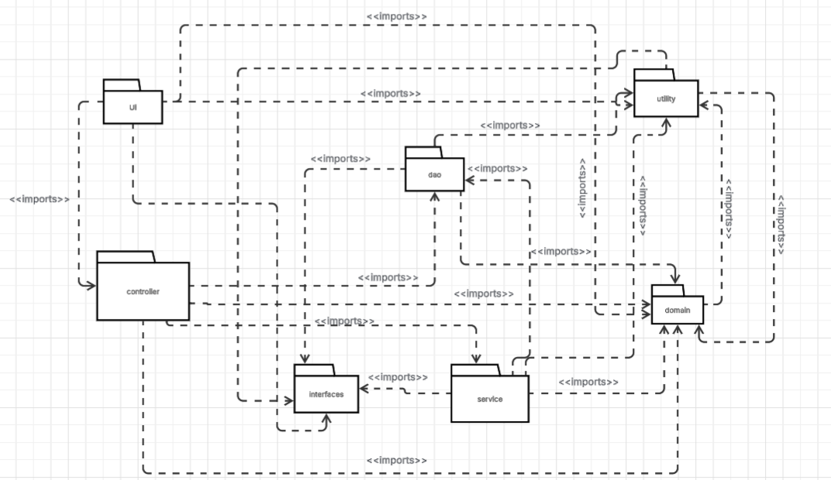

9. Deployment Diagram
Our deployment setup is straightforward since this is a desktop application:
- Client Machine: The user PC runs the JavaFX application. This single machine hosts the UI layer, business logic layer and data access layer all within the same JVM process.
- Database Server: MySQL runs on the same machine (localhost) or on a local network server. The DatabaseConnection singleton manages the JDBC connection.
- External Services: The application connects to Rozee.pk RSS feed and jobdataapi.com over the internet to fetch job listings. These are read only connections using HTTP GET requests.
We chose a desktop deployment because our target users need a simple, installable application rather than a web based solution. The MySQL database can be set up locally with minimal configuration.
[Deployment Diagram to be inserted here]

