

Digital Forensics Assignment #2

Submitted by: Abdul Moeez Siddiqui (CY-D)
Roll number: 22i-1637
Date: 8th September 2024

Introduction:

Write blockers are a vital tool in digital forensics because they stop data from being modified on external storage devices, which is especially important during the acquisition stage. The majority of write blockers on the market are expensive and proprietary. Our task for this assignment is to create a software-based write blocker for Windows 10/11 that protects external devices from being written to while maintaining read access.

First things first, we have to plug our USB/External device with our Laptop/Pc etc.

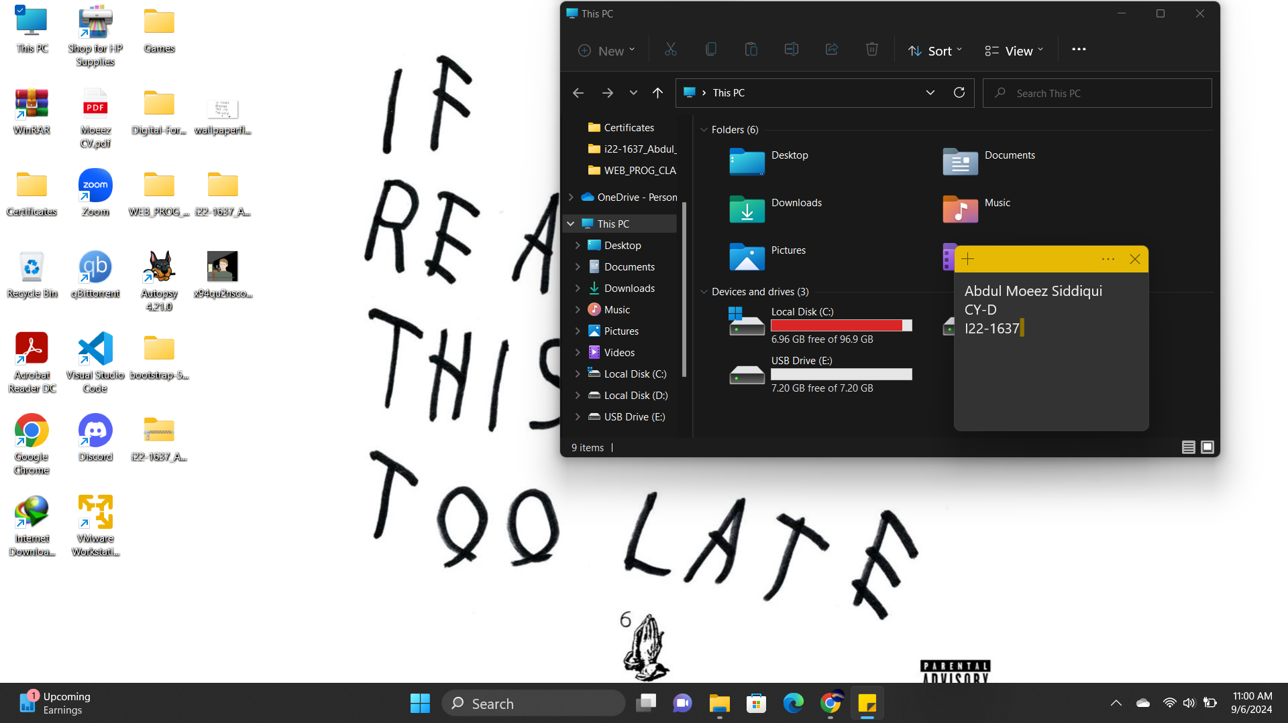

Next thing is that we can head towards the ‘Registry Editor’
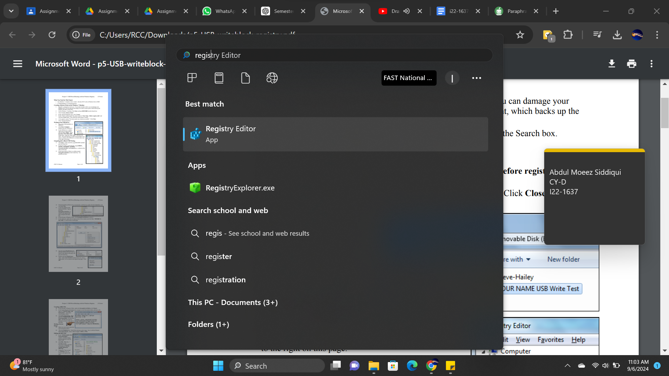

After accessing the editor, we can head to ‘HKEY_LOCAL_MACHINE ->System -> CurrentControlSet->Control’ and scroll down to see if there is a StorageDevicePolicies subkey (most likely isn’t present)

If it isn’t present, we can create a new key and name it StorageDevicePolicies:
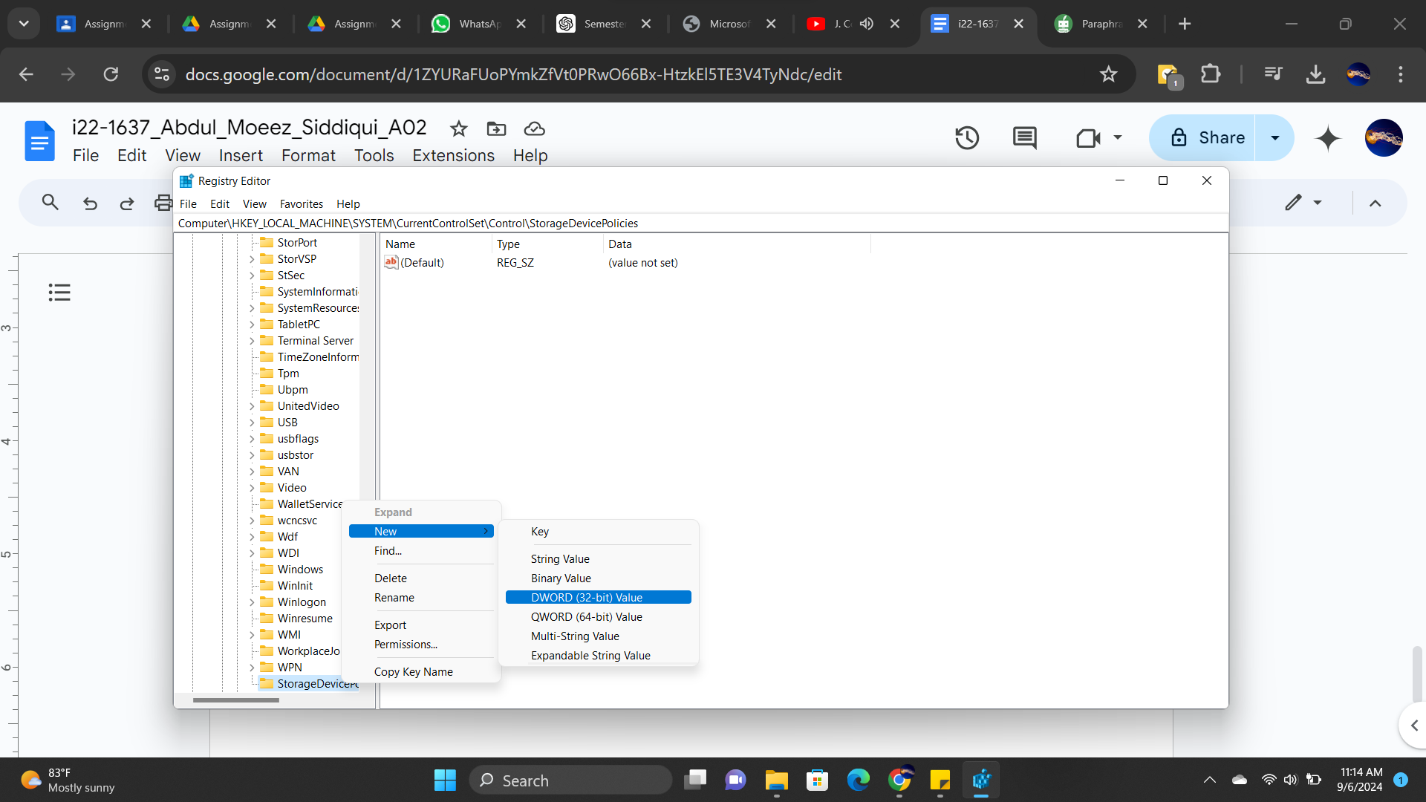

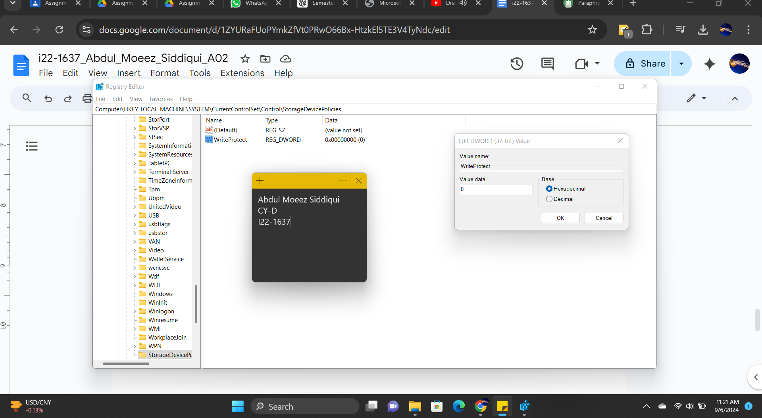

After right-clicking on the key, and clicking on DWORD, we can name it ‘WriteProtect’ or anything similar and we can see the value data.

The value data would most likely be ‘0’ by default, we will make changes and write it as ‘1’.

We can then export this key and make changes to the writing access etc.
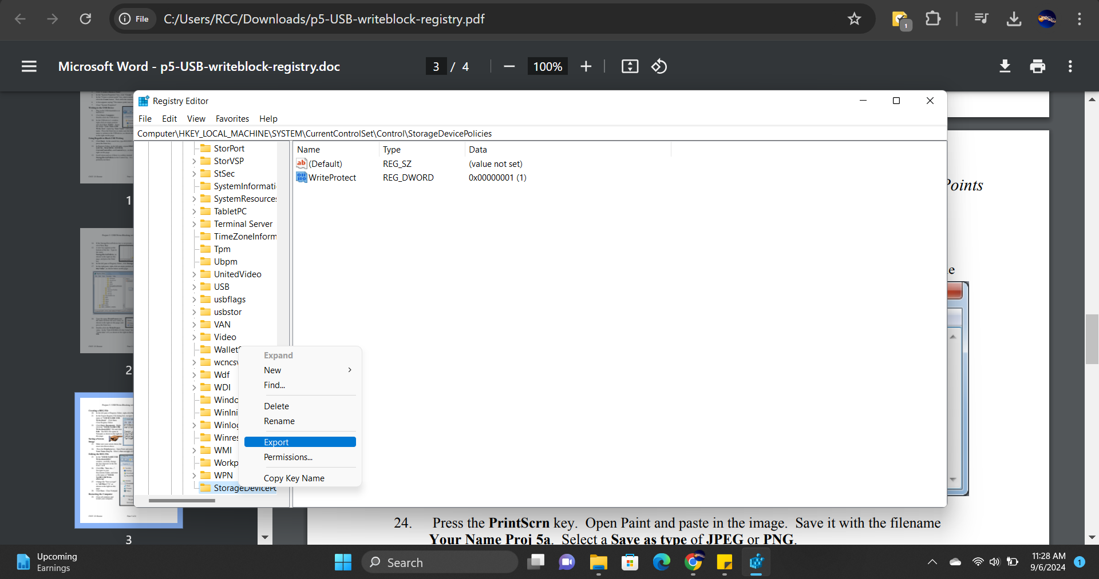

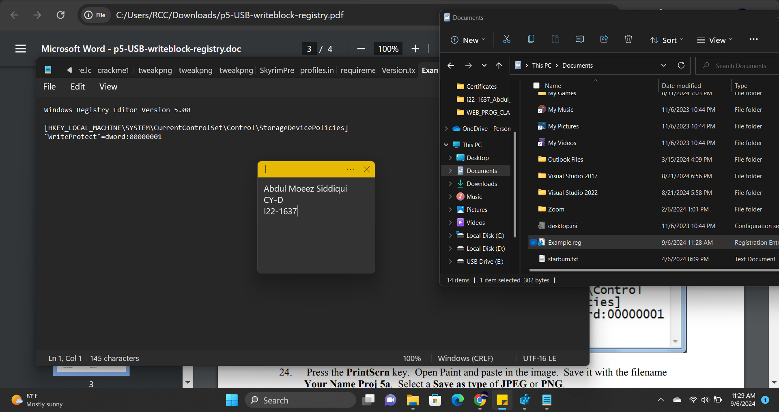

The current value for “WriteProtect” is currently 1, we can change it to 0 and save the file with another name: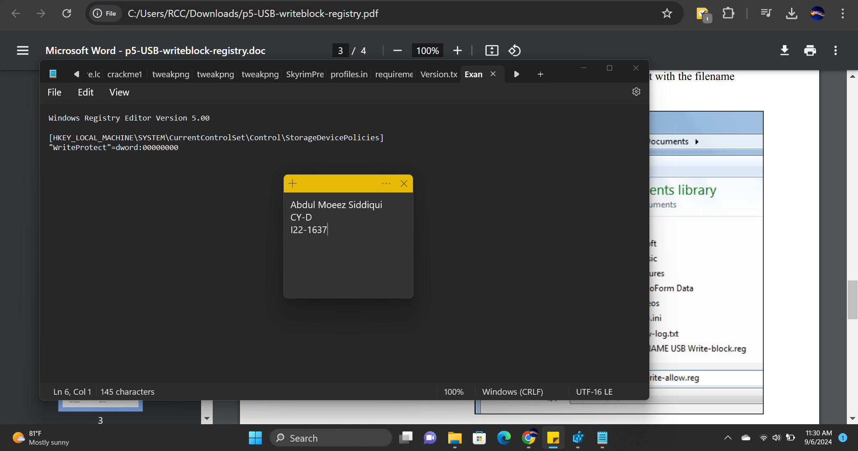

Now when we head into the USB drive/directory/etc, we can see that there is no option for creating a NEW folder.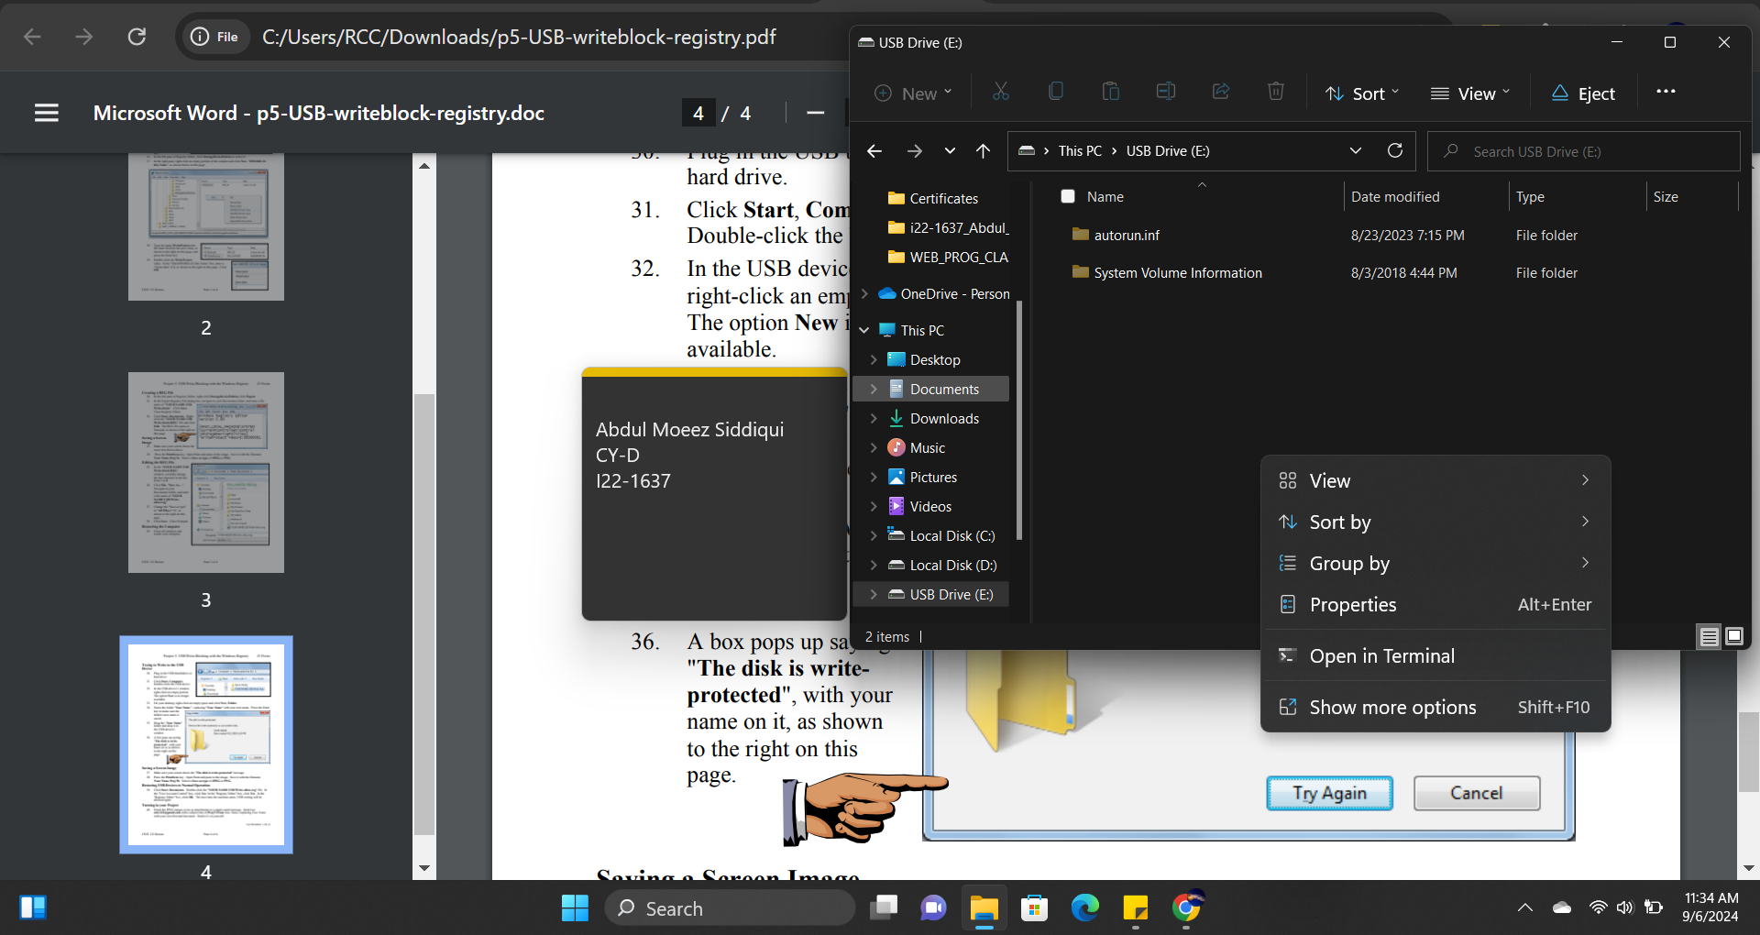

What we can try to do is that, we can create a new folder on our Desktop and rename it something e.g. our Name and we can then try to drag it to USB drive

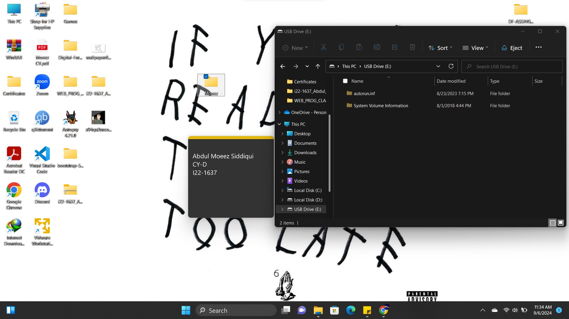
But even that isn’t working, and we are being restricted or ‘blocked’ as the disk is now ‘write-protected’ meaning that the changes we made work.

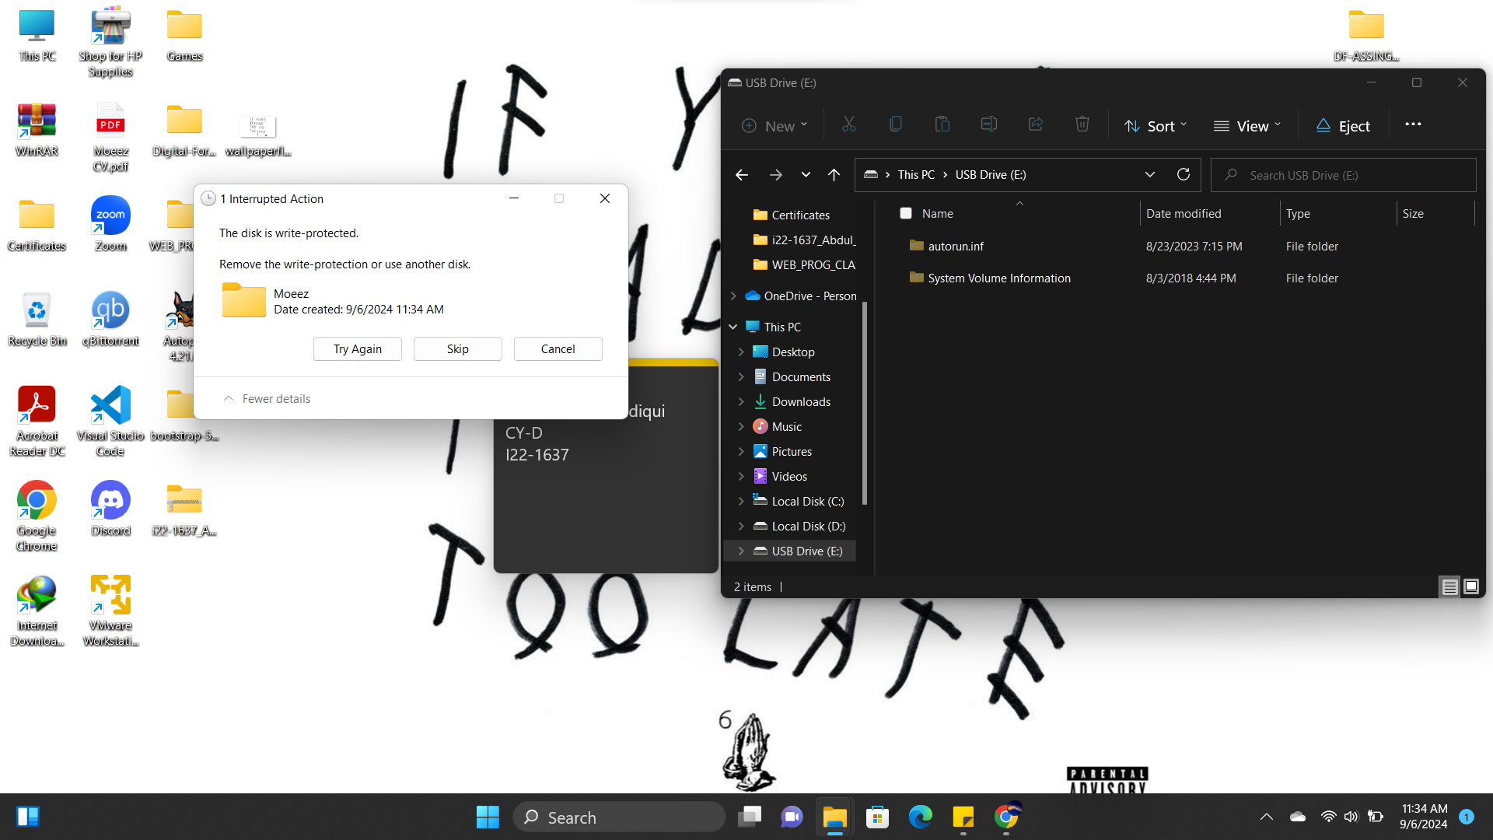

HOWEVER!!!

In order for this to continue, we would have to manually go into the registry editor and make changes. We can automate this process by creating a script/our own write-blocker that does the exact thing for us.

Once we have the script, all we have to do is run it and it will ask us if we want to run the python script:

(Full Process can be seen in the demo/videos submitted alongside this report.)

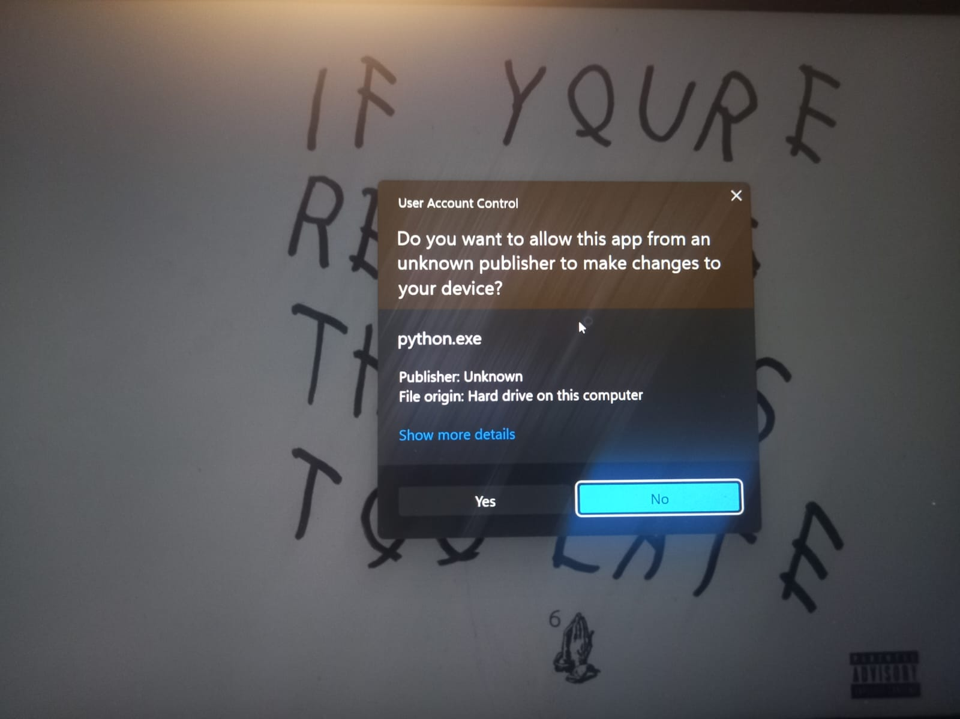

We will click on ‘yes’ and the following pops up:

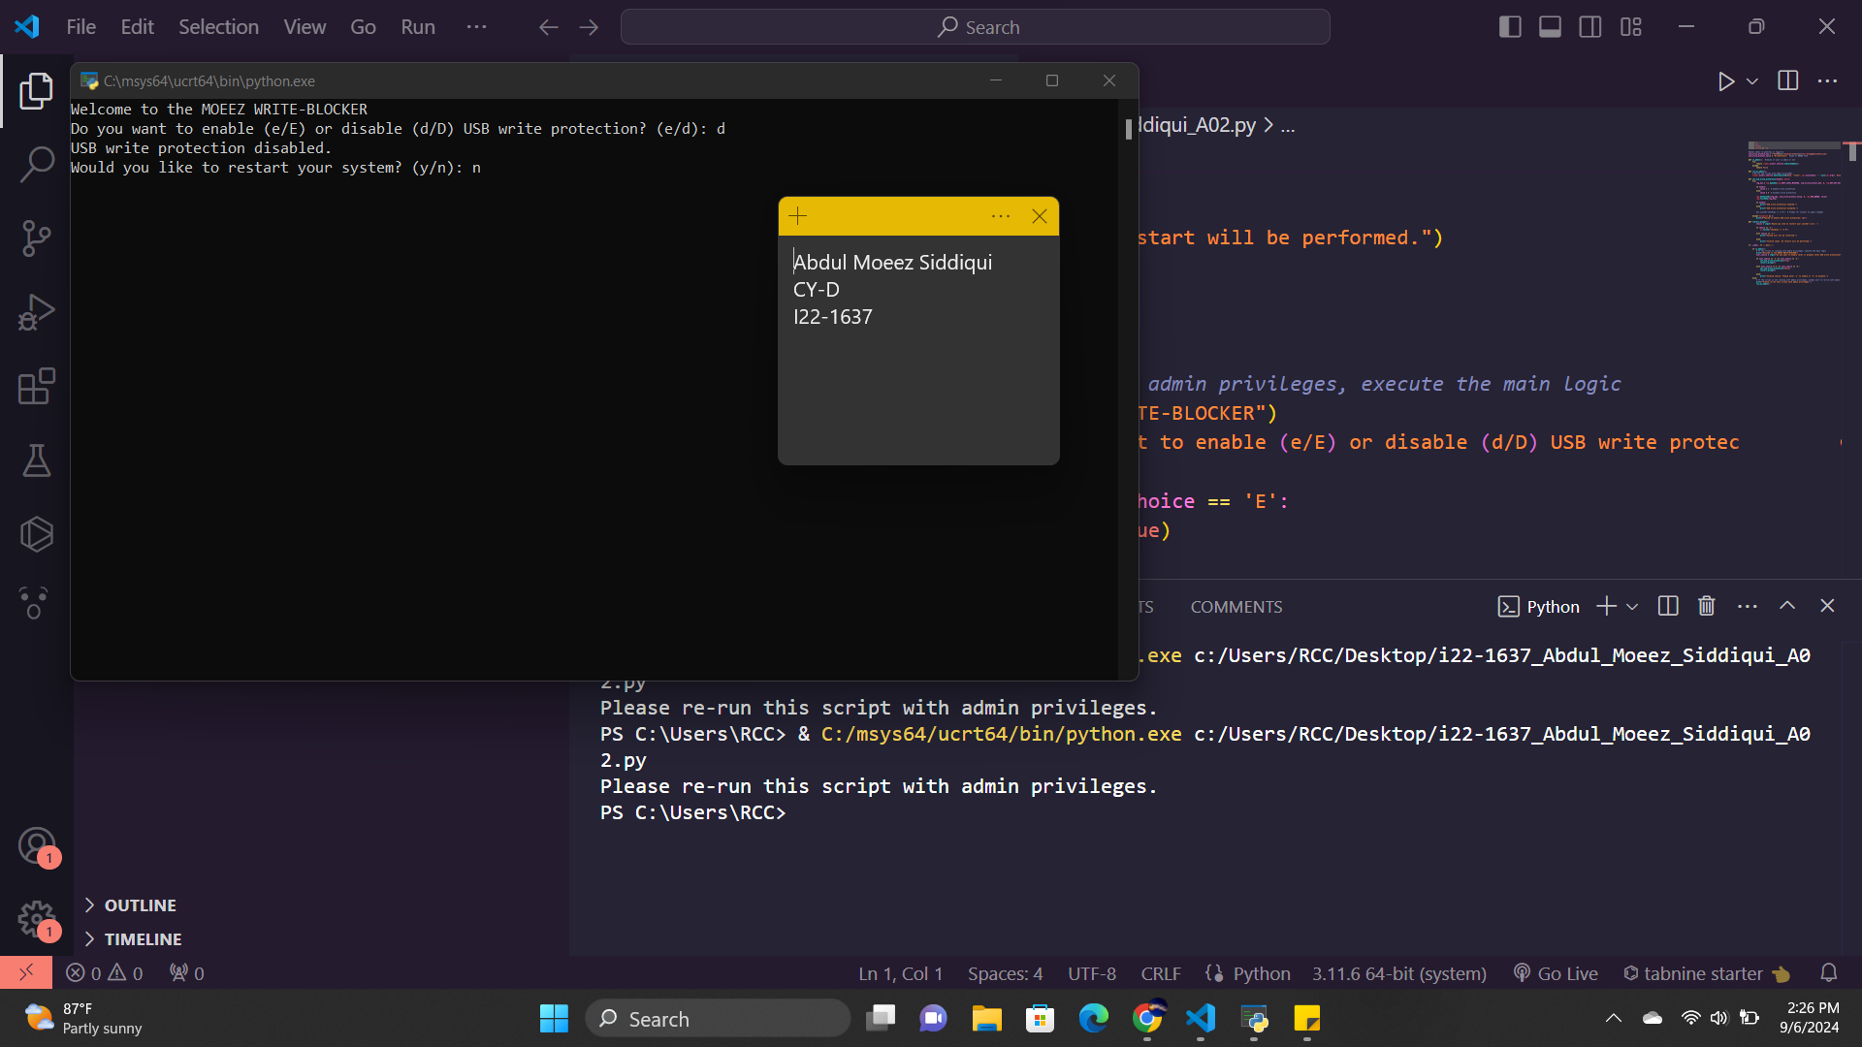

We are given a choice in between whether we wanna enable or disable write protection.
And we also gave a choice if they wanna restart their system in order to fully establish the write protection or want to disable it etc.

Eg if we click ‘e’ or ‘E’ to enable and restart our computer, we will see that we are unable to add a new folder to our usb drive or drag any folder/documents etc into the drive as it has been successfully been write-protected.

We can try this on a .txt file too:
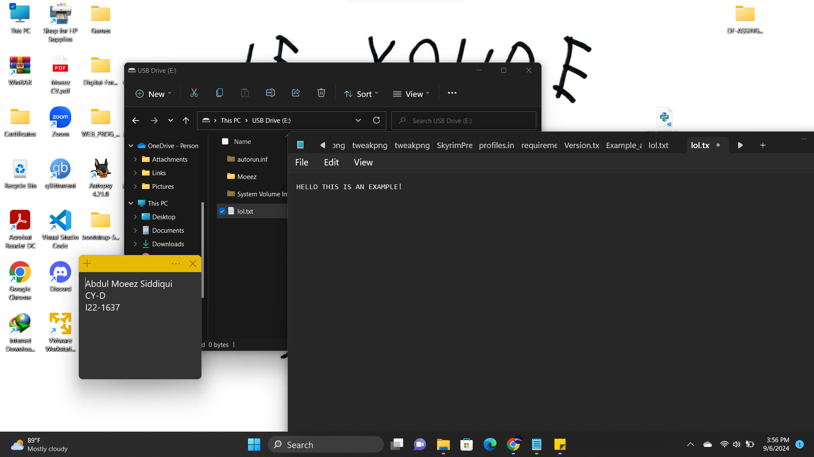

Before enabling write-protection, we made a simple text file and wrote something in it

After running the script, selecting enable/’e’ and restarting the system. We can actually write in it however, it cannot be saved meaning that any sort of writing isn’t technically able to ruin any data/evidence as it doesn’t get saved.
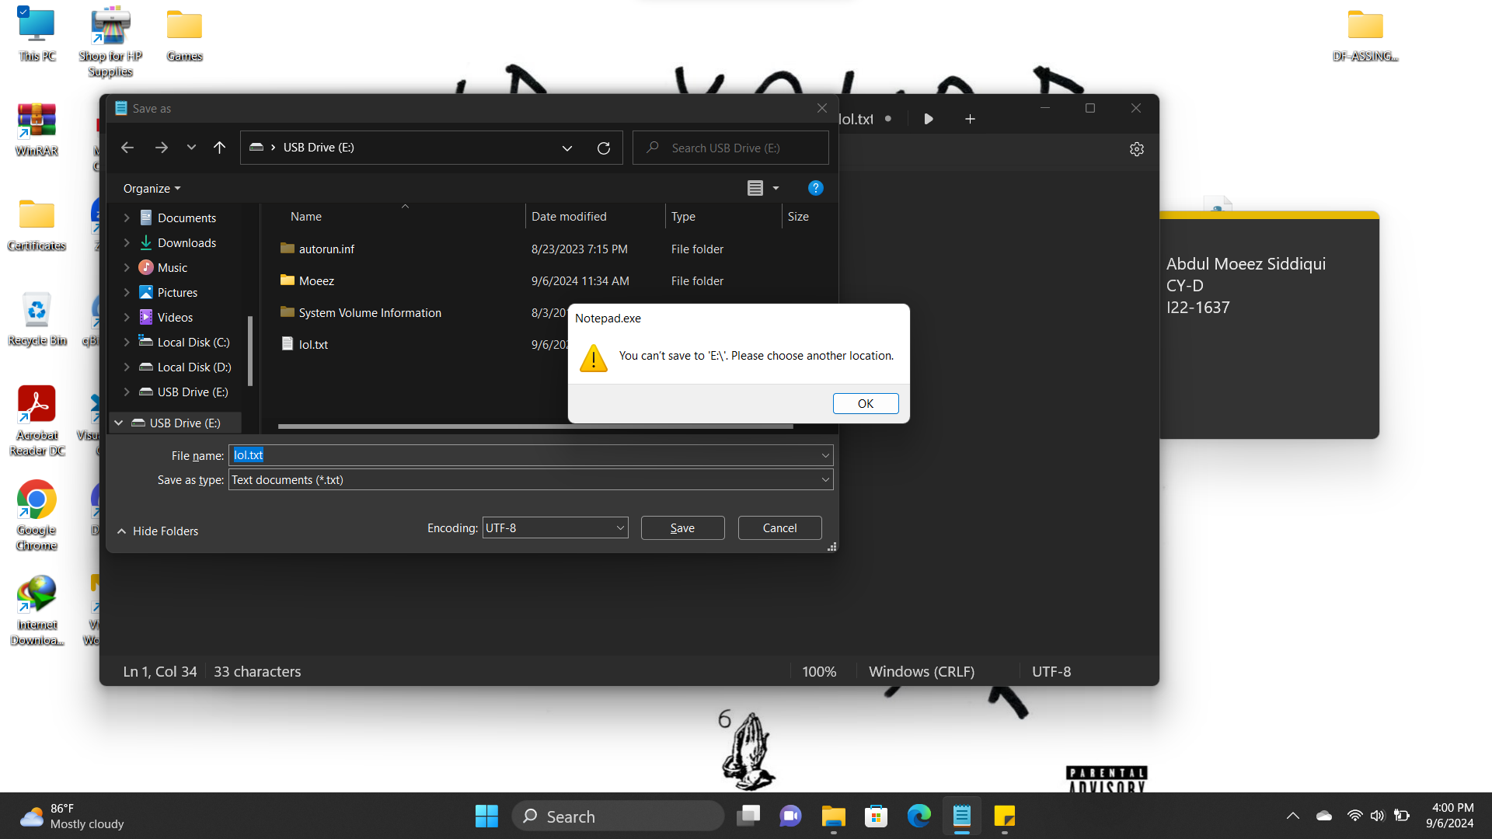

SUMMARY:
For Windows 10/11, this project involves creating a software-based write blocker that preserves read access while preventing unwanted changes to external devices. Initially, the StorageDevicePolicies entry must be created in the Registry Editor, and the WriteProtect value must be set to "1" in order to manually enable write protection. This effectively blocks changes by preventing any new data from being written to the USB drive.

This is made easier by automating the procedure with a Python script. Inquiring as to whether they would like to enable or disable write protection, the script gives the user the choice and suggests restarting the system to make the changes take effect. The user cannot add, edit, or transfer files to the USB device when write protection is enabled, which serves as an effective indicator that the write-blocker is operating as intended.

REFERENCES:

- Building my own write blocker

- Write Blockers- An Introduction - GeeksforGeeks

- GitHub - Juuuho/Windows_WriteBlocker: Windows Registry based external storage write blocker

