Project Report

Submitted By
Abdul Moiz Hassan (22I-2560)
Muhammad Hassaan Mansur (22I-2421)

Submitted to
Sir Zaheer Sani

3rd Dec
Fall 2025



Department of Software Engineering
FAST – National University of Computer & Emerging Sciences

9. Threat Modeling (STRIDE Framework)
This section evaluates security risks in the proposed End-to-End Encrypted Messaging & File-Sharing System using the STRIDE threat modeling framework. The analysis covers threats, affected components, proposed mitigations, and the corresponding implemented defenses in the final system.

9.1 System Components Considered
The following components were analyzed:
- Client Application (React + WebCrypto)
- Key Exchange Protocol (Signed ECDH)
- Messaging & File Upload APIs
- Replay Protection Mechanism
- Backend Server (Node.js + Express)
- Database Layer (MongoDB)
- Network Channel (HTTPS + WebSockets)

9.2 STRIDE Threat Model

S — Spoofing Identity
Threats
- Attacker attempts to impersonate a legitimate user during login.
- Attacker injects a fake public key during key exchange (MITM).
- Forged session tokens to access restricted APIs.
Vulnerable Components
- /api/auth/login
- Unsigned ECDH (demonstrated insecure version)
- Any endpoint requiring a userId parameter
Countermeasures
- Password hashing using bcrypt.
- JWT-based authentication.
- Signed ECDH: client identity key signs ephemeral key.
- Verification of digital signatures during key exchange.
Implemented Defenses
- Passwords stored as salted bcrypt hashes
- JWT tokens issued after successful login
- Client identity key stored only on device (never sent to server)
- Server verifies digital signatures → your route: signed-ecdh
- MITM detection logged under "INVALID_SIGNATURE"

T — Tampering with Data
Threats
- Attacker modifies encrypted messages in transit.
- Attacker replaces public keys during key exchange (MITM).
- Tampering with IVs, nonces, files, or ciphertext.
Vulnerable Components
- DH key exchange (insecure version)
- Message ciphertext storage
- File uploads
Countermeasures
- AES-256-GCM provides authenticated encryption (integrity + confidentiality).
- Signed ECDH prevents tampering with ephemeral public keys.
- Server-side validation of IV, nonce, and sequence number.
- ReplayState prevents tampering with sequence ordering.
Implemented Defenses
- AES-GCM authentication tag validation
- Signed ECDH blocks modified keys
- Sequence validation inside messages.js and files.js
- Nonce reuse detection prevents tampered/replayed messages
- Logging of "REPLAY_ATTACK_SEQUENCE" and "REPLAY_ATTACK_NONCE"

R — Repudiation
Threats
- User denies sending messages.
- Attacker denies performing malicious actions.
- No evidence trail to prove sequence of events.
Vulnerable Components
- Message send flow
- Replay detection flow
- File upload/download
Countermeasures
- Centralized security logging
- Unique sequence numbers for messages
- UserId included in log context
- Timestamps for every security-sensitive call
Implemented Defenses
- securityLogger stores permanent immutable logs
- All authentication attempts logged (AUTH_LOGIN_ATTEMPT)
- All message sends logged (MESSAGE_SEND_ATTEMPT, MESSAGE_SEND_SUCCESS)
- Replay blocks logged clearly
- Logs stored in MongoDB → preserved, tamper-resistant

I — Information Disclosure
Threats
- Plaintext messages leaked from server
- Private keys leaked
- Files exposed in transit
- Metadata revealing communication patterns
Vulnerable Components
- File storage
- Message storage
- Public network traffic
Countermeasures
- End-to-end encryption (AES-GCM) ensures server stores only ciphertext
- Private keys stored only on client (IndexedDB)
- HTTPS for transport security
- Public keys stored as JWK/PEM without private material
Implemented Defenses
- Server never receives plaintext messages
- Server stores only encrypted files (buffer)
- IV, nonce, sequence stored only for replay protection
- Identity private key is permanently client-side
- No plaintext logged anywhere in backend

D — Denial of Service (DoS)
Threats
- Replay flooding attacks
- High-frequency message sends with repeated nonces
- Resource exhaustion via repeated key exchanges
- File upload floods
Vulnerable Components
- /api/messages/send
- /api/files/upload
- /api/keyexchange/init
Countermeasures
- Sequence + nonce replay detection
- Strict timestamp validation
- Upload size control via Multer
- Express JSON size limit (optional enhancement)
Implemented Defenses
- Replay detection in messages.js
- Replay detection in files.js
- Logging of repeated attempts
- Strong timeout-based timestamp validation

E — Elevation of Privilege
Threats
- Attacker attempts to submit requests as another user
- Manipulation of senderId / receiverId in payload
- Injecting malicious key material to trick AES/GCM or ECDH flows
Vulnerable Components
- Message send flow
- Key exchange
- File download endpoint
Countermeasures
- JWT-based identity verification (optional → recommended)
- Signature verification during key exchange
- Strong validation on replay (prevents privilege escalation _)
- Metadata access logging (detect probing)
Implemented Defenses
- Signed ECDH validates the sender's identity
- Replay checks prevent unsolicited privilege escalation
- Logging of metadata access attempts
- "FILE_DOWNLOAD_ATTEMPT" and "METADATA_ACCESS" logs

9.3 Summary Matrix
A concise mapping table:

STRIDE Category | Example Threat | Vulnerable Component | Actual Implementation
Spoofing | MITM modifies ECDH key | Key exchange | Signed ECDH signature verification
Tampering | Modify ciphertext | Message storage | AES-GCM integrity tag
Repudiation | User denies action | Messaging | MongoDB security logs
Info Disclosure | Server leaks plaintext | Backend DB | End-to-end encryption
DoS | Replay flood | Messages/files | Sequence + nonce + timestamp validation
EoP | Inject invalid senderId | Message send | JWT auth + validation + logging

10. System Architecture & Documentation

10.1 High-level Architecture Diagram
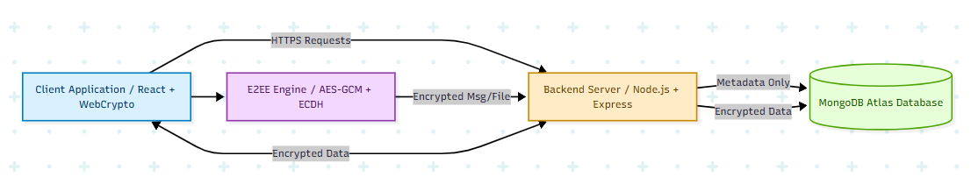

10.2 Client-side Flow Diagram

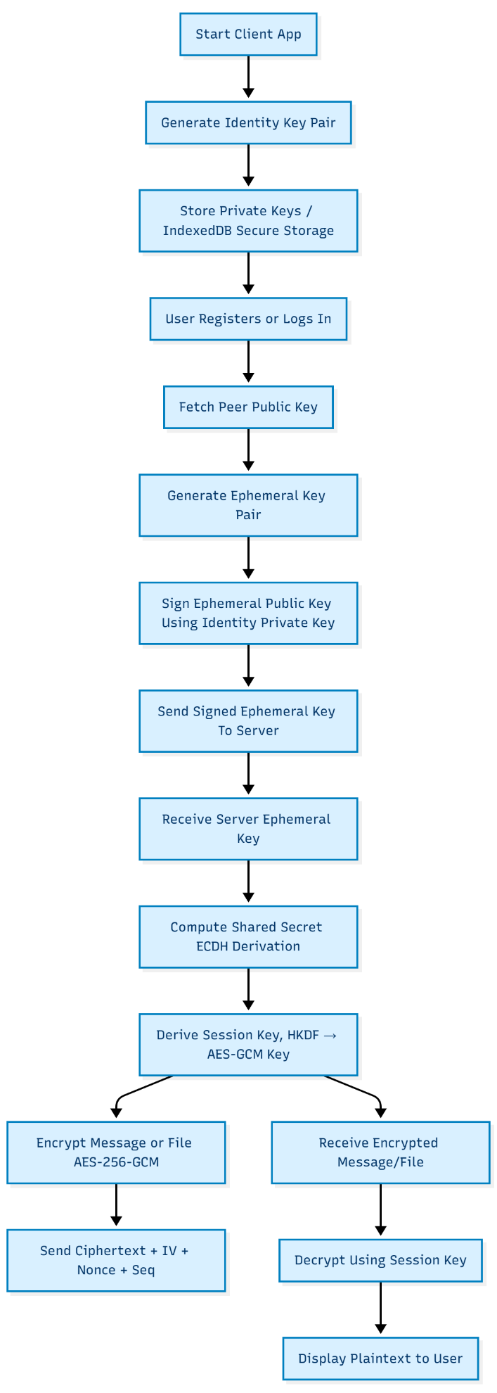

10.3 Key Exchange Protocol Diagram

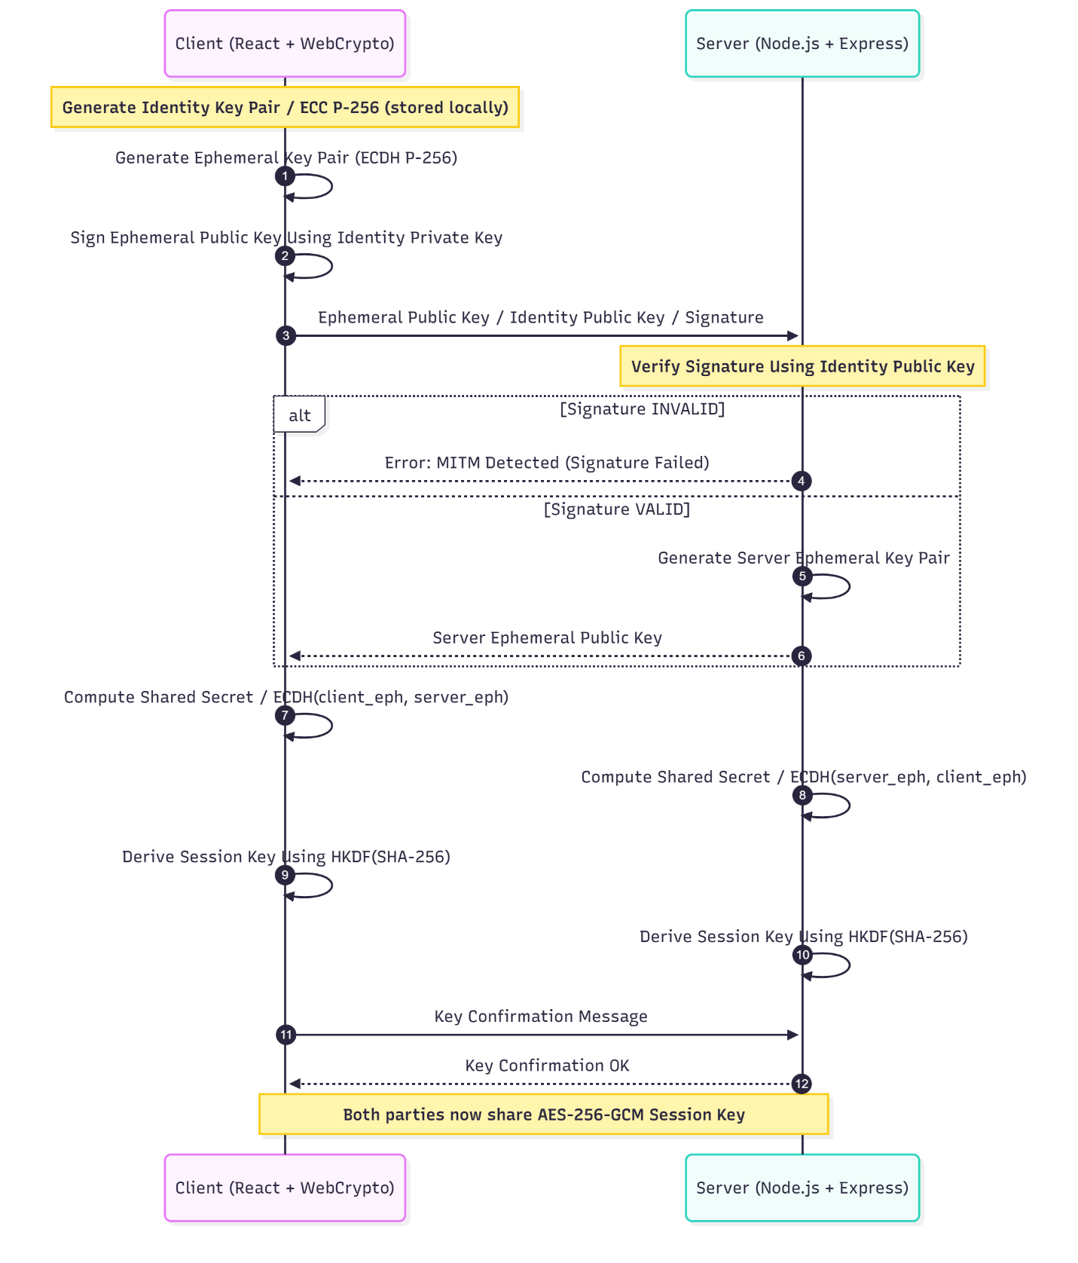

10.4 Encryption Workflow

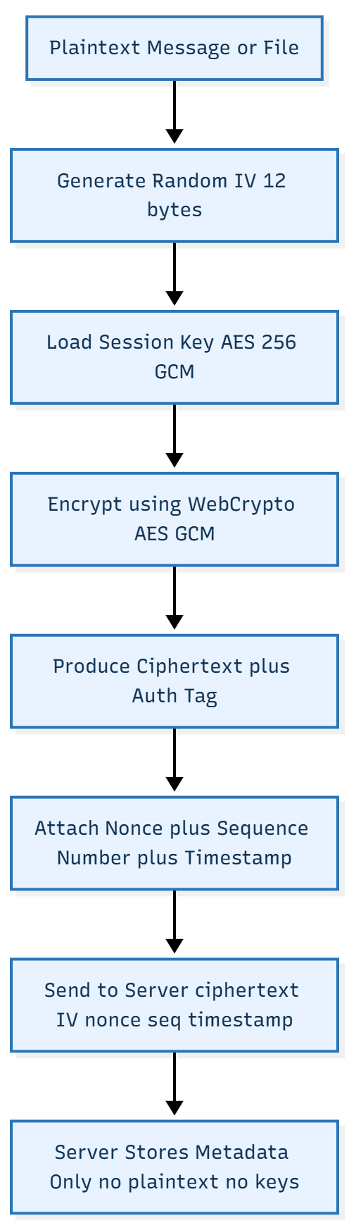

10.5 Decryption Workflow

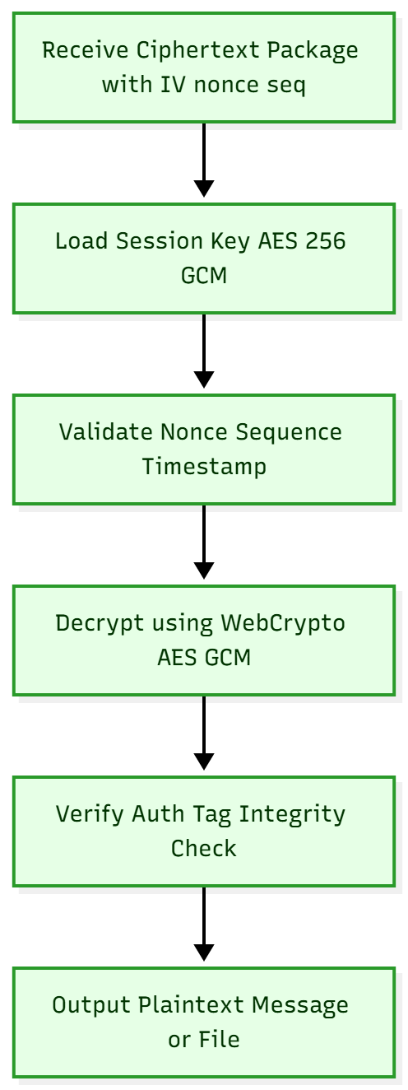

10.6 Schema Design

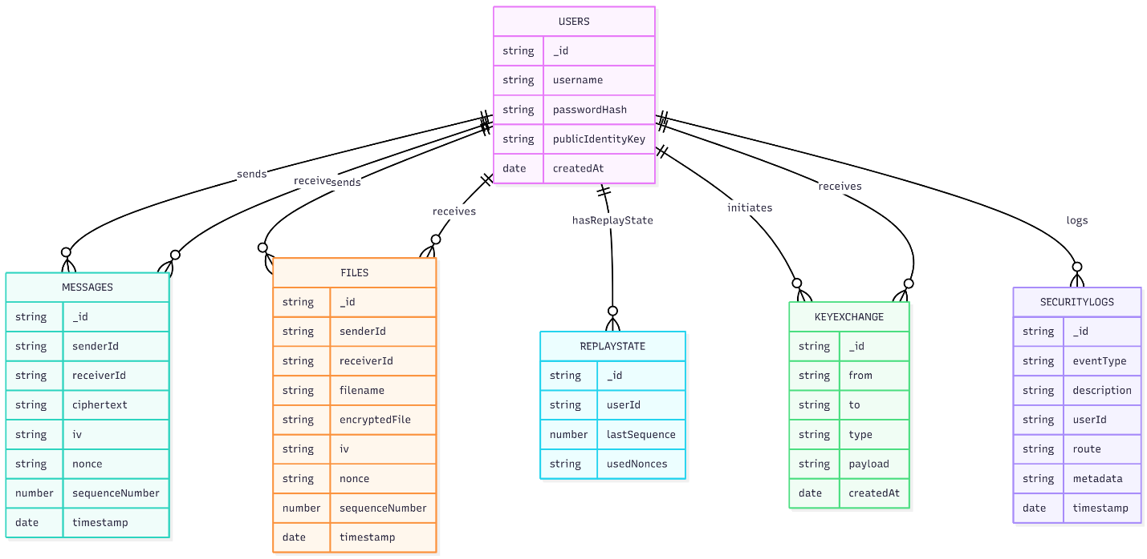

10.7 Deployment Description

This section describes how the End-to-End Encrypted Messaging & File-Sharing System is deployed and executed in a local development environment. The entire system runs on a developer machine, with a cloud-hosted MongoDB Atlas database used for persistent storage. All cryptographic operations are performed on the client side using the Web Crypto API to preserve end-to-end confidentiality.

1. Components Involved

1.1 Client Application (React + Vite)
- Runs locally on the developer machine
- Development server hosted at:
http://localhost:5173/
- Performs all cryptographic operations:
  - ECC identity key generation
  - Ephemeral key generation
  - Signed ECDH key exchange
  - AES-256-GCM message and file encryption
- Stores private keys in IndexedDB
- Sends only ciphertext + IV + nonce + sequence number to backend

1.2 Backend Server (Node.js + Express)
- Runs locally at:
http://localhost:4000/
- Provides REST API endpoints for:
  - User registration & login
  - Key exchange
  - Encrypted message delivery
  - Encrypted file upload/download
  - Replay protection
  - Logging & auditing
- Verifies digital signatures during key exchange
- Does not generate or access plaintext at any point

1.3 Database (MongoDB Atlas Cloud Cluster)
- Although the system runs locally, the database is cloud-hosted.
- MongoDB Atlas provides:
  - Document storage for users, messages, files
  - ReplayState tracking
  - Security logs
- Stores only encrypted data:
  - AES-GCM ciphertext
  - Encrypted file buffers
  - IVs, nonces, metadata
No plaintext is stored.

2. Local Deployment Workflow
2.1 Backend Setup
- Navigate to the server/ directory
- Install dependencies
- npm install
- Configure .env with:
- MONGO_URI=<your MongoDB Atlas URI>
- JWT_SECRET=<random strong key>
- Start the server with nodemon
- npm run dev
- The backend is now live on:
http://localhost:4000

2.2 Client Setup
- Navigate to the client/ directory
- Install dependencies
- npm install
- Start the development frontend
- npm run dev
- The client UI is available at:
http://localhost:5173

3. Local Network Communication (HTTPS via Proxy / Browser)
Although the application is served over HTTP in local development mode, all sensitive data is encrypted before being sent to the server.
- WebCrypto handles AES-GCM + ECDH in-browser
- The backend handles only ciphertext
- This preserves E2EE even in a non-production environment
In a production deployment, HTTPS would be mandatory.

4. Burp Suite / MITM Testing
For attack demonstrations:
- The client’s network traffic is proxied through Burp Suite running locally
- Unsigned ECDH requests show successful MITM
- Signed ECDH requests demonstrate prevention
No private keys leave the client device, so even in proxy mode plaintext never appears in the traffic inspector.

5. Summary of Local Deployment
Component | Runtime | Responsibilities
React Client | localhost:5173 | UI + WebCrypto + encryption
Node.js Server | localhost:4000 | API + logs + storing ciphertext
MongoDB Atlas | Cloud | Encrypted message/file metadata
Burp Suite | Local 127.0.0.1:8080 | MITM attack simulation

