Tiny Maze Result:

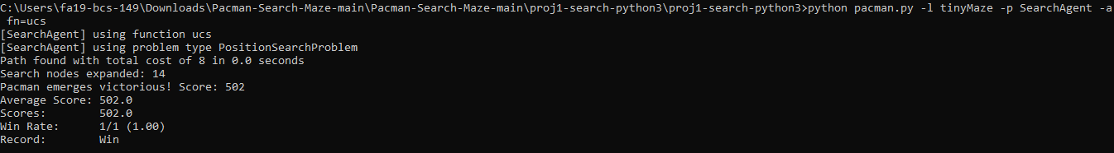

Small:

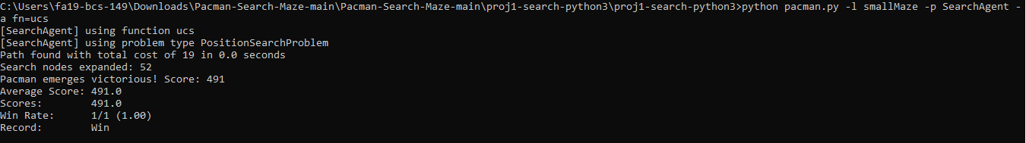

Medium:

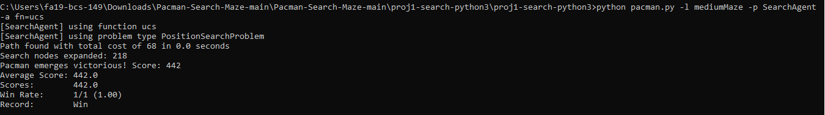

Big Maze:

Big Maze with Equal Cost to Prove working same as BFS:

Uniform Cost Search:

def uniformCostSearch(problem):
# Creating a priority queue
fringe = util.PriorityQueue()
# Setting initial node priority
fringe.push((problem.getStartState(), []), 1)

# To keep track of visited nodes
explored = []

while not fringe.isEmpty():
# Taking the strongest priority node first i.e. West or South First
state, actions = fringe.pop()

# if found goal return the actions
if problem.isGoalState(state):
return actions

# if not seen before just add it in the node
if state not in explored:
explored.append(state)

# get all successors and iterate over them
for successor, action, stepCost in problem.getSuccessors(state):
#print("Successor is State is actions ", successor, state, actions)
# if current action on successor function is north or east set cost to 2
# it will be 1 otherwise
if action == "East" or action == "North":
stepCost = 2

# if sucessor or path is not already checked
if successor not in explored:
next_actions = actions + [action]
successor_node = (successor, next_actions)
# Push the node after getting list of actions along with stepcost
fringe.push(successor_node, stepCost)

"""print("Start's successors:", problem.getSuccessors((3,3 )))

print(problem.isGoalState((1,1)))
print("Start ", problem.getStartState());
"""

return []

The End.

