**GenAi_Class_02**

* ChatDev
* Quivr

Base Environment and Virtual Environment

**Make complete project using ChatDev**

**Steps**

1. Anaconda
2. python
3. chatDev
4. virtual env
5. LLM all API keys(Direcrt variables using .env)
6. Write Prompt
7. run .py (command)

To survive in open source use (linux using wsl in windows 11 or Mac)

(Flappy bird)

**LangCHain**

Everything that is made like Chatdev bots are powered in backend by langchain general framework create all the backend

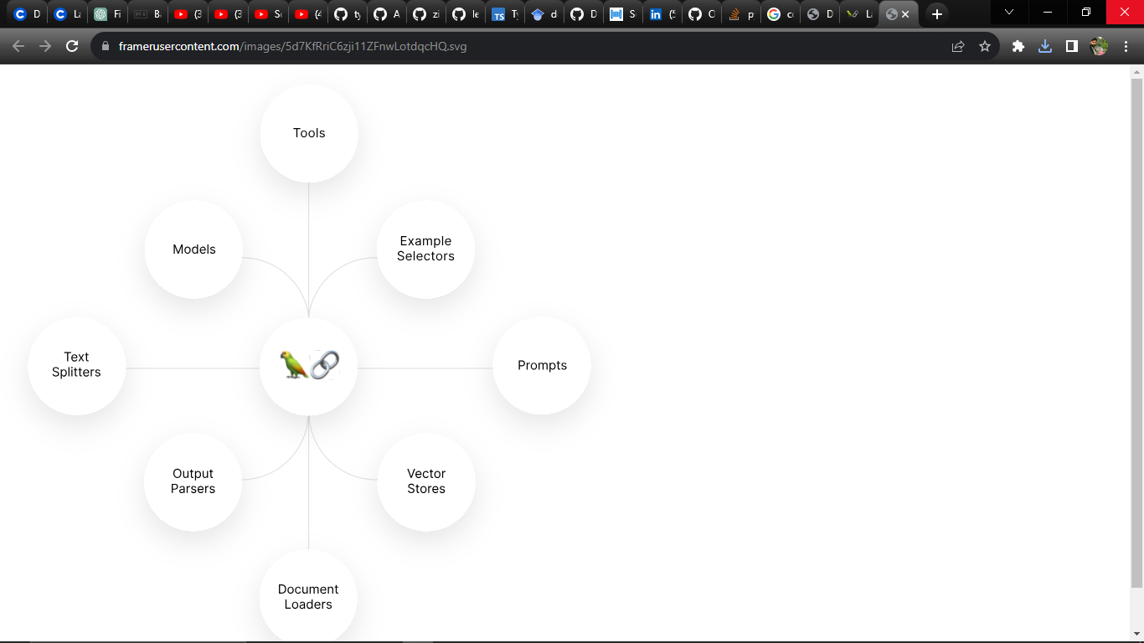

Vector database(pinecorn)