**Automated Attendance System using Facial Recognition**

**Abdul Rafay Siddiqui**

**Siddiqui.arafay01@gmail.com**

**Introduction:**

The main problem with the traditional attendance system is that it is subject to manipulation and there remains chance of human error during data entry. Though it is easier to implement and saves technology expenses, the organization cannot benefit from the innovations of data analysis which has huge implications. In addition to this, contemporary attendance method at classroom requires human intervention and cooperation from students which contributes to wastage of precious classroom time. This is an attendance project in which attendance of students will be marked automatically using face detection. The time at which student shows up in class and mark their attendance will also be recorded, for these purposes we have used OpenCV and Face Recognition Libraries.

**Methodoogy:**

Attendance Marking

Recognize Face

Detect Faces

Frame/Image

Excel Sheet Updated

Compare 128-D vectors to known dataset

Compute 128-D face embedding

Camera

**Result:**

The camera will take snaps of the faces in front of it and then it will extract its features and try detecting them by computing through 128-D face embedding and then comparing by 128-D vectors to known dataset, after that it will recognize the face and show the name on the screen. Afterwards it will mark their attendance by updating the excel sheet with name, date and time.

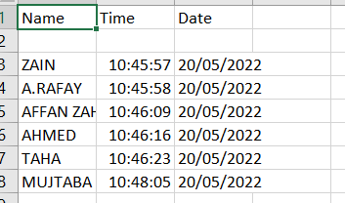

**Conclusion:**

The project will provide a path for a more robust and intelligent attendance monitoring system based on IoT for the employee of an organization. The worker can monitor attendance and check any discrepancy that may occur in the attendance by accessing the system on mobile phone. The futur work will consider implementing incremental learning in the system which detects any malicious attendance during run time.