Cyber Security Internship Program
NexaSecure Tech
Name: Abdul Rehman
Date: 27/03/2026

WEEK 2 – Ethical Hacking & Vulnerability Assessment

Day 8: Ethical Hacking Methodology

1. Information Gathering
- This is the first phase where the tester collects information about the target.
Purpose: Understand the target before attacking.
Activities:
- Identify target systems
- Gather domain/IP information
- Identify technologies used
- Find employees or emails (OSINT)
Tools:
- Nmap
- Maltego
- theHarvester
- Shodan

Scanning & Enumeration
- In this phase the tester scans the target network to find open ports, services, and vulnerabilities.
Activities:
- Port scanning
- Service detection
- OS detection
- User enumeration
Tools:
- Nmap
- Nikto
- OpenVAS

Gaining Access (Exploitation)
- Here the tester tries to exploit vulnerabilities to access the system.
Activities:
- Exploit vulnerabilities
- Password cracking
- Web application attacks
Tools:
- Metasploit Framework
- Burp Suite
- Hydra

Maintaining Access (Post-Exploitation)
- The tester checks how long access can be maintained.
Activities:
- Privilege escalation
- Create persistence
- Access sensitive data
Tools:
- Meterpreter
- Mimikatz

Covering Tracks & Reporting
- In real attacks hackers hide traces, but ethical hackers document everything instead.
Activities:
- Document vulnerabilities
- Provide remediation steps
- Create final report

Day 9: Reconnaissance

Information Gathering with theHarvester
theHarvester is used to collect:
- Emails
- Subdomains
- Hostnames
- IP addresses
- Company information
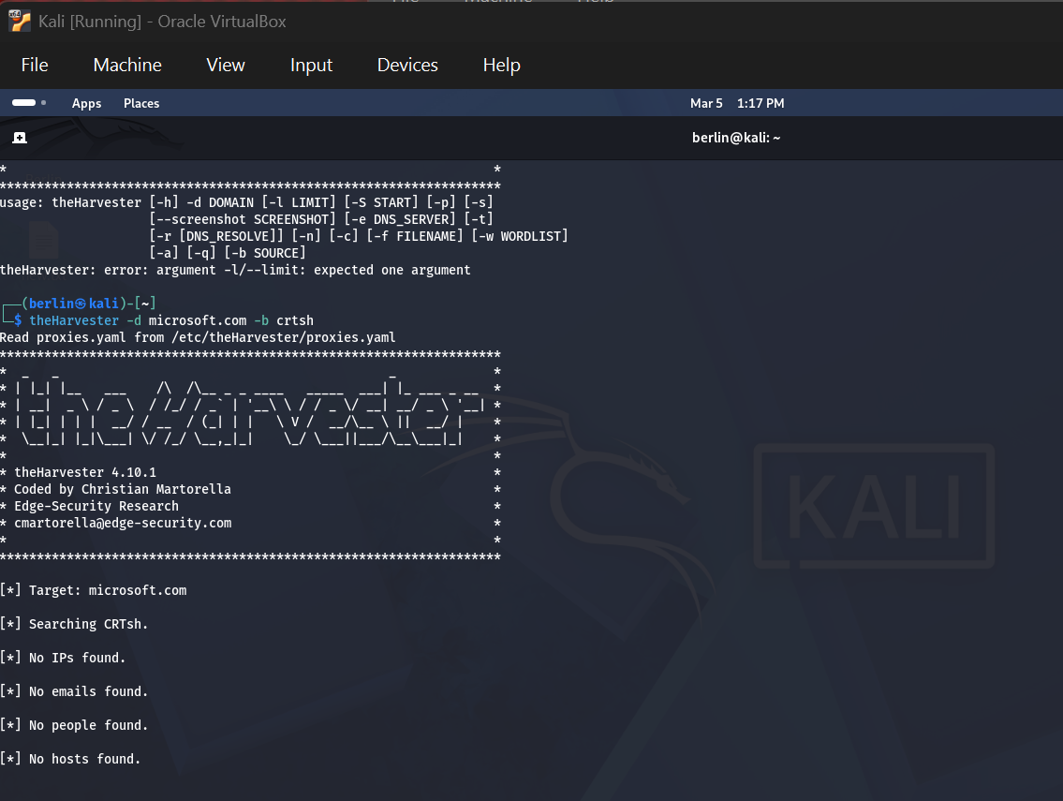

Information Gathering with WHOIS
WHOIS provides information about:
- Domain owner
- Organization name
- Registration date
- DNS servers
- Contact information

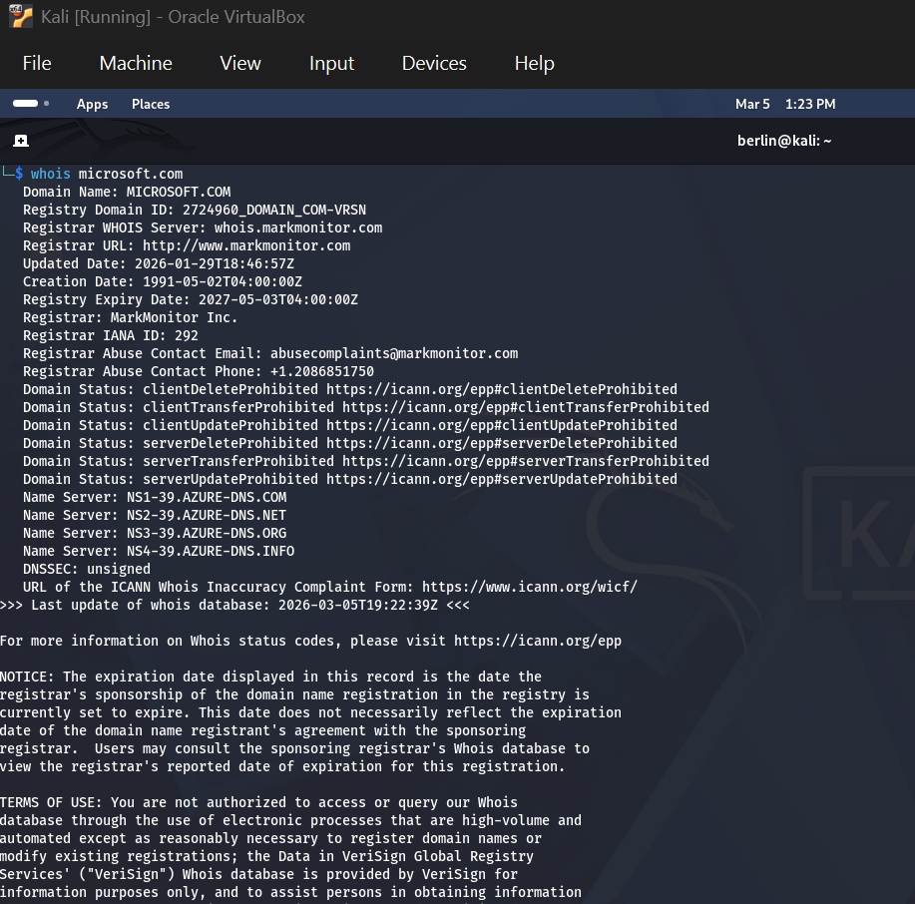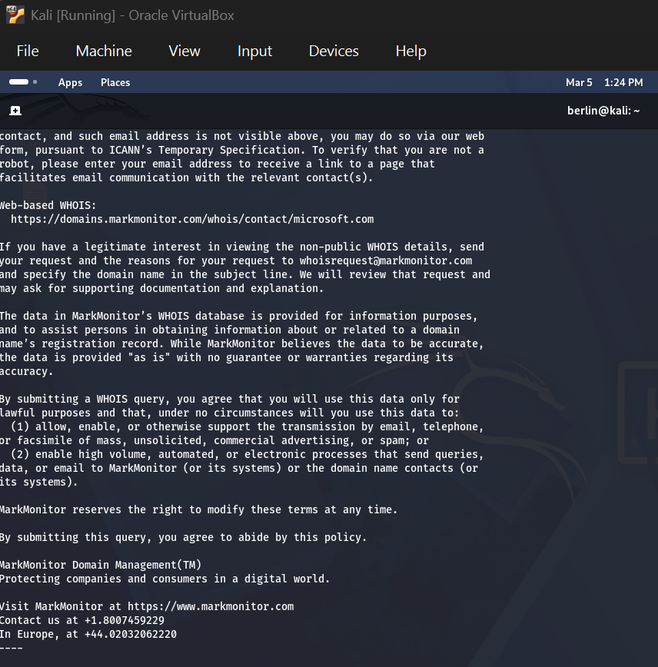

Day 10: Advanced Scanning

First find the machines in your lab network.

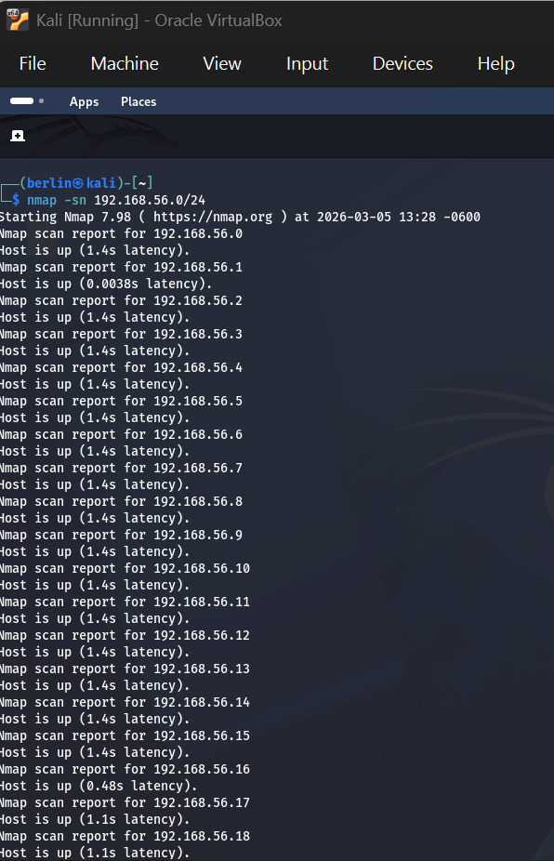

This command detects which services and versions are running.

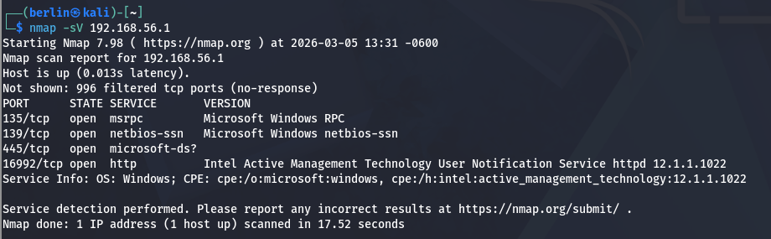
Now detect the Operating System of the target.

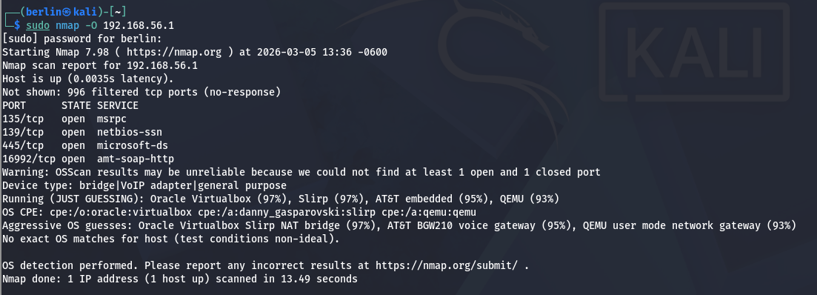

Day 11: Web Vulnerability Scanning

Nikto scans a web server for:
- Vulnerabilities
- Outdated software
- Dangerous files
- Misconfigurations

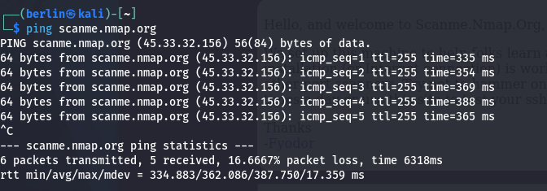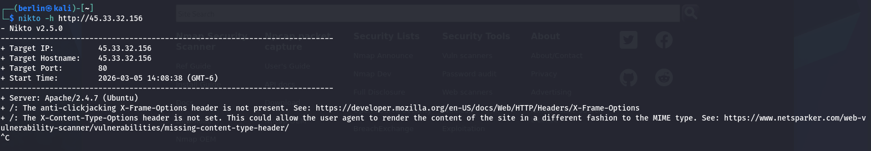

Day 12: SQL Injection Testing

SQLmap will automatically test the parameter cat=1 for SQL injection.
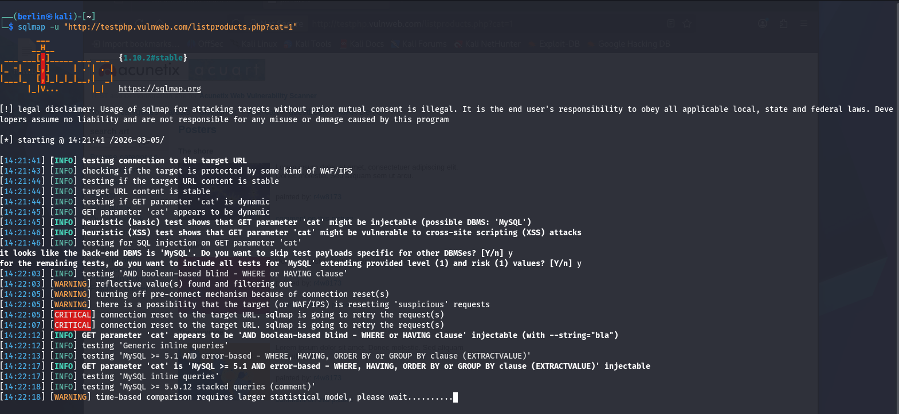
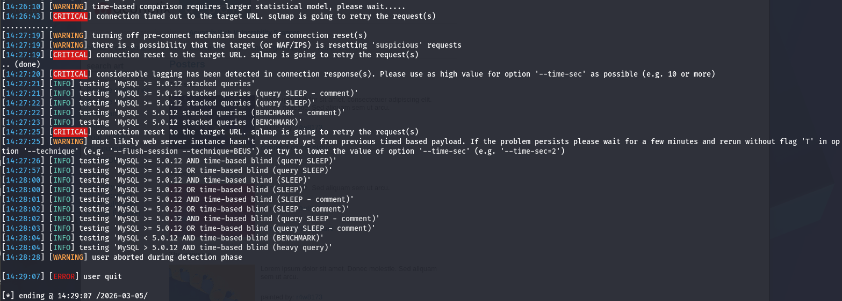

Day 13: Password Testing

Hydra is a tool used to perform brute-force attacks against login services such as SSH, FTP, HTTP, etc.

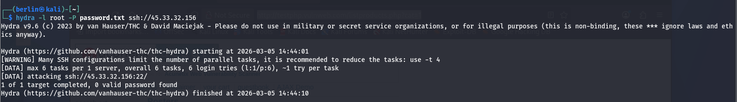

John the Ripper is used to crack password hashes.

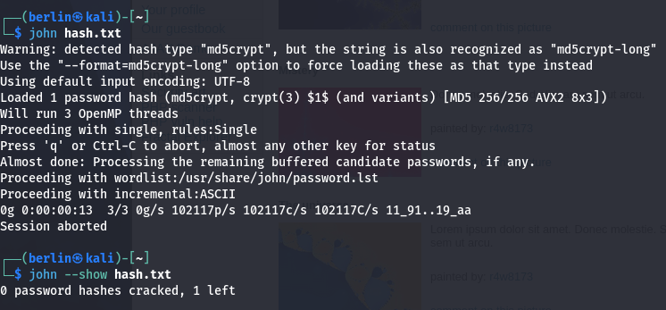
Day 14: Vulnerability Report Writing
1. Introduction
This report presents the results of a vulnerability assessment performed on a target system. The purpose is to identify security weaknesses and provide recommendations to improve system security.

2. Scope
- Target: Test System / Network
- Environment: Lab Setup
- Tools Used: Nmap, Nikto, SQLmap

3. Methodology
- Scanning: Identified open ports and services using Nmap
- Vulnerability Scanning: Checked for web vulnerabilities using Nikto
- Testing: Tested for SQL Injection using SQLmap

4. Recommendations
- Use strong password policies
- Validate all user inputs
- Close unnecessary ports
- Keep software updated

5. Methodology
- Information Gathering
- Scanning
- Vulnerability Identification
- Risk Analysis

6. Risk Classification
Use standard levels:
- Low → Minimal impact
- Medium → Moderate impact
- High → Serious risk
- Critical → Immediate threat

7. Detailed Vulnerability Description
User input is not validated, allowing attackers to execute malicious SQL queries.

Impact:
- Data leakage
- Unauthorized access
Recommendation:
- Use prepared statements
- Input validation

8. Conclusion
- Summary of overall security posture
- Importance of fixing critical issues first

Conclusion:
The system is vulnerable to attacks and requires urgent security improvements.

