Cyber Security Internship Program
NexaSecure Tech

Name: Abdul Rehman
Date: 27/03/2026

WEEK 3 – Web Security & Blue Team Basics
Day 15: OWASP Top 10 Overview

Purpose
- Identify the most common web security risks
- Provide guidance for secure development
- Help blue teams and developers prioritize defenses

OWASP Top 10 Categories (2021)

- Broken Access Control
Improper restrictions allow unauthorized access to data or functions.
- Cryptographic Failures
Weak or missing encryption exposes sensitive data.
- Injection
Malicious input is executed by the application (e.g., SQL, OS commands).
- Insecure Design
Lack of security considerations during system design.
- Security Misconfiguration
Incorrect or default system settings create vulnerabilities.
- Vulnerable and Outdated Components
Use of software with known security flaws.
- Identification and Authentication Failures
Weak authentication mechanisms (e.g., poor password controls).
- Software and Data Integrity Failures
Untrusted data or updates compromise system integrity.
- Security Logging and Monitoring Failures
Lack of logging and monitoring delays detection of attacks.
- Server-Side Request Forgery (SSRF)
Server makes unintended requests to internal or external systems.

Day 16: XSS Testing

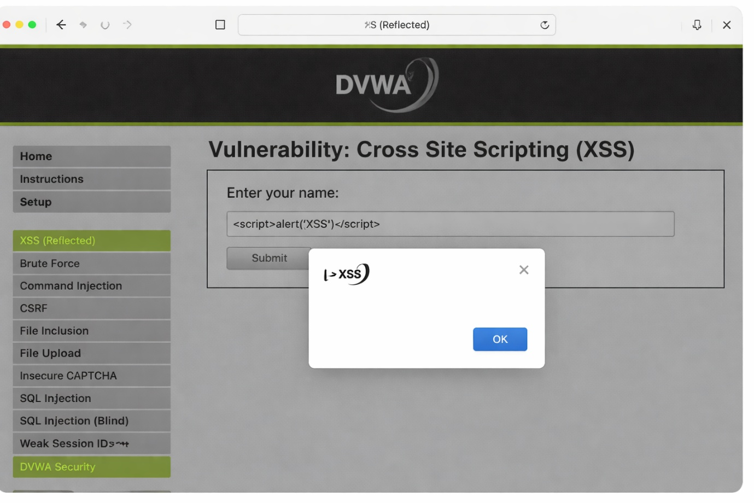

Day 17: SQLi Practice

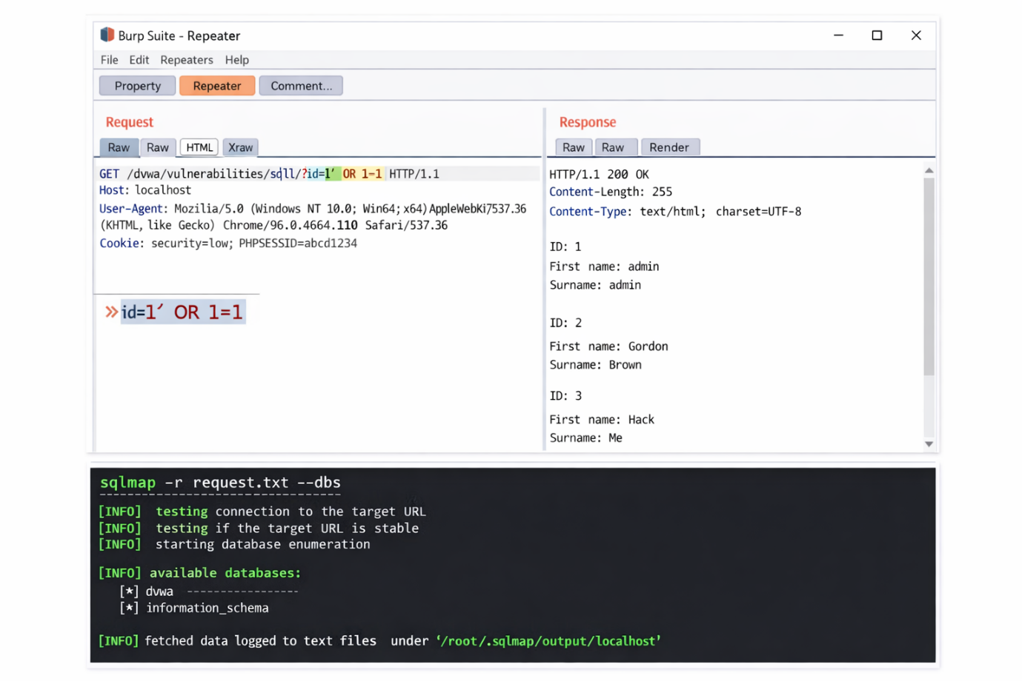

Day 18: Log Analysis Basics

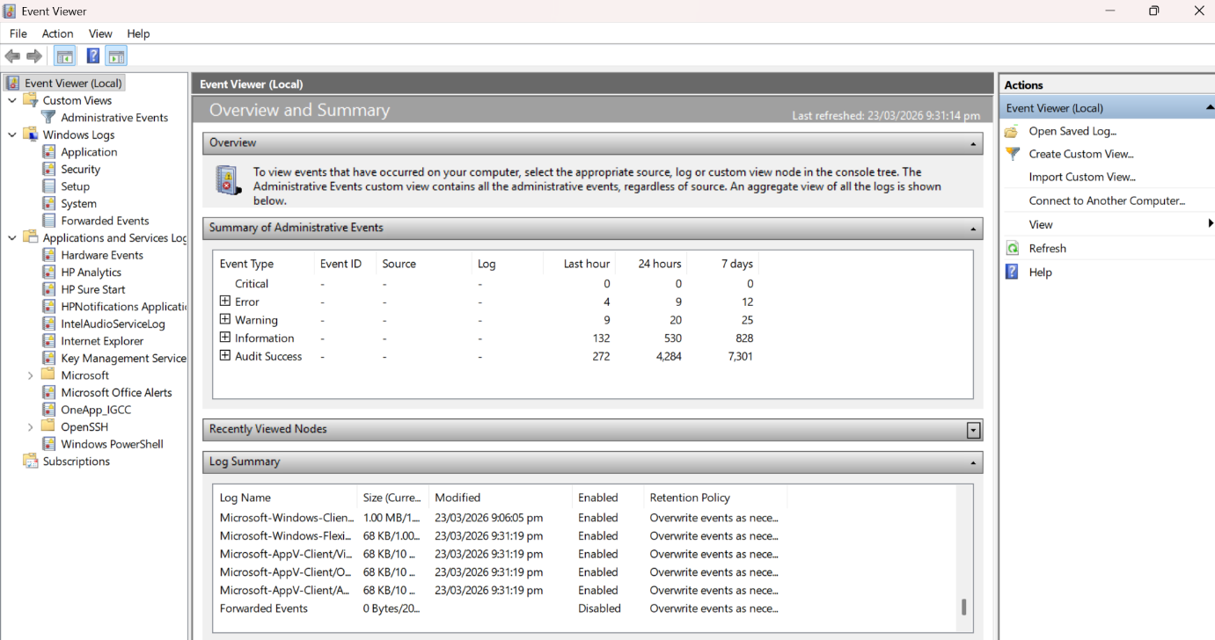

Day 19: Firewall Configuration

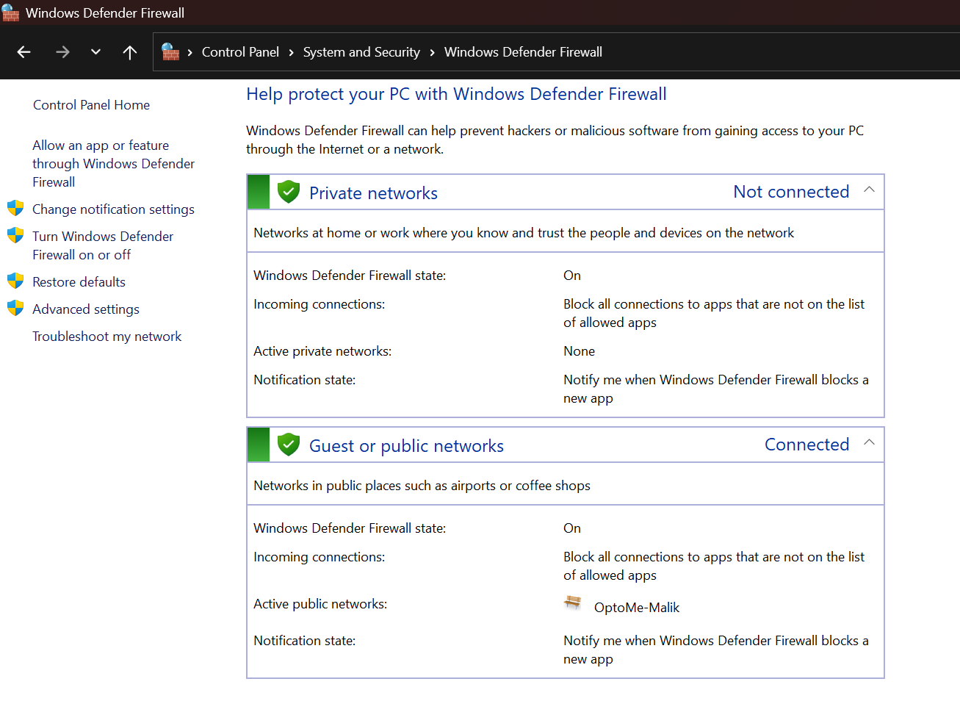
Day 20: IDS/IPS Overview

IDS (Intrusion Detection System):
A system that monitors network traffic and detects suspicious activity, then generates alerts but does not stop the attack.
IDS Working (Simplest):
- Watch traffic on the network.
- Check for attacks using rules or unusual behaviour
- Alert if something suspicious is found.
- Log details for review.
Remember: IDS only alerts, it does not block.

IPS (Intrusion Prevention System):
A system that monitors traffic and automatically blocks or prevents attacks in real time.
Simple difference:
- IDS → Detect only
- IPS → Detect + Block
IPS Working (Simple):
- Watch traffic on the network (inline, so it can block).
- Check for attacks using rules or abnormal behaviour.
- Block or drop malicious traffic automatically.
- Log details of the attack.
Remember: IPS detects and prevents attacks in real time.

Day 21: Incident Simulation
