

Air University - Islamabad
Islamabad, Pakistan

Project - Image Compression using SVD
Linear Algebra MA201
Dr. Ambreen Khan
BSSE-4-A

Made BY:
Abdul Rahman Waseem - 232011

Brief Introduction of the Topic:
Singular Value Decomposition (SVD) is a powerful linear algebra technique that factorizes a matrix into three components:
A=U.S.V^{T}
In the context of images (which are matrices of pixel values), SVD allows us to approximate the original image by keeping only the most significant singular values. This results in compression — a smaller data size with minimal loss in visual quality. By selecting only the top k singular values, we preserve the essential features (like shapes and colors) while discarding less important details (like fine textures or noise).
This technique is particularly useful in image storage, transmission, and preprocessing, where balancing quality and efficiency is important.
Example of the Problem:
Suppose we have a color image of size 400×400 pixels. Normally, it requires storing:
3 × 400 × 400 = 480,000 pixel values
If we apply SVD with only k = 50 singular values per channel, we store:
3 × 50 × ( 400 + 400 + 1 ) = 120,150 values
This compresses the image to just 25% of its original size!
The result visually looks almost the same to the human eye — clear shapes and colors remain visible — but a large portion of the data is saved. As we reduce k further, image quality drops more significantly, which we demonstrate visually using side-by-side comparisons.
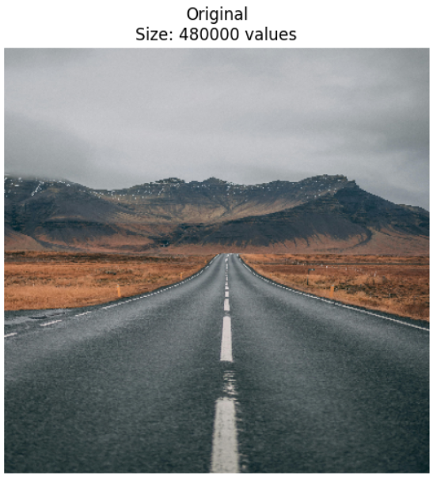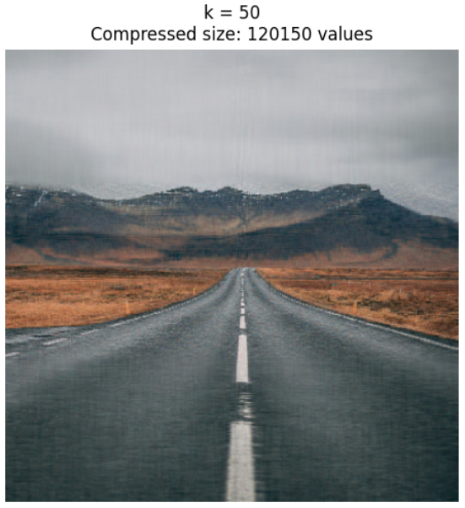
Source Code:
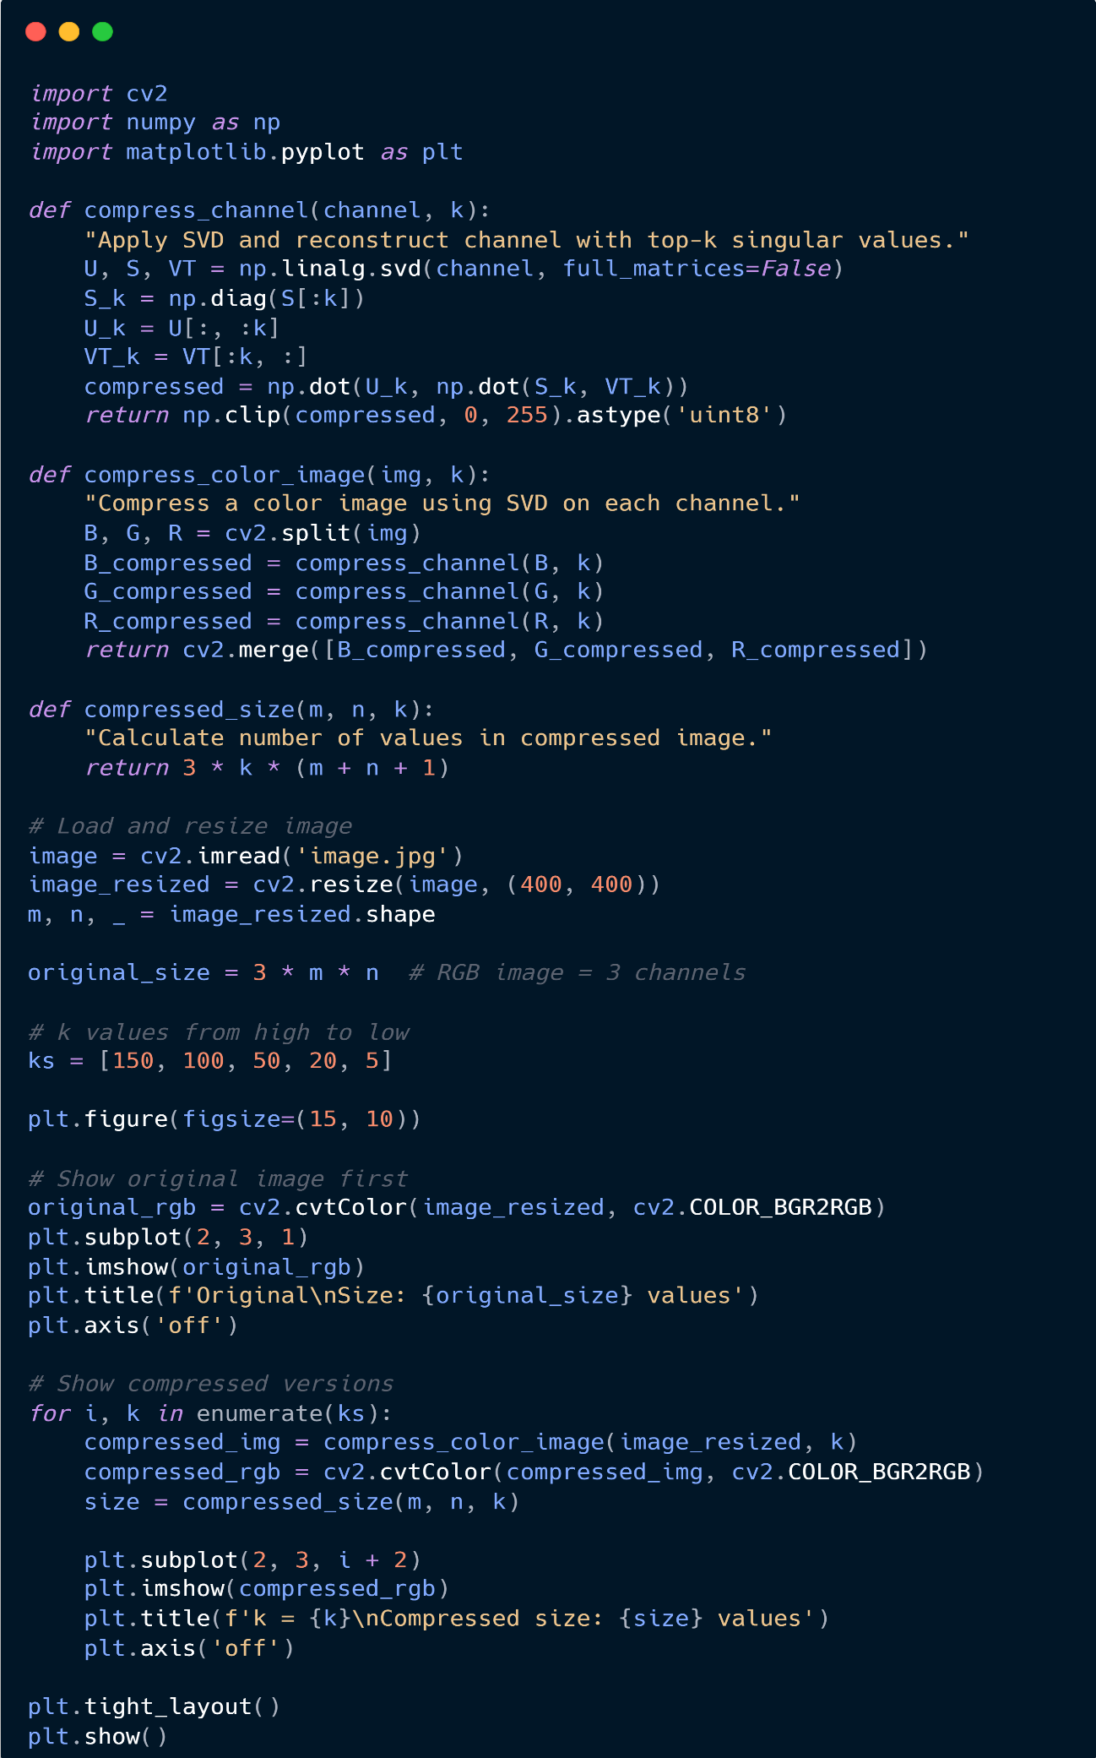
Output:
