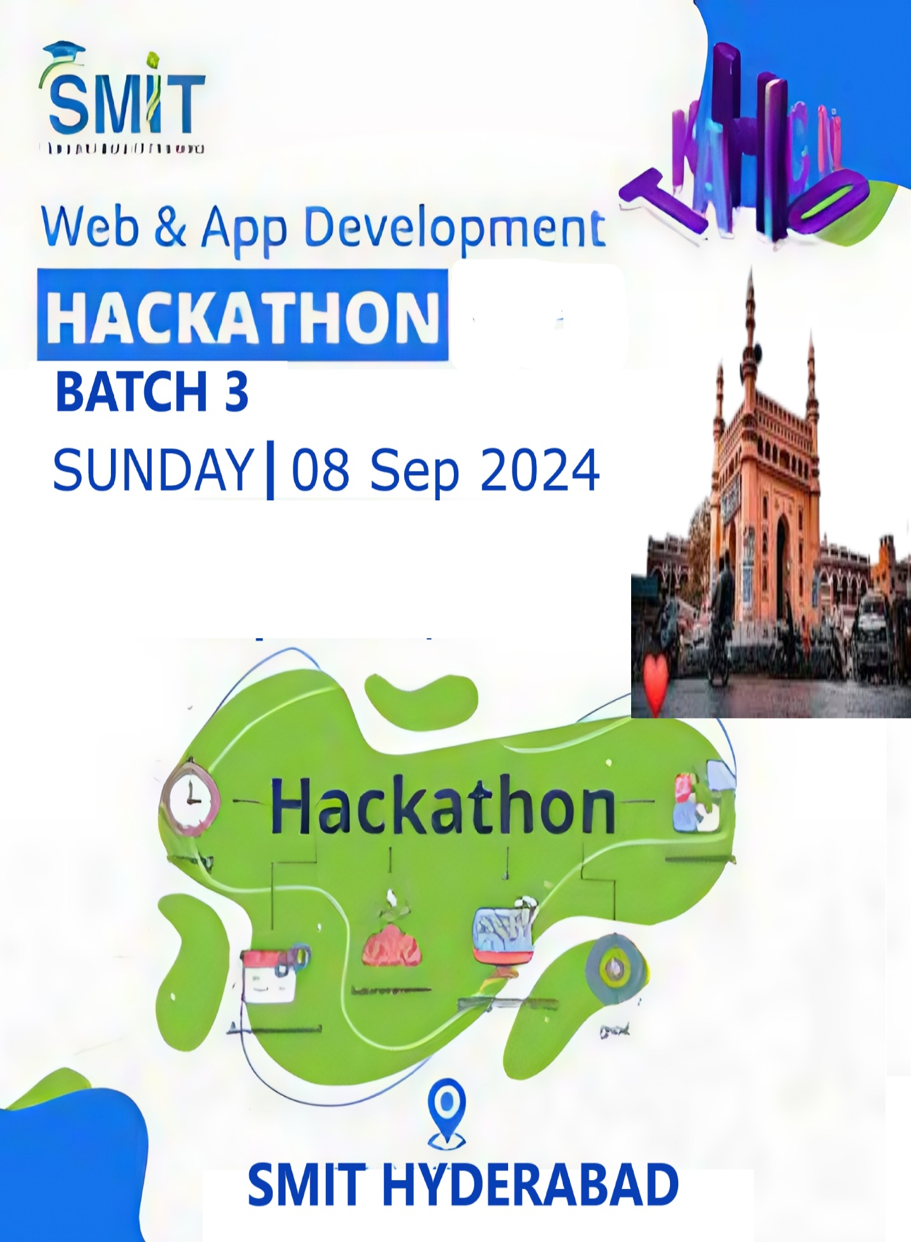**TASK:**

**Smit job portal & Event Management**

1. **Panel**
2. **Admin Panel**
3. **User Panel**

**Admin Panel**

1. **Add Jobs**
2. **View All Jobs**
3. **Delete Job**
4. **View User Applied Job**
5. **Add Event**
6. **View Join Person**
7. **Delete Event**

**User Panel**

1. **Signup**
2. **Login**
3. **View All Job**
4. **Filter Any Job**
5. **Applied Job**
6. **View All Event**
7. **Join Event**