HR Employee Attrition Analysis
Data Cleaning, Exploratory Analysis and Key Findings
Generated on 06 August 2026

1. Executive Summary
This report examines employee attrition using demographic, employment, compensation, satisfaction and experience-related variables. The purpose is to identify patterns associated with employees leaving the organisation.
Metric | Result
Total employees | 1,470
Employees who left | 237
Employees who stayed | 1,233
Overall attrition rate | 16.12%
Average employee age | 36.92 years
Average monthly income | 6,502.93

2. Dataset Overview
The cleaned dataset contains 1,470 employee records and 34 variables. Each row represents one employee and each column describes an employee characteristic, employment condition or outcome.
Variable Group | Variables | Purpose
Target variable | attrition, attrition_flag | Shows whether an employee left the company. The numerical flag uses 1 for Yes and 0 for No.
Employee identification | employee_number | Unique employee identifier. It should not be used as a predictive machine-learning feature.
Personal characteristics | age, gender, marital_status, education, education_field, distance_from_home | Basic demographic, education and commuting information.
Employment information | department, job_role, job_level, business_travel, job_involvement, over_time | Describes the employee's position and work conditions.
Salary and compensation | monthly_income, daily_rate, hourly_rate, monthly_rate, percent_salary_hike, stock_option_level | Contains income, payment-rate and compensation information.
Satisfaction and workplace | environment_satisfaction, job_satisfaction, relationship_satisfaction, work_life_balance | Numerical measures related to satisfaction and workplace experience.
Experience and tenure | total_working_years, years_at_company, years_in_current_role, years_since_last_promotion, years_with_curr_manager, num_companies_worked | Describes career experience, company tenure, promotion history and manager-related tenure.
Training and performance | training_times_last_year, performance_rating | Contains training frequency and employee performance information.

3. Data Preparation
- Converted column names into consistent snake_case format.
- Removed duplicate records when present.
- Removed extra spaces from text values.
- Removed columns that contained only one constant value.
- Created attrition_flag where Yes = 1 and No = 0.
- Created overtime_flag where Yes = 1 and No = 0.
Constant columns removed: employee_count, over18, standard_hours

4. Key Findings
- The overall employee attrition rate is 16.12%.
- Sales has the highest department-level attrition rate at 20.63%.
- Sales Representative has the highest job-role attrition rate at 39.76%.
- Employees working overtime have an attrition rate of 30.53%, compared with 10.44% for employees not working overtime.
- The median monthly income is 3,202 for employees who left and 5,204 for employees who stayed.
- Employees who left had spent an average of 5.13 years at the company, compared with 7.37 years for employees who stayed.
- These findings show associations in the dataset and should not be interpreted as proof that one factor directly causes attrition.

5. Attrition by Department
The following table compares department size, employees who left and the attrition rate within each department.
Department | Employees | Employees Left | Attrition Rate
Sales | 446 | 92 | 20.63%
Human Resources | 63 | 12 | 19.05%
Research & Development | 961 | 133 | 13.84%

6. Attrition by Job Role
Job-role attrition rates provide a more accurate comparison than departure counts alone because job roles have different numbers of employees.
Job Role | Employees | Employees Left | Attrition Rate
Sales Representative | 83 | 33 | 39.76%
Laboratory Technician | 259 | 62 | 23.94%
Human Resources | 52 | 12 | 23.08%
Sales Executive | 326 | 57 | 17.48%
Research Scientist | 292 | 47 | 16.10%
Manufacturing Director | 145 | 10 | 6.90%
Healthcare Representative | 131 | 9 | 6.87%
Manager | 102 | 5 | 4.90%
Research Director | 80 | 2 | 2.50%

7. Visual Analysis
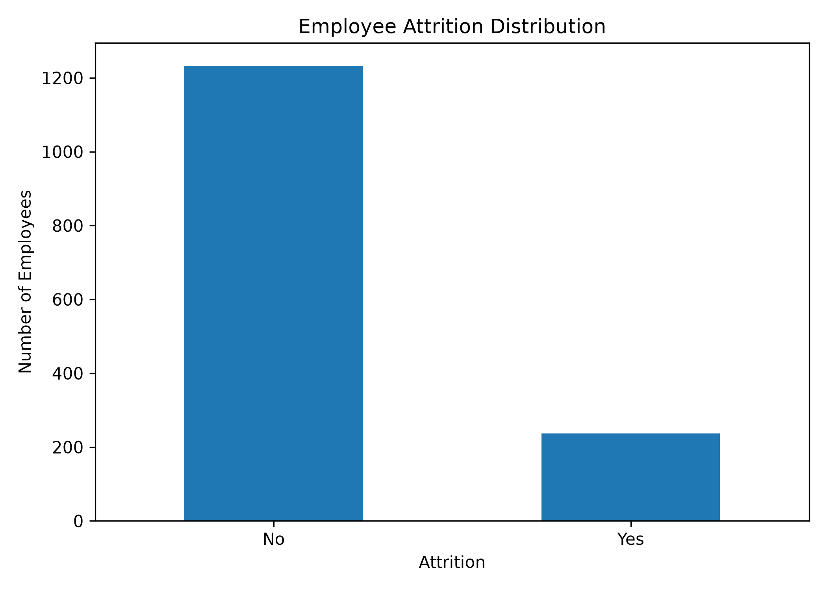
Figure 1: Employee Attrition Distribution
Comparison of employees who stayed and employees who left.
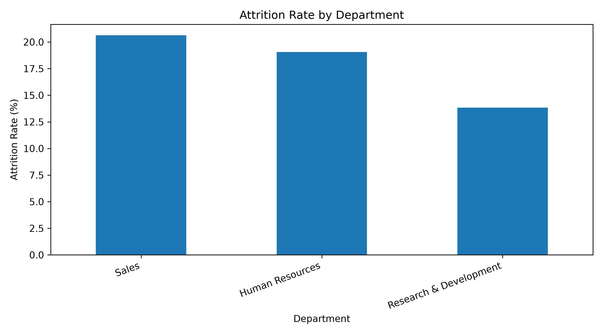
Figure 2: Attrition Rate by Department
Percentage of employees leaving within each department.
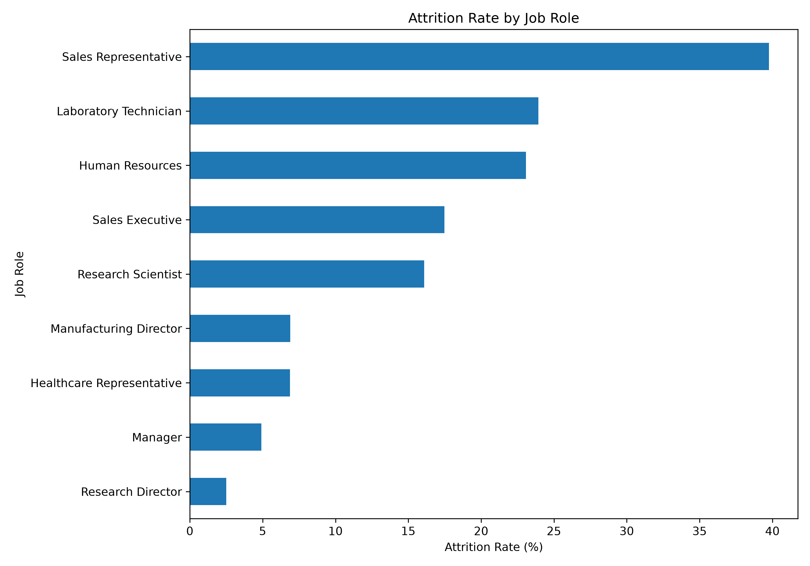
Figure 3: Attrition Rate by Job Role
Comparison of attrition rates across different job roles.
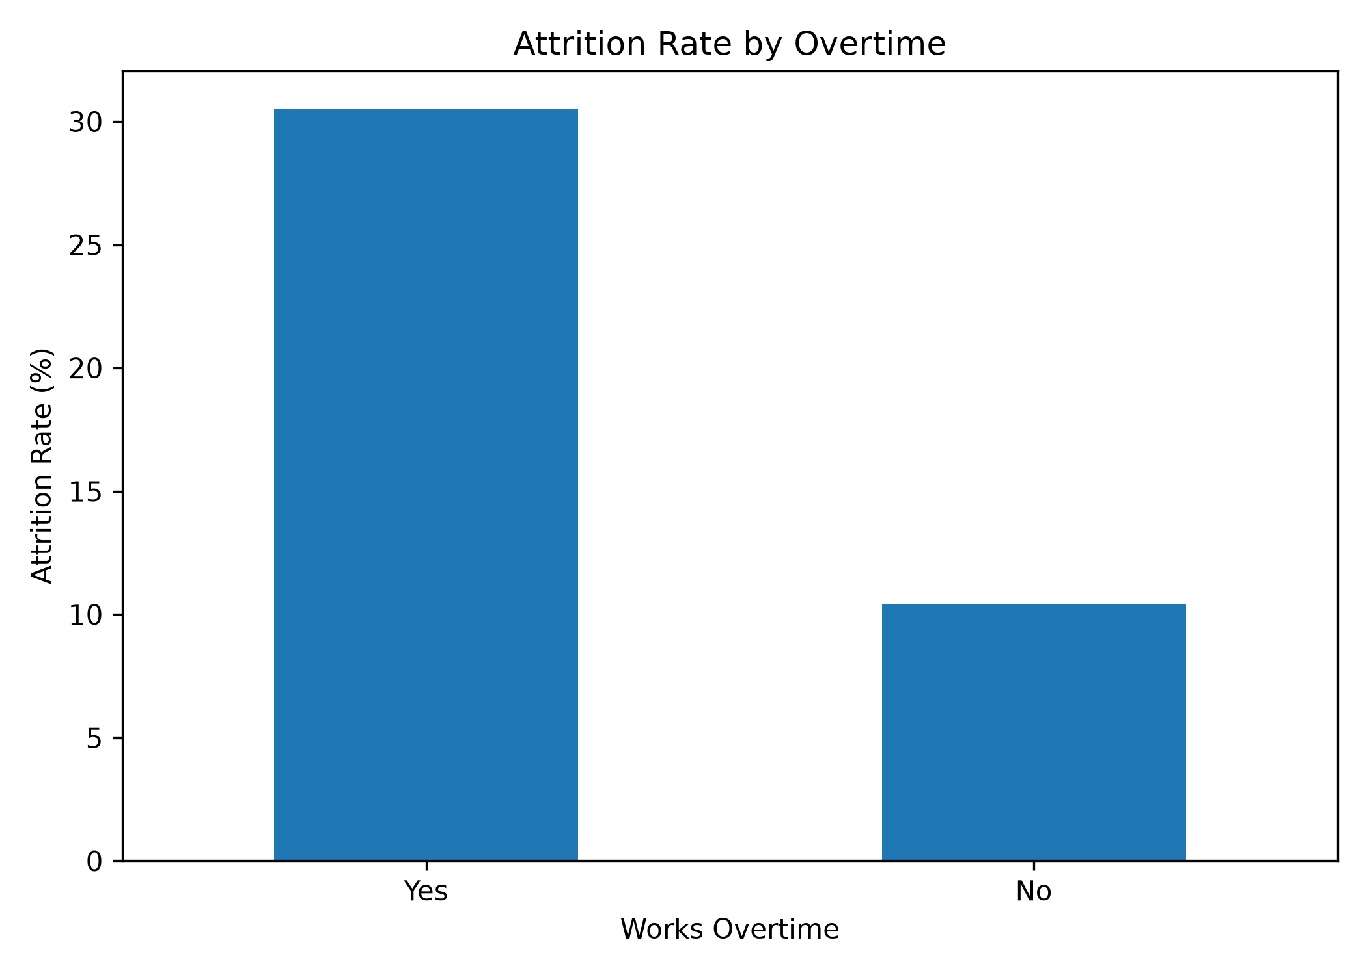
Figure 4: Attrition Rate by Overtime
Comparison between employees who work overtime and those who do not.
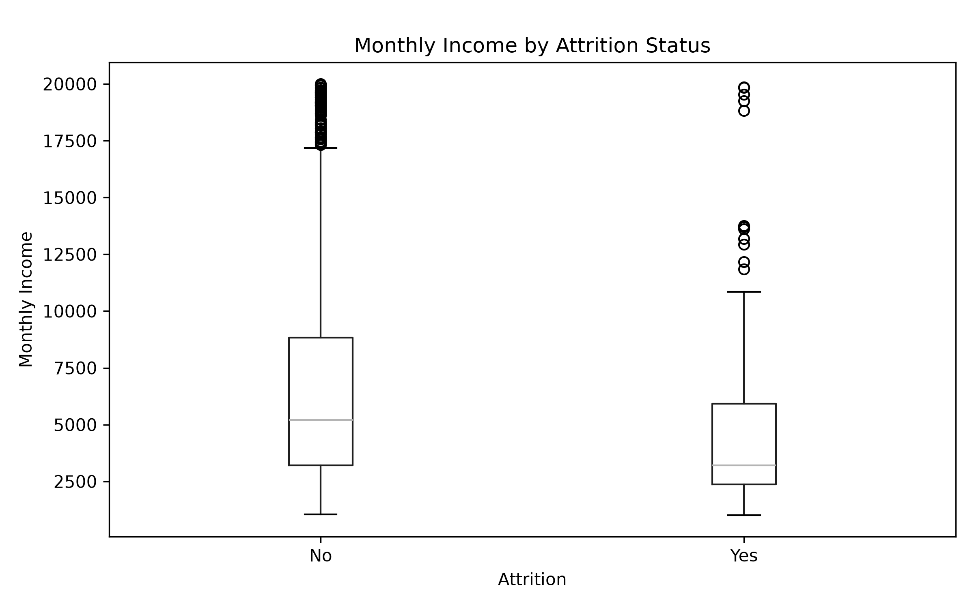
Figure 5: Monthly Income by Attrition Status
Distribution of monthly income for employees who stayed and left.

8. Conclusion
The analysis highlights differences in attrition across departments, job roles, overtime conditions, income and tenure. These findings can help HR teams identify groups requiring further investigation and design more targeted employee-retention strategies.

9. Limitations
- The dataset identifies statistical relationships but does not establish direct causation.
- The dataset does not include employee comments, exit-interview responses or detailed organisational policies.
- Some categorical ratings are stored as numerical codes, while their full label definitions are not included in the CSV.
- Attrition is imbalanced because substantially more employees stayed than left. This must be considered during modelling.

