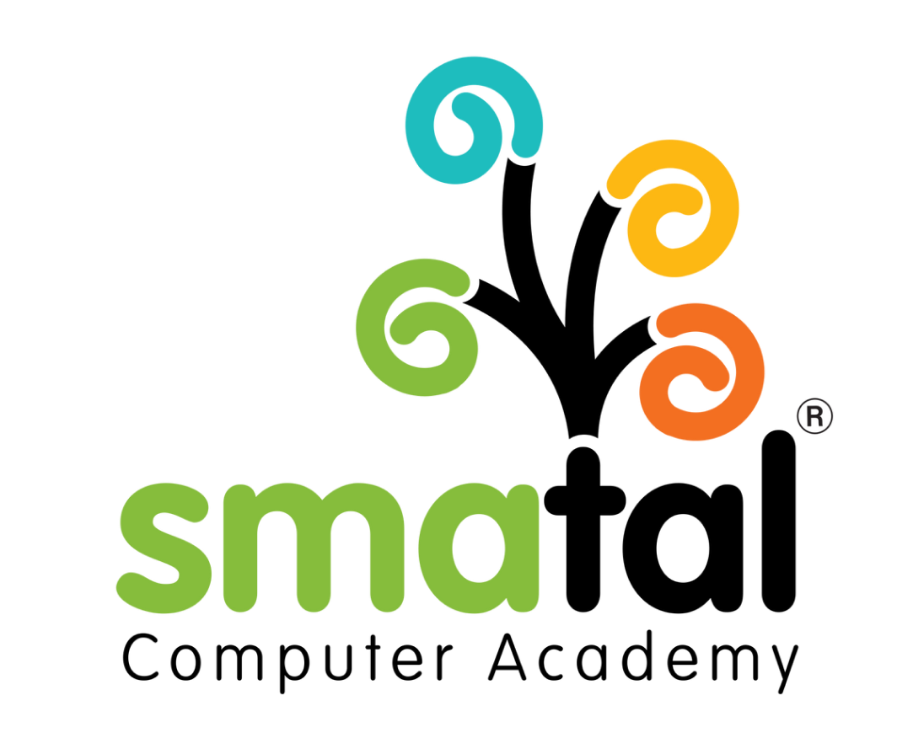 | Smatal Computer Academy  Learn • Grow • Succeed  Triplicane, Chennai | www.smatal.in | +91 96449 964912
______________________________________________________________________

Letter of Appointment

Date: {{CurrentDate}}
Emp ID: {{EmployeeID}}

To,
{{EmployeeFirstName}} {{EmployeeLastName}}
{{EmployeeAddress}}
Subject: Letter of Appointment - {{JobTitle}}
Dear {{EmployeeFirstName}},
Following your acceptance of our offer, we are pleased to confirm your appointment at Smatal Computer Academy as {{JobTitle}}, effective {{JoiningDate}}.

1. Terms of Employment
You will be employed in our {{EmployeeDepartment}} department. As an academy focused on industry-relevant skills and 100% practical training in domains like AI, Full Stack Development, Cloud & DevOps, Data Science, Cyber Security, and Digital Marketing, you are expected to maintain the highest standards of professionalism and dedication to our students.

2. Remuneration
Your annual remuneration is {{OfferSalary}}. Taxes and statutory deductions will be applicable as per prevailing government laws.

3. Working Hours and Leave
Standard working hours are structured to provide flexible timings and lifetime support to our students. Specific shifts will be discussed with your department head. Leave policies are governed by the Smatal Employee Handbook.

4. Confidentiality and Conduct
You are expected to keep all proprietary information, training modules, and student data strictly confidential. Smatal Computer Academy prides itself on expert trainers and a collaborative environment; you are expected to embody these values.
We welcome you to our team and wish you a long and successful career with Smatal.
For Smatal Computer Academy,
{{AuthorizedSignatoryName}}
{{AuthorizedSignatoryTitle}}

______________________________________________________________________
Declaration:
I have read, understood, and accept the terms and conditions of this appointment.
Signature: ______________________ | Date: ______________________

