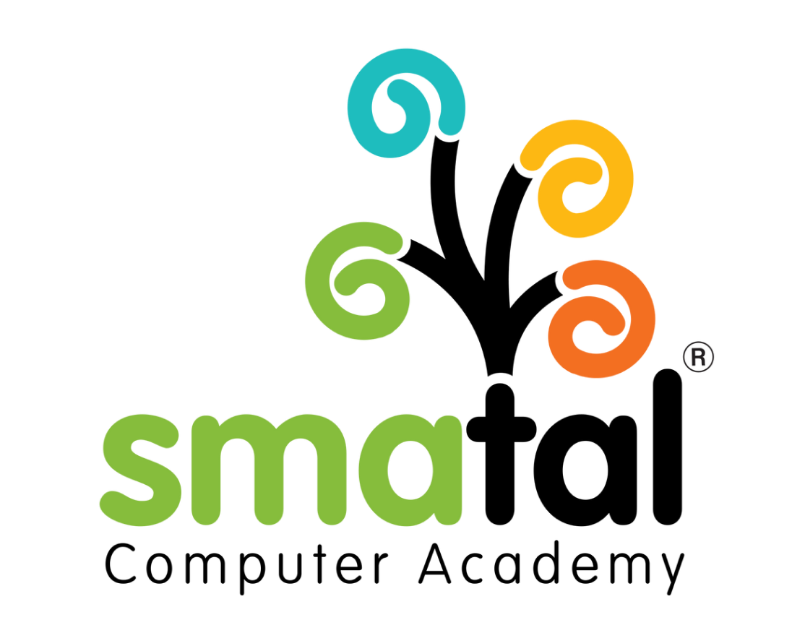 | Smatal Computer Academy  Learn • Grow • Succeed  Triplicane, Chennai | www.smatal.in | +91 96449 964912
______________________________________________________________________

Offer of Employment

Date: {{CurrentDate}}
Ref No: {{OfferReferenceNumber}}

To,
{{CandidateFirstName}} {{CandidateLastName}}
{{CandidateAddress}}
Subject: Offer of Employment - {{JobTitle}}
Dear {{CandidateFirstName}},
We are absolutely thrilled to offer you the position of {{JobTitle}} at Smatal Computer Academy. Your background, skills, and enthusiasm during the interview process demonstrated that you are an excellent fit for our vision of empowering the next generation with future-ready tech skills.

1. Position and Role
You will be joining our team as a {{JobTitle}} in the {{EmployeeDepartment}} department. Your primary role will be to uphold our standards of 100% practical and industry-relevant training, contributing directly to our mission.

2. Compensation and Benefits
Your total starting annual compensation will be {{OfferSalary}}. A detailed breakdown of your salary components, along with applicable taxes and deductions, will be provided on your date of joining.

3. Date of Joining and Location
Your scheduled date of joining is on or before {{JoiningDate}}. Your primary work location will be our Triplicane, Chennai academy.
Please review this offer carefully. To accept, kindly sign and return a copy of this letter no later than {{OfferExpirationDate}}.
We are confident that you will play a key role in helping our students Learn, Build, Deploy, and Get Hired. Welcome to the Smatal family!
Sincerely,
{{AuthorizedSignatoryName}}
{{AuthorizedSignatoryTitle}}
Smatal Computer Academy

______________________________________________________________________
Candidate Acceptance:
I accept this offer of employment and agree to the terms mentioned above.
Signature: ______________________ | Date: ______________________

