Course: DevOps for Cloud Computing
Chapter 1 of Verona (Book)
Traditional Development Vs DevOps Culture; Role of Cloud in DevOps.
Lecture 01
What is DevOps?
DevOps = Development + Operations
It is a combination of technical practices (automation, testing, Continuous Delivery, tools, etc.) and cultural changes (better teamwork, communication, and shared responsibility).
Its main purpose is to improve collaboration and reduce the time between between different teams involved in software development and delivery.
Origin of DevOps
- DevOps has roots in Agile software development.
- Agile Manifesto was introduced in 2001, emphasizing people, collaboration, working software, and responding to change.
- Patrick Debois was frustrated by the gap between development and operations.
- In 2009, he organized DevOpsDays in Ghent, Belgium.
- The term DevOps became popular from this movement.
Full scenario
The team releases every eight weeks. Development sends a ZIP file and deployment document to operations. Production configuration is maintained manually. QA receives a representative test environment late. The release needs a two-hour change meeting and a Saturday maintenance window. A missing environment variable causes a 70-minute rollback. A similar failure happened two releases earlier.
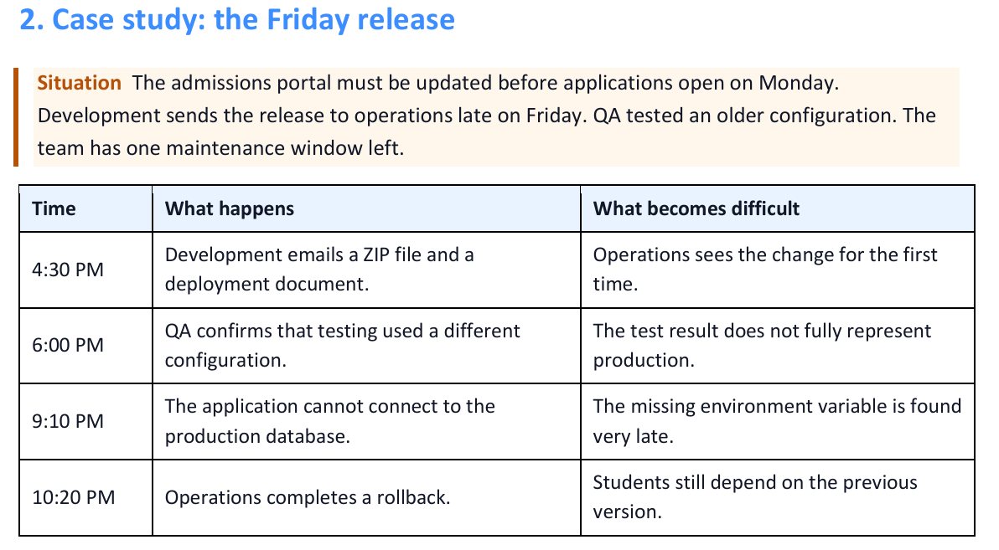
Traditional delivery and DevOps culture
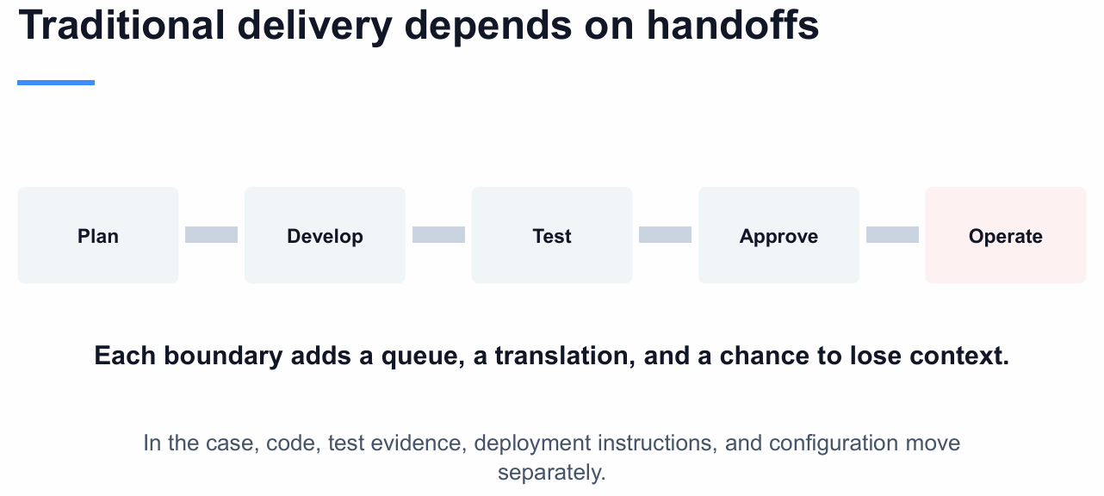
Traditional delivery
Traditional delivery often divides work into stages owned by separate departments. A request moves from planning to development, testing, approval, deployment, and operation. Each handoff can add waiting and can remove context from the change.
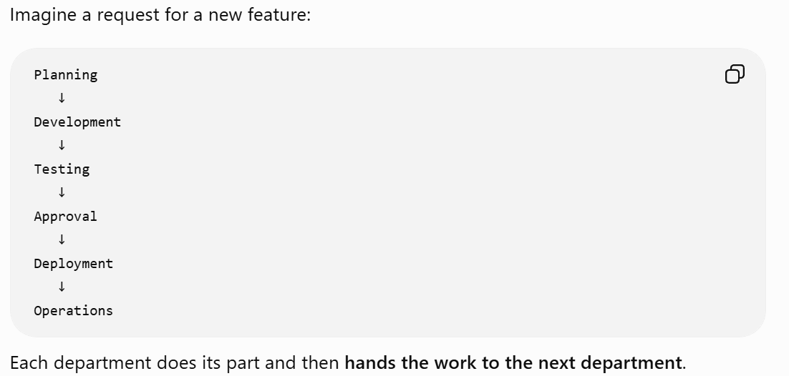
DevOps culture
DevOps joins development and operations with testing, security, product, and other contributors around one service. Specialists keep their expertise, but they share information and responsibility for the result experienced by the user.
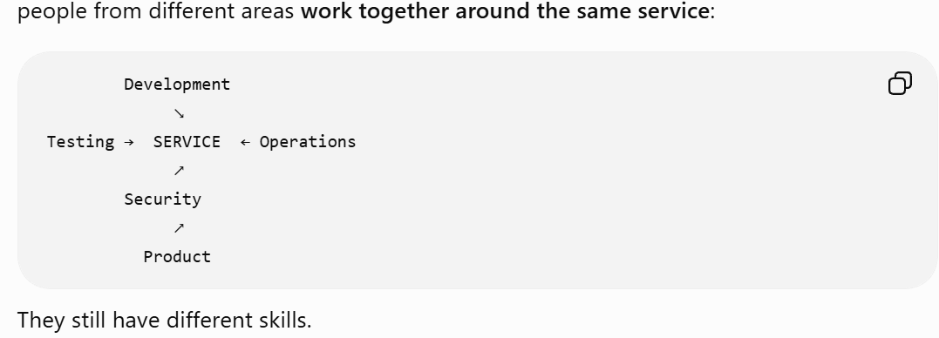

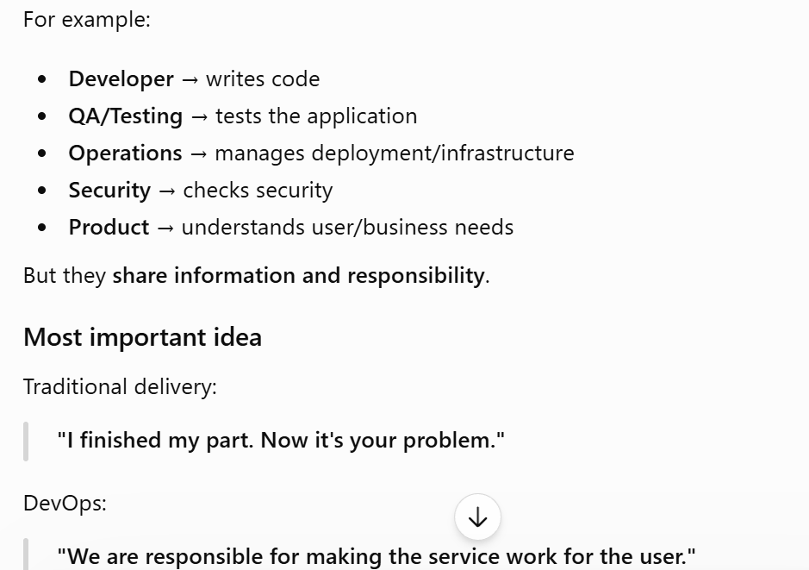
DevOps → shared responsibility + collaboration + fixing the root cause, rather than blaming one team.
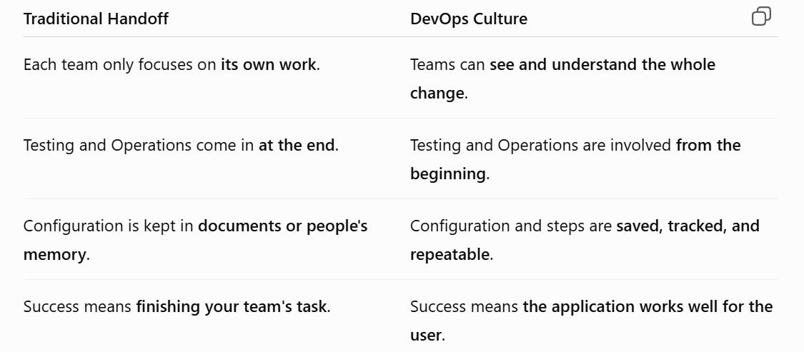
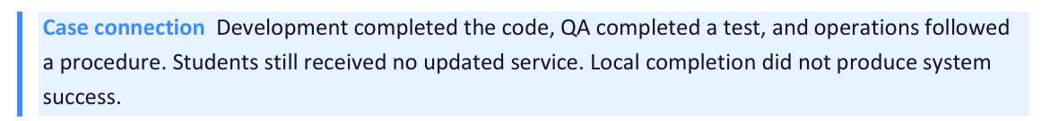
Departmental success can hide service failure
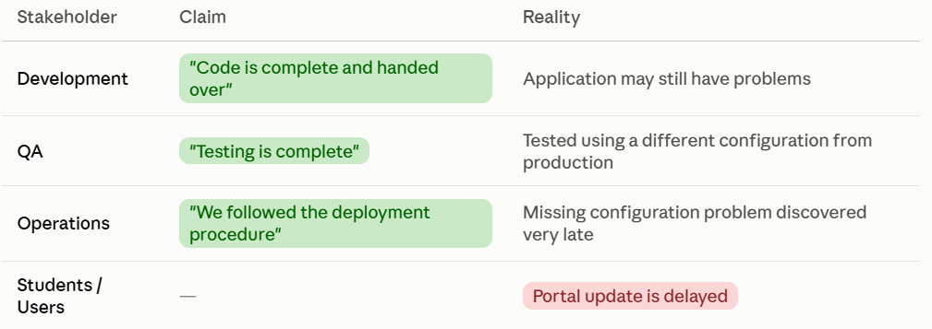
Doing your department's task correctly does not necessarily mean the whole service will succeed.
Tools should help people interact
This section is saying that tools should make teamwork easier, not create more separation between teams. The tools reflect the organizational walls which means if the company separates teams, and each team has completely separate tools, the tools also create separation between the teams. A shared workflow can provide one change record with different views for each role.
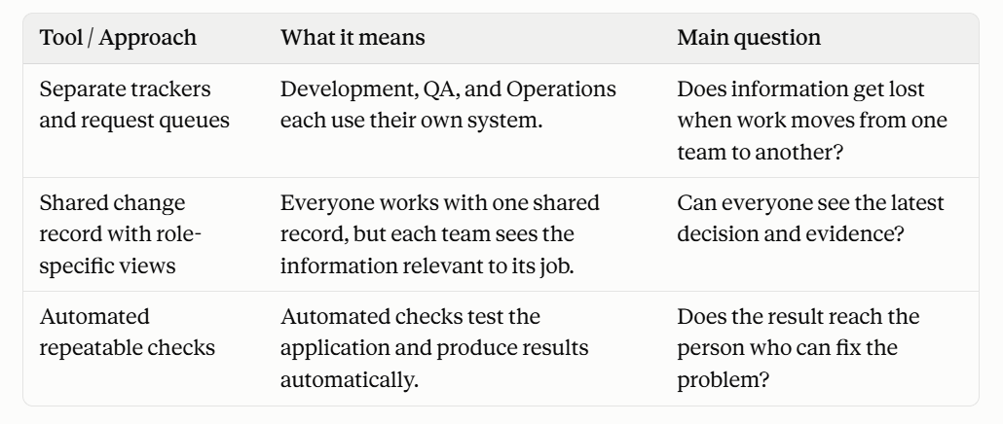
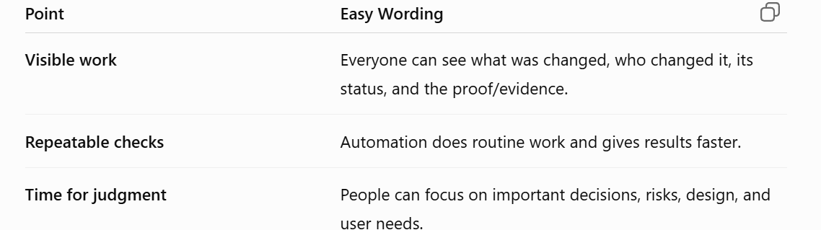
A tool earns its place when it reduces friction, removes repetitive work, or returns evidence sooner. Buying a tool alone does not change ownership.
Shared workflow keeps context visible
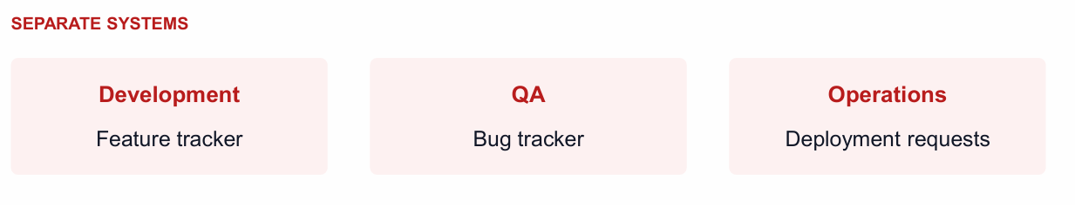
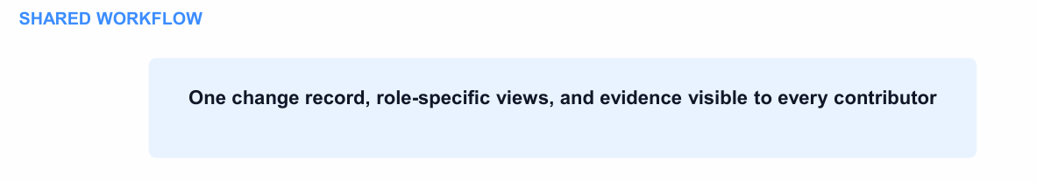
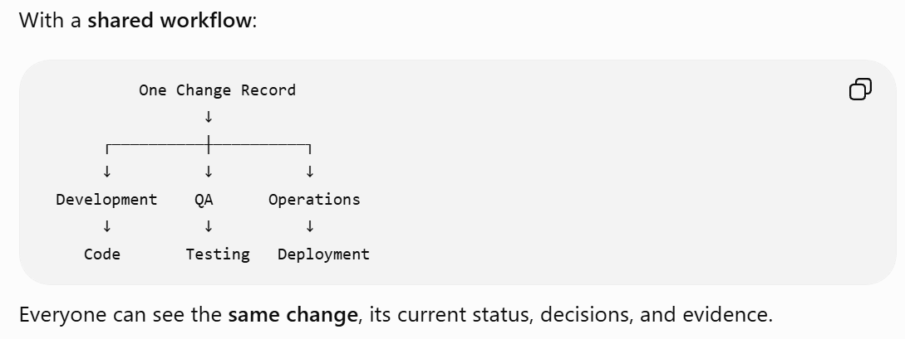

Example: “Update Student Portal”
- Developer: sees the code changes
- QA: sees the testing
- Operations: sees the deployment/configuration
They all work on the same change, but each focuses on the part related to their job
Useful speed reduces waiting and advances value (How fast is fast)
DevOps is not about simply doing work faster. It is about getting useful feedback/evidence faster so problems can be found and corrected early.
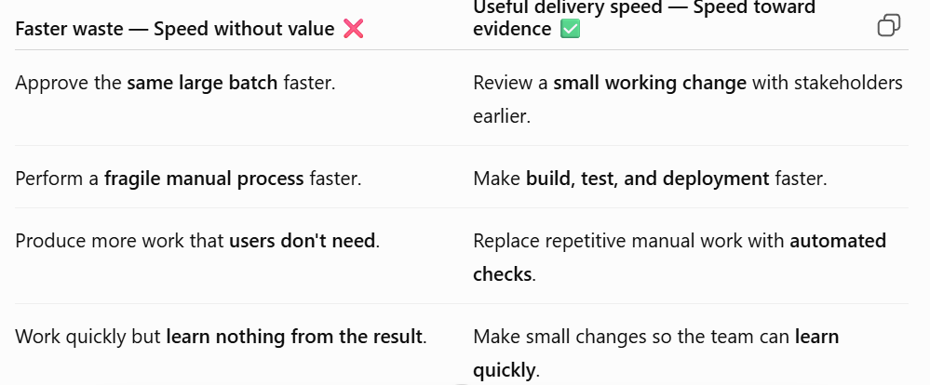
In the Friday case, the most expensive wait is the delay before the team tests the real configuration. Faster typing or a shorter meeting would not solve that feedback problem.
Smaller Changes Make Feedback Easier
Make small changes instead of making many changes at once. This helps you find problems faster and fix them more easily

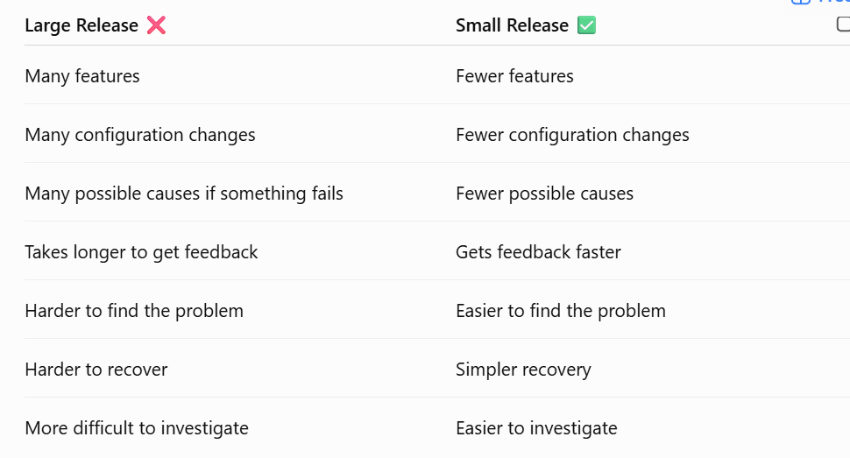
The Agile wheel of wheels
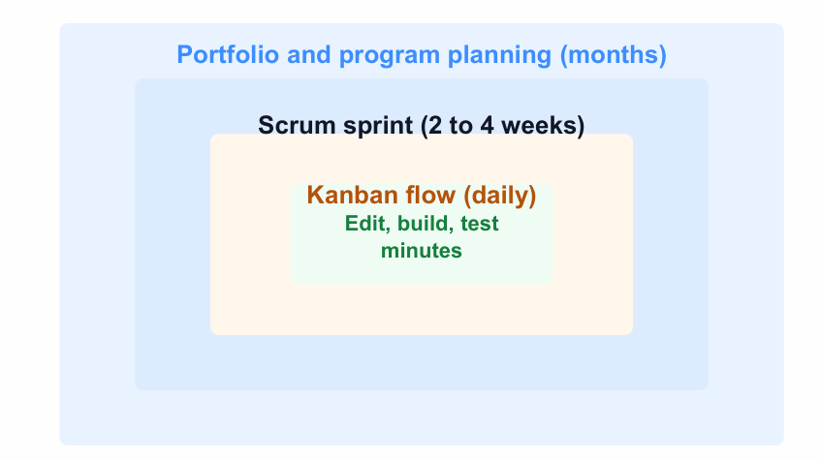
Agile work runs at several cadences. A developer may edit, build, and test within minutes. Kanban work may be reviewed daily. A Scrum sprint usually lasts two to four weeks. Program and portfolio decisions run over longer periods.
DevOps supports every cadence with delivery evidence
This means DevOps provides useful feedback/evidence at different time periods instead of waiting for a long release cycle.
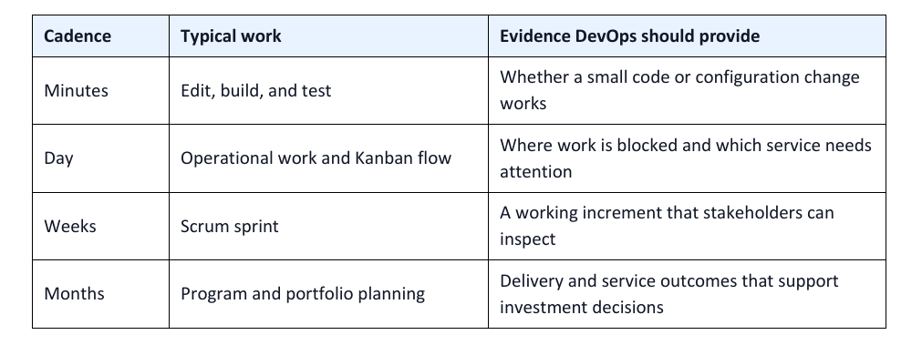
Imp Point: The most obvious and measurably concrete benefits of DevOps occur in the shorter cycles, which in turn make the longer cycles more efficient.
Problem DevOps Solve: Waiting 8 weeks to pass work from one team to another means problems may be found very late. DevOps gives feedback and finds problems earlier, so they can be fixed sooner.
Beware the “Cargo Cult” Agile Fallacy
1. What is Cargo Cult?
Cargo cult means copying the actions of others without understanding their real purpose.
Richard Feynman used the term “cargo cult science” to describe people who follow the steps of science but miss the important part: the actual purpose and reasoning behind them.
2. Simple Example
During World War II, people on some islands saw military airplanes landing and bringing useful supplies (cargo).
After the war, the airplanes stopped coming. The islanders copied what they had seen by making landing strips and imitating the military's activities, hoping the airplanes would return.
But they did not understand why those activities worked.
Cargo Cult Agile / DevOps
The same thing can happen with Agile and DevOps.
Simply doing an Agile/DevOps activity does not mean you are actually following Agile or DevOps.
Examples:
- Having a daily stand-up meeting does not automatically make a team Agile.
- Having a DevOps pipeline does not help if only the Operations team understands or uses it.
- Using automation is not useful if it does not improve feedback or reduce unnecessary work.
Main question to ask:
“Why are we doing this, and is it actually helping us?”
Goal of a DevOps Pipeline (Purpose Driven DevOps)
The purpose of a deployment pipeline is to:
- Get feedback faster
- Reduce manual work
- Help different teams work together
- Find problems earlier
- Deliver useful changes more efficiently
If a pipeline only makes Operations' work easier but does not improve collaboration or delivery for other teams, then it may be cargo cult DevOps.
Cargo Cult DevOps Vs Purpose Driven DevOps
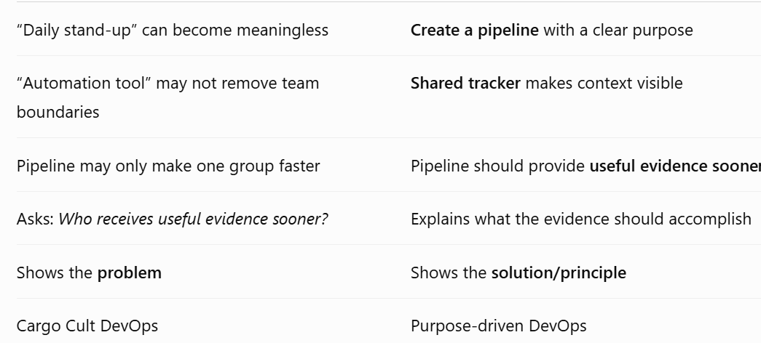
Sprint Retrospective
In Scrum, a sprint retrospective is a meeting where the team discusses:
- What went well?
- What went wrong?
- What should we improve?
The important part is acting on the improvements.
If the team identifies the same problem again and again but never fixes it, the retrospective is not achieving its purpose.
How DevOps Helps
Sometimes a problem keeps repeating because it involves another team and there is poor communication between teams.
DevOps helps by encouraging:
Cooperation + Shared responsibility + Better communication
This makes it easier to solve problems that cross team boundaries.
Main Lesson
Don't follow Agile or DevOps practices just because everyone else does. Understand their purpose and check whether they are actually improving your work.
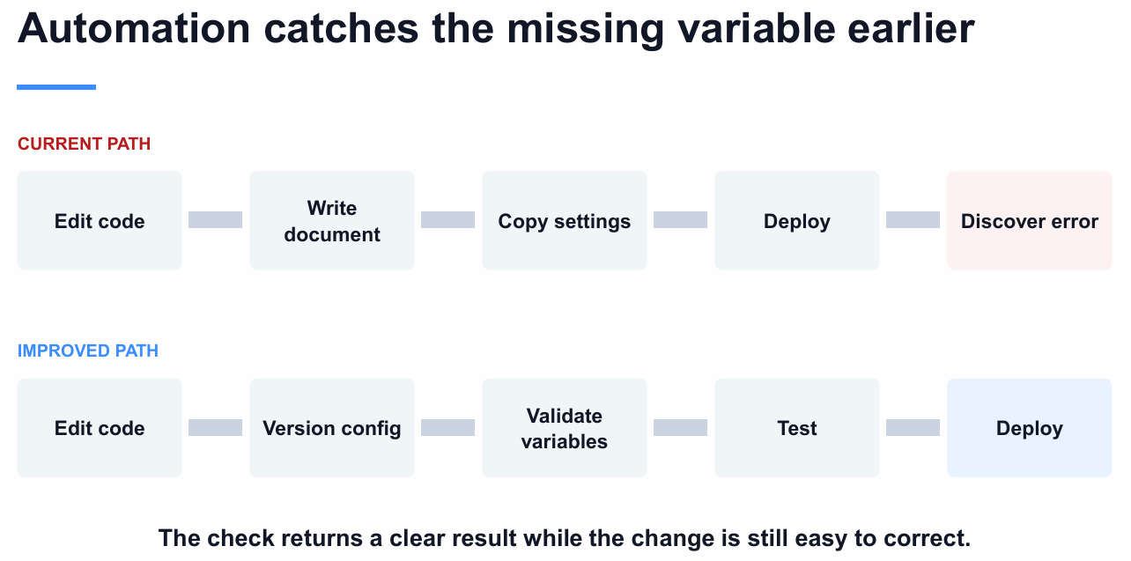
Cloud can shorten the path to a realistic test
The team needs a realistic testing environment that is similar to the real system.
With cloud services, the team can create and remove these environments whenever needed.
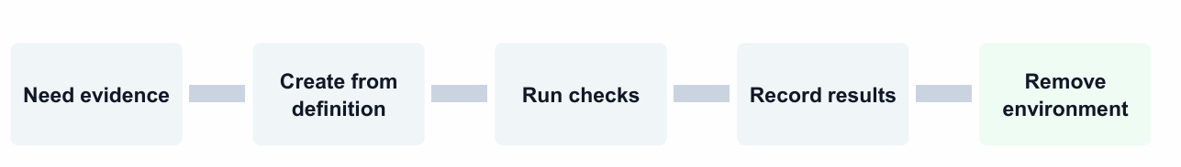
The process:
- Need evidence → We need to test whether the system works correctly.
- Create from definition → Create the testing environment using predefined settings/code.
- Run checks → Test the application.
- Record results → Save what happened and whether the test passed or failed.
- Remove environment → Delete the testing environment when finished.
Cloud lets us create testing environments whenever we need them and use them repeatedly.
But there are still things to manage
“The team still needs access rules, cost limits, validation, and cleanup.”
Meaning:
- Access rules → Who is allowed to use the cloud resources?
- Cost limits → Don't spend too much money.
- Validation → Make sure the environment is configured correctly.
- Cleanup → Delete unused resources so they don't keep costing money
Cloud capability needs engineering discipline
Cloud gives you powerful capabilities, but you need good engineering practices to use them properly.

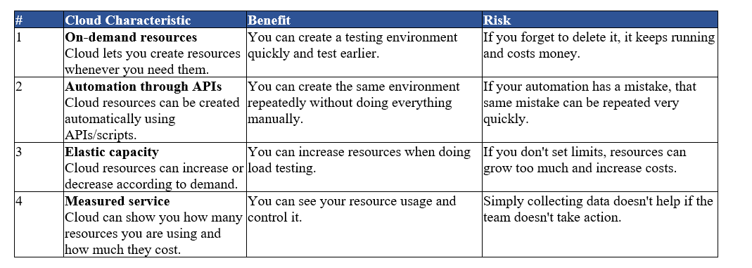
Key Point: Cloud is powerful, but it does not automatically make a team better; the team still needs discipline, limits, monitoring, and good practices.
Cloud vs Server
- Server: you may pay for the full server capacity even if you use only part of it.
- Cloud: resources can be used more flexibly, often through virtualization.
DevOps and ITIL
ITIL
ITIL (Information Technology Infrastructure Library) is a framework that provides organized practices for managing IT services, systems, and changes.
DevOps and ITIL can work together. They are not necessarily opposite approaches.
DevOps focuses on small, frequent, and automated changes, while ITIL provides formal processes and controls for managing IT changes.

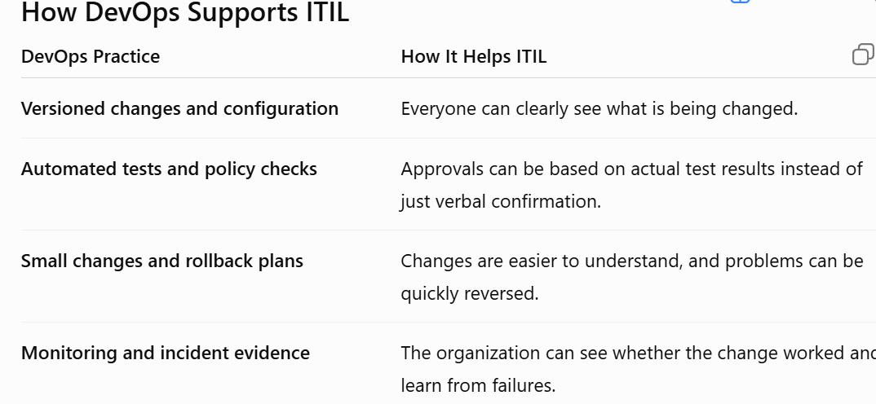
What About Large Legacy Systems?
Large organizations often have old and complex systems. These systems may have many connected parts.
A large change can therefore cause a bigger problem if something goes wrong.
For such changes, formal ITIL processes and coordination may still be necessary.
On the other hand, small changes can often be handled more quickly using DevOps automation, testing, monitoring, and rollback.
Key Idea: Governance Should Match Risk
The important point is:
The level of control should depend on how risky the change is.
For example:
- Small, low-risk change → automated testing + quick deployment + rollback
- Large, high-risk change → more formal review + approvals + coordination
DevOps does not necessarily remove ITIL controls.
Instead, DevOps can make ITIL controls faster and better by providing automated tests, clear evidence, monitoring, and repeatable processes.
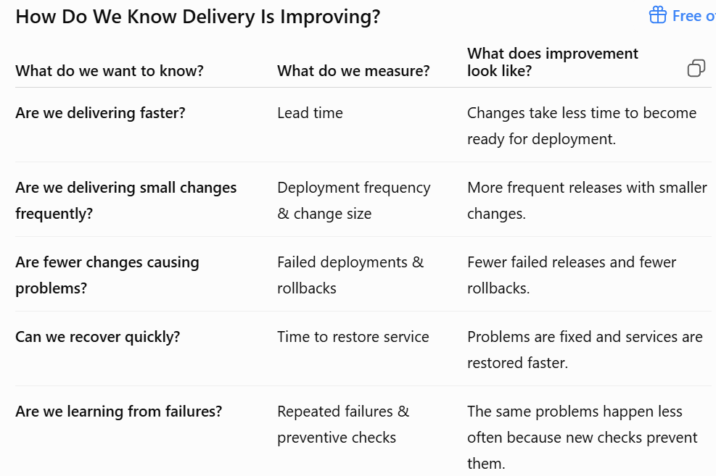

Chapter 1 of Sehgal (Book)
Introduction to Cloud Computing; Cloud Service Models: IaaS, PaaS, SaaS
Lecture 2
What is cloud computing?
Cloud computing refers to the delivery of computing services over the internet, including storage, processing power, and software applications.
It allows users to access resources and services on-demand, without the need for physical infrastructure or local servers.
Example: Instead of buying your own printer, you go to a print shop and pay only when you need a printout. Cloud computing works the same way — you "rent" computing power over the internet only when you need it.
Key Characteristics of Cloud Computing
These are the basic features that make something count as "cloud computing":
- On-Demand Self-Service — You can get storage or computing power yourself, anytime, without calling a company employee. It's like an ATM: you take out money whenever you want, without asking a bank teller.
- Broad Network Access — You can reach the service from anywhere using the internet, on a laptop, phone, or tablet.
- Resource Pooling — Many customers share the same big pool of computers, similar to how many tenants share one big apartment building's water and electricity supply.
- Rapid Elasticity — The service can grow or shrink quickly based on your needs, the same way a rubber band stretches and shrinks.
- Measured Service — You are billed only for what you actually use, just like an electricity bill that depends on your usage.
Example: A food delivery app during a big festival suddenly gets 10x more orders. Because the app runs on the cloud, extra computing power is added automatically (rapid elasticity), and the company only pays extra for the days it used more power (measured service).
Cloud Deployment Models
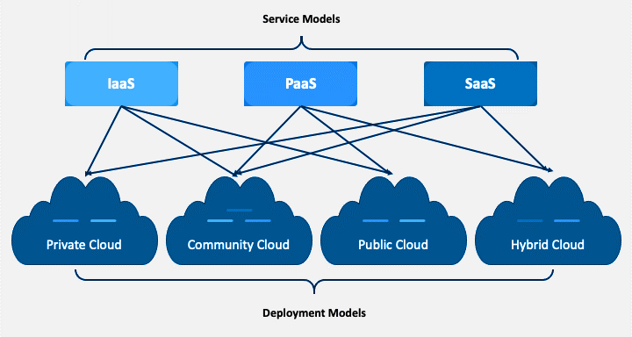
1. Public Cloud
The service is offered over the public internet and anyone can sign up and use it. It is usually the cheapest and most flexible option.
- Cost-effective for individuals and businesses that need scalability and flexibility.
- Big providers include AWS, Microsoft Azure, and Google Cloud (GCP).
Example: AWS
Suppose you have a website but don't want to buy your own server.
- You create an account on AWS.
- You rent a virtual server from AWS.
- Your website runs on that server.
- AWS manages the physical server, electricity, cooling, networking, etc.
- You pay according to the resources you use.
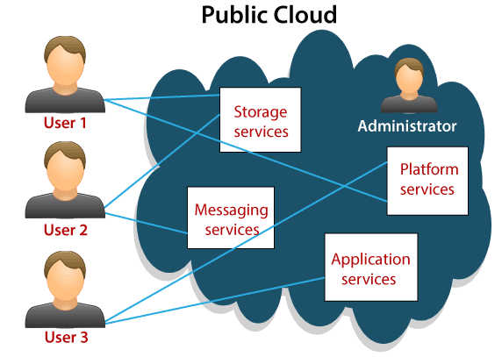
2. Private Cloud
The infrastructure belongs to just one organization. It can be kept on the company's own premises or hosted elsewhere, but only that company uses it.
- Built to match specific security, compliance, or performance needs.
- Gives more control, customization, and privacy, but costs more upfront.
Example:
Suppose a bank has its own private cloud.
- The bank has its own servers and storage.
- These resources are connected through the bank's network.
- Only authorized bank employees and systems can access them.
- The bank can store sensitive information, such as:
- Customer records
- Account information
- Transaction data
- The bank can control the security, access, and resources according to its needs.
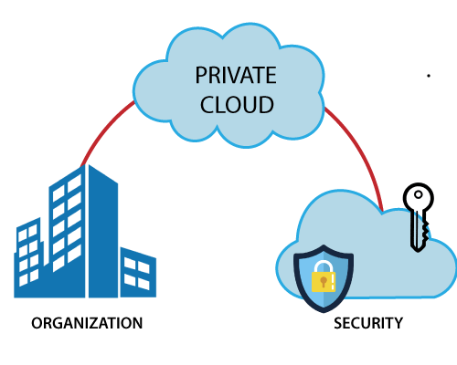
3. Hybrid Cloud
A mix of public and private clouds, connected together so data and applications can move between them.
- Businesses get the benefits of both worlds and use resources where they fit best.
- Supports moving workloads and integrating systems smoothly.

Example: Bank
- A bank normally keeps customer data, transaction records, and other sensitive information in its Private Cloud.
- During normal traffic, the Private Cloud handles the workload.
- If there is a sudden increase in website users, the bank can use the Public Cloud for additional workload.
- Sensitive data remains in the Private Cloud, while suitable workloads can use the Public Cloud.
- This helps the bank's website and services continue working smoothly during high traffic.
Cloud Bursting
Cloud Bursting means temporarily using Public Cloud resources when the Private Cloud needs extra capacity.
It usually happens when there is a sudden increase in workload or traffic.
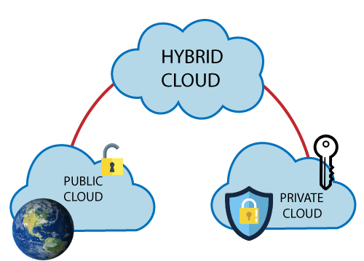

4. Community Cloud
Infrastructure is shared by a specific group of organizations that have similar needs, like the same industry or goals.
- Useful for government agencies, universities, or research groups.
- More affordable while still meeting the group's shared rules and requirements.
Example: Government Departments
Several government departments in the same country share one secure cloud system.
- The cloud uses security controls to protect government data from unauthorized access.
- It follows data protection laws, such as rules about how citizens' personal information must be stored and protected.
- Each department can access only the data it is authorized to use.
- Sharing the cloud helps departments reduce costs and use common resources.
- Only the government departments that are part of the specific community can use the cloud.
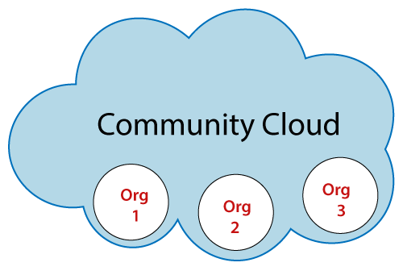
Cloud Service Models
Service models describe how much of the technology stack the cloud provider manages for you, versus how much you manage yourself.
1. Infrastructure as a Service (IaaS)
- The provider gives you virtual computers, storage, and networking.
- You control the operating system and everything installed on it.
- You can create and manage Virtual Machines (VMs), storage, and networks as needed.
- You don't need to buy or maintain the physical hardware yourself.
- Examples: AWS EC2, Azure Virtual Machines, Google Compute Engine
Real life Example
Example: It's like renting an empty apartment — you get the walls, electricity, and water connection, but you bring your own furniture and decide how to set it up.
Example: Azure Virtual Machines
Suppose you want to run a website, but you don't have your own physical server.
- You go to Microsoft Azure and create a Virtual Machine (VM).
- Azure provides the virtual CPU, memory, storage, and networking.
- You choose an operating system, such as Windows or Linux.
- You can then install Python, a web server, your website, or other software on the VM.
- You control the VM and the software, while Azure manages the physical hardware.
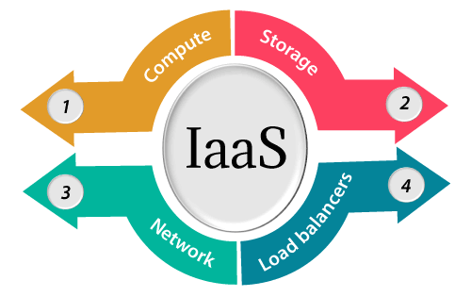
2. Platform as a Service (PaaS)
- The provider gives you a ready-made platform to build, test, and deploy your applications, so you don't have to worry about the servers underneath.
- You focus on writing and improving your application.
- The provider handles servers, storage, and networking for you.
- Examples: Heroku, Google App Engine, AWS Elastic Beanstalk.
Real life Example
Example: It's like renting a furnished, ready-to-cook kitchen — you just bring your ingredients (your code) and start cooking (building your app), instead of installing the stove and pipes yourself.
Example: Google App Engine
Suppose you create a Python web application.
- You write your Python code.
- You upload your application to Google App Engine.
- Google provides the environment needed to run your application.
- Google manages the servers/VMs, storage, networking, and infrastructure.
- You don't need to set up and manage the servers yourself.
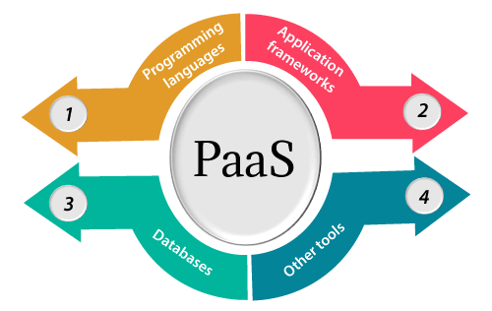
3. Software as a Service (SaaS)
- SaaS provides ready-made software applications over the Internet, usually through a subscription.
- Users can use the software directly through a web browser or API.
- The provider manages the servers, infrastructure, software, and data.
- Users don't need to install or manage the underlying servers.
- Users can usually customize some settings according to their needs.
- Examples: Salesforce, Microsoft Office 365, Google Workspace.
Real life Example
Example: Using Gmail to send an email — you never install or manage any software; you simply log in and use it.

Example: Gmail
Suppose you want to send an email:
- You open Gmail in your web browser.
- You can send, receive, and manage emails.
- Google manages the servers, storage, software, and networking.
- You don't need to install or manage the email servers yourself.
- You simply use Gmail as a service over the Internet.
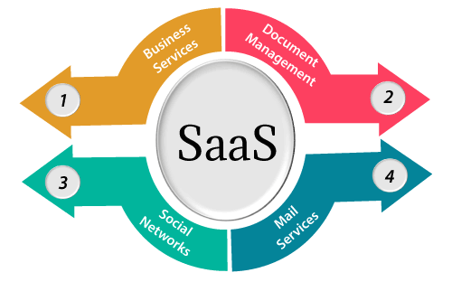
Note
Top to Bottom (IaaS → PaaS → SaaS): Control shifts from Consumer to Provider.
Bottom to Top (SaaS → PaaS → IaaS): Control shifts from Provider to Consumer.
Benefits of Cloud
Cost Savings: Pay only for the resources you use; no need to buy expensive hardware upfront.
Scalability: Easily increase or decrease resources according to demand.
Flexibility: Access applications and resources from anywhere with an Internet connection.
Reliability: Cloud providers offer high availability and backup/redundancy to reduce downtime.
Collaboration: Teams can easily work together and share data online.
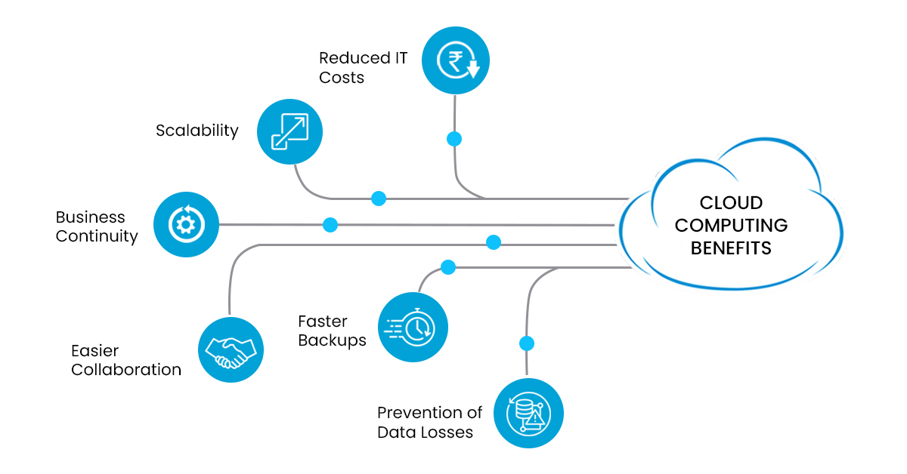
Common Cloud Computing Use Cases
- Data Storage and Backup: Store large amounts of data and create backups securely.
- Software Development and Testing: Quickly develop, test, and deploy applications using cloud resources.
- Web and Mobile Applications: Host websites and mobile apps in the cloud so users can access them from anywhere.
- Big Data Analytics: Process and analyze very large amounts of data using cloud resources.
- Disaster Recovery: Keep backups and recovery plans in the cloud so businesses can continue working after a failure or disaster.

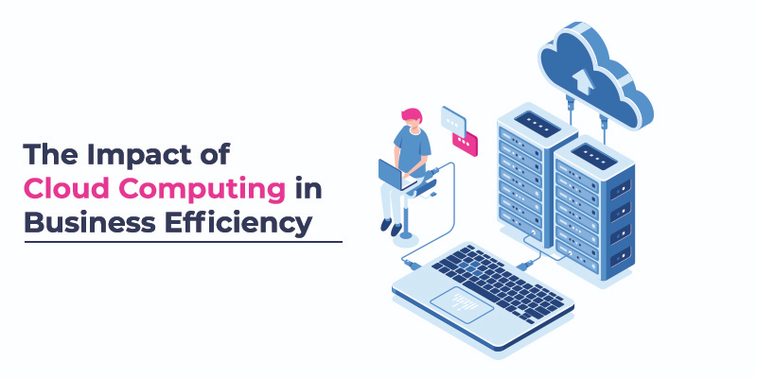
Cloud Architecture
Cloud architecture is simply how all the different parts of a cloud system are arranged and connected so that services can be delivered reliably, securely, and at scale.
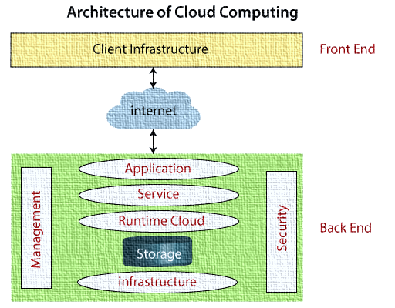

Illustration of above Diagram
Back End (The Cloud): The large green box containing Application, Service, Runtime Cloud, Storage, Infrastructure, Management, and Security represents the provider's cloud environment where all data processing, storage, and services live.
Internet (The Connection): The cloud graphic labeled "internet" in the middle acts as the network bridge connecting the user to the cloud backend.
Front End (The User/Client): The yellow box at the top (Client Infrastructure) represents the user's device, browser, or local application accessing the cloud.
NIST Architecture of Cloud
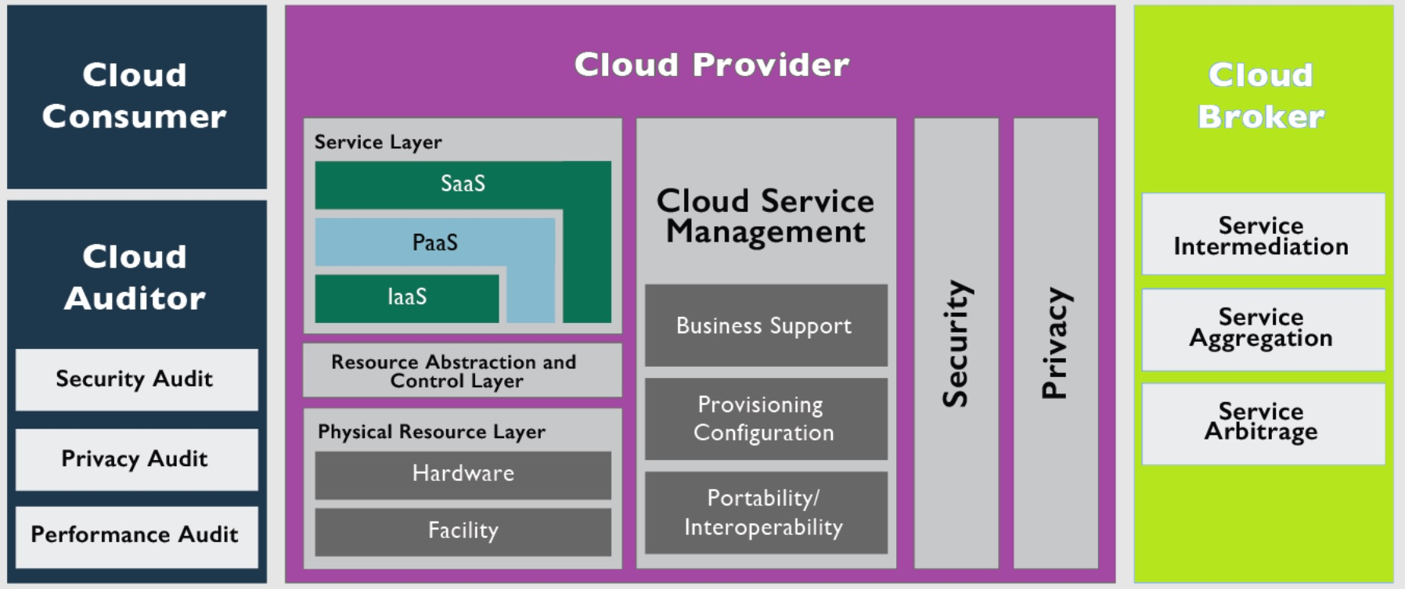
A well-known model (from NIST) describes five roles, or "players", involved in cloud computing:
- Cloud Consumer: The person or organization that uses the cloud provider's services. (Example: a startup using AWS to host its website.)
- Cloud Provider: The organization that offers the cloud services. (Example: Amazon, Microsoft, or Google.)
- Cloud Auditor: An independent party that checks and evaluates a cloud service's performance, security, and operations. (Example: a security firm reviewing whether a cloud provider follows privacy laws.)
- Cloud Broker: A middleman who manages how cloud services are used and negotiates deals between providers and consumers. (Example: a company that helps you pick and combine the best cloud services from different providers.)
- Cloud Carrier: The network/telecom company that connects the cloud provider to the cloud consumer. (Example: your internet service provider delivering the connection between you and the cloud.)
Cloud Architecture Best Practices
Up-front Planning: Plan capacity needs early and keep testing performance while designing the system, so there are no surprises later.
Security First: Protect every layer with encryption, regular updates, and strict access rules. Consider a "trust nothing by default" approach for extra safety.
Disaster Recovery Readiness: Automate backups and recovery steps so the system bounces back quickly if something goes wrong.
Maximize Performance: Keep monitoring usage and adjust resources so the system always runs smoothly.
Cost Optimization: Regularly check resource usage and turn off or resize what isn't needed, to avoid wasting money.
Conclusion
- Cloud computing delivers computing services over the internet, so businesses no longer need to build and maintain their own physical infrastructure.
- Its key features are on-demand self-service, broad network access, resource pooling, rapid elasticity, and measured service.
- The main deployment models are public, private, hybrid, and community clouds — each suited to different needs.
- The main service models — IaaS, PaaS, and SaaS — give different levels of control and convenience.
- Overall, cloud computing helps organizations save money, scale easily, and innovate faster.
Points to Remember
- Choose the deployment and service model that actually matches your needs — don't just pick the most popular one.
- Always prioritize security: use encryption and control who can access what.
- Plan ahead for disaster recovery so your business doesn't stop if something fails.
- Keep monitoring your resource usage to save money and keep performance high.
- Review and update your cloud setup regularly as your needs and technology change.
Note: We need security in cloud computing because multiple customers may share the same physical infrastructure, so their data and resources must be kept separate and protected.
Chapter 3 (Sehgal Book)
Introduction to Virtualization; Role of Virtualization in Cloud; Introduction to Hypervisors; Types of Hypervisors; Creation of a Linux based Virtual Machine
Roots of Cloud Computing
1. Introduction
The term Cloud Computing became popular about two decades ago, but its roots go back around 50 years or more.
In the past, users worked on terminals connected through cables to large computers called mainframes. Over time, technology developed, and computing resources became available through networks and the Internet.
Telecommunication companies also helped develop cloud computing by allowing multiple users to share the same physical network infrastructure instead of building separate connections for everyone.
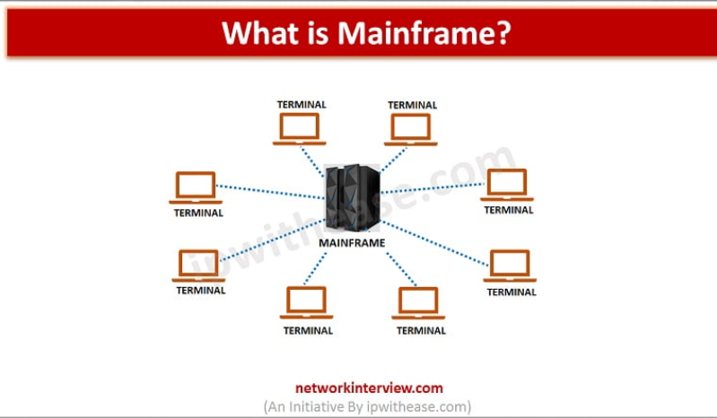
2. Shared Infrastructure
Shared infrastructure means multiple users share the same physical computing resources instead of having separate physical resources for each user.
Example: Two companies use different virtual machines on the same physical server.
3. Utility Computing
Utility Computing means providing computing resources as a service, where users pay according to their usage.
Example: A company rents computing power and pays only for the resources it uses.
4. Cloud Access
Cloud Access means accessing computing resources and services through a network, usually the Internet, whenever and wherever needed.
Example: You access your files on Google Drive using your mobile phone or laptop
The cloud computing pyramid
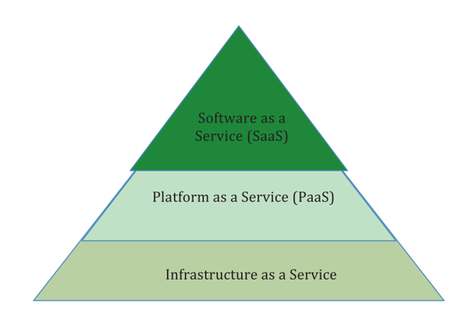
Note: This has already been discussed in Chapter 2 see Chapter 2 for details.
Cloud characteristics and virtual resources
- On-demand self-service
- Resource pooling
- Rapid elasticity
- Measured service
- Network access
See Chapter 2 for detail
What is Virtualization?
Virtualization lets one physical computer pretend to be several separate computers. A special piece of software called a hypervisor (or Virtual Machine Monitor, VMM) creates and manages these separate "guest" computers, each with its own operating system.
- Normal computer: One operating system directly manages the hardware for all its programs.
- Virtualized computer: A hypervisor sits between the hardware and several guest operating systems, giving each one its own "pretend" hardware.
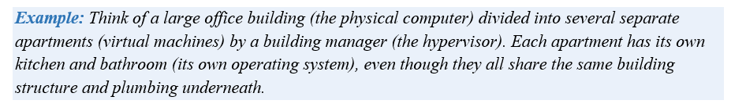
Virtual Machine (VM)
A virtual machine (VM) is a virtual computer that runs its own operating system and applications. Each VM is isolated from other VMs, so different users can work independently on the same physical machine.
Example: Windows and Linux can run on the same physical server using separate VMs.
Role of virtualization
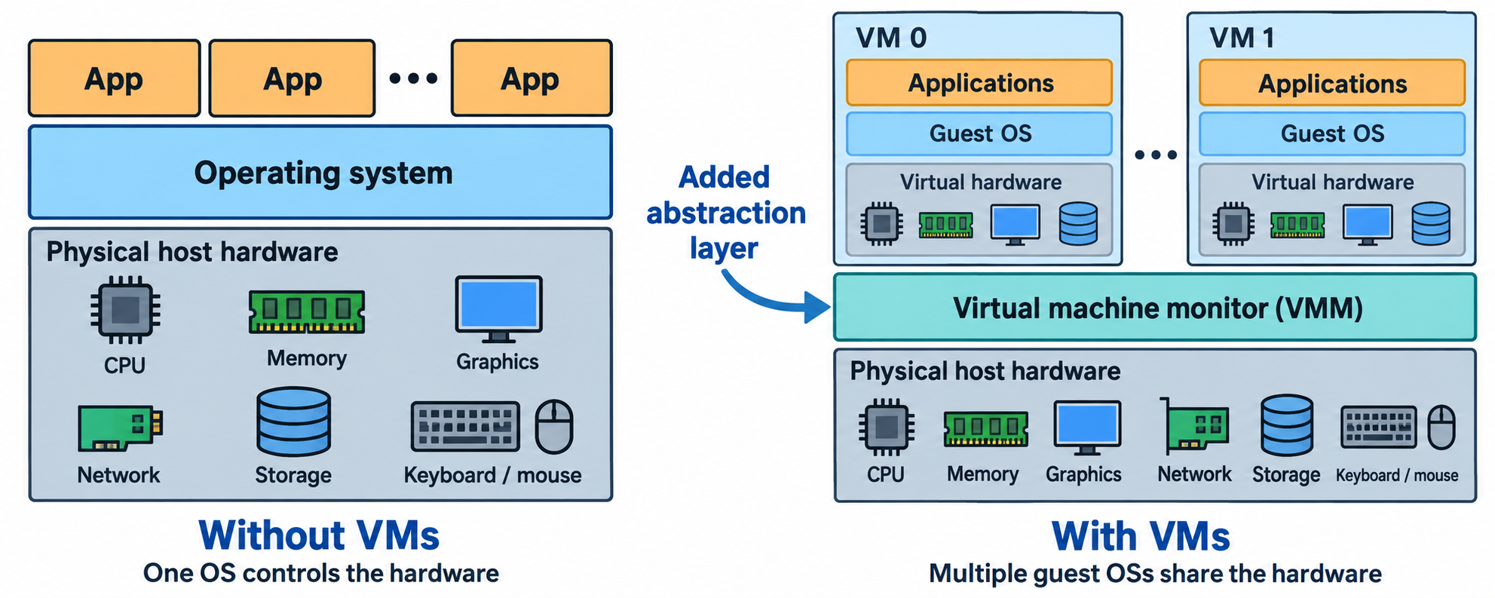
- One operating system manages processes on the left.
- On the right, a virtual machine monitor manages guests with their own operating systems.
Virtual CPU
The VM uses the physical CPU of the host computer to perform its tasks.
Virtual Memory
The VM gets a specific amount of memory (RAM) from the host computer.
Virtual Storage
The VM has a virtual disk that uses the host computer's storage.
Virtual Network
The VM has a virtual network adapter that connects it to a network.

Sharing capacity: the book’s example
Two companies needed 1,000 computers each, but at different times.
- Company P (Pharmaceutical company): Needed 1,000 machines continuously, 24/7 for one month, to test a drug.
- Company H (Hollywood studio): Needed 1,000 machines only for a weekend to render movie scenes.
If both companies needed separate physical computers, a large amount of hardware would be required, and some computers might remain unused at other times.
How did VMs solve the issue?
Virtual Machines (VMs) allowed multiple virtual computers to run on shared physical infrastructure.
- Company P ran its work on 1,000 VMs.
- During the weekend, Company H could start another 1,000 VMs on the same infrastructure.
- Company P's work might become slower because both companies were sharing resources, but the example says its confidentiality and integrity would not be affected.
Hypervisor
A hypervisor is system software that creates and manages Virtual Machines (VMs) on a physical computer.
Example: One physical server can run 3 VMs. The hypervisor manages the physical resources and distributes CPU, memory, and storage among these VMs.
- Physical Machine: The actual computer or server.
- Hypervisor: Creates, manages, and controls VMs.
- VMs: Virtual computers that run their own operating systems and applications.
Functions of a Hypervisor
- Virtual Machine Monitor: Provides virtual hardware to VMs and controls the execution of their guest operating systems.
- Resource Management: Allocates and manages CPU, memory, storage, and device access among VMs.
- Guest Separation: Keeps each VM's execution and state separate from other VMs, so they operate independently.
- VM Lifecycle Management: Allows VMs to be created, started, stopped, and configured.
Types of Hypervisors
There are two main types of hypervisors:
1. Type 1 Hypervisor — Bare-Metal
A Type 1 hypervisor runs directly on the physical hardware without needing a host operating system.
Example: VMware ESXi, Microsoft Hyper-V, Xen
Structure:
Physical Hardware → Hypervisor → VMs
Used mainly in: Servers and data centers.
2. Type 2 Hypervisor — Hosted
A Type 2 hypervisor runs on top of a host operating system like Windows, Linux, or macOS.
Example: Oracle VirtualBox, VMware Workstation
Structure:
Physical Hardware → Host OS → Hypervisor → VMs
Used mainly in: Personal computers, testing, and development.
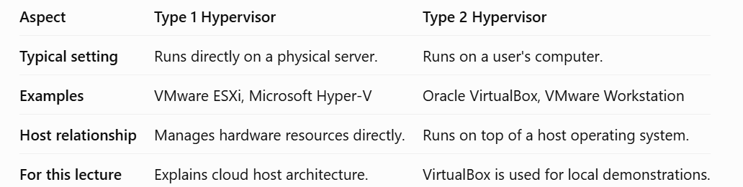
Cloud players and their concerns
Cloud Service Process
Cloud users request services through a Cloud portal, such as email. Their emails are stored on Cloud servers, which may be located in one or more remote data centers.
Users do not need to know the physical location of the servers. They mainly expect fast responses, secure data, and continuous service.
Quality of Service (QoS): It refers to the quality of service provided to users, including response time, performance, security, and availability.
Cloud service providers monitor performance to ensure good QoS. In some cases, third-party IT service providers manage hardware maintenance, while Cloud service providers monitor application performance.
Main Players in a Public Cloud
1. Facility Managers
- Manage the data center infrastructure, including servers, storage, power supplies, and cooling systems.
- Ensure the data center operates efficiently.
- Aim for maximum uptime at the lowest operational cost.
2. Cloud IT Managers or Service Providers
- Manage and schedule tasks across one or more data centers.
- Maximize the use of hardware resources while keeping extra capacity for sudden increases in demand.
- Monitor performance and plan for future capacity.
- Ensure secure and efficient data center operations.
3. Cloud Users
- Customers who rent Cloud resources to run their applications or provide services.
- Aim to provide the expected service quality at the lowest possible cost.
- Example: Netflix uses Amazon Web Services (AWS) to host its content.
4. End-Users
- People or businesses who use Cloud-based services through computers, mobiles, or other devices.
- Expect good service quality, data protection, and continuous availability.
5. IT Managers
- Manage an organization's computing infrastructure.
- May use the Cloud for data backups, sudden increases in workload, or non-critical business services.
- Ensure that the organization's computing needs are met efficiently.

Considerations for Cloud Data Centers
When choosing a Cloud service provider, important factors include SLA, resource allocation, load balancing, cost, performance, and security.
1. Service-Level Agreement (SLA)
SLA defines measurable service requirements between the Cloud provider and user.
Important SLA considerations include:
- Response time
- Output bandwidth
- Number of servers being monitored
- Changes in the environment
- Maintaining good quality of service (QoS)
2. Load Balancing
Load balancing means distributing jobs among servers or VMs so that one server does not become overloaded.
Example: If one VM is too busy, some jobs can be moved to another VM with available resources.
3. Migration
Migration means moving a website, application, or data from one computing environment to another.
Example: A company moves its website from GoDaddy to AWS to get more resources and scalability.

4. Performance
A Cloud system may sometimes perform slower than a dedicated group of powerful computers (HPC) because the Cloud's resources are shared and may have network or storage limitations.
- Lower network bandwidth
- Higher communication delays
- Variable storage performance
5. Security
Public Clouds are accessible to many users, so security is an important concern.
Possible threats include:
- Unauthorized access to data
- Denial-of-Service (DoS) attacks
- Malicious VMs
Cloud providers monitor VM resource usage to detect unusual behavior and may limit (throttle) resources to reduce the impact of attacks.
Linux Operating System Introduction
1. Kernel
The kernel is the core part of the Linux operating system. It manages the computer's main resources, such as:
- Processor (CPU): Decides which programs get CPU time.
- Memory (RAM): Manages how memory is used by programs.
- Devices: Manages devices such as disks, keyboards, network cards, and other hardware.
In simple words: The kernel acts as a bridge between software and computer hardware.
2. Distribution
A Linux distribution (distro) is a complete operating system built around the Linux kernel. It includes the kernel along with:
- System utilities
- Libraries
- Software and applications
- Package/software management tools
In simple words: A distribution gives you the Linux kernel + tools + software needed to use a Linux system.
3. Examples
Some popular Linux distributions are:
- Ubuntu: Popular and beginner-friendly.
- Debian: Known for stability.
- Fedora: Includes newer technologies and software.
- Red Hat Enterprise Linux (RHEL): Designed mainly for businesses and servers.
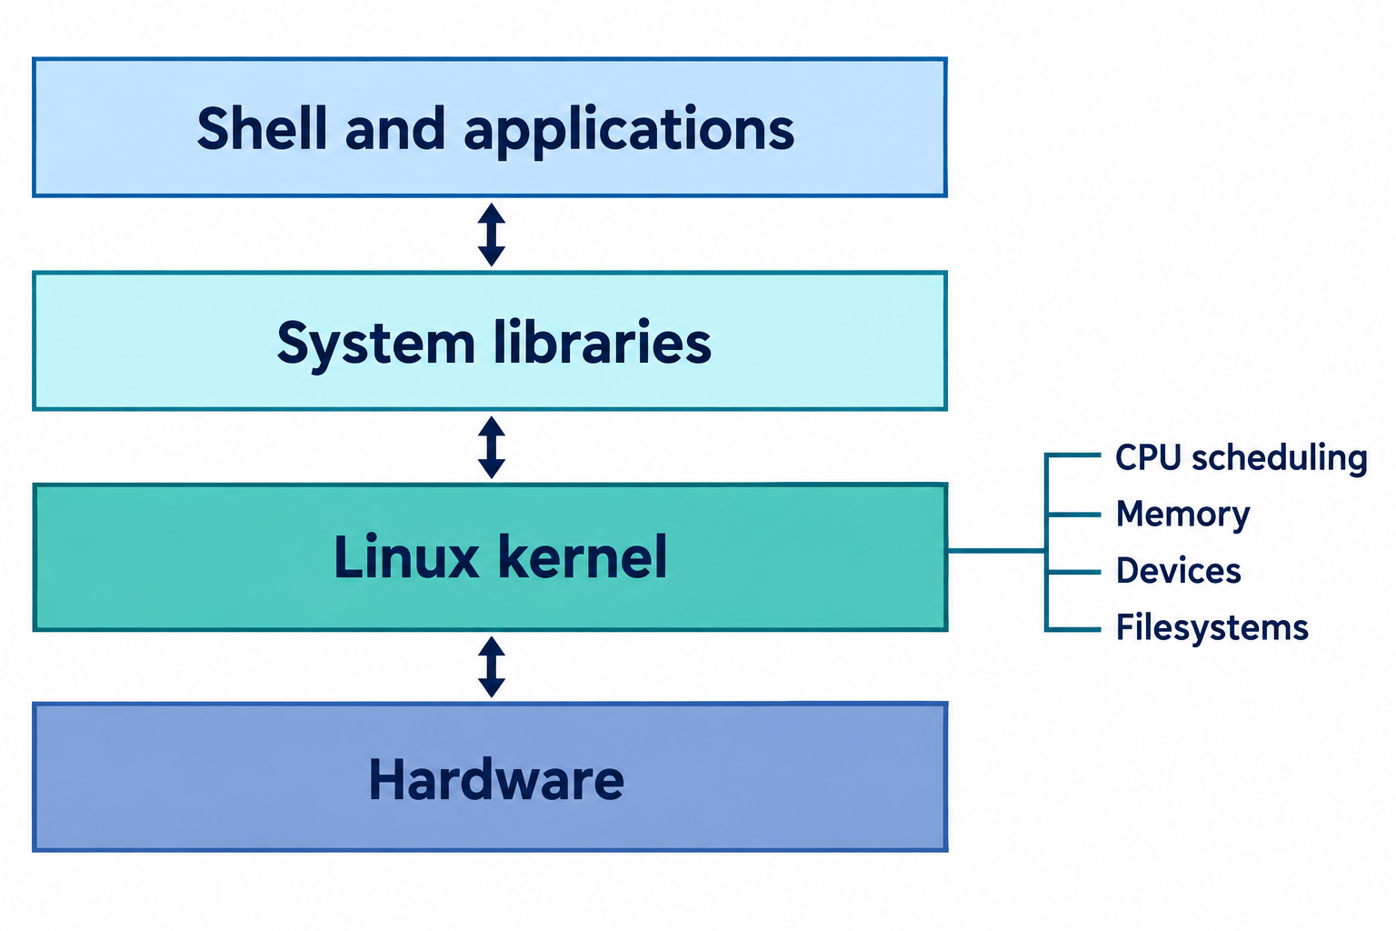
Linux Architecture
1. User Space
User space is where applications and shells run.
- Applications such as browsers, editors, and other programs run here.
- The shell allows users to give commands to the operating system.
- When an application needs hardware resources, it requests the kernel to provide them.
Example: You type ls in the shell. The shell asks the kernel to access the file system and show the files.
2. Kernel
The kernel is the core of the operating system. It manages and controls access to system resources such as:
- CPU
- Memory
- Storage
- Network
- Other hardware devices
Example: If an application needs memory, the kernel manages and provides the required memory.
3. Inside a VM
Inside a Virtual Machine (VM), the guest operating system has its own kernel.
The guest kernel does not directly control the physical hardware. Instead, it uses the virtual hardware provided by the hypervisor.
Example:
Physical Server → Hypervisor → VM → Guest Linux Kernel → Applications
So, the VM's Linux kernel thinks it is using hardware, but the hypervisor provides virtual versions of that hardware.
Importance of Linux in DevOps
Similar Environments
Linux can be used in development, testing, and production, making environments similar.
Repeatable Operations
Commands and configuration files make setup steps clear and repeatable.
Software Management
Package managers make it easy to install, update, and manage software.
Operational Visibility
Linux tools help developers check files, processes, CPU, memory, and other resources.

A view of the delivery process
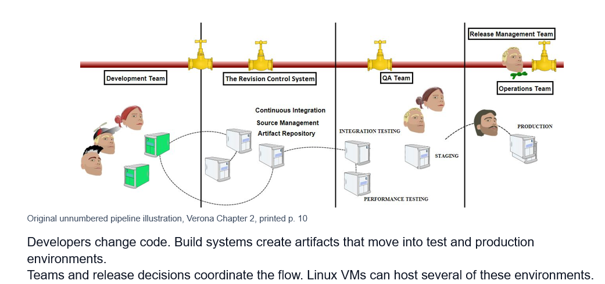
Development tools and runtime environments
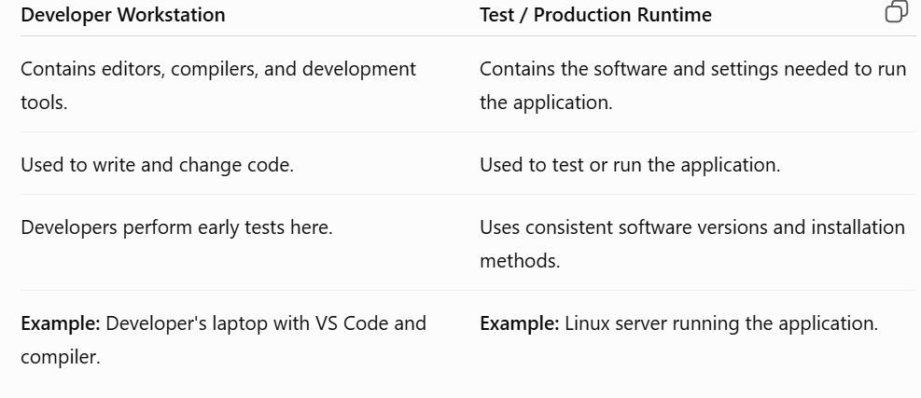
Terminal and command syntax
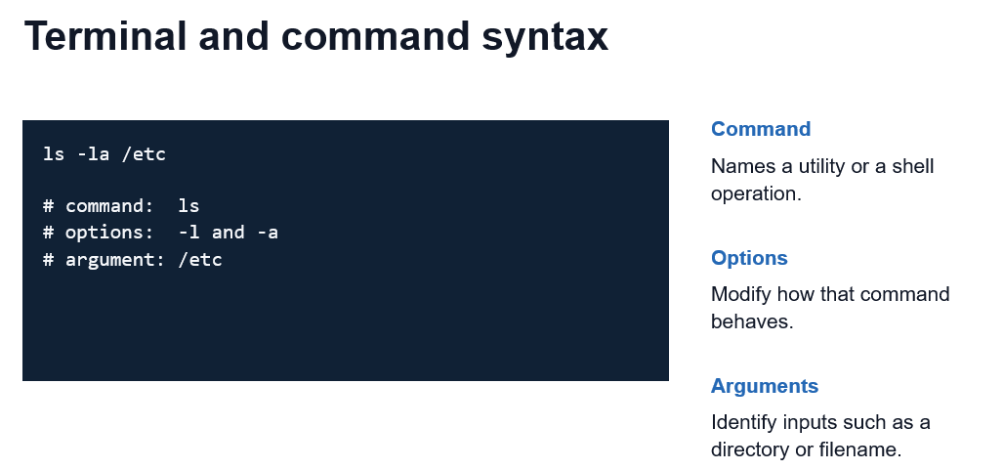

Paths and filesystem locations
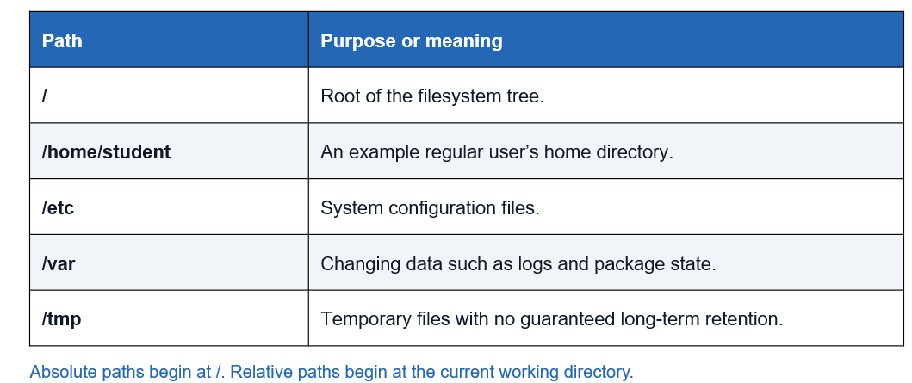
Navigating directories
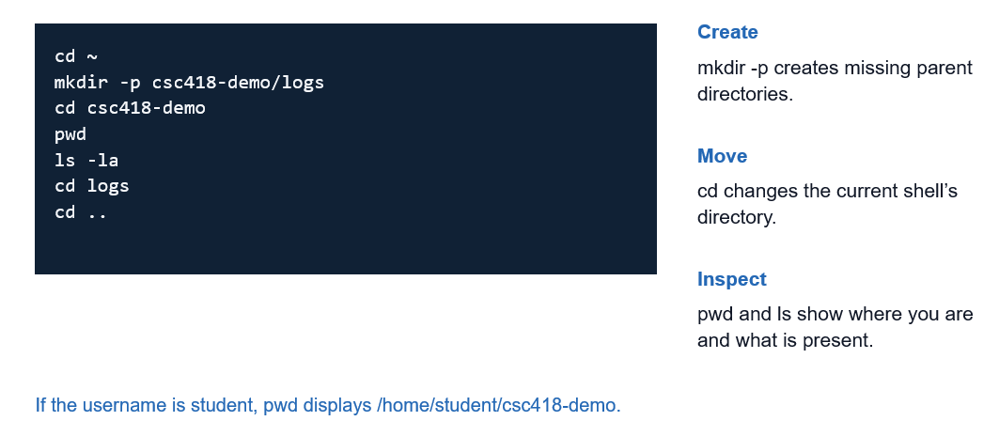
Creating, copying and moving files
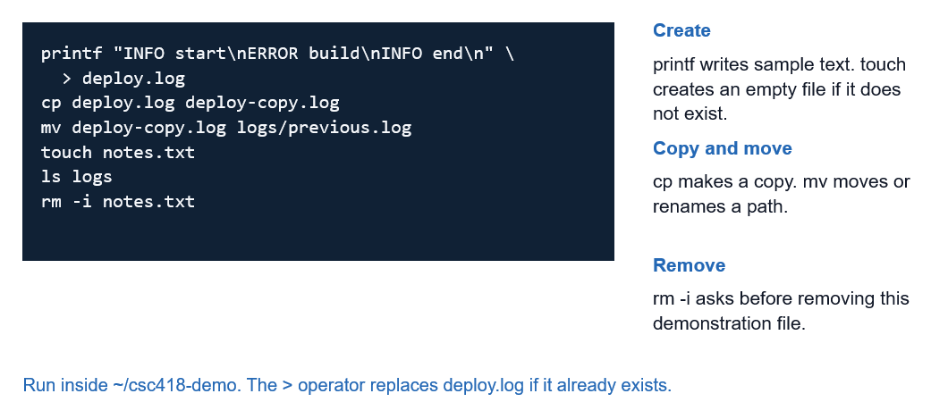
Reading and searching text
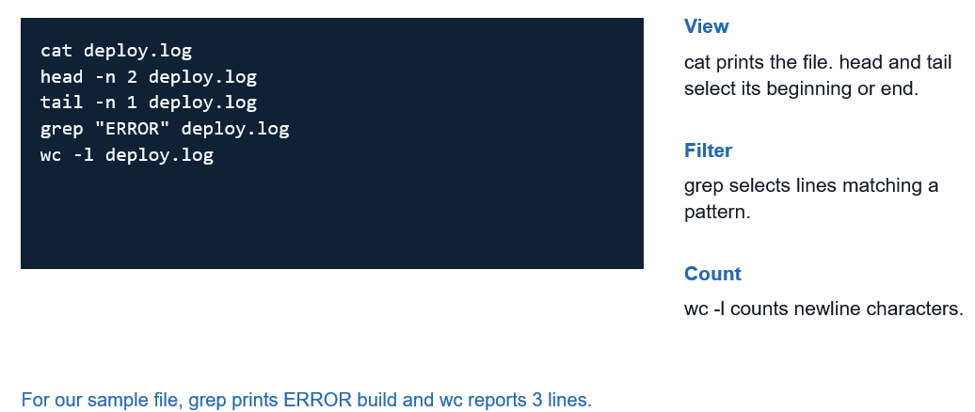
Pipes and redirection
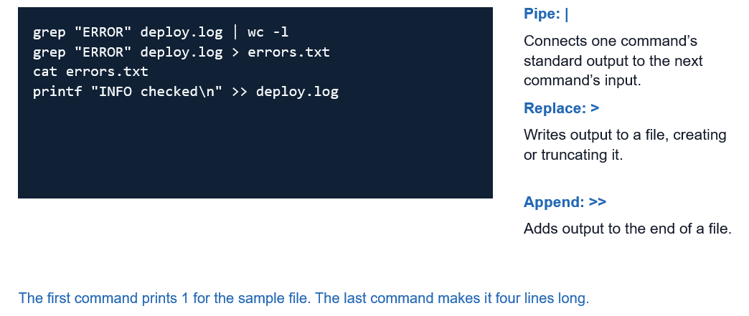
Basic process and resource utilities
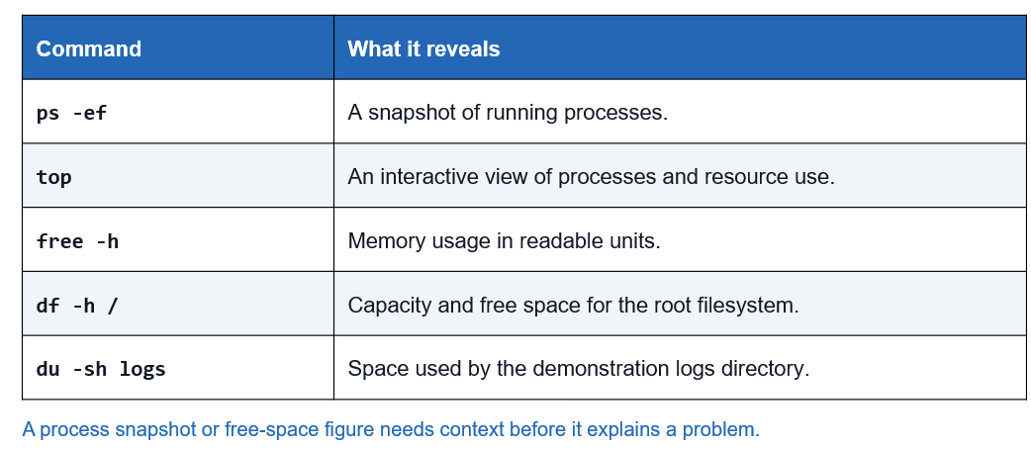
Getting help and using privileges
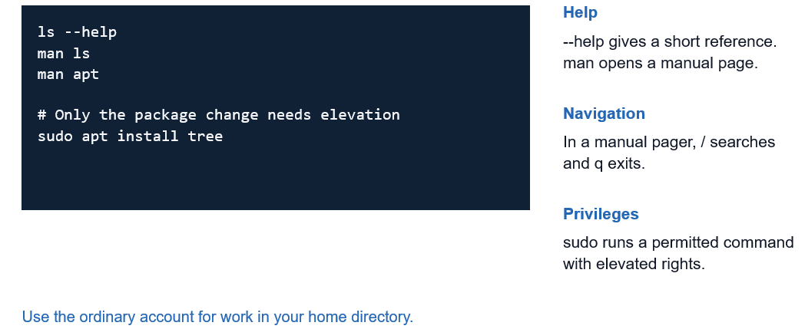
Package Managers
1. Package
A package is a bundle of software that contains the program, its version, and the other software it needs to work.
Example: A package for installing Python.
2. Repository
A repository is a place where software packages are stored and made available for download.
Example: Ubuntu has online repositories containing thousands of packages.
3. Package Manager
A package manager is a tool that installs, updates, and removes software. It also automatically installs any required dependencies.
Example: apt is a package manager in Ubuntu.

4. Installed State
The system keeps information about which packages are installed, their versions, and their files.
Example: The system can check that Python version 3.x is installed and know which files belong to it.
Linux package-management families
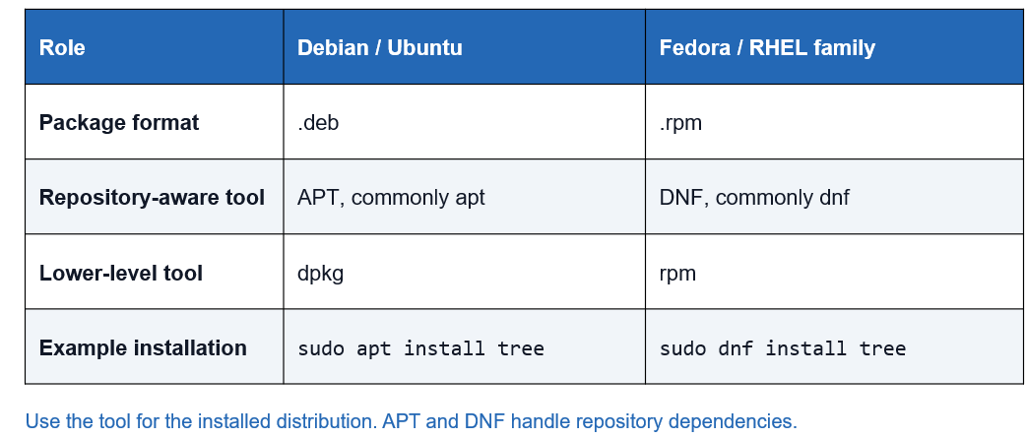
APT: update, inspect and install
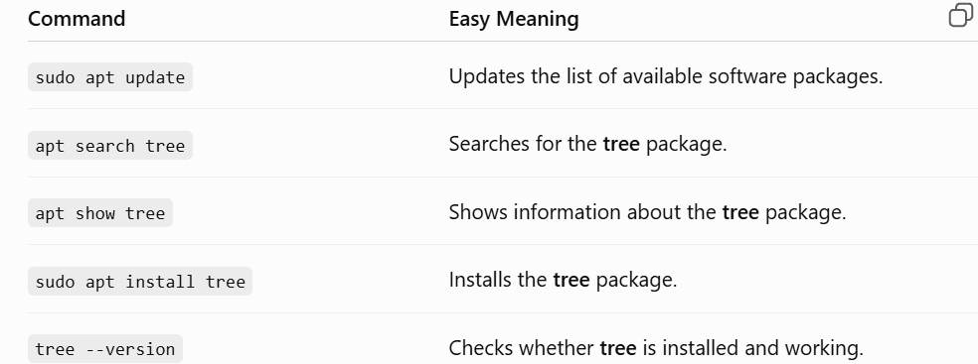

Steps:
1. Refresh: apt update gets the latest package information.
2. Inspect: apt search and apt show help you find and understand a package.
3. Install and Verify: apt install installs the package, and tree --version checks that it works.
APT: package queries and upgrades
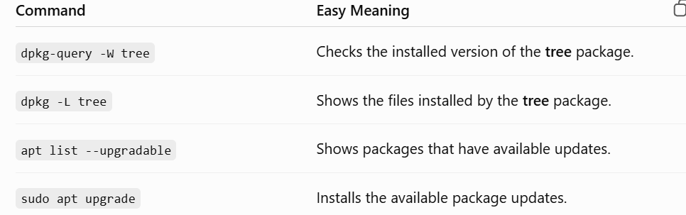
Steps:
1. Query: Check which version is installed and which files belong to the package.
2. Review: See which installed packages can be updated.
3. Upgrade: Install the available updates after reviewing the changes.
Important: The repository contains information about available packages, while the system keeps information about packages already installed.
Removing packages
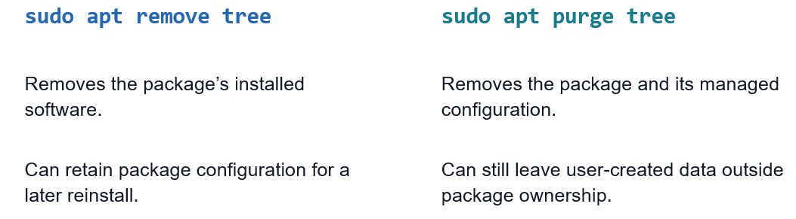
Test Environments, Staging and Release
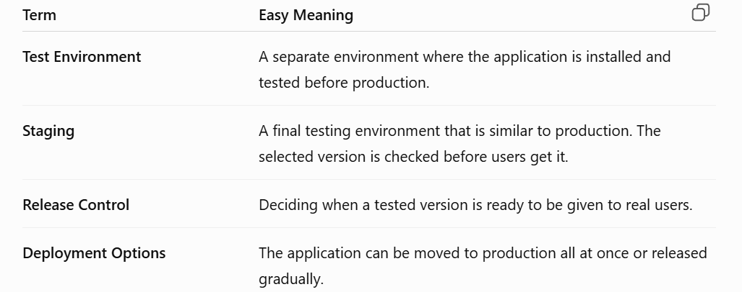
The Book's Authentication-Change Example
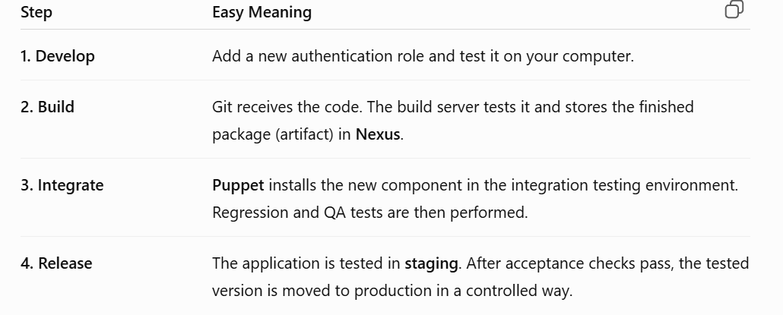
Delivery Cadence and Bottlenecks
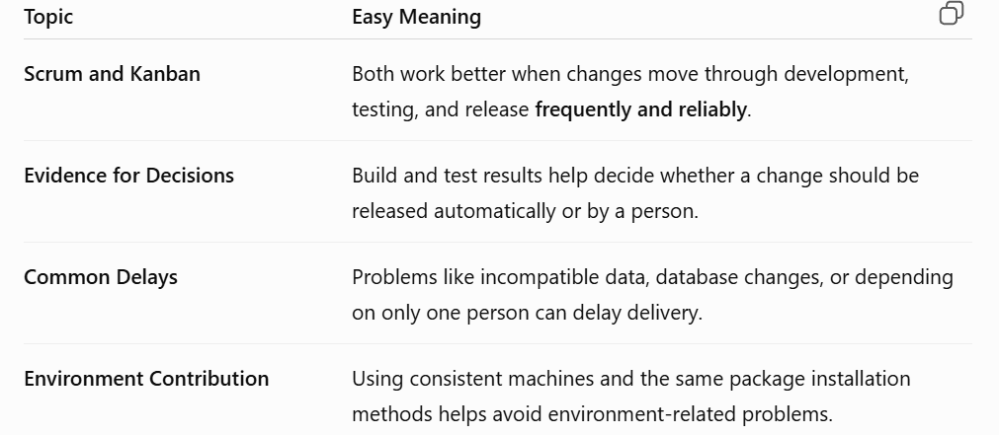
Chapter 3 of Practical DevOps (Book)
Lecture 5
Architecture, containers & Docker
Some Important Terms to Notice
There are three different things:
- Architectural unit: A part of the software system, such as a service or component.
- Deployable artifact: The packaged version of that software that can be deployed, such as a Docker image.
- Running instance: The actual software running on a machine, such as a Docker container
Architecture shapes delivery
Functional requirements
Describe what the application does.
- Example: Accept course registration or display a customer record.
Quality requirements
Describe how the system should behave and how easily it can change.
- Example: Stay available during a release and support frequent, small deployments.
Main point: A small change in source code can still require a large deployment, depending on the system architecture.

Architecture and Independent Deployment
Just because you divide an application into separate modules does not mean you can deploy those modules separately.
For example:
One application
- Module A
- Module B
- Module C
If you change Module A, you may still have to rebuild and deploy the whole application.
To deploy A separately, the architecture must be designed so that A, B, and C can work independently through proper interfaces.
So, remember:
Separate code ≠ separate deployment.
Verona’s Spelling-Correction Example
- The example shows how a very small change can require a large deployment.
- The application contains business logic + a website in one package.
- A developer fixes one spelling mistake on the website.
- Because everything is packaged together, the entire application must be rebuilt and deployed.
- This means a tiny change exposes the whole application to deployment/release risk.

A Monolithic Application
A monolithic application is an application where all major modules are packaged and deployed as one unit.
Even though everything is in one application, we should still create clear boundaries between modules to reduce unnecessary interlinking.
Example:
University Application
- Registration Module
- Fee Module
- Result Module
Each module should focus on its own responsibilities and should not depend heavily on the internal details of other modules.
Goal:
- High cohesion: Related responsibilities should stay together within a module.
- Low coupling: Modules should have fewer dependencies on each other.
A monolithic application
One deployment unit
The application’s modules ship together as one release.
Mostly local interaction
Modules commonly call each other inside the same process.
Simpler development and delivery
Local development, debugging, and release coordination involve fewer moving parts.
Broader release and scaling scope
A change may affect many features, and each replica usually contains the whole application.
Disadvantage of a monolithic architecture.
- Large deployment: If the whole application is packaged as one unit, changing one small part may require redeploying the whole package, making the entire application temporarily unavailable during deployment.
- Higher release risk: A change in one module can unexpectedly cause problems in other modules when the whole application is deployed.
- Harder to scale: You usually have to scale the whole application, even if only one module needs more resources.
- Tight coupling: Modules may become highly dependent on each other.
- Longer deployments: Building and deploying the entire application can take more time.
Separation of Concerns, Cohesion, and Coupling
- Separation of concerns: Give each part of the system a clear responsibility.
Example: Keep payment processing separate from product display.
- High cohesion: Keep related functionality together in the same module.
Example: Keep payment processing separate from product display.
- Low coupling: Keep dependencies between modules low.
Example: The Order module should use the Payment module's interface instead of directly accessing its internal payment data.
Backward Compatibility
Backward compatibility means making changes or adding new features to a system without breaking existing users, data, or functionality.
Example:
Suppose the old system uses Username + Password. In the new version, you introduce First Name + Last Name. You can temporarily keep the old fields optional so that old requests and users can still work while the new format is introduced.
Matangle’s Three-Tier Application
A three-tier application is an application divided into three separate tiers, where each tier has a specific responsibility. This separation makes the system easier to develop, maintain, and change.
1. Presentation tier
This tier handles the user interface and what the user sees and interacts with.
Example
React, JavaScript, and static HTML provide the user interface.
2. Application logic tier
This tier contains the application’s behavior and business logic. It processes requests and decides what the application should do.
Example
Clojure on the Java platform implements the application’s behavior.
3. Data tier
This tier is responsible for storing and retrieving data used by the application.
Example
PostgreSQL stores the customer records.
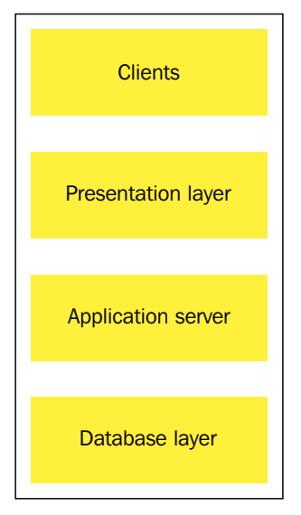
Database State Survives Application Releases (Updating the application does not necessarily mean losing the database data
)
This means the application can be updated or replaced without deleting the existing data in the database.
- Application binary can be replaced: We can deploy a new version of the application while the database keeps its existing records.
- Migration tools: Tools such as Liquibase track database changes and remember which changes have already been applied.
- Example: First, the database creates a customer table. Later, a migration adds an address field/table without losing the existing customer data.

