Human Computer Interaction and Computer Graphics
Lecture 1
Introduction to HCI
Definition of HCI
Human-computer interaction is a discipline concerned with the design, evaluation and implementation of interactive computing systems for human use and with the study of major phenomena surrounding them.
The major areas studied in HCI include how people think and behave, the tasks they perform, how they interact with technology, the capabilities of technology, the situation in which technology is used, usability, user experience, and social and ethical issues.
What fields does HCI cover?
- Computer Science: Deals with the technology, software, and computer systems used in HCI.
- Psychology: Studies how people think, learn, remember, and behave when using computers.
- Communication: Focuses on how users communicate and interact with computer systems.
- Education: Studies how technology can help people learn and teach effectively.
- Anthropology: Studies how culture and society affect the way people use technology.
- Design: Focuses on creating user-friendly and attractive interfaces, such as graphic and industrial designs.

Design
In HCI, design is a process of creating interactive systems that are effective, efficient, and satisfying for users within their specific context of use. It involves understanding users' needs, creating prototypes, testing them with real users to refine the interaction and ensure the final product is intuitive (easy to use without much instructions), accessible, and meets its intended goals.
Effectiveness: - Accuracy and completeness through which user fulfill their specified goals.
Efficiency: - The resources expanded in software through which u can achieve effectiveness.
Key Aspects of HCI Design
User-Centered Approach: HCI design focuses on users, their tasks, goals, and the situation in which they use the system, rather than only focusing on the technology.
key aspects of HCI Design
1. Interaction Design (IxD)
It focuses on how users interact with a system, such as clicking buttons or using voice commands, and how the system responds, such as showing messages, images, or sounds. The goal is to make the interaction easy and smooth.
2. Iterative Process
It means repeating the design process by identifying problems, creating different solutions (prototypes), testing them with users, and improving the design until the best solution is achieved.

3. Accessibility
Design systems so that everyone can use them, including people with disabilities, by following accessibility rules and guidelines.
4. Context of Use
The design should consider where, when, and how the system will be used, as well as the user's ability to think, understand, and remember.
What constitutes a good design?
There’s definitely more than one way to explain it, but if I were to describe designers in one term, it would be
Good design solves problems: Designers are basically problem solvers. They create solutions that address real problems.
Balances business goals and user needs: Good design finds a balance between what the business wants and what users need.
• Follows a proper process: Good design follows a process that uses UX (User Experience) principles and usability guidelines to achieve the desired result.
• Designed for humans: A good design is made for people and their needs, not just to make something functional or usable.
Understanding User Needs
- A good designer knows how to get into the mindset of his users, and turns their needs into a meaningful, desirable, and easy-to-use product or service
- “Good design is actually a lot harder to notice than poor design, in part because good designs fit our needs so well that the design is invisible.”- Don Norman
- It means that when a design works well and meets the user's needs, it becomes easy and natural to use, so users can use it without thinking much about it. In contrast, a poor design is easy to notice because it causes confusion, frustration, and difficulty for users in achieving their goals.
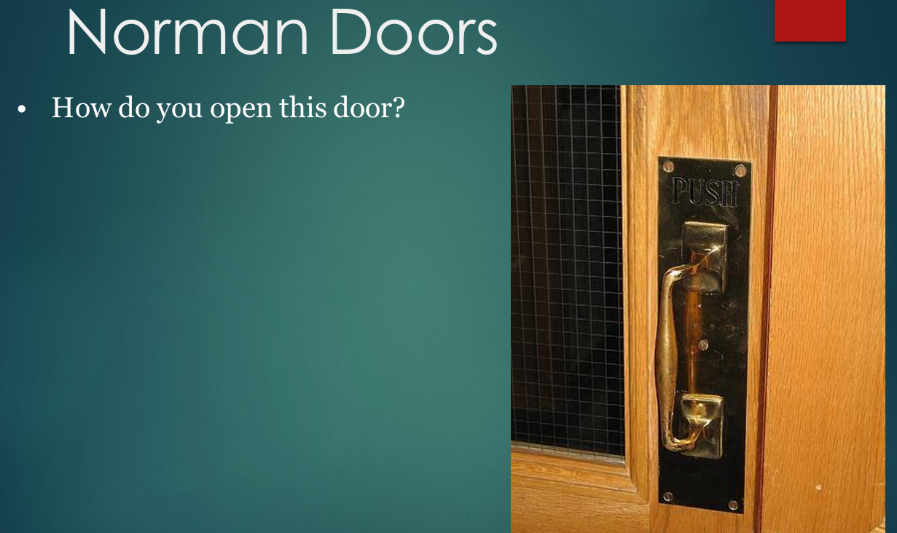
Don Norman Says: When simple things need pictures, labels or instructions the design has failed.
Design Principles of design:
- Use both knowledge in the world and knowledge in the head.
- Simplify the structure of tasks.
- Make things visible: bridge gulfs between Execution and Evaluation.
- Get the mappings right.
- Exploit the power of constraints.
- Design for error.
- When all else fails, standardize."
1. Use Knowledge in the World and Knowledge in the Head
- Knowledge in the world: Information that is visible in the environment or interface.
- Knowledge in the head: Information that users remember from their previous experience.
- Example: A calculator shows numbers and symbols (knowledge in the world), while the user remembers that + means addition (knowledge in the head).
- Design principle: Do not make users remember everything. Provide helpful labels, instructions, and visual cues. For example, use familiar and consistent icons, such as the magnifying glass for search, so users can understand their purpose easily.
2. Simplify the Structure of Tasks
- Make tasks simple, easy, and efficient.
- Remove unnecessary complexity.
- Reduce the number of steps or actions needed.
- Example: Divide a long form into smaller, easier steps instead of showing everything on one page.
3. Make Things Visible
- Make available actions and system responses clear and easy to see.
- Gulf of Execution: Users should understand what they can do in the system.
- Gulf of Evaluation: Users should understand what happened after they performed an action.
- Example: After clicking Submit, show a message: “Your form has been submitted successfully.”
4. Get the Mappings Right
- Mapping is the relationship between a control and its effect.
- Good mapping makes a system easy to understand.
- Poor mapping causes confusion.
- Example: Car seat controls should correspond to the direction in which the seat moves
5. Exploit the Power of Constraints
- Constraints: Limit users from doing wrong or incorrect actions.
- They help users make the correct choice.
- Example: A USB connector is shaped so that it can be inserted only in the correct direction.
6. Design for Error
- People make mistakes, so good systems should expect and handle them.
- Prevent errors whenever possible.
- Help users easily fix or recover from mistakes.
- Examples: Show a confirmation message before deleting, provide an Undo option, and use Auto-save.
7. When All Else Fails, Standardize
Use established standards and conventions.
Consistency reduces confusion and learning time.
Examples:
- 🔍Search
- 🗑 Delete
- ⚙ Settings
- Ctrl + C = Copy
Why we care about HCI
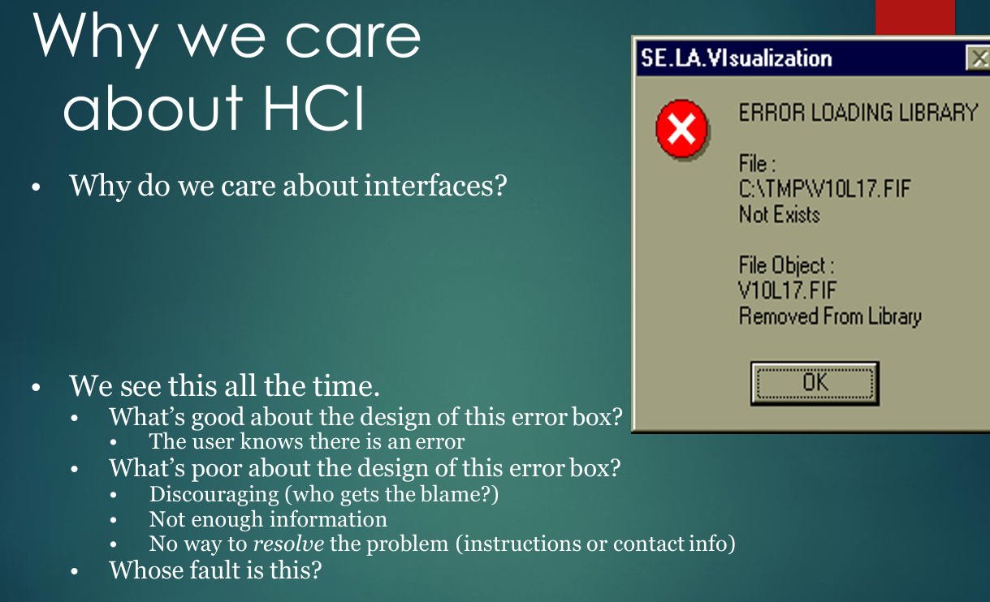
Bad Design (Interfaces)
- Encumbering: Difficulty between moving screens. Makes the task harder or takes extra steps.
- Confusing: User doesn’t understand what to do.
- Slow: Takes too much time to respond.
- Trust: User loses confidence when the system crashes or fails ((ex. windows crashing).

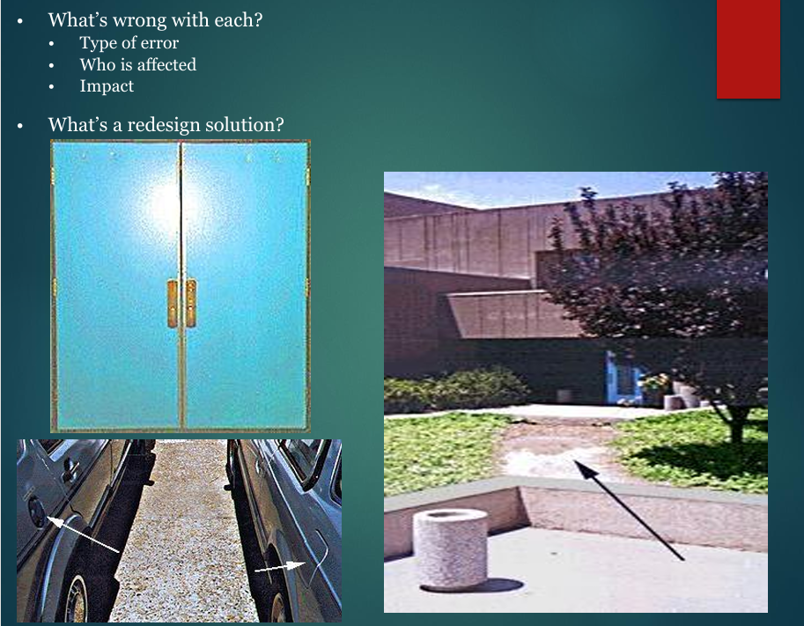
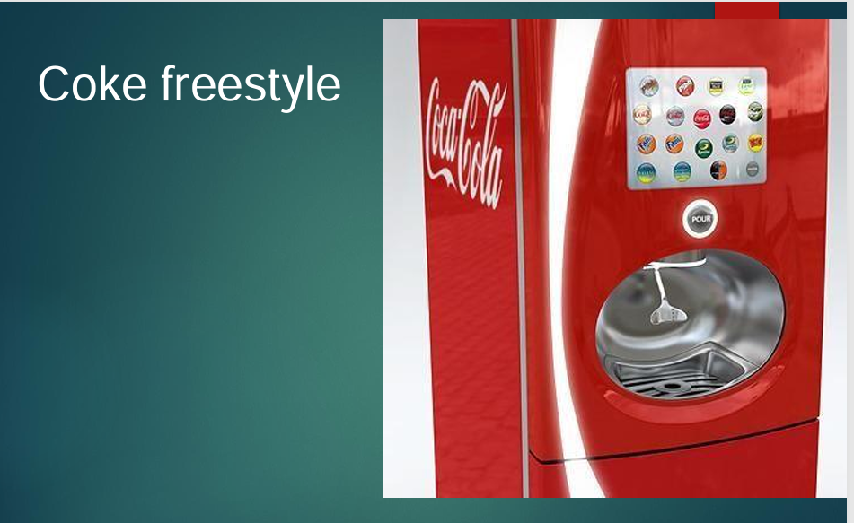

Explanation of Coke Freestyle
Before (Traditional Soda Fountain):
- Few Choices: Offered only 6 to 8 drink options.
- Multiple Levers: Used a separate physical lever and nozzle for every single drink.
- No Customization: You couldn't mix extra flavors (like Cherry or Vanilla) into your drink.
- Bulky Hardware: Required a lot of physical space to fit all the different nozzles and handles.
After (Coke Freestyle Machine):
- 100+ Choices: Offers over 100 drink options in a single machine.
- One Touchscreen: Replaced all physical levers with a smart touchscreen interface.
- Easy Customization: Allows you to easily add custom flavors like Cherry, Lime, or Vanilla to any base drink.
- Single Nozzle: Dispenses every drink combination from a single nozzle by pressing one POUR button.
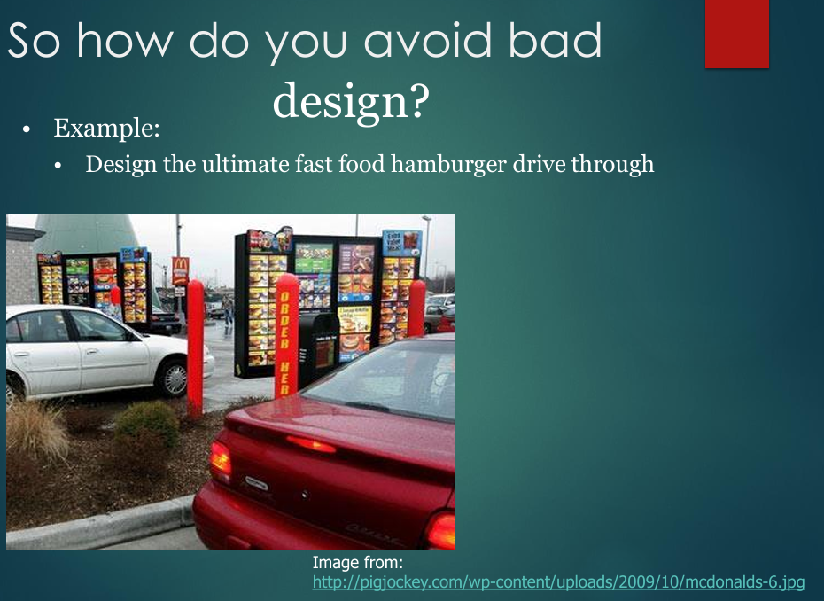
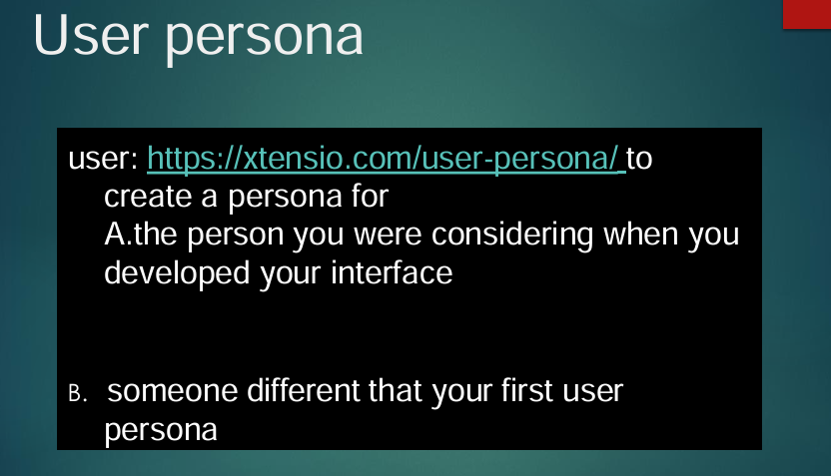

Explanation of Above Figure User Persona
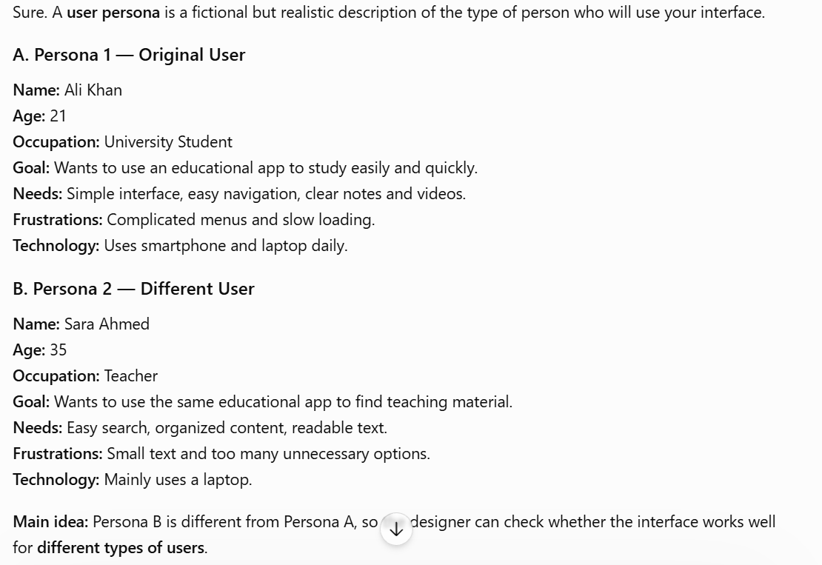
Did your design support?
- A customer who can’t read English?
- A customer who is hearing impaired?
- A customer who has never eaten a hamburger before?
- A customer who is health conscious?
- A customer who has an IQ of less than 80?
- A customer who is over 7’ tall
- Did you design an interface for you?
- Is not that what someone already did?

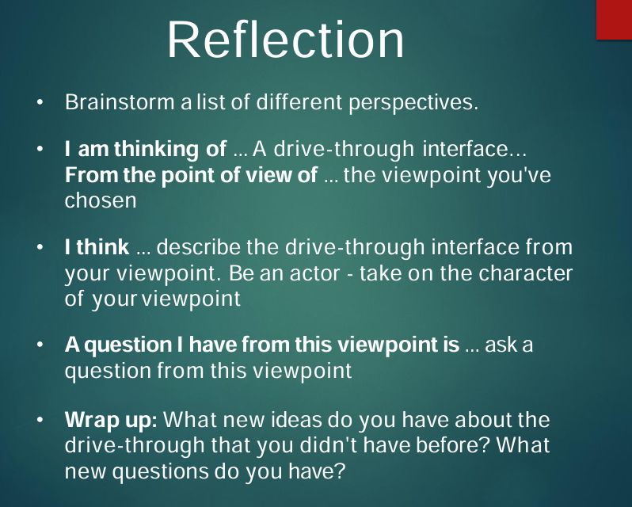
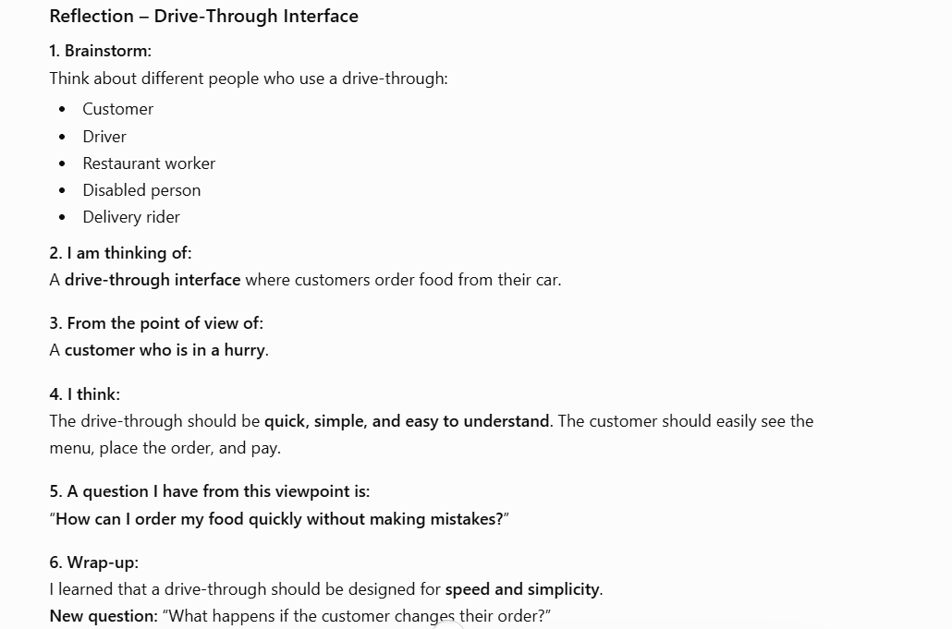
Good HCI
You can’t create one just by sitting around and dreaming one up mean You can’t create good HCI just by guessing.
What do you rely on?
- Known design solutions: Use designs that are already proven to work.
- Research: Study users and their needs.
- User feedback: Ask users what they like or dislike.
When should HCI be considered?
- Throughout the whole development process, not just at the end.
- This approach is called Lean UX.
Cultural and International Diversity
When designing an interface for people from different countries and cultures, we must consider their differences.
- Language: Users may speak different languages.
- Date/Time: Different countries write dates differently.
Example: 1/4/15 can mean different dates.
- Weights & Measures: Some use kg/km, others may use lb/miles.
- Reading: Some languages read left-to-right, while others read right-to-left.
- Phone & Addresses: Formats are different in different countries.
- Names & Titles: Naming styles and ways of addressing people can differ.
- SSN/ID/Passport: Identification numbers have different formats.
- Icons, Buttons & Colors: Symbols and colors can have different meanings.
- Etiquette & Tone: Some cultures prefer formal language, while others prefer casual language.
Real-world example: Nursing simulation
If we create a simulation for nursing students, we should consider the country or area where it will be used because healthcare practices and standards of care can differ from one place to another.
Elderly Users
Elderly users may have some changes that affect how they use technology.
- Motor skills: They may move their hands more slowly.
- Vision: They may have difficulty seeing small text.
- Hearing: They may need louder sounds.
- Touch: They may have difficulty using very small buttons.
- Mobility: Physical movement may be slower or difficult.
- Speed: They may need more time to complete tasks.
- Memory: They may forget steps or instructions.
- Technology experience: Some elderly people have little experience with technology.
How to design for elderly users?
- Use large fonts.
- Use large buttons.
- Use clear and simple instructions.
- Use louder/clear audio.
- Keep the interface simple and easy to navigate.
- Give users more time to complete tasks.

Children
Children are different from adults because their age, skills, attention, and goals change as they grow.
- Technology familiarity: Some children use technology from a young age.
- Physical dexterity: Young children may find double-clicking, dragging, or small buttons difficult.
- Attention span: Children may lose interest quickly.
- Varied backgrounds: Children have different access to technology and learning resources.
- Goals: They may use technology for learning, playing, and socializing.
How to design for children?
- Use large buttons and simple controls.
- Use colorful, attractive designs.
- Keep activities short and engaging.
- Provide easy instructions.
- Encourage creativity and exploration.
Example: A children's drawing app should have big buttons, simple tools, and colorful pictures so children can draw and explore easily.
Other goals of children
- Educational acceleration: Help children learn faster.
- Socialization: Help them communicate and play with friends.
- Self-confidence: Encourage them to feel proud of their work.
- Creativity: Allow them to make art, music, and explore new ideas.

Teenagers
- Teenagers are a special group: Their needs are different from adults and younger children.
- Next generation: They will be the future users of technology.
- Beta test new interfaces: They often try new apps, features, and trends.
- Technology: They commonly use phones, texting, games, simulations, and virtual worlds.
- Safety: Interfaces for teenagers should be safe and protect their privacy.
What do they like?
- Exploring: They like trying new things.
- Easy to reset: They don't mind experimenting if they can easily start again.
- Mistakes: They usually don't mind making mistakes while learning.
- Familiar characters: They enjoy familiar characters and repeated activities.
- Respectful language: They don't like being talked down to or inappropriate jokes.
Design
Focus group: Ask a group of teenagers about their needs, preferences, and experience before designing the interface.

Users with Disabilities
People with disabilities may need different ways to use an interface.
- Vision limitations: Use text-to-speech or screen readers.
- Blind users: A screen reader reads the text aloud.
- Low vision: Use large text and zoom options.
- Color-blind: Don't use color alone to show information.
- Hearing limitations: Convert sounds into visual signals.
- Deaf users: Provide captions/subtitles.
- Limited hearing: Use visual alerts along with sounds.
- Mobility limitations: Use keyboard, eye-gaze control, or head-controlled devices.
- Learning difficulties: Use simple instructions and clear layouts.
- Dyslexia: Use clear fonts, good spacing, and simple text.
Simple example:
A video website should provide captions for deaf users and text descriptions/screen-reader support for blind users.
Main idea: Good HCI should make technology accessible to everyone.
Universal Usability
Does not mean “dumbing down”: Make things simpler, but not so simple that they lose their purpose or important features.
- Helping disabled people has helped others: For example, a ramp (ڈھلوان راستہ) made for wheelchair users can also help parents with strollers and elderly people.
- A door handle is designed to be easy to use. For example, a handle that is easy to grip can help people with weak hands, but it can also make opening the door easier for everyone.
Goal: Address the needs of more users - unlike yourself!
Everyone is often not at full faculties at all times: For example, A door handle that is easy to grip can help someone who is injured or has weak hands.
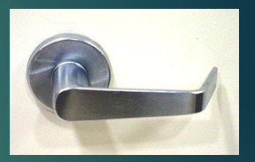
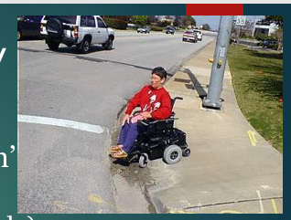
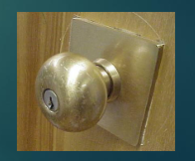

Universal Usability
Interface should handle diversity of users: The interface should be easy to use for different types of people.
- Backgrounds: People may have different educational or social backgrounds.
- Abilities: People may have different physical or mental abilities.
- Motivation: People may use the system for different reasons or goals.
- Personalities: People have different ways of thinking and behaving.
- Cultures: People may have different languages, traditions, and cultural habits.
- Technical capacity: People have different levels of computer and technology skills.

Physical Variation
Field of anthropometry: The study of human body measurements.
- Basic data about human dimensions: It measures things like height, weight, body size, etc.
- There is no “average” user: People have different body sizes and shapes.
- 5–95% measurements: Designers consider a wide range of people based on weight, height, gender, culture, etc.
- Large variance reminds us there is great “variety”: People can be very different from each other, so products should consider these differences.
Devices affected: Keyboards, screens, chairs, desks, car seats, etc.
- Keyboards: Most keyboards are the same size, even though people's hands are different.
- Screen brightness: People have different preferences and needs, so screen brightness can be adjusted.
- Chair height, back height, display angle: These should be adjustable to suit different users.
Physical Variation
What it tells: People have different physical sizes and shapes, so products should be designed to suit different users not the average users.
Example: Chair: People have different heights. An adjustable chair height allows different users to sit comfortably.
Goals for Requirement Analysis
Goal: Allow people to move easily between floors in a building.

Key Design Principles & Questions
1. Ascertain users' needs ("Who are the users?")
- Understand who will use the building and what they need.
- Example: Elevators for wheelchair users or heavy loads, and stairs for exercise or emergencies.
2. Ensure proper reliability ("How often do they move?")
- Understand how often people move between floors and make sure the system works properly.
- Example: Escalators can handle many people continuously, while elevators take people from one floor to another.
3. Promote standardization, integration, consistency, and portability ("What approaches are users familiar with?")
- User designs that people already know and understand.
- Example: People already know how stairs, escalators, and elevators work, so familiar designs make them easier to use.
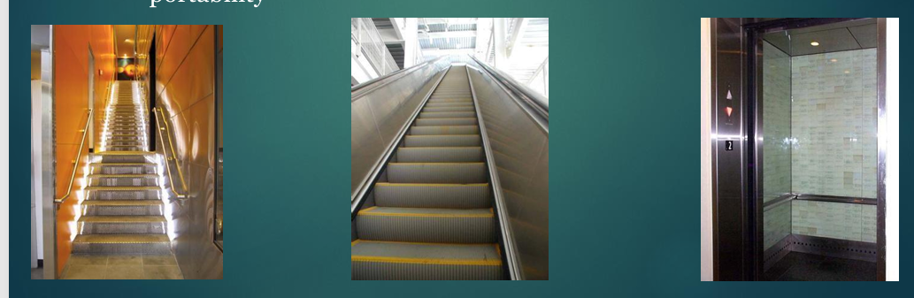
Goals for Requirement Analysis
Ascertain User’s Needs: Find out what users need from the system.
- Develop use cases: Describe how users will use the system.
- Actors (who): Who will use the system?
- Goals (what): What does the user want to do?
- Scope (for which situations): In which situations will the system be used?
- Environment (where): Where will the system be used?
- Minimal Guarantee (minimum to deliver): What is the minimum the system must provide?
- Satisfaction (when are you done): When will the user consider the task completed?
- Equipment (with what): What equipment or devices will be used?
Ensure Reliability
- Actions must function as specified: Every action should work as it is supposed to.
- Database data displayed must reflect the actual database: The information shown should match the real data in the database.
- Appease the user's sense of mistrust: Make the system reliable so users can trust it.
- The system should be available as often as possible: The system should work whenever users need it.
- The system must not introduce errors: The system should not create or add incorrect information.
- Ensure privacy and data security: Protect users' data from unauthorized access, deletion, or harmful changes.
Promote standardization, integration, consistency, and portability: Make the system easy to use and work well with other systems.
- Standardization: Use common features that users already know across different platforms.
  - Examples: Apple, Web, Windows, Smartphones, and common file formats.
- Integration: Make different applications work together.
- Consistency: Keep the same actions, terms, units, layout, colors, and text style throughout an application.
- Portability: Allow data and interfaces to be moved or used on different systems or platforms.
Usability Measures
Meaning: Usability measures tell us how good and easy an interface is to use.
ISO 9241:
- Effectiveness: Can the user complete the task correctly?
- Efficiency: How quickly and easily can the user complete the task?
- Satisfaction: Is the user happy with the interface?
Shneiderman:
- Time to learn: How long does it take to learn the system?
- Speed of performance: How quickly can the user complete tasks?
- Rate of errors: How many mistakes does the user make?
- Retention over time: Can the user remember how to use it after some time?
- Subjective satisfaction: How satisfied does the user feel while using it?
Usability Motivations
Different systems have different usability needs depending on their purpose.
1. Life-Critical Systems
Applications: Air traffic control, nuclear reactors, military, emergency services.
Requirements:
- High reliability
- Must work effectively even under stress
Less important:
- Cost
- Long training
- User satisfaction
- Remembering the system over time
2. Industrial and Commercial Use
Applications: Banking, insurance, inventory, reservations.
Requirements:
- High speed
- Short training
- Easy to learn and use
- Multiple languages
- Support different cultures
- Work on different platforms
3. Office, Home, and Entertainment
Applications: Email, ATMs, games, education, search engines, mobile phones.
Requirements:
- Easy to learn and use
- Easy to remember
- Low error rate
- User satisfaction
Difficulties:
- Cost
- Size of the device
4. Exploratory, Creative, Collaborative
Applications: Web browsing, search engines, simulations, scientific visualization, CAD, computer graphics, music composition, photo editing.
Requirements:
- Easy to explore and try new things
- Easy to create and edit
- Easy to work together with others
Example: A photo editing application should make it easy for users to edit, arrange, and share photos.
5. Socio-Technical Systems
Applications: Healthcare, voting, police systems.
Requirements:
- Trust: Users should trust the system.
- Security: User data should be protected.
- Accuracy: The system should give correct results.
- Veracity: Information should be true and reliable.
- Error handling: The system should handle mistakes properly.
- User tech-savviness: The system should be easy to use even for people with different levels of technical knowledge.
Goal: Remove the feeling of using a complicated computer system and make the experience simple and natural.
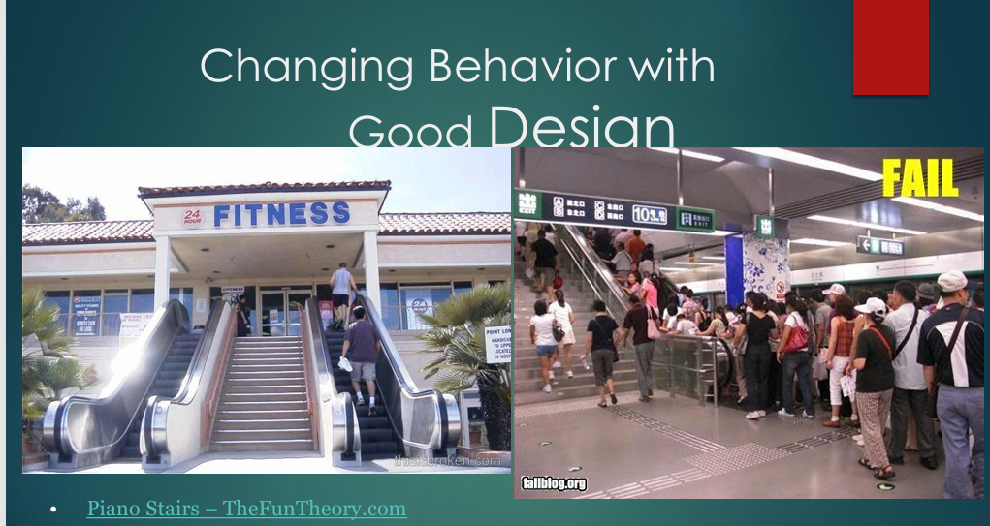
1. Left Image (Design Fail)
- Context: A 24-Hour Fitness gym has escalators on both sides of a staircase.
- Problem: People use the escalators instead of walking up the stairs.
- Core Issue: People choose the easier option. The design makes it convenient to use the escalator, even though they came to the gym to exercise.
2. Right Image (Design Fail / Congestion)
- The Context: A busy transit station where commuters crowd onto a narrow escalator while the adjacent stairs remain largely empty.
- The Problem: Poor layout and bad incentive alignment cause bottlenecking, inefficiency, and frustration.
How Good Design Changes Behavior
Good design can encourage people to choose better or more useful actions.
Example: Gym
- Bad design: Escalators are easier to use, so people take them instead of stairs.
- Good design: Make the stairs more visible and attractive, while placing the escalator less prominently.
- Result: More people may choose the stairs and exercise.
Main idea: Good design can guide people toward a desired behavior without forcing them.

Lecture 2
The Psychology of Usable Things
“When simple things need pictures, labels, or instructions, the design has failed.” [Don Norman, The Psychology of Everyday Things, 1988 [Norman 1988, page 9]
This chapter is based around Don Norman’s classic book, The Psychology of Everyday Things [Norman 1988].
The Psychopathology of Everyday Things
This means problems that happen when everyday products are poorly designed.
The design may look simple but if the user cannot understand how to use it, the design has failed.
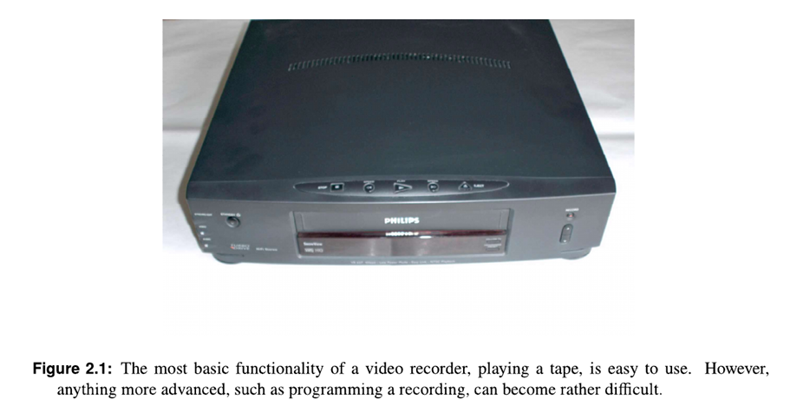
Example
Imagine a video recorder:
- Playing a tape: Put the tape in and press Play: very easy.
- Programming a recording: You want the recorder to automatically record a TV program at 8:00 PM tomorrow: you may have to set the date, time, channel, recording duration, etc. This can be confusing.
Example: Opening a Milk Carton
- Glass milk bottles were being replaced by new milk cartons.
- On live TV, a manager wanted to demonstrate how easy the new carton was to open.
- However, he had difficulty opening it, and things went wrong.
- This became a famous example of poor design and usability problems.
- The important point is: If a simple everyday task is difficult for the user, the problem may be the design, not the user.
Early Tractors
This is another example of poor design.
- Early tractors had a high center of gravity and a narrow wheelbase.
- When they were used on rough or hilly land, they could tip over easily.
- At first, when an accident happened, people called it “driver error” — meaning they blamed the driver.
- But the problem was actually more likely a “design error” because the tractor itself was not designed safely for rough, hilly surfaces.
- Modern tractors have a low center of gravity and wide wheelbase, making them more stable.

The Frustrations of Everyday Life
This means that everyday products may have many functions, but users may not know how to use all of them.
For example:
- Digital watch: You may know how to check the time, but not know how to use alarms, stopwatch, timer, etc.
- Mobile phone: You may use calls, messages, and camera, but not know every feature.
- Washing machine: You may know how to start a normal wash, but some other settings may be confusing.
- Video recorder: You may know how to play a video, but programming it to record at a specific time may be difficult.
Zeiss Slide Projector
During lectures, the presenter sometimes needs to:
- Move forward to the next slide.
- Move backward to the previous slide.
The projector uses one button for both functions:
- Short press: next slide
- Long press: previous slide
This is elegant design because one button performs two functions.
However, there is a problem:
A first-time user does not automatically know that a short press means forward and a long press means backward.

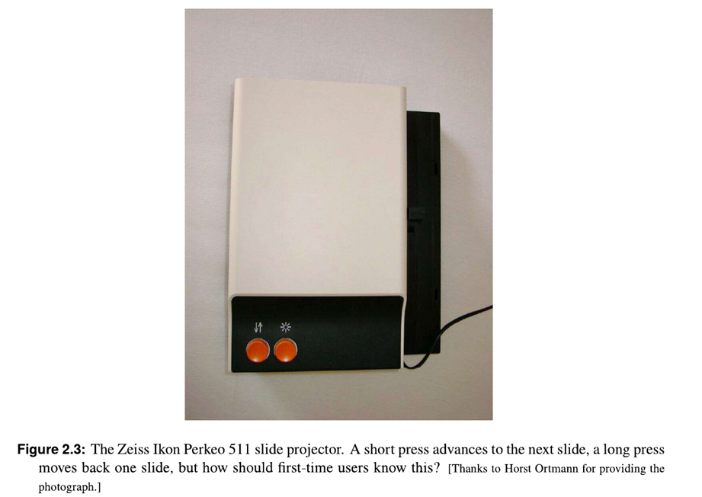
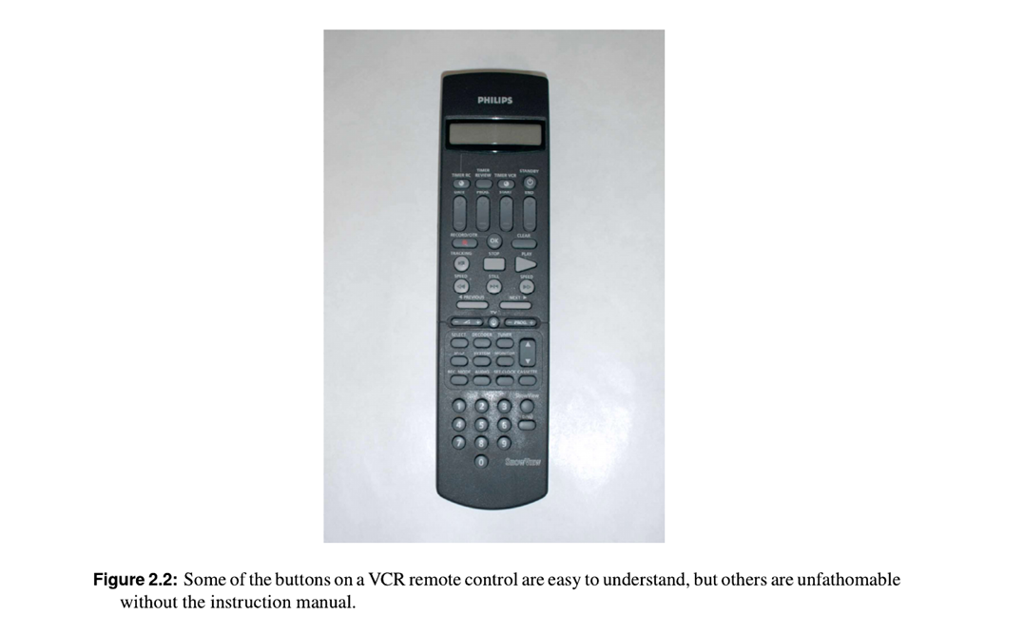

The Psychology of Everyday Things
Perceived and Real Affordances
Affordances are the possible actions a user can perform on an object.
- Perceived Affordances: The actions that the user thinks are possible.
- Real Affordances: The actions that are actually possible.
Example:
A button looks like it can be pressed.
- Perceived affordance: You think you can press the button.
- Real affordance: The button can actually be pressed.
Real World Affordances
For physical objects, there can be both real affordances and perceived affordances. They are not always the same.
Appearance indicates how to use something:
- A chair affords (suggests) sitting.
- Knobs afford turning.
- Slots afford inserting things.
- A button affords pushing.
When perceived affordances are used well, the user can understand what to do just by looking at the object.
Example: Rubbish bins
The shape of the slot tells you what type of rubbish should be put inside.
For example:
- Round opening: suggests cans
- Long/narrow slot: suggests paper
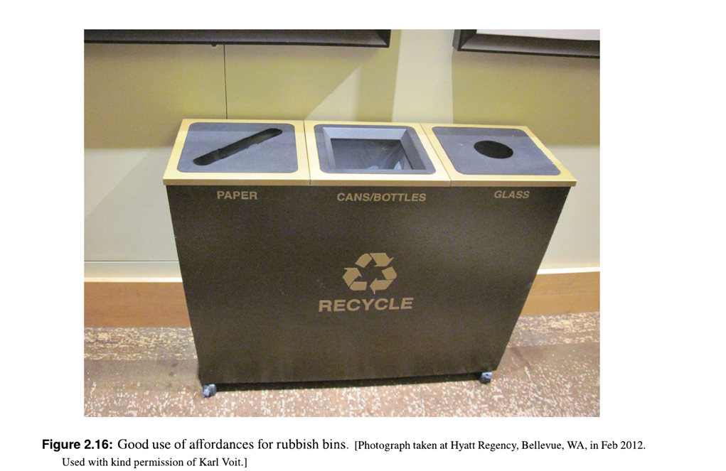
Norman Doors
- Norman doors are badly designed doors named after Don Norman.
- A Norman door is a door where the design makes you think you should do one thing, but you actually need to do the opposite.
- In other words, the door's appearance gives the wrong instruction.
Example
Light switch: You expect the switch to turn the light on when pushed up, but it works the opposite way.
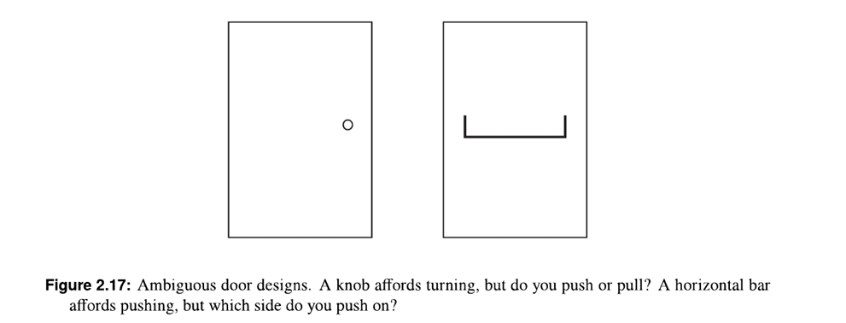
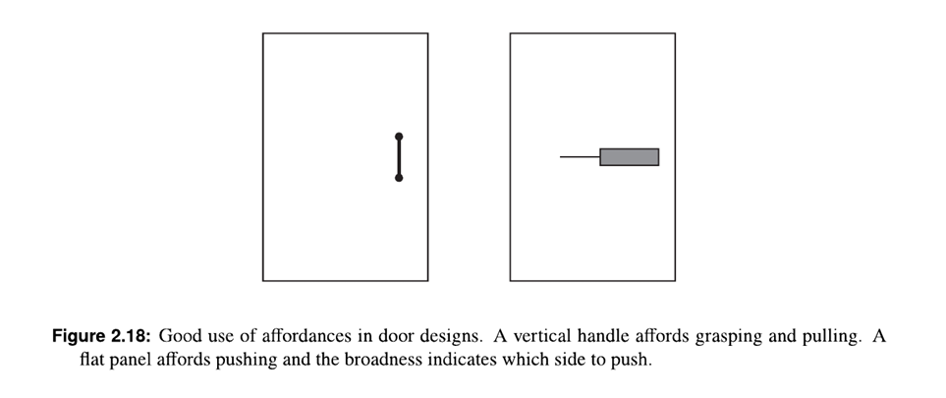
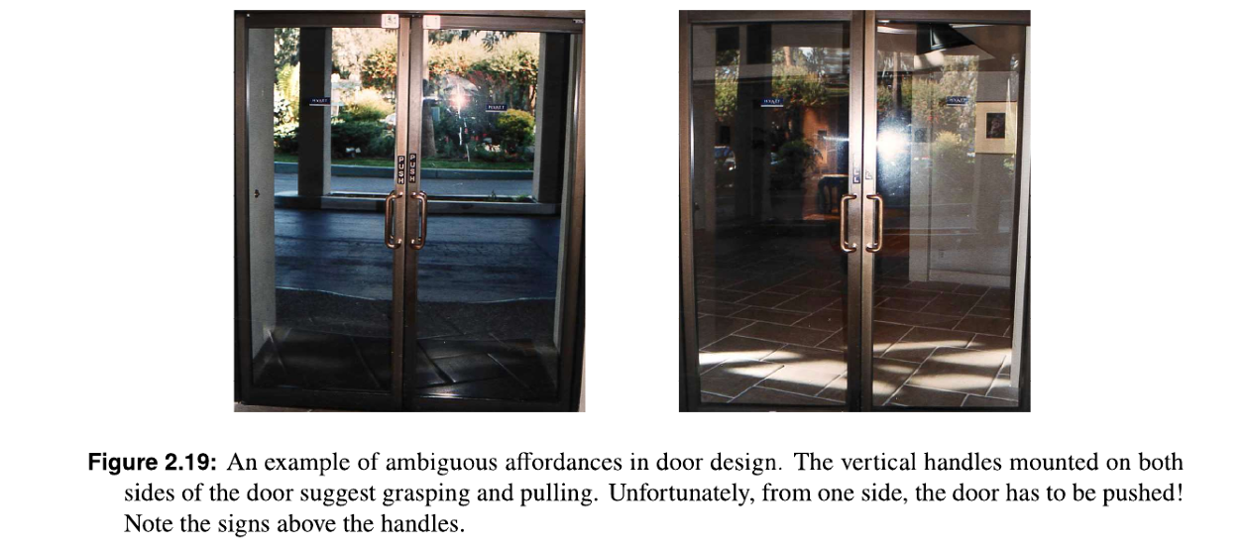

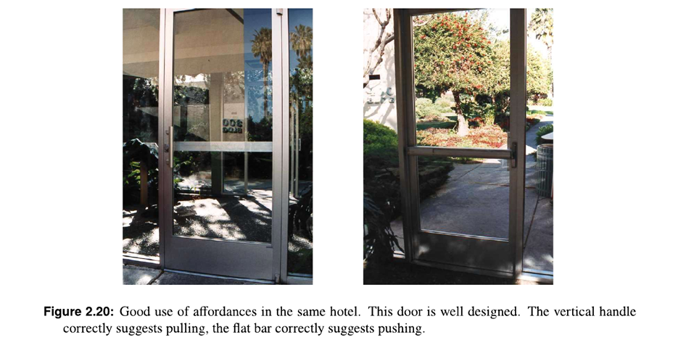
Labels
Norman means that simple objects should be easy to use without needing instructions.
“When simple things need pictures, labels, or instructions, the design has failed!”
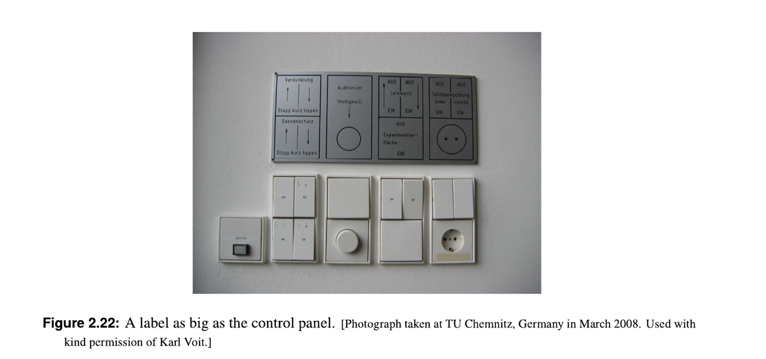

GUI Affordances
For screen-based interfaces (GUIs), the computer hardware already provides physical affordances.
Simple meaning
A GUI (Graphical User Interface) uses things on the screen that suggest what you can do.
For example:
- Button: looks like it can be clicked.
- Scrollbar: suggests you can move it up or down.
- Search box: suggests you can type something.
- Checkbox: suggests you can click to select/deselect.
Mappings
Mappings are the relationships between controls and their effects on a system.
Natural mapping means the control works in a way that is easy and natural to understand, often based on physical actions or common standards.
Examples
Steering wheel: Turn the wheel clockwise car turns right.
- Which control affects steering? Steering wheel
- Which direction should you turn it? Clockwise for right
Louder sound: means a greater amount or level.

Mapping of Cooker Controls
The question is:
How should the controls be arranged so that users easily know which control operates which hot plate?
There are three types:
- Arbitrary Mapping: Controls are arranged in a way that has no clear relationship with the hot plates. The user has to remember which control operates which plate.
- Paired Mapping: Each control is placed near the hot plate it controls. This makes the relationship easier to understand.
- Full Natural Mapping: The controls are arranged in the same pattern as the hot plates. For example:
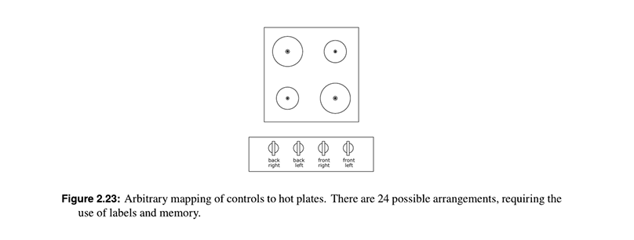
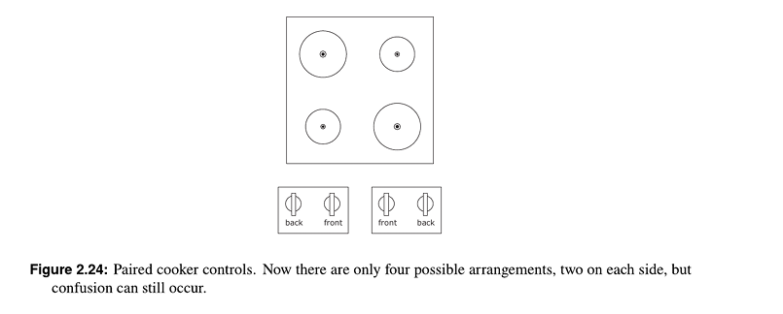
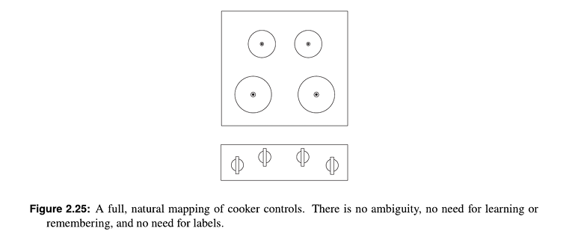
Constraints
The difficulty of dealing with a novel situation is directly related to the number of possibilities.
There are four types of constraints:
- Physical constraints: Physical features limit what you can do.
Example: A peg can only fit into a suitable hole.
- Semantic constraints: Our knowledge of the situation tells us what makes sense.
Example: A car steering wheel is used for steering, not for changing the radio station.
- Cultural constraints: Commonly accepted rules or conventions guide our actions.
Example: A red traffic light means stop.
- Logical constraints: Logical relationships tell us what should go where or what should happen.
Example: If cooker controls are arranged in the same pattern as the hot plates, you can logically identify which control operates which plate.

Constraints in Lego Motorbike
Motorbike toy with 12 parts. Constraints make its construction simple, even for adults!
- Physical: Front wheel only fits in one place.
- Semantic: The rider sits on the seat facing forward.
- Cultural: Red is a rear light, yellow a front light.
- Logical: Two blue lights, two white pieces, probably go together.
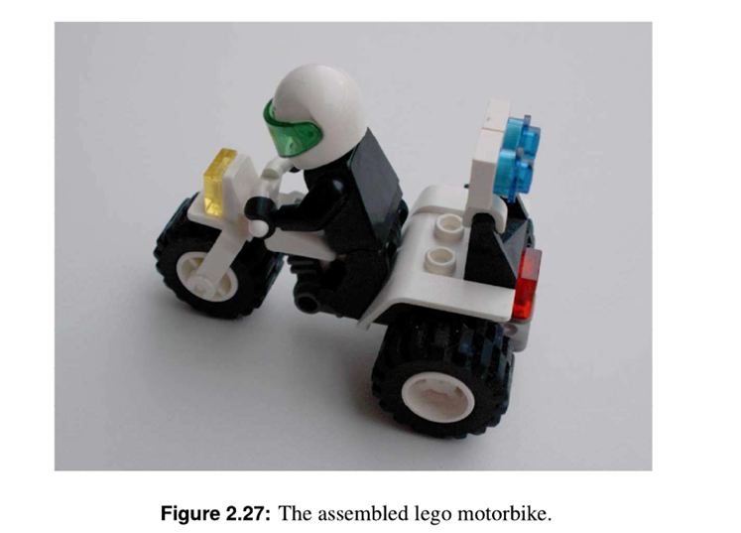
Conventions
Conventions are cultural rules or commonly accepted ways of doing things.
- They are cultural constraints.
- At first, they may be arbitrary (no reason), meaning there is no natural reason for them.
- Over time, people become familiar with them and accept them as normal.
- Conventions can be different in different cultures or countries.
Examples
1. Light switches
- America: Down = OFF
- Britain: Down = ON
2. Water taps
- America: Anti-clockwise = ON
- Britain: Anti-clockwise = OFF
3. Color red
The meaning of red can differ between cultures:
- America: Red = danger
- Egypt: Red = death
- India: Red = life
- China: Red = happiness
The Principle of Causality
Causality means the relationship between a cause and its effect.
In simple words:
- Cause: Something you do
- Effect: What happens because of it
Example:
You press the light switch → the light turns on.
Apparent Causality
Apparent causality means that something happens immediately after your action, so you think your action caused it.
Example:
You touch a computer → the computer suddenly crashes.
You may think:
“I touched it, so I caused the crash.”
But the crash may have happened by coincidence.
Two Types of False Causality
1. Coincidental Effects
Something happens by coincidence, but you think your action caused it.
Example:
- You touch a computer terminal.
- Immediately afterward, it stops working.
- You may believe touching it caused the problem, even though it was just coincidence.
Another example:
- You open an unfamiliar application.
- The computer crashes.
- You may think opening the application caused the crash, although it may have been unrelated.
2. Invisible Effects
You perform an action, but nothing appears to happen.
Because you cannot see a result, you may think your action did not work and repeat it.

Example:
- You click the Stop button.
- The system is unresponsive.
- Nothing happens immediately.
- You click Stop again and again.
Why is Feedback Needed?
Feedback tells the user that their action has been received or performed.
Example:
You click Stop → the button changes appearance or a message says “Stopping...”
Now you know the system received your command, so you do not keep clicking.
The Structure of Human Memory
Short-Term Memory (STM)
Short-term memory is the memory we use for information we need right now. It is also called working or temporary memory.
- Information stays in STM automatically and can be remembered without much effort.
- But STM can hold only a small amount of information: about 7 ± 2 items.
- STM is very fragile. A small distraction can make you forget the information.
Example:
You look up a 7-digit phone number and remember it long enough to dial it. But if someone starts talking to you or you get distracted, you may forget the number.
Long-Term Memory (LTM)
Long-term memory is the memory we use for information from the past.
- It takes time and effort to store information in LTM.
- It also takes time and effort to recall information from LTM.
- LTM has a very large capacity and can store around 100 million items according to the notes.
Example:
You learned your name, how to ride a bicycle, or multiplication tables a long time ago and can remember them later.
Knowledge in the Head and in the World
Not all the knowledge needed to perform an action has to be stored in our memory. Knowledge can be distributed between our mind and the environment.
- Partly in the head: Knowledge stored in our memory.
- Partly in the world: Information available in the environment, such as labels, signs, instructions, or displays.
- Partly in the constraints of the world: The physical or logical limitations of an object that guide us on what we can or cannot do.
Example:
When using a door, you don't need to remember how to open it. The handle and shape of the door give you clues about what to do, while the physical design limits how you can operate it.

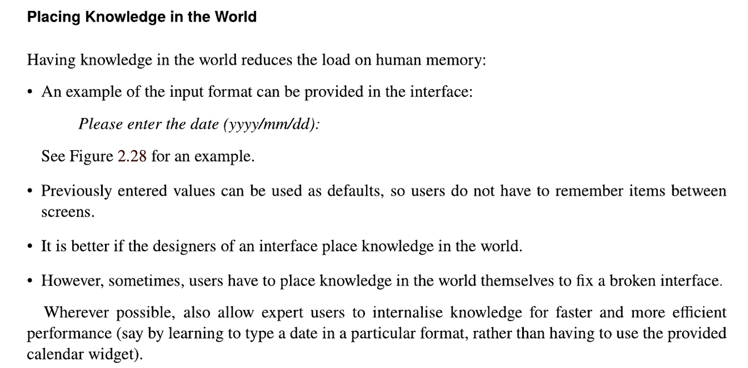
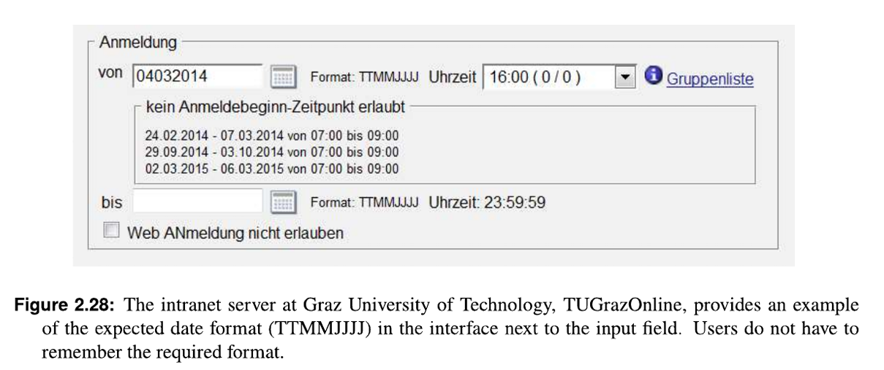
Superimposing Knowledge onto Control Panels
Superimposing knowledge means adding extra information to an object or interface so it becomes easier to understand and use.
Nuclear power plant workers added extra information to their control panels to make them easier and safer to use.
They did this in different ways:
- Sticky labels: Put labels on controls to remember what each control does.
- Tape: Used tape to group controls that are related to each other.
- Beer-tap handles: Put different handles on similar-looking knobs so workers could easily tell them apart.
Example:
If two knobs look almost the same, adding different handles helps the worker know which knob to use.
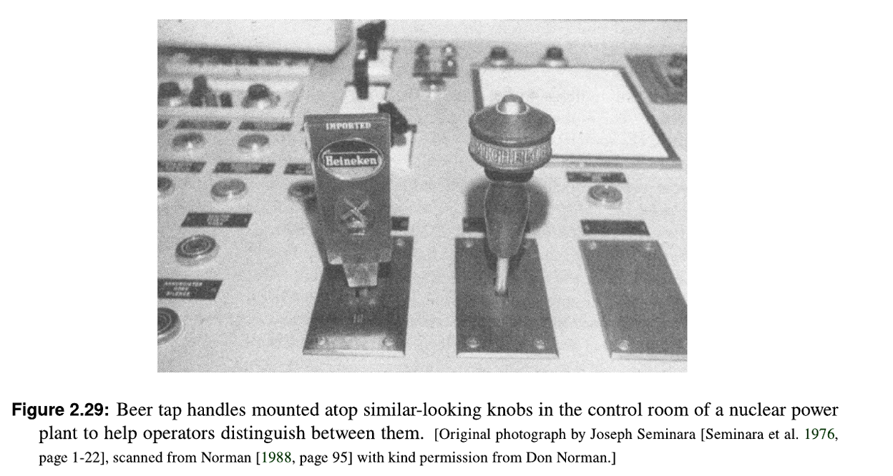
Shape Coding for Aircraft Control Knobs
This example shows how changing the shape of controls can prevent mistakes.
- During World War 2, some pilots accidentally retracted the landing gear instead of the flaps after landing.
- This happened because the landing gear and flap controls looked the same and were very close together.
- The C-47 aircraft did not have this problem because its controls were different and easier to distinguish.
- Lt. Alphonse Chapanis investigated the problem and realized that these were not simply pilot errors. The design of the controls was also causing the mistakes.
- As a quick solution:
  - A small rubber wheel was added to the landing gear control.
  - A wedge-shaped handle was added to the flap control.
- Now pilots could easily feel and recognize which control they were using.
- After the war, these different shapes became standard.

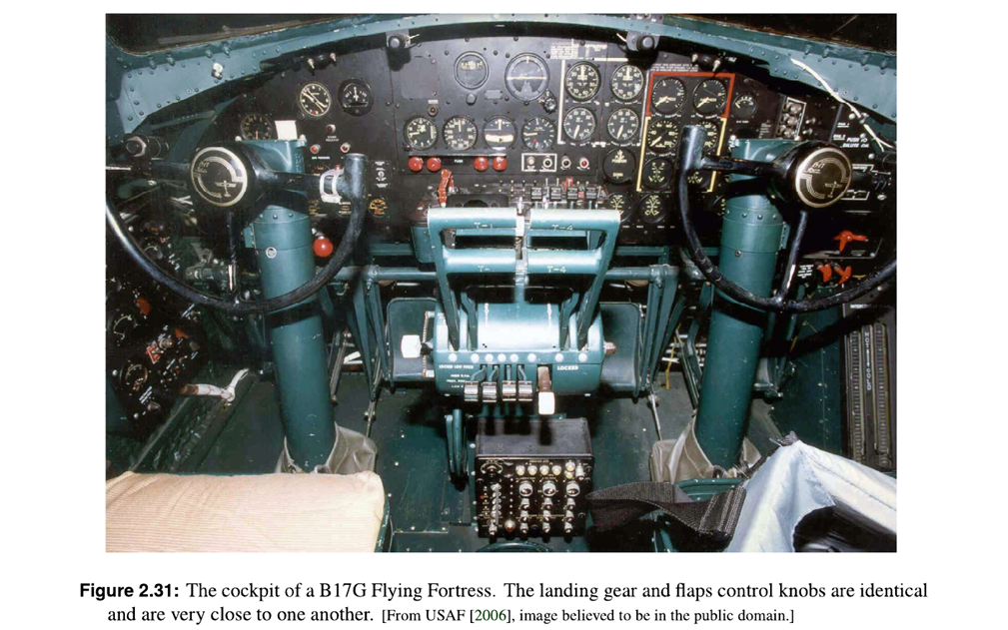
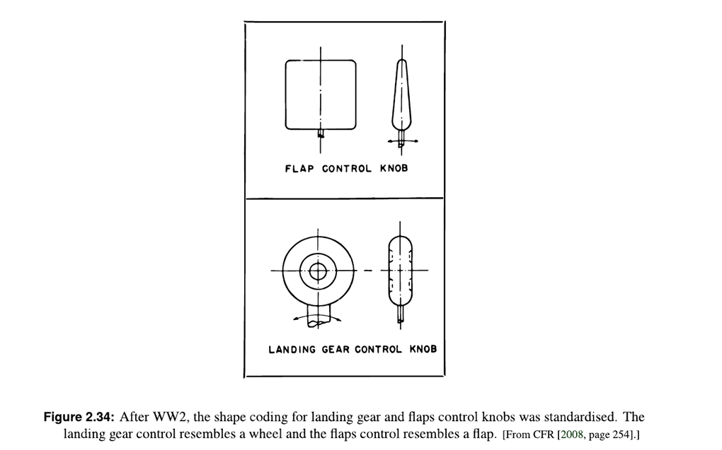
To Er is Human
- People make errors routinely; you must design for error.
- Assume that any error, that can be made, will be made!
Explorable Systems
You can never predict all the ways users will try to use an interface.
- Users may use a system in unexpected ways.
- Therefore, designers should make systems easy to explore and try.
- If a user makes a mistake, the action should be easy to undo or reverse.
Example:
If a user accidentally deletes something, there should be an Undo option to bring it back.
Categories of Error
There are two basic types of errors:
1. Slips:
A slip happens when you know the correct goal and action, but accidentally do the wrong action.
Example:
You want to click “Save”, but accidentally click “Delete” because you clicked the wrong button.
2. Mistakes:
A mistake happens when you choose the wrong goal or plan because your thinking or understanding is incorrect.
Example:
You want to save a file, but you think “Delete” will save it, so you deliberately click Delete.

Conceptual Model
A conceptual model is a person’s mental idea of how something works.
A user builds this idea based on different things:
- Familiarity: Previous experience with similar devices.
Example: You know a phone’s trash icon means delete because you have seen it before.
- Affordances: What an object appears to allow you to do.
Example: A button looks clickable, so you expect to press it.
- Mapping: How controls are related to their results.
Example: Turning the right knob makes the right speaker louder.
- Constraints: Things that limit what you can do.
Example: A USB can only fit correctly in one orientation.
- Causality: Understanding that one action causes another result.
Example: Pressing the power button turns the computer on.
- Instructions: Information that tells the user how to use something.
Example: Instructions say “Press Start to begin.”
- Interaction: Learning through actually using the device.
Example: After using an ATM several times, you learn how its buttons and screens work.
Important: A conceptual model can be wrong if these factors give the user misleading information.

