Statistics and Probability
Chapter 1
Exercise 1.1 Statistics Basics
Statistics
Statistics is a science of data in which learn methods or procedure used to collect, present, summarize, analyze and predict that data.
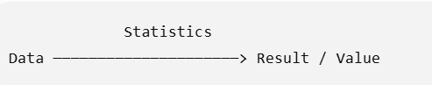
Population Vs Sample
1. Population
In statistics, population means the entire group of people, objects, or things that we want to study.
Example of Population
- Suppose we want to study the marks of BSE Fall 2023 students registered in MTH262.
- Population: All BSE Fall 2023 students registered in MTH262.
2. Sample
A sample means a small group of people or objects selected from a larger population for a study.
Example:
If there are 200 BSE Fall 2023 students registered in MTH262, and we collect information from 70 students, then:
- Population = 200 students
- Sample = 70 students
3. What is Sampling?
Sampling is the process of selecting a smaller group (sample) from a larger group (population) to collect data and study it.
Example:
If a university has 5,000 students, we select 200 students to conduct a survey.
- 5,000 students = Population
- 200 students = Sample
- Selecting the 200 students = Sampling
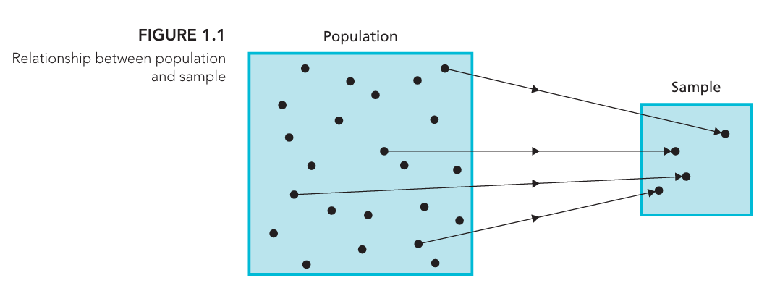
Types of Statistics
1. Descriptive Statistics
Descriptive statistics is the branch of statistics that collects, organizes, summarizes, and presents data so that it is easy to understand.
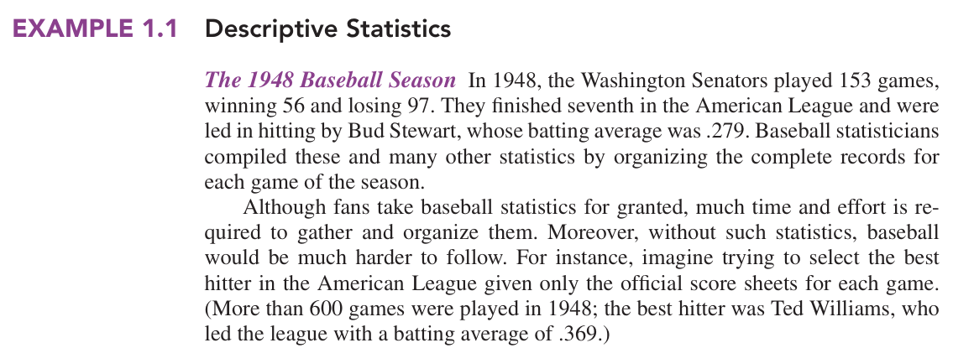
Example 1.1 (Easy Explanation of Above Example)
In 1948, the Washington Senators played 153 baseball games.
The collected data was:
- Games played: 153
- Games won: 56
- Games lost: 97
- League position: 7th
- Best hitter for the Senators: Bud Stewart
- His batting average: .279
Baseball statisticians collected and organized the records of all the games and summarized them using numbers such as wins, losses, and batting averages.
This is Descriptive Statistics because they are describing and summarizing the data that was collected.
Why is it useful?
Imagine having the score sheet for more than 600 games and trying to find the best hitter manually. It would be difficult.
Statistics makes it easier by summarizing the information. For example:
Ted Williams had a batting average of .369, which was the highest in the American League in 1948.
2. Inferential Statistics
Inferential statistics uses data from a sample to make conclusions or predictions about a larger population.
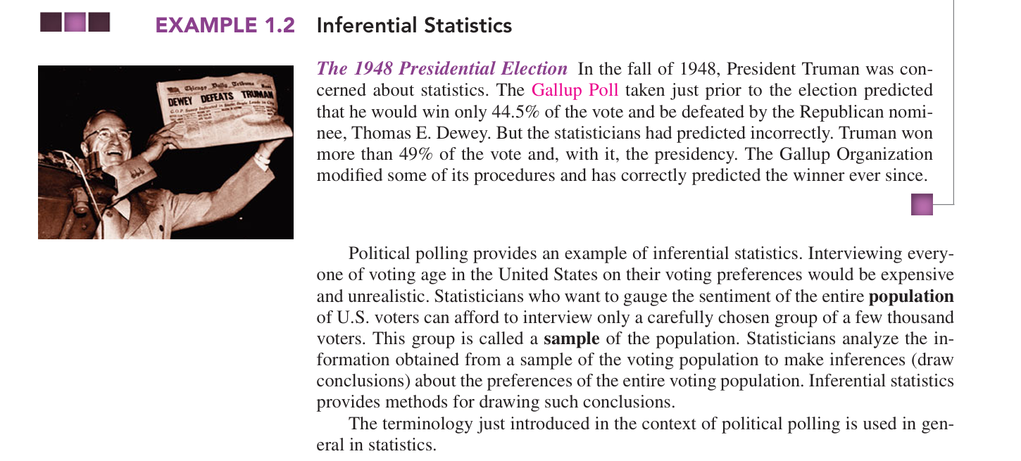
Example: 1948 Presidential Election (Easy Explanation of Above Example)
In 1948, Harry Truman was running for president against Thomas E. Dewey.
The Gallup Poll wanted to predict who would win. But they could not ask every voter in the USA, because there were too many people.
So, they:
- Selected a small group of voters → Sample
- Asked them who they planned to vote for
- Analyzed their answers
- Used the sample results to make a conclusion about ALL voters → Population
The poll predicted that Truman would get only 44.5% of the vote and would lose.
But the actual result was that Truman won more than 49% and became president.
Why is this Inferential Statistics?
Because they used information from a small sample to make a conclusion about the whole population.
Sample → Analyze data → Make conclusion about Population
More on Descriptive Statistics
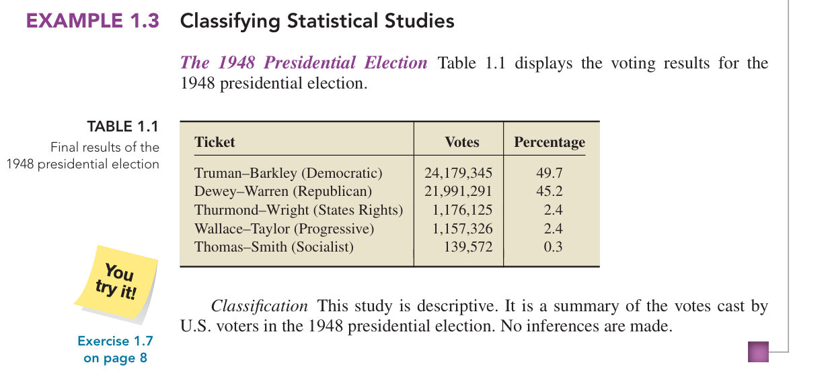

More on Inferential Statistics
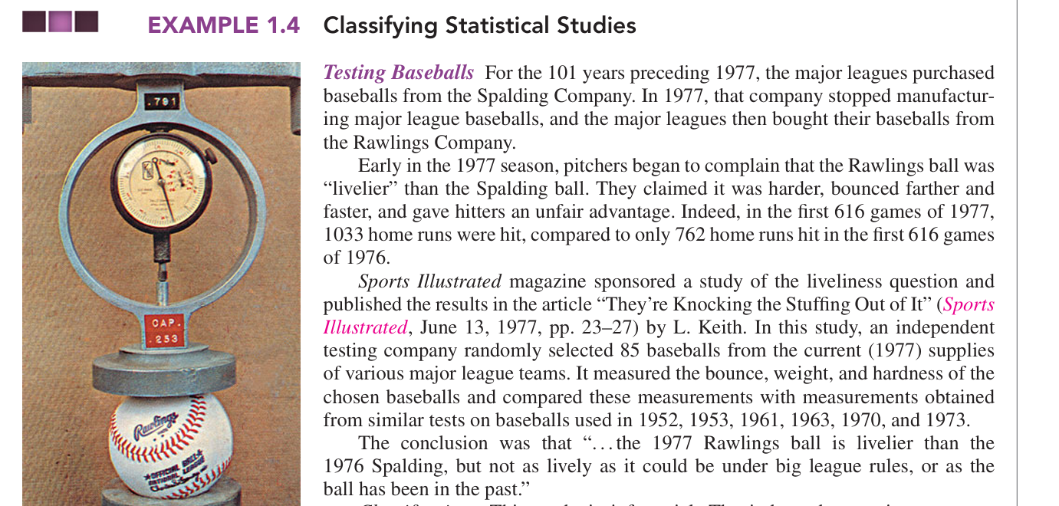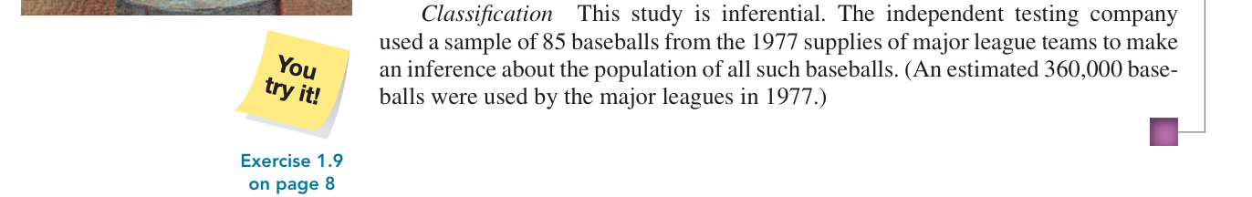
Shorter Version of Above Case Study
In 1977, pitchers complained that the new Rawlings baseball was “livelier” than the previous Spalding baseball. To investigate, an independent testing company randomly selected 85 baseballs from the 1977 supplies of major league teams and measured their bounce, weight, and hardness. Since it was not practical to test all 360,000 baseballs, the researchers used the sample of 85 to make a conclusion about the larger population. Therefore, this study is Inferential Statistics.
Types of statistical studies
1. Observational Study:
Researchers only observe and collect existing data. They do not change anything or give treatments. It can show an association (relationship) but usually cannot prove causation (cause and effect).
Example: Researchers compare men who already had a vasectomy with men who did not and observe their prostate cancer rates.
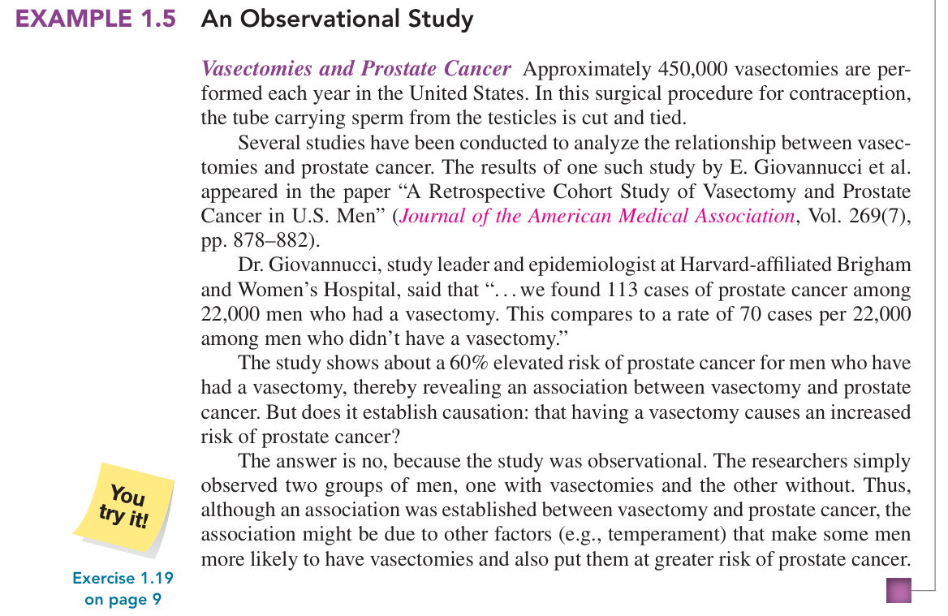
Shorter and Easier Explanation of Above Case Study
This study examined whether there was a relationship between vasectomy and prostate cancer. Researchers observed two groups of men: about 22,000 men who had a vasectomy and men who did not. They found 113 cases of prostate cancer among men with vasectomies compared with 70 cases per 22,000 among those without. However, the researchers did not assign or control who received a vasectomy; they simply observed existing groups. Therefore, it is an Observational Study, and it can show an association, but it cannot prove that vasectomy causes prostate cancer.

Vasectomy and Prostate
Vasectomy is a surgical procedure for male birth control. It involves cutting or blocking the tubes that carry sperm, so sperm cannot enter the semen.
Prostate is a small gland in the male reproductive system, located below the bladder. It helps produce the fluid that carries sperm.
2. Designed Experiment:
Researchers actively give treatments or make changes and then observe the results. This can help determine causation.
Example: Researchers give one group of patients a new medicine and another group a placebo, then compare their results.
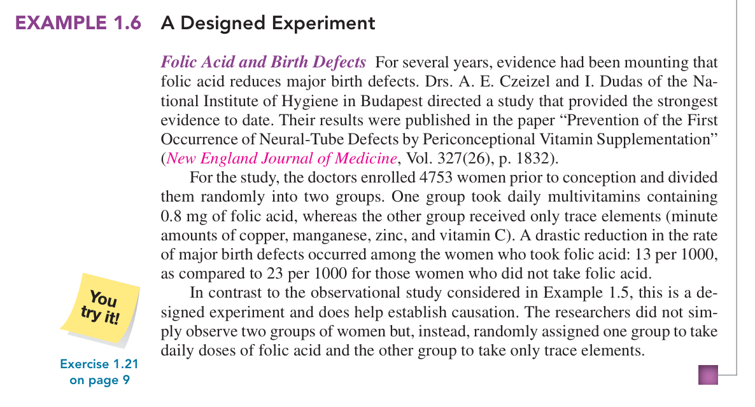
Shorter and Easier Explanation of Above Case Study
In this study, 4,753 women were randomly divided into two groups. One group took folic acid, while the other received only trace elements. The researchers then compared birth-defect rates: 13 per 1,000 with folic acid versus 23 per 1,000 without it. Because the researchers gave different treatments and randomly assigned the women, this is a Designed Experiment and provides evidence of causation.
Folic acid
Folic acid is a type of vitamin B (B9) that is important for the body.
In pregnant women, it helps the baby’s brain and spinal cord develop properly and can reduce the risk of certain birth defects.
Exercise Questions
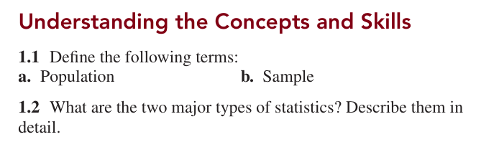
1.4 Explain two ways in which descriptive statistics and inferential statistics are interrelated.
Descriptive and inferential statistics are interrelated in the following two ways:
- Descriptive statistics summarize sample data.
For example, if we collect the marks of 100 students, we can calculate their average marks. This describes the data of those 100 students.
- Inferential statistics use sample data to draw conclusions about a population.
The results from those 100 students can be used to make conclusions or estimates about the marks of all students in the university.
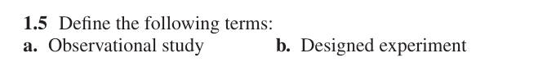
1.6 Fill in the following blank: Observational studies can re veal only association, whereas designed experiments can help establish
Ans: Causation.
Example
Suppose we want to know whether exercise helps improve exam marks.
- Observational study: We observe students and notice that students who exercise more often also tend to get higher marks. This shows an association, but we cannot say exercise is the cause because other factors may be involved.
- Designed experiment: We divide students into groups and give one group a planned exercise program while keeping other conditions similar. If the exercise group performs better, the experiment can provide evidence of causation.
In Exercises 1.7–1.12, classify each of the studies as either descriptive or inferential. Explain your answers.
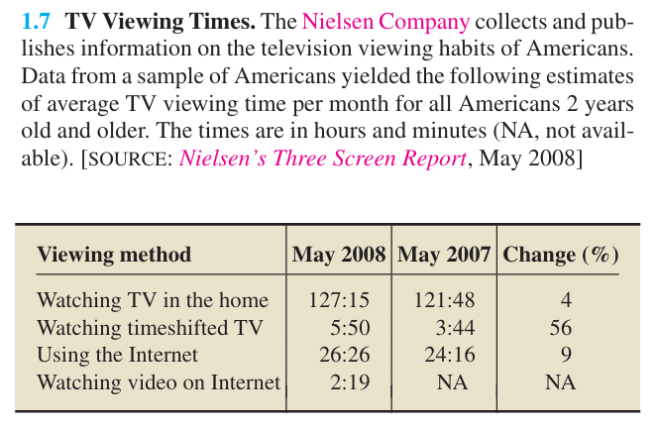
Answer: Inferential statistics.
Why? The Nielsen Company collected data from a sample of Americans and used it to estimate the TV viewing time of all Americans aged 2 and older.

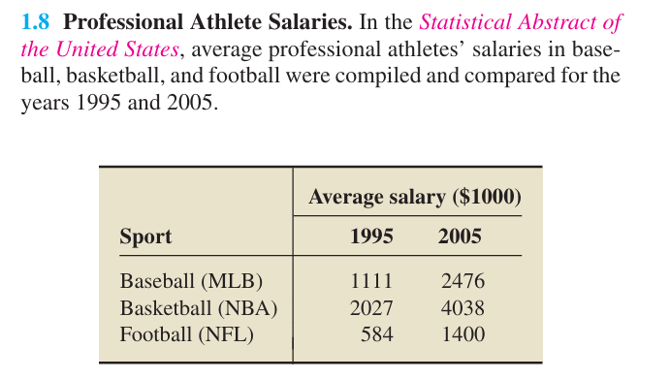
Answer: Descriptive statistics.
Why? The study compares the average salaries of professional athletes in baseball, basketball, and football for 1995 and 2005.
It is only summarizing and comparing the available salary data; it is not using a sample to make conclusions about a larger population.
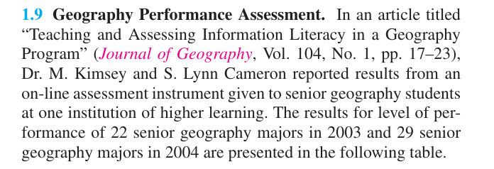
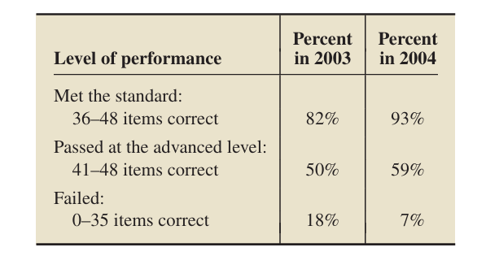
Answer: Descriptive Statistics
Why? The researchers collected and summarized the performance results of 22 students in 2003 and 29 students in 2004 at one institution. They presented the results using percentages.
They are describing the students' performance, not using the sample to make conclusions about a larger population.
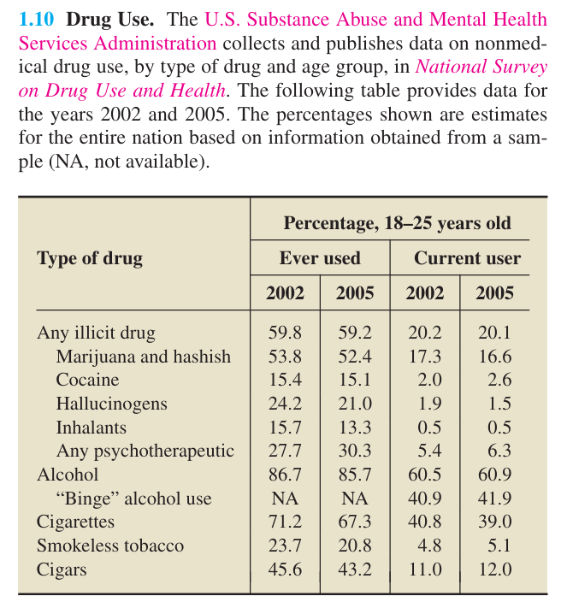
Answer: Inferential Statistics
Why? The data is collected from a sample of people, but the percentages are used to give estimates for the entire nation.
They use sample information to make conclusions about the larger population.
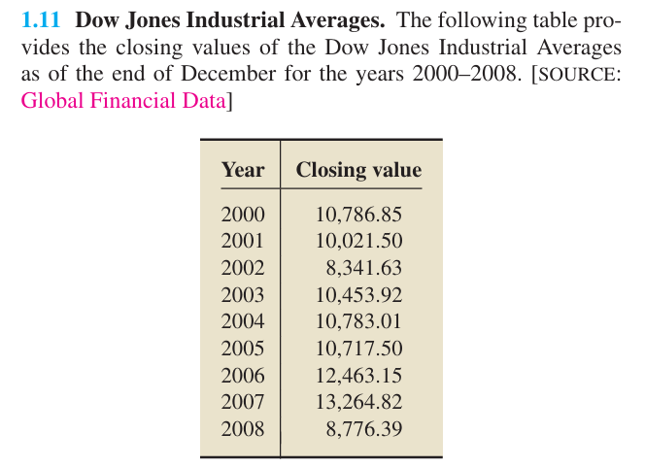
Answer: Descriptive Statistics
Why? The table simply shows the closing values of the Dow Jones Industrial Average from 2000 to 2008. It summarizes the recorded data for those years.
It does not use a sample to make conclusions about a larger population.
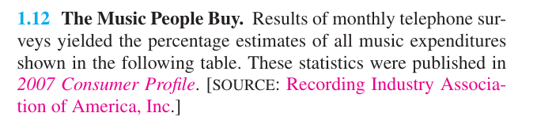
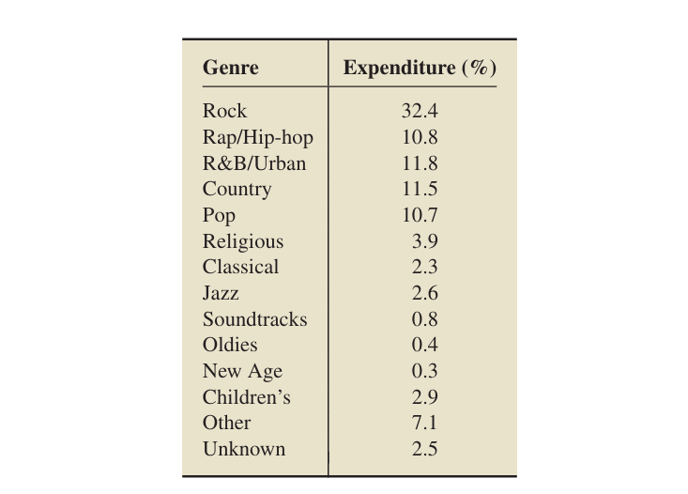
Answer: Inferential Statistics
Why? The percentages are based on monthly telephone surveys, which use a sample of people to estimate music expenditures for the larger population.
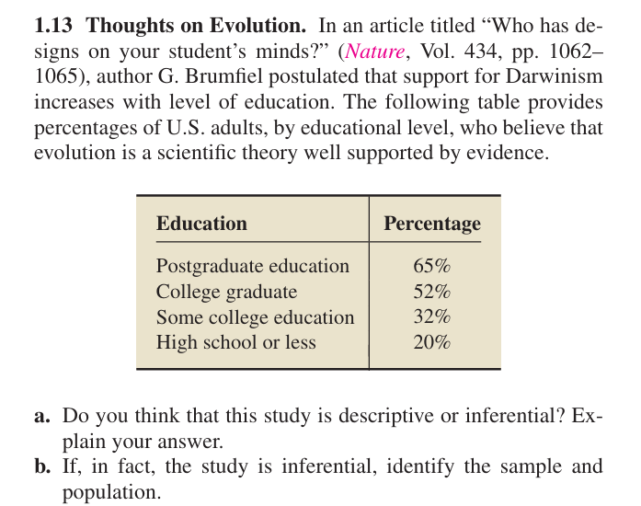
a. Answer: Inferential Statistics
Why?
The study uses data from U.S. adults to make a conclusion about the relationship between education level and support for evolution among the larger population of U.S. adults.
b. Sample and Population
- Sample: The U.S. adults who were included in the study/survey.
- Population: All U.S. adults.

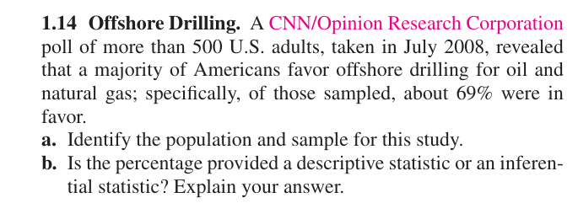
a. Population and Sample
- Population: All U.S. adults.
- Sample: The more than 500 U.S. adults who participated in the poll.
b. Answer: Inferential Statistics
Why?
The 69% was calculated from the sample of more than 500 adults and is used to estimate the opinion of all U.S. adults.

Exercise 1.2 Simple Random Sampling
Sampling Unit?
A sampling unit is the individual person, object, or item that can be selected from a population for a sample.
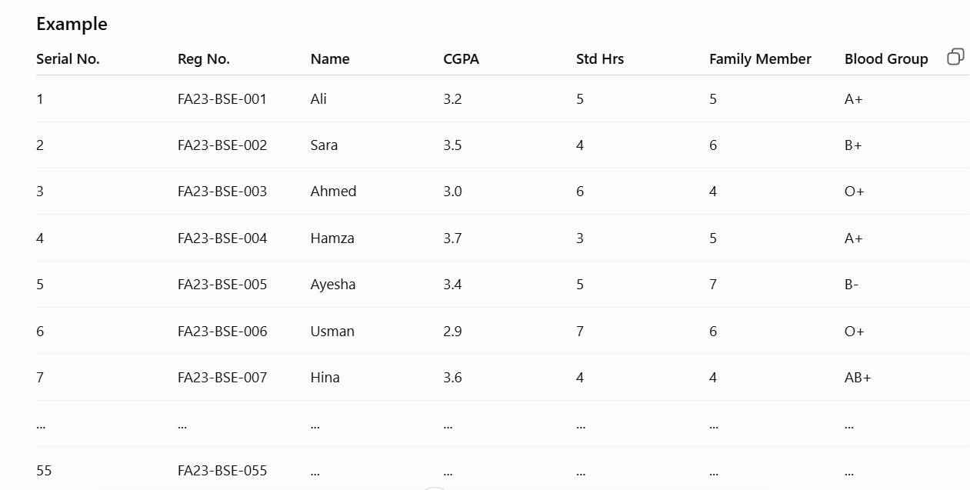
Population: All 55 students of FA23-BSE
Sample: The 7 students you selected
Sampling unit: One student
Sampling: The process of selecting those 7 students from the 55 students
Sampling Frame?
A sampling frame is a complete list of all the sampling units in a population from which we select our sample.
Sampling frame: The table/list containing all 55 students with their registration numbers, names, etc.

Census?
A census is a study in which we collect data from every member of the population.
Using your FA23-BSE example:
- Population: 55 students
- Census: Collect information from all 55 students
- Sample: Collect information from only 7 students
Sample Survey?
A sample survey is a survey in which we collect data from only a sample of the population, instead of everyone.
Using your FA23-BSE example:
- Population: 55 students
- Sample: 7 selected students
- Sample survey: Collect information from those 7 students.
Parameter vs Statistic
1. Parameter
A parameter is a value calculated from complete population data. It is fixed because the whole population is studied.
Example: If we collect the FSC marks of all 55 students and find that 80% passed, 80% is a parameter.
2. Statistic
A statistic is a value calculated from sample data. It can change from sample to sample because different samples may contain different students.
Example: If we select 7 students from the 55 and calculate their average CGPA, that average is a statistic.
Parameter = Population = Fixed
Statistic = Sample = Can change
Experiment?
An experiment is a study in which we change or control something and observe its effect on another variable.
Example:
Suppose we want to know whether more study hours improve CGPA. We give some students a specific study schedule and then compare their CGPA with other students.
Representative Sample?
A representative sample is a sample that properly reflects the important characteristics of the population.
Example:
Suppose there are 55 students in FA23-BSE, with different CGPAs, study hours, and backgrounds. If we select 7 students in a way that reasonably represents the different types of students in the class, those 7 students form a representative sample.
Homogeneity and Heterogeneity
These terms describe how similar or different the members of a population are.
1. Homogeneity
Homogeneity means the members are similar to each other.
Example:
A class that includes only male students is homogeneous because the students have a similar characteristic.
2. Heterogeneity
Heterogeneity means the members are different from each other.
Example:
A class that includes both male and female students is heterogeneous because the students have different characteristics.
Sampling Techniques: Probability Sampling vs Non-Probability Sampling
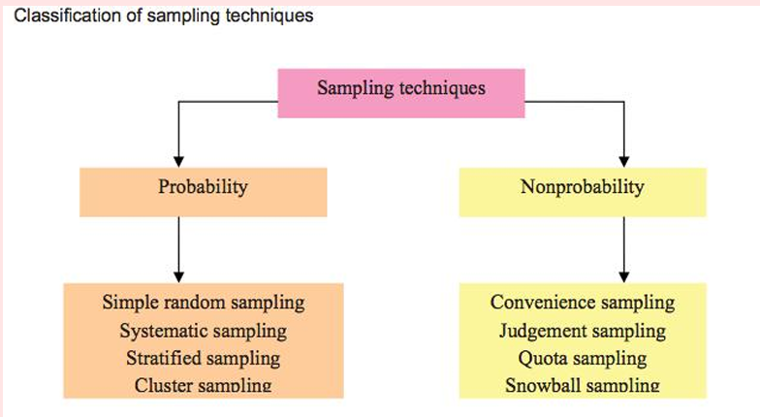
1. Probability Sampling
Every member of the population has a known chance of being selected, usually through random selection.
Example:
There are 55 students in a class. You randomly select 7 students using a lottery or random number generator.
Every student has a chance of being selected.
2. Non-Probability Sampling
Members are selected without random selection, so some members may have no known chance of being selected. The selection may depend on the selector's choice or preference, so it can be biased. Therefore, we cannot reliably generalize the results to the whole population.
Example:
A class has male and female students, but the selector chooses only male students for the sample.
This is non-random sampling because the selector chooses who to include.
Types of Probability Sampling
1. Simple Random Sampling
Every member of the population has an equal and known chance of being selected.
Example:
There are 55 students in a class. We need a sample of 7 students. We write all 55 names on slips and randomly pick 7 slips.
Everyone has an equal chance of being selected.

Data
Data is a collection of facts, information, or observations that are collected for a specific purpose.
Examples:
- Students' marks: 70, 85, 60, 90
- People's ages: 20, 25, 30
- Names, genders, heights, temperatures, sales, etc.
Types of Data
1. Primary Data
Primary data is the data that is collected directly by the researcher for a specific purpose.
Examples:
- Conducting a survey
- Interviewing people
- Taking measurements
- Doing an experiment
2. Secondary Data
Secondary data is data that has already been collected by someone else and is used by a researcher.
Examples:
- Government reports
- Books and research papers
- Websites
- Existing company records

Representation of Data
Data representation means showing or organizing data in a clear and understandable form so that it can be easily analyzed and interpreted.
1. Time Series Data
Time series data is data collected or recorded at different points in time, usually in chronological order.
Here, the same unit is observed repeatedly, while the time changes.
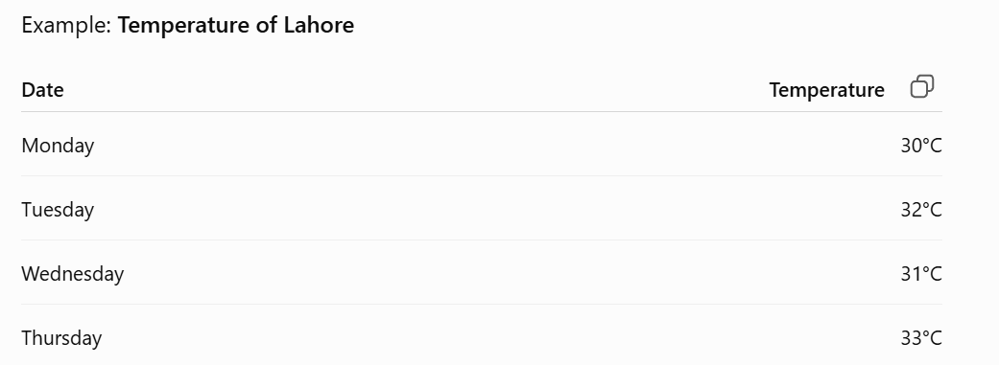
2. Cross-Sectional Data
Cross-sectional data is data collected from different people, places, or groups at the same point in time.
Here, the units change, while the time remains the same.
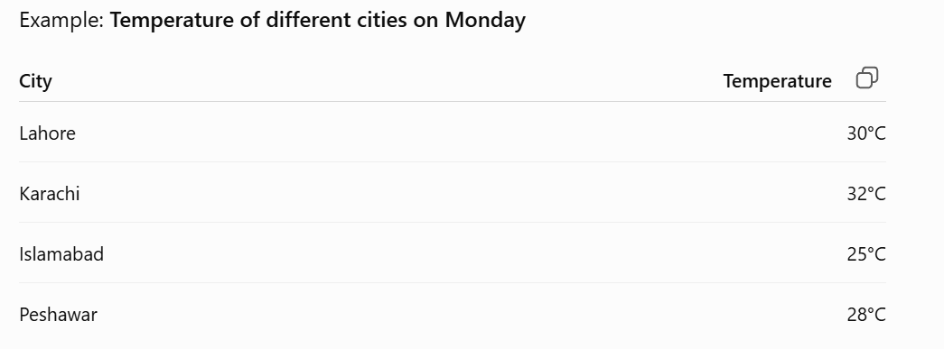

3. Panel Data
Panel data combines the features of time series data and cross-sectional data.
It collects data from multiple units over multiple points in time.
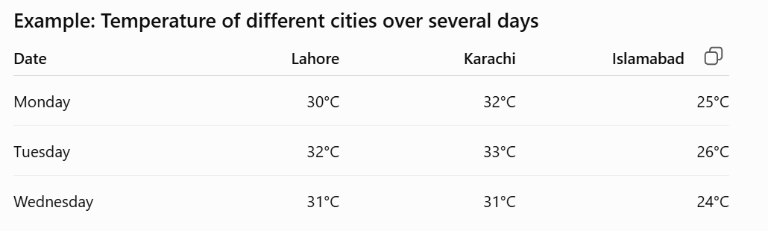
Study vs Auxiliary Variable
1. Study Variable
The study variable is the main variable that you are interested in studying or analyzing.
Example:
Suppose you want to study the average weight of students.
- Weight: Study variable
2. Auxiliary Variable
An auxiliary variable is an additional variable that helps you understand, estimate, or analyze the study variable more effectively.
Example:
Suppose you are studying students' weight:
- Weight: Study variable
- Age, height, gender: Auxiliary variables
Frequency Distribution
Frequency distribution is a table that organizes a data set into a suitable number of classes or groups and shows the frequency of each class.
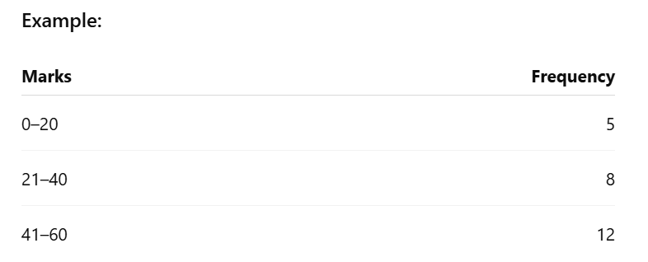
Grouped Data
Grouped data is data that is divided into groups or intervals (classes) instead of showing every individual value.
Example: Suppose students' ages are:
10, 11, 12, 13, 14, 15, 16, 17
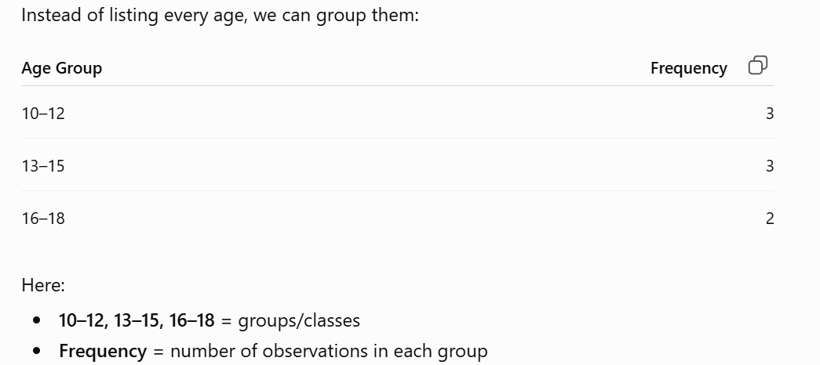

Percentage Frequency
Percentage frequency shows the frequency of a value or class as a percentage of the total frequency.
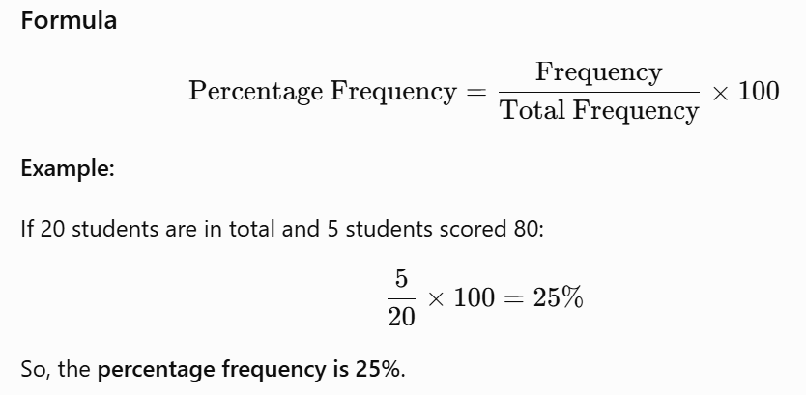
Cumulative Frequency Distribution
Cumulative frequency distribution is a table that shows the running total of frequencies up to each class.
