DevOps for Cloud Computing
Lecture 01
DevOps culture through a failed release
Traditional delivery, Agile roots, continuous delivery, and the role of cloud
What is DevOps?
DevOps = Development + Operations
It is a combination of technical practices (automation, testing, Continuous Delivery, tools, etc.) and cultural changes (better teamwork, communication, and shared responsibility).
Its main purpose is to improve collaboration and reduce the time between between different teams involved in software development and delivery.
Origin of DevOps
- DevOps has roots in Agile software development.
- Agile Manifesto was introduced in 2001, emphasizing people, collaboration, working software, and responding to change.
- Patrick Debois was frustrated by the gap between development and operations.
- In 2009, he organized DevOpsDays in Ghent, Belgium.
- The term DevOps became popular from this movement.
Full scenario
The team releases every eight weeks. Development sends a ZIP file and deployment document to operations. Production configuration is maintained manually. QA receives a representative test environment late. The release needs a two-hour change meeting and a Saturday maintenance window. A missing environment variable causes a 70-minute rollback. A similar failure happened two releases earlier.
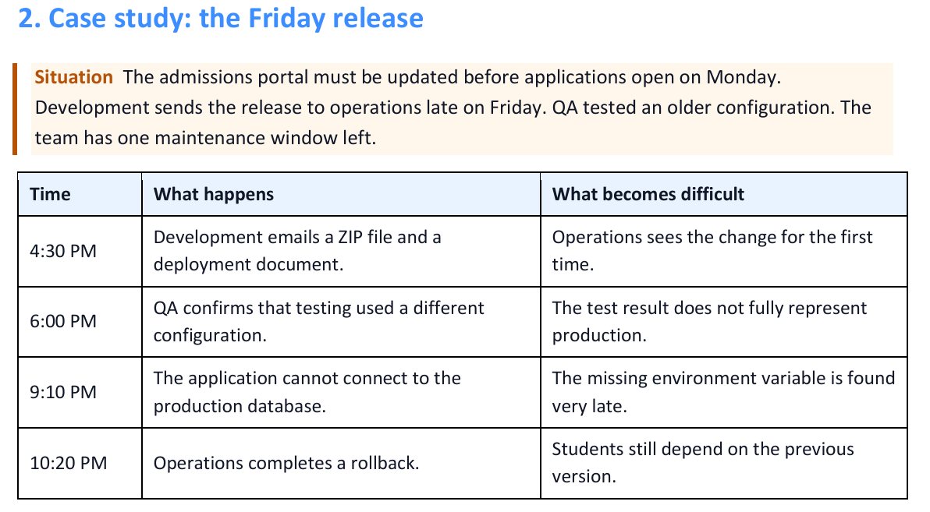
Traditional delivery and DevOps culture
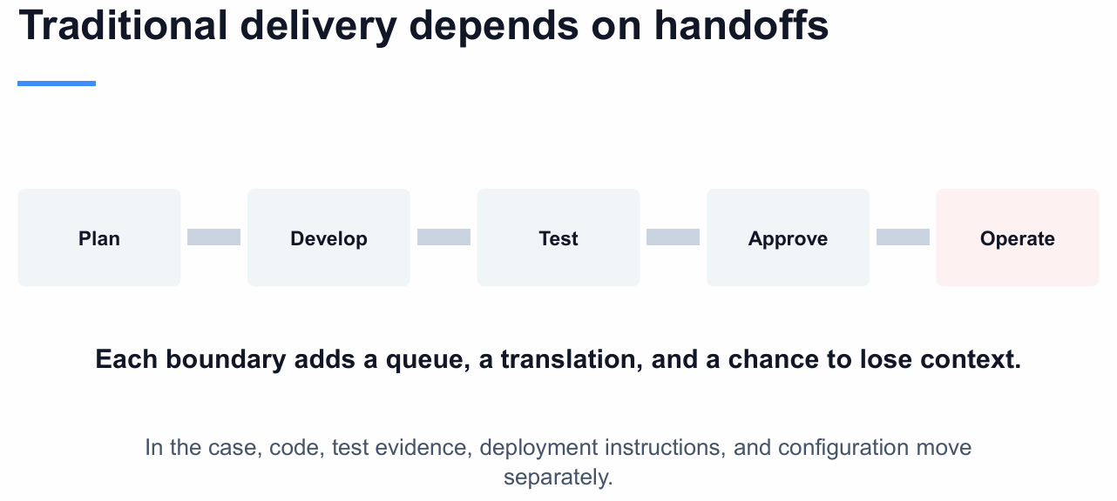
Traditional delivery
Traditional delivery often divides work into stages owned by separate departments. A request moves from planning to development, testing, approval, deployment, and operation. Each handoff can add waiting and can remove context from the change.
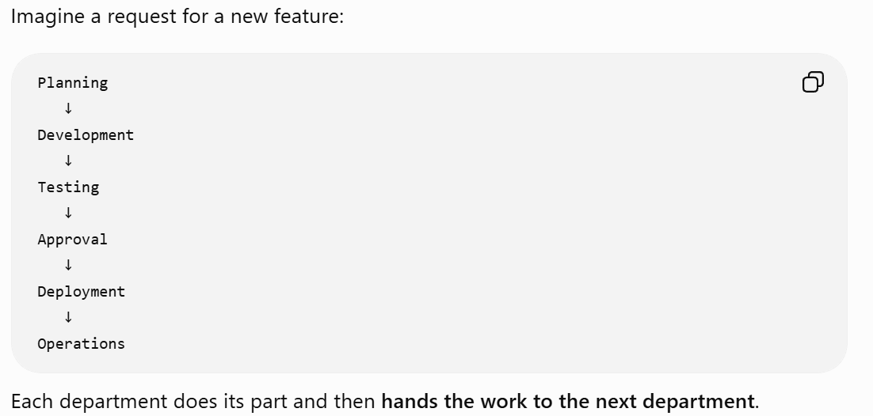
DevOps culture
DevOps joins development and operations with testing, security, product, and other contributors around one service. Specialists keep their expertise, but they share information and responsibility for the result experienced by the user.
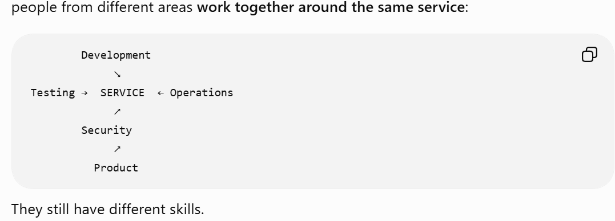

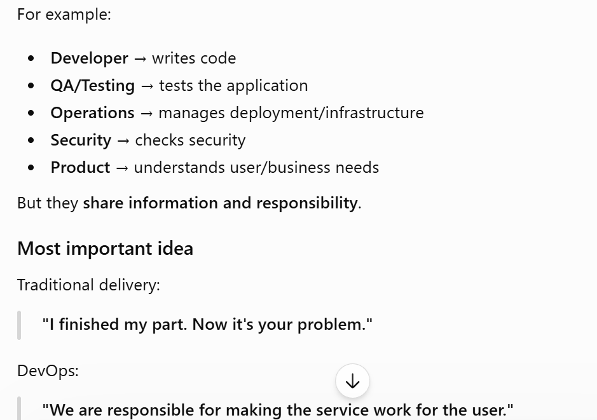
DevOps → shared responsibility + collaboration + fixing the root cause, rather than blaming one team.
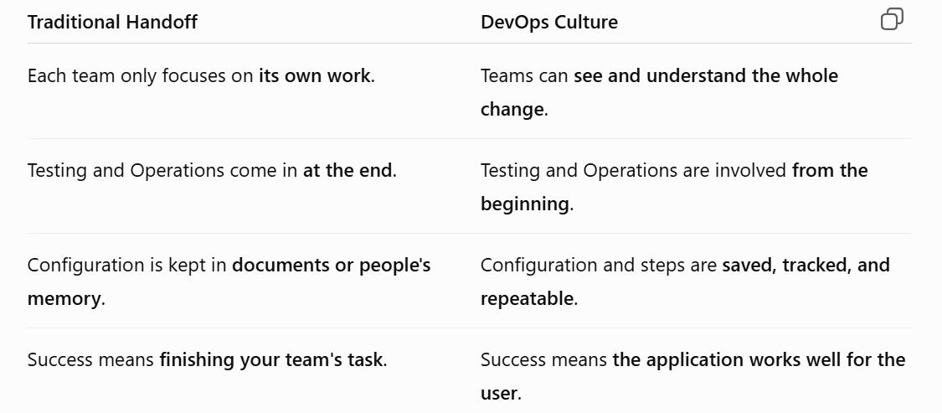
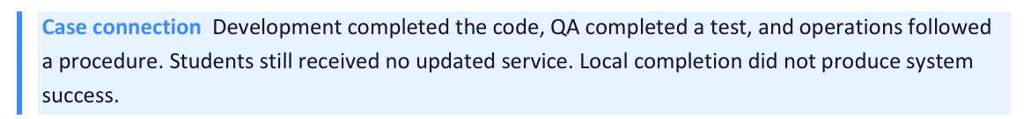
Departmental success can hide service failure
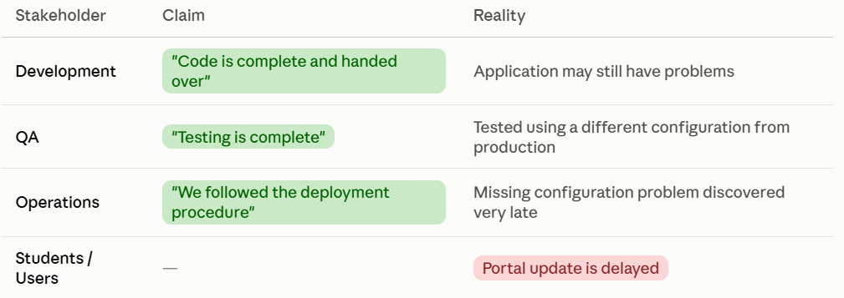
Doing your department's task correctly does not necessarily mean the whole service will succeed.
Tools should help people interact
This section is saying that tools should make teamwork easier, not create more separation between teams. The tools reflect the organizational walls which means if the company separates teams, and each team has completely separate tools, the tools also create separation between the teams. A shared workflow can provide one change record with different views for each role.
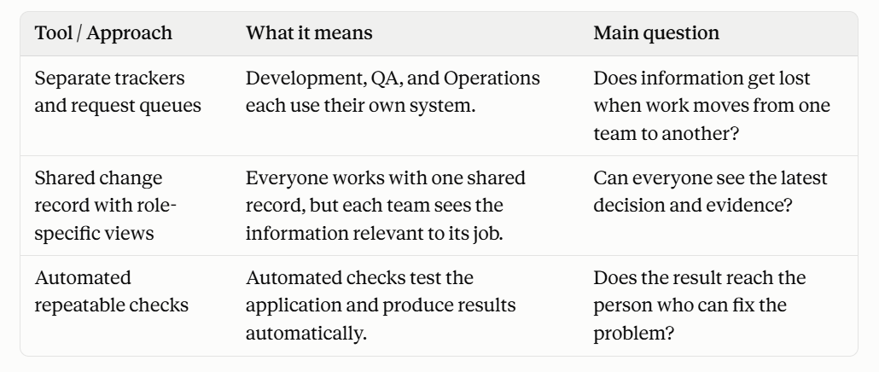
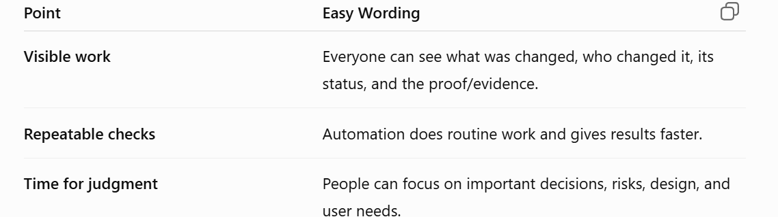
A tool earns its place when it reduces friction, removes repetitive work, or returns evidence sooner. Buying a tool alone does not change ownership.
Shared workflow keeps context visible
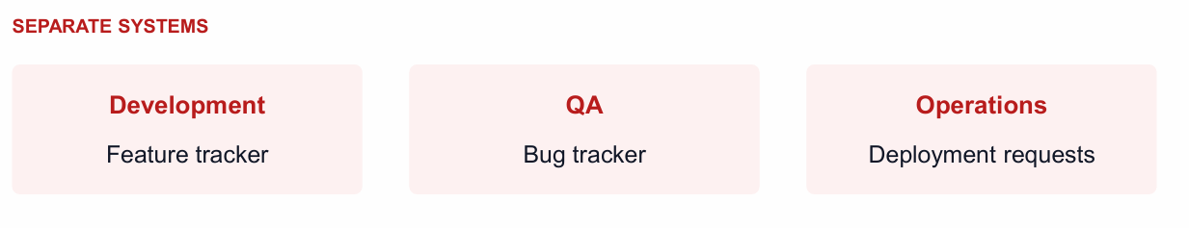
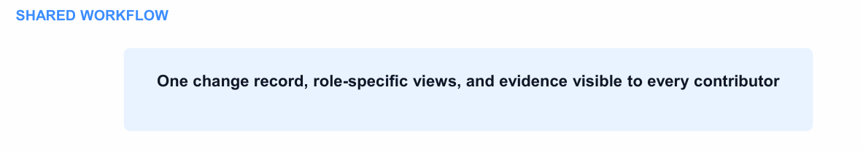
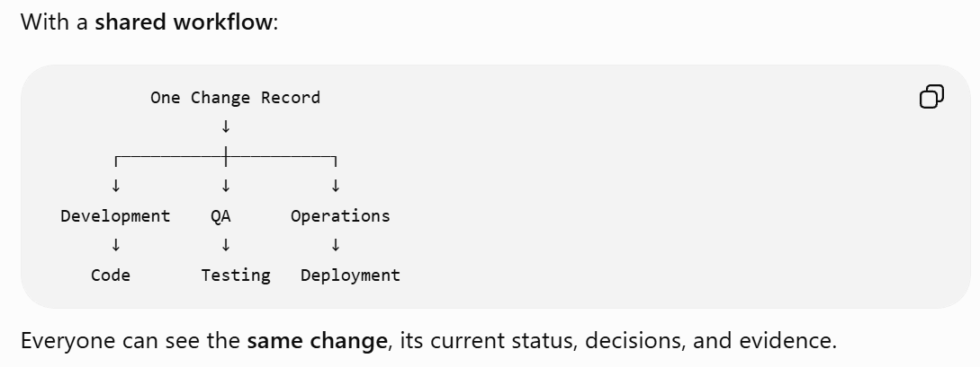

Example: “Update Student Portal”
- Developer: sees the code changes
- QA: sees the testing
- Operations: sees the deployment/configuration
They all work on the same change, but each focuses on the part related to their job
Useful speed reduces waiting and advances value (How fast is fast)
DevOps is not about simply doing work faster. It is about getting useful feedback/evidence faster so problems can be found and corrected early.
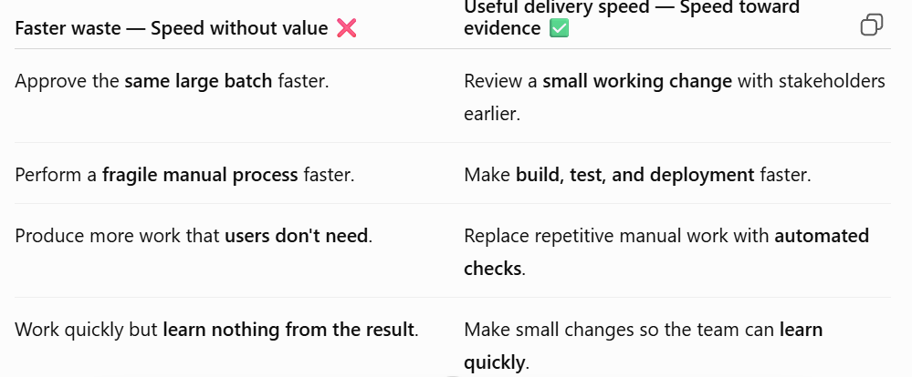
In the Friday case, the most expensive wait is the delay before the team tests the real configuration. Faster typing or a shorter meeting would not solve that feedback problem.
Smaller Changes Make Feedback Easier
Make small changes instead of making many changes at once. This helps you find problems faster and fix them more easily

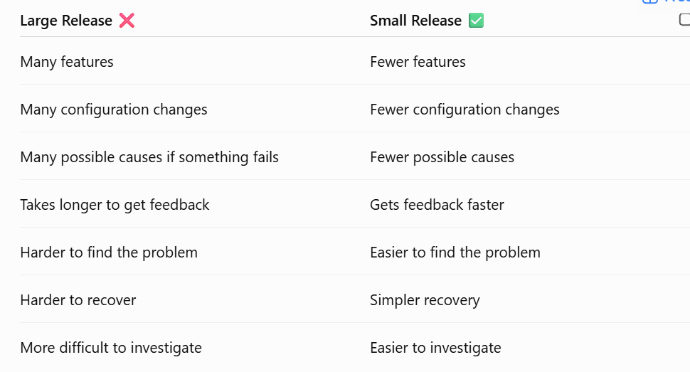
The Agile wheel of wheels
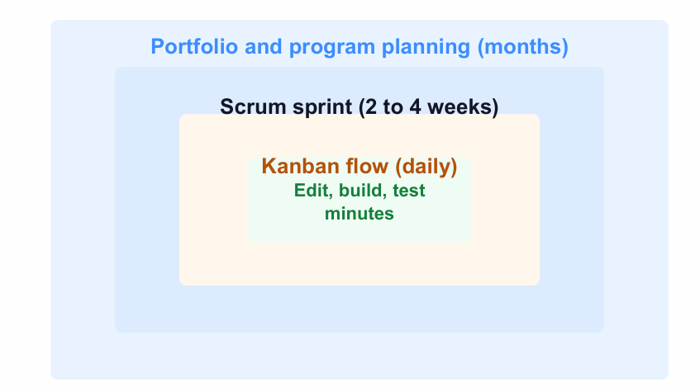
Agile work runs at several cadences. A developer may edit, build, and test within minutes. Kanban work may be reviewed daily. A Scrum sprint usually lasts two to four weeks. Program and portfolio decisions run over longer periods.
DevOps supports every cadence with delivery evidence
This means DevOps provides useful feedback/evidence at different time periods instead of waiting for a long release cycle.
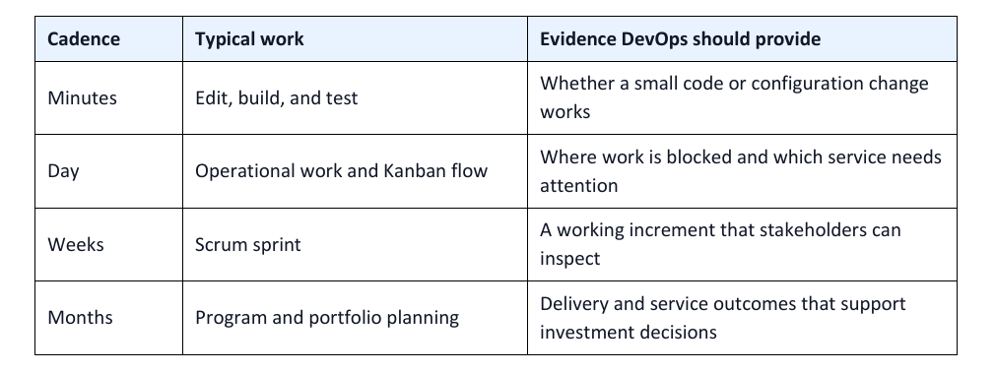
Imp Point: The most obvious and measurably concrete benefits of DevOps occur in the shorter cycles, which in turn make the longer cycles more efficient.
Problem DevOps Solve: Waiting 8 weeks to pass work from one team to another means problems may be found very late. DevOps gives feedback and finds problems earlier, so they can be fixed sooner.
Beware the “Cargo Cult” Agile Fallacy
1. What is Cargo Cult?
Cargo cult means copying the actions of others without understanding their real purpose.
Richard Feynman used the term “cargo cult science” to describe people who follow the steps of science but miss the important part: the actual purpose and reasoning behind them.
2. Simple Example
During World War II, people on some islands saw military airplanes landing and bringing useful supplies (cargo).
After the war, the airplanes stopped coming. The islanders copied what they had seen by making landing strips and imitating the military's activities, hoping the airplanes would return.
But they did not understand why those activities worked.
Cargo Cult Agile / DevOps
The same thing can happen with Agile and DevOps.
Simply doing an Agile/DevOps activity does not mean you are actually following Agile or DevOps.
Examples:
- Having a daily stand-up meeting does not automatically make a team Agile.
- Having a DevOps pipeline does not help if only the Operations team understands or uses it.
- Using automation is not useful if it does not improve feedback or reduce unnecessary work.
Main question to ask:
“Why are we doing this, and is it actually helping us?”
Goal of a DevOps Pipeline (Purpose Driven DevOps)
The purpose of a deployment pipeline is to:
- Get feedback faster
- Reduce manual work
- Help different teams work together
- Find problems earlier
- Deliver useful changes more efficiently
If a pipeline only makes Operations' work easier but does not improve collaboration or delivery for other teams, then it may be cargo cult DevOps.
Cargo Cult DevOps Vs Purpose Driven DevOps
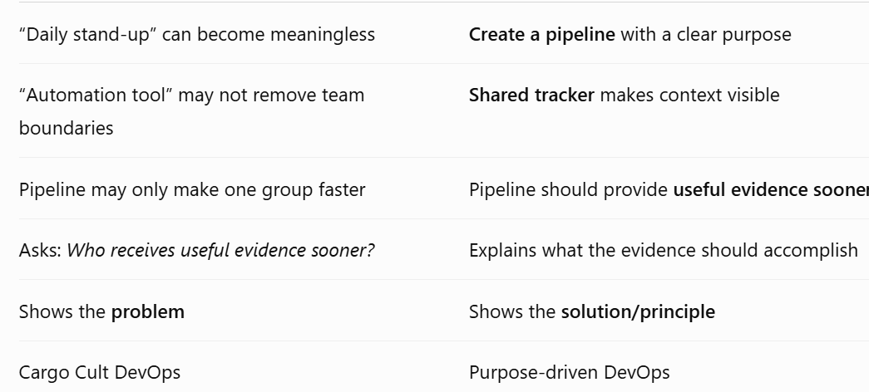
Sprint Retrospective
In Scrum, a sprint retrospective is a meeting where the team discusses:
- What went well?
- What went wrong?
- What should we improve?
The important part is acting on the improvements.
If the team identifies the same problem again and again but never fixes it, the retrospective is not achieving its purpose.
How DevOps Helps
Sometimes a problem keeps repeating because it involves another team and there is poor communication between teams.
DevOps helps by encouraging:
Cooperation + Shared responsibility + Better communication
This makes it easier to solve problems that cross team boundaries.
Main Lesson
Don't follow Agile or DevOps practices just because everyone else does. Understand their purpose and check whether they are actually improving your work.
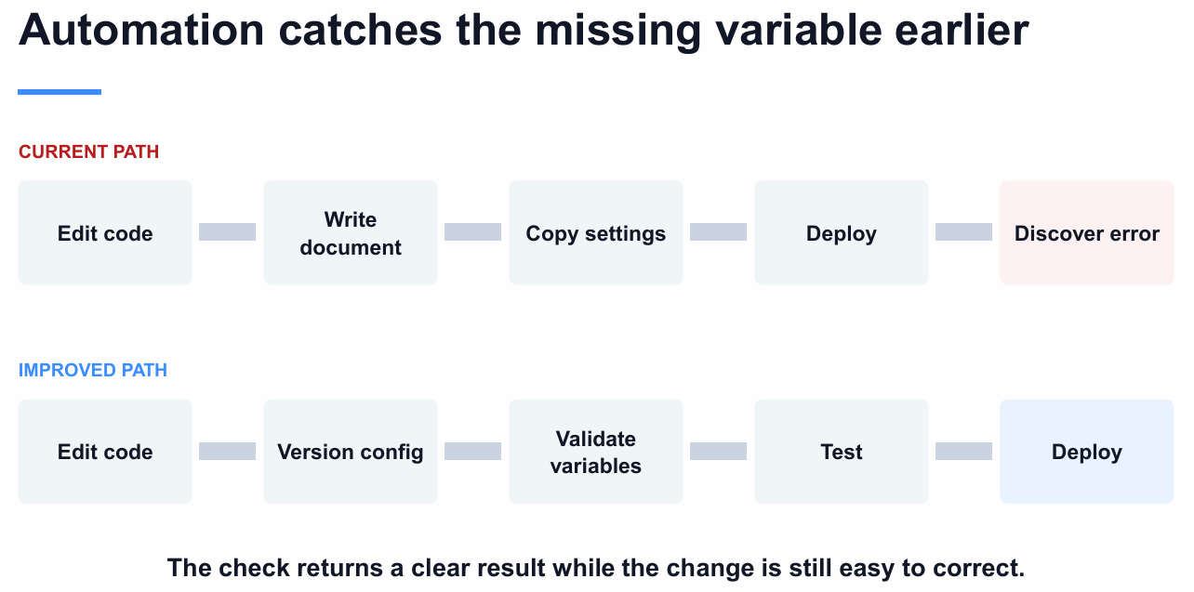
Cloud can shorten the path to a realistic test
The team needs a realistic testing environment that is similar to the real system.
With cloud services, the team can create and remove these environments whenever needed.
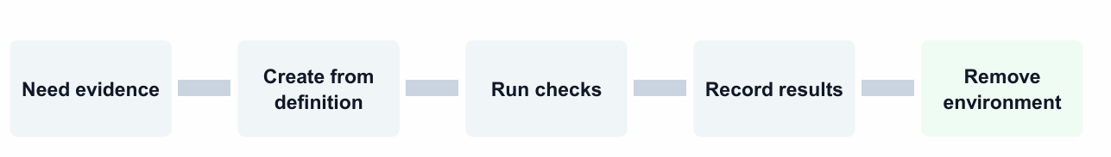
The process:
- Need evidence → We need to test whether the system works correctly.
- Create from definition → Create the testing environment using predefined settings/code.
- Run checks → Test the application.
- Record results → Save what happened and whether the test passed or failed.
- Remove environment → Delete the testing environment when finished.
Cloud lets us create testing environments whenever we need them and use them repeatedly.
But there are still things to manage
“The team still needs access rules, cost limits, validation, and cleanup.”
Meaning:
- Access rules → Who is allowed to use the cloud resources?
- Cost limits → Don't spend too much money.
- Validation → Make sure the environment is configured correctly.
- Cleanup → Delete unused resources so they don't keep costing money
Cloud capability needs engineering discipline
Cloud gives you powerful capabilities, but you need good engineering practices to use them properly.

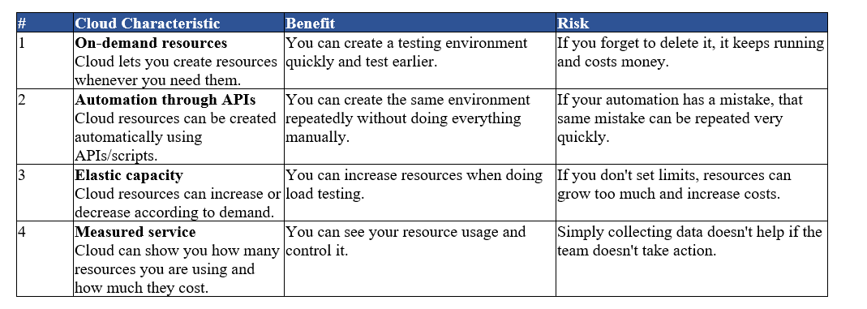
Key Point: Cloud is powerful, but it does not automatically make a team better; the team still needs discipline, limits, monitoring, and good practices.
Cloud vs Server
- Server: you may pay for the full server capacity even if you use only part of it.
- Cloud: resources can be used more flexibly, often through virtualization.
DevOps and ITIL
ITIL
ITIL (Information Technology Infrastructure Library) is a framework that provides organized practices for managing IT services, systems, and changes.
DevOps and ITIL can work together. They are not necessarily opposite approaches.
DevOps focuses on small, frequent, and automated changes, while ITIL provides formal processes and controls for managing IT changes.

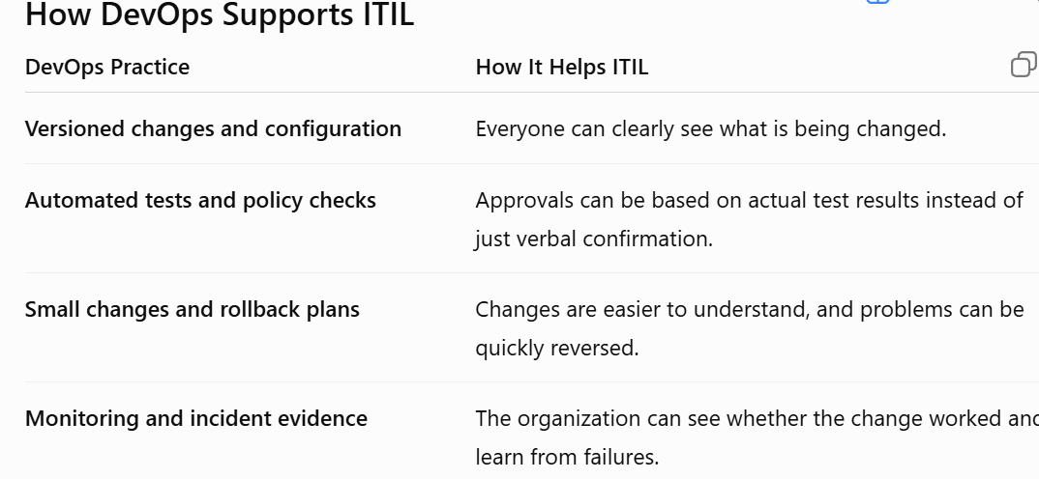
What About Large Legacy Systems?
Large organizations often have old and complex systems. These systems may have many connected parts.
A large change can therefore cause a bigger problem if something goes wrong.
For such changes, formal ITIL processes and coordination may still be necessary.
On the other hand, small changes can often be handled more quickly using DevOps automation, testing, monitoring, and rollback.
Key Idea: Governance Should Match Risk
The important point is:
The level of control should depend on how risky the change is.
For example:
- Small, low-risk change → automated testing + quick deployment + rollback
- Large, high-risk change → more formal review + approvals + coordination
DevOps does not necessarily remove ITIL controls.
Instead, DevOps can make ITIL controls faster and better by providing automated tests, clear evidence, monitoring, and repeatable processes.
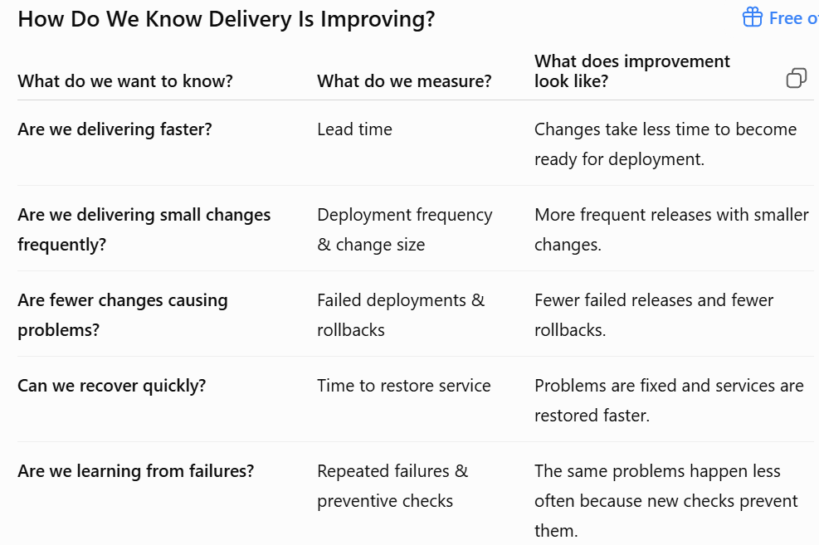

Lecture 2
Introduction to Cloud Computing
What is cloud computing?
Cloud computing refers to the delivery of computing services over the internet, including storage, processing power, and software applications.
It allows users to access resources and services on-demand, without the need for physical infrastructure or local servers.
Example: Instead of buying your own printer, you go to a print shop and pay only when you need a printout. Cloud computing works the same way — you "rent" computing power over the internet only when you need it.
Key Characteristics of Cloud Computing
These are the basic features that make something count as "cloud computing":
- On-Demand Self-Service — You can get storage or computing power yourself, anytime, without calling a company employee. It's like an ATM: you take out money whenever you want, without asking a bank teller.
- Broad Network Access — You can reach the service from anywhere using the internet, on a laptop, phone, or tablet.
- Resource Pooling — Many customers share the same big pool of computers, similar to how many tenants share one big apartment building's water and electricity supply.
- Rapid Elasticity — The service can grow or shrink quickly based on your needs, the same way a rubber band stretches and shrinks.
- Measured Service — You are billed only for what you actually use, just like an electricity bill that depends on your usage.
Example: A food delivery app during a big festival suddenly gets 10x more orders. Because the app runs on the cloud, extra computing power is added automatically (rapid elasticity), and the company only pays extra for the days it used more power (measured service).
Cloud Deployment Models
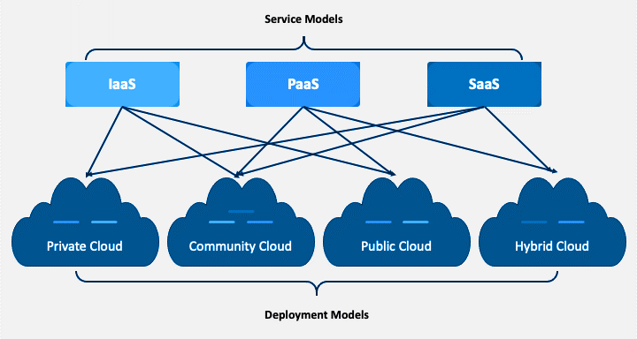
Public Cloud
The service is offered over the public internet and anyone can sign up and use it. It is usually the cheapest and most flexible option.
- Cost-effective for individuals and businesses that need scalability and flexibility.
- Big providers include AWS, Microsoft Azure, and Google Cloud (GCP).
Example: Using Gmail or Netflix — both run on servers shared by millions of other users around the world, but you don't need to know or manage any of that.
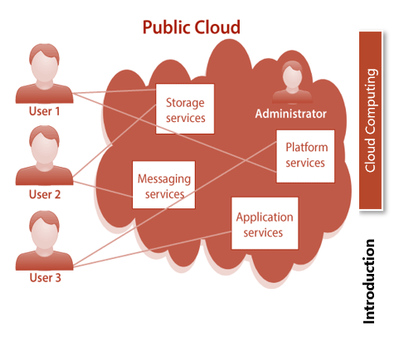
Private Cloud
The infrastructure belongs to just one organization. It can be kept on the company's own premises or hosted elsewhere, but only that company uses it.
- Built to match specific security, compliance, or performance needs.
- Gives more control, customization, and privacy, but costs more upfront.
Example: A bank keeping its customer transaction data on its own private servers so no other company can access that data.
