Entrepreneurship
Entrepreneurs:
Entrepreneurs are the people who take action to create something new by taking risk to make money.
Entrepreneurship:
Entrepreneurship is the process of starting, developing, and managing a business. It involves identifying market opportunities, taking financial risks, and using creativity and innovation to solve problems and meet customer needs.
Myths about Entrepreneurship:
- Dominant myths include that entrepreneurship is reserved for startups.
- Entrepreneurs have a special set of personality traits.
- Entrepreneurship can’t be taught.
- Entrepreneurs are extreme risk-takers.
- Entrepreneurs do not collaborate.
- Entrepreneurs devote large periods of time to planning
- Entrepreneurship is not a life skill.
Start Up:
A startup is a new business that starts with an idea to solve a problem or offer something new. It usually begins small but aims to grow fast.
Example:
Instagram started as a small app for sharing photos and quickly became popular worldwide.
Truth No 1: Entrepreneurship is not reserved for startups
Startup does not remain a startup. It can develop into an organization in its own right (means that the startup has grown enough to become a fully established and independent company). In simple words, this means that startups don’t always follow the same path. While Bob started a tech company in his garage and sold it to a big company, that’s just one example. Entrepreneurs can be found everywhere — in big companies, small family businesses, franchises, charities, or even nonprofits. You don’t have to start a business from scratch to be an entrepreneur. You can create new ideas and make a difference in big companies, small businesses, charities, or even family-run shops.
Scratch: You can also buy already small running business.
Truth #2: Entrepreneurs do not have a special set of personality traits
In our short parody, lone-wolf Bob is a tech genius who was born with the personality traits of a brilliant entrepreneur. In reality, there is no evidence to suggest that entrepreneurs have a special set of personality characteristics that distinguishes them from the rest of us.
Traits:
These four traits describe the common qualities that help entrepreneurs succeed:
- Desire for achievement – Entrepreneurs are motivated to reach goals and succeed. They work hard to turn their ideas into reality.
- Ability to influence events – They believe they can shape their future and make things happen through their actions and decisions.
- Risk-taking – Entrepreneurs are willing to take chances, even if there’s a possibility of failure, to try something new or better.
- Tolerance for uncertainty – They are comfortable dealing with unknowns and unexpected challenges, staying focused even when things are unclear.
Everyone can think Entrepreneurially:
In simple words, earlier studies focused on the personal traits of entrepreneurs, like risk-taking or achievement. But now, researchers focus more on how entrepreneurs think and act. They've found that there are common thinking patterns among entrepreneurs, and the good news is that anyone can learn these patterns. With practice, we can all start thinking and acting like entrepreneurs, even if we don’t have the natural traits.
- Researcher Saras Saraswathi studied serial entrepreneurs (those who start multiple businesses) and found common thinking patterns. She developed the effectuation theory, which means that while the future can’t be predicted, entrepreneurs can still shape and control it through their actions.
- In simple words, Saraswathi says that effectual entrepreneurs don’t try to guess what the future will be like — they create it themselves. They come up with new ideas, make new markets instead of just finding existing ones, and aren’t afraid to fail because they learn from mistakes. They also build strong connections with different people to help reach their goals, using their own creativity and effort to turn their vision into reality.
Truth #3: Entrepreneurship can be taught (it’s a method that requires practice)
This passage explains that, unlike lone-wolf Bob, who skips formal education to become an entrepreneur on his own, many people learn entrepreneurship in colleges and universities. These courses often teach it as a step-by-step (linear) process, where students learn to:
- Identify an opportunity – Find a business idea or market need.
- Understand resource requirements – Know what’s needed (money, skills, materials).
- Acquire resources – Get the needed tools, funding, or team.
- Plan – Make a clear business plan.
- Implement – Start and run the business.
- Harvest – Enjoy the results, like profit or selling the business.
The passage highlights that while some entrepreneurs go their own way, others follow a structured path taught in schools.
Truth #4: Entrepreneurs are not extreme risk-takers
This passage explains that the common belief that entrepreneurs love to take big risks, like gamblers, is not true. In fact, entrepreneurs who gamble too much often fail because they rely too much on luck.
Most successful entrepreneurs are careful risk-takers. They think through their decisions and consider what they’re willing to lose before moving forward. From the outside, their actions might seem risky, but they usually make smart, calculated moves.
Entrepreneurs follow a simple act–learn–build cycle:
- Act – Take small steps.
- Learn – See what works and what doesn’t.
- Build – Use that learning to improve the next step.
Entrepreneurship isn’t about betting everything at once (all-or-nothing); it’s about taking smart, small steps to reach success.
Truth #5: Entrepreneurs collaborate more than they compete
This passage highlights that entrepreneurship isn’t a solo journey. Community and collaboration are key, as entrepreneurs learn from others, share experiences, and support each other with a “pay it forward” attitude. They also work with customers to test ideas, investors to build trust, and family for support. Even competitors can collaborate, like when Steve Jobs and Bill Gates worked together on the Apple Mac. Such teamwork boosts efficiency, creativity, and innovation.
Truth #6: Entrepreneurs act more than they plan
Not all entrepreneurs need a detailed business plan to succeed. Many successful founders focused on taking action—talking to people, reaching customers, promoting their product, and learning from real feedback.
Investors focus less on detailed business plans and more on an entrepreneur's real progress. They want to see what steps the entrepreneur has already taken, how much customer interest they've generated, and how well they present their ideas, often using demos or videos. Most importantly, investors look for entrepreneurs who can adapt, take action, and improve based on feedback.
Truth #7: Entrepreneurship is a life skill
Entrepreneurship was once mainly about starting new businesses, but now it means more than that. Today, it’s seen as a life skill that helps people handle an uncertain future. It teaches us how to think creatively, solve problems, spot opportunities, adapt to change, and work towards our goals. These skills can be used in many areas of life, not just in business. Being entrepreneurial helps us create opportunities and achieve our ambitions.
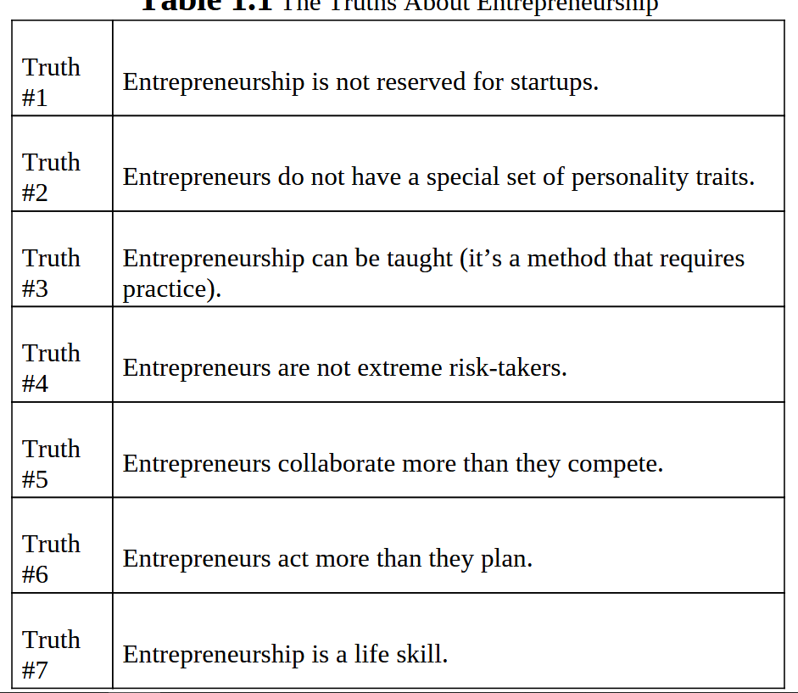
Types of Entrepreneurships:
Corporate Entrepreneurship
Corporate entrepreneurship or intrapreneurship is when employees in large companies create new products, services, or processes. They often work in special teams to develop and test ideas, which are then added to the main company.
Like regular entrepreneurs, they find new opportunities, form teams, and create useful innovations. Their main goal is to help the company grow, stay competitive, and make more profit.
Example:
Marian Croak, a Senior Vice President at AT&T, is a great example of a corporate entrepreneur. In 2005, while working on a text voting system for American Idol, she had an idea to use the same system for disaster relief. Marian Croak suggested a simple way for people to donate during emergencies using text messaging. She created a system where people could send a specific keyword (like “HELP” or “DONATE”) to a special number through SMS. A fixed amount, usually $5 or $10, would then be added to the person’s phone bill as a donation. The phone company would later transfer the collected donations to the relevant charity or relief organization. This made it quick and easy for people to contribute during disasters. This idea became a success, especially after the 2010 Haiti earthquake, when it raised over $30 million in donations.

Entrepreneurs Inside:
Entrepreneurs inside are employees who think and act like entrepreneurs within any type of organization, big or small, including businesses, governments, nonprofits, or cooperatives. Unlike corporate entrepreneurs who usually work in large companies, these entrepreneurs can exist anywhere. They often need support from managers or team members, which can be challenging if others resist new ideas. Building a group of supporters helps them get approval and prove there’s a market for their ideas.
Example:
Like all entrepreneurs, they aim to create value. A great example is the 2014 "Inglorious Vegetables" campaign by French supermarket Intermarche, which sold odd-looking vegetables at lower prices to reduce food waste. The campaign attracted more customers and proved there’s a market for imperfect produce.
Key Difference between two:
- Corporate Entrepreneurs innovate within big companies.
- Entrepreneurs Inside can innovate within any organization, regardless of size or type.
Buying a Franchise:
A franchise is a business model where an entrepreneur (called a franchisee) buys a license from an existing business (called a franchisor) to use its brand name, products, and business system. This allows the franchisee to run their own business under an already successful brand, like Subway or Hampton by Hilton.
Franchising helps entrepreneurs start faster because they don’t have to spend time creating a brand, setting up processes, or finding products—the system is already in place. That’s why it’s often called a “turnkey operation”, meaning the business is ready to run as soon as the owner "turns the key" and opens the doors.
The franchisee pays an upfront fee to buy the franchise and also pays royalties (a percentage of sales) to the franchisor regularly. Franchise costs can vary widely—from $50,000 to over $500,000—depending on the brand.
Example:
Popular franchises in the U.S. include Jimmy John’s, Anytime Fitness, Subway, and Supercuts, with over 750,000 franchise businesses running across the country.
Buying a small business:
Buying a small business is another way to become an entrepreneur. Instead of starting a new business from scratch, the entrepreneur buys an existing business and takes over its operations. This approach can be less risky since the business already has customers, equipment, staff, and a running system.
Example:
For example, in 2009, Chris Cranston bought a dog rehab center called Aquadog near Boston. She renamed it FlowDog but kept the loyal customers, pool equipment, staff, and a good lease. Chris felt starting a business from zero was too overwhelming, so buying an existing one made it easier for her. Since then, FlowDog has grown by 20% every year.
Social Entrepreneurship:
Social entrepreneurship involves creating businesses that solve social or environmental problems, like poverty or climate change. These businesses aim to make a positive impact while also earning a profit, helping them stay stable without relying on donations. It’s about finding innovative solutions to improve society and the environment. In short, social entrepreneurship is about finding creative ways to solve social and environmental issues while still running a stable business.
Example:
Social entrepreneurs solve problems by developing innovative products or services. For example, they might create affordable water filters for communities without clean water or launch educational apps for underprivileged children. These businesses focus on making a positive impact while staying profitable to keep helping others long-term.
Family Entrepreneurship:
A family enterprise is a business owned and run by family members, often across several generations. Each new generation has a chance to bring fresh ideas and help the business grow. However, many family businesses struggle to survive beyond the second or third generation because they may resist change and stick to old ways.
Some Statistics:
Family businesses are very common worldwide. In the U.S., around 80-90% of businesses are family-owned, employing about 65% of the workforce. Famous examples include Wal-Mart (USA), Carrefour (France), and Fiat (Italy). For long-term success, it’s important that family members pass down not just the business but also an entrepreneurial mindset to keep the company growing and adapting over time.
Serial Entrepreneurship:
Serial entrepreneurs are people who start multiple businesses, either at the same time or one after another. They are always looking for new ideas and opportunities.
Example:
Virgin is a group of companies started by Richard Branson. It began as a music store called Virgin Records in the 1970s. Over time, it expanded into many industries, including airlines (Virgin Atlantic), trains (Virgin Trains), banking (Virgin Money), telecommunications (Virgin Mobile), and even space travel (Virgin Galactic). The Virgin brand is known for trying new ideas and entering different markets.
Prediction Vs Creation
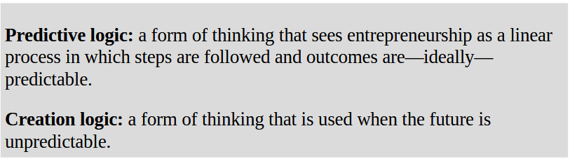

Prediction Approach (Old View):
- Entrepreneurship follows a step-by-step process.
- Success can be predicted by careful planning.
- Entrepreneurs set goals first and then gather the resources needed to achieve them.
Example:
A group of entrepreneurs wants to launch a mobile app for fitness tracking.
- They spend months doing market research and creating a detailed business plan.
- They seek investors to fund app development before starting.
- They build a fully functional app with many features before launching.
- They launch the app nationwide, hoping users will download it and love it.
This approach assumes success can be planned and predicted through careful preparation.
Creation Approach (New View):
- Entrepreneurship is unpredictable and requires flexibility.
- Entrepreneurs take action, learn from experience, and adapt.
- Instead of waiting for resources, they use whatever they have to create opportunities.
Example of Creation Approach (New View) – Tech Startup
A solo entrepreneur wants to create a fitness app but has limited money.
- They start with a simple prototype, like a basic step-tracking feature.
- They release it to a small group of users and collect feedback.
- They improve the app based on real user needs instead of guessing what features people want.
- As the app gains popularity, they add more features gradually and seek funding when needed.
This approach focuses on taking action, learning, and adapting instead of waiting for everything to be perfect.
When We Use Predictive Logic?
Prediction works best when things are certain and there is enough data to make informed decisions. Large companies often use this approach because they have clear goals, reliable information, and advanced planning tools. However, even with careful planning, success is not always guaranteed and it’s not an innovative also.
Traditional entrepreneurship follows the prediction logic, which means:
“If I can predict the future, I can control it.”
When We Use Creative Logic?
Creation works best in uncertain situations, where there isn’t enough information to predict outcomes. Instead of planning everything in advance, entrepreneurs use what they have and take action—like making a meal from whatever ingredients are in the kitchen when unexpected guests arrive.
Both approaches aim for the same goal (success), but the way entrepreneurs reach it is different. Prediction is structured and planned, while creation is flexible and adaptive and innovative.
“To the extent we can create future, we don’t need to predict it”
What it means:
- If you create opportunities through action, you don’t have to predict what will happen.
- You build the future step by step, using what you have instead of waiting for certainty.
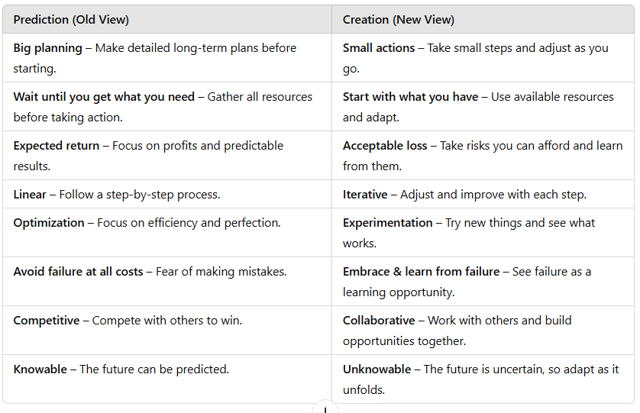

Balancing Prediction and Creation in Entrepreneurship
Entrepreneurs use both prediction and creation, but we are naturally better at prediction because of how we’ve been taught in school—focusing on right answers and measurable results. However, as babies, we were natural creators, learning through trial and error in an uncertain world.
For new businesses, prediction alone isn’t enough because the business environment is unpredictable. Startups can’t use advanced prediction tools like big companies, and they don’t have a set path to follow. Instead, they need to start by experimenting and adapting (creation) and later analyze data to make better decisions (prediction) as they grow.
Most entrepreneurs start with just an idea, not a detailed plan. They can’t predict things like product pricing or hiring without knowing their customers. So, instead of guessing, they need to take action, test their ideas, gather real feedback, and adjust as they go.
Five most important skill to practice an Entrepreneurship
Play helps entrepreneurs be more creative, open-minded, and innovative. It allows them to explore new ideas, take risks, and think outside the box. When we’re having fun, we feel more engaged, energetic, and creative, so why shouldn’t entrepreneurship also be fun? Play encourages problem-solving, teamwork, and learning through trial and error, which are all essential for entrepreneurs.

Learning by Doing
Instead of just reading about business, entrepreneurs experience real challenges. They make decisions on pricing, hiring, marketing, and investments—just like in real life.
Example: A player runs a virtual coffee shop and must decide how much to charge for coffee, when to hire more staff, and how to advertise.
Skill of Experimentation
The Skill of Experimentation means learning by taking action. Instead of just researching, entrepreneurs test ideas in the real world. Experimentation is about trying, learning, and improving—helping entrepreneurs make smarter decisions based on real-world experience.
Example
For example, if you create a new energy drink, you could spend weeks studying competitors' prices. But a better approach is to sell samples at different prices and get direct feedback from customers. This way, you learn not just about pricing but also about customer preferences.
Importance difference between Play and Experimentation
Experimentation is focused on real-world testing, while Play helps spark new ideas and ways of thinking in a fun and engaging way.
The Skill of Empathy
The skill of empathy is understanding the emotion, circumstances, intentions, thoughts, and needs of others. Empathy is being able to relate to how others are feeling because you have been in a similar situation yourself.
Example:
For example, you know how your best friend feels when her dog dies, because the same happened to you at one stage. Similarly, a nutritionist who has struggled to lose weight knows how a patient feels when attempting to do the same thing; and a former smoker knows how it feels for someone else who is trying to quit.
Why is Empathy Important for an Entrepreneur?
Empathy helps entrepreneurs understand the challenges and experiences of others, including fellow entrepreneurs, customers, and stakeholders. By putting themselves in someone else’s shoes, they can make better business decisions.
- Self-Reflection – Understanding the struggles of other entrepreneurs helps assess their own journey.
- Building Connections – Empathy fosters stronger relationships with customers, employees, and investors.
- Identifying Needs – By understanding people’s emotions and challenges, entrepreneurs can create products or services that solve real problems.
Skill of Creativity
Definition
The Skill of Creativity is the ability to generate new ideas, identify opportunities, and solve problems innovatively. Entrepreneurs use creativity to create opportunities rather than just discovering them.
Importance
- Encourages innovation and unique solutions.
- Helps overcome obstacles and adapt to uncertainty.
- Differentiates businesses from competitors.
How to Develop Creativity
- Stay curious and explore new ideas.
- Collaborate instead of competing.
- Build strong relationships and networks.
- Learn from failures and use them to improve.
Example
An entrepreneur notices that many people struggle with meal planning. Instead of waiting for a solution, they create an app that generates customized meal plans based on dietary preferences. Through feedback and improvements, the app becomes a successful business.
Skill of Reflection
Definition
The Skill of Reflection is the ability to think deeply about past experiences, analyze them, and learn from them. It helps entrepreneurs make better decisions by understanding what worked, what didn’t, and why.
Importance
- Helps improve decision-making.
- Encourages learning from mistakes.
- Provides new perspectives and insights.
- Connects different skills like creativity, play, empathy, and experimentation.
How to Develop Reflection
- Take time to think about past actions and their results.
- Ask yourself what went well and what could be improved.
- Write down lessons learned from experiences.
- Seek feedback from others.
Example
A startup launches a new app but gets low user engagement. By reflecting on user feedback (empathy), testing new features (experimentation), and brainstorming fresh solutions (creativity), they improve the app’s design and attract more users.
Understanding Mindset and Its Importance to Entrepreneurs
Definition of Mindset
Mindset refers to “the established set of attitudes ("وہ قائم شدہ رویے ہیں جو کسی فرد کے پاس ہوتے ہیں۔) held by someone.” It shapes how individuals approach challenges, make decisions, and perceive success or failure.
The Role of Mindset in Entrepreneurship
Entrepreneurs face constant uncertainty, risk, and challenges. Their mindset determines whether they view obstacles as barriers or opportunities. A strong mindset helps them stay strong, adjust to changes, and learn from mistakes.

Types of Mindsets
1. Fixed Mindset
A fixed mindset is the belief that intelligence, talent, and abilities are unchangeable. People with this mindset think success depends only on natural talent rather than effort.
Characteristics of a Fixed Mindset:
- Avoid challenges to prevent failure.
- View criticism as a personal attack.
- Believe others succeed due to luck or unfair advantages.
- Focus on looking smart rather than improving.
2. Growth Mindset
A growth mindset is the belief that intelligence, skills, and abilities can improve with dedication, effort, and practice. People with this mindset see challenges as opportunities to learn and grow.
Characteristics of a Growth Mindset:
- Embrace challenges and see them as learning experiences.
- Accept criticism and use it to improve.
- View failure as a step toward success.
- Focus on continuous learning and self-improvement.

The Impact of Mindset on Success
A growth mindset is essential for entrepreneurs as it helps them stay persistent, creative, and adaptable. Unlike those with a fixed mindset, growth-minded individuals see failure as a chance to learn and innovate, making them more likely to succeed.
Research on Luck and Mindset
In the 1990s, psychologist Richard Wiseman studied why some people feel lucky while others feel unlucky. His research showed that luck is shaped by mindset and behavior rather than being purely random.
People with a growth mindset create their own luck by staying positive, embracing opportunities, and learning from failures. In contrast, those with a fixed mindset blame luck for their failures, avoid challenges, and believe success depends on external factors. Wiseman’s study suggests that confidence, adaptability, and effort—key traits of a growth mindset—increase one's chances of success.
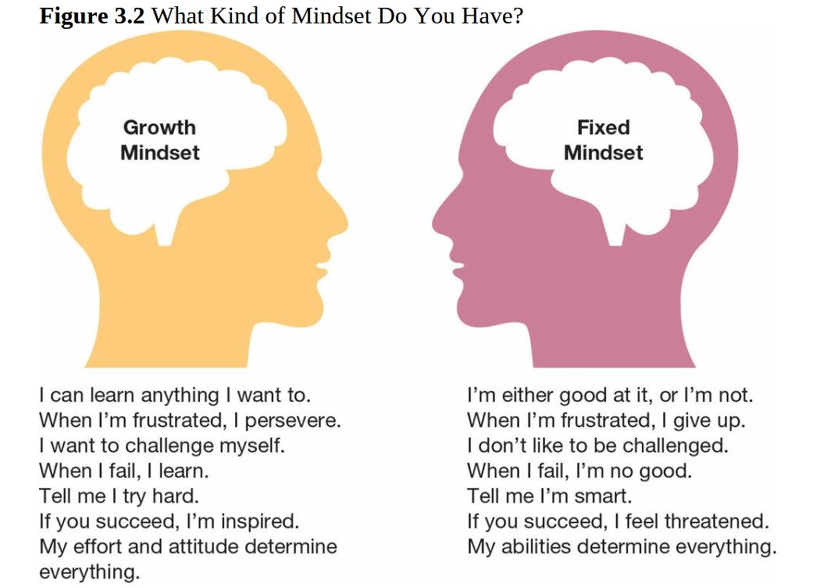

How Praise Affects Mindset
Studies show that praising intelligence instead of effort can lead to a fixed mindset. Psychologist Carol Dweck tested 5th-grade students with puzzles. She found that kids praised for their hard work chose harder puzzles next time, while those praised for being smart picked easier ones to avoid failure.
When children are praised for effort, they become more confident in facing challenges and learning from mistakes. But when praised for intelligence, they fear failure and avoid difficult tasks to protect their "smart" image.
Growth Mindset in Successful People
Dweck noticed that successful athletes, business people, writers, and musicians all share a growth mindset. They achieve success through hard work, practice, and persistence. She believes people with a growth mindset are generally happier and more successful.
Changing Your Mindset
Even if you have a fixed mindset, you can learn to develop a growth mindset. The first step is to notice the inner voice that creates self-doubt. Instead of accepting negative thoughts, challenge them and take action. Over time, this shift in thinking can improve confidence and success.

Entrepreneurial Mindset
A growth mindset is very important for entrepreneurs. In Chapter 2, we learned that entrepreneurs need a special way of thinking to find opportunities and handle challenges. There is no single definition of an entrepreneurial mindset, but it means being able to spot opportunities, take action, and stay organized even in uncertain situations. It also means not giving up, learning from mistakes, and being okay with challenges.
How Entrepreneurs Think
Successful entrepreneurs are not always born smart, but they use their intelligence in the right way. They apply problem-solving, reasoning, and experimenting to find new opportunities and take action. Since business is full of uncertainty, an entrepreneurial mindset helps them adapt, think carefully, and stay in control of their emotions to make better decisions.
Thinking About Thinking (Metacognition)
Metacognition means "thinking about your own thinking" and helps us learn better. For example, if you are reading a difficult legal paper and don’t understand some parts, you might go back, re-read, and try to understand instead of just moving on without getting it. This skill helps entrepreneurs make better decisions and solve problems effectively.
Understanding Business Models
A business model is a plan that explains how a company creates, delivers, and gains value. It includes the activities and resources needed to build a successful and growing business. Business models help companies grow by meeting unmet needs, offering unique products or services, or entering new markets.
Business Model vs. Business Plan
Many people confuse a business model with a business plan, but they are different. A business model explains how a business works, while a business plan is a detailed document that includes financial information, business goals, and steps to achieve them. The business plan supports the business model by outlining how to reach its goals.
Adapting Business Models
Businesses can change their way of working (their business model) to better fit customer needs. In the example of VF, they first charged startups a fee for services, but many startups found it hard to pay. So, VF changed its approach—instead of asking for direct payment, they took a small ownership share (equity) in the startup. This way, startups didn’t have to pay upfront, and VF could benefit later if the startup became successful. This kind of change makes the business more attractive and accessible to its customers.
The Four Parts of a Business Model
The Offering
The first part of a business model is the offering, which explains what you are selling, who your customers are, and how you will reach them. It focuses on the value you provide to customers and how your product or service makes their life easier, cheaper, faster, or better.
A key part of the offering is the Customer Value Proposition (CVP). This describes exactly what your business offers and why customers should choose you. We will discuss CVP in more detail later in this chapter.
Example:
Imagine you start a food delivery service for office workers.
- Offering: Deliver fresh, homemade meals to busy professionals.
- Customer Value Proposition (CVP): "Healthy, affordable, and quick meals delivered to your desk—saving you time and effort."
This shows what you offer, who it helps, and how it adds value.
Customer
Customers are the people who need and buy your product or service. Since a business can’t serve everyone, entrepreneurs must choose a specific group (target market) to focus on. It’s also important to find ways to reach customers and build strong relationships with them.
Example:
Suppose you launch a customized gift shop that sells unique, handmade gifts.
- Customers: Young adults, couples, and parents looking for personalized gifts for birthdays, weddings, and special occasions.
- How to Reach Them: Instagram and Facebook ads, influencer collaborations, and a website with an online store.
- How to Build Relationships: Offer special discounts, respond to customer messages quickly, and provide a loyalty program for repeat buyers.
Infrastructure
Infrastructure includes everything a business needs to run and deliver its product or service. This includes people, technology, suppliers, partners, facilities, and money.
Example:
Suppose you launch an online clothing store.
- Infrastructure Needed: A website, designers, fabric suppliers, manufacturers, a payment system, delivery partners, and customer support.
- How It Helps: These resources allow you to create stylish clothes, sell them online, process payments, and deliver orders efficiently.
Financial Viability
Financial viability means making sure a business earns enough money to cover its costs and stay profitable. It answers the question: How much does it cost to deliver our product or service to customers?
Example:
Imagine you start a meal delivery service.
- Costs: Buying ingredients, paying chefs, packaging, delivery, and marketing.
- Revenue: Charging customers for meal subscriptions.
- Financial Viability: You must price your meals high enough to cover costs and make a profit but low enough to attract customers.
Many people think a business model is just about making money, but it’s also about why customers would pay for your product and what value they get from it—this is where the Customer Value Proposition (CVP) comes in.

