PakQuant — Qiskit Fall Fest 2026 Hackathon
Team: Muhammad Abdul Rehman (26i-0526)
Muhammad Shehryar Malik
Muhammad Taha Ikram
Institution: FAST-NUCES Islamabad
Repository: https://github.com/Abdul-Rehman-9127/Pakquant

1. Problem and Who It Serves
During a power shortage, a grid operator must decide which facilities to keep powered. Not all facilities are equal: an ICU losing power can cost lives within minutes, while a shopping mall losing power costs only comfort.

2. Formulation

2.1 Decision Variables
x_i ∈ {0,1} for i = 1..5, where x_i = 1 means institution i is kept powered.

2.2 Objective
Maximize the total lives-at-risk score of the institutions kept powered:
maximize Σ scores[i] * x_i

2.3 Constraint
Supply is limited: the grid can only support exactly 3 of the 5 institutions this hour.
Σ x_i = 3

2.4 Test Instance
Institution | Lives-at-risk score
ICU | 100
Dialysis center | 80
Water pumping station | 40
School | 5
Mall | 1

The scores are not arbitrary — a shopping mall losing power is an inconvenience, while an ICU or dialysis center losing power threatens lives within minutes, so the ranking reflects that difference directly.

3. Why QAOA
QAOA was chosen because this problem is a combinatorial optimization over binary choices — exactly the structure QAOA is built for. The problem was first written as a QUBO (Quadratic Unconstrained Binary Optimization): the constraint "choose exactly 3" was folded into the objective itself as a penalty term, so that invalid combinations (choosing 2 or 4) score worse than valid ones. This QUBO was then converted into an Ising Hamiltonian, a sum of Pauli-Z terms, which QAOA's alternating cost and mixer layers can act on directly. QAOA does not search the 32 combinations one at a time; it builds a superposition over all of them and uses tunable angles (optimized classically via COBYLA) to shift probability toward the lowest-cost combination — in this case, ICU + dialysis + water.
At large scales this becomes an issue for traditional computers: the number of possible choices doubles with every institution added. With 5 institutions there are only 32 combinations, so brute force checks all of them instantly. At city scale — hundreds of facilities — brute force is no longer possible to run in any reasonable time. A quantum computer encodes all these combinations simultaneously as amplitudes in a superposition, so the search is built into the physics instead of enumerated one by one.

4. Architecture
The diagram below shows the full pipeline, from problem definition to final result:
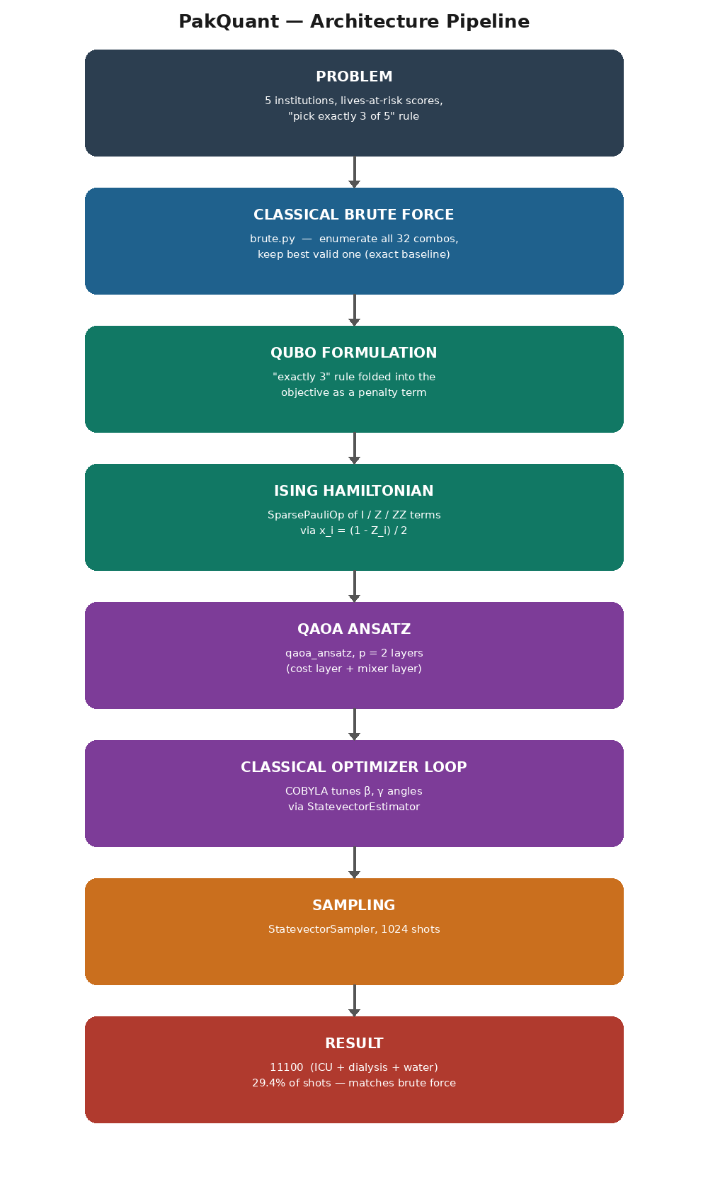

5. Implementation

5.1 Classical Baseline (brute.py)
Enumerates all 2^5 = 32 possible combinations, filters to those choosing exactly 3, and keeps the one with the highest total score.
Result: best k = 7, score = 220 (bits = 00111 → ICU + dialysis + water)

5.2 Quantum Solver (q1.py)
Builds the Hamiltonian from the QUBO, runs QAOA with p=2 layers, optimizes angles with COBYLA (scipy), then samples the tuned circuit 1024 times.

6. Results Against the Exact Baseline
Method | Best answer | Score | Notes
Brute force | ICU + dialysis + water | 220 | Exact, exhaustive, 32 combos checked
QAOA (p=2) | ICU + dialysis + water | 220 | Matches exactly, 29.4% of 1024 shots (301/1024)
QAOA 2nd result | ICU + dialysis + mall | — | Invalid — breaks the exactly-3 rule, 13.9% of shots

Final QAOA energy after COBYLA optimization: 205.34
Best angles found: [0.901, 0.237, 0.383, 1.558]

QAOA found the same optimal answer as the exact classical baseline, with a 29.4% per-shot success rate at a shallow depth of p=2 — meaning roughly 1 in 3 measurements already lands on the correct answer without any deeper circuit.

7. Limitations
Brute force scales badly, not QAOA: with 5 institutions there are only 32 combinations, so brute force is instant here — but that number doubles with every institution added. At 50 institutions, brute force would need to check 2^50 (over a quadrillion) combinations, which is no longer feasible on any classical computer in reasonable time. This is precisely the regime where a quantum approach is intended to help.
Honestly reporting the quantum result: QAOA matched the optimal answer, but only on 29.4% of the 1024 shots — meaning 71% of individual measurements were not the optimal combination. This is not a flaw unique to this implementation; it reflects the use of a shallow circuit (p=2 layers) and the current lack of fault-tolerant, large-scale quantum hardware. More layers (higher p) generally improve the probability of landing on the optimal answer, at the cost of a harder classical optimization (more angles for COBYLA to tune) and more circuit depth, which on real hardware means more exposure to noise.
This solver was run on a classical simulator (Qiskit's StatevectorEstimator and StatevectorSampler), not on real IBM quantum hardware. A simulator computes exact quantum state evolution with no hardware noise, so these results represent an idealized best case. Results on real hardware would likely show lower success rates due to gate errors, decoherence, and measurement noise — a real limitation of current quantum computing (the NISQ era) that this project does not yet test.

8. Next Steps
The direct next step is to run this same circuit on real IBM Quantum hardware (via Qiskit Runtime) rather than a simulator, to see how much the success rate drops once real noise is introduced — and to compare that honestly against the simulator's idealized 29.4%.

9. Credits
- Built using Qiskit (IBM open-source quantum SDK)
- Classical optimization via SciPy (COBYLA)
- AI assistance (Claude) was used for explanation and debugging support while writing and understanding the code and this report. All code was written and understood by the team, and all conclusions and results are our own.

