**Introduction**

Diving into the domain of deep learning, the PDF Helper project stands as a methodical exploration of natural language processing and document comprehension. With the application of the BERT model (Bidirectional Encoder Representations from Transformers), this project demonstrates the potential of deep learning models in extracting meaningful insights from intricate textual data.

The core objective of PDF Helper is to facilitate users in interacting with PDF documents in a more intuitive and dynamic manner. The BERT model's ability to comprehend the nuanced textual content within PDF files empowers users to pose specific questions related to the document. This approach enhances accessibility to information and broadens the scope of human-computer interaction.

A notable feature of PDF Helper is its text summarization capability. Beyond answering user queries, the model generates concise and coherent summaries of the PDF content. This summarization feature adds a layer of convenience, enabling users to quickly grasp key insights from a document without delving into its entirety.

In essence, PDF Helper leverages the capabilities of BERT, supported by the simplicity of Streamlit deployment, to create a dynamic platform for users to interact with PDF documents through natural language queries. This project represents a significant stride in bridging the gap between users and complex textual data, fostering a more intuitive and efficient approach to document exploration and understanding.

**Literature review**

The contemporary digital landscape has witnessed an exponential growth in the volume and diversity of electronic documents, necessitating effective solutions for document management and information extraction. Within this context, the "DocHelper" project emerges as a significant initiative, utilizing advanced deep learning methodologies, specifically BERT (Bidirectional Encoder Representations from Transformers). This literature review aims to comprehensively investigate the domain of document processing, with a specific focus on the integration of BERT for facilitating human-document interaction through natural language conversation. By critically examining the theoretical foundations of BERT, evaluating existing approaches to document comprehension, and analyzing the challenges and opportunities associated with the infusion of deep learning into document-centric applications, this review seeks to provide an exhaustive overview of the current state-of-the-art in the field. Through a systematic exploration, we aim to elucidate the advancements achieved by DocHelper and its broader implications for augmenting document accessibility and usability in the era of information overload.

Machine learning, particularly deep learning, has demonstrated unparalleled success in various natural language processing tasks, and BERT stands out as a prominent representative of this paradigm. BERT's bidirectional contextualized embeddings have proven to be highly effective in capturing intricate linguistic relationships, enabling superior performance in tasks such as question answering, text classification, and information retrieval. The incorporation of BERT into the domain of document processing signifies a significant step forward, as it addresses the nuances inherent in understanding the context and semantics of textual information within documents.

To contextualize the discussion, it is imperative to delve into the theoretical underpinnings of BERT. BERT, based on transformer architecture, employs attention mechanisms to capture contextual information from both preceding and succeeding words in a given sequence. This bidirectional approach enhances the model's ability to grasp intricate dependencies and semantic nuances, making it particularly adept at understanding the intricacies of natural language. As we explore the role of BERT in the DocHelper project, it becomes crucial to discern how this model's inherent capabilities contribute to the effective processing of documents for conversational interactions.

The landscape of document understanding is diverse, encompassing tasks such as text summarization, entity recognition, and sentiment analysis. BERT's versatility positions it as a robust candidate for document-centric applications, where nuanced comprehension is essential. Existing approaches in document processing have traditionally relied on rule-based systems, statistical methods, or shallow learning techniques. The integration of BERT disrupts this paradigm by leveraging deep neural networks to automatically learn intricate document representations, allowing for more nuanced and contextually rich interactions.

However, despite the promising prospects of incorporating BERT into document processing, several challenges must be addressed. The computational intensity of deep learning models, including BERT, poses scalability concerns, particularly when dealing with large document corpora. Additionally, the need for annotated training data and fine-tuning parameters for specific document domains remains a pertinent consideration. This review critically evaluates these challenges, providing insights into the potential limitations and avenues for future research and development.

In conclusion, the exploration of the DocHelper project and its integration of BERT represents a significant advancement in the realm of document processing and human-document interaction. The synergistic coupling of advanced deep learning techniques with the challenges posed by document-centric applications opens new vistas for enhancing the accessibility and usability of information embedded in electronic documents. As we navigate through the theoretical foundations, practical applications, and challenges associated with this integration, a comprehensive understanding of the current state-of-the-art in document processing and the transformative potential of the DocHelper project comes to the fore.

We start by taking a look upon the basics, the artificial neuron.

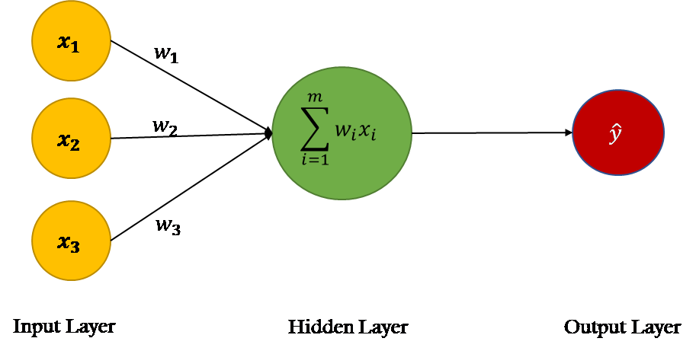

The field of machine learning has witnessed remarkable advancements in recent years, with artificial neural networks (ANNs) emerging as a cornerstone in various applications. At the core of ANNs lies the fundamental building block known as the artificial neuron. This literature review aims to provide a comprehensive exploration of artificial neurons, delving into their historical development, structural components, mathematical formulations, and functional significance within the broader context of machine learning.

Artificial neurons serve as the fundamental units in the construction of artificial neural networks, drawing inspiration from their biological counterparts. The inception of artificial neurons can be traced back to the pioneering work of Warren McCulloch and Walter Pitts in the 1940s, who aimed to model the basic principles of information processing in the human brain. Understanding the intricacies of artificial neurons is crucial for grasping the functioning of neural networks, which have become indispensable tools in diverse fields such as image recognition, natural language processing, and autonomous systems.

Perceptron Model - The simplest form of an artificial neuron is modeled after the perceptron, consisting of input weights, a summation function, an activation function, and an output. This section explores the architectural components and the flow of information within a perceptron.

Multilayer Perceptrons - To enhance the representational power of artificial neurons, multilayer perceptrons were introduced. The review elucidates the structure of MLPs, elucidating the role of hidden layers and the backpropagation algorithm in training these networks.

**Mathematical Formulations:**

1. Activation Functions: Artificial neurons employ activation functions to introduce non-linearity into the model. This section examines popular activation functions such as sigmoid, hyperbolic tangent, and rectified linear unit (ReLU), elucidating their impact on the learning dynamics.

2. Weight Initialization and Learning Rates: The review investigates weight initialization strategies and learning rate optimization, pivotal factors in training artificial neurons effectively. Understanding these aspects is crucial for mitigating issues such as vanishing gradients and slow convergence.

**Functional Significance:**

1. Feature Representation: Artificial neurons play a pivotal role in learning complex feature representations from input data, enabling neural networks to discern patterns and make predictions. This section discusses how artificial neurons contribute to feature extraction and abstraction.

2. Universal Function Approximators: The universal approximation theorem underscores the capability of artificial neurons to approximate any continuous function. The review examines the theoretical underpinnings of this theorem and its implications for the expressive power of neural networks.

From this simple digital artifact, the whole field of machine learning experienced a great boom.

**Neural networks**

Neural networks represent a cornerstone in the realm of machine learning, leveraging the principles of artificial neurons to model complex relationships in data. This literature review endeavors to present a thorough examination of neural networks, tracing their historical evolution, elucidating their architectural nuances, exploring training methodologies, and discussing their wide-ranging applications in contemporary machine learning scenarios.

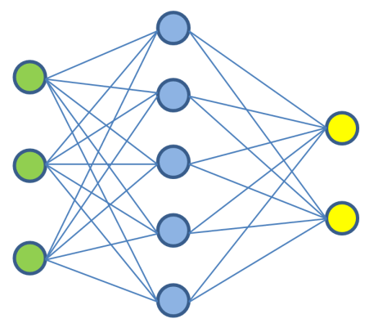

Architectural Components:

1. Feedforward Neural Networks (FNNs): The foundational structure of neural networks lies in feedforward architectures. This section dissects the components of FNNs, detailing the role of input layers, hidden layers, output layers, and the interconnecting weights. Special emphasis is placed on the abstraction of hierarchical features through these layers.

2. Recurrent Neural Networks (RNNs): Incorporating temporal dependencies, recurrent neural networks have gained prominence in sequence-based tasks. The review explores the architecture of RNNs, emphasizing their ability to capture context and dynamic patterns, making them suitable for applications such as speech recognition and time-series analysis.

Training Methodologies:

1. Backpropagation Algorithm: A cornerstone in training neural networks, backpropagation optimizes model parameters by minimizing the discrepancy between predicted and actual outputs. This section provides a detailed exposition of the backpropagation algorithm, exploring its mathematical foundations and practical implementation.

2. Optimization Techniques: To expedite training and enhance convergence, various optimization techniques have been proposed. The literature review investigates popular optimization algorithms such as stochastic gradient descent (SGD), Adam, and RMSprop, outlining their strengths and limitations.

Applications in Machine Learning:

1. Image Recognition: Neural networks have demonstrated unprecedented success in image recognition tasks. This section examines the application of convolutional neural networks (CNNs), a specialized form of neural networks, in extracting hierarchical features from images and classifying objects.

2. Natural Language Processing (NLP): The review delves into the role of recurrent neural networks and transformer architectures in NLP tasks, including language translation, sentiment analysis, and text generation. Neural networks have revolutionized language understanding and generation capabilities.

Challenges and Future Directions:

1. Overfitting and Regularization: Despite their success, neural networks are susceptible to overfitting. This section discusses challenges related to model generalization and explores regularization techniques aimed at mitigating overfitting.

2. Explainability and Interpretability: As neural networks grow in complexity, the need for model interpretability becomes paramount. The literature review explores challenges associated with the interpretability of neural networks and highlights ongoing research in explainable AI.

**Machine learning** (ML), an interdisciplinary field at the intersection of computer science and statistics, has become a linchpin in the technological landscape. This literature review aims to provide an exhaustive exploration of machine learning, spanning its historical roots, foundational concepts, diverse techniques, and the burgeoning trends that shape its trajectory. As machine learning continues to permeate various facets of our daily lives, understanding its underpinnings and staying abreast of recent developments is essential for both practitioners and researchers.

1. Introduction:

1.1 Historical Overview:

The roots of machine learning can be traced back to the mid-20th century, with early foundations laid by pioneers such as Alan Turing and Arthur Samuel. This section offers a chronological overview, highlighting key milestones that have propelled machine learning from theoretical conjectures to practical implementations.

1.2 Significance and Motivation:

In an era marked by exponential growth in data generation, machine learning provides a systematic approach to extracting meaningful insights and making predictions. This section underscores the importance of machine learning in addressing complex problems and driving innovations across diverse domains.

2. Foundations of Machine Learning:

2.1 Supervised Learning:

Supervised learning forms the bedrock of machine learning, where algorithms learn from labeled training data to make predictions or classifications. This section elucidates the principles behind supervised learning, exploring algorithms such as linear regression, support vector machines, and decision trees.

2.2 Unsupervised Learning:

Unsupervised learning, a paradigm where algorithms extract patterns from unlabeled data, is examined in detail. Clustering, dimensionality reduction, and generative models constitute the core focus, with discussions on k-means, principal component analysis (PCA), and autoencoders.

2.3 Reinforcement Learning:

The literature review delves into the realm of reinforcement learning, where agents learn optimal behaviors through interaction with an environment. Concepts such as Markov decision processes, Q-learning, and policy gradients are explored, highlighting applications in gaming, robotics, and autonomous systems.

3. Advanced Techniques in Machine Learning:

3.1 Deep Learning:

The advent of deep learning, a subfield of machine learning, has revolutionized the landscape with neural networks of unprecedented depth. This section explores the architecture of deep neural networks, convolutional neural networks (CNNs) for image processing, recurrent neural networks (RNNs) for sequential data, and the transformative impact of transformer models.

3.2 Transfer Learning and Meta-Learning:

To address challenges related to limited labeled data, transfer learning and meta-learning strategies have gained prominence. This section delves into techniques that enable models to leverage knowledge gained from one task to enhance performance on another, fostering adaptability and efficiency.

4. Machine Learning Applications:

4.1 Healthcare:

Machine learning applications in healthcare, including disease diagnosis, drug discovery, and personalized medicine, are examined. The review discusses the transformative potential of ML in revolutionizing healthcare delivery and improving patient outcomes.

4.2 Finance:

In the financial sector, machine learning algorithms play a pivotal role in fraud detection, risk assessment, and algorithmic trading. This section explores the application of ML techniques such as support vector machines and deep learning models in financial analytics.

4.3 Natural Language Processing (NLP):

The intersection of machine learning and natural language processing is a burgeoning area with profound implications for human-computer interaction. The literature review explores NLP applications, sentiment analysis, language translation, and conversational agents, emphasizing the role of machine learning in understanding and generating human language.

5. Emerging Trends and Challenges:

5.1 Explainable AI:

As machine learning models grow in complexity, the challenge of interpretability becomes paramount. The review discusses the need for explainable AI and explores emerging techniques that enhance the interpretability of black-box models.

5.2 Federated Learning:

The literature review investigates the paradigm of federated learning, an approach that enables model training across decentralized devices while preserving data privacy. This emerging trend is explored in the context of edge computing and the Internet of Things (IoT).

5.3 Ethical Considerations:

As machine learning applications proliferate, ethical concerns regarding bias, fairness, and accountability have come to the forefront. This section delves into the ethical dimensions of machine learning, discussing ongoing efforts to address these concerns and foster responsible AI.

**Deep learning**, a subfield of machine learning, has emerged as a powerful paradigm revolutionizing the landscape of artificial intelligence. This literature review aims to provide an in-depth exploration of deep learning, elucidating its foundational architectures, fundamental techniques, and the cutting-edge advancements shaping its trajectory. As deep learning continues to drive breakthroughs in various domains, a nuanced understanding of its principles and ongoing developments is essential for researchers, practitioners, and enthusiasts alike.

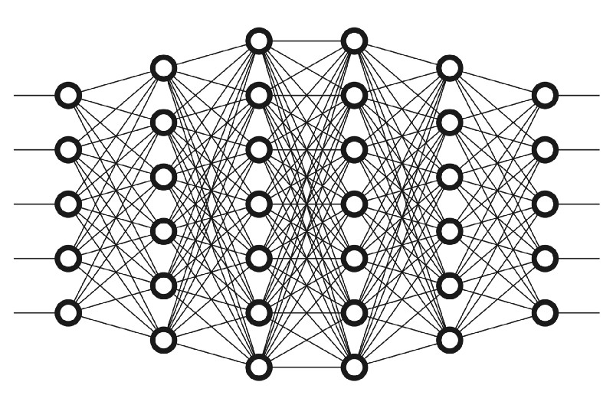

1.1 Distinction from Machine Learning:

Deep learning, as a subset of machine learning, diverges in its emphasis on neural networks with multiple layers, enabling the hierarchical abstraction of features. This section establishes the distinction between traditional machine learning and deep learning and highlights the transformative impact of deep neural architectures.

1.2 Motivation:

The increasing complexity of data and the demand for sophisticated pattern recognition have propelled the prominence of deep learning. This section emphasizes the motivation behind the surge in interest, citing its success in domains such as computer vision, natural language processing, and speech recognition.

2. Foundational Architectures:

2.1 Feedforward Neural Networks (FNNs):

Deep learning often begins with an exploration of feedforward neural networks. This section revisits the basic principles of FNNs, highlighting how the stacking of multiple hidden layers facilitates the extraction of hierarchical features from input data.

2.2 Convolutional Neural Networks (CNNs):

CNNs, a specialized form of neural networks designed for spatial data, have revolutionized image processing. The literature review delves into the architecture of CNNs, emphasizing their application in tasks such as image classification, object detection, and semantic segmentation.

2.3 Recurrent Neural Networks (RNNs):

For sequential and time-series data, recurrent neural networks have proven indispensable. This section explores the architecture of RNNs, their ability to capture temporal dependencies, and their applications in tasks like language modeling and speech recognition.

3. Fundamental Techniques in Deep Learning:

3.1 Backpropagation and Gradient Descent:

The foundational principles of backpropagation and gradient descent are integral to training deep neural networks. This section revisits these techniques, emphasizing their role in optimizing model parameters and mitigating challenges associated with vanishing and exploding gradients.

3.2 Transfer Learning and Pre-trained Models:

To address the data scarcity challenge, transfer learning has gained prominence in deep learning. The literature review explores techniques that leverage pre-trained models, such as fine-tuning and feature extraction, to boost performance on specific tasks.

4. Advanced Architectures and Techniques:

4.1 Generative Adversarial Networks (GANs):

The review delves into the realm of generative adversarial networks, exploring their unique architecture and applications in generating realistic synthetic data, image-to-image translation, and style transfer.

4.2 Transformer Models:

The advent of transformer models has redefined natural language processing and beyond. This section explores the architecture of transformers, the attention mechanism, and their applications in tasks like machine translation and language understanding.

5. Applications of Deep Learning:

5.1 Computer Vision:

Deep learning has demonstrated unparalleled success in computer vision applications. This section explores the role of deep neural networks, particularly CNNs, in image recognition, object detection, and facial recognition.

5.2 Natural Language Processing (NLP):

The literature review examines the transformative impact of deep learning in NLP, including applications such as sentiment analysis, text generation, and language translation. Attention mechanisms in transformers have significantly advanced the capabilities of NLP models.

5.3 Autonomous Systems and Robotics:

Deep learning plays a pivotal role in the development of autonomous systems and robotics. This section explores applications in self-driving cars, robotic navigation, and sensor data interpretation.

6. Current Frontiers and Challenges:

6.1 Self-Supervised Learning:

The review investigates the paradigm of self-supervised learning, an emerging trend that leverages unlabeled data for model training. This approach has shown promise in addressing data scarcity and enhancing model generalization.

6.2 Explainability and Interpretability:

As deep learning models become increasingly complex, the literature review explores challenges related to model interpretability and efforts to develop techniques for explaining the decision-making processes of deep neural networks.

**Transformer models**, a breakthrough in deep learning architecture, have reshaped the landscape of artificial intelligence, particularly in the domain of natural language processing (NLP). This literature review aims to provide an extensive exploration of transformer models, elucidating their foundational architecture, attention mechanism, diverse variants, and the transformative impact on NLP applications. As transformer models continue to expand their footprint into various domains, understanding their principles and ongoing developments is essential for researchers, practitioners, and enthusiasts.

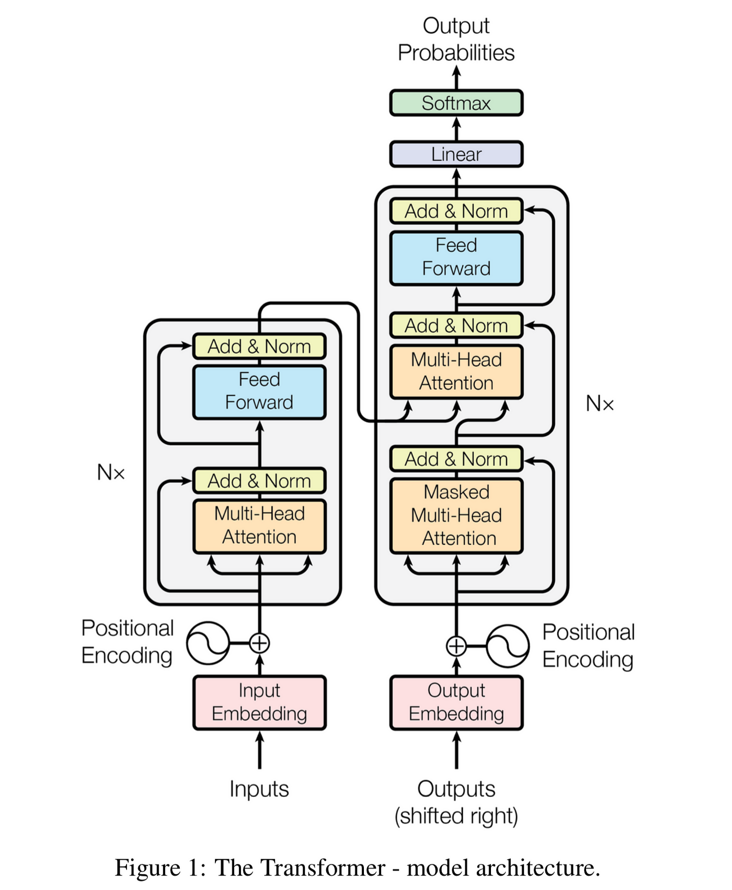

1. Introduction:

1.1 Genesis of Transformers:

The inception of transformer models in the seminal paper "Attention is All You Need" by Vaswani et al. marked a paradigm shift in deep learning. This section delves into the historical context, tracing the development of transformers and highlighting their departure from traditional recurrent and convolutional architectures.

1.2 Motivation:

The motivation behind the surge in interest and widespread adoption of transformer models lies in their ability to capture long-range dependencies efficiently, making them especially well-suited for complex tasks such as language translation, sentiment analysis, and text generation.

2. Foundational Architecture:

2.1 Attention Mechanism:

The crux of transformer models is the attention mechanism, allowing them to selectively focus on different parts of the input sequence. This section provides an in-depth exploration of the attention mechanism, its mathematical formulation, and its pivotal role in enabling parallelized processing of input data.

2.2 Transformer Architecture:

The review dissects the architecture of transformers, comprising encoder and decoder layers. Each layer integrates self-attention mechanisms and feedforward neural networks, creating a modular and scalable structure. The section also explores the role of positional encoding in handling sequential data.

3. Variants and Innovations:

3.1 BERT (Bidirectional Encoder Representations from Transformers):

The introduction of BERT marked a milestone in NLP by pre-training models on large corpora in a bidirectional manner. This section delves into the architecture of BERT, its pre-training objectives, and the impact it had on downstream tasks such as question answering and named entity recognition.

3.2 GPT (Generative Pre-trained Transformer):

GPT, another influential variant, is explored for its unidirectional language model pre-training. This section discusses the autoregressive nature of GPT, the use of transformers for language modeling, and its applications in text completion and generation.

4. Transfer Learning Paradigm:

4.1 Fine-Tuning and Domain Adaptation:

Transformer models facilitate transfer learning by pre-training on large datasets and fine-tuning on task-specific data. The literature review discusses the principles of fine-tuning and domain adaptation, exploring their applications across various domains.

4.2 Multimodal Transformers:

The intersection of vision and language processing is examined through the lens of multimodal transformers. This section explores how transformers have been adapted to process both textual and visual information, leading to advancements in tasks like image captioning and visual question answering.

5. Applications of Transformer Models:

5.1 Language Translation:

Transformer models have set new benchmarks in machine translation tasks. The review explores how attention mechanisms enable transformers to handle varying-length input and output sequences, improving translation quality and fluency.

5.2 Sentiment Analysis:

In sentiment analysis, transformer models exhibit exceptional performance in capturing contextual nuances and dependencies within text. This section delves into the applications of transformers in sentiment analysis, showcasing their ability to understand and interpret sentiment across diverse contexts.

5.3 Question Answering:

Transformers have shown remarkable success in question answering tasks. The literature review explores how attention mechanisms enable models to focus on relevant parts of the input sequence, enhancing their ability to extract accurate answers.

6. Current Frontiers and Challenges:

6.1 Cross-Lingual Understanding:

The review investigates ongoing research in cross-lingual understanding, exploring how transformer models are being adapted to handle multiple languages efficiently. The challenges associated with low-resource languages are also discussed.

6.2 Efficient Transformer Architectures:

Efforts to streamline and optimize transformer architectures for resource-constrained environments are explored. This section discusses techniques such as knowledge distillation and model quantization, aiming to deploy transformer models on edge devices.

6.3 Ethical Considerations:

As transformer models become increasingly influential, ethical considerations related to biases in pre-training data and the impact on societal narratives are discussed. Ongoing efforts to address these concerns are highlighted.

Title: BERT (Bidirectional Encoder Representations from Transformers): A Deep Dive into Pre-training and Applications in Natural Language Processing

**BERT (Bidirectional Encoder Representations from Transformers)**

BERT has emerged as a groundbreaking transformer-based model, redefining the landscape of natural language processing (NLP). This literature review provides a detailed exploration of BERT, encompassing its foundational pre-training methodology, architecture, fine-tuning strategies, and the transformative impact it has had on various NLP applications. Understanding BERT's principles and its evolving role in language understanding is crucial for researchers, practitioners, and enthusiasts engaged in the field of artificial intelligence.

1. Introduction:

1.1 Genesis of BERT:

The advent of BERT marked a pivotal moment in NLP, as it departed from traditional unidirectional language models. This section delves into the motivations behind BERT's development, its key contributors, and the paradigm shift it introduced in pre-training strategies.

1.2 Motivation:

BERT's motivation lies in its ability to comprehend contextual information bidirectionally, allowing it to capture intricate relationships within sentences and improve performance on a myriad of downstream NLP tasks. This section emphasizes the motivation driving the adoption of BERT across the NLP community.

2. Foundational Pre-training Methodology:

2.1 Masked Language Model (MLM):

The crux of BERT's pre-training lies in the MLM objective, where random tokens within a sentence are masked, and the model is trained to predict these masked tokens. This section provides a detailed explanation of the MLM strategy, elucidating how it facilitates bidirectional contextual understanding.

2.2 Next Sentence Prediction (NSP):

To enhance BERT's ability to understand sentence relationships, the NSP objective is introduced. This section explores the NSP strategy, discussing its role in training BERT to discern whether two sentences are contiguous or not.

3. BERT Architecture:

3.1 Transformer-Based Architecture:

BERT adopts the transformer architecture, leveraging self-attention mechanisms to capture contextual dependencies. This section revisits the transformer architecture, emphasizing how it is tailored for BERT's pre-training objectives and bidirectional understanding.

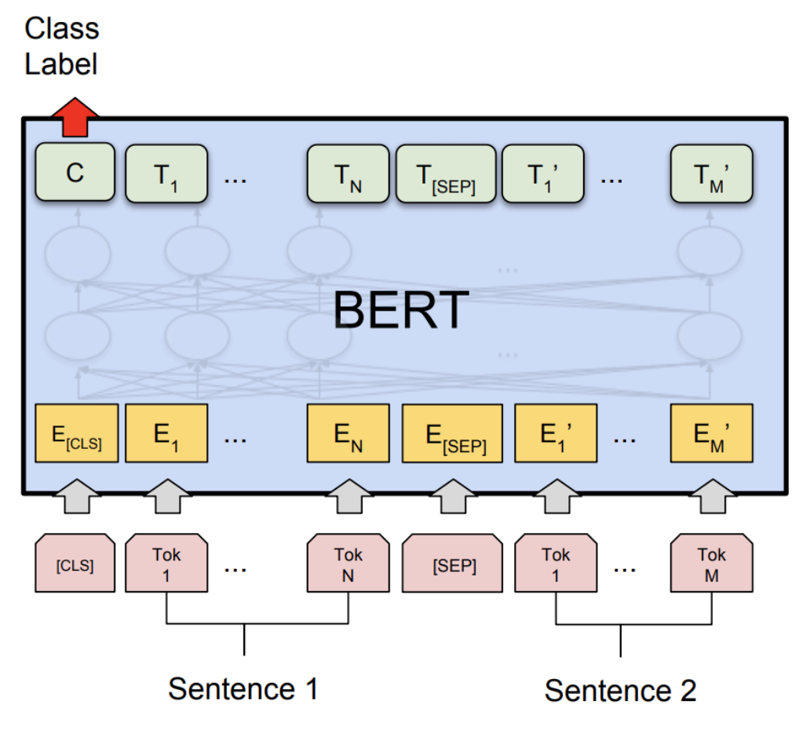

3.2 Encoder Layers and Attention Mechanisms:

The literature review dissects the architecture of BERT's encoder layers, detailing the multiple attention heads and the mechanisms that enable the model to attend to different parts of the input sequence simultaneously.

4. Fine-Tuning Strategies:

4.1 Task-Specific Fine-Tuning:

BERT's pre-trained representations can be fine-tuned on task-specific datasets. This section explores fine-tuning strategies, discussing how task-specific objectives are incorporated to adapt BERT to various NLP applications.

4.2 Transfer Learning and Multitask Learning:

The review explores BERT's efficacy in transfer learning, emphasizing its ability to generalize knowledge across diverse NLP tasks. Multitask learning approaches, where BERT is simultaneously trained on multiple tasks, are also discussed.

5. Applications of BERT:

5.1 Named Entity Recognition (NER):

BERT has demonstrated exceptional performance in NER tasks, accurately identifying and classifying entities within text. This section explores how BERT's bidirectional contextual understanding enhances its capability in NER.

5.2 Question Answering:

The literature review examines BERT's contributions to question answering tasks, showcasing its ability to comprehend complex queries and provide accurate responses. The impact of BERT on question answering benchmarks is discussed.

5.3 Sentiment Analysis:

BERT's bidirectional contextual understanding is harnessed in sentiment analysis tasks. This section explores how BERT captures nuanced sentiments within text, contributing to improved sentiment analysis models.

6. Current Frontiers and Challenges:

6.1 Knowledge Integration:

The review investigates ongoing research on integrating external knowledge into BERT, enhancing its contextual understanding by leveraging external resources. Challenges associated with knowledge integration are discussed.

6.2 Robustness and Generalization:

As BERT models are deployed in real-world scenarios, the literature review explores challenges related to model robustness and generalization. Ongoing efforts to address these challenges and improve BERT's reliability are highlighted.

6.3 Multimodal BERT:

Exploring the intersection of BERT and multimodal tasks, this section discusses efforts to extend BERT's capabilities to process both textual and visual information. Applications in tasks like image captioning and visual question answering are explored.

7. Conclusion:

In conclusion, BERT stands as a transformative model in NLP, revolutionizing the way machines understand and process language. This literature review has provided a comprehensive exploration of BERT's pre-training methodology, architecture, fine-tuning strategies, and applications across diverse NLP tasks. As BERT continues to evolve, addressing current challenges and pushing the frontiers of its capabilities will contribute to its sustained impact on artificial intelligence and language understanding.

**Problem Definition**

The PDF Helper project emerges from the recognition of a pervasive challenge in the realm of digital information management, specifically pertaining to the interaction with PDF documents. The underlying predicament centers around the constrained accessibility and inherent rigidity in engaging with the intricate textual data encapsulated within PDF files. This challenge is amplified by the intricate nature of human language, often nuanced and context-dependent, which poses difficulties for conventional methods of information extraction and comprehension.

In seeking to address this multifaceted issue, PDF Helper endeavors to harness the potential of deep learning, with a particular focus on the BERT (Bidirectional Encoder Representations from Transformers) model. The crux of the problem lies in the conventional methods' inadequacy to facilitate a truly dynamic and intuitive interaction with textual data within PDF documents. Users are often restricted to keyword-based searches, lacking the flexibility to pose questions in a natural language format, hindering the efficiency and depth of their exploration.

The confined nature of traditional PDF document interaction methods becomes evident when attempting to extract meaningful insights or comprehend complex content comprehensively. The existing paradigm falls short in enabling users to navigate through the intricacies of documents, inhibiting the potential for rich, contextual understanding. This limitation is especially pronounced when users aim to pose specific questions related to the document content, as traditional approaches struggle to interpret the contextual nuances and respond accurately.

Moreover, the contemporary landscape of document comprehension tools often neglects the necessity for succinct and coherent summaries of content. Users are compelled to delve into the entirety of a document to glean key insights, consuming valuable time and impeding the efficiency of information retrieval. This lack of text summarization functionality further compounds the challenges faced by users in efficiently extracting relevant information from voluminous textual data.

In essence, PDF Helper seeks to unravel the complexities of user interaction with PDF documents, recognizing the inadequacies of conventional methods in facilitating dynamic, natural language-based queries and comprehensive information extraction. By venturing into the domain of deep learning and adopting the BERT model, the project endeavors to redefine the landscape of document exploration and understanding, offering users a more intuitive, efficient, and enriched interaction with intricate textual data within PDF files.

**Objectives**

The objectives of the PDF Helper deep learning project are intricately designed to revolutionize document interaction by harnessing the power of the BERT model and deploying a user-friendly interface through Streamlit. The primary goals of this innovative undertaking are as follows:

1. **Enhance Information Retrieval from PDFs:**
   * Improve user accessibility to information stored in PDF documents.
   * Facilitate efficient and accurate retrieval of relevant content through natural language queries, leveraging the power of BERT model.
2. **Streamline Document Understanding:**
   * Enable users to ask context-aware questions about PDF content, promoting a more intuitive interaction with the document.
   * Enhance comprehension by providing concise text summarizations, aiding users in quickly grasping key information within the document.
3. **User-Friendly Document Exploration:**
   * Foster a user-friendly interface using Streamlit, allowing seamless interaction with the deep learning model.
   * Empower users to navigate and comprehend PDF documents effortlessly, transforming a traditionally static format into an interactive knowledge resource.
4. **Promote Learning and Research:**
   * Cater to students, researchers, and professionals by facilitating easy exploration and extraction of knowledge from academic papers and research articles.
   * Encourage a more interactive and dynamic approach to engaging with scholarly content, enhancing the learning and research experience.
5. **Efficient Document Review:**
   * Support professionals in fields such as law, finance, and consulting by streamlining the process of reviewing detailed documents.
   * Enable users to extract key insights and information swiftly, improving productivity and decision-making in document-intensive tasks.

**Methodology Used**

The DocHelper project leverages a combination of advanced natural language processing (NLP) techniques and machine learning (ML) methodologies, predominantly utilizing BERT (Bidirectional Encoder Representations from Transformers) as the cornerstone for its question-answering functionality. The implementation is carried out in Python, incorporating several prominent ML libraries, and the user interface is developed using Streamlit.

During the development phase, our team harnessed a diverse array of libraries and technologies to bring the DocHelp application to life. The integration of these tools played a pivotal role in shaping the application's functionality and user experience. Here's a brief overview of the key libraries and technologies employed:

Langchain: Langchain served as a foundational element, contributing to the application's linguistic capabilities. It played a crucial role in processing and understanding natural language queries, enriching DocHelp with advanced language processing capabilities.

Streamlit: Streamlit emerged as the framework for building the user interface of DocHelp. Its simplicity and efficiency allowed for the creation of an intuitive and dynamic interface that facilitates seamless user interactions with the application.

Transformers: Leveraging the Transformers library, specifically BERT (Bidirectional Encoder Representations from Transformers), enhanced the language understanding capabilities of DocHelp. BERT's advanced natural language processing played a central role in interpreting and responding to user queries accurately.

Requests: The Requests library facilitated efficient handling of HTTP requests, enabling seamless communication between DocHelp and external resources, ensuring smooth data retrieval and processing.

Torch: PyTorch's Torch library was instrumental in implementing and fine-tuning machine learning models within the application. This included the integration of BERT for language processing tasks.

Einops: Einops, a library for tensor manipulation, contributed to the efficient handling and transformation of data structures within DocHelp, enhancing the overall processing pipeline.

Accelerate: Accelerate played a role in optimizing the application's performance by leveraging hardware acceleration, ensuring efficient execution of computational tasks.

BitsandBytes: BitsandBytes contributed to low-level data manipulation tasks, providing essential functionality for handling binary data and file operations within DocHelp.

Py2PDF played a vital role in parsing and extracting information from PDF documents, enhancing the application's document processing capabilities.

Beautiful Soup (bs4): Beautiful Soup facilitated web scraping tasks, allowing DocHelp to extract relevant information from web-based sources, thereby enriching its data retrieval capabilities.

Sentence Transformers: The Sentence Transformers library contributed to the generation of meaningful document embeddings, enhancing the application's ability to understand and compare textual content.

ChromaDB: ChromaDB emerged as a robust database solution, seamlessly handling document storage, retrieval, and manipulation within DocHelp.

Pydantic-Settings: Pydantic-Settings provided a streamlined approach to managing application settings, ensuring flexibility and ease of configuration.

PyPDF: PyPDF played a role in handling PDF-related tasks, contributing to the application's capabilities in extracting and manipulating content from PDF documents.

Streamlit-Chat: Streamlit-Chat enriched the user interface by integrating chat functionalities, creating an engaging and interactive environment for users to interact with DocHelp.

This comprehensive integration of libraries and technologies showcases the diversity and depth of the tools employed to create a feature-rich, dynamic, and user-friendly document assistance application.

Metrics such as EM, precision, recall, and F1 score are employed to assess the model's accuracy, and adjustments are made to optimize the system's responsiveness to user queries.

If we take the theoretical answers and predicted answers, the number of shared words between theoretical and predicted answer is the basis for f1 score.precision is the ratio of the number of shared words to the total number of words in the prediction, and recall is the ratio of the number of shared words to the total number of words in the ground truth.

In conclusion, the methodologies employed in DocHelper synergize cutting-edge NLP techniques, powerful ML libraries, and a user-friendly interface, providing a robust and effective solution for users seeking to extract information from PDF documents through intuitive questioning. The integration of BERT, Python, and associated libraries ensures a cohesive and efficient implementation, while Streamlit enhances the overall user experience. The project reflects a comprehensive approach to document analysis, underscoring the interdisciplinary nature of modern natural language processing applications.

**Conclusion and Future Scope**

In conclusion, the PDF Helper project emerges as a pioneering endeavor in the realm of deep learning, specifically within the domains of natural language processing and document comprehension. By harnessing the power of the BERT model, this project not only showcases the immense potential of deep learning models but also addresses the critical need for enhancing user interaction with PDF documents.

The overarching goal of PDF Helper, to facilitate a more intuitive and dynamic interaction with PDFs, is commendably achieved through BERT's prowess in comprehending intricate textual data. The model's capability to interpret nuanced content empowers users to extract meaningful insights and pose specific questions, thereby expanding the horizons of human-computer interaction and information accessibility.

An outstanding feature of PDF Helper lies in its text summarization capability, providing users with concise and coherent summaries of PDF content. This not only addresses user queries but also adds a layer of convenience, allowing users to quickly grasp key insights without navigating through the entire document.

In essence, PDF Helper, with its reliance on BERT and the simplicity of Streamlit deployment, establishes itself as a dynamic platform for users to interact with PDF documents through natural language queries. This project represents a significant leap forward in bridging the gap between users and complex textual data, ushering in a more intuitive and efficient approach to document exploration and understanding. As technology continues to advance, PDF Helper serves as a testament to the possibilities that lie at the intersection of deep learning and document processing, paving the way for further innovation in the field.

**Limitations**

1. **Single Language Support:** One of the notable limitations of the PDF Helper project is its restriction to a single language, specifically English. The BERT model, while highly effective in understanding and processing textual data, is trained on English language corpora. As a result, the model's proficiency is confined to English, and it may encounter challenges when handling documents in other languages. This limitation could be a hindrance for users who require multilingual support, especially in diverse and globalized environments.
2. **Inability to Parse Images:** Another significant constraint of the PDF Helper project is its incapability to parse images within PDF documents. While the BERT model excels in processing and comprehending textual content, it lacks the inherent ability to interpret or extract information from non-textual elements such as images. This limitation restricts the project's applicability in scenarios where visual content plays a crucial role, such as documents containing charts, graphs, or diagrams. Users seeking insights from visual data will find the PDF Helper less suitable for their needs.
3. **Limited Document Format Compatibility:** PDF Helper focuses exclusively on PDF documents, and it does not extend its functionality to other document formats. This limitation can be restrictive for users who work with a variety of document types, such as Microsoft Word (.docx), PowerPoint (.pptx), or other common formats. The inability to handle diverse document formats limits the project's versatility and may necessitate users to employ additional tools or platforms for processing documents in formats other than PDF.
4. **Response Length Constraint:** Due to the context size limitation, the responses generated by PDF Helper are constrained in length. The BERT model processes information in context, and the context window has a practical size limit. Consequently, when generating responses or summaries, PDF Helper may truncate or limit the length of the output. This limitation could impact the comprehensiveness of responses, especially for lengthy or complex documents, where a more extensive summary might be desired. Users may find themselves needing to navigate through the entire document separately for a complete understanding, defeating the purpose of a concise summary.

While PDF Helper represents a commendable advancement in natural language processing and document comprehension, addressing these limitations could further enhance its utility and broaden its applicability across a wider range of scenarios and user requirements. Future iterations or complementary tools might seek to overcome these constraints for a more comprehensive and versatile document processing solution.

The future scope of the PDF Helper project holds tremendous potential for expansion and refinement, with opportunities to overcome current limitations and introduce innovative features. As the technology landscape evolves, the following avenues present promising directions for further development:

1. Multilingual Support:

Enhancing the language capabilities of PDF Helper to support multiple languages would significantly broaden its user base. Incorporating multilingual models or language translation capabilities could empower users to interact with documents in languages beyond English, making the tool more inclusive and adaptable to diverse linguistic contexts.

2. Image Processing Integration:

Addressing the current limitation related to image parsing would be a key focus for the future. Introducing features that allow the model to comprehend and extract information from images within PDF documents would make PDF Helper more versatile. This could involve integrating computer vision models or collaborating with image processing technologies to extend the tool's comprehension to visual content.

3. Expanded Document Format Compatibility:

To cater to a wider range of user needs, future iterations of PDF Helper could extend support to various document formats beyond PDF. Integrating parsers for common formats such as Microsoft Word, PowerPoint, and others would enhance the tool's versatility, enabling users to interact with documents in the format of their choice.

4. Contextual Understanding Improvement:

Enhancing the model's context handling and response generation capabilities, particularly for lengthy documents, would contribute to a more comprehensive user experience. Techniques like improved context window management or more sophisticated summarization algorithms could address the current constraint on response length, providing users with richer and more detailed insights.

5. User Interface Enhancements:

Improving the user interface and user experience would contribute to the overall accessibility of PDF Helper. Streamlining the interaction process, providing clear instructions, and implementing intuitive features could make the tool more user-friendly, appealing to a broader audience with varying levels of technical expertise.

6. Collaboration and Integration with External Tools:

Exploring partnerships or integrations with other tools and platforms in the document processing ecosystem could add value to PDF Helper. Seamless collaboration with popular productivity suites or document management systems could enhance the workflow and utility of the tool within professional and organizational settings.

7. Scalability and Performance Optimization:

As the user base grows, optimizing the scalability and performance of PDF Helper would be crucial. Implementing efficient algorithms, leveraging distributed computing, and ensuring the tool's responsiveness even with large and complex documents would contribute to a robust and reliable user experience.

8. Feedback Mechanism and Continuous Learning:

Establishing a feedback loop with users and implementing mechanisms for continuous learning could aid in refining the model based on real-world usage. Regular updates and improvements, guided by user feedback and emerging technological trends, would ensure that PDF Helper remains a cutting-edge solution in the evolving landscape of deep learning and document processing.

By exploring these future directions, PDF Helper has the potential to evolve into a comprehensive and indispensable tool for users seeking efficient and intelligent interactions with textual data in various formats.