**About Dataset**

**Flipkart Customer Review and Rating**

**Context**

The dataset was produced by extracting data from Flipkart.com using a crawler (or bots) that crawled to the deepest of the web pages (more than 13 thousand mobile reviews) on 02-23-2023.

**Content**

The dataset consists of 9 columns

1. **product_id**: Product id
2. **product_title**: Mobiles name on which customer gives the reviews
3. **rating**: Ratings given by the customer
4. **summary**: Reviews summary or details given by the customer
5. **review**: Reviews given by the customer
6. **location**: Location of customer
7. **date**: Date on which customer gives the review
8. **upvotes**: Up votes given by the customer
9. **downvotes**: Down votes given by the customer

**Interpretation:**

The ratings are number of Stars given my customer to the product.  
These stars can be interpreted in many ways like

* **Sentiment ( Positive or Negative )**

This can be achieved by forming into a binary classification model with a threshold function like

rating >=4 -> Positive

rating <4 -> Negative

* **Ratings**

This can be achieved by considering ratings as individual class. Several other visualisations, interpretations and models can be drawn from the dataset.

**List of Products:**

['POCO C31 (Shadow Gray, 64 GB)',

'REDMI 10 (Caribbean Green, 64 GB)',

'Infinix HOT 20 Play (Racing Black, 64 GB)',

'Infinix HOT 20 Play (Luna Blue, 64 GB)',

'Infinix HOT 20 Play (Fantasy Purple, 64 GB)',

'REDMI 10 (Midnight Black, 64 GB)',

'Infinix HOT 20 Play (Aurora Green, 64 GB)',

'MOTOROLA G62 5G (Midnight Gray, 128 GB)',

'APPLE iPhone 11 (White, 128 GB)',

'vivo T1 44W (Midnight Galaxy, 128 GB)',

'vivo T1 44W (Starry Sky, 128 GB)',

'MOTOROLA g52 (Charcoal Grey, 64 GB)',

'vivo T1 44W (Midnight Galaxy, 128 GB)',

'MOTOROLA G62 5G (Frosted Blue, 128 GB)',

'POCO C31 (Shadow Gray, 32 GB)',

'MOTOROLA g52 (Charcoal Grey, 128 GB)',

'POCO C31 (Royal Blue, 64 GB)',

'POCO M4 Pro (Cool Blue, 64 GB)',

'vivo T1 44W (Starry Sky, 128 GB)',

'vivo T1 44W (Midnight Galaxy, 128 GB)']

**Basic Information:**

BASE_URL = 'https://www.flipkart.com/'

SEARCH_QUERY = "mobile"

TOP_N_PRODUCTS = 20

REVIEW_PAGES_TO_SCRAPE_FROM_PER_PRODUCT = 150 #10 Reviews exist per page

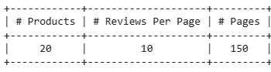

**Dataset Sample:**

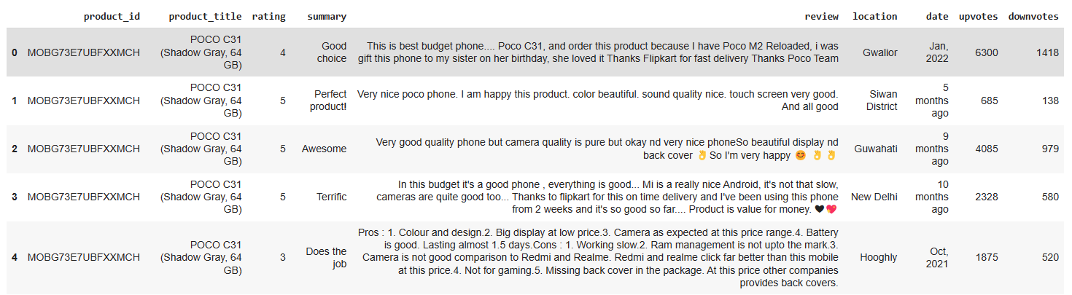

**Acknowledgements**

This dataset was created by Abdul Manan using web-crawling service.

**Inspiration**

Analyses of the product specification and brand, sentiment can be performed.