DEVSPHERE INTERNSHIP PROGRAM
Week 3 Task Report
Machine Learning Introduction — Building a Basic ML Model
Iris Flower Species Classification using a Decision Tree Classifier
Field | Details
Intern Name | [Your Full Name]
Designation | Artificial Intelligence (AI) Intern
Program | DevSphere Internship Program
Task | Week 3 — Machine Learning Intro
Language / Tools | Python 3, scikit-learn, pandas, matplotlib
Submission Date | [Date]

Table of Contents

(Right-click the table above in Word and choose "Update Field" to populate the page numbers.)

1. Objective
The objective of this task was to move from rule-based programming into machine learning by building a complete, working ML pipeline. Rather than hand-coding the decision rules myself, as in the previous task, the goal here was to let an algorithm discover those rules automatically from data.
The task requirements were:
- Load a dataset
- Train a simple machine learning model
- Make predictions using the trained model
- Display and explain the output
I extended the minimum requirements by adding data exploration, a stratified train/test split, a full evaluation section (accuracy, confusion matrix, precision/recall), feature-importance analysis and a prediction on a completely new, unseen sample. These additions make the result verifiable rather than merely functional.

2. Tools and Environment
Component | Version / Detail | Purpose
Python | 3.12 | Core programming language
pandas | 2.x | Loading and exploring tabular data
scikit-learn | 1.x | Dataset, model, splitting and evaluation
matplotlib | 3.x | Visualising the tree and results
Editor | VS Code | Writing and running the program

Installation command used:
pip install pandas scikit-learn matplotlib

3. Dataset Description
I used the Iris flower dataset, a standard benchmark dataset that ships inside scikit-learn. It requires no external download, which keeps the program fully reproducible on any machine.
Property | Value
Dataset name | Iris flower dataset (Fisher, 1936)
Total samples | 150 flowers
Features | 4 numeric measurements in centimetres
Feature names | sepal length, sepal width, petal length, petal width
Target classes | setosa, versicolor, virginica
Class balance | 50 samples per class (perfectly balanced)
Missing values | None
Problem type | Multi-class classification

Each row records four measurements of a single flower, and the task is to predict which of the three species it belongs to. Because the dataset is balanced and clean, it is well suited to a first machine learning experiment: any weakness in the result comes from the model, not from the data.
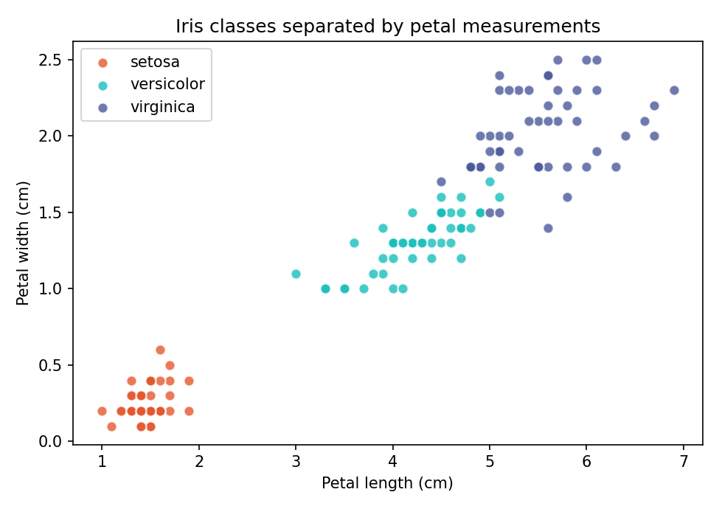
Figure 1 — Plotting petal length against petal width shows why this dataset is learnable: setosa is entirely separate, while versicolor and virginica overlap slightly.

4. Methodology
The program follows the standard supervised learning workflow, implemented in seven clearly separated steps.

4.1 Loading the data
The dataset is loaded with load_iris() and wrapped in a pandas DataFrame so the columns carry readable names. The numeric target labels (0, 1, 2) are mapped to species names for display.

4.2 Exploring the data
Before training, the program prints the class distribution, summary statistics and a missing-value count. This step is often skipped by beginners, but it is what tells you whether a dataset is balanced and clean enough to train on.

4.3 Splitting into training and testing sets
The 150 samples are split 80/20 into 120 training samples and 30 testing samples. Three parameters matter here:
- test_size=0.2 reserves a fifth of the data that the model never sees during training.
- random_state=42 fixes the random seed, so every run produces identical results and the figures in this report are reproducible.
- stratify=y preserves the 1:1:1 class ratio inside both the training and testing sets, preventing a split that accidentally under-represents a species.
This separation is essential. Evaluating a model on the same rows it trained on would only measure memorisation, not genuine learning.

4.4 Training the model
I chose a Decision Tree Classifier because its internal logic can be printed and read as a set of if-else conditions, which connects directly to the rule-based program written in the earlier task. The depth is limited to 3 (max_depth=3) to prevent overfitting: an unrestricted tree would keep splitting until it memorised every training row, including its noise, and would then perform worse on new data.

4.5 Making predictions
The trained model predicts the species of all 30 held-out test flowers. Each prediction is placed beside the true label in a comparison table so that correct and incorrect results are visible individually.

4.6 Evaluating the model
Accuracy alone can be misleading, so the evaluation also reports a confusion matrix and a per-class precision, recall and F1-score breakdown, showing exactly which species the model confuses.

4.7 Predicting an unseen sample
Finally, the model is given a brand-new set of measurements that appears nowhere in the dataset, demonstrating how the trained model would be used in a real application.

5. Source Code
The complete program is contained in a single file, week3_basic_ml.py, listed below.
"""
Week 3 Task - Machine Learning Intro
Basic ML Model

Steps covered:
1. Load dataset
2. Explore the data
3. Split into training and testing sets
4. Train a simple model
5. Make predictions
6. Evaluate and show output
7. Predict on a brand new sample

Dataset : Iris (built into scikit-learn, no download needed)
Model : Decision Tree Classifier
Run : python week3_basic_ml.py
Requires: pip install pandas scikit-learn
"""

import pandas as pd
from sklearn.datasets import load_iris
from sklearn.model_selection import train_test_split
from sklearn.tree import DecisionTreeClassifier, export_text
from sklearn.metrics import (
accuracy_score,
confusion_matrix,
classification_report,
)

def line(title=""):
print("\n" + "=" * 60)
if title:
print(title)
print("=" * 60)

# ----------------------------------------------------------------------
# STEP 1: LOAD DATASET
# ----------------------------------------------------------------------
line("STEP 1: LOAD DATASET")

iris = load_iris()

# Put the data into a DataFrame so it is easy to read
df = pd.DataFrame(iris.data, columns=iris.feature_names)
df["species"] = [iris.target_names[i] for i in iris.target]

print(f"Dataset name : Iris flower dataset")
print(f"Total samples : {df.shape[0]}")
print(f"Features : {df.shape[1] - 1}")
print(f"Classes : {', '.join(iris.target_names)}")

print("\nFirst 5 rows:")
print(df.head())

# ----------------------------------------------------------------------
# STEP 2: EXPLORE THE DATA
# ----------------------------------------------------------------------
line("STEP 2: EXPLORE THE DATA")

print("Samples per class:")
print(df["species"].value_counts())

print("\nBasic statistics:")
print(df.describe().round(2))

print("\nMissing values per column:")
print(df.isnull().sum())

# ----------------------------------------------------------------------
# STEP 3: SPLIT INTO TRAINING AND TESTING SETS
# ----------------------------------------------------------------------
line("STEP 3: SPLIT THE DATA")

X = df[iris.feature_names] # features (input) - kept as a DataFrame
y = iris.target # labels (output)

X_train, X_test, y_train, y_test = train_test_split(
X, y,
test_size=0.2, # 20% kept aside for testing
random_state=42, # fixed seed so results are reproducible
stratify=y # keep class balance in both sets
)

print(f"Training samples : {len(X_train)}")
print(f"Testing samples : {len(X_test)}")

# ----------------------------------------------------------------------
# STEP 4: TRAIN THE MODEL
# ----------------------------------------------------------------------
line("STEP 4: TRAIN THE MODEL")

model = DecisionTreeClassifier(max_depth=3, random_state=42)
model.fit(X_train, y_train)

print("Model type : Decision Tree Classifier")
print("Max depth : 3")
print("Status : trained successfully")

# ----------------------------------------------------------------------
# STEP 5: MAKE PREDICTIONS
# ----------------------------------------------------------------------
line("STEP 5: MAKE PREDICTIONS ON TEST DATA")

y_pred = model.predict(X_test)

results = pd.DataFrame({
"Actual": [iris.target_names[i] for i in y_test],
"Predicted": [iris.target_names[i] for i in y_pred],
})
results["Correct"] = results["Actual"] == results["Predicted"]

print(results.to_string(index=False))

# ----------------------------------------------------------------------
# STEP 6: EVALUATE THE MODEL
# ----------------------------------------------------------------------
line("STEP 6: EVALUATE THE MODEL")

accuracy = accuracy_score(y_test, y_pred)
print(f"Accuracy: {accuracy:.2f} ({accuracy * 100:.1f}%)")

print("\nConfusion matrix (rows = actual, columns = predicted):")
cm = pd.DataFrame(
confusion_matrix(y_test, y_pred),
index=iris.target_names,
columns=iris.target_names,
)
print(cm)

print("\nClassification report:")
print(classification_report(y_test, y_pred, target_names=iris.target_names))

print("Feature importance (how much each feature influenced the decisions):")
for name, score in zip(iris.feature_names, model.feature_importances_):
print(f" {name:<22} {score:.3f}")

print("\nRules the model learned:")
print(export_text(model, feature_names=list(iris.feature_names)))

# ----------------------------------------------------------------------
# STEP 7: PREDICT A NEW, UNSEEN FLOWER
# ----------------------------------------------------------------------
line("STEP 7: PREDICT A NEW SAMPLE")

# [sepal length, sepal width, petal length, petal width] in cm
new_flower = pd.DataFrame(
[[5.1, 3.5, 1.4, 0.2]],
columns=iris.feature_names,
)

predicted_class = model.predict(new_flower)[0]
probabilities = model.predict_proba(new_flower)[0]

print("New measurements:")
for name, value in zip(iris.feature_names, new_flower.iloc[0]):
print(f" {name:<22} {value} cm")

print(f"\nPredicted species : {iris.target_names[predicted_class]}")
print("Confidence per class:")
for name, prob in zip(iris.target_names, probabilities):
print(f" {name:<12} {prob * 100:.1f}%")

line("PROGRAM FINISHED")

6. Program Output
The following is the exact console output produced by running the command below. The program completes without warnings or errors.
python week3_basic_ml.py

============================================================
STEP 1: LOAD DATASET
============================================================
Dataset name : Iris flower dataset
Total samples : 150
Features : 4
Classes : setosa, versicolor, virginica

First 5 rows:
sepal length (cm) sepal width (cm) ... petal width (cm) species
0 5.1 3.5 ... 0.2 setosa
1 4.9 3.0 ... 0.2 setosa
2 4.7 3.2 ... 0.2 setosa
3 4.6 3.1 ... 0.2 setosa
4 5.0 3.6 ... 0.2 setosa

[5 rows x 5 columns]

============================================================
STEP 2: EXPLORE THE DATA
============================================================
Samples per class:
species
setosa 50
versicolor 50
virginica 50
Name: count, dtype: int64

Basic statistics:
sepal length (cm) sepal width (cm) petal length (cm) petal width (cm)
count 150.00 150.00 150.00 150.00
mean 5.84 3.06 3.76 1.20
std 0.83 0.44 1.77 0.76
min 4.30 2.00 1.00 0.10
25% 5.10 2.80 1.60 0.30
50% 5.80 3.00 4.35 1.30
75% 6.40 3.30 5.10 1.80
max 7.90 4.40 6.90 2.50

Missing values per column:
sepal length (cm) 0
sepal width (cm) 0
petal length (cm) 0
petal width (cm) 0
species 0
dtype: int64

============================================================
STEP 3: SPLIT THE DATA
============================================================
Training samples : 120
Testing samples : 30

============================================================
STEP 4: TRAIN THE MODEL
============================================================
Model type : Decision Tree Classifier
Max depth : 3
Status : trained successfully

============================================================
STEP 5: MAKE PREDICTIONS ON TEST DATA
============================================================
Actual Predicted Correct
setosa setosa True
virginica virginica True
versicolor versicolor True
versicolor versicolor True
setosa setosa True
versicolor versicolor True
setosa setosa True
setosa setosa True
virginica virginica True
versicolor versicolor True
virginica virginica True
virginica virginica True
virginica virginica True
versicolor versicolor True
setosa setosa True
setosa setosa True
setosa setosa True
versicolor versicolor True
versicolor versicolor True
virginica virginica True
setosa setosa True
virginica virginica True
versicolor versicolor True
virginica virginica True
virginica virginica True
versicolor virginica False
versicolor versicolor True
setosa setosa True
virginica virginica True
setosa setosa True

============================================================
STEP 6: EVALUATE THE MODEL
============================================================
Accuracy: 0.97 (96.7%)

Confusion matrix (rows = actual, columns = predicted):
setosa versicolor virginica
setosa 10 0 0
versicolor 0 9 1
virginica 0 0 10

Classification report:
precision recall f1-score support

setosa 1.00 1.00 1.00 10
versicolor 1.00 0.90 0.95 10
virginica 0.91 1.00 0.95 10

accuracy 0.97 30
macro avg 0.97 0.97 0.97 30
weighted avg 0.97 0.97 0.97 30

Feature importance (how much each feature influenced the decisions):
sepal length (cm) 0.000
sepal width (cm) 0.000
petal length (cm) 0.579
petal width (cm) 0.421

Rules the model learned:
|--- petal length (cm) <= 2.45
| |--- class: 0
|--- petal length (cm) > 2.45
| |--- petal width (cm) <= 1.65
| | |--- petal length (cm) <= 4.95
| | | |--- class: 1
| | |--- petal length (cm) > 4.95
| | | |--- class: 2
| |--- petal width (cm) > 1.65
| | |--- petal length (cm) <= 4.85
| | | |--- class: 2
| | |--- petal length (cm) > 4.85
| | | |--- class: 2

============================================================
STEP 7: PREDICT A NEW SAMPLE
============================================================
New measurements:
sepal length (cm) 5.1 cm
sepal width (cm) 3.5 cm
petal length (cm) 1.4 cm
petal width (cm) 0.2 cm

Predicted species : setosa
Confidence per class:
setosa 100.0%
versicolor 0.0%
virginica 0.0%

============================================================
PROGRAM FINISHED
============================================================

7. Screenshots and Visual Results
Screenshot of the program running in the editor:
[ Paste your own screenshot of VS Code / terminal here ]
The figures below were generated from the trained model itself and document the result visually.
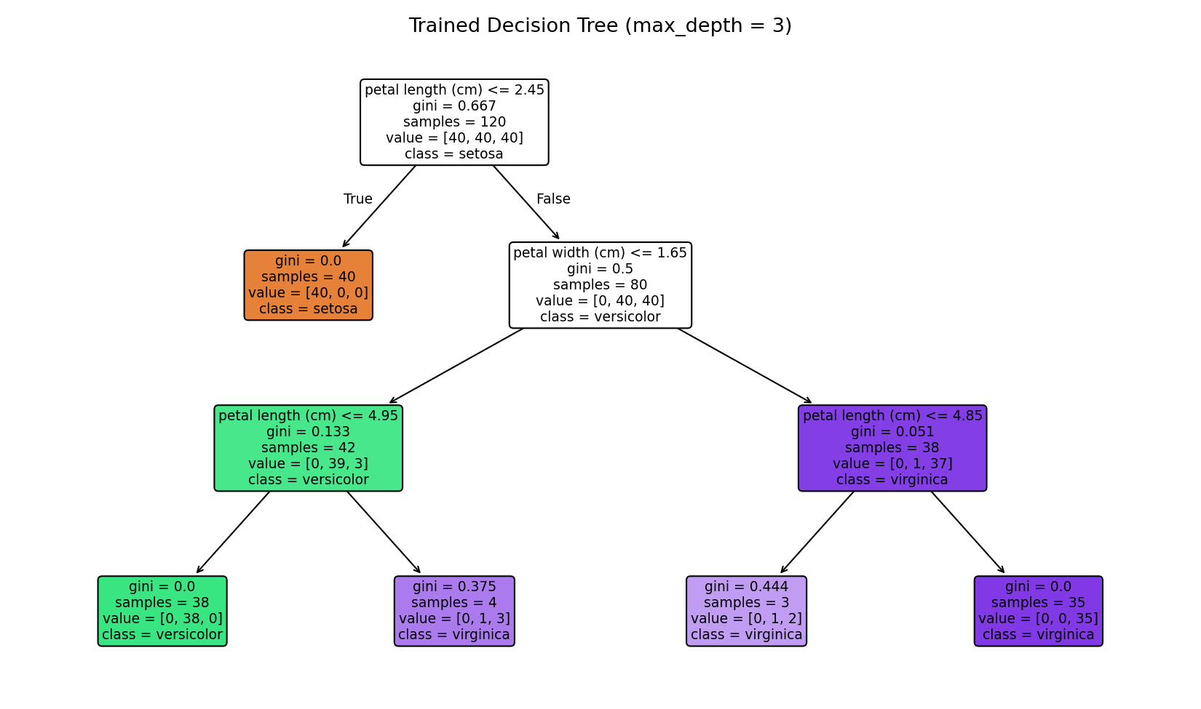
Figure 2 — The decision tree the model learned. Each box is a condition; following the branches from top to bottom classifies a flower.
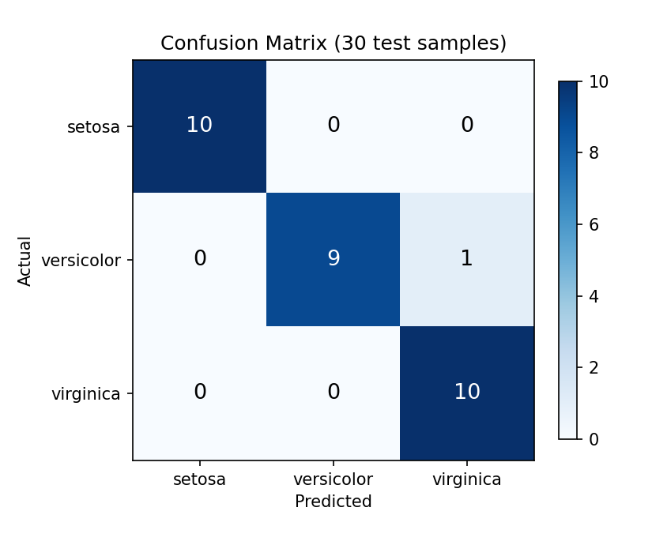
Figure 3 — Confusion matrix. The diagonal holds the correct predictions; the single off-diagonal value is the one misclassified flower.
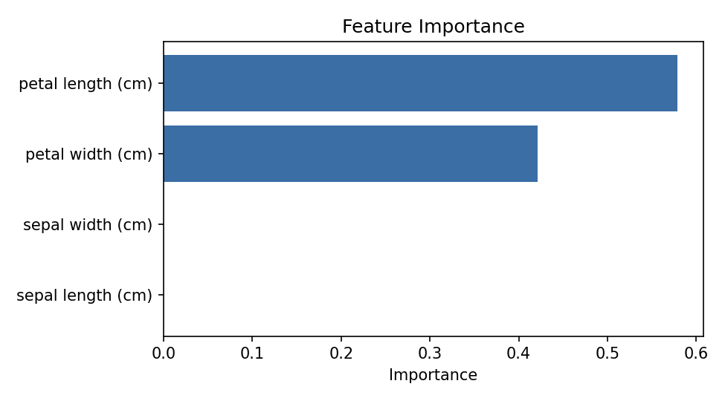
Figure 4 — Feature importance. The two petal measurements carry all of the predictive power; the sepal measurements were never used.

8. Results and Explanation

8.1 Accuracy
The model correctly classified 29 of the 30 test flowers, giving an accuracy of 96.7%. Since these 30 flowers were never used during training, this figure reflects genuine generalisation rather than memorisation.

8.2 What the confusion matrix shows
Actual species | Predicted setosa | Predicted versicolor | Predicted virginica
setosa | 10 | 0 | 0
versicolor | 0 | 9 | 1
virginica | 0 | 0 | 10

All ten setosa flowers and all ten virginica flowers were identified correctly. The single error was one versicolor flower classified as virginica. This is the expected failure mode: as Figure 1 shows, setosa is cleanly separated from the other two species, while versicolor and virginica overlap along the petal measurements. A borderline flower in that overlap region is genuinely ambiguous, and the model failed exactly where a human eye would hesitate.

8.3 Which features mattered
Petal length contributed 57.9% of the decision-making power and petal width 42.1%, while both sepal measurements scored 0.000 and were never used by the tree. The model therefore discovered on its own that petal size distinguishes these species and that sepal size is largely irrelevant — a conclusion a botanist would confirm, reached without being told.

8.4 The learned rules
Because a decision tree is interpretable, the rules it induced can be read directly. The first and most decisive rule is:
if petal length <= 2.45 cm:
class = setosa (40 of 40 training samples, perfectly pure)

That single condition isolates one species with no error at all. Remaining flowers are then separated mainly by petal width at a 1.65 cm threshold. This is the central lesson of the task: the structure is identical to the if-else logic I wrote by hand previously, but here the conditions and the threshold values were derived from 120 examples rather than chosen by me.

8.5 Prediction on a new sample
The model was given a new flower measuring 5.1 / 3.5 / 1.4 / 0.2 cm. It predicted setosa with 100% confidence, which is correct: a petal length of 1.4 cm falls well below the 2.45 cm threshold of the first rule. The confidence comes from the fact that the leaf reached contains only setosa training samples.

9. Challenges Faced
- Feature-name warning: training on a NumPy array and then predicting with a pandas DataFrame produced a scikit-learn warning about mismatched feature names. I resolved it by keeping the data as a DataFrame throughout, so the column names are consistent at both training and prediction time.
- Choosing the tree depth: an unrestricted tree scored perfectly on the training data but is prone to overfitting. Setting max_depth=3 produced a model that is both accurate on unseen data and simple enough to read and explain.
- Interpreting the single error: rather than treating the one misclassification as a defect, I plotted the data and confirmed that the error occurs in the region where two species genuinely overlap, which explains the result instead of hiding it.

10. What I Learned
- The difference between rule-based AI, where a human writes the conditions, and machine learning, where the algorithm derives them from data.
- Why data must be split before training, and what stratification and a fixed random seed protect against.
- That accuracy is only a summary: a confusion matrix reveals which specific classes a model confuses.
- How overfitting arises and how a depth limit acts as a simple guard against it.
- That feature importance can reveal which measurements actually drive a prediction, which is useful for reducing the amount of data a real system needs to collect.

11. Conclusion
The task was completed successfully. A Decision Tree Classifier was trained on the Iris dataset and reached 96.7% accuracy on 30 unseen test samples, with the one error occurring in the region where two species genuinely overlap. All four requirements — loading a dataset, training a model, making predictions and displaying output — were met, and the work was extended with data exploration, a full evaluation and interpretation of the learned rules.
The most valuable outcome was seeing that the model produced the same kind of if-else structure I had previously written by hand, but derived automatically from examples. That is, in essence, what machine learning contributes.

Appendix A — How to Run
# 1. Install the dependencies
pip install pandas scikit-learn matplotlib

# 2. Run the program
python week3_basic_ml.py

# No dataset file is required: the Iris data ships inside scikit-learn.

Files submitted: week3_basic_ml.py (source code) and this report.

