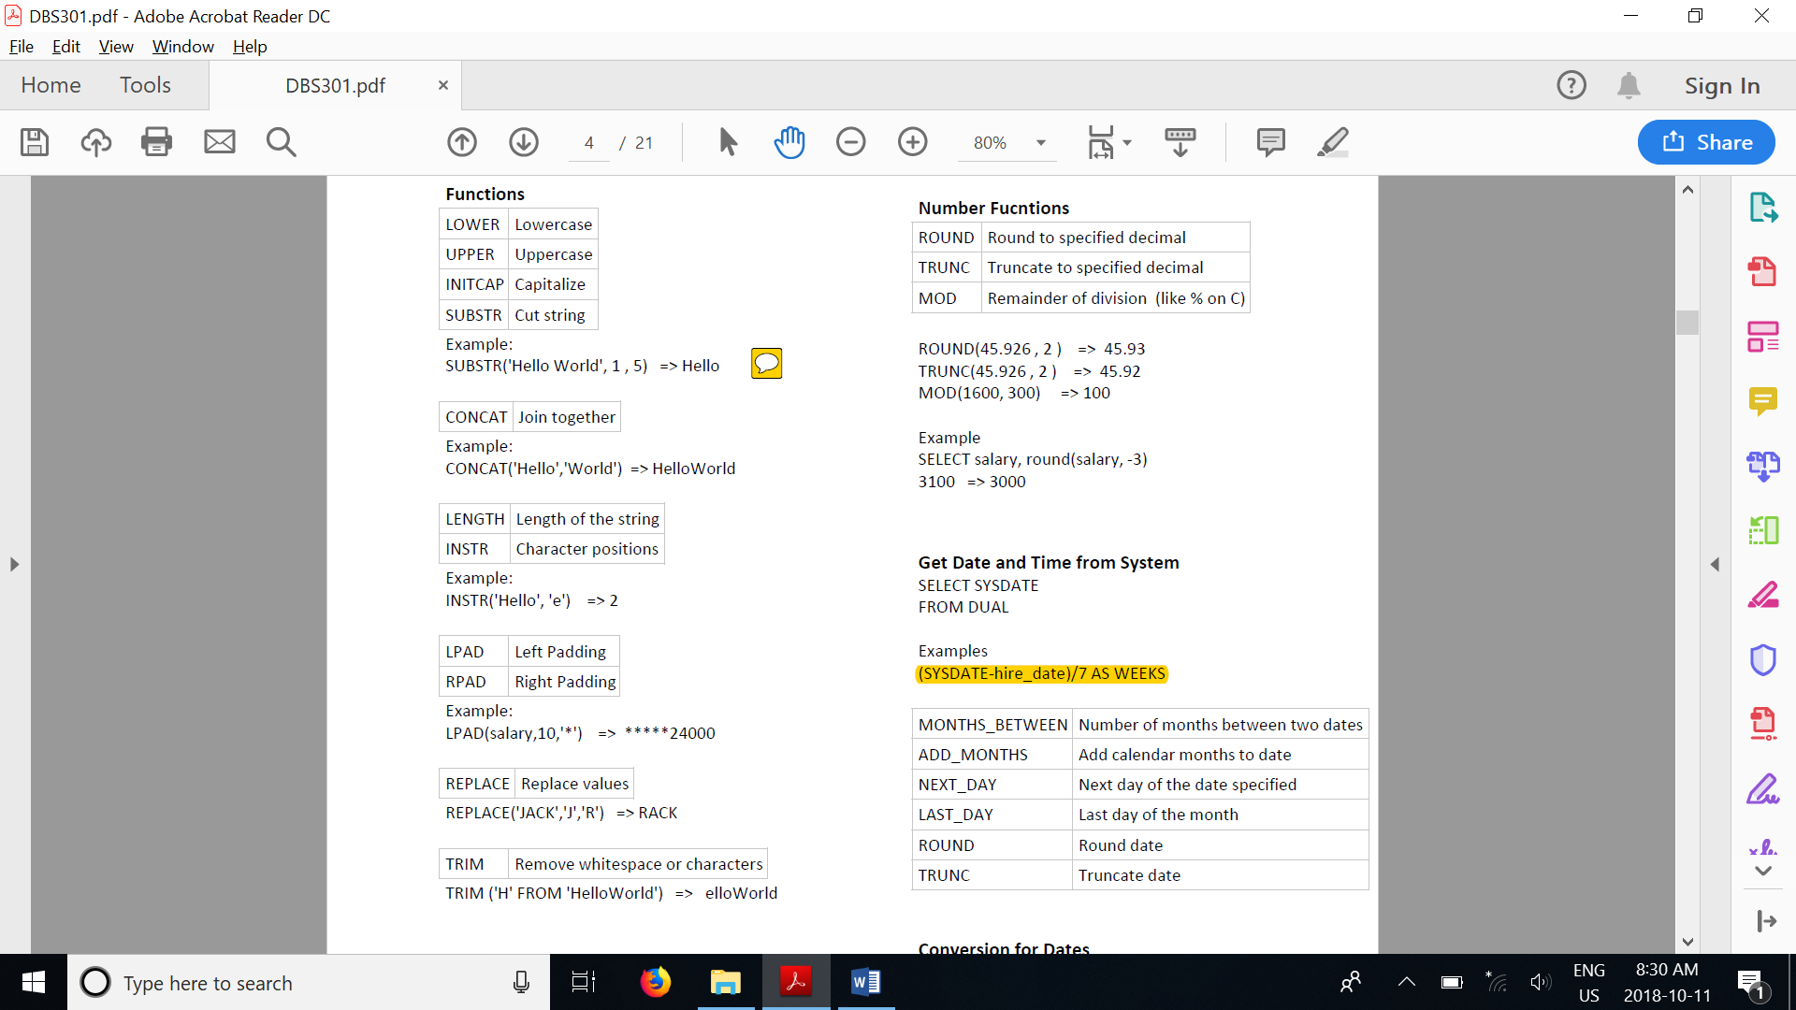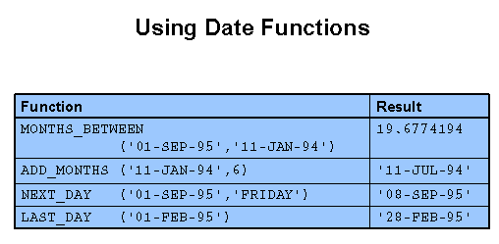LPAD(to_char(hire_date, 'fmDD-MON-YYYY'),11,'0')

select to_char(sysdate,'fm ddth "of" Mon YYYY')

COUNT (*) – returns the number of rows in a table

SELECT AVG (NVL (commission_pct, 0))

FROM employees;

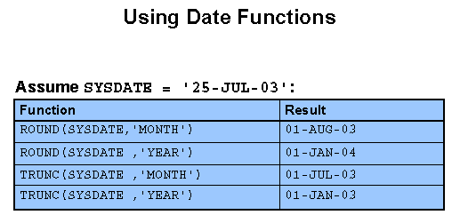

NVL (city, 'Unavailable' )

SELECT last_name, job_id, salary

CASE job_id WHEN 'IT_PROG' THEN 1.10*salary

WHEN 'ST_CLERK' THEN 1.15*salary

ELSE salary END "REVISED_SALARY"

FROM EMPLOYEES;

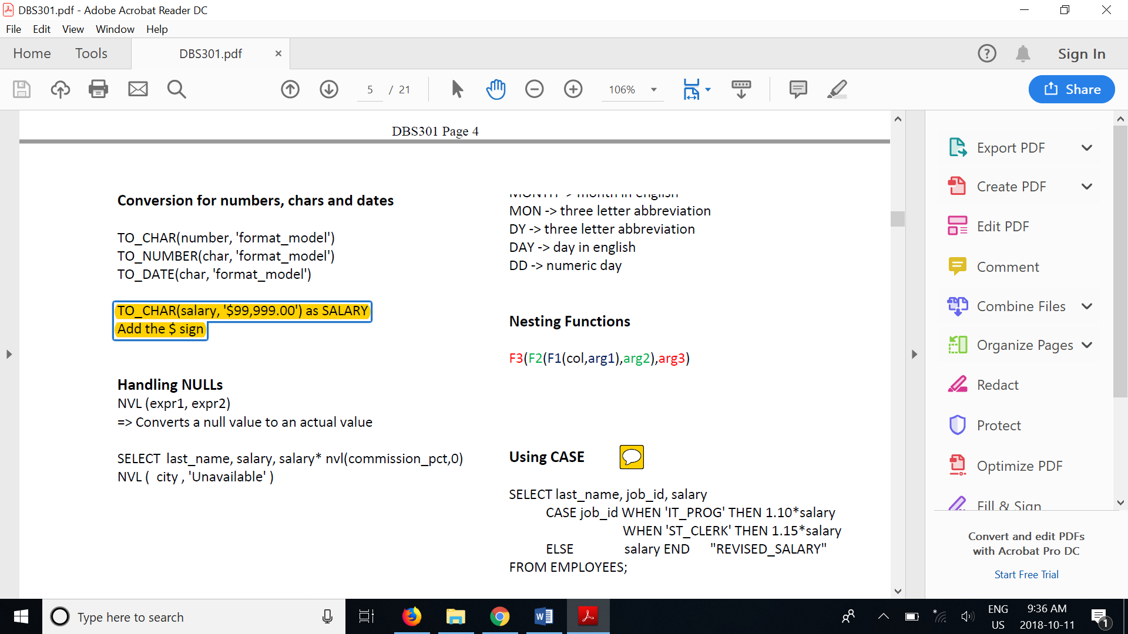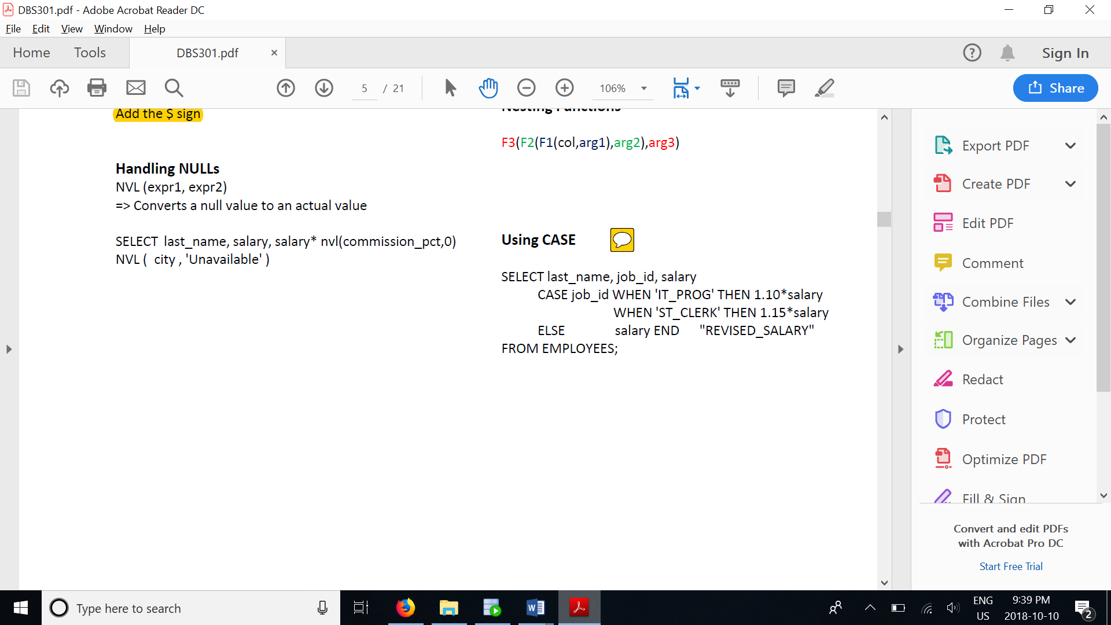

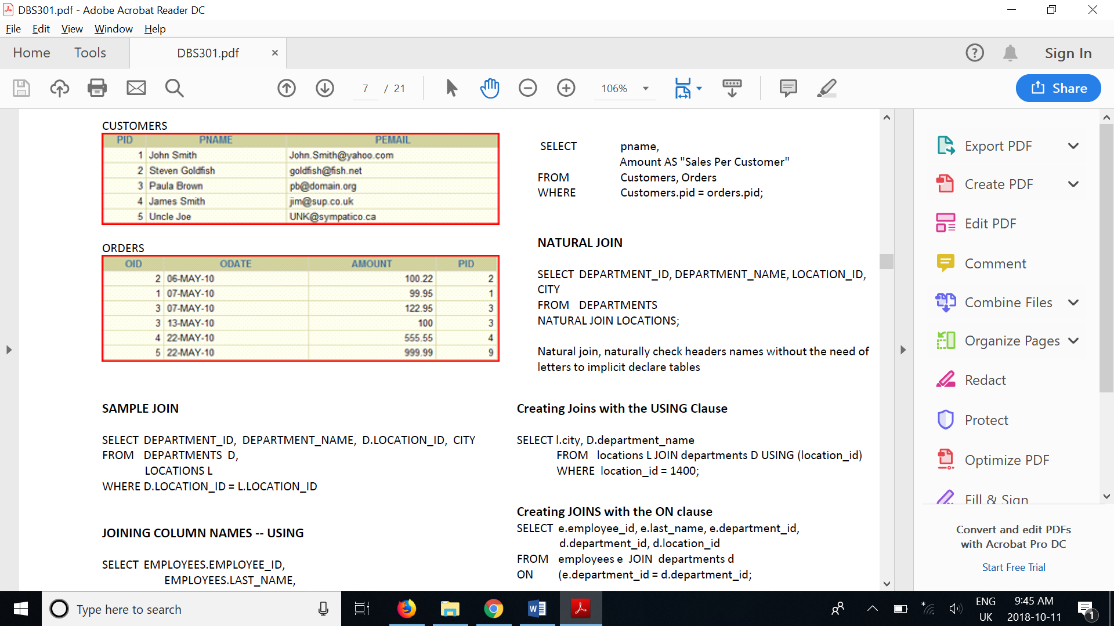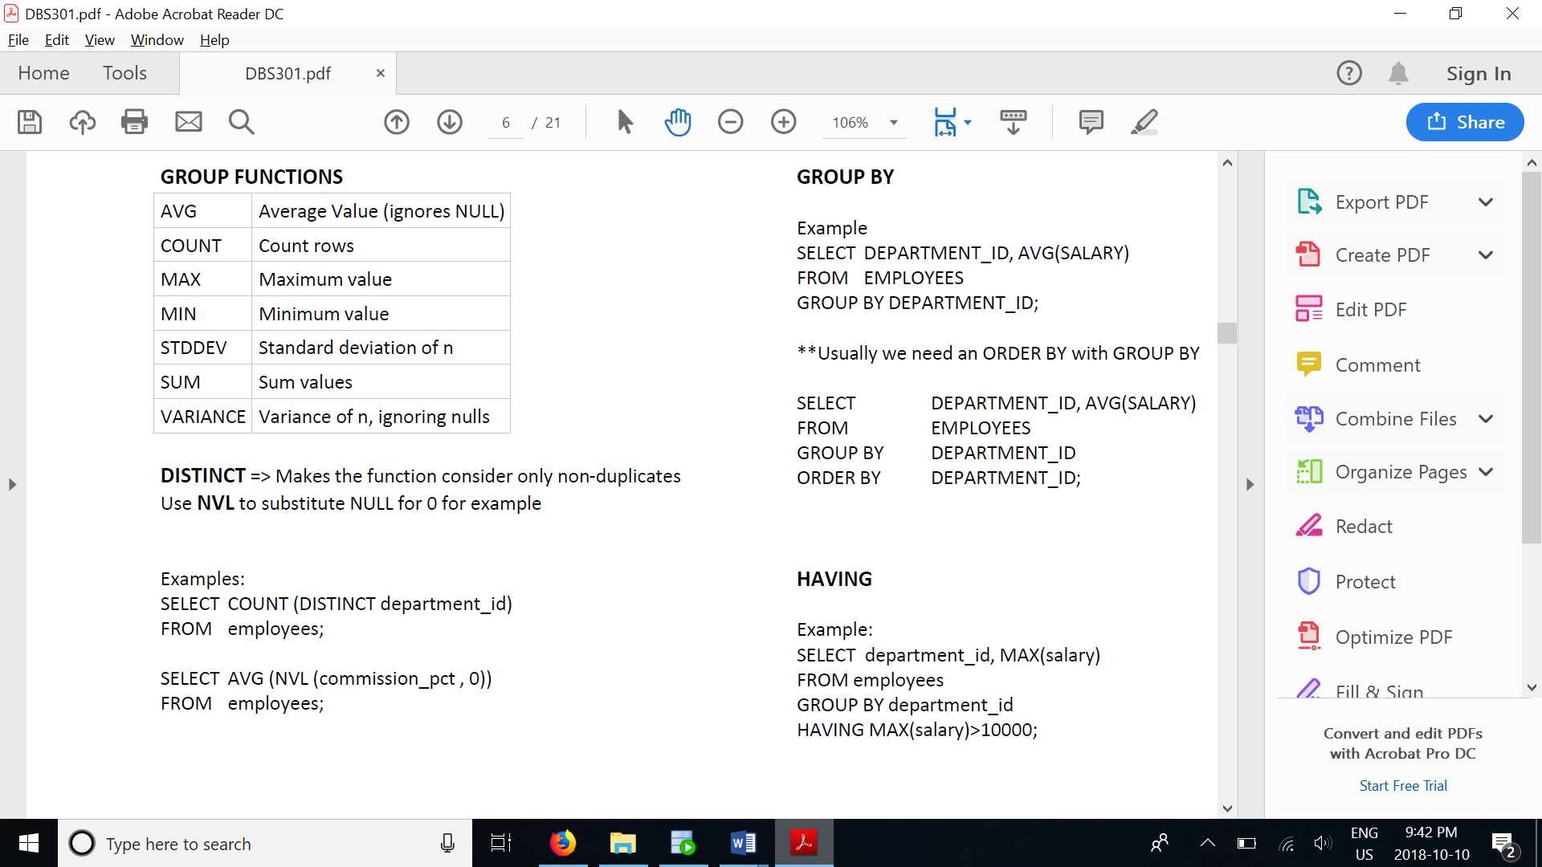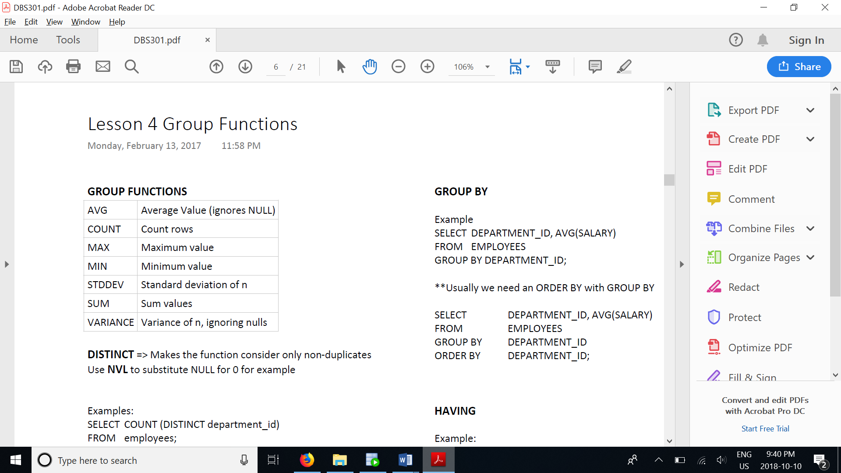

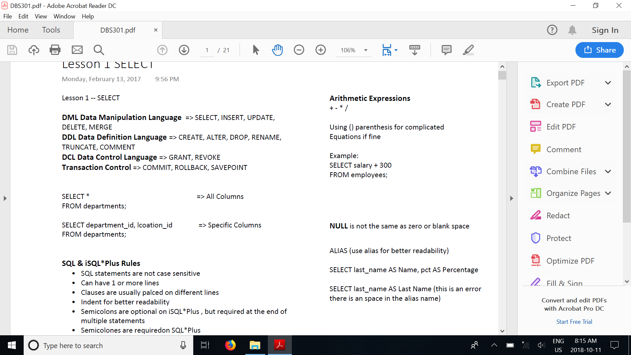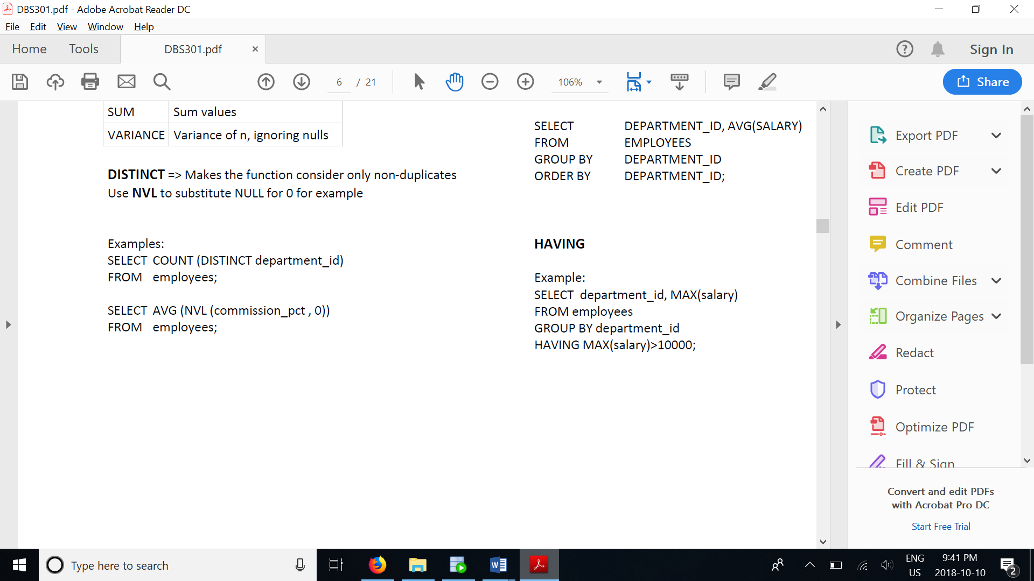

SELECT supplier_name,

DECODE(supplier_id, 10000, 'IBM',

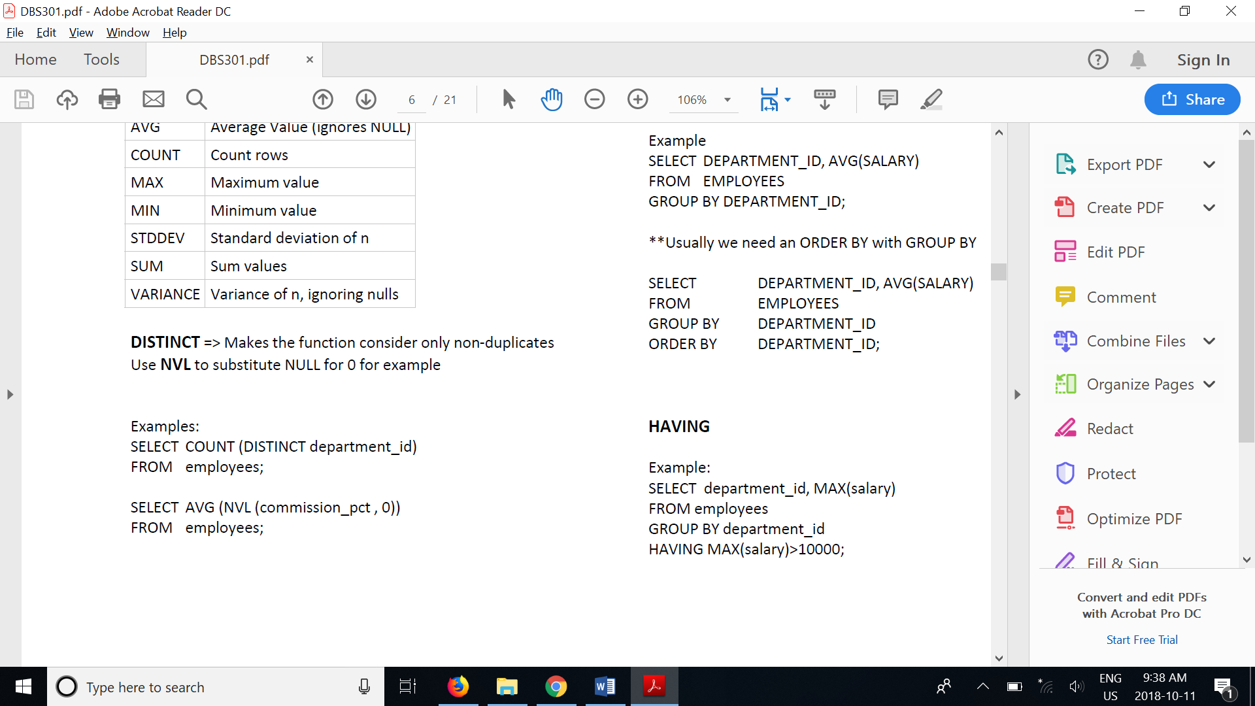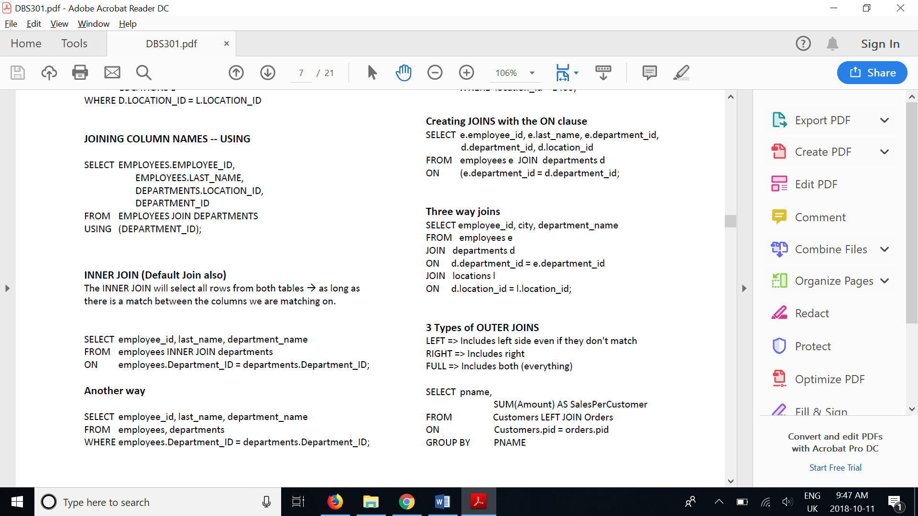 10001, 'Microsoft',

10002, 'Hewlett Packard',

'Gateway') result

FROM suppliers;

SELECT player_name,

weight,

CASE WHEN weight > 250 THEN 'over 250'

WHEN weight > 200 THEN '201-250'

WHEN weight > 175 THEN '176-200'

ELSE '175 or under' END AS weight_group

FROM benn.college_football_players

select e.last_name "Employee", e.employee_id "Emp#", m.last_name "Manager", f.manager_id "Mgr#"

from employees e, departments f, employees m

where e.department_id = f.department_id

AND f.manager_id = m.manager_id

AND e.last_name NOT in m.last_name;