Les01 -- SELECT – review but using Oracle

These are the commands used on the course

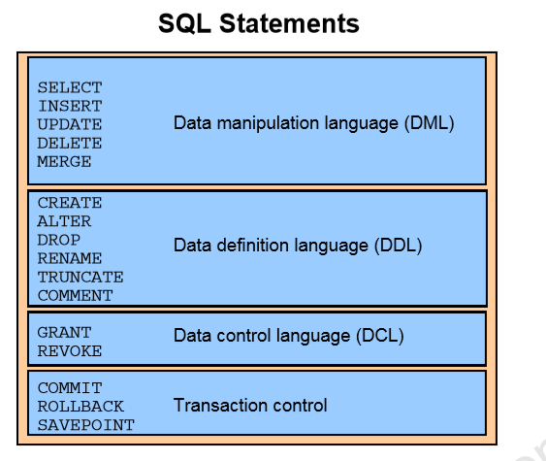

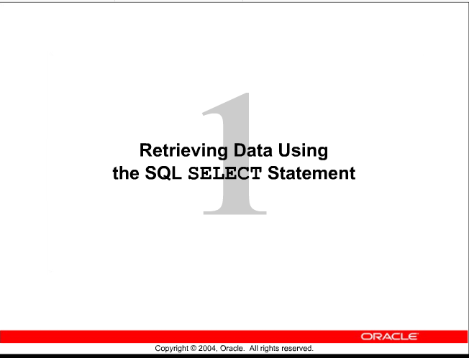

2

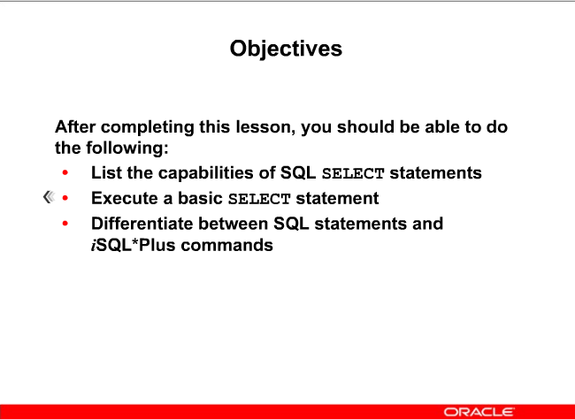

SCHEMA – working with this semester

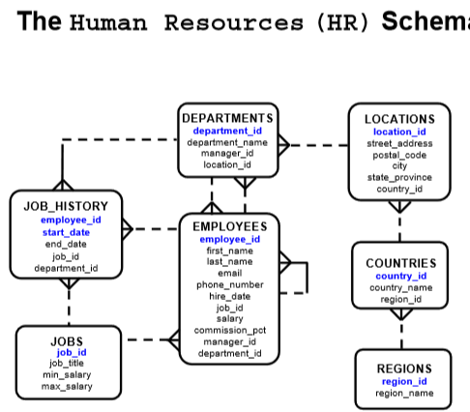

REWRITE this in a better layout for readability

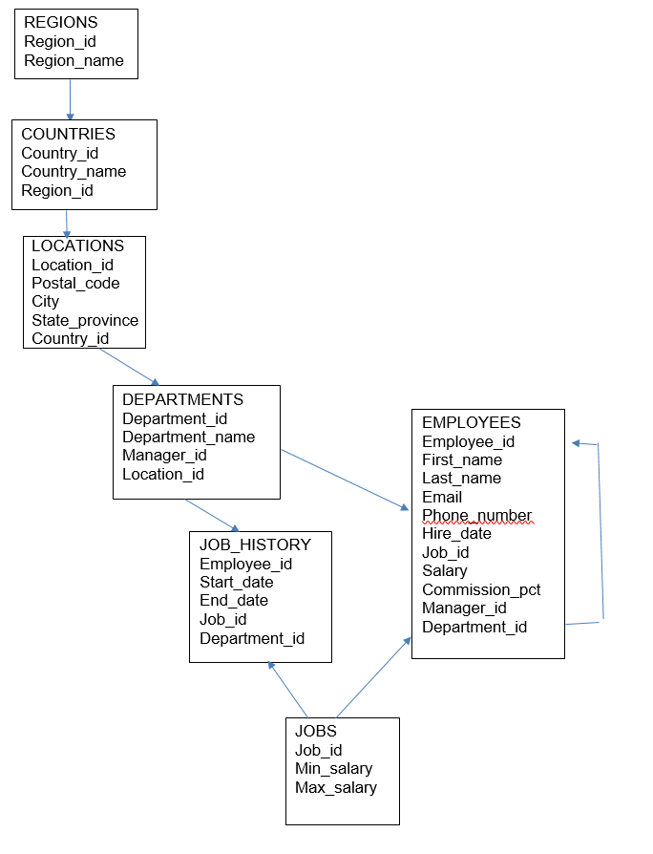

3 (1-4) _ repeats DBS201 – and why?

# 3 ACTIONS ON TABLES

* + **1 PROJECTION**
  + **2 SELECTION**
  + **3 JOIN**
  + **Done through SELECT statement**

SELECT – Retrieving data from a table

**1 PROJECTION** -- Retrieving specific columns of data such as ALL student names and phone numbers



**2 SELECTION** – Returns only rows to meet the specific restriction such as all male students from a table of students



**3 JOIN** – Returning data from 2 different tables such as course name and the student name

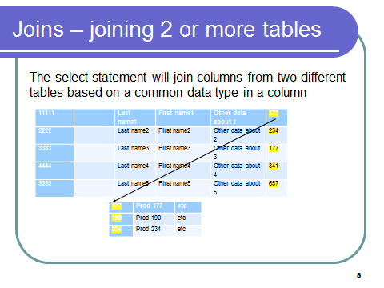

More on this in a later week’s lesson

FORMAT of the SELECT statement

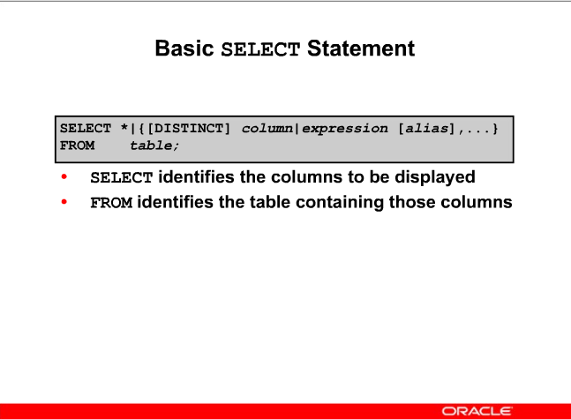

PROJECTION –

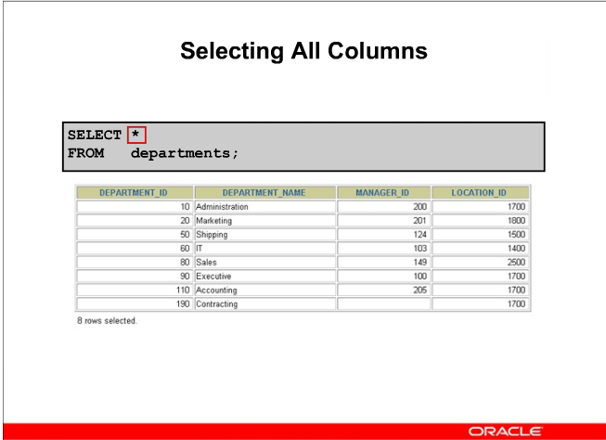

Use the DESCRIBE command to see the structure of the tables

OR

SELECT * FROM TABS: 🡸 to see the tables

SELECTION --

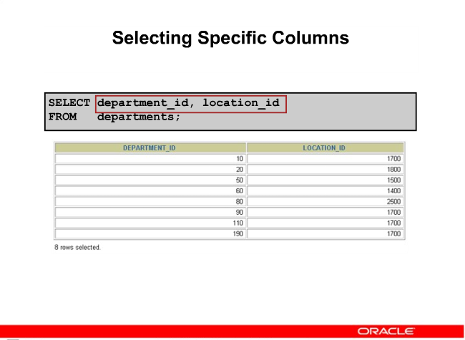

SELECT department_id, location_id

FROM departments;

Demo cut and paste for labs

Also fixed font -- courier new

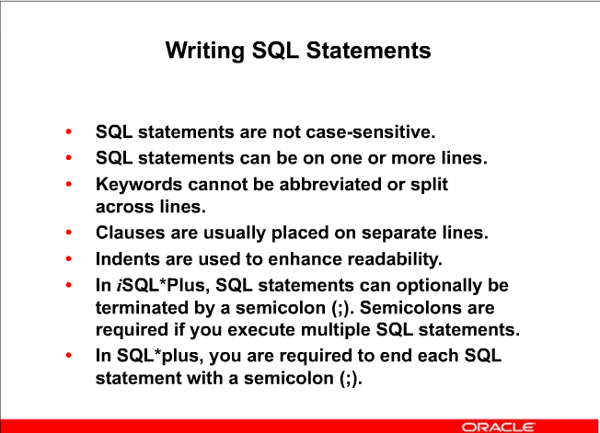

LAYOUT is important. Bad layout will have marks deducted.

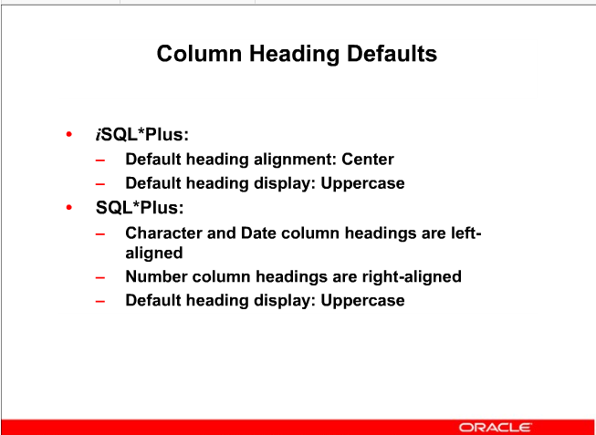

9

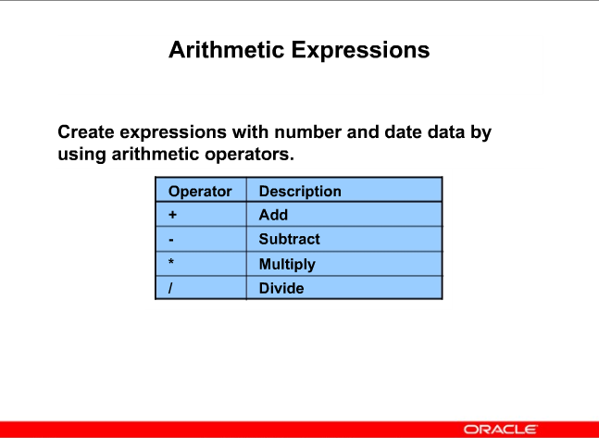

10

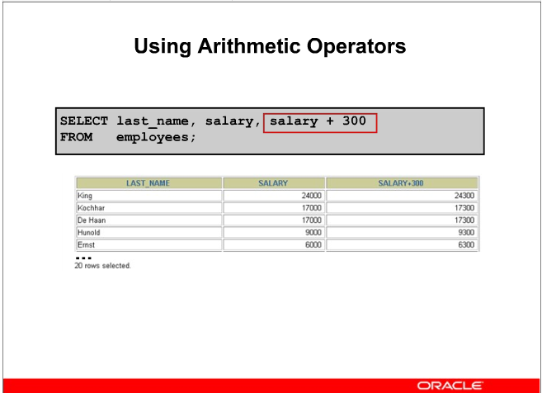

Note how it adds to the salary an additional 300

As in ALL languages it is important to know the order of operation when there are multiple operators

SELECT last_name, salary, salary + 300

FROM employees;

**PROBLEM:**

**Show yearly salary.**

**Raise everyone’s salary (which we will assume is monthly) by 100 dollars per month, then multiply it out by 12 to see yearly salary**

11

Raise everyone’s salary (which we will assume is monthly) by 100 dollars then multiply it out by 12 to see yearly salary

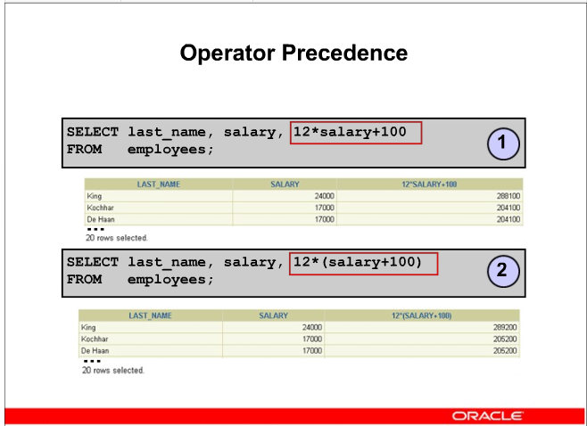

289,200

288,100 is the result

Not a large difference for EACH employee.

For the company with 20 employees that is 24,000

Now if you have 1000 employees, that raise is 24 million.

Would be nice if we could total the salaries to see the results.

12

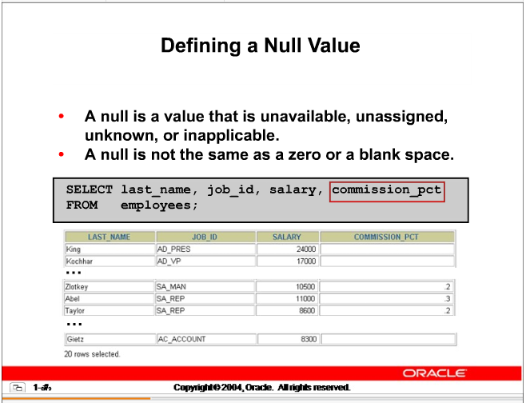

13

**PROBLEM**

Multiply the monthly salary by 12 to get yearly salary.

Then multiply it by the percent to get the commission earned

SELECT last_name, salary * 12 * commission_pct

FROM employees;

What Happens ….

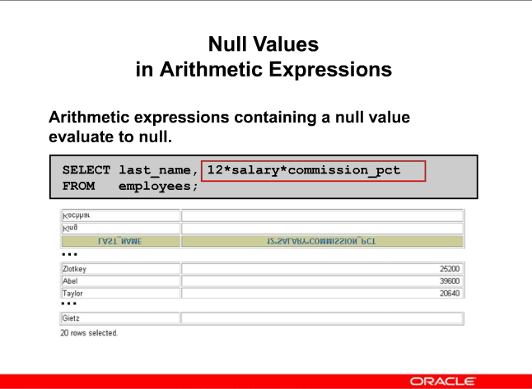

SELECT last_name, salary * 12 * commission_pct

FROM employees

# NOTE: Column Names are not nice – need to fix it with an alias

LAST_NAME SALARY*12*COMMISSION_PCT

------------------------- ------------------------

King

Kochhar

De Haan

Hunold

Ernst

Lorentz

Mourgos

Rajs

Davies

Matos

Vargas

Zlotkey 25200

Abel 39600

Taylor 20640

Grant 12600

Whalen

Hartstein

Fay

Higgins

Gietz

20 rows selected

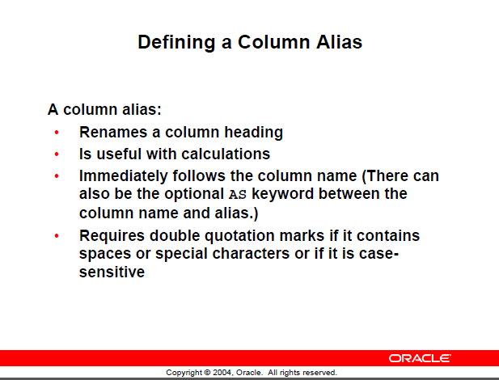

**NOTE: Alias names maximum length of 30**

Try these.

SELECT last_name AS name, commission_pct as comm

FROM employees;

SELECT last_name AS Last Name, commission_pct as comm

FROM employees;

-- This last one won’t work as there is a space in the alias name

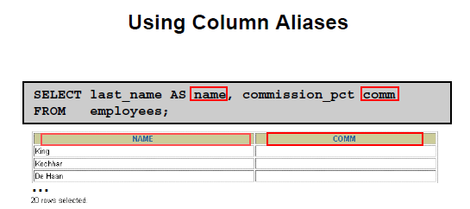

Note that used lowercase, but the default display is UPPERCASE

Using double quotes --

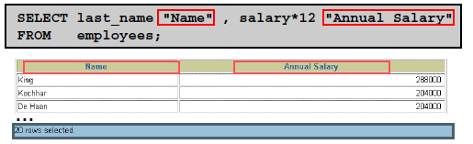

**PROBLEM:**

Display last name and job id from the employees table and look at the result

SELECT last_name, job_id AS "Employees"

FROM employees;

Results are spread out and title Employees ---- in wrong location ……

LAST_NAME Employees

------------------------- ----------

Abel SA_REP

Davies ST_CLERK

De Haan AD_VP

Change the look with a **CONCATENATE OPERATOR**

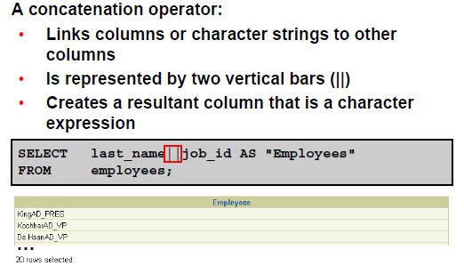

Notice this works whereas on the iSeries it "appeared" to not work.

STILL NOT NICE LOOKING ………. Need to improve it.

How ?????

ASIDE: There is a concatenate function available later

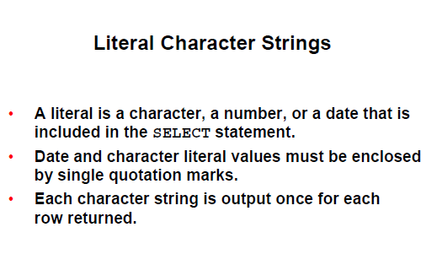

**NOTE:**

**Single quotes for literals**

**Double quotes for alias names**

**PROBLEM:**

**Revise previous SQL 🡪 require Last name and job id with the ‘is a’ between it but nicely displayed**

**Give it a good title**

Example:

Bob is a Dean

(answer on next page)

**PROBLEM:**

**Revise previous SQL 🡪 require Last name and job id with the ‘is a’ between it but nicely displayed**

**Give it a good title**



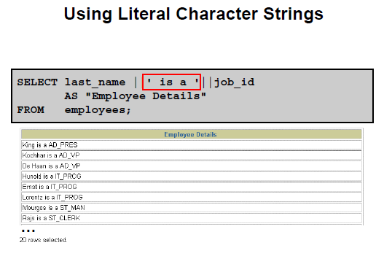

**ALTERNATE – don’t recall ever seeing it used … but**

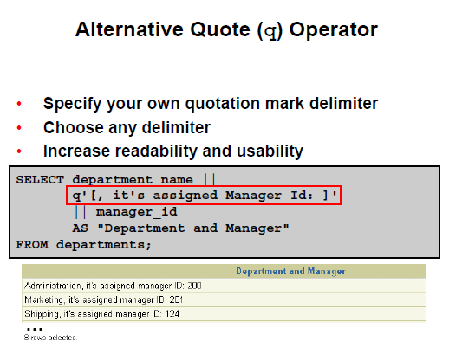

SELECT last_name|| q'[ has the job: ]' || job_id

FROM employees;

**PROBLEM:**

**Using the employees table, display all the departments in HR**

**SELECT department_id**

**FROM employees;**

See the duplicates as there are 20 rows displayed

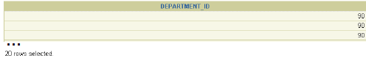

**SELECT DISTINCT department_id**

**FROM employees;**

DEPARTMENT_ID

-------------

10

20

50

60

80

90

110

8 rows selected.

PROBLEM:

Show the distinct salary and job id within department. Meaning if people in department 20 have the same salary and job_id only show one of them.

SELECT DISTINCT (salary, job_id), department_id

FROM employees

ERROR 🡺 see message … doesn’t look like the error is correct

WHY?

If you use DISTINCT, it must be for ALL selected columns

SQLPLUS command and NOT SQL

