4

Now 5 in 11g

Reporting Aggregate Data

Using the Group Functions

Objectives

After completing this lesson AND

practicing, you will begin to understand the following:

• Describe the use of group functions

• Group data by using the GROUP BY clause

• Include or exclude grouped rows by using the

HAVING Clause

This lesson further addresses functions.

It focuses on obtaining summary information (such as averages) for groups of rows.

It discusses how to group rows in a table into smaller sets and

* how to specify search criteria for groups of rows.

Lesson Agenda

Group Functions

Grouping Rows

Nesting Group Functions

What Are Group Functions

Group Functions 🡺 operate on sets of rows

🡺 to give one result per group of rows

EXAMPLE:

SELECT AVG (salary)

FROM employees;

AVG(SALARY)

One result from a set of rows

8775

=========================

Single Row functions worked on single rows and returned 1 result per row

SELECT UPPER(last_name) …

Each row selected changed the format of whatever last_name was stored as to display in UPPER case

Group functions (multi-row functions)

🡪 Operate on sets of rows to give one result per group.

- These sets may comprise the entire table or the table split into groups

Types of Group Functions

AVG

COUNT

MAX

Group

Functions

MIN

1 result

STDDEV

SUM

VARIANCE

OPTIONS you can use with the functions

(go to examples)

AVG ( [distinct | ALL] EXPRE}) n )

- Average value of n, ignoring null values

COUNT ( { * [distinct | ALL] })

- Number of rows where expr evaluates to something other than null

- count all selected rows using * including duplicates and nulls unless use distinct

MAX([DISTINCT|ALL]expr)

- Maximum value of expr, ignoring null

MIN([DISTINCT|ALL]expr)

-Minimum value of expr, ignoring null values

SUM([DISTINCT|ALL]n)

- Sum values of n, ignoring null values

STDDEV([DISTINCT|ALL]x)

- Standard deviation of n, ignoring null

VARIANCE ([DISTINCT|ALL]x)

- Variance of n, ignoring null values

GROUP FUNCTION SYNTAX

PROBLEM:

President wants to know data about salaries, such as AVERAGE, what the highest and lowest paid person's salary is and the company's total salary payout.

🡺 🡺 GO BACK to previous page and find the appropriate function

**SELECT AVG (SALARY),**

**MAX (SALARY), -- highest paid**

**MIN (SALARY), -- lowest opaid**

**SUM (SALARY) -- total of all salaries**

**FROM EMPLOYEES;**

**AVG(SALARY) MAX(SALARY) MIN(SALARY) SUM(SALARY)**

**----------- ----------- ----------- -----------**

**8775 24000 2500 175500**

**How would we change the SQL for the President to show the same results but for Sales Reps only**

Show the same for all Sales Reps

SELECT AVG (salary), MAX (salary),

MIN (salary), SUM (salary)

FROM employees

WHERE job_id LIKE '%REP%';

**AVG(SALARY) MAX(SALARY) MIN(SALARY) SUM(SALARY)**

**----------- ----------- ----------- -----------**

**8150 11000 6000 32600**

GUIDELINES

1

DISTINCT

- Makes the function consider only non-duplicate values

ALL

- Makes function consider every value

DEFAULT value is ALL and does not need to be specified

2

The DATA TYPES with the syntax ***expr*** argument may be

CHAR, VARCHAR2

NUMBER, DATE

3

All group functions ignore null values. To substitute for null use NVL etc…

Using MIN, MAX function examples

You can use MIN and MAX for the following

- Numeric

- Character

- Date

Find the newest and oldest employee by hire_date

This shows the most senior employees, the one working the longest and the most junior employee

SELECT MIN(HIRE_DATE),

MAX (HIRE_DATE)

FROM EMPLOYEES;

MIN(HIRE_ MAX(HIRE_

--------- ---------

Poor titles due partly to column width too small to show title

17-JUN-87 29-JAN-00

Find the first person alphabetically by last name

Find the last employee by last name

🡺 Applied to character columns

SELECT **min** (last_name) as "First in line",

**max** (last_name) as "Always last to be called"

FROM employees;

First in line Always last to be called

------------------------- -------------------------

Abel Zlotkey

Using the Count Function

COUNT (*) – returns the number of rows in a table

SELECT COUNT (*)

FROM EMPLOYEES;

Using COUNT with an expression

SELECT COUNT (commission_pct)

FROM EMPLOYEES

WHERE DEPARTMENT_ID = 80;

NOTE:

Count supplies the number of row that satisfies the SELECT statement in a table

Count with an expression returns the number of rows that meet the condition

select count(last_name)

from employees

where last_name between 'A' and 'G' 🡺 returns 5

Adding an expression returns non-null values

Adding DISTINCT returns the number of rows that are distinct from all the rows that are not null.

**Find the percentage of employees that receive a commission**

SELECT COUNT (*),

COUNT(COMMISSION_PCT), COUNT(COMMISSION_PCT)/COUNT(*)

FROM EMPLOYEES

**How many departments are there in the employees table?**

DISTINCT Examples

SELECT COUNT (DISTINCT department_id)

FROM employees;

COUNT (DISTINCTDEPARTMENT_ID)

----------------------------

7

**What is the average commission percent paid?**

GROUP FUNCTIONS and NULL

PROBLEM – average of just those who receive commission or of all employees

SELECT AVG (commission_pct)

FROM employees;

AVG (COMMISSION_PCT)

-------------------

.2125

SELECT AVG (NVL (commission_pct, 0))

FROM employees;

AVG (NVL (COMMISSION_PCT,0))

--------------------------

.0425

Groups of Data

All group functions have treated the table so far as one large group

Sometimes the information needs to be divide into smaller groups

Example: Average by department

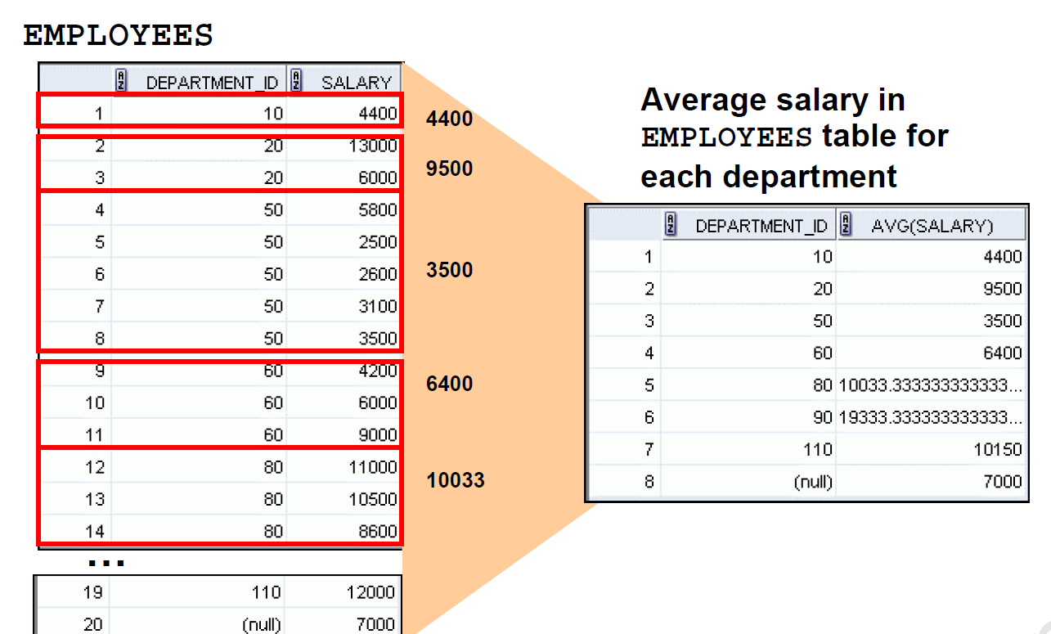

GROUP BY

SELECT DEPARTMENT_ID, AVG(SALARY)

FROM EMPLOYEES;

ERROR at line 1:

ORA-00937: not a single-group group function

Why an error?

The use of department_id results in a row of output for each row in the employee table

The AVG wants a single result for the entire table.

🡺 🡺 There is no sensible way to display that.

Introduces the GROUP BY to apply the group function by department_id

SELECT DEPARTMENT_ID, AVG(SALARY)

FROM EMPLOYEES

GROUP BY DEPARTMENT_ID;

DEPARTMENT_ID AVG(SALARY)

------------- -----------

7000

90 19333.3333

Rewrite the code to clean up the output

20 9500

110 10150

50 3500

80 10033.3333

60 6400

10 4400

8 rows selected

To clean up output

SELECT DEPARTMENT_ID, round(AVG(SALARY),0)

FROM EMPLOYEES

GROUP BY DEPARTMENT_ID;

GROUP BY

The GROUP BY column does not need to be in the select

SELECT AVG(SALARY)

FROM EMPLOYEES

GROUP BY DEPARTMENT_ID;

AVG(SALARY)

-----------

7000

19333.3333

Notice that the output is correct but is not very meaningful to the user

9500

10150

3500

10033.3333

6400

4400

GROUP BY often needs an ORDER BY

SELECT DEPARTMENT_ID, AVG(SALARY)

FROM EMPLOYEES

GROUP BY DEPARTMENT_ID

ORDER BY DEPARTMENT_ID;

DEPARTMENT_ID AVG(SALARY)

------------- -----------

10 4400

20 9500

50 3500

60 6400

80 10033.3333

90 19333.3333

110 10150

7000

Grouping by more than 1 column

Groups within groups

PROBLEM:

**Display the total salary paid to each job title within each department**

Select department_id , job_id, sum(salary)

From employees

Group by department_id, job_id;

LOGIC

Group employee by department

Within department group job titles

Sum up that lower grouping

SELECT department_id, job_id, SUM(salary)

FROM employees

GROUP BY department_id, job_id;

DEPARTMENT_ID JOB_ID SUM(SALARY)

------------- ---------- -----------

110 AC_ACCOUNT 8300

90 AD_VP 34000

Again, hard to see if it truly worked.

What would improve it?

50 ST_CLERK 11700

80 SA_REP 19600

50 ST_MAN 5800

80 SA_MAN 10500

110 AC_MGR 12000

90 AD_PRES 24000

60 IT_PROG 19200

20 MK_MAN 13000

SA_REP 7000

10 AD_ASST 4400

20 MK_REP 6000

IMPROVED

**SELECT department_id, job_id, SUM(salary)**

**FROM employees**

**GROUP BY department_id, job_id**

**ORDER BY department_id, job_id**

DEPARTMENT_ID JOB_ID SUM(SALARY)

------------- ---------- -----------

10 AD_ASST 4400

20 MK_MAN 13000

20 MK_REP 6000

50 ST_CLERK 11700

50 ST_MAN 5800

60 IT_PROG 19200

80 SA_MAN 10500

80 SA_REP 19600

90 AD_PRES 24000

90 AD_VP 34000

110 AC_ACCOUNT 8300

110 AC_MGR 12000

SA_REP 7000

13 rows selected

Restricting Which Groups to Show

🡪NOT by using the WHERE clause

🡪 using the HAVING clause

**Find the maximum salary by department if maximum salary greater than 10,000**

Select department_id , max(salary)

From employees

Group by department_id

Having Max(salary) > 10000

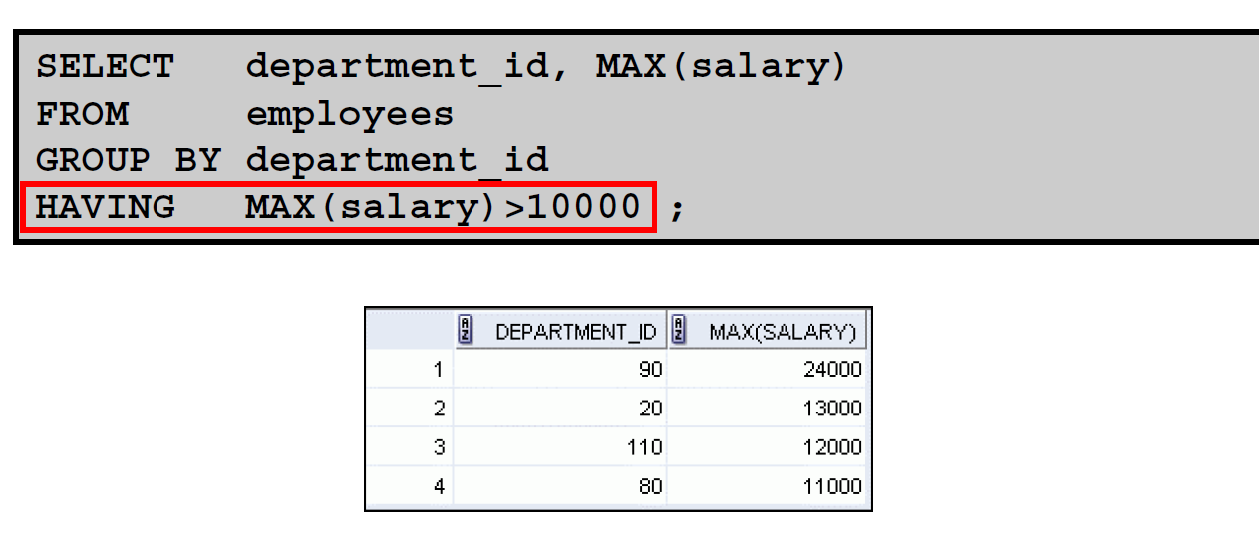

Again nicer if put department in order

Add the ORDER BY clause

Nesting Group Functions

PROBLEM:

Display the department with the highest average salary

SELECT MAX(AVG(salary))

FROM employees

GROUP BY department_id;

MAX(AVG(SALARY))

----------------

19333.3333

PRACTICE:

**1 Write a query to determine how many job_ids there are.**

**count(job_id)**

**2 Write a query to find out how many people have the same job**

**3 Determine the number of managers (without listing them)**

**HINT: use the manager_id**

**4 HR department want top know the range of salaries and what the difference is**

**1 Write a query to determine how many job_ids there are.**

**SELECT count(distinct job_id)**

**FROM employees**

**2 Write a query to find out how many people have the same job**

**SELECT job_id, count(*)**

**FROM employees**

**group by job_id**

**3 Determine the number of managers (without listing them)**

**HINT: use the manager_id**

**SELECT count(distinct manager_id)**

**FROM employees**

**4 HR department want top know the range of salaries and what the difference is**

**SELECT max(salary),**

**min(salary),**

**max(salary)-min(salary) as "Difference"**

**FROM employees**