Lab on Subqueries and Set operators

Copy the query and screen shot of the result beneath each question in this document. Submit on Blackboard.

Solve the following:

1. Create a report that displays the employee number, last name, and salary of all employees who earn more than the average salary. Sort the results in order of ascending salary.

Statement:

select employee_id, last_name, salary

from employees

where salary >(select avg(salary)

from employees)

order by salary asc;

Result:

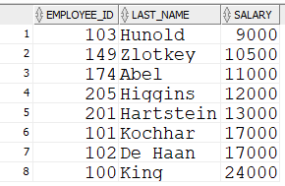

1. Write a query that displays the employee number and last name of all employees who work in a department with any employee whose last name contains a “u.”

Statement:

select employee_id, last_name

from employees

where department_id IN (select department_id

from employees

where last_name LIKE '%u%');

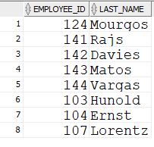

1. The HR department needs a report that displays the last name, department number, and job ID of all employees whose department location ID is 1700.

Statement:

select last_name, department_id, employee_id

from employees

where department_id IN (select department_id

from departments

where location_id = 1700);

Output:

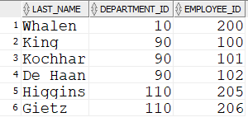

1. Create a report for HR that displays the last name and salary of every employee who reports to King.

Statement:

select last_name, salary

from employees

where manager_id = (select employee_id

from employees

where last_name = 'King');

Output:

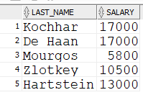

1. Create a report that displays the department number, last name, and job ID for every employee in the Executive department.

Statement:

select department_id, last_name, job_id

from employees

where department_id = (select department_id

from departments

where department_name = 'Executive');

Output:

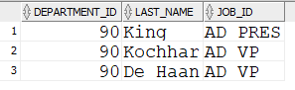

1. The HR department needs a list of department IDs for departments that do not contain the job ID ST_CLERK. Use the set operators to create this report.

Statement:

select department_id

from departments

UNION

select department_id

from employees

where department_id NOT IN (select department_id

from employees

where job_id = 'ST_CLERK');

Output:

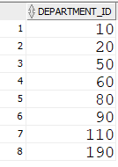

1. Create a report that lists the employee IDs and job IDs of those employees who currently have a job title that is the same as their job title when they were initially hired by the company (that is, they changed jobs but have now gone back to doing their original job).

Statement:

select employee_id, job_id

from employees

INTERSECT

(select employee_id, job_id

from job_history)

order by employee_id;

Output:

