**Name:**

Abdul Subhan

**Roll No:**

21I-1223

Creating the frontend of Application

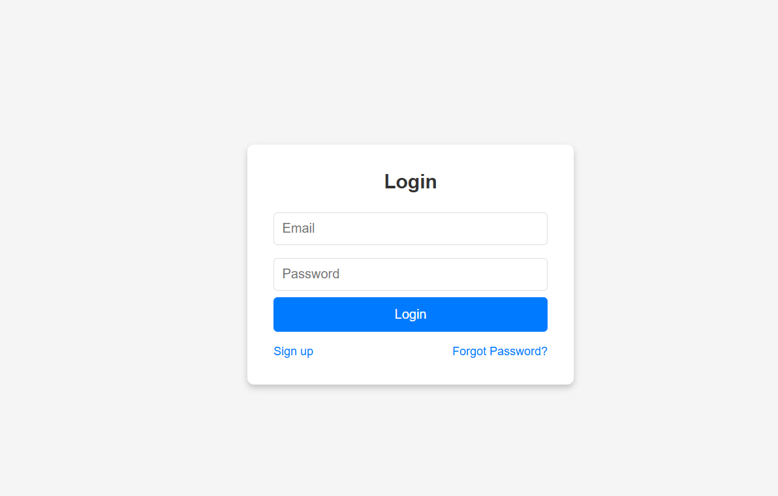

Creating the docker files for frontend and backend and MongoDB official image

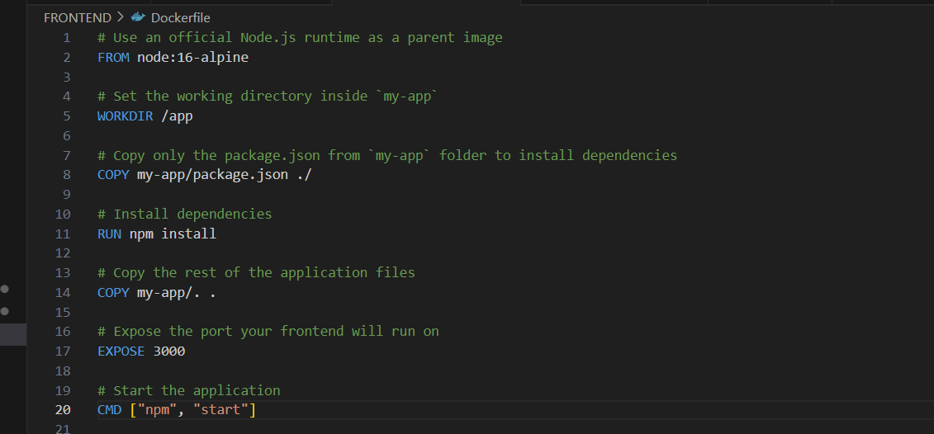

Creating the docker compose file to build images on docker desktop using below command

docker-compose up --build

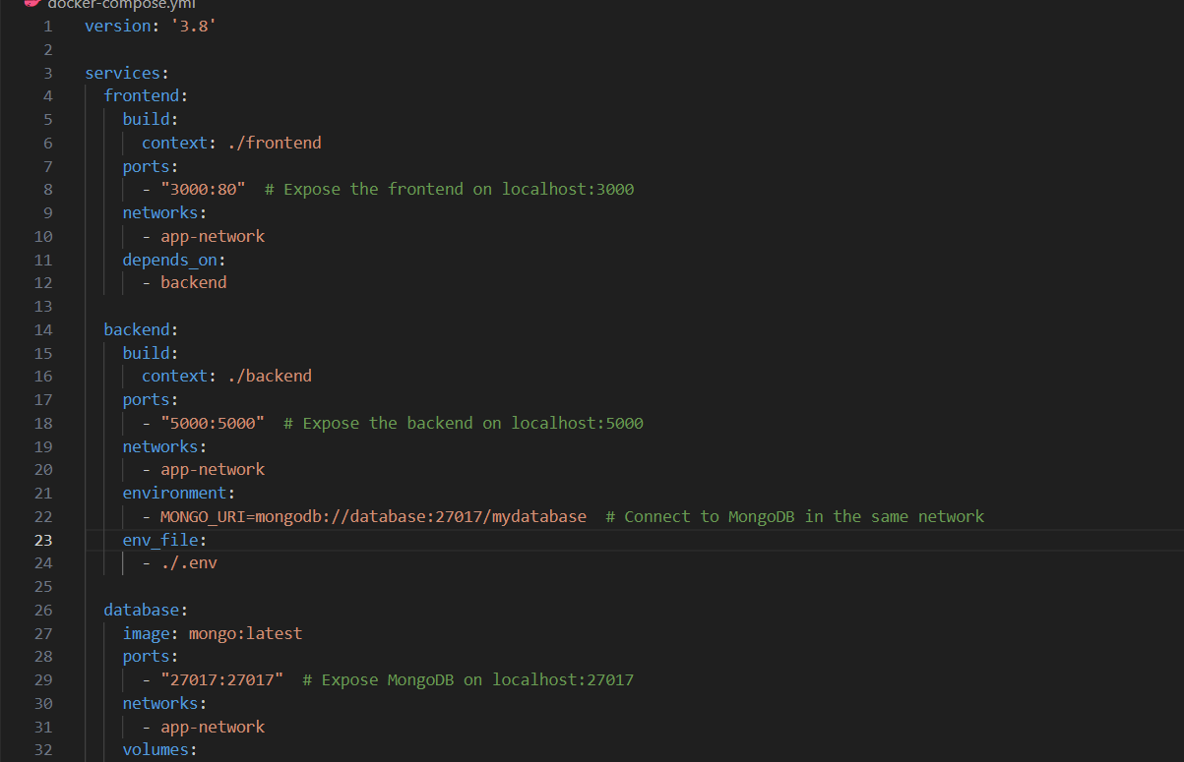

Images are build on the docker desktop

Runing container of Assignment

Creating the deployment of frontend backend and database

Applying the deployments and services using following commands

kubectl apply -f frontend-deployment.yaml

kubectl apply -f backend-deployment.yaml

kubectl apply -f database-deployment.yaml

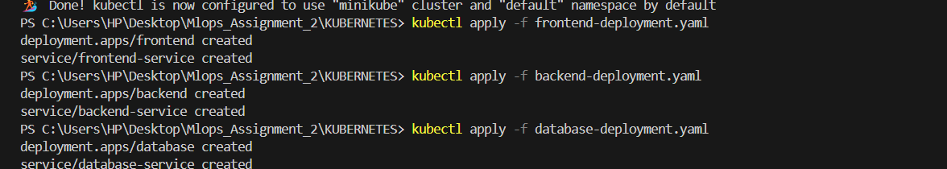

Now pusging the frontend and backend images to docker hub registry

Getting the pods that are running

Minikube dashboard

Runing services of minikube

Expose the frontend service externally,

