Project Proposal
Project Title: Gym Management System
Course Name: Object Oriented Programming
Project Description:
A gym management system is a GUI based software that integrates and automates various aspects of running a gym, fitness, or yoga business. It enhances the customer experience and helps with marketing.
We are making this project in java using NetBeans while applying the concepts of OOP. Our gym management system has the features like Member Management, Class and Schedule Management, Billing and Payments, Gym Access and Check-In, Personal Training Management, Equipment and Facility Management, Reporting and Analytics, Communication and Notifications.
Functionalities:
The overall functions of the gym management system are Member Profiles, Membership Renewal, Membership Cancellation, Class Enrollment, Attendance Tracking, Membership Plans, Payment Processing, Check-In System, Session Scheduling, Progress Tracking, Equipment Inventory, Financial Reports, Performance Analytics, Member Communication, Automated Reminders.
These features and functionalities are designed to streamline gym operations, enhance member experience, and provide gym administrators with efficient tools for managing memberships, classes, payments, and overall gym performance.
Class Diagram:
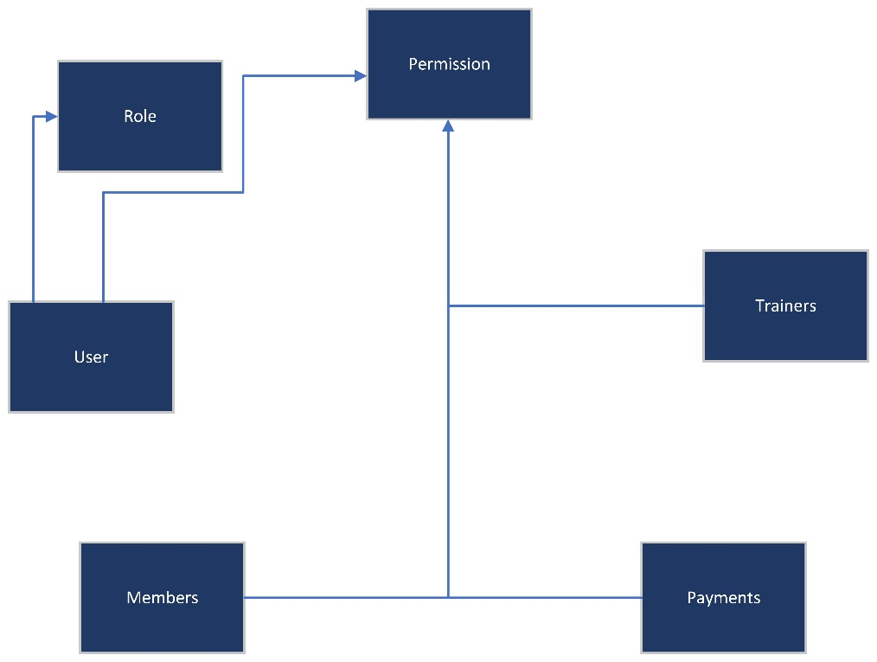
Expected Time: 1-2 Weeks.

