Assignment # 1



Made by: Abdul Wasay
Registration number: FA25/BSE-002
Course:Programming Fundamentals
Instructor: Muzaffar Iqbal
Class:BSE-1A

Question 1:

a.
Syntax Error name | Error statement | Explanation
“Reached the end of file while parsing.” | 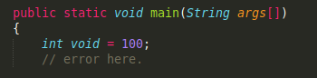 | The closing brace of main method is missing.
“error:not a statement” |  | This Variable name starts with a number,Which is against Java’s variable naming rules.
“error: ';' expected” | 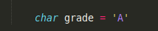 | Semicolon after the vaiable defintion statement is missing.Each java statement must end with a semicolon.

b.

Logical Error Statement | Error | Reason for error
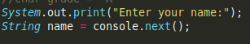 | If the name consists of two or more words,the words after the first one are lost. | next() only inputs one words, and stops taking input after whitespace.
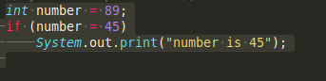 | The if block always executes.Regardless of the conidition. | = operator assigns 45 to number, so the condition is always true.
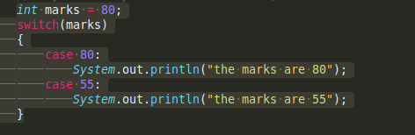 | Both the cases run when marks are 80.Output:  80  55 | Missing break statement,causes  control to fall through to next case.

c.

Run time error Statement | Error | Reason for Error
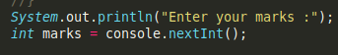 | Program crashes if user enters any non-integer value. | nextInt() expects an integer, non-integer causes dateattype mismatch gives,  InputMismatchException
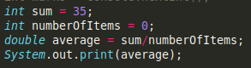 | ArthematicException  / by zero | Divion by zero causes error when the code is ran.
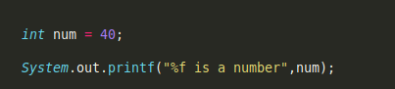 | W

d.

Error satement(s) | Error | Correction
count = 1; | Undeclared Variable | int count = 1;
sum = count + PRIME; | Undeclared variable  (sum is undeclared) | int sum = count + PRIME;
x := 25.67 | Undeclared variable and invalid syntax for assigment operator | double x = 25.67;
newNum = count * ONE + 2; | Undeclared variables  (ONE and newNum are undeclared) | final int ONE = 1;  int newNum = count * ONE + 2;
sum + count = sum; | Invalid assigment  (variable is always on the left and expression is on the left) | sum = sum + count;
x = x + sum * COUNT; | Undeclared variable  (Java is Case sensitive,  COUNT != count ) | x = x + sum * count;
System.out.println("count = " + count + ", sum = " + sum +", PRIME = " + Prime); | undeclared variable  ( case-senstive,  PRIME != Prime ) | System.out.println("count = " + count + ", sum = " + sum +", PRIME = " + PRIME);

Output:

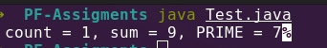

Question 2 :

Example No. | Comments | Special Symbols | Reserved Words | Predefined Identifiers | User-defined Identifiers | Std Input Object | Std Output Object
1 | /*This program will calculate product of three numbers */ | ; | int | System | num1 | (theres none) | System.out
2 | // first number | { | public | println | num2
3 | // second number | } | class | out | num3
4 | // third number | + | static |  | result
5 | //product of numbers | * | public

Question 3:

a.

int x,y;
x = 10;
char ch = ‘B’;
x = x+5;
double payRate = 12.50;
firstNum = tempNum;
int temp = x;
x=y; // puts the value of y in x
y=temp; //puts the old value of x in y
System.out.println(“x = ” + x + “y = ” + y + “ x+12/y-18” +(x+12/y-18);
char grade = ‘A’;
int number1,number2,number3,number4;
x = Math.round(z);

b.
Statement | Expression | a | b | c | d
1 | a = (b++) + 3 * ++d; | 15 | 7 | UND | 3
2 | c = 2 * d + (++b) + a; | 5 | 7 | 16 | 2
3 | b = 2 * (++c) - (a++); | 5 | UND | UND | 2
4 | d = d++ + d + b++ + b; | 5 | 7 | UND | 17

c.
Statement | Expression | a | b | c | sum
1 | sum = a + b + (int) c; | 3 | 5 | 14.1 | 12
2 | c /= a; | 3 | 5 | 4.7 | UND
3 | b += (int) c - a; | 3 | 16 | 14.1 | UND
4 | a *= 2 * b + (int) c; | 72 | 5 | 14.1 | UND

Note for the Reader:

Sorry for the readibilty issues below, due to the line breaks, i have tried my best to keep them readable using same indentation length, since the font can no longer be shortened without
making the code invisible.

Question 4:

Source code:

import java.util.Scanner;

public class QuadraticFormula
{
public static void main(String args[])
{
Scanner console = new Scanner(System.in);

// note: print used instead of println because println asks for value in one line and
// then takes the value in the next line, thus making the format look ugly

System.out.print("Enter the value of a, b, c : "); // asking user for value of a,b, and c
double a = console.nextDouble(); // takes value from the user and puts it in a
double b = console.nextDouble(); // takes value from the user and puts it in b
double c = console.nextDouble(); // takes value from the user and puts it in

// parenthesis in this program have been used solely mostly to improve readibitly.

double disc = (b*b) - (4 * a * c); // can also be written as pow(b,2) - (4*a*c);

if(disc > 0)
{

// sqrt used becuase manual says "can" , which indicates choice, and because sqrt looks more clear.

double firstRoot = ( (-1*b) + Math.sqrt(disc) ) / (2 * a);
double secondRoot = ( (-1*b) - Math.sqrt(disc) ) / (2 * a);
System.out.printf("\nThe eqaution has two roots %.6f and %.6f” ,firstRoot,secondRoot);

}
else if(disc == 0)
{

double root = ( (-1*b) + Math.sqrt(disc) ) / (2 * a);
System.out.printf("\nThe eqaution has one root %.6f",root);

}
else
{

System.out.println("\nThe eqaution has no real roots.");

} // end of if else if block

}//end of method main
}// end of class

Output:
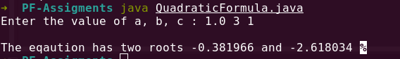

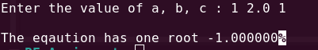

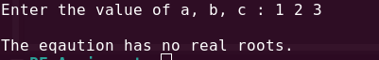

Question 5:

Source code:
public class RandomMonthGenerator
{
public static void main(String args[])
{
int max = 12;
int min = 1;
int randomMonthNumber = (int)(Math.random()*(max - min)) + 1;
// here max - min gives the range, while 1 to keep the minimum 1.

switch(randomMonthNumber)
{

case 1:
System.out.println("January");
break;

case 2:
System.out.println("Febuary");
break;

case 3:
System.out.println("March");
break;

case 4:
System.out.println("April");
break;

case 5:
System.out.println("June");
break;

case 6:
System.out.println("July");
break;

case 7:
System.out.println("August");
break;

case 8:
System.out.println("September");
break;

case 10:
System.out.println("October");
break;

case 11:
System.out.println("November");
break;

case 12:
System.out.println("December");
break;

} // end of switch

}// end of method main
}// end of class

Output:
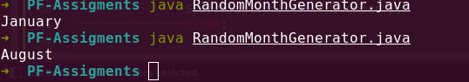

Question 6:

import java.util.Scanner;

public class MonthIndentifier
{
public static void main(String args[])
{
Scanner console = new Scanner(System.in);

// Gives a nice little menu explaining how a the Days are numbered.

System.out.println("\n0.Sunday\n1.Monday\n2.Tuesday\n3.Wedensday\n4.Thursday\n5.Friday\n6.Satur day");

// Takes Today number from the user and puts it in currentDay

System.out.print("\nEnter the Today's number:");
int currentDayNumber = console.nextInt();

// Takes the number of days elapsed.
System.out.print("Enter teh number of days elapsed since today: ");
int daysElapsedNumber = console.nextInt();

if(currentDayNumber>= 0 && currentDayNumber <7)
{
if(daysElapsedNumber>=0)
{
// calculates the future day number and takes out the week part of it ,
// and store the remmainder (future Day Number) in futureDayNumber.

int futureDayNumber = ( currentDayNumber + daysElapsedNumber ) % 7;

// had to intialize these to emptu string , else the compiler threw an error,
// saying that the var's might not be intialized ( probably because intialization is in a switch statement)

String currentDay=" ",futureDay= " ";

// converts the current day number to its respective day name.

switch(currentDayNumber)
{
case 0:
currentDay = "Sunday";
break;
case 1:
currentDay = "Monday";
break;
case 2:
currentDay = "Tuesday";
break;
case 3:
currentDay = "Wedensday";
break;
case 4:
currentDay = "Thursday";
break;
case 5:
currentDay = "Friday";
break;
case 6:
currentDay = "Saturday";
break;
}// end of currentDay switch

// converting the current day number to its respective day name.

switch(futureDayNumber)
{
case 0:
futureDay = "Sunday";
break;
case 1:
futureDay = "Monday";
break;
case 2:
futureDay = "Tuesday";
break;
case 3:
futureDay = "Wedensday";
break;
case 4:
futureDay = "Thursday";
break;
case 5:
futureDay = "Friday";
break;
case 6:
futureDay = "Saturday";
break;
}// end of futureday switch

// displaying the ouput.

System.out.printf("Today is %s and the future day is %s",currentDay,futureDay);

}//end of if block of daysElapsedNumber
else
{

System.out.println("Invalid input!");

}//end of else of daysElapsedNumber
}//end of if block of currentDayNumber
else
{

System.out.println("Invalid input!");

}//end of else block of currentDayNumber

}//end of method main
}// end of class

Output:
