Lab 03
Made by: Abdul wasay
Reg. no: FA25/BSE-002.
Class: BSE-1A

Activity 1:
import java.util.*;

public class Activity1
{
public static void main(String args[])
{
Scanner console = new Scanner(System.in);
double distance, mass;

distance = 3.24783E4;
mass = 4.89366498E20;

System.out.printf("The distance from the car is %.4e meters.",distance);
System.out.printf("\nThe mass of the car is: %.4e kgs.",mass);
}
}

output:
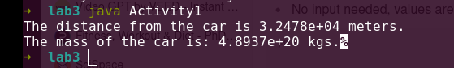

Activity 2:

import java.util.*;

public class Acitivity2
{
public static void main(String args[])
{
double regularWages;
double basePay = 30;
double regularHours = 50;
double overtimeWages;
double overTimePay = 40.50;
double overtimeHours = 15;
double totalWages;

regularWages = basePay * regularHours;
overtimeWages = overTimePay * overtimeHours;
totalWages = regularWages + overtimeWages;
System.out.printf("Wages for this week is $%.2f", totalWages);
}
}

output:
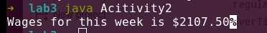

Activity 3:

public class Activity3
{
public static void main(String [] args)
{
double monthlyPay = 6000.0;
double contribution;
// caculates and displays a 5% contribution.
contribution = monthlyPay * 0.05;
System.out.printf("\n5 percent is $%.2f per month.",contribution);
// caculates and displays a 8% contribution.
contribution = monthlyPay * 0.08;
System.out.printf("\n8 percent is $%.2f per month.",contribution);
// caculates and displays a 10% contribution.
contribution = monthlyPay * 0.10;
System.out.printf("\n10 percent is $%.2f per month.",contribution);

}
}

Output:
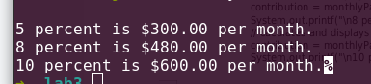

Activity 4:
public class Activity4
{
public static void main(String args[])
{
// Declares a variety of doubel variable.
double num1 = 127.47433;
double num2 = 842.893345;
double num3 = 11489.33893;
double num4 = 2943.22;
double num5 = 1.8;
double num6 = 2344.9999;
// Displays each variable in a field of 8 spaces including 2 decimal spaces.In left aligned sequence because it looks more clean.

System.out.printf("%-8.2f\n", num1);
System.out.printf("%-8.2f\n", num2);
System.out.printf("%-8.2f\n", num3);
System.out.printf("%-8.2f\n", num4);
System.out.printf("%-8.2f\n", num5);
System.out.printf("%-8.2f\n", num6);
System.out.printf("%-8.2f\n", num1);
}
}

Output:

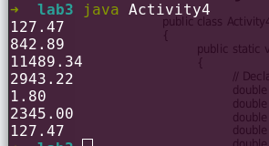

Activity 5:

import java.util.Scanner;

public class Activity5
{
public static void main(String args[])
{
Scanner console = new Scanner(System.in); // choose object name as console because it looks more formal.

System.out.print("Enter purchase amount: ");
double purchaseAmount = console.nextDouble();

double tax = purchaseAmount * 0.06;

System.out.println("\nSales tax is $"+(int)(tax * 100)/100.0); // demomstrates explicit and imiplicit conversion.

}
}

Output:
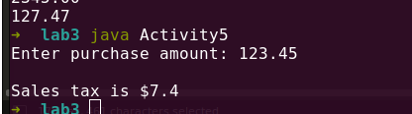

Task 1:
import java.util.Scanner;
public class Task1
{
public static void main(String args[])
{
Scanner console = new Scanner(System.in);
System.out.print("Enter the total amount: ");
double totalAmount = console.nextDouble();
int cents = (int)(totalAmount * 100);
int dollars = (int)(cents /100);

cents %=100; // puts the remaining cents in cents.
int remCents = cents;
int quarters = cents / 25; // extracts the quarter and saves in quarter;
cents %= 25;
int dimes = cents / 10; // extracts the dimes and saves in dimes.
cents %= 10;
int nickels = cents / 5; // extracts the pennies and saves in pennies.
cents %= 5;

int pennies = cents;

System.out.printf("\nThe amount is %d dolars, %d cents, %d quarters, %d dimes, %d nickels and %d pennies.",dollars,remCents,quarters,dimes,nickels,pennies);
}
}

Output:
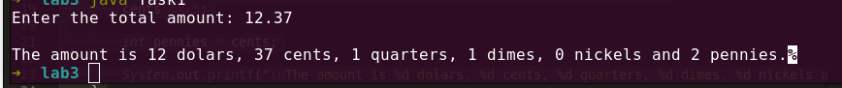

Task2:

import java.util.*;

public class Task2
{
public static void main(String args[])
{
Scanner console = new Scanner(System.in);
System.out.print("Enter the number of students: ");
int n = console.nextInt();
System.out.print("\nEnter the total number of apples: ");
int k = console.nextInt();

int studentsShare = k / n;
int remApples = k % n;

System.out.print("\nEach students will get " + studentsShare + "apples");
System.out.print("\nThe remaining apples will be " + remApples);

}
}

Output:

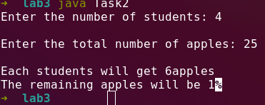

Task3:

import java.util.*;

public class Task3
{
public static void main(String args[])
{
Scanner console = new Scanner(System.in);

System.out.print("Enter the number of students in the first class:");
int a = console.nextInt();

System.out.print("\nEnter the number of students in the second class:");
int b = console.nextInt();

System.out.print("\nEnter the number of students int the third class:");
int c = console.nextInt();

int totalStudents = a + b + c;
int desks = totalStudents/2;
int Totaldesks = desks + (totalStudents % 2); // adds a desk for a single student if the total number of students is odd.
System.out.print("\nThe number of desks required are:"+Totaldesks);

}
}

Output:

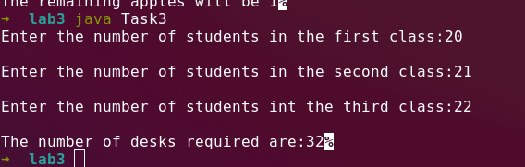

Task 4:

import java.util.*;

public class Task4
{
public static void main(String args[])
{
Scanner console = new Scanner(System.in);

System.out.print("Enter the numbers of minutes passed since midnight: ");
int N =console.nextInt();

int hours = N/60;
int minutes = N%60;

System.out.print("\nThe time right now is "+hours+" "+minutes);

}
}

Output:

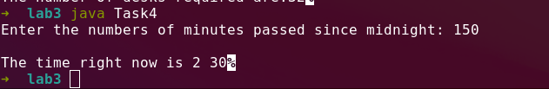

'

Task 5:

import java.util.*;

public class Task5
{
public static void main(String args[])
{
Scanner console = new Scanner(System.in);

double cartonSpace = 3.78;
double prodCostPerLiter = 0.38;
double profitPerCarton = 0.27;
// takes amount of milk produced from the user.
System.out.print("Enter the total amount of milk ( in liters ) produced in the morning: ");
double milkProduced = console.nextDouble();

int numberOfCartons = (int)(Math.round(milkProduced/cartonSpace));

System.out.println(numberOfCartons+"\n cartons are needed for holding " + milkProduced + "liters of milk");
double totalProdCost = milkProduced*prodCostPerLiter;

System.out.println("The cost for producing "+ milkProduced + "liters of milk is " + totalProdCost);
double totalProfit = profitPerCarton * numberOfCartons;

System.out.println("The profit made for "+ numberOfCartons + " cartons of milk is : " + totalProfit);

}
}

Output:

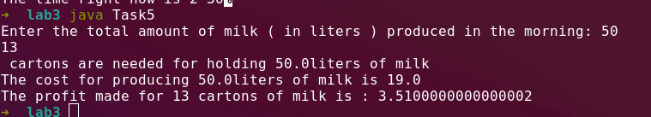

Task 6:

import java.util.*;

public class Task6
{
public static void main(String args[])
{
Scanner console = new Scanner(System.in);

System.out.print("Enter the pay rate for an hour: ");
double payRatePerHour = console.nextDouble();

System.out.print("\nEnter the numbers of hours worked per week: ");
double hoursWorked = console.nextDouble();

double baseIncome = payRatePerHour * (hoursWorked * 4); // finds the income
double tax = baseIncome * 0.14; // finds the tax ( 14 %)
double taxatedIncome = baseIncome - tax;

System.out.print("\nYour income before the taxes is $" + baseIncome);
System.out.print("\nYour income after the taxes is $" + taxatedIncome);

double clothsAndAccessExpenditure = 0.10 * taxatedIncome;
System.out.print("\nYour clothes and accessories expenditure is :$ " + clothsAndAccessExpenditure);

double schoolSupppliesExpenditure = 0.01 * taxatedIncome;
System.out.print("\nYour school supplies expenditure is :$ " + schoolSupppliesExpenditure);

double remIncome = taxatedIncome - clothsAndAccessExpenditure - schoolSupppliesExpenditure;

double boundExpen = 0.25 * remIncome;
System.out.print("\nYour bounds expenses are :$ " + boundExpen);

int numberOfDollars = (int)boundExpen;
double parentsBound = numberOfDollars * 0.50;

System.out.print("\nYour parents bought you bounds worth of : $"+ parentsBound );

}
}

output
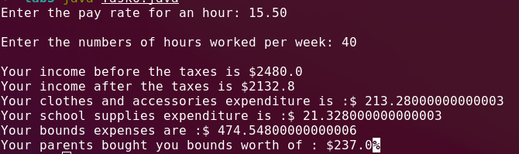

Task 7:

import java.util.*;

public class Task7
{
public static void main(String args[])
{
Scanner console = new Scanner(System.in);

System.out.print("Enter the number of class A seats sold: ");
int numberSeatClassA = console.nextInt();
int incomeSeatA = numberSeatClassA * 20;

System.out.print("\nEnter the number of class B seats sold: ");
int numberSeatClassB = console.nextInt();
int incomeSeatB = numberSeatClassB *15;

System.out.print("\nEnter the number of class C seats sold: ");
int numberSeatClassC = console.nextInt();
int incomeSeatC = numberSeatClassC * 10;

System.out.print("\nEnter the number of class D seats sold: ");
int numberSeatClassD = console.nextInt();
int incomeSeatD = numberSeatClassD * 5;

int totalIncome = incomeSeatA + incomeSeatB + incomeSeatC + incomeSeatD;
System.out.print("\nThe total income generated is: $"+ totalIncome);

System.out.printf("\nClass A seats: $%d , Class A Income: $%d",numberSeatClassA,incomeSeatA);

System.out.printf("\nClass B seats: $%d , Class B Income: $%d",numberSeatClassB,incomeSeatB);

System.out.printf("\nClass C seats: $%d , Class C Income: $%d",numberSeatClassC,incomeSeatC);

System.out.printf("\nClass D seats: $%d , Class D Income: $%d",numberSeatClassD,incomeSeatD);

}
}

Output:
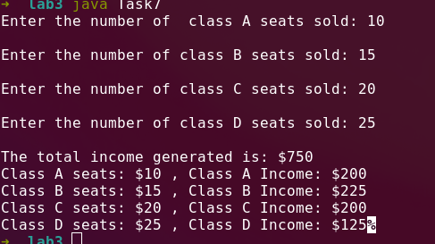

Task 8:

import java.util.*;

public class Task8
{
public static void main(String args[])
{
Scanner console = new Scanner(System.in);

System.out.print("Enter a number between 0 - 1000: ");
int orgNum= console.nextInt();

int firstDigit = orgNum% 10; // puts the last digit in firstDigit
int newNum = orgNum / 10; // removes the last digits from the orginal number
int secondDigit = newNum % 10; // puts the second last digit in secondDigit.
newNum = newNum / 10; // removes the second last digtit from newNum
int thirdDigit = newNum % 10; // puts the third last digit in thirdDigit/
newNum = newNum / 10; // removes the third last digit from newNum.
int fourthDigit = newNum % 10;

int digitSum = firstDigit + secondDigit + thirdDigit + fourthDigit;

System.out.print("\nThe sum of digits of the given number is "+ digitSum);

}
}

Output

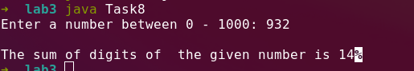

Task 9:

import java.util.*;

public class Task9
{
public static void main(String args[])
{
double x = 75.3987;
double y = 982.89764;

System.out.printf("%.2f %n", x);
System.out.printf("%.2f %n", y);
System.out.printf("%.3f %n", x);
System.out.printf("%.3f %n", y);
}
}

Task 9:

import java.util.*;

public class Task9
{
public static void main(String args[])
{
double x = 75.3987;
double y = 982.89764;

System.out.printf("%.2f %n", x);
System.out.printf("%.2f %n", y);
System.out.printf("%.3f %n", x);
System.out.printf("%.3f %n", y);
}
}

output:
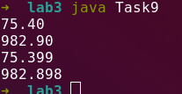

Task 10:

import java.util.*;

public class Task10
{
public static void main(String args[])
{

System.out.printf("%-10s %-10s %-10s %-10s %-10s","Degrees","Radians","Sine","Cosine","Tangent");
System.out.printf("\n---------------------------------------------------------------------");
int degrees = 30;
double radians = Math.toRadians(degrees);
double sin = Math.sin(radians);
double cos = Math.cos(radians);
double tan = Math.tan(radians);

System.out.printf("\n%-10d %-10.4f %-10.4f %-10.4f %-10.4f",degrees,radians,sin,cos,tan);

degrees = 60;
radians = Math.toRadians(degrees);
sin = Math.sin(radians);
cos = Math.cos(radians);
tan = Math.tan(radians);

System.out.printf("\n%-10d %-10.4f %-10.4f %-10.4f %-10.4f",degrees,radians,sin,cos,tan);

}
}

Output:

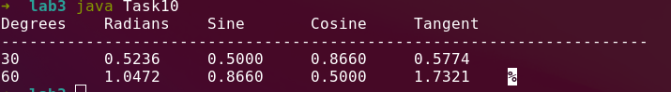

//FInally this is the end. Now i can sleep.( its 11:19 pm right now).

