
Name: Abdul Wasay
Reg.No: FA25-BSE-002
Class: BSE-1A
Instructor: Muzaffar Iqbal

COURSE:Programming fundamentals
ASSIGNMENT 3

Question 1:
Code

import java.util.Scanner;
public class FindingUniqueElementsInArray
{
public static void main(String[] args) {
Scanner input = new Scanner(System.in);
int[] list = new int[10];
int[] unique = new int[10]; //max unique numbers can be 10 numbers
//flag variable to check if value was found or not
boolean isUniqueValue;
System.out.print("Enter 10 Numbers: ");
int uniqueIndex = 0;
for(int i = 0; i<10; i++)
{
isUniqueValue = true;
list[i] = input.nextInt();
for(int j=i-1; j>=0; j--)
{
if(list[i] == list[j])
{
isUniqueValue = false;
break;
}
}

if(isUniqueValue)
{
unique[uniqueIndex] = list[i];
uniqueIndex++;
}
}//end of outer for
System.out.println("The number of distinct numbers is " + uniqueIndex);
System.out.print("The distict Numbers are:");
for(int i=0; i<unique.length; i++)
{ //breaks when unique value ends
if(i<unique.length-2) // to avoid arrayIndexOutOfBound exception
{
if(unique[i] == 0 && unique [i+1] == 0 )
break;
}
System.out.print(unique[i]+ " ");
}//outer for
}//main
}//class
Output
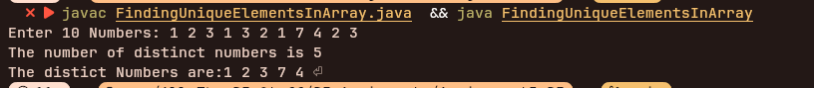

Question 2:
Code:
import java.util.Scanner;

public class EliminatingDuplicateItemsFromArray
{
public static void main(String[] args) {
Scanner input = new Scanner(System.in);
int list[] = new int[10];
System.out.print("Enter Ten Numbers: ");
for(int i=0; i<list.length; i++)
{
list[i] = input.nextInt();
}
int[] duplicateFreeArray = elimintaeDuplicates(list);

System.out.print("The distinct Numbers are: ");
for(int n:duplicateFreeArray)
System.out.print(n + " ");

}//main

public static int[] elimintaeDuplicates(int[] list)
{
int[] cleanedArray = new int[list.length];
//flag variable to check if value was found or not
boolean isUniqueValue;
System.out.print("Enter 10 Numbers: ");
int uniqueIndex = 0;
for(int i = 0; i<10; i++)
{
isUniqueValue = true;
for(int j=1; j<uniqueIndex; j--)
{
if(list[i] == cleanedArray[j])
{
isUniqueValue = false;
break;
}
}

if(isUniqueValue)
{
cleanedArray[uniqueIndex] = list[i];
uniqueIndex++;
}
}//end of outer for
int[] duplicateFreeArray = new int[uniqueIndex];
return Arrays.copyOf(cleanedArray,uniqueIndex);
}//eliminateDuplicate
}//class

Output:

` Question 3:
Code:
import java.util.Scanner;
import java.util.Arrays;
public class sortedCheckOnArray
{
public static void main(String[] args) {
Scanner input = new Scanner(System.in);

System.out.print("Enter a number of elements: ");
int size = input.nextInt();

int arr[] = new int[size];

System.out.print("Enter array elements: ");
for(int i = 0; i<arr.length; i++)
{
arr[i] = input.nextInt();
}
if(isSorted(arr))
{
System.out.print("Array is already Sorted: ");
for(int i = 0; i<arr.length; i++)
{
System.out.printf("%3d",arr[i]);
}
}
else
{
System.out.println("Array is not already sorted");
Arrays.sort(arr);
System.out.print("The Sorted array is: ");
for(int n : arr)
{
System.out.printf("%2d",n);
}
}//end of else
System.out.println();//an extra line , for the custom runjava function in shell
}//end of main

public static boolean isSorted(int arr[])
{
boolean sortedFlag = true;

for(int i = 0; i<arr.length; i++)
for(int j = i ; j<arr.length; j++)
if(arr[i]>arr[j])
{
sortedFlag = false;
return sortedFlag; //to avoid unnecessary itirations
}

return sortedFlag;
}//main
}//class

Output:
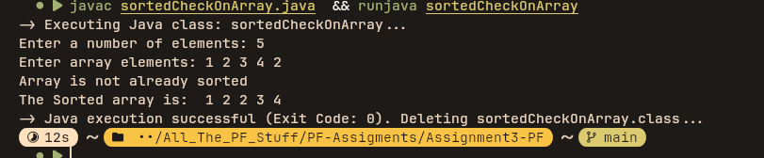

Question 4
Code:
import java.util.Scanner;
import java.util.Arrays;

public class CheckForConsectuiveFourElements
{
public static void main(String[] args) {
Scanner input = new Scanner(System.in);

System.out.print("Enter the Number of elements you want in the array: ");
int arrSize = input.nextInt();
int[] testList = new int[arrSize];
System.out.print("Enter the Values: ");
for(int i=0; i<testList.length; i++)
{
testList[i] = input.nextInt();
}

if(isCosecutiveFour(testList))
System.out.println("The list has consecutive fours");
else
System.out.println("The list has no consecutive fours");

}//main

public static boolean isCosecutiveFour(int[] list)
{
boolean isCosective = false;
for(int i =0 ; i<(list.length-3); i++)
{
if(list[i] == list[i+1] && list[i+1] == list[i+2]
&& list[i+2] == list[i+3] )
{
isCosective = true;
return isCosective; //to avoid extra itirations.
}
}

return isCosective;
}
}//class

Output:

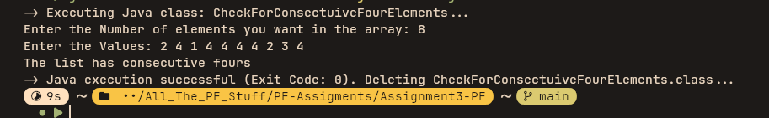

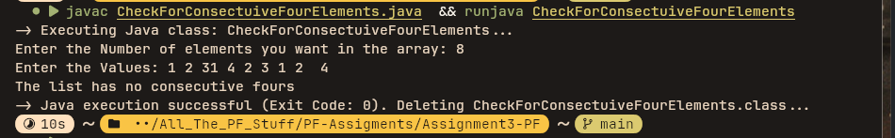

Question 5

Code:
import java.util.Scanner;
import java.util.Arrays;

public class MergingSortedArrays
{
public static void main(String[] args) {
Scanner input = new Scanner(System.in);

System.out.print("Enter the number of elements in the first list: ");
int arr1Size = input.nextInt();
int[] arr1 = new int[arr1Size];

System.out.print("Enter the values of array 1:");

for(int i = 0; i<arr1.length; i++)
{
arr1[i] = input.nextInt();
}

System.out.print("Enter the number of elements in the second list: ");
int arr2Size = input.nextInt();
int[] arr2 = new int[arr2Size];

System.out.print("Enter the values of array 2:");

for(int i = 0; i<arr2.length; i++)
{
arr2[i] = input.nextInt();
}

int[] mergedArray = mergeArrays(arr1, arr2);

System.out.print("The sorted merged array is: ");

for(int n: mergedArray)
{
System.out.print(n+ " ");
}
}//main

public static int[] mergeArrays(int[] arr1, int[] arr2)
{
int[] mergedArray = new int[arr1.length + arr2.length];
int mergedIndex= 0;
for(int i =0 ; i<arr1.length; i++)
{
mergedArray[mergedIndex] = arr1[i];
mergedIndex++;
}

for(int i =0; i<arr2.length; i++)
{
mergedArray[mergedIndex] = arr2[i];
mergedIndex++;
}

Arrays.sort(mergedArray);

return mergedArray;

}
}//class

Output:

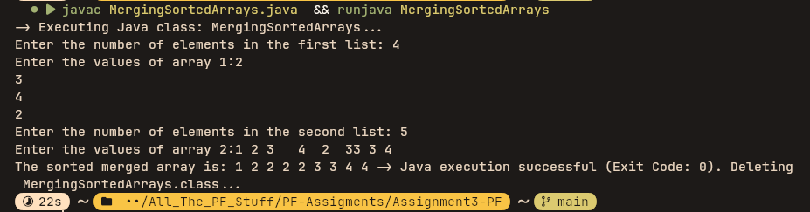

Question 6

Code:

import java.util.Scanner;
import java.util.Arrays;

public class MulitiplyingMatrices
{
public static void main(String[] args) {
Scanner input = new Scanner(System.in);

System.out.print("Enter the number of rows of Matrix 1: ");
int r1 = input.nextInt();

System.out.print("Enter the number of coloumns of matrix 1: ");
int c1 = input.nextInt();
int[][] matrix1 = new int[r1][c1];

//matrix 1 inputs
for(int i =0 ; i<matrix1.length; i++)
{
for(int j=0; j<matrix1[i].length; j++)
{
System.out.printf("Enter value number %d of %d row :",j,i);
matrix1[i][j] = input.nextInt();
}
System.out.println();
}

System.out.print("Enter the number of row of Matrix 2: ");
int r2 = input.nextInt();

System.out.print("Enter the number of coulumn of Matrix 2: ");
int c2 = input.nextInt();

int[][] matrix2 = new int[r2][c2];

//matrix 2 inputs

for(int i =0 ; i<matrix2.length; i++)
{
for(int j=0; j<matrix2[i].length; j++)
{
System.out.printf("Enter value number %d of %d row :",j,i);
matrix2[i][j] = input.nextInt();
}
System.out.println();
}

if(c1 == r2)
{
int[][] newMatrix = multiplyMatrices(matrix1, matrix2);
for(int i =0; i<newMatrix.length; i++)
{
for(int j=0; j<newMatrix[i].length; j++)
{
System.out.printf("%3d",newMatrix[i][j]);
}
System.out.println();
}
}
else
{
System.out.println("The matrixes are not Multiplyable");
}

}//main

public static int[][] multiplyMatrices(int[][] matrix1, int[][] matrix2)
{
// assumes they are multiplyable
int r1 = matrix1.length;
int c1 = matrix1[0].length;
int c2 = matrix2[0].length;
int[][] productMatrix = new int[matrix1.length][matrix2[0].length];

for(int i=0; i<r1; i++)
{
for(int j = 0; j<c2; j++)
{
int sum = 0;
for(int k=0; k<c1; k++)
sum += matrix1[i][k] * matrix2[k][j];
productMatrix[i][j] = sum;
}
}

return productMatrix;
}

}

Output:
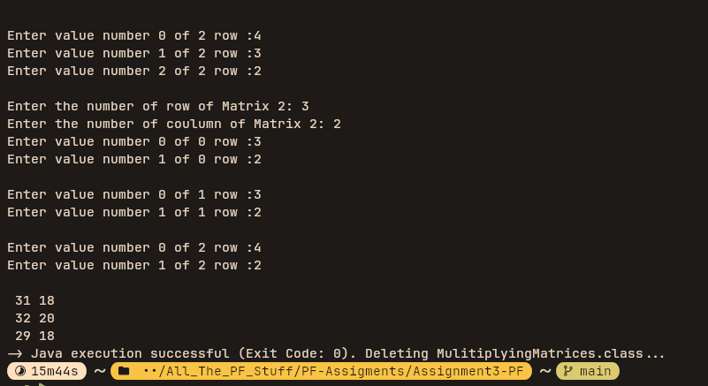
Question 7

Code

import java.util.Scanner;
import java.util.Arrays;

public class RandomMatrixAndIdenticalCheck
{
public static void main(String[] args) {
Scanner input = new Scanner(System.in);

System.out.print("Enter the length of the matrix: ");
int size = input.nextInt();

int[][] matrix = new int[size][size];

for(int i = 0; i< matrix.length; i++)
{
for(int j = 0; j<matrix[i].length; j++)
{
matrix[i][j] = (int)(Math.round((Math.random())));
System.out.printf("%-3d",matrix[i][j]);
}
System.out.println();
}

boolean isNoSameElementRow = true;
//zero and ones row chcker
for(int i = 0; i<matrix.length; i++)
{
boolean isRowZero = true;
boolean isRowOne = true;
for(int j = 0; j<matrix[i].length; j++)
{
int currentElement = matrix[i][j]; //to make changes easier
if(currentElement == 0)
{
isRowOne = false;
}
else
{
isRowZero = false;
}
}

if(isRowZero)
{
isNoSameElementRow = false;
System.out.println("All 0s on Row "+(i+1));
}
else if(isRowOne)
{
isNoSameElementRow = false;
System.out.println("All 1s on Row"+(i+1));
}
}//outer for

if(isNoSameElementRow)
System.out.println("No same number on a Row");

//coulumn check
boolean isNoSameElementColumns = true;
for(int i = 0; i<matrix.length; i++)
{
boolean isCoulumnZero = true;
boolean isCoulumnOne = true;
for(int j = 0; j<matrix[i].length; j++)
{
int currentElement = matrix[j][i]; //to make changes easier
if(currentElement == 0)
isCoulumnOne = false;
else
isCoulumnZero = false;
}

if(isCoulumnZero)
{
isNoSameElementColumns = false;
System.out.println("All 0s on column "+(i+1));
}
else if(isCoulumnOne)
{
isNoSameElementColumns = false;
System.out.println("All 1s on coulumn"+(i+1));
}
}//outer for

if(isNoSameElementColumns)
System.out.println("No Same Numbers on a column");

//check for major diagonal
boolean isDiagZero = true, isDiagOne = true;
for(int i = 0; i<matrix.length; i++)
{
for(int j=0; j<matrix[i].length; j++)
{
if(i == j)
{
int currentElement = matrix[i][j];
if(currentElement == 0)
{
isDiagOne = false;
}
else
{
isDiagZero = false;
}
}
}
}//outer for

if(isDiagZero)
System.out.println("All 0s on Major Diagonal");
else if(isDiagOne)
System.out.println("All 1s on Major Diagnoal");
else
System.out.println("No Same numbers on the major Diagonal");

//check for sub diagonal

boolean isSubDiagZero = true;
boolean isSubDiagOne= true;

for(int i = 0; i<matrix.length; i++)
{
for(int j= 0;j<matrix.length; j++)
{
if(i+j == matrix.length-2)
{
//condition for sub-diagonal element met
int currentElement = matrix[i][j];
if(currentElement == 0)
isSubDiagOne = false;
else
isSubDiagZero = false;
}
}
}//end of outer for

if(isSubDiagZero)
System.out.println("All 0s on the subdiagonal");
else if(isSubDiagOne)
System.out.println("All 1s on the subdiagonal");
else
System.out.println("No same numbers on the sub-diagonal");

}//main
}//class

Output

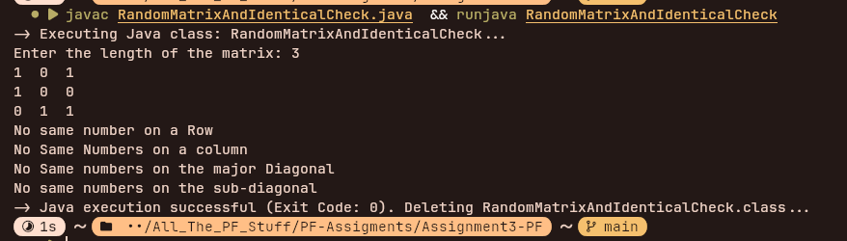

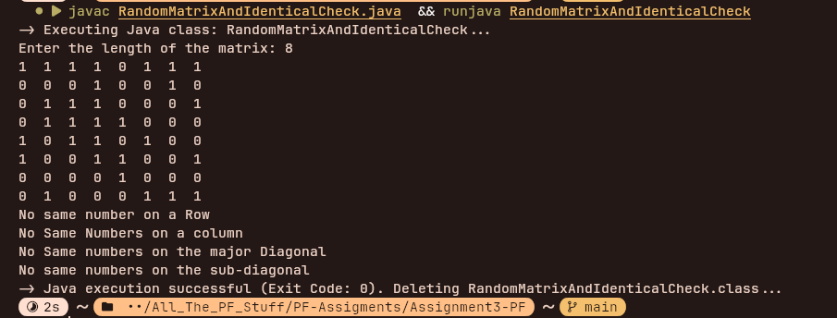

Question 8

Code

import java.util.Scanner;
import java.util.Arrays;

public class StudentManger
{
public static void main(String[] args) {
Scanner input = new Scanner(System.in);

int students[][] = new int[10][6];

for(int i =0; i<students.length; i++)
{
for(int j =0; j<students[i].length; j++)
{
//decides the prompt to be displyed
if(j!=0)
{
int currentSubjectNo =j;
System.out.println("Enter the students+"+(i+1)+"'s "+(findSubject(currentSubjectNo)) + "'s Marks:");
}
else
{
System.out.println("Enter the student "+(i+1)+"'s Roll no: ");
}

students[i][j]=input.nextInt();
}
}//outer for

int highestTotal = 0;
int highestTotalRollNo = 0;
for(int i = 0; i<students.length; i++)
{
int totalMarks = 0;
for(int j= 1; j<students[i].length; j++)
totalMarks += students[i][j];

if(totalMarks > highestTotal)
{
highestTotal = totalMarks;
highestTotalRollNo = students[i][0];
}
}

int highestPfRollno = students[0][0];
int highestPfMarks = students[0][1];
for(int i =0;i<students.length; i++)
{
if(students[i][1] > highestPfMarks)
{
highestPfMarks = students[i][1];
highestPfRollno = students[i][0];
}
}

System.out.println("The rollno of the student with the highest total marks is: "+highestTotalRollNo);
System.out.println("The rollno of the student with the highest Pf marks is: "+highestPfRollno);

for(int i =0 ; i <students.length; i++)
{
int highest = 0;
for(int j =1; j<students[i].length; j++)
{
int currentMarks = students[i][j];

if(currentMarks > highest)
highest = currentMarks;
}

System.out.println("The higest marks of rollno " +students[i][0]+ " is " + highest);
}

}//main

public static String findSubject(int subjectNo)
{
switch(subjectNo)
{
case 1:
return "Programming Fundamentals";
case 2:
return "ICT";
case 3:
return "Funcational English";

case 4:
return "Civics";
case 5:
return "Islamic Studies";
default:
return "Something ducked up";
}
}//findSubject
}//class

Output
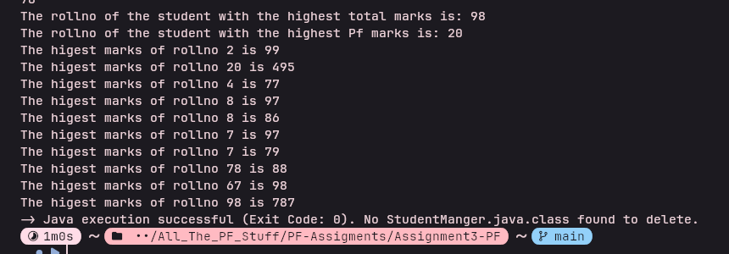

Question 9
Code

import java.util.Scanner;
import java.util.Arrays;

public class ArraysNewMethods
{
static Scanner input = new Scanner(System.in);
public static void main(String[] args) {

System.out.println("Enter the size of the array: ");
int size = input.nextInt();

int arr[] = new int[size];
System.out.print("Enter the Elements of the array: ");
for(int i=0; i<arr.length; i++)
arr[i] = input.nextInt();

//till here, array intialized
int choice;
do{
choice = 0;

System.out.println("\t\t\tMain Menu.");
System.out.println("count the number of occurence of an element."
+"\nPartition Array"
+"\nFind the frequencies of the elements"
+"\nDo circular movement"
+"\nShift cicular movement");

System.out.print("Enter your choice: ");
choice = input.nextInt();

switch(choice)
{
case 1:
count(arr);
break;
case 2:
partition(arr);
break;
case 3:
duplicates(arr);
break;
case 4:
circular(arr);
break;
case 5:
shiftCicular(arr);
break;
case 6:
return;
default:
System.out.println("Invalid Choice, Please enter a valid choice.");
}
}while(choice != 0);

System.out.print("Goodbye");
}//main

public static void count(int [] arr)
{
int count = 0;
System.out.print("Enter the number whose occurence you want to find in the given array");
int x = input.nextInt();

for(int i=0; i<arr.length; i++)
{
if(arr[i] == x)
count++;
}

System.out.println(x+" occurs "+ count +" number of times in the given array.");
}

public static void partition(int[] arr)
{
int x = arr[0];
int temp, index = 1;
for(int i=1; i<arr.length; i++)
{
if(arr[i]<x)
{
temp = arr[index]; // Store the element at index
arr[index] = arr[i]; // Move smaller element to index
arr[i] = temp; // Put the element originally at index back at i
index ++;
}

}//end of for
arr[0] = arr[index-1];
arr[index - 1] = x;
//display the new matrix
for(int i =0; i<arr.length; i++)
{
System.out.println(arr[i]+", ");
}
}

public static void duplicates(int[] arr)
{
int[] unique = new int[10];

for(int i=0; i<arr.length; i++)
{
int count = 0;
for(int j=0; j<arr.length; j++)
if(arr[i] == arr[j])
count++;

System.out.println(arr[i]+" occurs " + count +" times ");
}
}

public static void circular(int[] arr)
{
int[] cicularArray = new int[arr.length];
for(int i =0; i<arr.length; i++)
{
cicularArray[i] = arr[(i+1)%arr.length] + arr[(i+2)%arr.length]; //modulus by length, to avoid overflow
}

printArray(cicularArray);

}

public static void shiftCicular(int[] arr)
{
int[] shiftedArray = new int[arr.length];
for(int i=0; i<arr.length; i++)
{
shiftedArray[i] = arr[(i+2)%arr.length];
}

printArray(shiftedArray);
}

public static void printArray(int[] arr)
{
for(int i =0; i<arr.length; i++)
{
System.out.print(arr[i]+" ");
}
}
}//class

Output

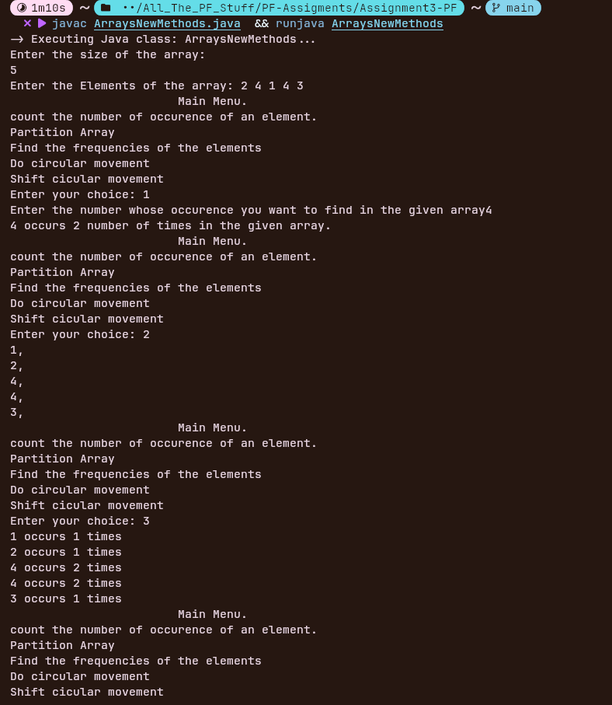
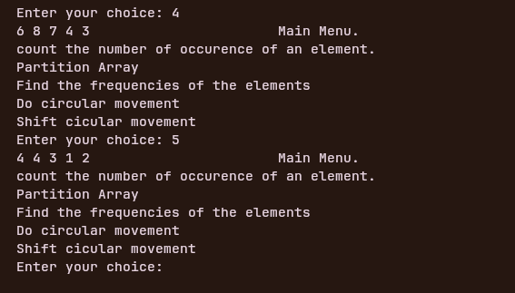

Question 10
Code
import java.util.Scanner;
import java.util.Arrays;

public class MulitiplyingMatrices
{
public static void main(String[] args) {
Scanner input = new Scanner(System.in);

System.out.print("Enter the number of rows of Matrix 1: ");
int r1 = input.nextInt();

System.out.print("Enter the number of coloumns of matrix 1: ");
int c1 = input.nextInt();
int[][] matrix1 = new int[r1][c1];

//matrix 1 inputs
for(int i =0 ; i<matrix1.length; i++)
{
for(int j=0; j<matrix1[i].length; j++)
{
System.out.printf("Enter value number %d of %d row :",j,i);
matrix1[i][j] = input.nextInt();
}
System.out.println();
}

System.out.print("Enter the number of row of Matrix 2: ");
int r2 = input.nextInt();

System.out.print("Enter the number of coulumn of Matrix 2: ");
int c2 = input.nextInt();

int[][] matrix2 = new int[r2][c2];

//matrix 2 inputs

for(int i =0 ; i<matrix2.length; i++)
{
for(int j=0; j<matrix2[i].length; j++)
{
System.out.printf("Enter value number %d of %d row :",j,i);
matrix2[i][j] = input.nextInt();
}
System.out.println();
}

if(c1 == r2)
{
int[][] newMatrix = multiplyMatrices(matrix1, matrix2);
for(int i =0; i<newMatrix.length; i++)
{
for(int j=0; j<newMatrix[i].length; j++)
{
System.out.printf("%3d",newMatrix[i][j]);
}
System.out.println();
}
}
else
{
System.out.println("The matrixes are not Multiplyable");
}

}//main

public static int[][] multiplyMatrices(int[][] matrix1, int[][] matrix2)
{
// assumes they are multiplyable
int r1 = matrix1.length;
int c1 = matrix1[0].length;
int c2 = matrix2[0].length;
int[][] productMatrix = new int[matrix1.length][matrix2[0].length];

for(int i=0; i<r1; i++)
{
for(int j = 0; j<c2; j++)
{
int sum = 0;
for(int k=0; k<c1; k++)
sum += matrix1[i][k] * matrix2[k][j];
productMatrix[i][j] = sum;
}
}

return productMatrix;
}

}

Output

