
Name: Abdul Wasay
Reg. no: FA25-BSE-002
Class: BSE-1A

Programming Fundamentals
LAB 10
Activity 1

Code

import java.util.Scanner;

public class SumOfRowsMatrix
{
public static void main(String[] args) {
Scanner input = new Scanner(System.in);

int[][] array = new int[3][4];

for(int i =0; i<array.length; i++)
{
System.out.println("Enter array elements of Row # "+(i+1));
for(int j =0; j<array[i].length; j++)
array[i][j] = input.nextInt();
}

System.out.println("The given 2D array is.... ");

for(int i =0; i<array.length; i++)
{
for(int j=0; j<array[i].length; j++)
System.out.print(array[i][j]+"\t");
System.out.println();
}

int sum;

for (int i =0; i<array.length; i++)
{
sum = 0;
for(int j =0; j<array[i].length; j++)
sum += array[i][j];

System.out.println("Sum of Row "+(i+1)+" is "+sum);
}
}//main
}//class

Output

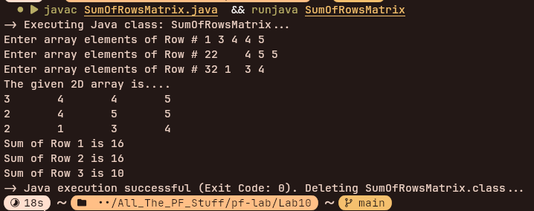

Activity 2

Code

import java.util.Scanner;

public class ArrayElementsPrimeCheck
{
public static void main(String[] args) {
Scanner input = new Scanner(System.in);

int[][] array = {{11,12,13}, {14,15,16}, {17,18,19}, {20,21,22} };
System.out.println("The given 2D array is ........");

for(int i=0; i<array.length; i++)
{
for(int j=0; j<array[i].length; j++)
System.out.print(array[i][j]+"\t");
System.out.println();
}

System.out.println("The prime numbers in 2D arrays are .... ");

int n=0;
for(int i =0; i<array.length; i++)
for(int j=0; j<3; j++)
if(isPrime(array[i][j]))
{
System.out.println(array[i][j]);
n++;
}
System.out.println("Total Prime Numbers = " +n);
}//main

public static boolean isPrime(int n)
{
boolean prime = true;

for(int i =2; i<Math.sqrt(n); i++)
{
if(n%i == 0)
{
prime = false;
break;
}
}

return prime;
}//end of isPrime
}//class

OUTPUT

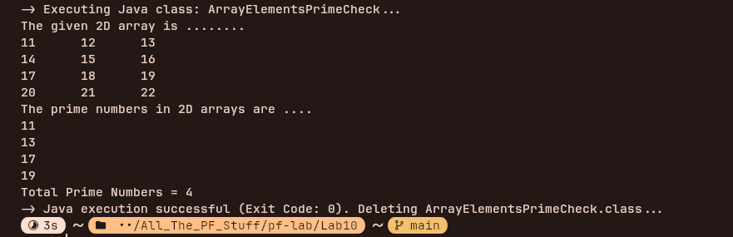

Activity 3
Code
import java.util.Scanner;

public class TransposeOfMatrix
{
public static void main(String[] args) {
Scanner input = new Scanner(System.in);

int[][] matrix1 = {{1,2,3,4}, {5,6,7,8}, {9,10,11,12}};

//matrix for storing transpose

int matrix2[][] = new int[4][3];

for(int i =0; i<matrix1.length; i++)
{
for(int j=0; j<matrix1[i].length; j++)
System.out.print(matrix1[i][j]+"\t");
System.out.println();
}

matrix2 = transpose(matrix1);

System.out.println("Transpose of the given matrix is ..");

for(int i =0; i<matrix2.length;i++)
{
for(int j=0; j<matrix2[i].length; j++)
System.out.print(matrix2[i][j]+"\t");
System.out.println();
}

}//main

public static int[][] transpose(int[][] matrix)
{
int[][] trans = new int[4][3];
for(int i=0; i<4;i++)
for(int j=0; j<3; j++)
trans[i][j]= matrix[j][i];

return trans;
}//transpose
}//class

Output

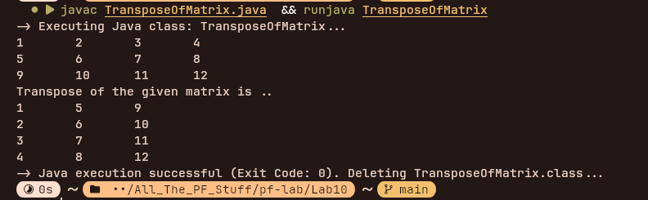

Activity 4

Code
import java.util.Scanner;

public class DiagonalSumMatrix
{
public static void main(String[] args) {

Scanner input = new Scanner(System.in);
int[][] matrix = new int[4][4];
for(int i =0; i<matrix.length; i++)
{
System.out.println("Enter array elements of row # "+(i+1));
for(int j=0; j<matrix[i].length; j++)
matrix[i][j] = input.nextInt();
}

System.out.println("Orginal Matrix is: ");
for(int i =0; i<matrix.length; i++)
{
for(int j=0 ; j<matrix[i].length; j++)
System.out.print(matrix[i][j]+"\t");
System.out.println();
}

int sum =0;

for(int i=0; i<matrix.length; i++)
{
for(int j=0;j<matrix[i].length; j++)
if( i == j)
{
sum += matrix[i][j];
break;
}
}

System.out.println("Sum of the diagonal is "+sum4);
}//main
}//class

Output
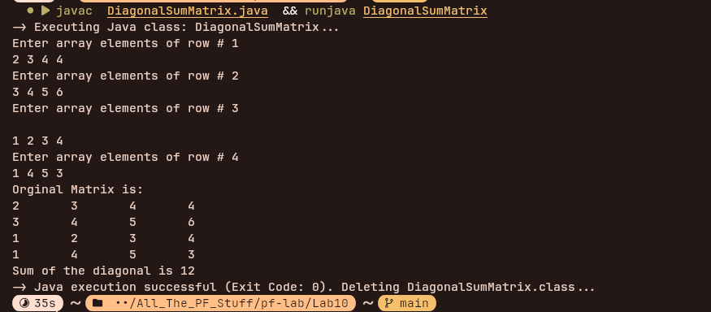

Task 1
Code
import java.util.Scanner;

public class MaxSumRow
{
public static void main(String[] args) {
Scanner input = new Scanner(System.in);

int[][] array = new int[3][4];

for(int i=0; i<array.length;i++)
{
System.out.println("Enter elements of Row # "+(i+1));
for(int j=0; j<array[i].length; j++)
array[i][j] = input.nextInt();
}

int maxRowSum =0;
int maxRow =1;//default value
for(int i =0;i<array.length;i++)
{
int sum = 0;
for(int j=0;j<array.length; j++)
sum += array[i][j];

if(sum>maxRowSum)
{
maxRowSum = sum;
maxRow = i+1;
}
}

System.out.println("Row #"+maxRow+" has the maximum sum");

//part 2

int maxColumnSum = 0;
int maxColumn = 1;

for(int i =0;i<array.length;i++)
{
int sum = 0;
for(int j=0;j<array.length; j++)
sum += array[j][i];

if(sum>maxColumnSum)
{
maxColumnSum = sum;
maxColumn = i+1;
}
}

System.out.println("Column #"+maxColumn+" has the highest sum");

}
}//class

Output

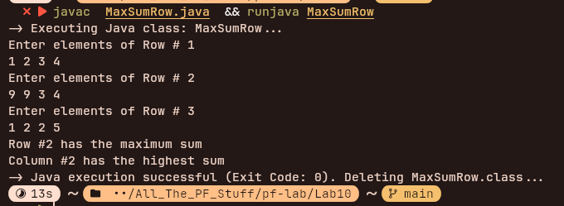

Task 2
Code

import java.util.Scanner;

public class MaxPrimeRowFinder
{
public static void main(String[] args) {
Scanner input = new Scanner(System.in);

int[][] array = new int[3][4];

for(int i=0 ; i<array.length; i++)
{
System.out.print("Enter the elements of Row #"+(i+1));

for(int j=0; j<array[i].length; j++)
array[i][j] = input.nextInt();
}

int maxRowPrimeNum = 0;
int maxRowPrime = 1;
for(int i=0; i<array.length; i++)
{
int primeCount = 0;
for(int j=0; j<array[i].length; j++)
if(isPrime(array[i][j]))
primeCount++;

if(primeCount > maxRowPrimeNum)
{
maxRowPrimeNum = primeCount;
maxRowPrime = i+1;
}
}

int maxColumnPrimeNum = 0;
int maxColumnPrime = 1;

for(int i=0; i<array[0].length; i++)
{
int primeCount = 0;
for(int j=0; j<array.length; j++)
if(isPrime(array[j][i]))
primeCount++;

if(primeCount > maxColumnPrimeNum)
{
maxColumnPrimeNum = primeCount;
maxColumnPrime = i+1;
}
}

if(maxRowPrimeNum > maxColumnPrimeNum)
System.out.println("The maximum number of prime numbers is in Row #"+maxRowPrime);
else
System.out.println("The maximum number of prime numbers is in Column #"+maxColumnPrime);

}//main

public static boolean isPrime(int n)
{
boolean prime = true;

for(int i =2; i<Math.sqrt(n); i++)
{
if(n%i == 0)
{
prime = false;
break;
}
}

return prime;
}//end of isPrime
}//class

Output

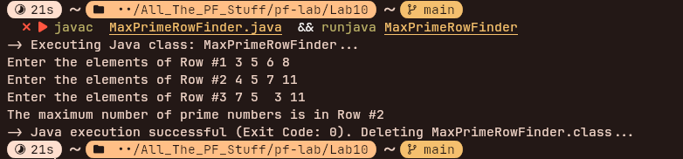

Task 3
Code
import java.util.Scanner;
import java.util.Arrays;

public class MultiplyingMatrices
{
public static void main(String[] args) {
Scanner input = new Scanner(System.in);

int[][] matrix1 = new int[3][4];

//matrix 1 inputs
System.out.printf("%40s","Matrix 1 Elements\n");
for(int i =0 ; i<matrix1.length; i++)
{
System.out.printf("Enter the values of row %d:",i+1);
for(int j=0; j<matrix1[i].length; j++)
{
matrix1[i][j] = input.nextInt();
}
System.out.println();
}

int[][] matrix2 = new int[4][3];

//matrix 2 inputs

System.out.printf("%40s","Matrix 2 Elements\n");
for(int i =0 ; i<matrix2.length; i++)
{
System.out.printf("Enter values of row %d :",i+1);
for(int j=0; j<matrix2[i].length; j++)
{
matrix2[i][j] = input.nextInt();
}
System.out.println();
}
System.out.println("The New Matrix is : ");
int[][] newMatrix = multiplyMatrices(matrix1, matrix2);
for(int i =0; i<newMatrix.length; i++)
{
for(int j=0; j<newMatrix[i].length; j++)
{
System.out.printf("%-5d",newMatrix[i][j]);
}
System.out.println();
}
}//main

public static int[][] multiplyMatrices(int[][] matrix1, int[][] matrix2)
{
// assumes they are multiplyable
int r1 = matrix1.length;
int c1 = matrix1[0].length;
int c2 = matrix2[0].length;
int[][] productMatrix = new int[matrix1.length][matrix2[0].length];

for(int i=0; i<r1; i++)
{
for(int j = 0; j<c2; j++)
{
int sum = 0;
for(int k=0; k<c1; k++)
sum += matrix1[i][k] * matrix2[k][j];
productMatrix[i][j] = sum;
}
}

return productMatrix;
}

}//class

Output

s