
Name: Abdul Wasay
Reg. no: FA25-BSE-002
Class: BSE-1A

Programming Fundamentals
Lab Assignment 2
QUESTION 1
Code
import java.util.Scanner;

public class SumOfDiagonalMatrix
{
public static void main(String[] args) {
Scanner input = new Scanner(System.in);

System.out.println("Enter the length of the matrix you want to enter: ");
int size = input.nextInt();

double[][] matrix = new double[size][size];

System.out.printf("Enter elements of a %d-by-%d matrix, row by row: \n",size,size);

for (int i =0; i<matrix.length; i++)
for(int j=0; j<matrix[i].length; j++)
matrix[i][j] = input.nextDouble();

double diagSum = sumMajorDiagonal(matrix);

System.out.println("The sum of the elemetns of the major diagonal is:"+diagSum);
}

public static double sumMajorDiagonal(double[][] arr)
{
double sum=0;

for(int i =0; i<arr.length; i++)
for(int j=0; j<arr[i].length; j++)
if(i == j)
sum += arr[i][j];

return sum;
}
}//class

Output
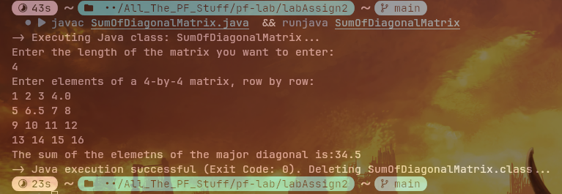

QUESTION 2
Code
import java.util.Scanner;

public class TheatreSeatsStatus
{
public static void main(String[] args) {
Scanner input = new Scanner(System.in);

int[][] theatreSeats = new int[5][10];

for(int i=0; i<theatreSeats.length; i++)
for(int j=0; j<theatreSeats[i].length; j++)
theatreSeats[i][j] = (int)(Math.round(Math.random()));

int totalSeats = findTotalAvailSeats(theatreSeats);

int[] rowSeats = findRowsAvailSeats(theatreSeats);

printArray(theatreSeats);

System.out.println("The total number of seats avalable in the theatre is "+totalSeats);

for(int i =0; i<rowSeats.length; i++)
System.out.println("The seats avalable in Row "+(i+1)+" are: "+rowSeats[i]);
}

public static int findTotalAvailSeats(int[][] theatreSeats)
{
int availCount = 0;

for(int i =0; i<theatreSeats.length; i++)
for(int j=0; j<theatreSeats[i].length; j++)
if(theatreSeats[i][j] == 1)
availCount++;

return availCount;
}

public static int[] findRowsAvailSeats(int[][] theatreSeats)
{
int[] rowAvailCounts= new int[theatreSeats.length];
for(int i=0; i<theatreSeats.length; i++)
{
int availCount = 0;
for(int j=0; j<theatreSeats[i].length; j++)
if(theatreSeats[i][j] == 1)
availCount++;

rowAvailCounts[i] = availCount;
}

return rowAvailCounts;
}

public static void printArray(int[][] arr)
{
for(int i=0; i<arr.length; i++)
{
for(int j=0; j<arr[i].length; j++)
System.out.printf("%5d",arr[i][j]);
System.out.println();
}
}
}//class

Output
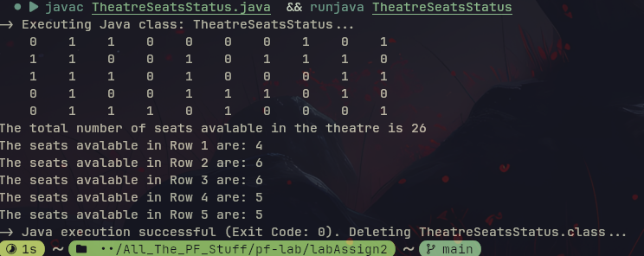

Question 3
Code
import java.util.Scanner;

public class StudentsMarks
{
public static void main(String[] args) {
Scanner input = new Scanner(System.in);

int[][] studentsMarks = new int[3][4];
populateArrayFromUser(studentsMarks,input);

findAndPrintAverage(studentsMarks);

findAndPrintHigestMarks(studentsMarks);
}
public static void populateArrayFromUser(int[][] students, Scanner input)
{
for(int i=0; i<students.length; i++)
{
System.out.print("Enter the Marks of student no "+(i+1));
for(int j=0; j<students[i].length; j++)
studentsMarks[i][j] = input.nextInt();
}
}//populateArrayFromUser

public static void findAndPrintAverage(int[][] students)
{
for(int i=0; i<students.length; i++)
{
int sum = 0;

for(int j=0;j<students[i].length; j++)
{
sum += students[i][j];
}
final int TOTALSUBJECTS = 4;
int avg = (int)(sum/TOTALSUBJECTS);
System.out.print("The average marks of student no "+(i+1)+" is ");
}
}

public static void findAndPrintHigestMarks(int[][] marks)
{
int highestMarks;
for(int i=0; i<marks[0].length; i++)
{
highestMarks = 0;

for(int j=0; j<marks.length; j++)
{
if(marks[j][i]>highestMarks)
highestMarks = marks[i][j];
}

System.out.println("The highest marks in subject no "+(i+1)+" is "+highestMarks);
}
}//findAdnPrintHighestMarks
}//class

Output
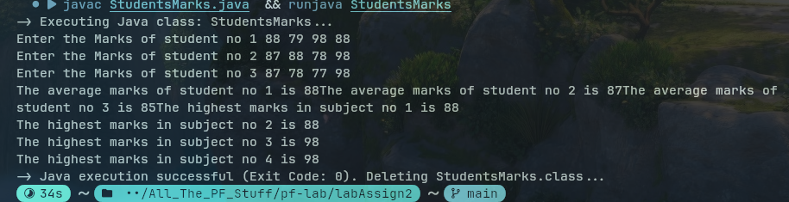

Question 4
Code
import java.util.*;

public class YearlyRaifallCalculator
{
public static void main(String[] args) {
Scanner input = new Scanner(System.in);

int[][] cityRainMonth = new int[5][12];

takeMonthlyRains(cityRainMonth,input);

int[] yearlyRains = calculateAndPrintYearlyRainfall(cityRainMonth);

int highestRainCity = calculateHigestRainfallCity(yearlyRains);

System.out.println("city "+highestRainCity+" has the highest rainfall.");
}//main
public static void printArray(int[][] arr)
{
for(int i =0; i<arr.length; i++)
{
for(int j=0; j<arr[i].length; j++)
System.out.printf("%6d",arr[i][j]);
System.out.println();
}
}//printArray

public static void takeMonthlyRains(int[][] cityRainMonth,Scanner input)
{
for(int i=0; i<cityRainMonth.length; i++)
{
System.out.print("Enter the rainfall recieved in city "+(i+1)+" in each of the 12 months.");
for(int j=0; j<cityRainMonth[i].length; j++)
cityRainMonth[i][j] = input.nextInt();

System.out.println();
}
}//takeMonthlyRains

public static int[] calculateAndPrintYearlyRainfall(int[][] cityRainMonth)
{
int[] cityYearlyRains = new int[cityRainMonth.length];
for(int i=0; i<cityRainMonth.length; i++)
{
int yearlyRain = 0;
for(int j=0; j<cityRainMonth[i].length; j++)
yearlyRain += cityRainMonth[i][j];
cityYearlyRains[i] = yearlyRain;
System.out.println("The yearly rainfall of city"+(i+1)+" Is "+yearlyRain+" mm per sq.inch");
}
return cityYearlyRains;
}//calculateAndPrintYearlyRainfall

public static int calculateHigestRainfallCity(int[] cityYearlyRains)
{
int highestRainCity=0;
int highestRain = cityYearlyRains[0];
for(int i =0; i<cityYearlyRains.length; i++)
{
if(cityYearlyRains[i]>highestRain)
{
highestRain = cityYearlyRains[i];
highestRainCity = i+1;
}
}

return highestRainCity;
}
}//class

Output
`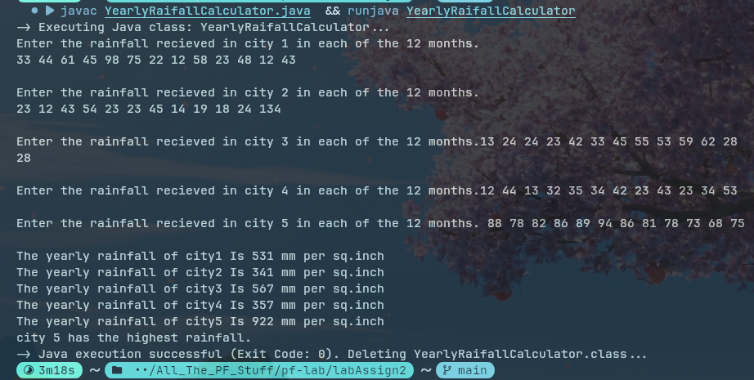

Question 5
Code
import java.util.*;

public class PattternPrintingUsingRecursion
{
public static void main(String[] args) {
Scanner input = new Scanner(System.in);

printPiramid(5);
System.out.println();
printRightAlignedTriangle(5);
System.out.println();
printLeftAlignedTriangle(5);
System.out.println();
printFlippedTriangle(5);
}

public static void printPiramid(int n)
{
if(n>0)
printPiramid(n-1);

for(int i=1; i<=5-n; i++)
System.out.print(" ");
for(int i =1; i<=n; i++)
System.out.print("* ");
System.out.println();
}

public static void printRightAlignedTriangle(int n)
{
if(n>1)
printRightAlignedTriangle(n-1);

for(int i=1; i<=5-n; i++)
System.out.print(" ");
for(int i =1; i<=n; i++)
System.out.print(" *");
System.out.println();
}

public static void printLeftAlignedTriangle(int n)
{
if(n>1)
printLeftAlignedTriangle(n-1);

for(int i=1; i<=n; i++)
System.out.print("* ");
System.out.println();
}

public static void printFlippedTriangle(int n)
{

for(int i=n; i>=1; i--)
System.out.print("* ");
System.out.println();
if(n>1)
printFlippedTriangle(n-1);
}
}//class

Output
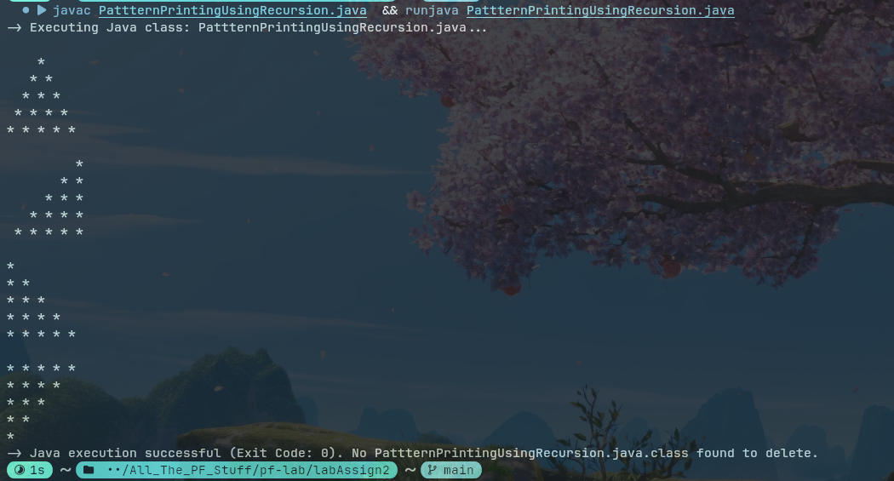

Question 6
Code
import java.util.Scanner;
import java.util.Arrays;
public class MultidimensionalArrayMethods
{
public static void main(String[] args) {
Scanner input = new Scanner(System.in);
//can generate input mismatch exception
System.out.println("Enter the number of rows in the 2D array: ");
int rowSize = input.nextInt();
System.out.println("Enter the number of elmenets in each row of the 2D array");
int columnSize = input.nextInt();
int[][] array = new int[rowSize][columnSize];

putDataInArray(array, input);//done
putRandomValueInArray(array);//done
printArray(array);//done
shuffleArray(array);//done
findAndPrintLargestElement(array);//done
findAndPrintSumOfAllElements(array);//done
findAndPrintLargestRow(array);//done
findAndPrintColumnSum(array);//on this
}

public static void putDataInArray(int[][] array, Scanner input)
{
for(int i=0; i<array.length; i++)
{
System.out.printf("Enter the Elements of Row %d: ",i+1);
for(int j=0; j<array[i].length; j++)
array[i][j] = input.nextInt();
System.out.println();
}
printArray(array);
}//putDataInArray

public static void putRandomValueInArray(int[][] array)
{
for(int i=0; i<array.length; i++)
{
for(int j=0; j<array[i].length; j++)
array[i][j] = (int)(Math.round(Math.random()*50));
}

printArray(array);
}

public static void printArray(int[][] array)
{
for(int i=0; i< array.length; i++)
{
for(int j=0; j<array[i].length; j++)
System.out.printf("%6d",array[i][j]);
System.out.println();
}
}

public static void shuffleArray(int[][] array)
{
System.out.println("Before shuffle, Array looks like this ");
printArray(array);

for(int i=0; i<array.length; i++)
{
for(int j=0; j<array[i].length; j++)
{
int columnShuffleIndex = (int)(Math.random()*(array[i].length-1));
int rowShuffleIndex = (int)(Math.random()*(array.length-1));
//swapped this array index to a random one
int temp = array[i][j];
array[i][j] = array[rowShuffleIndex][columnShuffleIndex];
array[rowShuffleIndex][columnShuffleIndex] = temp;
}
}

System.out.println("After shuffle: ");
printArray(array);
}

public static void findAndPrintLargestElement(int[][] array)
{
int highestElement =0;
int highestElementIndex = 0;

for(int i=0; i<array.length; i++)
for(int j=0; j<array[i].length; j++)
if(array[i][j]>highestElement)
{
highestElement = array[i][j];
highestElementIndex = i;
}

System.out.println("The largest element is "+highestElement+" And its index is "+highestElementIndex);

}

public static void findAndPrintSumOfAllElements(int[][] array)
{
int sum=0;
for(int i =0; i<array.length; i++)
{
for(int j=0; j<array[i].length; j++)
sum += array[i][j];
}

System.out.println("The sum of the Elemetns of the elments is: "+sum);
}

public static void findAndPrintLargestRow(int[][] array)
{
int largestRow =0;
int largestSum = 0;
for(int i =0; i<array.length; i++)
{
int rowSum = 0;

for(int j=0; j<array[i].length; j++)
rowSum += array[i][j];

if(rowSum > largestSum)
{
largestSum = rowSum;
largestRow= i+1;
}
}

System.out.println("The row with the largest sum is row "+largestRow);
}

public static void findAndPrintColumnSum(int[][] array)
{
for(int i=0; i<array[0].length; i++)
{
int sum = 0;
for(int j=0; j<array.length; j++)
sum += array[j][i];

System.out.println("The Sum of the column "+(i+1)+" is "+sum);
}
}
}//class

Output
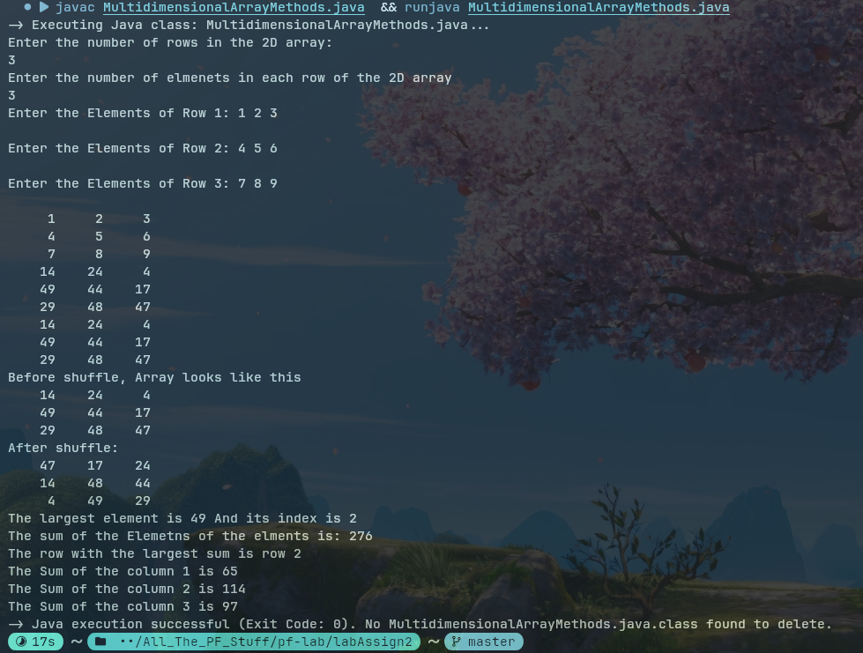

Question 7
Code
import java.util.*;
public class RandomMatrixFiller
{
public static void main(String[] args) {
Scanner input = new Scanner(System.in);
//can generate input mismatch exception
System.out.println("Enter the number of rows in the 2D array: ");
int rowSize = input.nextInt();
System.out.println("Enter the number of elmenets in each row of the 2D array");
int columnSize = input.nextInt();
double[][] array =new double[rowSize][columnSize];

putRandomValueInArray(array);

printArray(array);
int columnChoice;
do
{
System.out.println("Enter the column to find its sum: ");
columnChoice = input.nextInt();
}while(columnChoice >=columnSize || columnChoice < 0);

double sum = sumColumn(array, columnChoice-1);

System.out.printf("The sum of the required column is %.2f",sum);
}

public static double sumColumn(double[][] m, int n)
{
double sum=0;

for(int i =0; i<m.length; i++)
sum += m[i][n];

return sum;
}

public static void putRandomValueInArray(double [][] array)
{
Random random = new Random();
for(int i=0; i<array.length; i++)
{
for(int j=0; j<array[i].length; j++)
array[i][j] = Double.parseDouble(String.format("%.2f",random.nextDouble()*50));
}

printArray(array);
}

public static void printArray(double[][] array)
{
for(int i=0; i< array.length; i++)
{
for(int j=0; j<array[i].length; j++)
System.out.printf("%10.2f",array[i][j]);
System.out.println();
}
}
}//class

Output
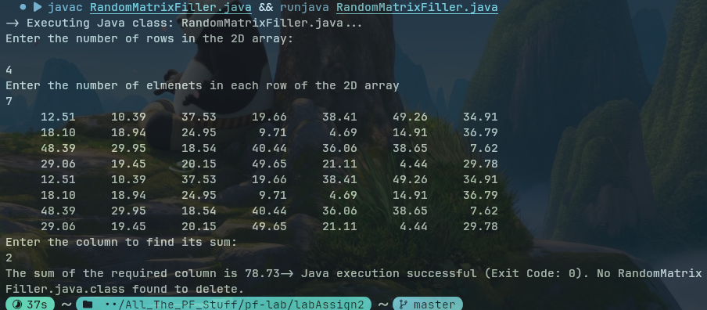

Question 8
Code

import java.util.Scanner;
import java.util.Random;
import java.util.Arrays;

public class LargestOneRow
{
public static void main(String[] args) {
Scanner input = new Scanner(System.in);

int[][] matrix = new int[4][4];

fillMatrixWithOneAndZeros(matrix);

printArray(matrix);

int largestRow = findLargestRow(matrix);

int largestColumn = findLargestColumn(matrix);

System.out.printf("The largest Row index: %d\n",largestRow);

System.out.printf("The largest Column index : %d\n",largestColumn);
}//main

public static void printArray(int[][] array)
{
for(int i=0; i< array.length; i++)
{
for(int j=0; j<array[i].length; j++)
System.out.printf("%6d",array[i][j]);
System.out.println();
}
}

public static void fillMatrixWithOneAndZeros(int[][] matrix)
{
Random random = new Random();

for(int i=0; i<matrix.length; i++)
for(int j=0; j<matrix[i].length; j++)
matrix[i][j] = random.nextInt(2);

}

public static int findLargestRow(int[][] matrix)
{
int higestOneCount= 0;
int higestOneRowIndex =0;
for(int i=0; i<matrix.length; i++)
{
int count =0;
for(int j=0; j<matrix[i].length; j++)
if(matrix[i][j] == 1)
count++;

if(count>higestOneCount)
{
higestOneCount = count;
higestOneRowIndex = i;
}
}

return higestOneRowIndex;
}

public static int findLargestColumn(int[][] matrix)
{
int highestCount= 0;
int highestColumnIndex = 0;

for(int i=0; i<matrix[0].length; i++)
{
int count =0;

for(int j=0; j<matrix.length; j++)
if(matrix[j][i]==1)
count++;

if(count > highestCount)
{
highestCount = count;
highestColumnIndex = i;
}
}

return highestColumnIndex;
}//largestColumn
}//class

Output
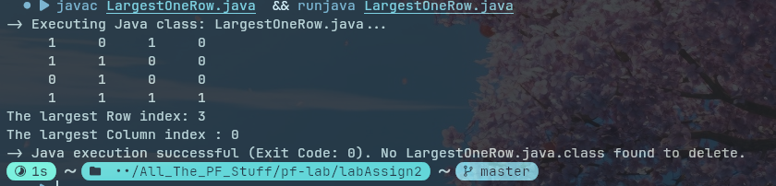
s

