
PF
LAB 12
Made by: ABDUL WASAY
Registration No.: FA25-BSE-002
Section: 1A
Teacher:MR.Muzaffar Iqbal
Activity-1:
Input:
import java.util.*;
import java.io.*;

public class Activity1
{
public static void main(String args[])
{
try{
char ch[] = {'j','a','v','a'};

FileOutputStream os = new FileOutputStream("test.txt");

for(int i=0; i< ch.length; i++)
{
os.write(ch[i]);
}
os.close();

FileInputStream is = new FileInputStream("test.txt");
int size = is.available();

for(int i=0; i<size; i++)
{
System.out.print((char)is.read()+" ");
}
is.close();
}catch(IOException e){
System.out.print("Exception"+e);
}
}
}
Output:
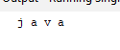
Activity-2:
Input:

package lab13;
import java.util.*;
import java.io.*;
public class Lab13 {
public static void main(String[] args) {

Scanner cin= new Scanner(System.in);
try{
while(true)
{
boolean qFound = false;
PrintWriter writer = new PrintWriter(new FileWriter("test.txt",true));
System.out.println("Enter characters, 'q' to quit.");
String userInput = cin.nextLine();
if(userInput.equals("q"))
break;
writer.print(userInput);

writer.close();
}

System.out.println("The given data is as below");
Scanner is = new Scanner(new File("test.txt"));

while(is.hasNext())
{
String output = is.nextLine();
System.out.print(output);
}
}catch(IOException e)
{
System.out.println("Exception");
}
}

}
Output:
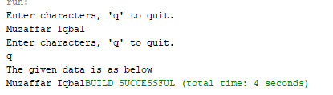

Activity-3:
Input:
package lab13;
import java.util.*;
import java.io.*;

public class Activity3 {
public static void main(String[] args) {
int rno = 101;
String name = "Muzaffar";

int marks = 88;
try{
FileOutputStream fos = new FileOutputStream("myfile.txt");
PrintWriter writer = new PrintWriter(fos);

writer.println(rno);
writer.println(name);
writer.println(marks);
System.out.println("Successfully written");

writer.close();
}
catch(IOException e)
{
System.out.println("An error occurred.");
}
}
}
Output:
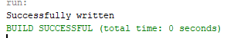
Activity-4:
Input:
package lab13;
import java.util.*;
import java.io.*;
public class Activity4 {
public static void main(String[] args) {
try{
File Obj = new File("myfile.txt");
Scanner reader = new Scanner(Obj);
while(reader.hasNext())
{
int rno = reader.nextInt();
System.out.println("R. No ="+rno);
String name = reader.next();
System.out.println("Name = "+name);
int marks = reader.nextInt();
System.out.println("Marks ="+ marks);
}
reader.close();
}catch(FileNotFoundException e)
{
System.out.println("An error has occurred.");
}
}
}

Output:
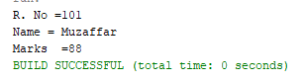
Activity-5:
Input:
package lab13;
import java.util.*;
import java.io.*;
public class Activity5 {
public static void main(String[] args) {
Scanner input = new Scanner(System.in);
int rno;
String name;
int marks;
try{
FileOutputStream file = new FileOutputStream("myfile.txt");
PrintWriter writer = new PrintWriter(file);

while(true)
{
System.out.print("Enter roll no ");
rno = input.nextInt();
input.nextLine();
if(rno == 0)
break;
System.out.print("Enter name ");
name = input.nextLine();
System.out.print("Enter Marks");
marks = input.nextInt();

writer.print(rno);
writer.print(name);
writer.print(marks);
}

System.out.println("Successfully written.");
writer.close();
}
catch(IOException e)
{
System.out.println("An error has occurred");
}
}
}
Output:

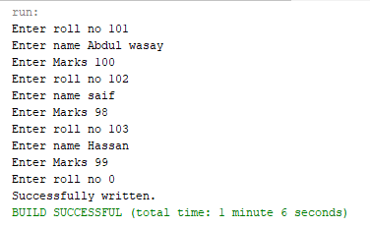
Activity-6:
Input:
import java.util.*;
import java.io.*;
public class Acitivity6 {
public static void main(String[] args) {
try{
File Obj = new File("myfile.txt");
Scanner reader = new Scanner(Obj);
while(reader.hasNext())
{
int rno = reader.nextInt();
reader.nextLine();
System.out.println("R. No ="+rno);
String name = reader.next();
reader.nextLine();
System.out.println("Name = "+name);
int marks = reader.nextInt();
reader.nextLine();
System.out.println("Marks ="+ marks);
}
reader.close();
}catch(FileNotFoundException e)
{
System.out.println("An error has occurred.");
}
catch(Exception e)
{
System.out.println(e);
}

}
}

Output:
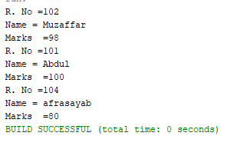

LabTask-01:
Input:
import java.util.*;
import java.io.*;

public class Task1
{
public static void main(String[] args) {
Scanner input = new Scanner(System.in);
int nums[] = new int[10];
for(int i =0; i<10; i++)
{
System.out.printf("Enter the %d Integer value: ",i+1);
nums[i] = input.nextInt();
}

try(PrintWriter pw = new PrintWriter("test.txt"))
{

pw.write(Arrays.toString(nums)
.replace("["," ")
.replace("]"," ")
.replace(","," "));
}catch(IOException e1)
{
System.out.println("An error occured , "+e1.toString());
}
}
}
Output:
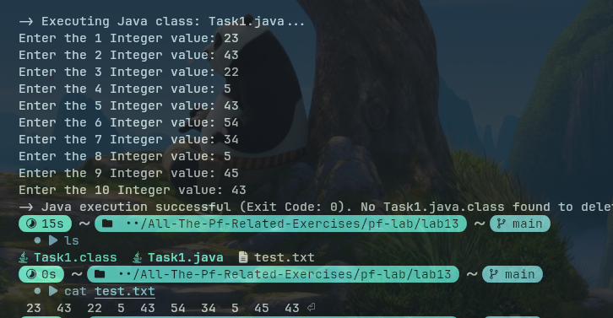
LabTask-02:
Input:
import java.util.*;
import java.io.*;

public class Task2
{
public static void main(String[] args)
{
ArrayList<Integer> nums = new ArrayList<>();
try(FileInputStream fis = new FileInputStream("test.txt"))
{
Scanner fileReader = new Scanner(fis);
while(fileReader.hasNextInt())
{
int currentNum = fileReader.nextInt();
nums.add(currentNum);
}

int[] numArray = new int[nums.size()];
for(int i =0; i<nums.size(); i++)
{
numArray[i] = nums.get(i);
}

Arrays.sort(numArray);

String data = Arrays.toString(numArray).replace("["," ").replace("]"," ").replace(","," ");

System.out.printf("""
The array in sorted form is
%s
""",data);
}
catch(IOException e1)
{
System.out.println("Somethign wnet wrong");
}
}
}
Output:
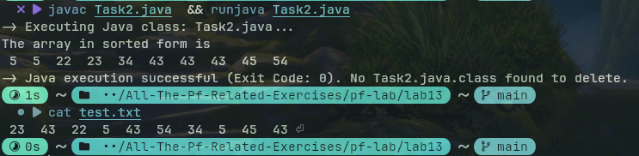

LabTask-3:
Input:
import java.util.*;
import java.io.*;

public class Task3
{
public static void main(String[] args)
{
try(FileInputStream fis = new FileInputStream("test.txt"))
{
ArrayList<Integer> nums = new ArrayList<>();
Scanner fileReader = new Scanner(fis);
while(fileReader.hasNextInt())
{
int currentNum = fileReader.nextInt();
nums.add(currentNum);
}
ArrayList<Integer> cleanedList = new ArrayList<>();

for(int element : nums)
if(!isPrime(element))
cleanedList.add(element);
int[] cleanedArray = new int[cleanedList.size()];
for(int i =0; i<cleanedList.size(); i++)
{
cleanedArray[i] = cleanedList.get(i);
}

String data = Arrays.toString(cleanedArray).replace("["," ").replace("]"," ").replace(","," ");

fileReader.close();

FileOutputStream fos = new FileOutputStream("test.txt");
PrintStream writer = new PrintStream(fos);

writer.println(data);

fos.close();
}//try
catch(IOException e1)
{
System.out.println("An error occuered ."+e1.toString());
}
}//main

public static boolean isPrime(int n)
{
if(n==0 || n==1 || n == 2 )
return false;
else
for(int i=2; i<=Math.sqrt(n); i++)
if(n%i == 0)
return false;

return true;//executes only if the inner if didint execute
}
}//class
Output:
