
Name: Abdul Wasay
Reg. no: FA25-BSE-002
Class: BSE-1A

PF
LAB 11
ACTIVITY 1

CODE
import java.util.*;

public class Activity1
{
public static void main(String[] args) {
Scanner input = new Scanner(System.in);

int a,b, choice;
do{
System.out.print("Enter 1st value "); a = input.nextInt();
System.out.print("Enter 2nd value "); b = input.nextInt();
System.out.print("1: Add\n2:Subtract\n3:Multiply\n4:Divide\n5:Quit\nEnter your choice: ");
choice = input.nextInt();

try{
switch(choice)
{
case 1:
System.out.println(a+"+"+b+"="+(a+b));
break;
case 2:
System.out.println(a+"-"+b+"="+(a-b));
break;
case 3:
System.out.println(a+"*"+b+"="+(a*b));
break;
case 4:
System.out.println(a+"/"+b+"="+(a/b));
break;
case 5:
break;
default:
System.out.println("You have entered an invalid choice");
}
}
catch(ArithmeticException e)
{
System.out.println("It is divide By ZERO Exception");
System.out.println("Try Again...");

}
}while(choice!=5);
}//main
}//classs

OUTPUT
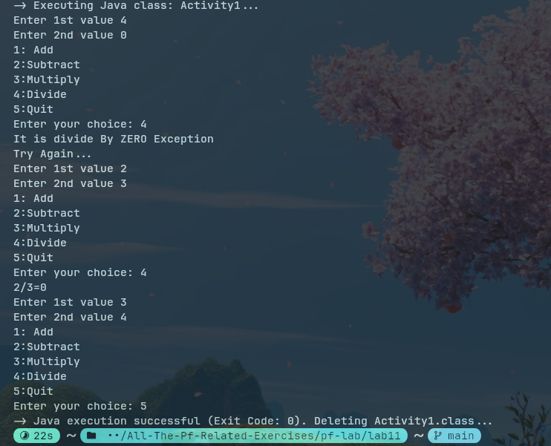

ACTIVITY 2
CODE
import java.util.*;

public class Activity2
{
public static void main(String[] args) {
Scanner input = new Scanner(System.in);

while(true)
{
try{
System.out.print("Enter an Integer Value ");
int n = input.nextInt();
System.out.println("Factorial = "+factorial(n));
break;
}
catch(InputMismatchException ex)
{
System.out.println("You have entered An invalid input ");
System.out.println("Try again");
input.nextLine();
}
}//while
}//main

static long factorial(int n)
{
long f=1;
for(int i =1; i<=n; i++)
f= f*i;
return f;
}
}//class

Output
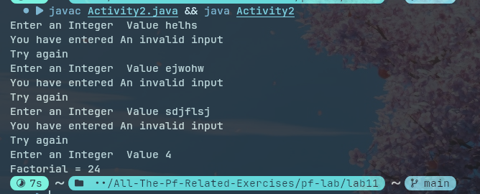

ACTIVITY 3
CODE
import java.util.*;

public class Activity3
{
public static void main(String[] args) {
Scanner input = new Scanner(System.in);

int array[] = {11, 5, 8, 3, 21, 7, 66, 33, 31, 90};
int choice=1;
while(choice ==1)
{
try{
System.out.print("Enter an integer value to search in array: ");
int n=input.nextInt();
System.out.print("Enter the index of the array: ");
int index = input.nextInt();

if(array[index] == n)
System.out.println("You won");
else
System.out.println("You lost");

System.out.println("Do you want to continue..... (Press 1 for YES and 0 for NO) ");
choice = input.nextInt();
if(choice ==0 ) break;
}
catch (InputMismatchException ex)
{
System.out.println("You have enteered an invalid input type ");
System.out.println("Try Again ");
input.nextLine();
}
catch(ArrayIndexOutOfBoundsException ex2)
{
System.out.println("You have entered an invalid Index");
System.out.println("Try Again");
input.nextLine();
}
}//while
}//main
}//class

OUTPUT
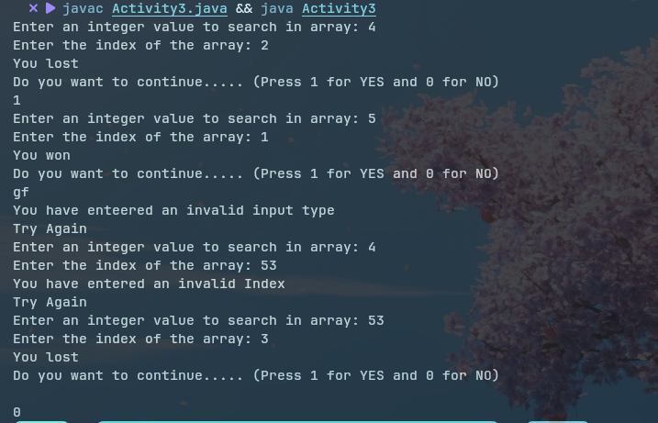

ACTIVITY 4
CODE
import java.util.*;

public class Acitivity4
{
public static void main(String[] args) {
Scanner input = new Scanner(System.in);

try
{
int arr[] = {5, 0, 1, 2};
try{
int x = arr[3]/arr[1];
}
catch(ArithmeticException ae)
{
System.out.println("Divide by zero ");
}
arr[4] = 3;
}
catch(ArrayIndexOutOfBoundsException e)
{
System.out.println("Array Index out of bound Exception ");
}
}//main
}//class

OUTPUT
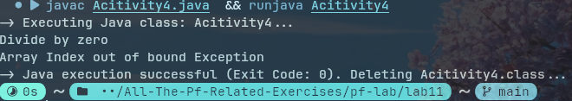

TASK 1
CODE
import java.util.*;

public class Task1
{
public static void main(String[] args) {
Scanner input =new Scanner(System.in);

int num1, num2, sum;
while(true)
{
try{
System.out.print("Enter the first Integer value: ");
num1 = input.nextInt();
System.out.print("Enter the second integer value: ");
num2 = input.nextInt();

sum = num1+num2;

System.out.print("The sum is "+sum);
break;
}
catch(InputMismatchException ex)
{
System.out.println("Invalid input type...");
System.out.println("Try again.....");
input.nextLine();
}
catch(Exception e)
{
System.out.println("Unknown Error occured..");
}
}//while
}//main
}//class

OUTPUT
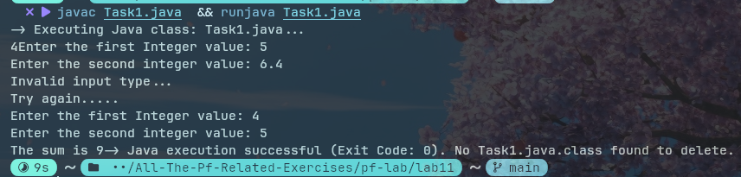

TASK 2
CODE
import java.util.*;

public class Task2
{
public static void main(String[] args) {
Scanner input =new Scanner(System.in);

int array[] = new int[10];

for(int i=0; i<array.length; i++)
{
while(true)
{
try{
System.out.print("Enter the element no "+(i+1)+" ");
array[i] = input.nextInt();
break;
}
catch(InputMismatchException e)
{
System.out.println("Please enter a valid Number ");
input.nextLine();
}
}//end of while
}

while(true)
{
try{
System.out.println("Enter an index to find the value at that index: ");
int index = input.nextInt();
System.out.println("The value at "+index+" is "+array[index]);

break;
}
catch(InputMismatchException e)
{
System.out.println("Invalid index , pls enter a valid index");
input.nextLine();
}
catch(ArrayIndexOutOfBoundsException ex)
{
System.out.println("Invalid Index, pls enter the index within 9");
input.nextLine();
}
catch(Exception exc)
{
System.out.println("An Unknown Error occured ");
input.nextLine();
}
}//while
}//main
}//class
OUTPUT
