
Name: Abdul Wasay
Reg. no: FA25-BSE-002
Class: BSE-1A

PF
Assignment 4
QUESTION 1

CODE
import java.util.*;
import java.io.*;

public class StoreDataInFile
{
public static void main(String[] args) {
Scanner input = new Scanner(System.in);
ArrayList<String> studentRno = new ArrayList<>();
ArrayList<String> studentName = new ArrayList<>();
ArrayList<Integer> studentMarks = new ArrayList<>();

int i =0;
while(true)
{
System.out.println("Enter the rno of the student no "+(i+1));
String rno = input.nextLine();
System.out.println("Enter the Name of the student no "+(i+1));
String name = input.nextLine();
System.out.println("Enter the Marks of the student no "+(i+1));
int marks = input.nextInt();
input.nextLine();

if(marks == 0)
break;
studentName.add(name);
studentMarks.add(marks);
studentRno.add(rno);

i++;
}

try
{
FileOutputStream file = new FileOutputStream("students.txt",true);
PrintStream writer = new PrintStream(file);
for(int j =0; j<studentMarks.size(); j++)
{
writer.println(studentRno.get(j));
writer.println(studentName.get(j));
writer.println(studentMarks.get(j));
}
}
catch( IOException e)
{
System.out.println("Something Went wrong.");
}
}
}
OUTPUT
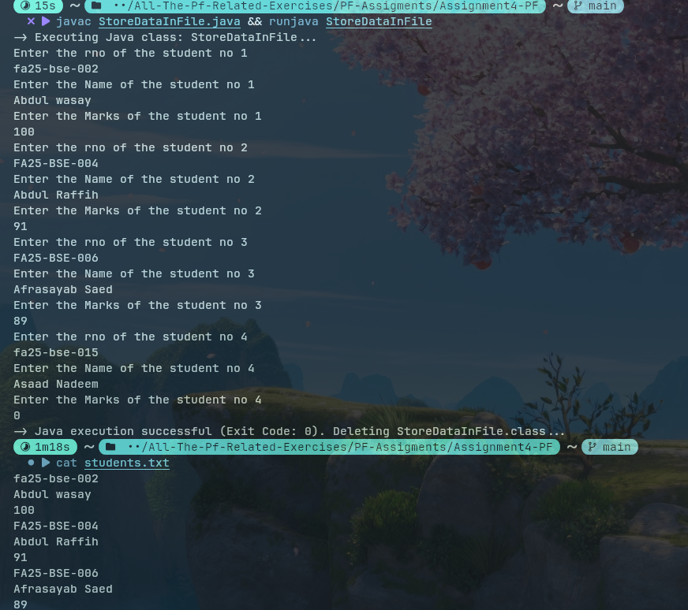

QUESTION 2
CODE
import java.util.*;
import java.io.*;

public class ReadDataInFile
{
public static void main(String[] args) {

ArrayList<String> studentRno = new ArrayList<>();
ArrayList<String> studentName = new ArrayList<>();
ArrayList<Integer> studentMarks = new ArrayList<>();
try(FileInputStream file = new FileInputStream("students.txt"))
{
Scanner reader = new Scanner(file);

while(reader.hasNextLine())
{
studentRno.add(reader.nextLine());
studentName.add(reader.nextLine());
studentMarks.add(reader.nextInt());
reader.nextLine();//clear the nextLine
}
reader.close();
}
catch(IOException e)
{
System.out.println("Some error Occurred................."+e);
}
int numOfPassStudents=0;

for(int i =0; i<studentMarks.size();i++)
if(studentMarks.get(i) >50)
numOfPassStudents++;

System.out.println("The total Number of passed students are "+(numOfPassStudents));
}//main
}//class
Output
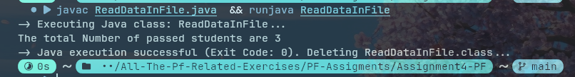

QUESTION 3
CODE
import java.util.*;
import java.io.*;

public class UpdateStudent
{
public static void main(String[] args) {

ArrayList<String> studentRno = new ArrayList<>();
ArrayList<String> studentName = new ArrayList<>();
ArrayList<Integer> studentMarks = new ArrayList<>();
try(FileInputStream file = new FileInputStream("students.txt"))
{
Scanner reader = new Scanner(file);

while(reader.hasNextLine())
{
studentRno.add(reader.nextLine());
//reader.nextLine();//clear the nextline
studentName.add(reader.nextLine());
//reader.nextLine();//clear the nextline
studentMarks.add(reader.nextInt());
reader.nextLine();//clear the nextLine
}
reader.close();
}
catch(IOException e)
{
System.out.println("Some error Occurred................."+e);
}
int numOfPassStudents=0;

for(int i =0; i<studentMarks.size();i++)
if(studentMarks.get(i)==49)
{
System.out.println("Grace marks to "+studentName.get(i));
studentMarks.set(i, 50);
}

try
{
FileOutputStream file = new FileOutputStream("students.txt");
PrintStream writer = new PrintStream(file);
for(int j =0; j<studentMarks.size(); j++)
{
writer.println(studentRno.get(j));
writer.println(studentName.get(j));
writer.println(studentMarks.get(j));
}
}
catch( IOException e)
{
System.out.println("Something Went wrong.");
}
}//main
}//class

OUTPUT
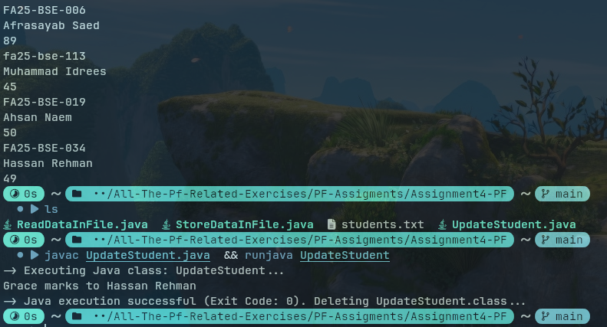

QUESTION 4
CODE
import java.util.*;
import java.io.*;

public class RemoveFailedStudents
{
public static void main(String[] args) {

ArrayList<String> studentRno = new ArrayList<>();
ArrayList<String> studentName = new ArrayList<>();
ArrayList<Integer> studentMarks = new ArrayList<>();
try(FileInputStream file = new FileInputStream("students.txt"))
{
Scanner reader = new Scanner(file);

while(reader.hasNextLine())
{
studentRno.add(reader.nextLine());
//reader.nextLine();//clear the nextline
studentName.add(reader.nextLine());
//reader.nextLine();//clear the nextline
studentMarks.add(reader.nextInt());
reader.nextLine();//clear the nextLine
}
reader.close();
}
catch(IOException e)
{
System.out.println("Some error Occurred................."+e);
}
int numOfPassStudents=0;

for(int i =0; i<studentMarks.size();i++)
if(studentMarks.get(i)<50)
{
System.out.println("Removing Roll no :"+studentRno.get(i));
studentRno.remove(i);
studentName.remove(i);
studentMarks.remove(i);
}

try
{
FileOutputStream file = new FileOutputStream("students.txt");
PrintStream writer = new PrintStream(file);
for(int j =0; j<studentMarks.size(); j++)
{
writer.println(studentRno.get(j));
writer.println(studentName.get(j));
writer.println(studentMarks.get(j));
}
}
catch( IOException e)
{
System.out.println("Something Went wrong.");
}
}//main
}//class

Output
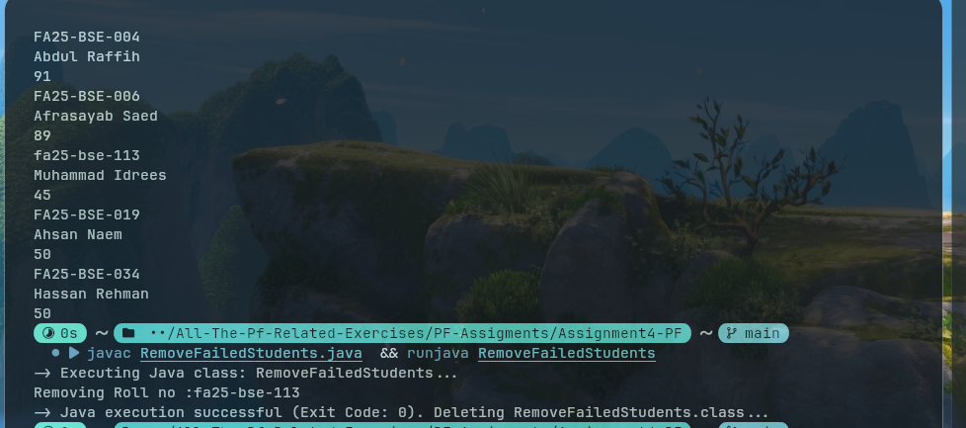

Question 5

Code
import java.util.*;
import java.io.*;

public class FIndingMaximumMarks
{
public static void main(String[] args) {

ArrayList<String> studentRno = new ArrayList<>();
ArrayList<String> studentName = new ArrayList<>();
ArrayList<Integer> studentMarks = new ArrayList<>();
try(FileInputStream file = new FileInputStream("students.txt"))
{
Scanner reader = new Scanner(file);

while(reader.hasNextLine())
{
studentRno.add(reader.nextLine());
//reader.nextLine();//clear the nextline
studentName.add(reader.nextLine());
//reader.nextLine();//clear the nextline
studentMarks.add(reader.nextInt());
reader.nextLine();//clear the nextLine
}
reader.close();
}
catch(IOException e)
{
System.out.println("Some error Occurred................."+e);
}

int maxMarks = studentMarks.get(0);
String maxName = studentName.get(0);
for(int i =0; i<studentMarks.size();i++)
if(studentMarks.get(i) >maxMarks)
{
maxMarks = studentMarks.get(i);
maxName = studentName.get(i);

}

System.out.println(maxName+" has Acheived the highest Marks by acheving "+maxMarks+" marks.");

}//main
}//class

Output
