REPRODUCIBLE EMPIRICAL RESEARCH × LLM EVALUATION

Beyond Aggregate Growth
  - Nigeria’s 2010–2025 Economic Performance and the Reliability of Language-Model Statistical Interpretation
A linked empirical-economic and controlled LLM benchmark report
Prepared for 8p8.dev Research • 28 October 2026
STATUS: PRELIMINARY RESEARCH REPORT — HUMAN ANNOTATION AND INFERENTIAL MODEL COMPARISONS PENDING
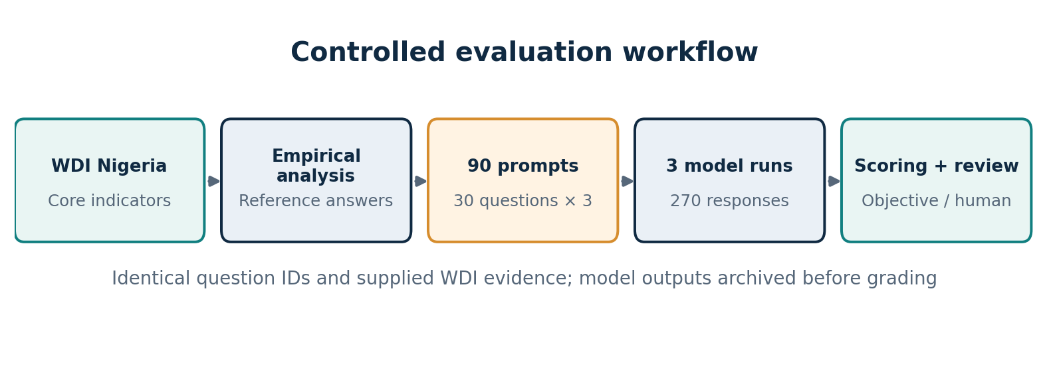
Figure 1. Documented evaluation workflow. The research combines verified WDI-derived quantitative questions with three independent model runs of 90 prompts each.
Evidence inventory: 30-question answer key, 90 original GPT-4o Mini response records, original/recovered graders, archived audit tables, and screenshots of completed GPT-6 Luna and GPT-6.1 Terra evaluations. The complete original annual WDI extract and the full Luna/Terra raw response files were not supplied for this draft.

Abstract
This report connects a descriptive analysis of Nigerian economic performance (2010–2025) with a controlled evaluation of OpenAI language models interpreting the same World Development Indicators (WDI) evidence. The economic benchmark uses real GDP, real GDP per capita, and population, complemented by a verified question-level answer key. From 2010 to 2025, the archived benchmark indicates aggregate real GDP growth of 45.80% and population growth of 42.54%, while real GDP per capita increased only 2.29%. Real output per person fell 13.81% from 2015 to 2020, illustrating why aggregate growth does not automatically imply a corresponding improvement in output per resident. Thirty questions were presented under three information conditions (data only; data with definitions; data with verification instructions), producing 90 prompts per model. Three OpenAI models were run once per prompt (270 responses in total). Under strict automated scoring (±0.01 percentage point for numerical answers), GPT-4o Mini, GPT-6 Luna and GPT-6.1 Terra achieved 48/72 (66.67%), 71/72 (98.61%) and 72/72 (100.00%) respectively, on objectively scorable items. The GPT-4o Mini extraction required recovery of 34 embedded JSON objects, demonstrating a material distinction between formatting compliance and interpretative correctness. Eighteen evidence-sufficiency answers per model (54 total) require human assessment; fabricated evidence, unsupported claims and causal overreach therefore remain unquantified. Findings are descriptive, specific to this benchmark, and not evidence of general model superiority.
Keywords: Nigeria; World Development Indicators; real GDP; GDP per capita; population growth; large language models; numerical reliability; evidence fidelity; output format compliance.

Executive summary
- Economic evidence: total output and population both rose markedly over 2010–2025; average real output per person was essentially stagnant in comparison. The largest displayed deterioration was 2015–2020.
- Benchmark design: 30 unique questions × 3 controlled prompt conditions × 3 OpenAI models = 270 model responses, with 72 objectively scorable and 18 evidence-limitation questions per model.
- Strict objective scoring: GPT-4o Mini 66.67%, GPT-6 Luna 98.61%, GPT-6.1 Terra 100.00%. These exclude human-only evidence reasoning and do not justify universal claims.
- Format issue: the initial GPT-4o Mini grader reported 37.50% because 34 responses included prose plus fenced JSON; correcting extraction raised the relaxed-tolerance objective score to 83.33%.
- Research implication: score numeric accuracy, logical interpretation, unsupported claims and structured-output compliance separately; do not treat a format failure as a mathematical error.
- Publication status: quantitative and format audits are complete for available materials, while qualitative/human evaluation, raw-data provenance checks and paired inferential comparisons remain pending.

1. Research scope, objectives and questions
The investigation consists of two connected but analytically distinct studies: Research 001, a reproducible empirical assessment of Nigerian macroeconomic indicators; and Research 002, a controlled benchmark of model interpretation reliability. Both use the same WDI-derived economic evidence, but they make different claims. The empirical study describes economic outcomes. The LLM study tests whether models faithfully interpret given evidence.

1.1 Research questions
- RQ1. How did Nigerian aggregate real GDP, real GDP per capita and population change between 2010 and 2025, and which subperiods diverged?
- RQ2. How accurately do models calculate changes and classify real-output and per-capita trends when supplied with these values?
- RQ3. Does supplying metadata or verification instructions change performance on identical questions?
- RQ4. Do models avoid unsupported inferences about poverty, household wealth, unemployment, inequality or the sole causal effect of economic policy?
- RQ5. How much does the estimated model ranking depend on numerical tolerance and the JSON recovery method?

1.2 Hypotheses (pre-specified retrospectively for exposition; not registered)
H1: objective answer accuracy differs between evaluated model versions. H2: the effect of added metadata or verification guidance is model-dependent. H3: stronger objective accuracy does not necessarily imply stronger evidence discipline. H4: some observed errors are attributable to format noncompliance rather than incorrect economic results. Because these hypotheses were formalized after preliminary results, any confirmatory language would be inappropriate without a new preregistered replication.

2. Economic data and measurement
The benchmark covers Nigeria (country code NGA) over 2010–2025. The core series are GDP in constant local currency units (NY.GDP.MKTP.KN), GDP per capita in constant local currency units (NY.GDP.PCAP.KN), and total population (SP.POP.TOTL). The World Bank defines constant-price GDP as aggregate output adjusted for price changes; per-capita GDP divides GDP by the midyear population [1–3]. The report uses values reproduced in the archived benchmark and saved response evidence, not an independently inspected annual CSV.
Indicator | Operational meaning | Source code / unit
Real GDP | Total price-adjusted economic output | NY.GDP.MKTP.KN; trillion constant LCU
Real GDP per capita | GDP divided by population; not median income | NY.GDP.PCAP.KN; constant LCU per person
Population | Midyear residents used as denominator | SP.POP.TOTL; million persons

A 2010–2025 window has 16 annual observations and spans 15 elapsed years. Values may change when WDI revises country series. A final publication needs the original extraction date, WDI download or API snapshot, reference-year metadata, and a dataset checksum.

2.1 Selected-year benchmark observations
Year | Real GDP, trillion LCU | Real GDP/capita, LCU | Population, million
2010 | 155.359 | 932,285.78 | 166.643
2015 | 198.509 | 1,041,104.41 | 190.672
2020 | 192.028 | 897,345.01 | 213.996
2025 | 226.519 | 953,654.33 | 237.528

Table 1. Selected observations from the archived WDI-derived benchmark. Values shown here are anchored to the available key/response records; this is not a substitute for the full annual dataset.

2.2 Descriptive change decomposition
For beginning and ending years 0 and 1, cumulative percentage change is 100 × (X₁ / X₀ − 1). GDP per capita = GDP / population; consequently (1 + gGDPpc) = (1 + gGDP) / (1 + gPopulation) for consistent ratio-series comparisons. The latter is an accounting identity, not a causal estimate.
Period | Real GDP | GDP per capita | Population
2010–2015 | +27.77% | +11.67% | +14.42%
2015–2020 | -3.26% | -13.81% | +12.23%
2020–2025 | +17.96% | +6.28% | +11.00%
2010–2025 | +45.80% | +2.29% | +42.54%
2015–2025 | +14.11% | -8.40% | +24.57%

Table 2. Cumulative percent changes calculated from selected benchmark values; results may differ by 0.01 pp from answer-key display rounding.
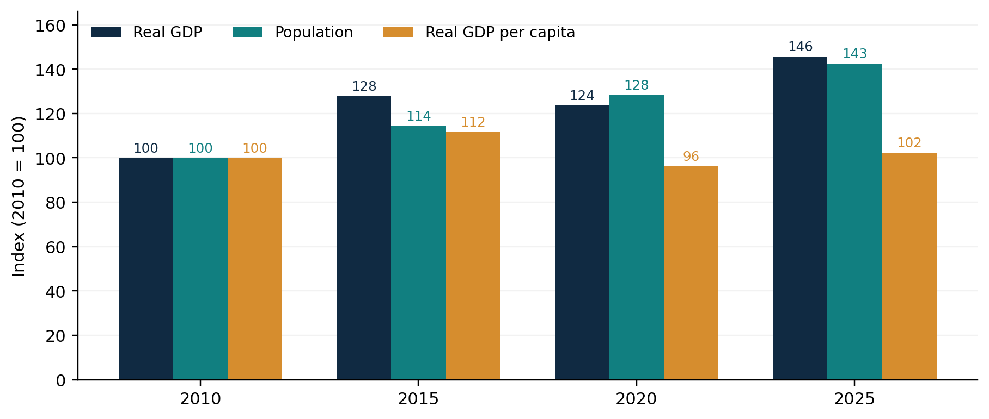
Figure 2. Selected-year indexed values (2010 = 100). Bar heights compare the four observed anchor years; annual trajectories between those years are not shown.

2.3 Economic interpretation
Over the full benchmark window, real GDP rose by approximately 45.80% while population grew by approximately 42.54%, leaving real GDP per capita only 2.29% higher. The 2015–2020 period is particularly revealing: GDP contracted by about 3.26%, population grew 12.23%, and output per resident declined 13.81%. From 2020 to 2025, per-capita output recovered 6.28%, yet remained about 8.40% below its 2015 value. Therefore the evidence does not support a statement that real GDP per capita fell monotonically throughout 2010–2025, nor that total GDP increased continuously each year.
The three indicators cannot establish changes in poverty rates, household disposable income, the income distribution, employment or policy causality. They capture output and population, not the full distribution of welfare. This distinction is central to the LLM evidence-limitation questions.

3. LLM experimental design and implementation
The experimental unit is a question–condition–model response. Thirty unique item IDs were generated once, then presented in three conditions to each model: A_table_only (numeric WDI table); B_with_metadata (table plus series descriptions/units); and C_with_verification (table and metadata plus instruction to check calculations and abstain from unsupported claims). The outcome key was held separately from inference prompts. Each model was evaluated once per prompt in the completed runs. API tools were disabled in the archived GPT-4o Mini outputs.
Question type | Unique items | Responses per model | Primary evaluation
Cumulative numerical change | 12 | 36 | Numeric tolerance against reference
Direction/divergence classification | 6 | 18 | Exact yes/no match
Evidence sufficiency | 6 | 18 | Human evidence-claim annotation
Overall trend sign | 6 | 18 | Exact yes/no match
Total | 30 | 90 | 72 automatic + 18 human-only

The six evidence-sufficiency questions appear under each of the three prompt conditions, creating 18 human-only cases per model. The same question IDs are paired across conditions, and the same question-condition pairs are shared across models; treating all responses as unrelated observations would overstate statistical independence.

3.1 Models and experiment records
Model | Stored / reported responses | Evidence status
gpt-4o-mini-2024-07-18 | 90, directly verified from uploaded JSONL | Raw responses and audit available
gpt-6-luna | 90, as shown in terminal screenshots | Summary and grading screenshots; raw JSONL unavailable
gpt-6.1-terra | 90, as shown in terminal screenshots | Summary and grading screenshots; raw JSONL unavailable

The GPT-4o Mini output metadata confirms text inference with 2,048 maximum output tokens, temperature unset, tool usage disabled, and 90 requests spanning 28 October 2026, 10:57–11:04 UTC. The model name, settings and evaluation dates for the other two models should be extracted directly from their original JSONL logs for final archival publication. Model families differ in capabilities and output behavior; a same-provider comparison is not a controlled architecture ablation.

3.2 Automated and qualitative outcomes
For answer_type=number, the original grader checks |reported numeric_value − reference| ≤ a fixed tolerance; for answer_type=yes_no, it requires an exact normalized yes/no match. Evidence-limitation items deliberately do not receive automated truth labels. The corrected grader can recover a single JSON object contained in a fenced block when the original output had additional text. It preserves the raw output and tracks parsing failures independently.
The output/review schema also includes human_correct, unsupported_claim, contradicted_data, fabricated_statistic, unjustified_causality, appropriate_abstention, and notes. These qualitative dimensions must be coded from actual responses and supplied data, not inferred from the automated correctness result.

4. Quantitative benchmark findings

4.1 Comparison under the stricter scoring tolerance
Model | A: data only | B: metadata | C: verification | Overall (72)
GPT-4o Mini | 17/24 (70.83%) | 17/24 (70.83%) | 14/24 (58.33%) | 48/72 (66.67%)
GPT-6 Luna | 24/24 (100%) | 23/24 (95.83%) | 24/24 (100%) | 71/72 (98.61%)
GPT-6.1 Terra | 24/24 (100%) | 24/24 (100%) | 24/24 (100%) | 72/72 (100%)

Table 4. Objective scoring at ±0.01 percentage point for numerical items and exact binary correctness. Mini was recalculated from uploaded raw results; Luna/Terra values come from user-shared audit screenshots. Human-only questions are excluded.
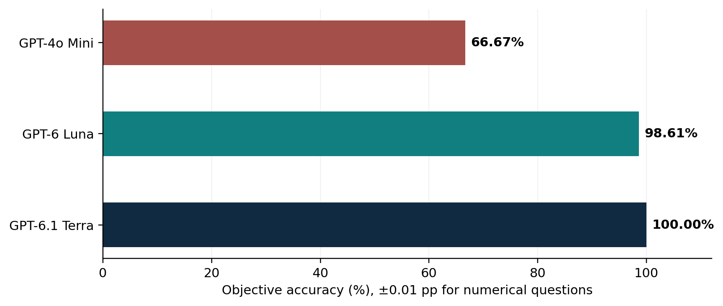
Figure 3. Overall strict objective benchmark accuracy, 72 automatically scored responses per model. No confidence intervals or claims of statistical significance are implied.
The strict benchmark shows a 31.94 percentage-point difference between Luna and GPT-4o Mini, while Terra exceeds Luna by one answer (1.39 points). These are descriptive contrasts within the fixed prompt bank. Because the question bank is small, reused across conditions, and limited to three variables, the present evidence cannot establish a model-wide or generational causal effect.

4.2 Sensitivity to numeric tolerance
Tolerance (pp) | GPT-4o Mini | GPT-6 Luna | GPT-6.1 Terra
±0.01 | 48/72 (66.67%) | 71/72 (98.61%) | 72/72 (100%)
±0.02 | 52/72 (72.22%) | 71/72 (98.61%) | 72/72 (100%)
±0.05 | 57/72 (79.17%) | 71/72 (98.61%) | 72/72 (100%)
±0.25 | 60/72 (83.33%) | 71/72 (98.61%) | 72/72 (100%)

Table 5. Sensitivity analysis. All numerical answers were requested to two decimal places; ±0.25 pp represents a relatively permissive margin.
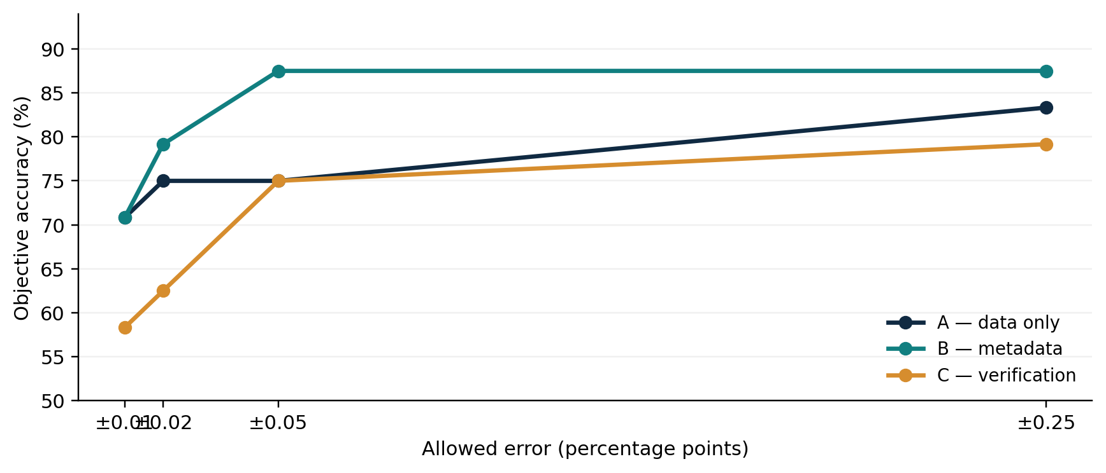
Figure 4. GPT-4o Mini’s accuracy changes notably as numeric tolerance increases; note that binary-item scoring remains exact for all tolerances.
At ±0.25 pp, the model ranking remains the same, but the Mini score rises by 16.66 points. Thus model comparisons should always specify tolerance. The ±0.01 results align more closely with two-decimal reporting but should be supplemented by exact-rounding and source-reference verification before formal publication.

4.3 GPT-4o Mini structured-output compliance
Observed processing outcome | Number | Share of 90
Accepted by original parser | 56 | 62.22%
Rejected as malformed JSON | 34 | 37.78%
Recovered as single fenced JSON blocks | 34 | 37.78%
Response records retained | 90 | 100%

All 34 initial parse failures were numerical questions containing free-form explanations and a fenced JSON object; the corrected audit extracted the embedded structured answer without inferring answers from prose. This restored the relaxed objective accuracy from the original reported 27/72 (37.50%) to 60/72 (83.33%). The initial 37.50% was a pipeline artifact, not a fair estimate of reasoning correctness. The 56 parser successes should not be described as verified “strict JSON only” outputs without inspecting the exact parsing contract.

4.4 GPT-4o Mini error-type breakdown (±0.25 pp)
Category | Correct / evaluated | Accuracy
Numerical change | 35/36 | 97.22%
Divergence logic | 9/18 | 50.00%
Trend sign | 16/18 | 88.89%
Evidence limits | Not automatically scored | Human review

The clearest diagnostic is that numerical calculation and logical comparison are not interchangeable skills. In several divergence responses, the model stated that both indicators declined yet returned “yes” to the question asking whether GDP rose while GDP per capita fell. This is not a rounding issue; it is a mismatch between cited evidence and the binary conclusion.

5. Selected response-level error analysis
Benchmark item | Required reasoning | Observed GPT-4o Mini behavior | Interpretation
NGA-WDI-015 | 2016–2020 GDP grew while GDPpc fell? Reference: No. | In multiple conditions returned Yes while citing GDP decline and GDPpc decline. | Contradiction: correct reported evidence, wrong logical answer.
NGA-WDI-025 | 2010–2015 GDPpc increased overall? Reference: Yes. | In two conditions answered No although cited endpoints show an increase. | Confusion of endpoint change with within-period monotonicity.
NGA-WDI-008 | GDPpc percent change 2010–2025: +2.29%. | Condition C returned +1.53%; the working substituted an incorrect difference. | Arithmetic failure beyond reasonable tolerance.
NGA-WDI-009 | Population change 2010–2015: +14.42%. | Condition B gave +14.41% amid prose with fenced JSON. | Near-correct number plus format noncompliance; separately score both.

These cases illustrate at least three mechanisms: arithmetic errors, evidence–conclusion contradictions, and instruction/format noncompliance. They are drawn from uploaded GPT-4o Mini raw outputs and the supplied answer key. They should be independently re-annotated under a published rubric before being treated as adjudicated examples of hallucination.

5.1 Calibrated conclusions about the prompts
The benchmark includes six questions asking whether aggregate output, per-capita output and population alone prove reductions in poverty, increases in median income, falling inequality, falling unemployment, gains for every household, or the sole causal effect of policy. The defensible response in each case is that evidence is insufficient. A yes/no or an abstention flag is not enough to certify a model’s justification: evaluators must check whether the explanation is supported, whether external economic facts were invented, and whether model self-confidence is consistent with appropriate caution.

6. Discussion, contribution and limitations

6.1 Substantive conclusions supported now
- Aggregate GDP growth is not equivalent to proportional per-capita gains, because population enters the denominator mechanically. The displayed 2015–2020 contraction and subsequent recovery should not be flattened into a monotonic trend.
- On this specific objective benchmark, two newer evaluated OpenAI models show markedly higher numerical and binary-item accuracy than the older GPT-4o Mini snapshot, although capability tier, architecture, prompt-following, and date are confounded.
- GPT-4o Mini’s initially low automated accuracy was largely driven by an avoidable parser artifact; reporting raw and recovered metrics separately prevents an erroneous model assessment.
- Format adherence, exact numeric precision, and economic evidence discipline are distinct constructs and should be measured with distinct outcome variables.

6.2 Boundaries of inference
- The benchmark is deliberately narrow: three economic indicators, 30 underlying questions and one response per prompt per model. It does not test rich regression interpretation, multivariate causal inference or independent literature use.
- The same items are repeated across conditions, making response-level independence an untenable assumption. The current report gives descriptive statistics, not p-values or causal effects of model-generation advances.
- Luna and Terra raw outputs were not attached, so case-level paired tests, response-level confidence, exact timestamp/configuration checks and independent automated reproduction remain outstanding.
- The full extracted annual WDI dataset and original economic chart files were not attached. Selected-year values can be reconstructed from archived responses, but all chart series and revisions need revalidation against the original CSV.
- The reference key should be audited for exact rounding, country-year consistency and WDI metadata vintage. Numerical tolerance should be fixed before evaluating any preregistered repeat.
- 54 evidence-limit answers (18 × 3 models) still need human correctness scoring; hallucination and causal-overreach rates are not yet known. The one reviewed example from earlier conversation does not substitute for a complete blinded audit.
- API cost and latency, if discussed, should be derived from model-specific token logs and billing records; the user’s screenshot totals do not support a cross-model cost-effectiveness estimate.

6.3 Recommended statistical follow-up
After recovering item-level Luna/Terra results, align records by (item_id, condition, repeat). For binary correctness contrasts, use paired exact McNemar tests or question-level clustered bootstrap intervals rather than treating model outputs as independent. For condition effects, calculate paired item-level differences within each model. Multiple comparisons should be controlled or explicitly labelled exploratory. With one sample per prompt and ceiling effects near 100%, uncertainty is likely high despite large percentage gaps; use effect sizes and paired discordance tables rather than relying on p-values alone. For a future repetition design, freeze the code, prompts, exact model IDs, data snapshot, reasoning settings and grading criteria in advance.

7. Human annotation and publication completion plan
Task | Deliverable | Publication criterion
Evidence-limit review | 54 scored responses with reasons and labels | Each response independently checked against its input data
All-response claim audit | 270 response-level claim tags | Fabrication, contradiction and unjustified causality separated
Rater reliability | Second rater or blinded adjudication log | Documented agreement and disagreement resolution
Data provenance | WDI annual extract + hash + retrieval date | Series names, units and vintage traceable
Pairwise comparison | Matched per-item dataset and intervals | No incorrect independence assumptions
Reproducibility package | Read-only archived prompts, model outputs and scripts | Fresh run can reproduce published tables
Publication release | 8p8.dev article + methods appendix + GitHub | Limitations and pending results removed/resolved

For coding, human_correct marks the substantive answer; unsupported_claim flags statements beyond the three supplied indicators; contradicted_data flags conflicts with observed series; fabricated_statistic flags invented or wrong numerical facts offered as evidence; unjustified_causality flags unsupported policy effects; and appropriate_abstention marks responsible recognition of insufficient evidence. Reviewers should quote a short offending claim and explain the decision in notes. Preserve immutable raw records; save annotated copies separately.

8. Reproducibility and data availability
The report uses a frozen 30-item ground-truth key and 90 archived GPT-4o Mini outputs, with SHA-256 digests reported in the earlier audit: response file 0353f2e7c04ad19298c59bdb49b71de1d511dcb182499f2e0d79c8eb4b6e6747; answer key 76718a75fd43e518f7997f20f861be090f0ec102383c1fb20c503e9b03600d9d. These hashes refer to the particular uploaded file contents and should be recomputed against final GitHub artifacts, whose line endings or filenames may differ.
Illustrative Windows Git CMD commands used in the experiment:
python scripts/run_llm.py --provider openai --model gpt-4o-mini-2024-07-18 --repeats 1 --output results/gpt4o_mini_outputs.jsonl
python scripts/grade_recovered.py --input results/gpt4o_mini_outputs.jsonl --answer-key results/answer_key.jsonl --prefix gpt4o_mini_audit_
python scripts/grade_recovered.py --input results/model_outputs.jsonl --answer-key results/answer_key.jsonl --prefix luna_audit_
python scripts/grade_recovered.py --input results/terra_outputs.jsonl --answer-key results/answer_key.jsonl --prefix terra_audit_
Do not rerun APIs to fix grading artifacts. Archive original JSONL outputs and create derived CSVs as new files. If the full experiment is to be independently rerun, record all environment dependencies and model-access limitations. The reported Gemini API capacity failures are excluded from the three-model OpenAI comparison and must not be counted as model interpretation errors.

9. Conclusion
The Nigerian WDI evidence and the LLM benchmark tell connected stories. From 2010 to 2025, headline real GDP growth greatly exceeded the gain in real GDP per person; per-capita output also suffered a substantial 2015–2020 decline before partial recovery. Interpreting these indicators requires attention to definitions, denominators, comparison intervals and limits on causal inference. When three OpenAI models were tested on 30 controlled questions under three information conditions, their strict objective accuracy varied sharply: 66.67%, 98.61% and 100%. For GPT-4o Mini, 34 initially invalidly formatted outputs concealed extractable JSON answers; once recovered, its relaxed objective score increased from the originally reported 37.50% to 83.33%. These facts support a concrete contribution: statistical interpretation benchmarks must isolate arithmetic, logical consistency, evidence fidelity and response format. The study is ready for an internally reproducible quantitative working paper, but not yet for claims about hallucination rates or universally superior models until human annotation, input-data archiving and matched statistical comparisons are complete.

References and research evidence
[1] World Bank. Metadata Glossary: GDP (constant LCU), NY.GDP.MKTP.KN. https://databank.worldbank.org/metadataglossary/africa-development-indicators/series/NY.GDP.MKTP.KN
[2] World Bank. Metadata Glossary: GDP per capita (constant LCU), NY.GDP.PCAP.KN. https://databank.worldbank.org/metadataglossary/africa-development-indicators/series/NY.GDP.PCAP.KN
[3] World Bank. Nigeria GDP per capita (constant LCU), country series. https://data.worldbank.org/indicator/NY.GDP.PCAP.KN?locations=NG
[4] WDI research project. answer_key.jsonl (30 items × 3 conditions; user-supplied archived file, 28 October 2026).
[5] WDI research project. gpt4o_mini_outputs.jsonl (90 user-supplied archived model responses, 28 October 2026).
[6] WDI research project. grade.py and grade_recovered.py; objective_accuracy and accuracy_sensitivity audit CSVs (October 2026).
[7] WDI research project. GPT-6 Luna and GPT-6.1 Terra terminal and sensitivity CSV screenshots shared in conversation (28 October 2026). Raw files not attached.
[8] McNemar paired binary comparison method (background): NCBI StatPearls, “McNemar and Mann–Whitney U Tests.” https://www.ncbi.nlm.nih.gov/books/NBK560699/

Appendix A. Ground-truth question bank (abbreviated)
These are the 30 item definitions that generated the 90 model prompts; the final public release should include each complete prompt, the source table, and its condition-specific wording. References here are taken verbatim from the supplied answer key rather than independently recalculated from original annual WDI CSV.
ID | Category | Question summary | Reference
001 | Numerical change | What was the cumulative percentage change in real GDP (constant LCU) from 2010 to 2015? | +27.77%
002 | Numerical change | What was the cumulative percentage change in real GDP (constant LCU) from 2015 to 2020? | -3.26%
003 | Numerical change | What was the cumulative percentage change in real GDP (constant LCU) from 2020 to 2025? | +17.96%
004 | Numerical change | What was the cumulative percentage change in real GDP (constant LCU) from 2010 to 2025? | +45.80%
005 | Numerical change | What was the cumulative percentage change in real GDP per capita (constant LCU) from 2010 … | +11.67%
006 | Numerical change | What was the cumulative percentage change in real GDP per capita (constant LCU) from 2015 … | -13.81%
007 | Numerical change | What was the cumulative percentage change in real GDP per capita (constant LCU) from 2020 … | +6.28%
008 | Numerical change | What was the cumulative percentage change in real GDP per capita (constant LCU) from 2010 … | +2.29%
009 | Numerical change | What was the cumulative percentage change in total population from 2010 to 2015? | +14.42%
010 | Numerical change | What was the cumulative percentage change in total population from 2015 to 2020? | +12.23%
011 | Numerical change | What was the cumulative percentage change in total population from 2020 to 2025? | +11.00%
012 | Numerical change | What was the cumulative percentage change in total population from 2010 to 2025? | +42.54%
013 | GDP/GDPpc divergence | Between 2010 and 2015, did real GDP increase while real GDP per capita decreased? | no
014 | GDP/GDPpc divergence | Between 2015 and 2016, did real GDP increase while real GDP per capita decreased? | no
015 | GDP/GDPpc divergence | Between 2016 and 2020, did real GDP increase while real GDP per capita decreased? | no
016 | GDP/GDPpc divergence | Between 2020 and 2021, did real GDP increase while real GDP per capita decreased? | yes
017 | GDP/GDPpc divergence | Between 2021 and 2025, did real GDP increase while real GDP per capita decreased? | no
018 | GDP/GDPpc divergence | Between 2010 and 2025, did real GDP increase while real GDP per capita decreased? | no
019 | Evidence limit | can we establish that the percentage of Nigerians living below the poverty line fell from … | insufficient
020 | Evidence limit | can we establish that median household disposable income rose from 2010 to 2025? State whe… | insufficient
021 | Evidence limit | can we establish that income inequality fell from 2010 to 2025? State whether the evidence… | insufficient
022 | Evidence limit | can we establish that the national unemployment rate fell from 2010 to 2025? State whether… | insufficient
023 | Evidence limit | can we establish that all Nigerian households became wealthier from 2010 to 2025? State wh… | insufficient
024 | Evidence limit | can we establish that economic policy was the sole cause of changes in real GDP per capita… | insufficient
025 | Trend sign | Did Nigeria's real GDP per capita increase overall from 2010 to 2015? | yes
026 | Trend sign | Did Nigeria's total real GDP increase overall from 2010 to 2015? | yes
027 | Trend sign | Did Nigeria's real GDP per capita increase overall from 2015 to 2020? | no
028 | Trend sign | Did Nigeria's total real GDP increase overall from 2015 to 2020? | no
029 | Trend sign | Did Nigeria's real GDP per capita increase overall from 2020 to 2025? | yes
030 | Trend sign | Did Nigeria's total real GDP increase overall from 2020 to 2025? | yes

Appendix table. Question text shortened for layout; original user file is the authoritative full answer key.

