Create table realEstate in Hive database, with all the columns present in dataset. Also Load dataset into table realEstate.

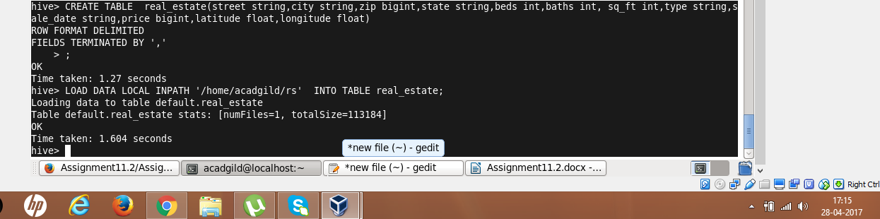

Using Dynamic partition give separate lists of residential apartments with more than 2 beds. Also include columns in following order City,Baths,Sq_feet,Price,flat_type,Beds respectively.

