Table creation and load the data

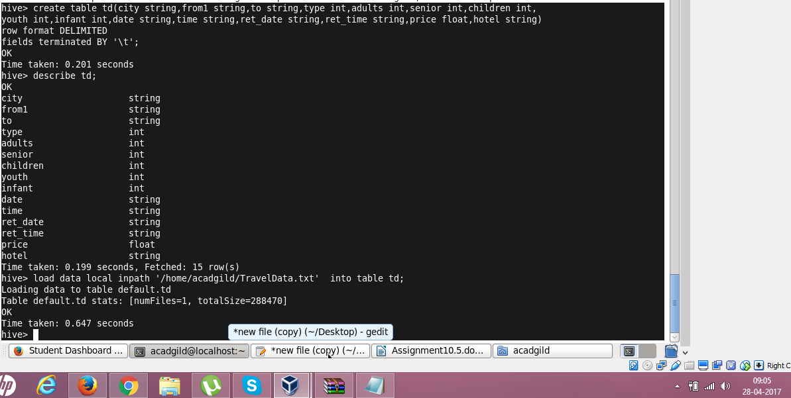

1.Write a hive query to find the top 20 destination people travel the most: Based on the given data

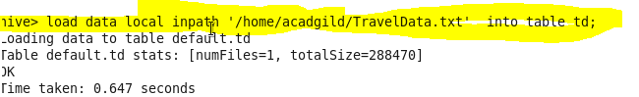

Result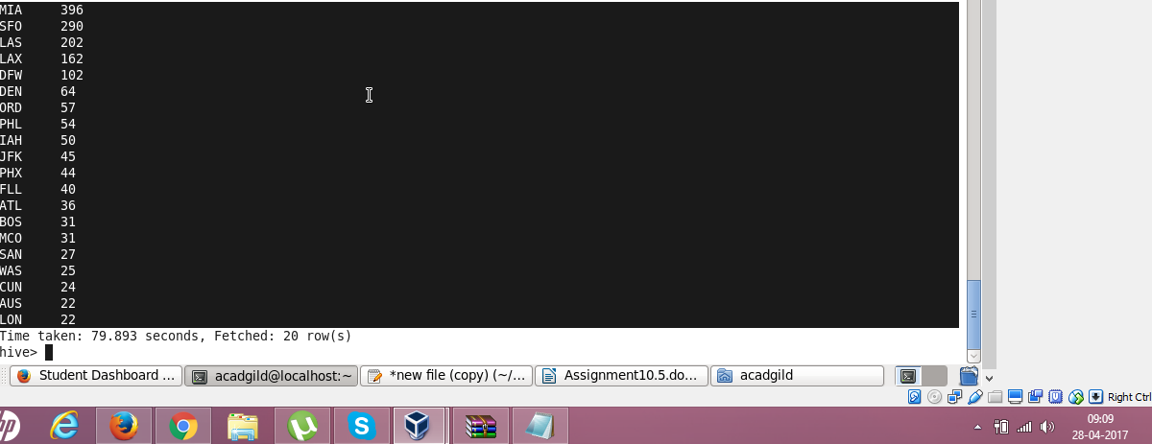

2. Write a hive query to find the top 20 locations from where people travel the most

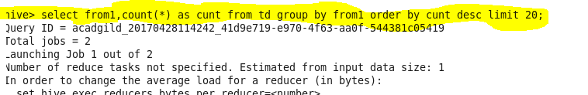

Result

