Create table and load the data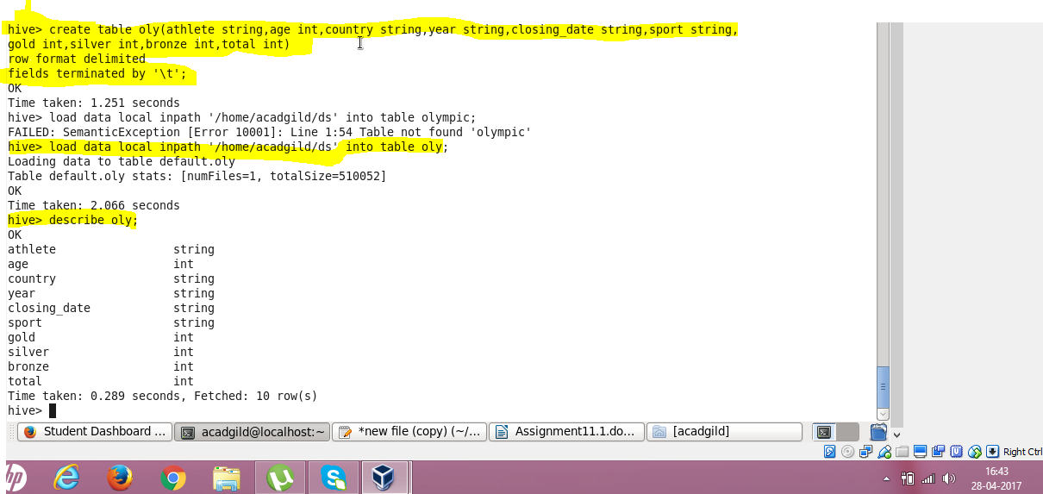

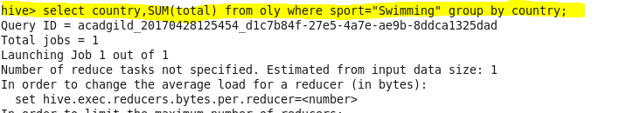Write a Hive program to find the number of medals won by each country in swimming

Result

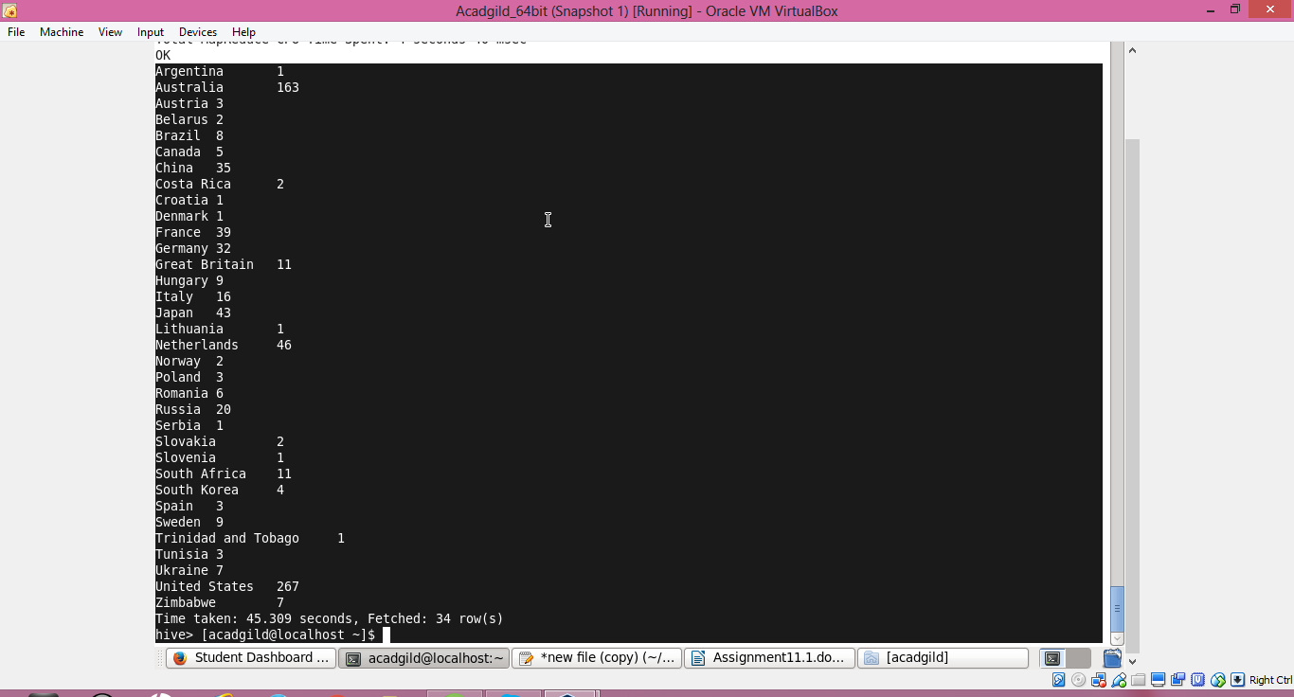

● Write a Hive program to find the number of medals that India won year wise.  
