Write a word count program using partitioner and implement the following logic in the partitioner words with length 5 should go into reducer 1 and words with length 6 should go into reduer 2 and the rest of the words should go into reducer 3.

Driver class:

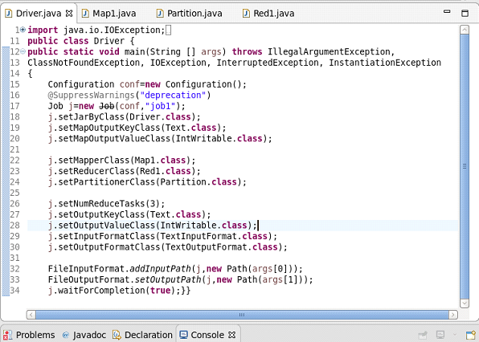

Mapper class:

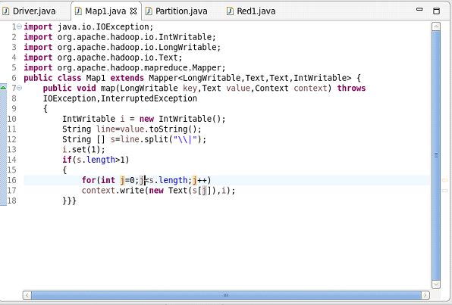

Partisioner:

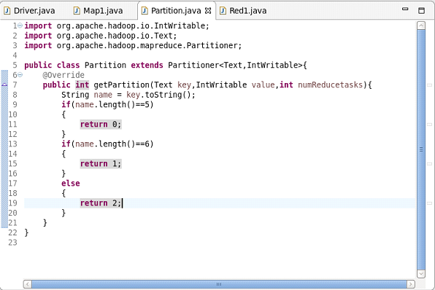

Reducer:

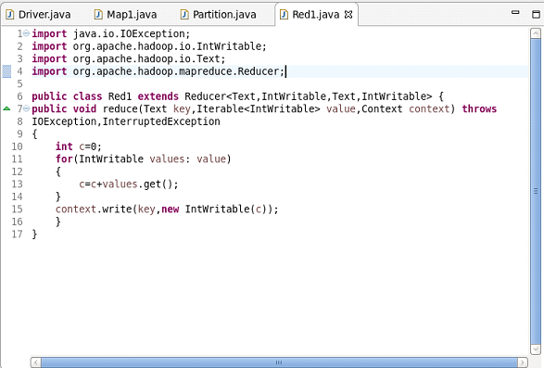

Output:

