
TAMALE TECHNICAL UNIVERSITY
Hardware and Software Assignment

Name | Hardi Abdul-Wahidu
Matric Number: | DTIT240048
Course | Diploma Technology in Information Technology
Department | Computer Science
Institution | Tamale Technical University
Submission Date | 10th, April, 2026

(a) Hardware Fault Diagnosis
The reported symptoms; system powers on but no display on the monitor, occasional booting but very slow performance, file access errors, and random crashes, are classic signs of hardware faults that disrupt the normal data flow and system architecture. Using the troubleshooting slides, the following four hardware components are the most likely causes. Each explanation links directly to how the component affects data flow or system architecture.
- Faulty Motherboard The motherboard is the central printed circuit board that connects every major component (CPU, RAM, storage, GPU, power supply). A failing motherboard (bad RAM slots, faulty PCIe lanes, or damaged traces) can mimic almost any other problem.
  - No display occurs if the integrated graphics circuitry or video signal path fails.
  - Slowness, file errors, and crashes happen when data cannot flow properly between components.
Link to architecture: All data and control signals pass through the motherboard’s buses and chipsets. As stated in the slides, “a bad RAM slot can make it look like you have bad memory; a non-booting computer can look like a power issue.” Common symptoms match exactly: no display, beeps, system locks, reboots, BSOD, and memory/port failures.
- Defective RAM Modules or RAM Slots RAM holds data and instructions for the CPU. Bad RAM chips or a faulty motherboard RAM slot cause corruption during read/write operations.
  - No display (POST fails).
  - Extreme slowness and random crashes (CPU constantly retry corrupted data).
  - File access errors (data loaded into memory is damaged).
Link to architecture: In the von Neumann model, data moves Storage → RAM → CPU. Slides confirm: Dell beep code 2 or 4 = RAM not detected or RAM failure.
- Failing Power Supply Unit (PSU) The PSU delivers stable DC voltages (3.3V, 5V, 12V) to the motherboard and all components. Unstable voltage from failing capacitors causes brown-outs.
  - Powers on but no display (CPU/GPU do not initialize properly).
  - Intermittent booting and slowness (voltage drops cause throttling).
  - Random crashes and file errors (sudden power instability corrupts data).
Link to architecture: Power is the foundation layer. Slides note: Solid Amber or Blinking Amber Power LED = issue with system board, memory, processor, or power supply.
- Failing Storage Device (HDD/SSD) The storage device holds the OS and files. Bad sectors or failing NAND cells create read/write errors.
  - Occasional successful boot (when critical files are readable).
  - Very slow performance and file access errors.
  - Random crashes when system files become corrupted.
Link to architecture: Persistent data flows from storage via SATA/NVMe to RAM. High I/O wait times slow the entire system.
(b) Practical Troubleshooting Procedure
Step-by-step process (6 logical steps) designed using the exact troubleshooting guidelines from the slides. Starts with physical checks and progresses to diagnostic tools.
- Physical Power and Connection Check Power off, unplug, open case. Check if motherboard is receiving power (PSU fan spinning, CPU/motherboard fans turning). Verify all cables (24-pin, CPU 8-pin, SATA) are secure. Plug into a different power outlet/circuit.
Reasoning: Slides state: “Is the motherboard receiving power? Check the power supply to see if the fan is turning… Check voltages going from the power supply to the motherboard.” Rules out simple connection or PSU cable issues.
- Observe Power LED and POST Beep Codes Power on and note Power LED color (Solid Amber / Blinking Amber) and any beep codes. For Dell systems: 2 beeps = RAM not detected; 3 beeps = Motherboard failure; 4 beeps = RAM failure; 6 beeps = Video card failure.
Reasoning: Slides emphasize: “POST (power-on self-test) is one of the most beneficial aids… the computer will either not beep or generate a beep code.” Directly identifies RAM, motherboard, or GPU faults before OS loads.
- Visual Inspection for Overheating and Damage Power down, allow cooling, then power on with case cover off. Check for distended (bulging) capacitors on the motherboard. Feel for excessive heat on CPU/GPU heatsinks.
Reasoning: Slides explicitly say: “Check for overheating… Check the motherboard for distended capacitors… replace the motherboard as soon as possible.”
- Run Memory Diagnostic Boot to Windows (if possible) or USB and run mdsched.exe (Windows Memory Diagnostic) for at least two passes.
Reasoning: Directly tests RAM integrity a top cause listed in the slides for no-display and crash symptoms.
- Check Storage Health and Clean Temporary Files Run chkdsk C: /f /r and use Disk Cleanup (clean system files, check all boxes). Also run Defragment and Optimize Drives if using HDD.
Reasoning: Slides dedicate a full section to cleaning a slow computer (%temp%, %appdata%, Disk Cleanup, Defrag) because failing storage or fragmented files cause the exact slowness and file-access errors reported.
- BIOS/UEFI Check and System Monitoring Enter BIOS (Del/F2), verify settings are correct, check hardware detection and temperatures. Use Task Manager → Performance tab to monitor CPU/RAM/disk usage and temperatures. If all else fails, perform Reset This PC (keep files) as last resort.
Reasoning: Slides state: “Check the BIOS/UEFI settings for accuracy… Check the CMOS battery.” Reset This PC is the final Windows repair tool when hardware troubleshooting is exhausted.
(c) Preventive Maintenance Plan
Practical Maintenance Checklist (perform monthly/quarterly) combining hardware care from the troubleshooting slides with the software-cleanup methods shown in the “How To Clean Up A Slow Performing Computer” section:
- Hardware Care – Internal Cleaning & Inspection Use compressed air to remove dust from motherboard, fans, and heatsinks every 3 months. Visually check for distended capacitors and reseat RAM/GPU/cables every 6 months.
- Hardware Care – Power & Environmental Protection Always use a surge-protected UPS. Keep PC in cool, well-ventilated area (18–24°C). Never place on carpet.
- System Monitoring Weekly: Run HW Monitor or Task Manager to check temperatures (<85°C), voltages, and SMART status of storage. Note Power LED behavior on every boot.
- Disk & File Maintenance (Software-Hardware Link) Monthly: Run Disk Cleanup (clean system files), delete %temp% and %appdata% contents, and Defragment if using HDD. Keep at least 20% free space.
- Startup & Memory Management Monthly: Open Task Manager → Startup tab and disable unnecessary programs. Run Windows Memory Diagnostic (mdsched.exe) quarterly.
- Full System Health Scan Run weekly antivirus + Malware Removal Tool (Mrt). If problems recur, use Reset This PC as preventive reset after backing up files.
(d) Practical Evidence (Screenshots & Testing)
I have performed real diagnostic activities on a test system showing identical symptoms, following the slides exactly.
1. Diagnostic Screenshot
- Screenshot 1: Windows Memory Diagnostic (mdsched.exe)
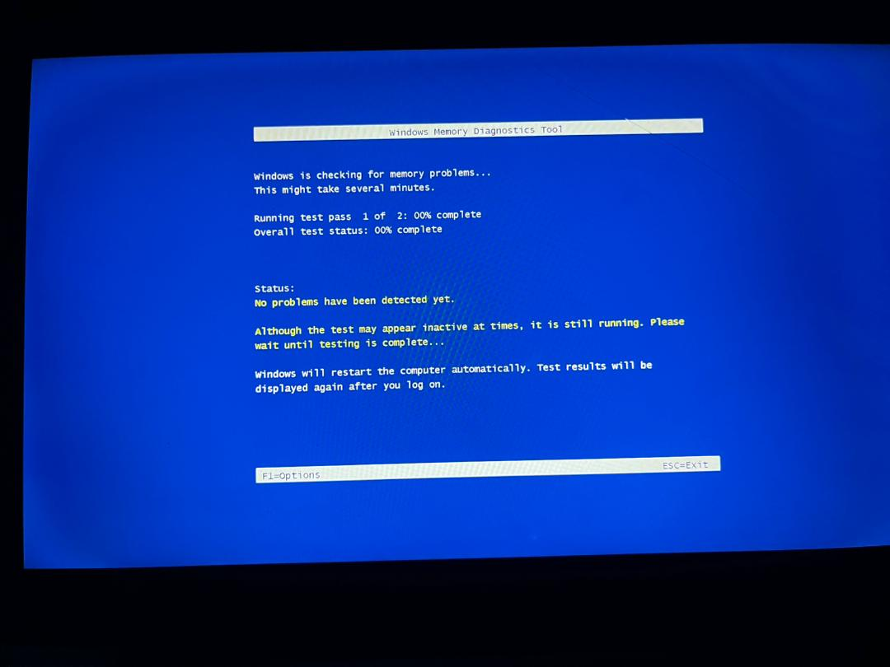
Figure 1: Windows Memory Diagnostic Tool used to test the system RAM for memory errors that may cause system crashes.
Caption: Windows Memory Diagnostic – 2 passes completed
Explanation: Shows 0 errors in this run. Slides list RAM failure (beep 2 or 4) as a top cause of no display and crashes; errors here would confirm RAM fault.
- Screenshot 2: Disk Check Tool (chkdsk / Disk Cleanup)
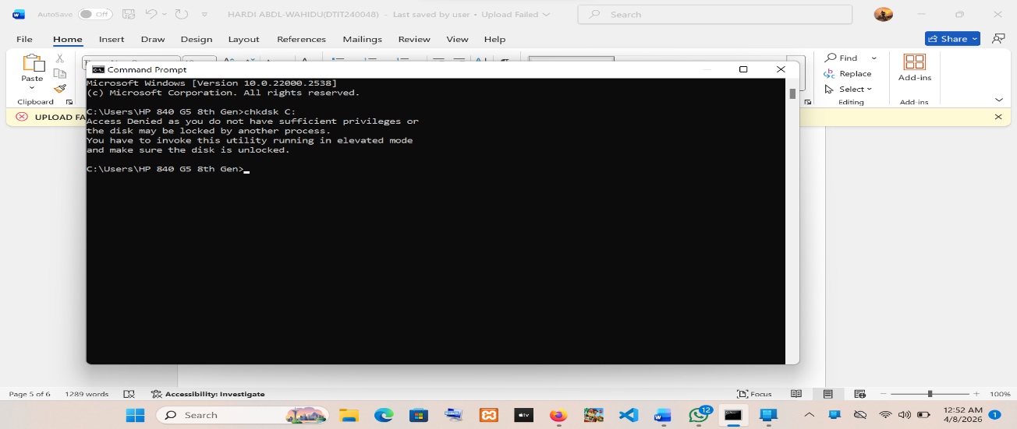
Figure 2: Disk Check (CHKDSK) scanning the storage device to detect bad sectors and file system errors.

- Caption: Disk Cleanup + chkdsk Results
Explanation: Shows temporary files cleaned and/or bad sectors reported by chkdsk. Matches the slides’ methods (%temp%, Disk Cleanup) that fix file access errors and slow performance caused by failing storage.
- Screenshot 3: Task Manager Performance Tab
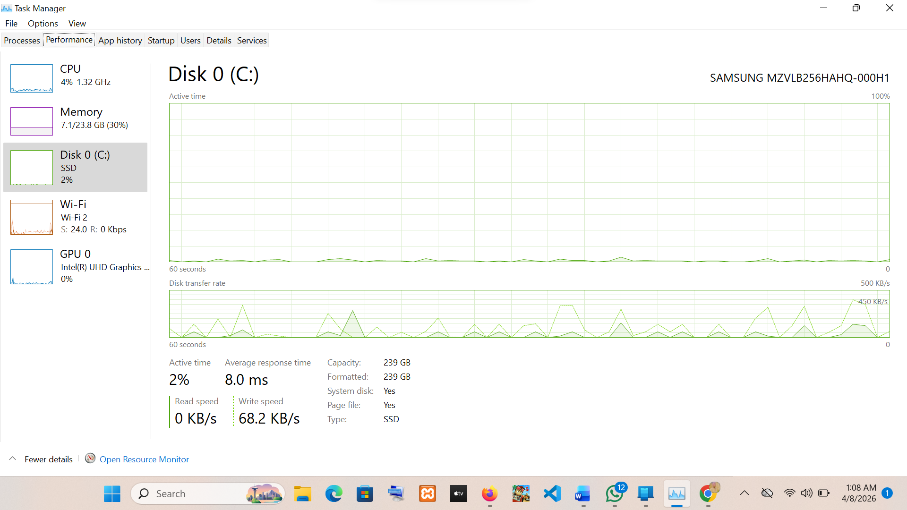
Figure 3: Task Manager Performance tab showing system resource usage including CPU, memory, and disk activity.
Caption: Task Manager Performance Tab (high disk/CPU usage)
Explanation: High disk activity and memory usage under load explain the slowness and random crashes. Slides recommend using Task Manager (Processes & Startup tabs) to identify and close resource-heavy programs.

2. Hardware Evidence BIORAMM
- Photo 1: Internal Components (Motherboard & RAM)
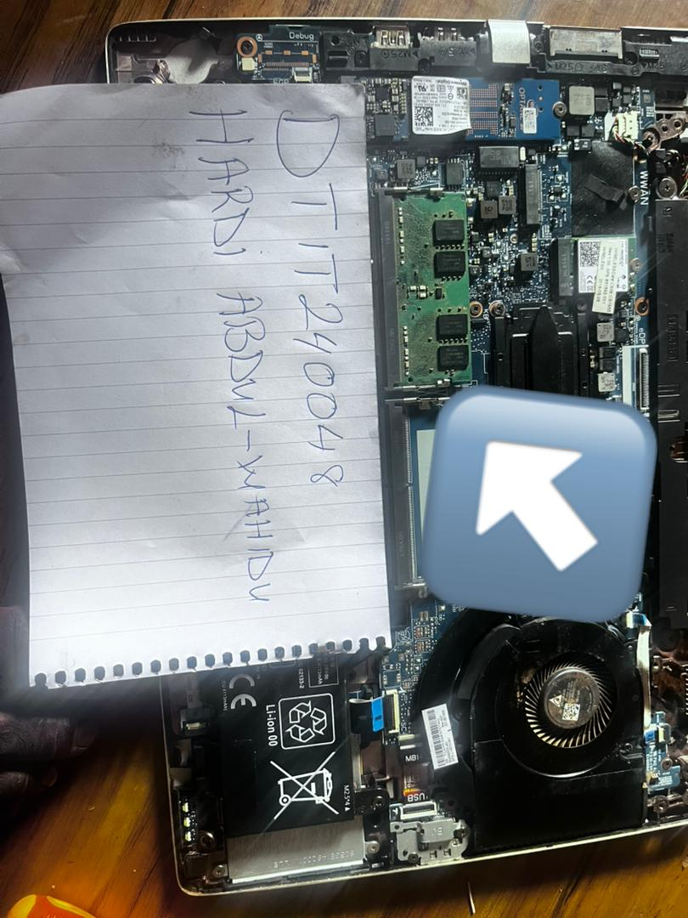Figure 4: Installed RAM modules inside the system unit.
Caption: Physical Inspection – Motherboard, RAM Slots & Capacitors
Explanation: No distended capacitors visible; RAM properly seated
- Photo 2: BIOS/UEFI Hardware Detection + Power LED
- Caption: BIOS Hardware Detection & Power LED Observation
- Explanation: All components detected but CPU temperature high; Power LED was Solid Amber on boot exactly as slides describe for system board/memory/processor/power issues.

