**Ikigugu Group Ltd: Portfolio Landing Page Collaboration Exercise**

**I.Problem Definition**

Ikigugu Group Ltd members, will collaboratively design a Personal Portfolio Landing Page. Each member will contribute a profile card in their respective role section (e.g., UI/UX Designer, Developer, Engineer), allowing everyone to practice Git commands for version control and deployment to GitHub Pages.

**II.Project Overview**

1. **HTML Structure:** Each member creates a profile card under their assigned role section.
2. **CSS Styling:** Members follow the provided CSS styles for consistency.
3. **JavaScript Interactivity:** Interactive navigation and form validation have been pre-added.
4. **Version Control:** Git commands will be used for committing, pushing, and merging changes.
5. **Hosting:** The project will be deployed to GitHub Pages, allowing all team members to view the live page.

**III.Exercise Steps**

The project manager, Munyentwari Clement, has set up the repository on GitHub, added each member as a collaborator, and created a basic project structure. Members will follow the steps below to complete their tasks. The entire exercise is designed to be completed in 90 minutes.

**IV.Step-by-Step Instructions**

1. **Initial Setup (10 minutes)** 
   * **Goal:** Each member forks and clones the repository to work locally.
   * **Instructions:** 
     + Fork the repository created by the project manager on GitHub. o Clone the forked repository to your local machine.
     + **Git command(s):**

git clone <your-forked-repo-url> cd portfolio-landing-page

* + Add the main repository as a remote to pull future updates:
    - **Git command(s):**

git remote add upstream <original-repo-url>

1. **Create Your Profile Card in HTML (15 minutes)** 
   * **Goal:** Each member adds their profile card to the HTML file within their assigned role section.
   * **Instructions:** 
     + Navigate to your role section in ‘index.html’ (e.g., UI/UX Designer, Full-Stack Developer).
     + Create a profile card within the designated <div class="profile-grid"> container.
     + Use the provided HTML structure for consistency. - Example HTML Structure for Profile Card:

<div class="profile-card">

<img src="images/your-photo.jpg" alt="Your Role" class="profile-picture">

<h3>Your Name</h3>

<p>Brief description of your expertise.</p>

<a href="https://linkedin.com/in/your-profile" target="_blank">LinkedIn</a>

<a href="cv/your-cv.pdf" download>Download CV</a>

</div>

1. **Styling Your Profile Card with CSS (10 minutes)** 
   * **Goal:** Apply consistent styling to the profile card by following the provided CSS.
   * **Instructions:** 
     + Open style.css and locate styles for ‘.profile-card’, ‘.profile-picture’, and other related classes.
     + Ensure your profile card matches the layout, font, and color specifications.
     + Do not change the CSS file; adhere to the pre-defined styles for consistency.
2. **Adding Interactivity with JavaScript (5 minutes)** 
   * **Goal:** Verify interactive elements, such as the contact form and smooth scrolling, which have been pre-configured.
   * **Instructions:** 
     + No additional JavaScript is required. Confirm that the navigation links smoothly scroll to each section and that the contact form has validation enabled.
     + Test the interactive elements to familiarize yourself with the final user experience.

1. **Commit and Push Your Changes (15 minutes)** 
   * Goal: Commit your work and push changes to your forked repository.
   * Instructions:
     + Stage the modified files (e.g., index.html where your profile card is added).
       - **Git command:** 
         * git add index.html
     + Commit your changes with a descriptive message.
       - **Git command:** 
         * git commit -m "Add profile card for [Your Name] - [Your Role]"
     + Push to your forked repository ▪ **Git command:**

• git push origin main

1. **Pull and Merge Changes from the Main Repository (15 minutes)** 
   * Goal: Synchronize your repository with the latest changes from the main repository and resolve any conflicts.
   * Instructions:
     + Pull changes from the main repository to your local copy.
       - **Git command:** 
         * git pull upstream main
     + Resolve conflicts if multiple team members have modified the same sections.

Ensure that your profile card and others are correctly added.

* + - Stage and commit any resolved conflicts.
      * **Git command(s):** 
        + git add .
        + git commit -m "Resolve merge conflicts in [Your Section]"
    - Push your resolved changes to your forked repository.
      * **Git command:** 
        + git push origin main

1. **Create a Pull Request (PR) to the Main Repository (10 minutes)** - **Goal:** Submit your work for review by creating a pull request.
   * **Instructions:** 
     + Go to the GitHub page of your forked repository o Click “New Pull Request” and ensure your changes are proposed to be merged into the main repository.

* Add a description for your pull request and submit it for review.

**7. Review and Merge by Project Manager (10 minutes)**

* Goal: The project manager reviews and merges all pull requests.
* **Instructions:** 
  + The project manager checks that all profile cards are correctly placed and that there are no unresolved conflicts.
  + Conflicts are resolved if necessary, and the final code is merged into the main branch.
  + The merged project is now ready for deployment.

**8. Deploy on GitHub Pages (5 minutes)**

* **Goal:** Deploy the project on GitHub Pages to view the live portfolio.
* **Instructions:** 
  + Go to the main repository’s settings on GitHub.
  + Enable GitHub Pages by selecting the main branch as the source under the “Pages” settings.
  + Share the GitHub Pages link with team members to review the live project.

**V.** **Expected Outcomes**

By following these steps, each team member will:

* Gain experience with Git and GitHub: Commit, push, pull, resolve conflicts, and merge.
* Create a collaborative portfolio page: Each role is represented through individual profile cards.
* Deploy a live webpage using GitHub Pages.

**VI.Current collaborators:**

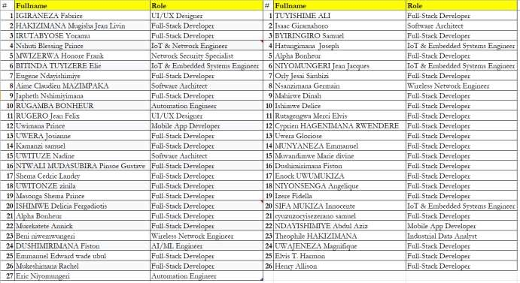

**VII.Expected look: (https://clement007.github.io/ikigugu-exercise-1-1/)**

