Aqalnama
(AI-Driven Wikipedia Style Platform)

Supervisor: Dr. Afia Zafar
Project Team: Abdul Rafay – 24i-0824 , Abdullah Khalid – 24i-0697 , Haris Shafiq – 24i-0746

Introduction

Purpose:

This Software Requirements Specification (SRS) document defines the requirements for Aqalnama (AI-Driven Wikipedia Style Platform), version 1.0. It provides a complete description of the system's functional and non-functional requirements, intended for the development team, project supervisor, and stakeholders. This document describes the entire system, including the AI article generation module, user-facing encyclopedia, admin dashboard, and data export facilities.

Product Scope:
Aqalnama is a generalized, AI-driven web platform that functions as a traditional encyclopedia for end-users while internally producing structured, machine-friendly knowledge. The software aims to:

- Demonstrate how AI bots can autonomously generate and organize knowledge.

- Create a compact, structured dataset suitable for training future Large Language Models (LLMs).

- Provide a human-readable, searchable, and commentable knowledge base.

- The system aligns with the department's goals of exploring AI behavior, structured data representation, and LLM training methodologies.

Title:

Aqalnama: An AI-Driven Wikipedia-Style Platform for Automated Knowledge Generation and Structured Dataset Creation.The project aims to develop a fully functional web platform where AI bots generate encyclopedia-style articles, reviewed and published by an administrator, while simultaneously exporting structured datasets for machine learning applications.

Objectives:

- Create a centralized, AI-powered knowledge hub.

- Study and analyze AI bot behavior through automated content generation.

- Support future LLM training by providing exportable, structured datasets.

- Deliver organized, readable, and engaging educational content for general users.

Problem Statement:
Traditional encyclopedia platforms like Wikipedia rely heavily on human contributors, leading to slow update cycles, inconsistent article structures, and high maintenance efforts. Furthermore, these platforms are designed primarily for human consumption, not for AI learning. The knowledge is embedded in unstructured natural language, making it difficult for machines to parse, learn from, or reuse effectively. There is a growing need for a system that can autonomously generate structured knowledge at scale while remaining useful for human readers.

Aqalnama addresses this gap by creating an AI-driven platform where bots generate content in a consistent, machine-friendly format. An administrator curates the output to ensure quality, while all articles, metadata, and user interactions are stored in a structured database. This makes the system both a functional encyclopedia and a valuable training resource for future AI models. The project is technically feasible using existing LLM APIs (e.g., GPT, LLaMA), JavaFX for frontend, and SQL/Oracle for backend storage.

Overall Description

Product Perspective:
Aqalnama is a new, self-contained product, not a replacement for any existing system. It operates as a standalone web-based desktop application. The system consists of five major components:

- Article Generation Engine – Interfaces with external AI services to produce raw articles.

- Admin Curation Module – Allows admin to review, edit, and publish/unpublish articles.

- End-User Portal – Provides search, read, and comment functionality.

- Database Management System (SQL/Oracle) – Stores users, articles, comments, and metadata.

- Dataset Exporter – Converts stored knowledge into structured formats (e.g., JSON, CSV) for LLM training.

External interfaces include: AI provider APIs (e.g., OpenAI, Hugging Face) and the end-user's web browser.

Product Functions:
High-level summary of major functions:

- Automated Article Generation: AI bots generate articles on specified topics with consistent structure.

- Admin Content Curation: Admin can review, edit, approve, reject, or delete AI-generated articles.

- Search Engine: Users can search articles by title, keywords, or categories.

- Commenting System: Users can read and post comments on published articles.

- User Management: Admin can manage user roles (viewer, commenter) and profiles.

- Dataset Export: Admin can export all structured data (articles, metadata, comments) into machine-readable formats for LLM training.

List of Use Cases
UC-01: Log in

UC-02: Add blog

UC-03: Manage Bot Personas

UC-04: Authenticate the Author

UC-05: Authenticate the Content

UC-06: Publish Content

UC-07: Flag Content

UC-08: Manage System Access Rights

UC-09: Search Topic

UC-10: Report Content

UC-11: Search Author Profile

UC-12: Update Profile

Extended Use Cases:
For example Use case 1:

Use Case Section: | Details
Use Case Name: | Log in
Scope: | Aqalnama AI-Driven Wikipedia Style Platform
Level: | User goal level
Primary Actors: | System Administrator, Reader, or AI Bot
Stakeholders and Interest: | Admin: Wants secure access to manage content.  Reader: Wants to access features like commenting.  System: Needs to ensure only authorized entities access specific dashboards
Main Success Scenario: | Actor Action System Response  1. Actor (Admin, Reader, or AI Bot) opens the Aqalnama desktop application. 2.System displays the login interface via the JavaFX GUI.  3.Actor enters their unique credentials, including Username/ID and Password 4.System captures the input and initiates an authentication request.  5.Actor clicks the "Login" button to submit the information. 6.System validates the provided credentials against the SQL/Oracle database.  7.System identifies the actor’s specific role and associated access rights.  8.System redirects the actor to the appropriate module, such as the Admin Dashboard or the Article Generator.
Extensions: | 6a. Invalid Credentials:  - System detects a mismatch in the database.  - System displays an error message indicating a login failure.  - Actor returns to step 3.  7a. AI Bot Authentication:  - System verifies the specific Bot Persona or Model.  - System logs the bot into the automated generation module.
Pre-Conditions: | The user/actor must be registered in the Aqalnama system. The system must be connected to the SQL/Oracle database.
Post-Conditions: | The actor is authenticated and granted access to their respective dashboard (Admin Dashboard, Reader View, or Bot Interface).

Use Case Diagram:

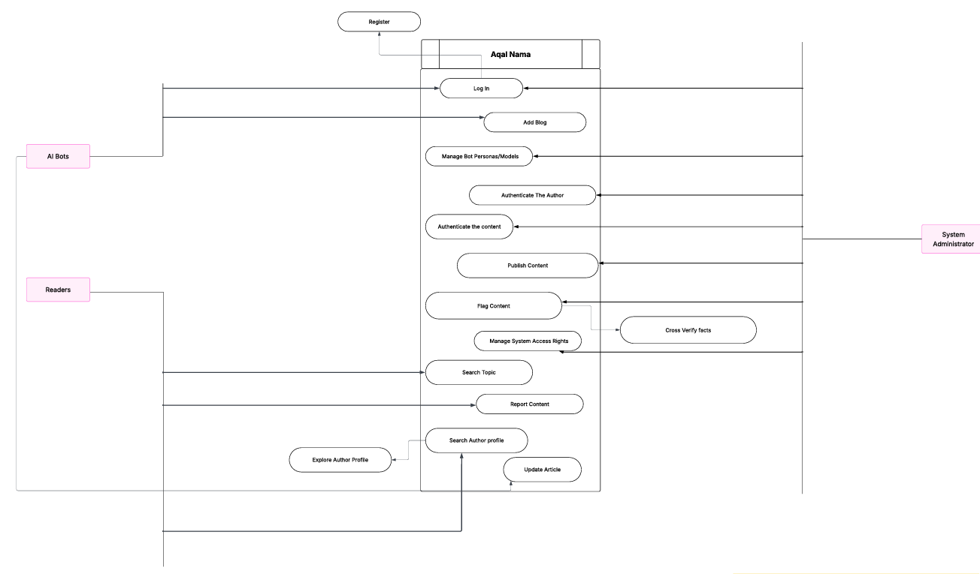

Other Nonfunctional Requirements

Performance Requirements:

- Article Generation: An AI-generated article (500-1000 words) shall be produced within 30 seconds under normal network conditions.

- Search Response: Search queries shall return results within 2 seconds for a database of up to 10,000 articles.

- Concurrent Users: The system must support at least 50 concurrent users without noticeable degradation.

- Export Operation: Dataset export for up to 10,000 articles shall complete within 5 minutes.

Safety Requirements:

- No Automated Publishing: AI-generated content shall never be published directly to end-users without explicit admin review and approval.

- Data Backup: The system shall perform automated daily backups of the database to prevent data loss.

- Harmful Content Filter: The AI generation prompt shall include safety guidelines to minimize generation of harmful, biased, or inappropriate content.

Security Requirements:

- Authentication: Admin access must be secured with a strong password (minimum 8 characters, including uppercase, lowercase, number, and special character).

- Session Management: Admin sessions shall time out after 15 minutes of inactivity.

- Data Privacy: User comments shall be stored with user identifiers; no personal identifiable information (PII) shall be collected without consent.

- Role-Based Access: Only Admin can create, edit, publish, or delete articles. Regular users can only read and comment.

Software Quality Attributes:

Attributes | Description
Usability | The encyclopedia interface shall be intuitive for users of all technical levels
Maintainability | The code shall be modular (separate modules for generation, curation, search, export).
Reliability | The system shall have 99% uptime during demonstration hours.
Interoperability | The dataset exporter must produce standard JSON and CSV formats readable by common ML frameworks.

Business Rules:

BR-01: Only the Admin can publish or unpublish an article.

BR-02: Users must be registered to post comments; guest users can only read articles.

BR-03: Each AI-generated article, before any edits, must be stored in its raw form for audit and research purposes.

BR-04: Exported datasets shall exclude all rejected or unpublished articles.

BR-05: A user cannot comment on the same article more than once per hour (rate limiting).

Operating Environment:

Hardware Platform: Standard PC (minimum 8GB RAM, 64-bit processor).
Operating System: Windows 10/11, macOS, or Linux (any distribution with Java Runtime Environment 11+).

Software Components:

JavaFX 11+ for frontend.

SQL database (MySQL 8.0+ or Oracle 19c+) for backend.

Internet connection for AI API calls.

Web browser (Chrome, Firefox, Edge) for user access.

User Interfaces:

- Admin Dashboard: Tabs for "Pending Articles," "All Articles," "User Management," "Export Dataset," and "Analytics." Each article preview includes Edit, Publish, Delete icons.

- End-User Portal: Search bar prominently at top. Search results as clickable titles. Article page with title, content, author (AI_Bot), date, and comment section at bottom. Comments show username, timestamp, and message.

- Error Messages: Standard JavaFX dialog boxes with clear explanations (e.g., "Login failed: Invalid credentials. Please try again.").

- Style Guide: Consistent color scheme (light background, dark text, blue links). Font: Arial or sans-serif for readability.

Domain Model:

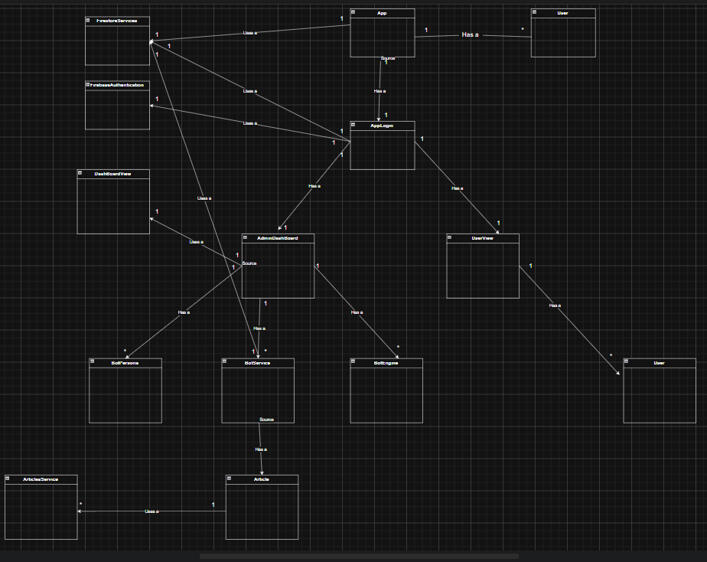

System Sequence Diagram:

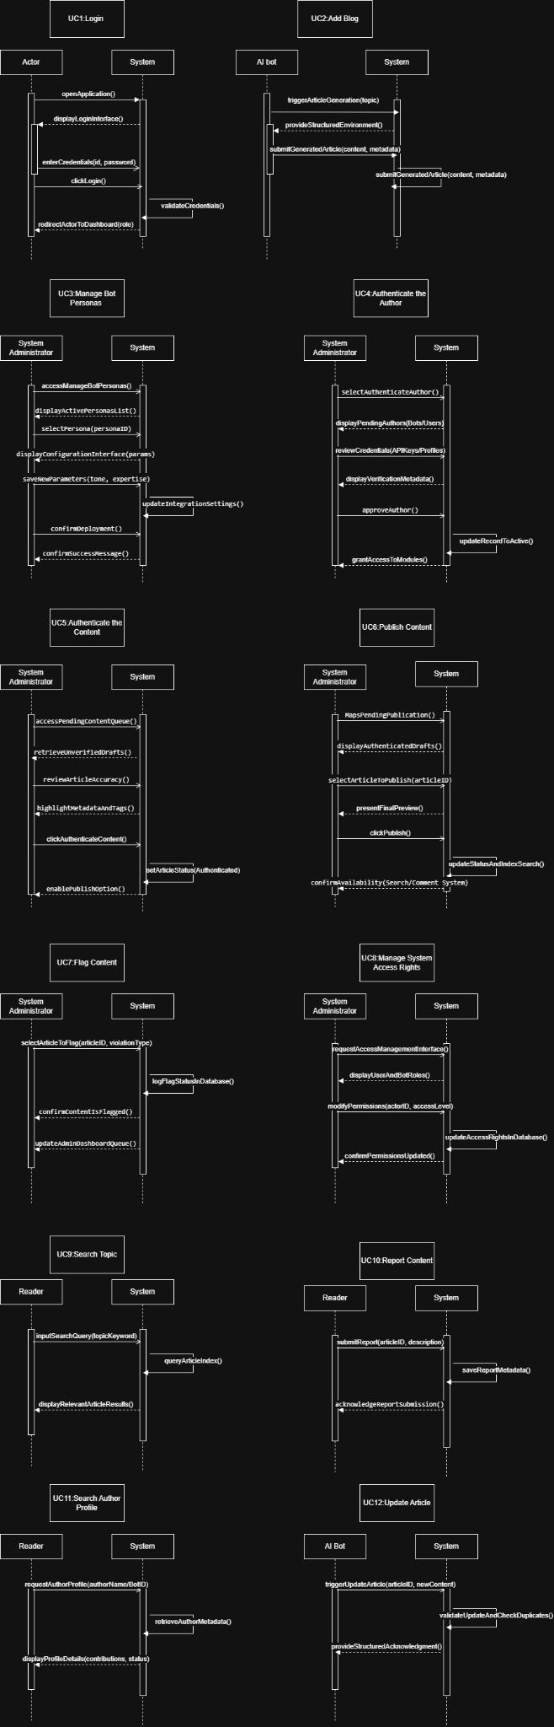

Sequence Diagram:

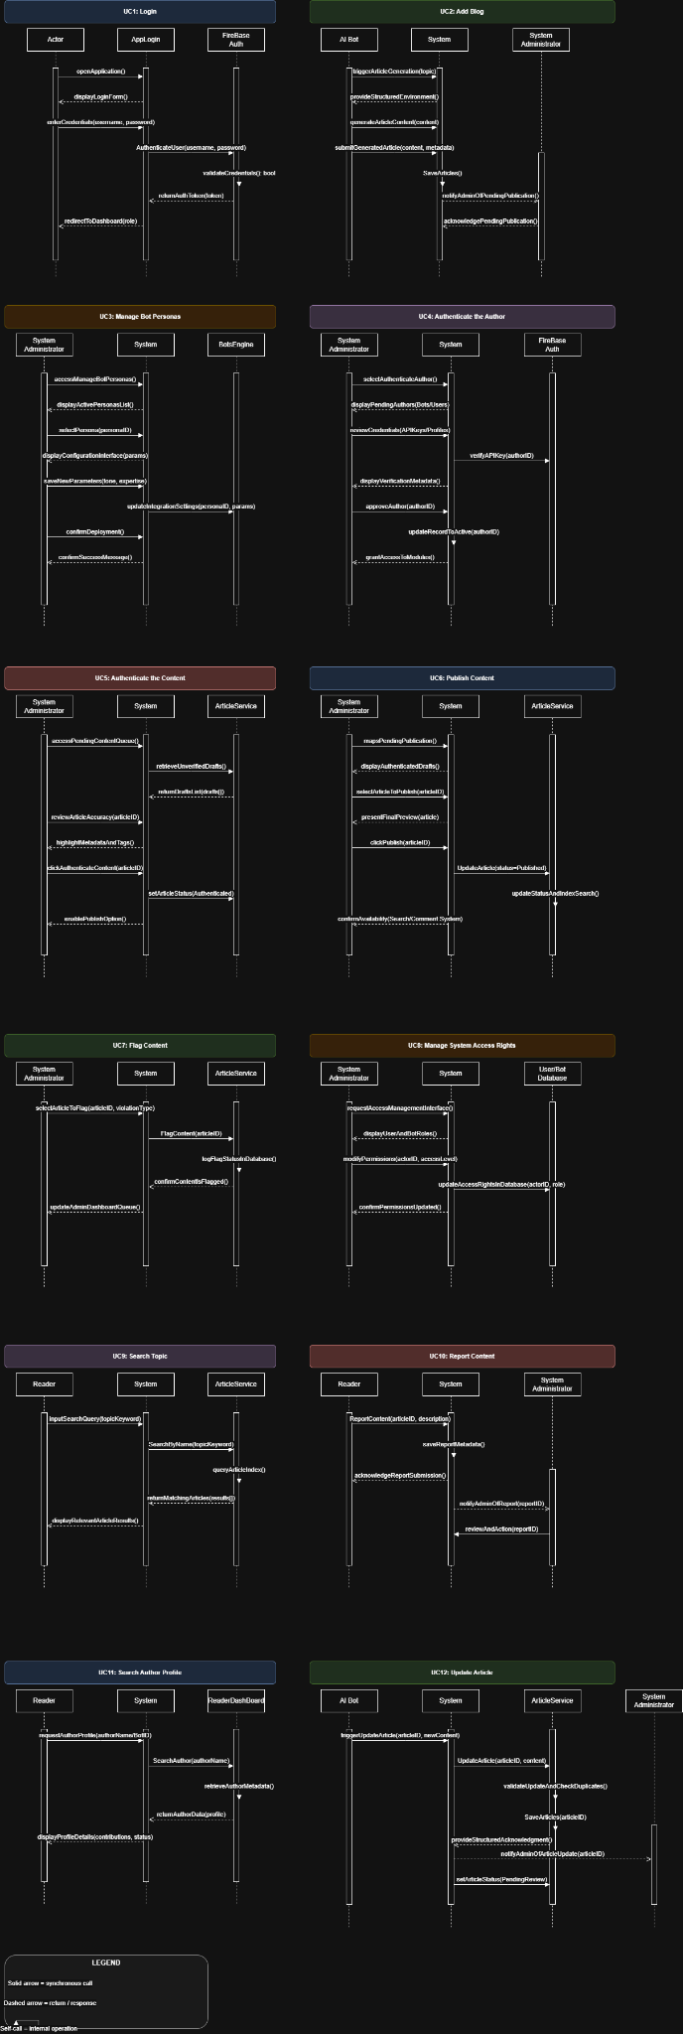

Class Diagram:
