ARCHITECTURE DOCUMENT
RISC-V Network Telemetry and Secure Packet Monitoring SoC
Name: Abdul Aleem
Roll Number: 1602-23-735-001
Final Year Honours Project | RTL-Based SoC Design and Verification
Document control | Value
Version | 1.0
Status | Draft — architecture defined; VeeR EL2 supplied RTL configuration pending sign-off
Processor | VeeR EL2 RV32IMC, faculty-provided
System bus | AHB-Lite
Additional IPs | Custom Network Telemetry + AES-128 + CRC32
Primary proof | RTL simulation + embedded C execution
Course alignment | Block diagram, memory map, interface specifications, bus protocol details

DESIGN RULE
Addresses, register offsets, interrupt wiring, and bus implementation are specified as the current project baseline. Items explicitly marked “proposed/provisional” must be re-validated against the exact faculty-supplied VeeR EL2 RTL build before downstream RTL is frozen.

Contents
- 1. Purpose, Scope and Requirements Traceability
- 2. System Architecture
- 3. Block Diagram and Data Flow
- 4. Memory Map
- 5. Interface Specifications
- 6. AHB-Lite Bus Protocol Details
- 7. Interrupt and Reset Architecture
- 8. Software/Application Architecture
- 9. Verification Architecture
- 10. Implementation Phases and Definition of Done
- 11. Risks, Open Items and Design Constraints
- 12. Resources and IP Provenance

1. Purpose, Scope and Requirements Traceability
This document is the implementation-oriented architecture specification for the proposed RISC-V Network Telemetry and Secure Packet Monitoring SoC. It translates the project abstract into the information needed to design RTL, develop software drivers, construct verification environments, and review the SoC as a complete system. It specifically provides the course-mandated block diagram, complete proposed memory map, interface specifications, and bus protocol details.

1.1 Course Requirement Traceability
Course expectation | Architecture response | Evidence / artifact
Provided RISC-V processor | VeeR EL2 RV32IMC is the central processing element. | VeeR integration + CPU software execution
Instruction Memory | 32-KB system-bus instruction SRAM at 0x0000_0000. | Memory map + IFU transactions
Data Memory | 32-KB system-bus data SRAM at 0x0001_0000. | Memory map + LSU transactions
Bus Interconnect | AHB-Lite single-layer interconnect; two masters, eight slaves. | Bus specification + timing verification
UART | Memory-mapped console/reporting peripheral. | Register tests + encrypted result output
Timer | Free-running count/compare timer with packet-event timestamp use. | Register tests + timestamp check
GPIO | Status output for CPU alive, packet received, AES busy, packet error. | Software/GPIO test + waveform
3 additional IPs minimum | Network Telemetry Engine + AES-128 + CRC32. | IP RTL + integration tests
Complete memory map | All system memories and peripheral/IP windows assigned. | Section 4
Application on processor | Embedded C initializes, services interrupts, reads telemetry, runs AES, reports UART. | Software + CPU simulation
Simulation and verification | Layered IP, bus, CPU, interrupt, and end-to-end tests. | Section 9 + waveforms
RTL/testbenches/software/report/presentation | Defined in implementation and verification deliverables. | Project release package

1.2 Scope and Non-Goals
- In scope: VeeR EL2 integration, AHB-Lite interconnect, instruction/data memory, UART, Timer, GPIO, Network Telemetry Engine, AES-128, CRC32, embedded C application, simulation and verification.
- Packet model: Ethernet-like byte stream containing Ethernet/IPv4/UDP information; testbench provides packet stimulus directly to the telemetry engine.
- Out of scope: Ethernet PHY, GMII/RGMII, board-specific MAC/PHY interfaces, TCP/IP stack, ARP, DHCP, Linux/RTOS, DDR controller, multi-core operation, cache, AXI4 fabric, and DMA in the initial implementation.

2. System Architecture

2.1 Processor
The central CPU is the faculty-provided VeeR EL2 (RV32IMC) core. The architecture assumes the configuration in which the instruction-fetch unit and load-store unit expose system-bus masters and AHB-Lite is selected as the core bus option. The exact supplied build must be inspected before final RTL freeze to confirm bus mode, ICCM/DCCM presence and sizing, reset vector, and interrupt/PIC configuration.

2.2 Bus Topology
The proposed fabric is a single-layer AHB-Lite interconnect. The VeeR instruction-fetch (IFU) and load-store (LSU) masters arbitrate onto one shared bus. Address decoding selects one of eight slaves: instruction memory, data memory, UART, Timer, GPIO, Network Telemetry Engine, AES-128, and CRC32. The interconnect is responsible for master selection, slave select generation, read-data multiplexing, HREADY propagation, and default error responses.

2.3 Mandatory Infrastructure
Block | Function | Bus access
Instruction Memory | Program storage / instruction fetch | IFU read; implementation may enforce non-writeable behavior
Data Memory | Stack, variables, software state | LSU read/write
UART | Console output and encrypted telemetry reporting | LSU read/write
Timer | Free-running time base, compare/match interrupt, packet timestamp source | LSU read/write
GPIO | Hardware-visible status signals | LSU read/write

3. Block Diagram and Data Flow
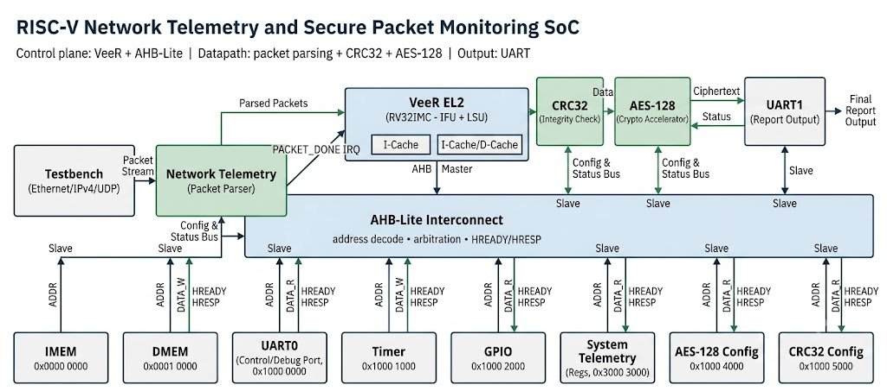
Figure 3.1 — Top-level SoC architecture.

3.1 Master/Slave Topology
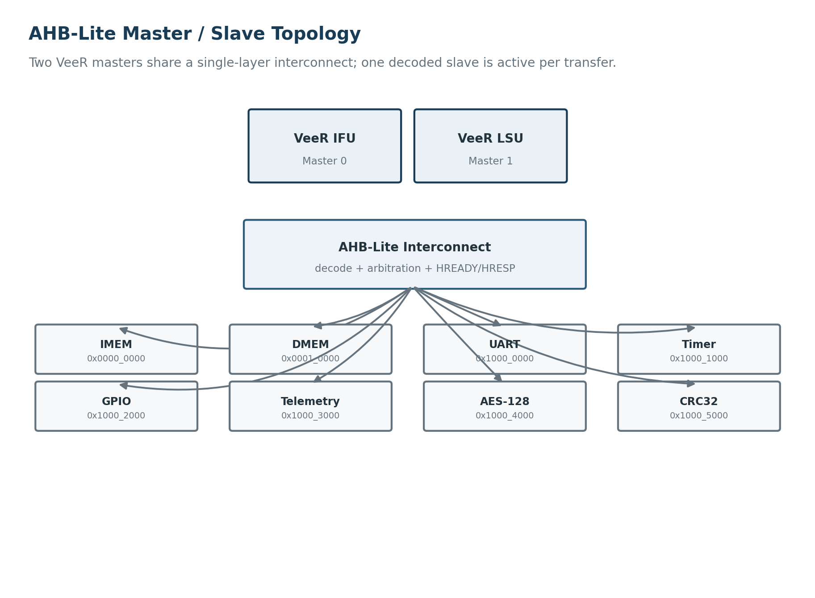
Figure 3.2 — AHB-Lite master/slave topology and base addresses.

3.2 End-to-End Functional Data Flow
The application-level path is intentionally coherent: the hardware parses and counts network traffic, CRC32 verifies the same packet stream, the CPU receives a packet-completion interrupt and reads the resulting telemetry fields, software constructs a 128-bit telemetry record, AES-128 encrypts that record, and UART reports the protected result. This makes the RISC-V core an active coordinator of a hardware-accelerated workload rather than a processor attached to unrelated peripherals.
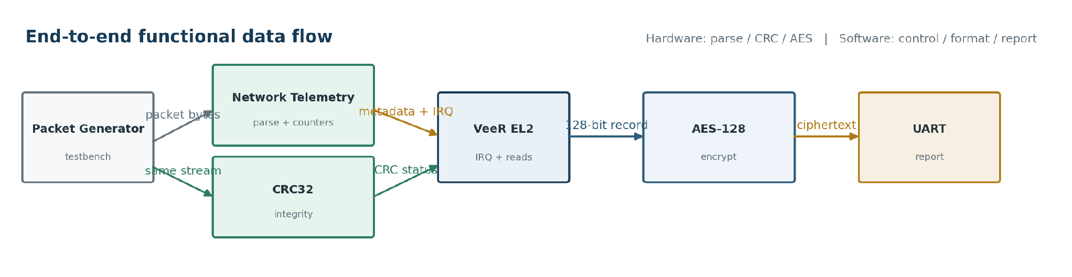
Figure 3.3 — End-to-end packet-to-encrypted-telemetry data flow.

4. Memory Map
STATUS: PROVISIONAL
The following map is the current implementation baseline. Before RTL freeze, verify that system-bus memories do not overlap any enabled VeeR ICCM/DCCM regions and confirm the supplied reset/vector configuration.

Start | End | Size | Block | Access
0x0000_0000 | 0x0000_7FFF | 32 KB | Instruction Memory (IMEM) | IFU: read/execute
0x0001_0000 | 0x0001_7FFF | 32 KB | Data Memory (DMEM) | LSU: read/write
0x1000_0000 | 0x1000_0FFF | 4 KB | UART | LSU: read/write
0x1000_1000 | 0x1000_1FFF | 4 KB | Timer | LSU: read/write
0x1000_2000 | 0x1000_2FFF | 4 KB | GPIO | LSU: read/write
0x1000_3000 | 0x1000_3FFF | 4 KB | Network Telemetry Engine | LSU: read/write
0x1000_4000 | 0x1000_4FFF | 4 KB | AES-128 Accelerator | LSU: read/write
0x1000_5000 | 0x1000_5FFF | 4 KB | CRC32 Accelerator | LSU: read/write

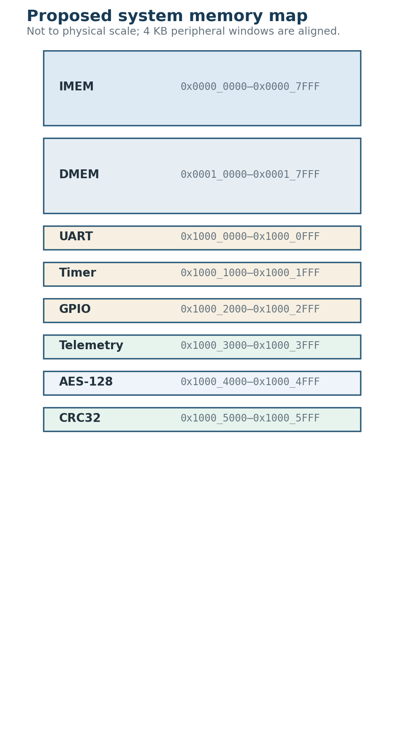
Figure 4.1 — Proposed system memory map, shown schematically rather than to physical scale.

4.1 Decode Rules
- IMEM occupies 0x0000_xxxx; DMEM occupies 0x0001_xxxx.
- Peripheral and accelerator registers occupy aligned 4-KB windows under 0x1000_xxxx.
- The interconnect decodes the upper address region first, then the local 4-KB window to assert exactly one HSEL per transfer.
- Unmapped addresses are routed to a default slave that returns an AHB-Lite ERROR response.

5. Interface Specifications
All memory-mapped registers are 32-bit and word-aligned unless explicitly stated otherwise. The register maps below define the software-visible contract used by the embedded application and the verification environment. Reserved bits must read as zero and ignored writes must not alter architecturally defined state.

5.1 UART — Base 0x1000_0000
Offset | Register | R/W | Description
0x00 | TXDATA | W | Byte to transmit; write initiates transmission
0x04 | RXDATA | R | Last received byte
0x08 | STATUS | R | bit0 TX_BUSY; bit1 RX_VALID
0x0C | CONTROL | R/W | bit0 TX_IRQ_EN; bit1 RX_IRQ_EN
0x10 | BAUD_DIV | R/W | Baud-rate divisor

5.2 Timer — Base 0x1000_1000
Offset | Register | R/W | Description
0x00 | COUNT | R | Free-running counter
0x04 | COMPARE | R/W | Compare value for match / periodic interrupt
0x08 | CONTROL | R/W | bit0 ENABLE; bit1 IRQ_EN; bit2 AUTO_RELOAD
0x0C | STATUS | R/W1C | bit0 MATCH; write 1 to clear

5.3 GPIO — Base 0x1000_2000
Offset | Register | R/W | Description
0x00 | OUT | R/W | bit0 CPU_ALIVE; bit1 PKT_RX; bit2 AES_BUSY; bit3 PKT_ERR
0x04 | DIR | R/W | Direction; all design-defined bits are outputs

5.4 Network Telemetry Engine — Base 0x1000_3000
Streaming interface: pkt_valid, pkt_data[7:0], pkt_last. The byte stream is independent of the AHB-Lite register interface. The engine parses Ethernet-like headers, IPv4, and UDP information; records selected fields; maintains counters; captures the Timer value at packet completion; and raises a packet-done interrupt.
Offset | Register | R/W | Description
0x00 | STATUS | R | bit0 PARSER_BUSY; bit1 PACKET_READY
0x04 | CONTROL | R/W | bit0 ENABLE; bit1 IRQ_EN
0x08 | PACKET_COUNT | R | Total packets processed
0x0C | BYTE_COUNT | R | Total bytes processed
0x10 | ERROR_COUNT | R | Malformed/dropped packet count
0x14 | UDP_COUNT | R | UDP packet count
0x18 | TCP_COUNT | R | TCP packet count
0x1C | LAST_PACKET_LENGTH | R | Length of most recent packet
0x20 | LAST_SRC_IP | R | Source IPv4 address
0x24 | LAST_DST_IP | R | Destination IPv4 address
0x28 | LAST_SRC_PORT | R | Source UDP/TCP port
0x2C | LAST_DST_PORT | R | Destination UDP/TCP port
0x30 | LAST_PROTOCOL | R | Protocol classification
0x34 | LAST_PACKET_TIMESTAMP | R | Timer snapshot at packet completion
0x38 | IRQ_STATUS | R/W1C | bit0 PACKET_DONE; write 1 to clear
0x3C | IRQ_ENABLE | R/W | bit0 PACKET_DONE_EN

5.5 AES-128 Accelerator — Base 0x1000_4000
The AES wrapper exposes a register-style control/data interface around the selected open-source core. Software loads a 128-bit key, initializes the key schedule, loads a 128-bit plaintext block, starts encryption, waits for completion, and reads a 128-bit ciphertext result.
Offset | Register | R/W | Description
0x00 | CONTROL | R/W | bit0 START/INIT; bit1 IRQ_EN
0x04 | STATUS | R | bit0 BUSY; bit1 DONE
0x08–0x14 | KEY0–KEY3 | R/W | 128-bit key, four 32-bit words
0x18–0x24 | DATA0–DATA3 | R/W | 128-bit plaintext block
0x28–0x34 | RESULT0–RESULT3 | R | 128-bit ciphertext block

AES SOFTWARE SEQUENCE
1) Write KEY0–KEY3. 2) Start key initialization. 3) Poll STATUS.BUSY until clear. 4) Write DATA0–DATA3. 5) Start encryption. 6) Poll STATUS.DONE or service AES interrupt. 7) Read RESULT0–RESULT3.

5.6 CRC32 Accelerator — Base 0x1000_5000
The CRC32 block wraps a byte-serial LFSR-based core configured for the Ethernet-FCS polynomial/width/reflection behavior. Packet bytes may be accumulated as part of the streaming path; the register interface exposes control, validity, data, and result state for software and verification.
Offset | Register | R/W | Description
0x00 | CONTROL | R/W | bit0 RESET_CRC; write 1 to reinitialize
0x04 | STATUS | R | bit0 VALID
0x08 | DATA | W | Next byte to accumulate
0x0C | RESULT | R | Implementation-defined pass/fail and CRC result status; exact bit allocation must be frozen with the wrapper RTL

CRC32 WRAPPER NOTE
The source core exposes the byte-serial CRC datapath; the AHB-Lite wrapper owns the control/status/result register behavior. The exact RESULT bit allocation should be fixed in the RTL interface specification before driver coding.

6. AHB-Lite Bus Protocol Details
All instruction fetches, data accesses, and peripheral/IP register transactions use the same AMBA 3 AHB-Lite transfer protocol. The bus is synchronous to HCLK and uses pipelined address/data phases. Each transfer is selected by HTRANS; control information is presented in the address phase, followed by write data or read data in the data phase. HREADY determines when the current transfer completes and permits wait-state insertion.

6.1 Core Bus Signals
Signal | Width | Driver | Use
HCLK | 1 | System | Rising-edge synchronous bus clock
HRESETn | 1 | System | Active-low reset
HADDR | 32 | Master | Transfer address
HTRANS | 2 | Master | IDLE / BUSY / NONSEQ / SEQ
HWRITE | 1 | Master | 1 = write, 0 = read
HSIZE | 3 | Master | Transfer size
HWDATA | 32 | Master | Write data
HRDATA | 32 | Slave | Read data
HREADY | 1 | Slave / interconnect | 1 = transfer complete; 0 = wait
HRESP | 1 | Slave / default slave | 0 = OKAY; 1 = ERROR
HSELx | per slave | Interconnect | Decoded slave select

6.2 Single Write Transfer
A normal peripheral write uses HTRANS = NONSEQ with HWRITE = 1 in the address phase. The selected slave then accepts HWDATA during the data phase. If the slave requires additional time, it holds HREADY low; the master keeps the transfer active until HREADY returns high. For simple register writes, the expected implementation is zero wait states unless an IP explicitly requires otherwise.
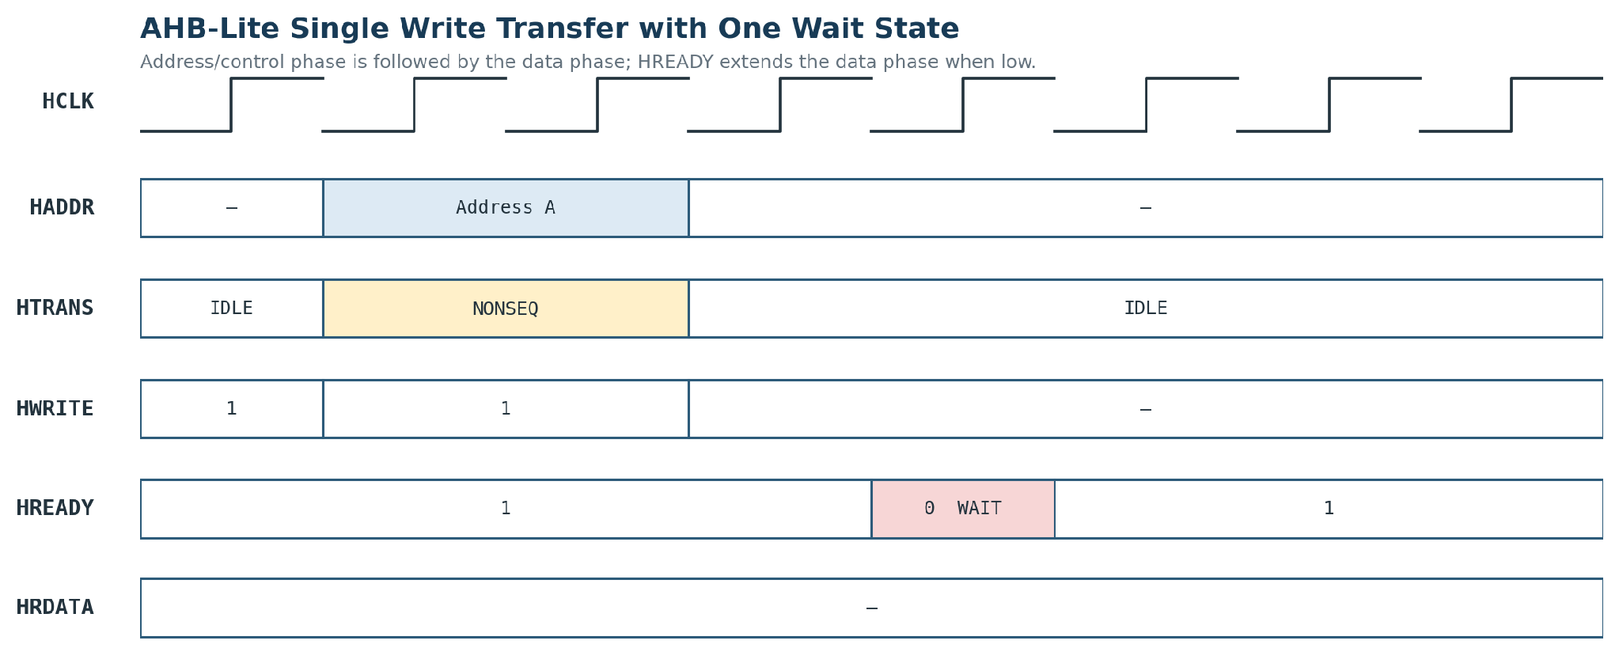
Figure 6.1 — AHB-Lite single write transfer with one wait state.

6.3 Single Read Transfer
A normal peripheral read uses HTRANS = NONSEQ with HWRITE = 0 in the address phase. The selected slave returns the requested value on HRDATA during the data phase and completes the transfer by asserting HREADY. The read timing is identical in structure to a write, except that data direction reverses.
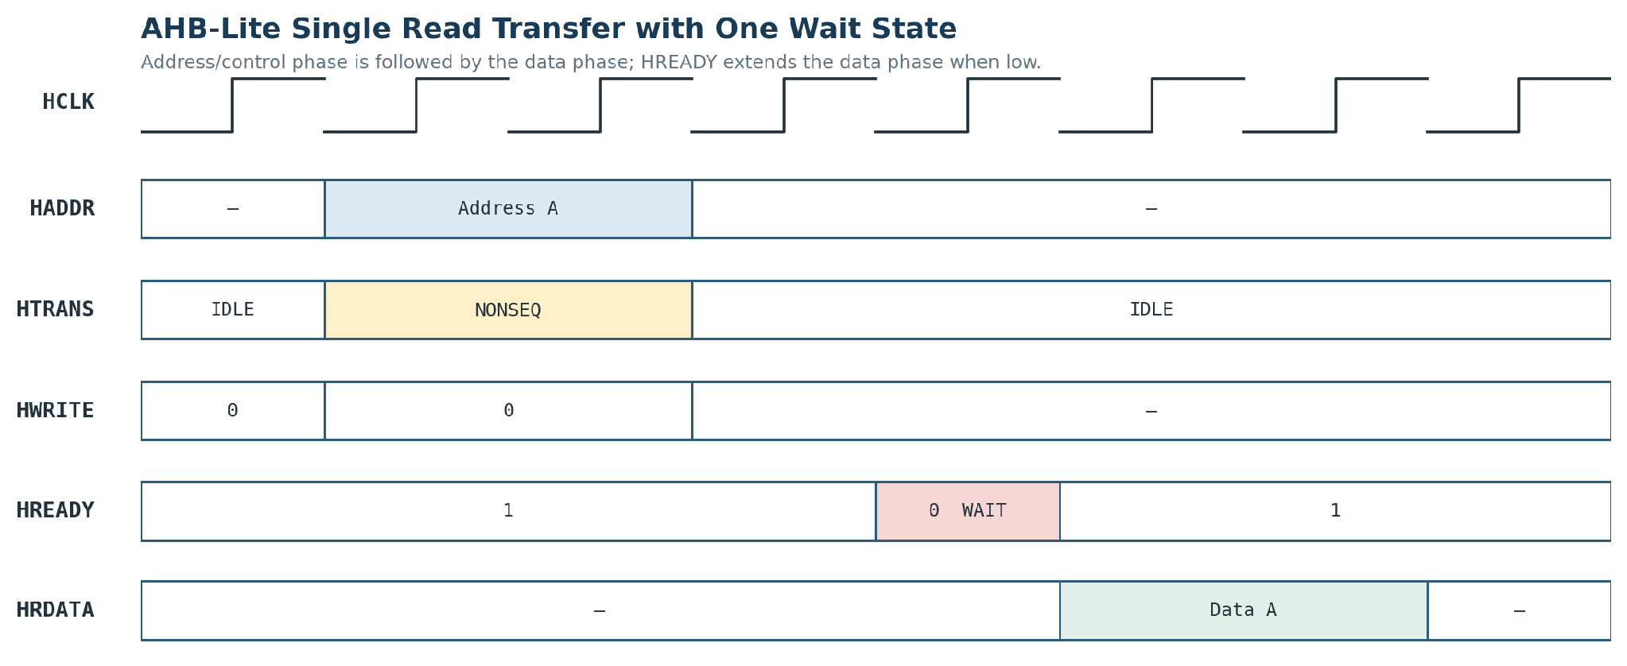
Figure 6.2 — AHB-Lite single read transfer with one wait state.

6.4 Interconnect Rules
- Address decode: select one slave from HADDR; no overlapping windows are permitted.
- Arbitration: the current baseline uses fixed priority LSU > IFU to keep interrupt/service traffic responsive; this policy must be validated against the supplied VeeR master behavior during integration.
- Read-data multiplexing: HRDATA returned to the active master is taken only from the selected slave.
- HREADY propagation: the interconnect propagates the selected slave HREADY to the current master.
- Unmapped address: route to a default slave and return HRESP = ERROR; retain a deterministic HREADY completion path.
- Alignment: software uses 32-bit word-aligned accesses for defined registers; byte streaming to the telemetry/CRC blocks occurs on their dedicated datapaths.

7. Interrupt and Reset Architecture

7.1 Interrupt Sources
Source | Condition | Purpose
Timer | COUNT reaches COMPARE | Periodic software timing
UART | TX/RX event when enabled | Optional console servicing
Network Telemetry Engine | PACKET_DONE | Notify CPU that telemetry registers are valid
AES-128 | DONE | Optional completion interrupt for ciphertext availability

The exact interrupt aggregation mechanism depends on the supplied VeeR EL2 build. The current architecture allows separate peripheral interrupt sources to be combined into the core external interrupt input(s), either through a simple aggregation layer or through the core-supported interrupt/PIC mechanism once that configuration is confirmed.

7.2 Reset Behavior
- HRESETn is the system-wide active-low reset.
- Memories return to implementation-defined reset state suitable for software boot and verification.
- Peripheral control registers reset disabled and clear pending status where applicable.
- Telemetry counters and CRC state reset to known values; AES status clears BUSY/DONE.

8. Software/Application Architecture
The processor executes a bare-metal embedded application whose purpose is to demonstrate complete hardware/software coordination. The application configures the mandatory peripherals, enables the additional IPs, services the packet-completion interrupt, retrieves telemetry fields, and invokes AES encryption before reporting the final result over UART.

8.1 Application Flow
Step | Software action | Hardware interaction
1 | Initialize UART, Timer, GPIO | Program base control registers
2 | Initialize telemetry / CRC / AES | Enable engines and clear status
3 | Enable interrupts | Configure Timer / Telemetry / AES IRQ sources
4 | Wait for network event | Telemetry engine parses stream in hardware
5 | Read telemetry registers | LSU accesses Network Telemetry register bank
6 | Validate CRC status | Read CRC result/status
7 | Assemble 128-bit telemetry record | Software formats four 32-bit words
8 | Run AES-128 | Write key/data, start, poll or service IRQ
9 | Report result | UART writes encrypted telemetry + packet statistics

8.2 Suggested Source Organization
- startup.S
- linker.ld
- main.c
- uart.c / uart.h
- timer.c / timer.h
- gpio.c / gpio.h
- network.c / network.h
- aes.c / aes.h
- crc.c / crc.h
- interrupts.c / interrupts.h

9. Verification Architecture
Verification is layered from the smallest IP block upward. The objective is to produce reproducible evidence that each block is correct in isolation, that the bus and software interfaces are correct, and that the complete application performs the intended packet-to-encrypted-telemetry function.
Level | Scope | Primary checks / evidence
1 | AES-128 | Known NIST AES-128 vectors; key load, start, busy, done, result
2 | CRC32 | Reference-model comparison; empty input, known strings, varied lengths, back-to-back packets
3 | Network parser | Valid Ethernet/IPv4/UDP; malformed EtherType/protocol; varied lengths; field extraction and counters
4 | AHB-Lite peripherals | Register read/write, reset values, unmapped access, HREADY stalls, HRESP error path
5 | Interconnect | IFU→IMEM; LSU→DMEM/peripherals; arbitration; read-data mux; no wrong-slave select
6 | CPU software | Boot, UART banner, memory test, GPIO test, Timer interrupt, IP initialization
7 | End-to-end | Packet injection → telemetry → CRC → interrupt → VeeR → AES → UART

SCOREBOARD / REFERENCE MODELS
Use software/reference models for AES and CRC32 and a transaction-level expected-telemetry model for the parser. The scoreboard compares DUT output to expected values rather than relying only on waveform inspection.

9.1 Recommended Completion Targets
- 100+ directed/randomized packet cases covering valid and malformed packet classes.
- 10+ AES test vectors including repeated and varied plaintext/key values.
- 10+ CRC cases including known references and differing packet lengths.
- Full register-level read/write coverage for all memory-mapped peripherals and accelerators.
- Interrupt assertion, clear, and re-arm checks for Timer, Telemetry, and AES where enabled.
- At least one complete waveform proving packet input, telemetry extraction, CPU interrupt handling, AES operation, and UART report.

10. Implementation Phases and Definition of Done
Phase | Deliverable | Exit criterion
0 | VeeR bring-up | Supplied RTL configuration confirmed; CPU executes a basic program
1 | SoC infrastructure | AHB-Lite fabric + memories + reset/clock + address decode verified
2 | Mandatory peripherals | UART + Timer + GPIO integrated and software-accessible
3 | Network Telemetry Engine | Packet stream produces correct registers and interrupt
4 | CRC32 integration | Packet integrity path produces correct expected CRC/status
5 | AES-128 integration | CPU successfully encrypts a telemetry block and reads result
6 | Software application | End-to-end bare-metal application runs
7 | End-to-end verification | Packet/vector/interrupt/register tests and waveforms complete
8 (optional) | Synthesis / FPGA demo | Only after simulation proof is stable

MINIMUM VIABLE CHECKPOINT
The current project plan treats Phases 0–4 as the minimum defensible complete SoC checkpoint: CPU + interconnect + mandatory peripherals + Network Telemetry Engine + CRC32. AES integration is deliberately later so the core system can be demonstrated before the final cryptographic integration step.

11. Risks, Open Items and Design Constraints
Item | Status | Resolution / action
VeeR EL2 bus mode | OPEN | Confirm AHB-Lite vs AXI4 directly from supplied RTL build before interconnect RTL freeze
ICCM/DCCM presence and size | OPEN | Check supplied configuration; revalidate system memory windows
Reset/vector mapping | OPEN | Confirm boot address and reset behavior before linker script finalization
Interrupt aggregation | OPEN | Choose simple aggregation or VeeR PIC based on actual core build
AES wrapper details | CONTROLLED | Freeze exact wrapper FSM and status semantics during integration
CRC RESULT register semantics | CONTROLLED | Freeze exact pass/fail/CRC bit allocation with wrapper RTL
Physical networking | OUT OF SCOPE | Use direct testbench packet injection
DMA / performance scaling | OUT OF SCOPE (initially) | Only add after functional requirements are met

12. Resources and IP Provenance
Component | Source | License / role
VeeR EL2 RV32IMC | chipsalliance/Cores-VeeR-EL2 | Apache-2.0; faculty-provided processor
VeeRwolf reference SoC | chipsalliance/VeeRwolf | Apache-2.0; reference integration pattern
AES-128 | secworks/aes | BSD-2-Clause; adapted accelerator IP
CRC32 | alexforencich/verilog-lfsr | MIT; adapted byte-serial CRC core
CRC32 usage reference | alexforencich/verilog-ethernet | MIT; reference for byte-stream usage

Source repositories and licenses are included so the project report can record provenance and attribution. The custom Network Telemetry Engine is authored specifically for this SoC and remains the principal project-specific RTL contribution.

