RISC-V Network Telemetry & Secure Packet Monitoring SoC
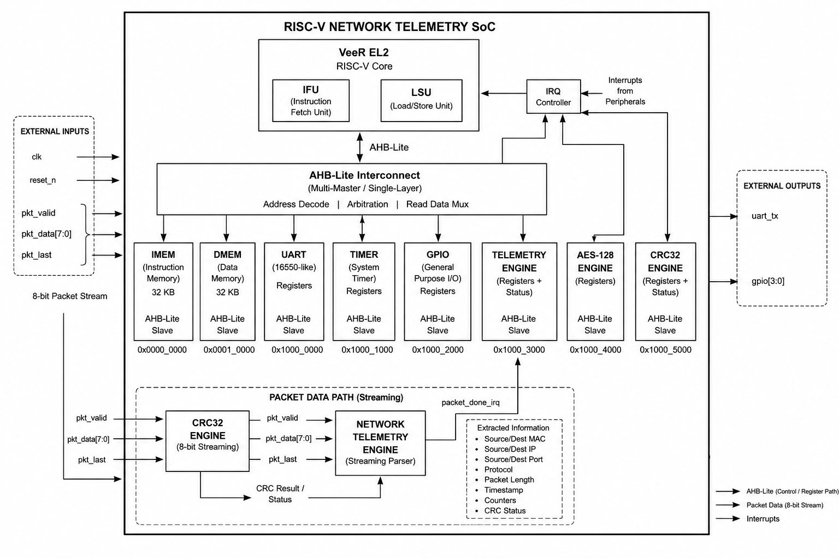
figure - SoC Block Diagram

