**CS2004**

**Software Engineering**

**Assignment 02**

**Software Design & development**

**Submitted by:** Abdul Ahad

**Roll number:** 23i-2014

**Date:** 27-04-2025

Table of Contents

Project Introduction: 4

User stories (all sprints): 4

User Stories (Customer): 5

1.1 Story ID: US-1 5

1.2 Story ID: US-2 5

1.3 Story ID: US-3 5

1.4 Story ID: US-4 6

1.5 Story ID: US-5 6

1.6 Story ID: US-6 6

1.7 Story ID: US-7 6

User Stories (Employee) 7

2.1 Story ID: US-8 7

2.2 Story ID: US-9 7

2.3 Story ID: US-10 7

2.4 Story ID: US-11 8

2.5 Story ID: US-12 8

User Stories (Admin): 8

3.1 Story ID: US-13 8

3.2 Story ID: US-14 9

3.3 Story ID: US-15 9

3.4 Story ID: US-16 9

3.5 Story ID: US-17 10

3.6 Story ID: US-18 10

Design: 10

1. Use-case Diagram 10

2. Sequence Diagrams: 11

Fetch order status diagram: 12

Login diagram: 12

Purchase Order Diagram: 13

Class Diagram: 13

Activity Diagrams: 14

Manage account details diagram: 15

Place order Diagram: 16

Login Activity Diagram: 17

Architecture: 17

Actual implementation screenshots: 18

Product Burn down chart for the project: 21

Work Division between group members: 21

Lesson learnt by group: 22

# Project Introduction:

Water, electricity and gas are the three most important things in any home. Unfortunately, nowadays due to increasing demand and decreasing supply, water scarcity is a big problem for many homes and communities. To combat water scarcity issue, people order tankers that deliver water to their homes. However, the system used to deliver water is now a legacy system that still depends on manual bookkeeping and logistics. Quench Thirst aims to streamline the process by digitalizing the ordering system, where users can place complaints about water, and the employee can see the optimized route to take to deliver water to everyone’s home.

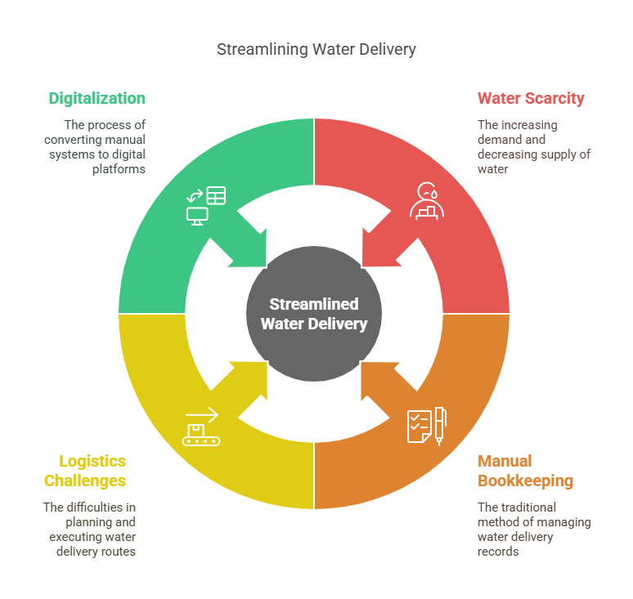

# User stories (all sprints):

We have categorized user stories in documents based on the roles of user that our application is mainly handling. These include **Admin, employees, and the customers.**

## User Stories (Customer):

### 1.1 Story ID: US-1

**Story Title**: **User Registration**  
**User Story**:

**As a new user**,  
**I want** to create an account,  
**So that** I can log in and place water tanker orders.

**Acceptance Criteria (And I know I am done when):**

1. I can open a registration page and fill in required details (email, password, address).
2. The system verifies that email is unique.
3. On successful registration, I receive confirmation and can log in.

* Importance: High
* Estimate: 3 Story Points
* Type: *Manage Data*

### 1.2 Story ID: US-2

**Story Title**: **User Login**  
**User Story**:

**As a registered user**,  
**I want** to log in with my credentials,  
**So that** I can securely access my account and place orders.

**Acceptance Criteria (And I know I am done when):**

1. I can enter my username/email and password on the login page.
2. The system validates my credentials and grants access if correct.
3. If credentials are incorrect, I receive an appropriate error message.

* Importance: High
* Estimate: 2 Story Points
* Type: *Workflow*

### 1.3 Story ID: US-3

**Story Title**: **Profile Management**  
**User Story**:

**As a user**,  
**I want** to view and edit my profile (name, address, contact info),  
**So that** my account information stays accurate.

**Acceptance Criteria (And I know I am done when):**

1. I can see my current profile data on a “My Account” or “Profile” page.
2. I can update my name, address, or phone number, and the system saves changes.
3. Any required fields (like email) cannot be changed to an already-registered email.

* Importance: Medium
* Estimate: 3 Story Points
* Type: *Manage Data*

### 1.4 Story ID: US-4

**Story Title**: Product Ordering  
**User Story**:  
As a user,  
I want to order products from the available list,  
So that I can get water delivered to my address.

**Acceptance Criteria (And I know I am done when)**:

1. I can view available water products with details (name, price, size).
2. I can add selected products to the cart and proceed to check out.
3. I can complete the order by selecting a delivery address and payment method.

* **Importance**: High
* **Estimate**: 5 Story Points
* **Type**: Transaction

### 1.5 Story ID: US-5

**Story Title**: Address Management  
**User Story**:  
As a user,  
I want to update my delivery address,  
So that my orders are sent to the correct location.

**Acceptance Criteria (And I know I am done when)**:

1. I can add a new address to my profile.
2. I can update or delete an existing address.
3. Address validation ensures correct formatting (e.g., no blank fields).

* **Importance**: High
* **Estimate**: 3 Story Points
* **Type**: Manage Data

### 1.6 Story ID: US-6

**Story Title**: View Order Status and History  
**User Story**:  
As a user,  
I want to view my recent orders and their status,  
So that I can keep track of my deliveries.

**Acceptance Criteria (And I know I am done when)**:

1. I can see a list of my past and ongoing orders on the "Orders" page.
2. Each order shows key details: order ID, products, total amount, and delivery status.
3. I can click on an order to see full details.

* **Importance**: High
* **Estimate**: 4 Story Points
* **Type**: View Information

### 1.7 Story ID: US-7

**Story Title**: Provide Feedback  
**User Story**:  
As a user,  
I want to submit feedback about my experience,  
So that the service can improve based on customer input.

**Acceptance Criteria (And I know I am done when)**:

1. I can submit a rating and comment after an order is delivered.
2. Feedback is linked to a specific order for better context.
3. I receive confirmation that my feedback was submitted successfully.

* **Importance**: Medium
* **Estimate**: 2 Story Points
* **Type**: Manage Data

## User Stories (Employee)

### 2.1 Story ID: US-8

**Story Title**: **Employee Login**  
**User Story**:

**As a delivery employee**,  
**I want** to log in with my employee credentials,  
**So that** I can access and update my assigned deliveries.

**Acceptance Criteria (And I know I am done when):**

1. I enter my username/password on an employee login screen.
2. The system validates my role as “Employee.”
3. I gain access to a driver-specific dashboard upon successful login.

* **Importance**: High
* **Estimate**: 2 Story Points
* **Type**: *Workflow*

### 2.2 Story ID: US-9

**Story Title**: Deliver Orders in Processing  
**User Story**:  
As a delivery employee,  
I want to view and update orders assigned to me,  
So that I can mark them as delivered after completing the task.

**Acceptance Criteria (And I know I am done when)**:

1. I can see all assigned orders marked as "Processing" in my dashboard.
2. I can update the order status to "Delivered" after delivery.
3. System records delivery time and updates customer notification.

* **Importance**: High
* **Estimate**: 3 Story Points
* **Type**: Transaction

### 2.3 Story ID: US-10

**Story Title**: Employee Profile Management  
**User Story**:  
As a delivery employee,  
I want to view and update my profile details,  
So that my personal information stays current.

**Acceptance Criteria (And I know I am done when)**:

1. I can see my profile details like name, contact info on a "My Account" page.
2. I can update my contact information if needed.
3. Critical details like role or employee ID are not editable by the employee.

* **Importance**: Medium
* **Estimate**: 2 Story Points
* **Type**: Manage Data

### 2.4 Story ID: US-11

**Story Title**: View Delivered Orders (Performance Tracking)  
**User Story**:  
As a delivery employee,  
I want to see a list of all orders I have delivered,  
So that I can track my delivery history and performance.

**Acceptance Criteria (And I know I am done when)**:

1. I can view a history page showing all the orders I delivered.
2. Each record includes delivery date, customer rating (if any), and delivery time.
3. I can filter my delivered orders by date range.

* **Importance**: Medium
* **Estimate**: 3 Story Points
* **Type**: View Information

### 2.5 Story ID: US-12

**Story Title**: View and Respond to Customer Feedback  
**User Story**:  
As a delivery employee,  
I want to view feedback left by customers on my deliveries,  
So that I can acknowledge good service or improve my performance.

**Acceptance Criteria (And I know I am done when)**:

1. I can see feedback related to my deliveries.
2. I can respond to feedback if required (e.g., apologize, thank the customer).
3. The system shows feedback rating and comments clearly linked to specific orders.

* **Importance**: Medium
* **Estimate**: 2 Story Points
* **Type**: Manage Data

# User Stories (Admin):

### 3.1 Story ID: US-13

**Story Title**: **Admin Login**  
**User Story**:

**As an admin**,  
**I want** to log in securely,  
**So that** I can manage the system without unauthorized access.

**Acceptance Criteria (And I know I am done when):**

1. I enter admin credentials, and the system verifies my admin role.
2. Upon success, I see the admin dashboard with system management tools.
3. Unauthorized attempts are denied with an error message.

* **Importance**: High
* **Estimate**: 2 Story Points
* **Type**: *Workflow*

### 3.2 Story ID: US-14

**Story Title**: **Manage Users**  
**User Story**:

**As an admin**,  
**I want** to add, edit, or remove user accounts (customers or employees),  
**So that** user data remains accurate and only valid accounts exist.

**Acceptance Criteria (And I know I am done when):**

1. I can see a list of all users with their roles.
2. I can create a new user by filling in the required data (name, email, role).
3. I can edit user details or delete accounts, and the system reflects these changes immediately.

* **Importance**: High
* **Estimate**: 5 Story Points
* **Type**: *Manage Data*

### 3.3 Story ID: US-15

**Story Title**: View All Orders  
**User Story**:  
As an admin,  
I want to view all customer orders,  
So that I can monitor order statuses and manage operations effectively.

**Acceptance Criteria (And I know I am done when)**:

1. I can see a list of all orders with details like customer name, order status, total price, and payment status.
2. I can filter orders by status (Processing, Delivered, Cancelled).
3. I can view full order details on clicking a specific order.

* **Importance**: High
* **Estimate**: 4 Story Points
* **Type**: View Information

### 3.4 Story ID: US-16

**Story Title**: View Overall Sales  
**User Story**:  
As an admin,  
I want to view total sales and revenue reports,  
So that I can track the business’s financial performance.

**Acceptance Criteria (And I know I am done when)**:

1. I can view a dashboard showing total revenue, number of orders, and average order value.
2. I can filter sales data by date range (daily, monthly, yearly).
3. Sales graphs and statistics are updated in real-time.

* **Importance**: High
* **Estimate**: 5 Story Points
* **Type**: Analytics

### 3.5 Story ID: US-17

**Story Title**: Manage Inventory  
**User Story**:  
As an admin,  
I want to add, update, or remove products from inventory,  
So that only available and up-to-date items are sold.

**Acceptance Criteria (And I know I am done when)**:

1. I can add new products with details like name, price, stock quantity, and category.
2. I can edit product information or remove products from the catalog.
3. The stock quantity updates automatically when a purchase is made.

* **Importance**: High
* **Estimate**: 5 Story Points
* **Type**: Manage Data

### 3.6 Story ID: US-18

**Story Title**: Respond to Feedback  
**User Story**:  
As an admin,  
I want to view and respond to customer feedback,  
So that we can address customer concerns and improve service quality.

**Acceptance Criteria (And I know I am done when)**:

1. I can view all feedback entries submitted by users.
2. I can post a response or mark feedback as addressed.
3. Feedback records are updated after admin action is taken.

* **Importance**: Medium
* **Estimate**: 3 Story Points
* **Type**: Manage Data

# Design:

## Use-case Diagram

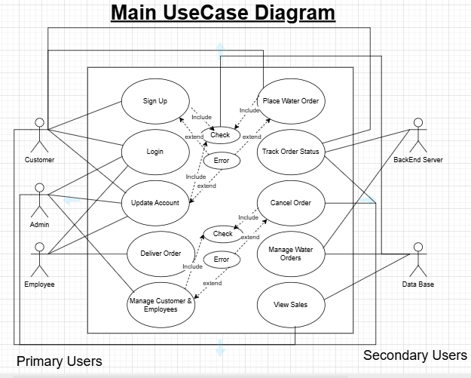

## Sequence Diagrams:

There are three sequence diagrams as mentioned in the task to do.

These are listed below.

1. Fetch order status diagram.
2. Purchase order diagram.
3. Login diagram.

### Fetch order status diagram:

### Login diagram:

### Purchase Order Diagram:

## Class Diagram:

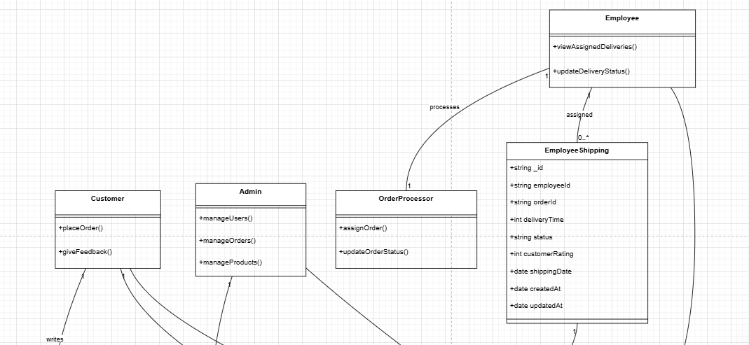

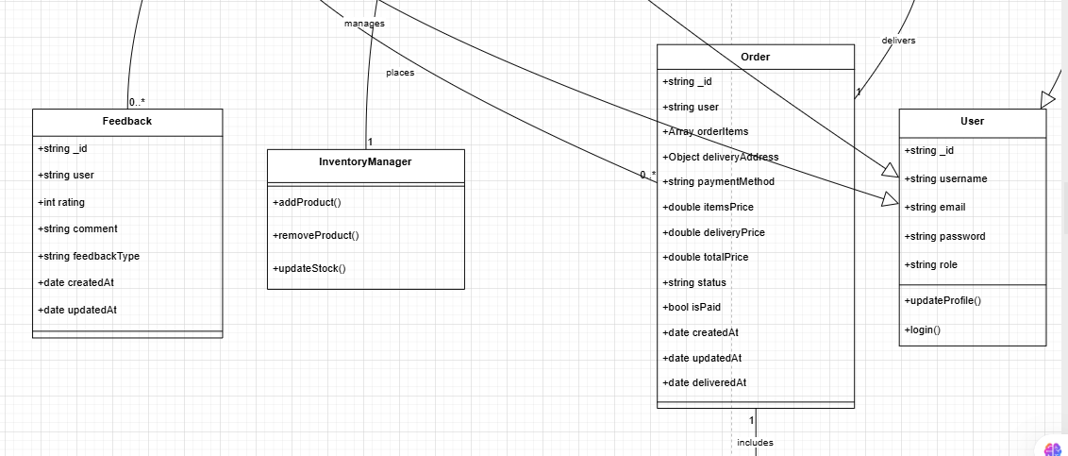

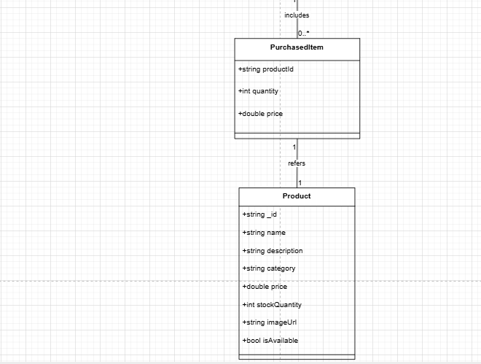

## Activity Diagrams:

There are three activity diagrams. These are listed below.

1. Login activity diagram.

2. Placement of order diagram.

3. Manage account details diagram.

### Manage account details diagram:

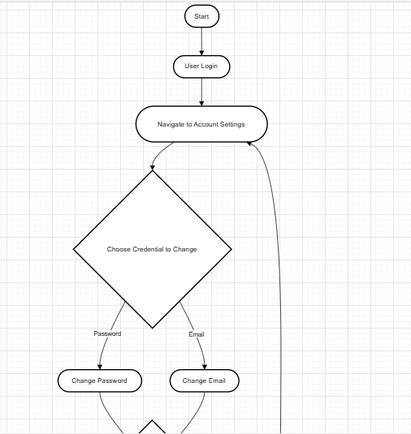

### Place order Diagram:

### Login Activity Diagram:

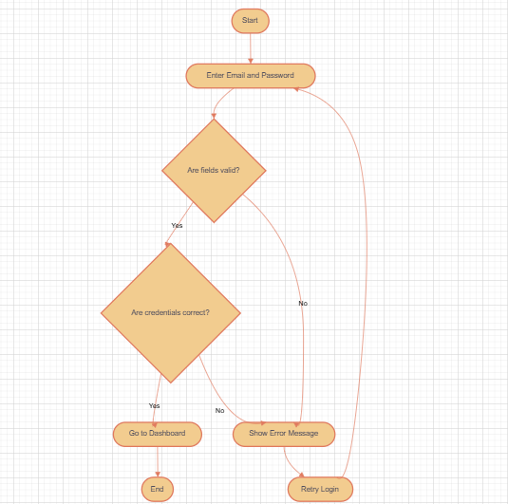

# Architecture:

Our application is basically working on the client server model. Here is a short depiction of how it is built.

# Actual implementation screenshots:

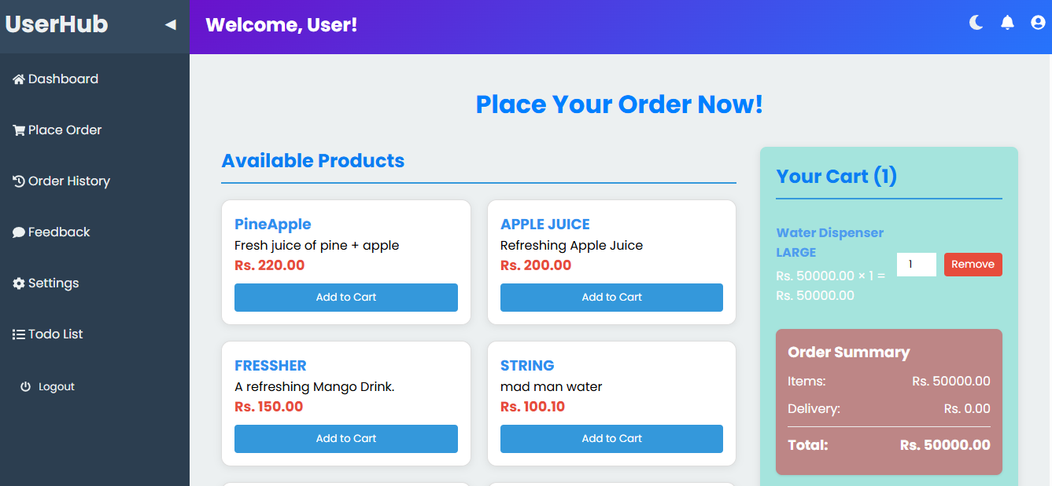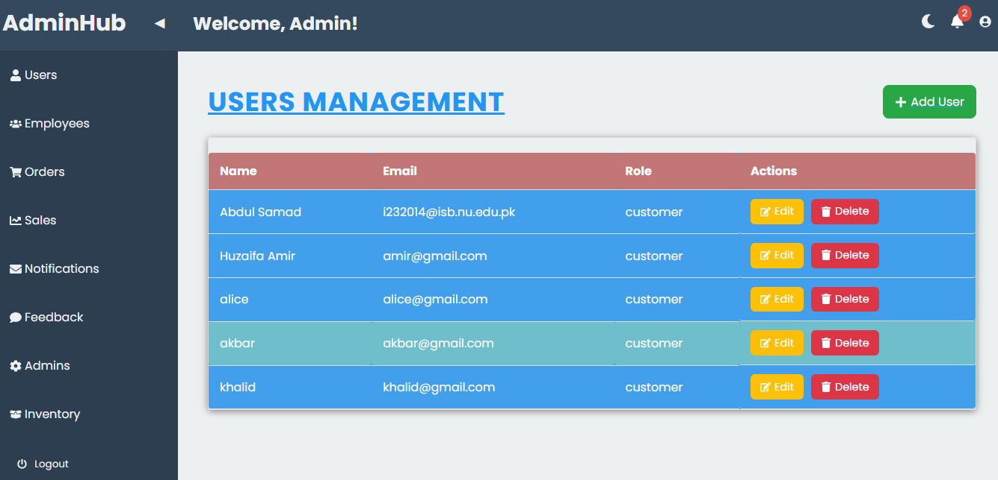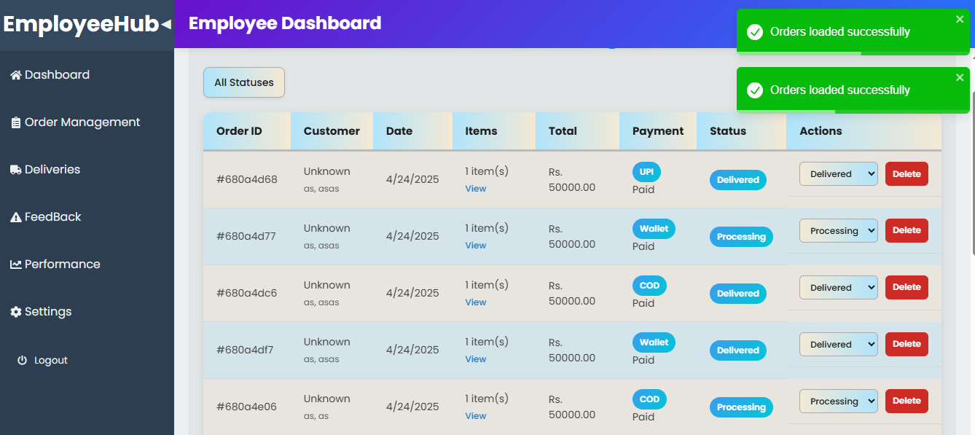

# Trello board screen shots:

# Testcases:

|  |  |  |  |
| --- | --- | --- | --- |
| Test Case ID | Scenario | Expected Result | Status |
| TC-01 | Profile Creation | A new user profile is created and redirected to dashboard | Passed |
| TC-02 | User Login | User logs into their dashboard successfully | Passed |
| TC-03 | Product Listing Display | All active products with name, price, image are shown correctly | Passed |
| TC-04 | Profile Update | Profile updates are saved and reflected immediately | Passed |
| TC-05 | Product Purchase | Order is placed successfully, and confirmation message is shown | Passed |
| TC-06 | Incorrect Login | Shows error: "Invalid Credentials" | Passed |
| TC-07 | Duplicate Email Signup | Shows error: "Email already exists" | Passed |
| TC-08 | View Order History | List of previous orders is shown correctly | Passed |
| TC-09 | Logout | Remove all the locally stored data in cache. | Passed |
| TC-10 | Add Feedback | Feedback saved successfully | Passed |
| TC-11 | Update Address | New delivery address is updated and saved | Passed |
| TC-12 | View Order Status | Correct order status (e.g., "Processing", "Delivered") is displayed | Passed |
| TC-13 | Employee Login | Employee logs in and accesses delivery dashboard | Passed |
| TC-14 | Delivery Assigned Orders | Employee marks orders as delivered | Passed |
| TC-15 | View Delivered Orders | Employees see list of successfully delivered orders | Passed |
| TC-16 | Respond to Feedback | Employee/Admin responds to customer feedback | Passed |
| TC-17 | Admin Login | Admin logs in and accesses admin panel | Passed |
| TC-18 | Manage Users | Admin can add, edit, or delete users successfully | Passed |
| TC-19 | Manage Products (Inventory) | Admin can add, update, or delete products | Passed |
| TC-20 | View Overall Sales | Admin views total sales and revenue reports | Passed |
| TC-21 | Security - Access Control | Unauthorized users cannot access admin or employee panels | Passed |

# Product Burn down chart for the project:

# Work Division between group members:

|  |  |
| --- | --- |
| Member Name | Responsibility |
| Abdul Ahad | Frontend Development (UI/UX) |
| Khalid Umar | Backend Development (Routes + Controllers) |
| Huzaifa Amir | Database Design and Integration |
| Abdul Ahad | Testing, Bug Fixes, Documentation |

# Lesson learnt by group:

