QISKIT FALL FEST 2026 HACKATHON | DOMAIN: HEALTHCARE
Kinship Screening with QAOA
Whom to test in thalassaemia cascade screening when kits are limited: a quantum optimisation study in Qiskit
Team: Syed Muhammad Saad Bukhari, Abdul Ahad, Faizan
Repository: github.com/AbdulAHAD968/Qiskit-IBM
Date: 12 November 2026. Software: Qiskit 2.6.2, Qiskit Aer 0.18.2, Python 3.11.0. Simulator only.
Summary
For one home visit with k test kits, which relatives of a thalassaemia patient should be tested? We choose exactly k people to maximise the expected number of at-risk couples identified. A couple is resolved only when both partners are tested, so the value sits on pairs of people and the problem is a quadratic binary optimisation with a cardinality constraint. That is the form QAOA represents directly.
We implement a constrained QAOA in Qiskit (Dicke start state built from gates, XY ring mixer) that can only output plans with exactly k kits, compare it with a penalty QAOA baseline, and score both against exact answers and against the rule field teams use today.
The simple rule fails. Testing the highest carrier probabilities misses the best plan in 98% of 10-relative families and 100% of 16-relative families, reaching 45% and 35% of the best value.
Constrained QAOA works as designed. Every shot uses exactly k kits. At depth 3 its quality is 0.62 on 10 qubits and 0.50 on 16 qubits, against 0.31 and 0.24 for a random valid plan, and one shot is the best plan 12 and 32 times more often than a random valid pick. Penalty QAOA stays near random (0.34 and 0.26) and wastes 39% of its shots on invalid plans at 16 qubits.
It scales by decomposition. Networks of 48 relatives and 12 kits are solved to the proven optimum with circuits of at most 9 qubits.
No speedup is claimed. Brute force and simulated annealing solve these sizes; section 6 lists what did not work, with numbers.

1. Problem and users
Beta-thalassaemia major is an inherited blood disorder. A child is affected only when both parents carry the gene. About 5 percent of people in Pakistan are carriers, and one estimate puts births of children with thalassaemia major at about 5,250 a year [1]. Patients depend on regular blood transfusions for life.
The most efficient way to find at-risk couples is cascade screening: start from a family that already has an affected child and test the relatives. In the study that introduced the approach in Pakistan, 183 of 591 tested relatives in such families were carriers (31 percent) against none of 397 in control families, and 17 of 214 married couples in those families were both carriers (8 percent) [1]. Marriage inside the family drives this concentration: in the 2017-18 Demographic and Health Survey 49.6 percent of ever-married women were married to a first cousin, and about 64 percent to a relative of some kind [3].
Capacity is the bottleneck. The Punjab Thalassaemia Prevention Project covers all 36 districts of Punjab from nine regional centres with 48 field officers, and reports low uptake of cascade testing among relatives [2]. The legal duty is growing: in 2026 the National Assembly and the Senate passed a compulsory thalassaemia screening bill for the Islamabad Capital Territory that asks for premarital screening reports and for screening and counselling of patients' blood relatives [4].
The decision. On every home visit a field officer has k test kits for one extended family and must choose who is tested. A couple's risk is known only when both partners are tested, so the value of a plan sits on pairs of people, and the natural rule, test whoever is most likely to be a carrier, spends kits on people whose partners go untested. Users: field officers planning one visit, and programme managers spreading kits across families.
Originality. We searched for earlier work applying quantum optimisation to cascade screening or to test allocation on family trees and found none; two searches cannot prove that none exists. The closest published work studies QAOA on the underlying graph problems, maximum k-vertex cover and densest k-subgraph [5]. The problem framing and the weights derived from genetics are ours; the constrained QAOA design is borrowed and credited.

2. Formulation
Table 1. Decision variables, objective and constraint.
Element | Definition
Decision variable x_{i} | 1 if relative i is tested in this visit, otherwise 0
Pair weight w_{ij} | Probability that i and j are both carriers, computed from the family tree
Link strength c_{ij} | Probability that the couple link is real: 1 for married or engaged couples, lower for a possible future match between unmarried cousins
Single weight p_{i} | Probability that i is a carrier
Relevance r_{i} | How much knowing matters: 1.0 unmarried or engaged adult, 0.7 married adult, 0.5 child, 0.1 elder
Objective | Expected number of at-risk couples found, plus lambda = 0.05 times the relevance-weighted number of carriers found
Constraint | Exactly k people are tested. Relatives who are absent or decline are fixed to 0

maximise F(x) = ∑_{(i,j) ∈ C} c_{ij} w_{ij} x_{i} x_{j} + λ ∑_{i} r_{i} p_{i} x_{i} subject to ∑_{i} x_{i} = k, x_{i} ∈ {0, 1}

The first term is not a proxy. For a married or engaged couple it is exactly the probability that the visit identifies them as an at-risk couple: both tested and both carriers. For a possible future match the term is multiplied by c_{ij}, the probability that the match happens; each unmarried person marries at most one cousin, so the first-cousin marriage rate of 0.5 is shared equally among the eligible cousins. The second term is a small reward for each single carrier found. The affected child and the two parents are not decision variables: the child is diagnosed and the parents are obligate carriers.
Where the weights come from. A pedigree engine (genetics.py) treats the family tree as a Bayesian network over genotypes: one gene, standard recessive inheritance, founders in Hardy-Weinberg proportions for a 5 percent carrier rate. The affected child is known to have two copies and everyone else is known not to. The probabilities p_{i} and w_{ij} are computed exactly by variable elimination, which also handles the loops created by cousin marriages. Table 2 compares the engine with textbook values. The test suite also checks it against full enumeration of all 3¹⁰ genotype assignments on a family with a cousin marriage.
Table 2. Pedigree engine against textbook values (q is the allele frequency, 0.0257).
Relative of the affected child | Textbook value | Engine
Parent of the affected child | 1 | 1.0000
Unaffected sibling | 2/3 | 0.6667
Grandparent | about 1/2 (exact: (1 + q) / 2) | 0.5128
Aunt or uncle | about 1/2 (exact: 2 / (4 - q)) | 0.5032
First cousin | about 1/4 | 0.2657
Married-in spouse | population rate | 0.0440
Member of a family with no affected child | population rate | 0.0488
Both grandparents carriers (joint) | not a product (exact: q) | 0.0257

The last row is the reason the problem is quadratic. Each grandparent alone is a carrier with probability 0.513, but both together only with probability 0.026, because the father's single copy almost surely came from one of them. Pair values cannot be assembled from single-person probabilities.
Test instances. All families are synthetic and seeded (pedigree.py); no patient data is used. The generator builds three or four generations around one affected child. With probability 0.6 the parents are first cousins, with probability 0.4 one paternal and one maternal sibling are married to each other (an exchange marriage), and unmarried cousins of opposite sex are linked as engaged or as possible matches.
Table 3. Seeded test instances.
Size | Relatives (qubits) | Kits k | Valid plans | Used for
S | 10 | 4 | 210 | brute force, noise study, worked example
M | 16 | 5 | 4,368 | main simulator results, trade-off curve
L | 48 in 4 linked families | 12 | about 7 x 10¹⁰ | exact integer programme, decomposition

Calibration. Across 120 synthetic families the average carrier probability among testable relatives is 36%, against 31 percent of tested relatives in [1]. Among married couples other than the index parents the average probability that both are carriers is 2.3%; counting the index parents it is 26%, against 8 percent of all married couples in the much larger families of [1]. The calibration is approximate and is listed as a limitation.
Measures. Every method is scored against the exact optimum by four numbers: quality, the expected value of a measured plan scaled so that the worst valid plan is 0 and the best is 1; the probability that one shot is the best plan; the share of shots that use exactly k kits; and the value of a plan divided by the optimum.

3. Quantum method
Table 4. How the problem is represented in the algorithm.
Problem piece | Quantum piece | Qiskit building block
Is relative i tested? | Qubit i; state |1> means tested | QuantumCircuit
Couple weight c_{ij} w_{ij} | ZZ rotation on qubits i and j | rzz, SparsePauliOp
Single weight | Z rotation on qubit i | rz
Exactly k tests | Dicke start state and XY ring mixer | cx, cry, ry, XXPlusYYGate
Tuning the angles | Classical optimiser loop | Aer EstimatorV2 with SciPy COBYLA
Reading out plans | Sampling the circuit | Aer SamplerV2

Mapping. With x_{i} = (1 - z_{i}) / 2 the objective becomes F = const + ∑_{i} a_{i} z_{i} + ∑_{i<j} b_{ij} z_{i} z_{j}, with b_{ij} = c_{ij} w_{ij} / 4 and a_{i} = -λ r_{i} p_{i} / 2 - ∑_{j} c_{ij} w_{ij} / 4. The cost layer applies RZZ(2γ b_{ij}) on every couple link and RZ(2γ a_{i}) on every qubit; coefficients are divided by their root mean square so that useful angles are of order one. A test confirms that the Estimator energy of each of the 2^{n} basis states equals the objective of that plan, and that the cost layer is the diagonal matrix exp(-iγF).
Why QAOA. The objective is a sum over pairs of yes-or-no decisions, which is the form QAOA encodes natively [7]: one two-qubit rotation per couple link and no helper qubits. The algorithm is hybrid and shallow, so it runs on a simulator at our sizes. The exactly-k rule fits the quantum alternating operator ansatz, in which the start state and the mixer keep the state inside the feasible set [8].
Constrained QAOA, the main method. The start state is the Dicke state, the equal superposition of all C(n, k) plans with exactly k ones. Qiskit 2.6 has no built-in Dicke state, so circuits.py builds it from gates with the deterministic scheme of Baertschi and Eidenbenz [6] (order kn gates, no helper qubits), using CNOT, controlled RY and a doubly controlled RY written with four CNOTs. The mixer is a ring of XX+YY rotations applied in parity order [9]. Each rotation swaps a tested and an untested neighbour, so the number of ones, and with it the number of kits, never changes. The design follows Cook, Eidenbenz and Baertschi [5]. Tests confirm that the circuit prepares the Dicke state exactly for sizes up to n = 10 and that no probability leaves the valid plans.
Penalty QAOA, the baseline. Standard QAOA starts from the uniform superposition over all 2^{n} bitstrings, uses RX mixers and subtracts A(∑_{i} x_{i} - k)² from the objective. A is set to 1.1 times the largest gain any single extra test can bring, which is enough to keep the constrained optimum as the global optimum of the penalised function (checked by a test). The penalty needs a ZZ rotation on every pair of qubits.
Training and read-out. Angles are tuned by SciPy's COBYLA on expectation values from the Aer Estimator primitive. Depth 1 starts from a 16 by 10 grid over the two angles. Depth p + 1 starts from the tuned depth-p angles, once stretched by the INTERP rule [10] and once with an added identity layer, so a deeper circuit never starts worse than the shallower one. Plans are read out with the Aer Sampler primitive (4,096 shots); the best measured valid plan is the one handed to the field officer. Exact statevector probabilities are used only to report metrics without shot noise. The quantum computation is therefore material: the delivered plan is a measured bitstring of the circuit.
How hard is the problem? With equal weights it is the densest-k-subgraph problem, which is NP-hard; the best known polynomial-time algorithm guarantees only a factor of about n^{1/4} [12]. Stronger conditional hardness results exist [13], but their author revised the underlying complexity assumption in 2026, so we do not lean on them. These are worst-case statements about general graphs, and section 6 reports that our family graphs are far from the worst case.
Assumptions and limits of the quantum part. Results are noise-free statevector simulations unless stated. Depth is limited to p = 3. No error mitigation is used. The noise study assumes all-to-all connectivity. No real quantum processor was used.

4. Architecture and implementation
Classical code prepares the weights, tunes the circuit and checks the answers. The quantum circuit is the step that proposes screening plans (Figure 1).
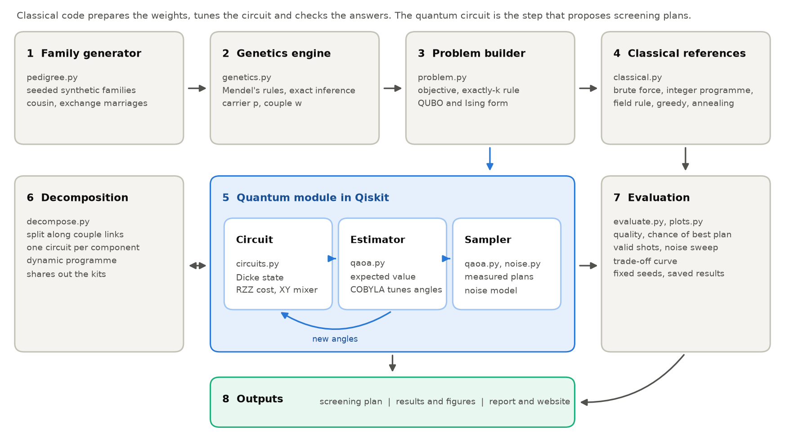
Figure 1. System architecture in eight parts. Part 5 is the quantum component, built, tuned and sampled through Qiskit primitives.
Table 5. Modules of the repository.
Module | Role
kinship/pedigree.py | Seeded synthetic families with cousin and exchange marriages; layout for drawing
kinship/genetics.py | Exact carrier and couple probabilities by variable elimination
kinship/problem.py | Objective, exactly-k rule, QUBO and Ising mapping, instance files
kinship/classical.py | Brute force, integer programme (HiGHS via SciPy), field rule, greedy, simulated annealing
kinship/quantum/circuits.py | Dicke state, cost layer, XY ring mixer, both QAOA circuits
kinship/quantum/qaoa.py | Angle tuning with the Estimator, read-out with the Sampler, metrics
kinship/quantum/noise.py | Transpilation to RZ, SX, X, CZ and the Aer noise model
kinship/decompose.py | Split along the couple graph; dynamic programme over kit budgets
kinship/evaluate.py, plots.py | Experiment runner with fixed seeds; every figure from saved results
kinship/demo.py | One-command demonstration on one family
tests/ | 46 checks: genetics values, objective, Ising mapping, circuits

How to run. With Python 3.10 or later:
pip install -r requirements.txt
python -m kinship.demo # one family, one plan, about 20 seconds
python -m kinship.evaluate all # every number in this report
python -m kinship.plots # every figure
pytest # 46 checks

Reproducibility. Versions are pinned, seeds are fixed, raw results are saved as JSON, and the figures, the website data and this report are generated from those files by scripts. The full experiment matrix took 8 minutes on 8 processes of a laptop. Interpretable output. The demo prints the plan in plain language, names the relatives to test, reports the expected number of at-risk couples found and its percentage of the best plan, and draws the family tree with the chosen relatives highlighted (Figure 3).

5. Results

5.1 The problem is not trivial
Table 6. Classical rules against the exact optimum on 50 seeded families per size.
Size | Rule | Value / optimum, mean | Worst family | Misses the best plan
S (10 relatives, 4 kits) | Field officer's rule | 45% | 13% | 98%
S (10 relatives, 4 kits) | Relevance-weighted rule | 53% | 22% | 94%
S (10 relatives, 4 kits) | Greedy | 85% | 46% | 56%
S (10 relatives, 4 kits) | Simulated annealing | 100% | 98% | 2%
M (16 relatives, 5 kits) | Field officer's rule | 35% | 17% | 100%
M (16 relatives, 5 kits) | Relevance-weighted rule | 45% | 25% | 100%
M (16 relatives, 5 kits) | Greedy | 83% | 38% | 82%
M (16 relatives, 5 kits) | Simulated annealing | 100% | 91% | 4%

The field officer's rule missed the best plan in 98% of the 10-relative families and in 100% of the 16-relative families. It spends kits on grandparents and siblings whose partners are not tested. Weighting by relevance helps a little. Greedy selection does much better, and simulated annealing with swap moves finds the best plan in almost every family (Figure 2). On average 69% of the best plan's value comes from the couple term.
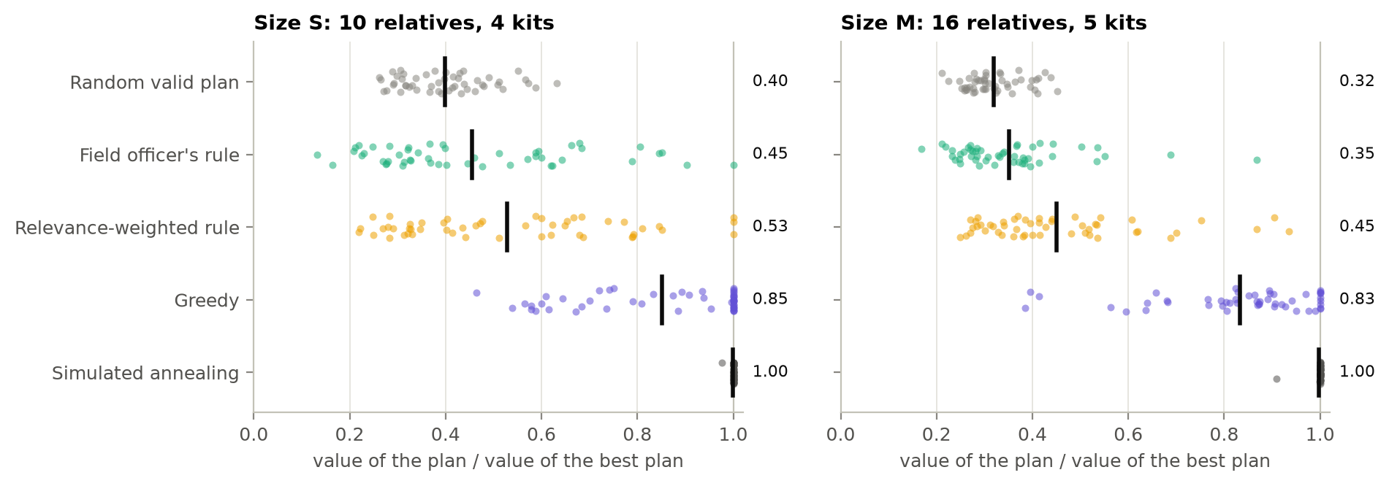
Figure 2. Value of each rule's plan divided by the best plan. One dot per seeded family; the black bar and the number are the mean.

5.2 QAOA against the references
Table 7. Mean over 20 size-S and 12 size-M families, noise-free. Quality: 0 = worst valid plan, 1 = best. Shots for 95%: shots needed to see the best plan with 95 percent probability (median).
Size | Method | p | Quality | Best plan per shot | Valid shots | Shots for 95%
S | Random valid plan |  | 0.312 | 0.52% | 100% | 628
S | Field officer's rule |  | 0.416 |  | 100%
S | Greedy |  | 0.864 |  | 100%
S | Simulated annealing |  | 1.000 |  | 100%
S | Constrained QAOA | 1 | 0.498 ± 0.090 | 2.5% | 100% | 119
S | Constrained QAOA | 2 | 0.582 ± 0.092 | 4.6% | 100% | 64
S | Constrained QAOA | 3 | 0.624 ± 0.107 | 5.9% | 100% | 70
S | Penalty QAOA | 1 | 0.323 ± 0.087 | 0.32% | 51% | 1,044
S | Penalty QAOA | 2 | 0.332 ± 0.085 | 0.48% | 69% | 668
S | Penalty QAOA | 3 | 0.344 ± 0.082 | 0.71% | 86% | 437
M | Random valid plan |  | 0.240 | 0.027% | 100% | 13,084
M | Field officer's rule |  | 0.270 |  | 100%
M | Greedy |  | 0.740 |  | 100%
M | Simulated annealing |  | 1.000 |  | 100%
M | Constrained QAOA | 1 | 0.383 ± 0.052 | 0.20% | 100% | 2,077
M | Constrained QAOA | 2 | 0.459 ± 0.058 | 0.50% | 100% | 1,154
M | Constrained QAOA | 3 | 0.504 ± 0.067 | 0.98% | 100% | 867
M | Penalty QAOA | 1 | 0.247 ± 0.042 | 0.012% | 38% | 28,881
M | Penalty QAOA | 2 | 0.253 ± 0.042 | 0.017% | 49% | 20,202
M | Penalty QAOA | 3 | 0.259 ± 0.041 | 0.025% | 61% | 13,276

Constrained QAOA improves with depth on both sizes (Figures 4 and 5). At depth 3 its quality is 0.62 on 10 qubits and 0.50 on 16 qubits, against 0.31 and 0.24 for a random valid plan and 0.42 and 0.27 for the field officer's rule. The chance that one shot is the best plan rises to 5.9% and 0.98%, which is 12 and 32 times a random valid pick, and every shot uses exactly k kits. In every instance the best of the 4,096 measured plans was the exact optimum; at these sizes that alone is a weak statement (section 6), which is why the table reports per-shot numbers.
Penalty QAOA learns the constraint before it learns the objective. Its share of valid shots grows from 51% to 86% on 10 qubits and from 38% to 61% on 16 qubits, but the quality of those valid shots stays near random (0.34 and 0.26). Constrained QAOA does not beat the stronger classical heuristics: greedy reaches 0.86 and 0.74, and simulated annealing finds the optimum in 100% and 92% of these families.
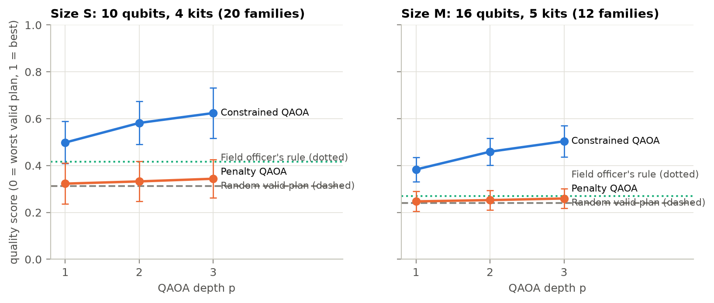
Figure 4. Quality against QAOA depth. Whiskers: one standard deviation over families.
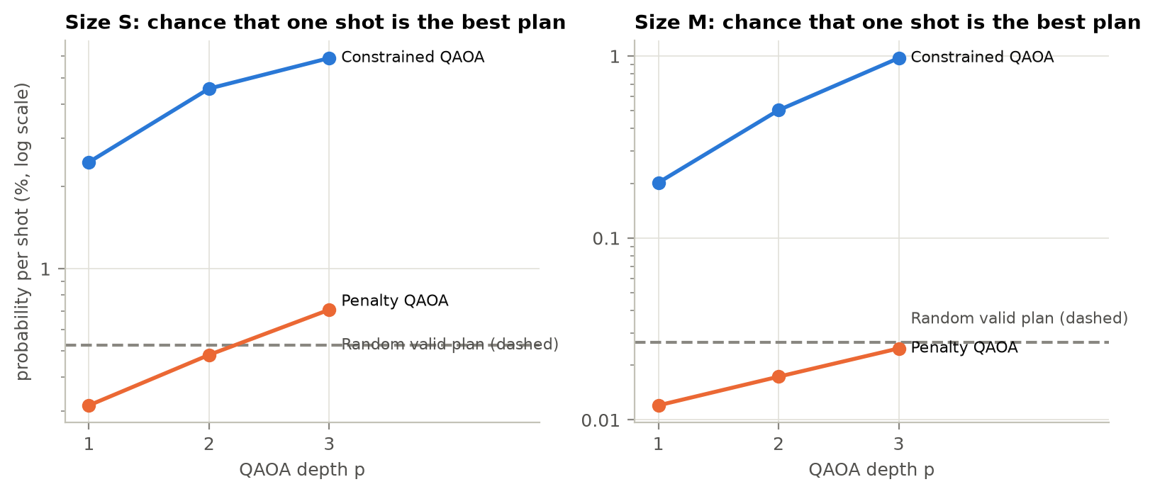
Figure 5. Probability that a single shot is the best plan (log scale).

5.3 A worked example
Figure 3 shows instance S-16, chosen by a fixed rule (the size-S instance with the largest optimum among those with at least five couple links), not by QAOA performance. The field officer's rule tests Paternal aunt 1, Sibling 1, Sibling 2, Sibling 3: 0.000 expected at-risk couples, 32% of the best plan. The best plan measured from the constrained QAOA circuit tests Cousin 1, Cousin 2, Sibling 1, Sibling 2: 0.252 expected at-risk couples, which equals the exact optimum. One shot is the best plan with probability 8.3%, against 0.48% for a random valid plan.
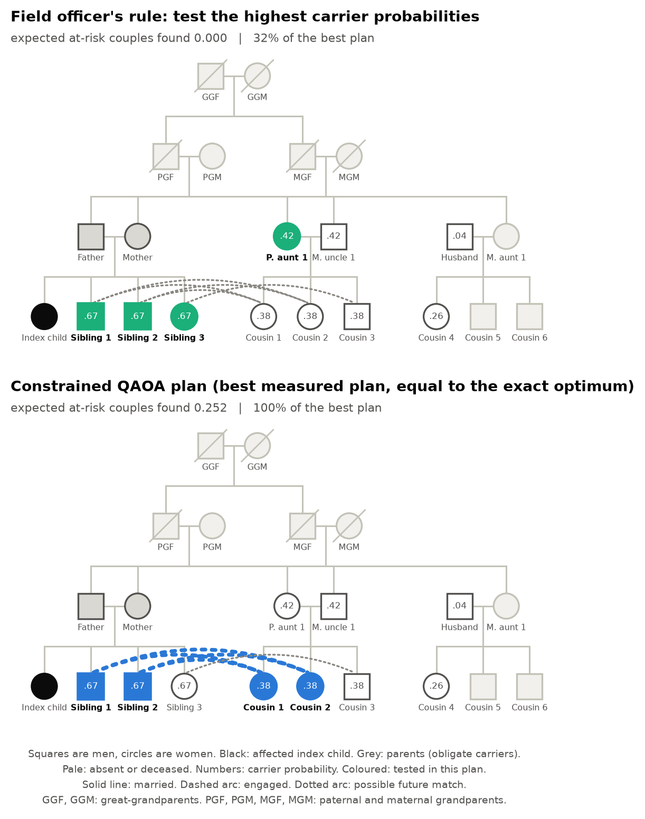
Figure 3. One family, two plans. The field rule tests people whose partners are not tested; the QAOA plan resolves the possible matches between siblings and cousins.

5.4 Circuit cost
Table 8. Circuit size after transpilation to RZ, SX, X, CZ at optimisation level 3 (first instance of each size).
Size | Circuit | p | CZ gates, all-to-all | Depth | CZ gates, line of qubits
S (10 qubits) | Dicke start state alone |  | 144 | 489 | 225
S (10 qubits) | Constrained QAOA | 1 | 172 | 514 | 327
S (10 qubits) | Constrained QAOA | 3 | 228 | 565 | 449
S (10 qubits) | Penalty QAOA | 1 | 90 | 121 | 179
S (10 qubits) | Penalty QAOA | 3 | 270 | 275 | 499
M (16 qubits) | Dicke start state alone |  | 330 | 889 | 636
M (16 qubits) | Constrained QAOA | 1 | 374 | 912 | 942
M (16 qubits) | Constrained QAOA | 3 | 466 | 970 | 1365
M (16 qubits) | Penalty QAOA | 1 | 240 | 205 | 408
M (16 qubits) | Penalty QAOA | 3 | 720 | 475 | 1194

The constrained circuit pays a fixed price for its start state: 144 CZ gates on 10 qubits and 330 on 16. After that each layer is cheap, about 28 and 46 CZ gates, against 90 and 240 for the penalty circuit, which needs a rotation on every pair of qubits. At depth 3 on 16 qubits the constrained circuit is the smaller one (466 against 720 CZ gates).

5.5 Under noise
We ran the 10-qubit circuits on Aer with a depolarising error on every CZ gate, a tenth of that on single-qubit gates and a readout error at twice that rate (6 families, 4,096 shots). Shots without exactly k ones are discarded and the surviving share is reported (Figure 6). For constrained QAOA at depth 1 the share of valid shots falls from 100% to 86% at 0.1 percent error and to 37% at 1 percent; the quality of the surviving shots falls from 0.49 to 0.42, and the chance of the best plan from 2.4% to 0.57%, the level of a random valid pick (0.56%). Penalty QAOA is shallower but starts from 52% valid shots and its quality stays at the random level (0.31) throughout. No real quantum processor was used.
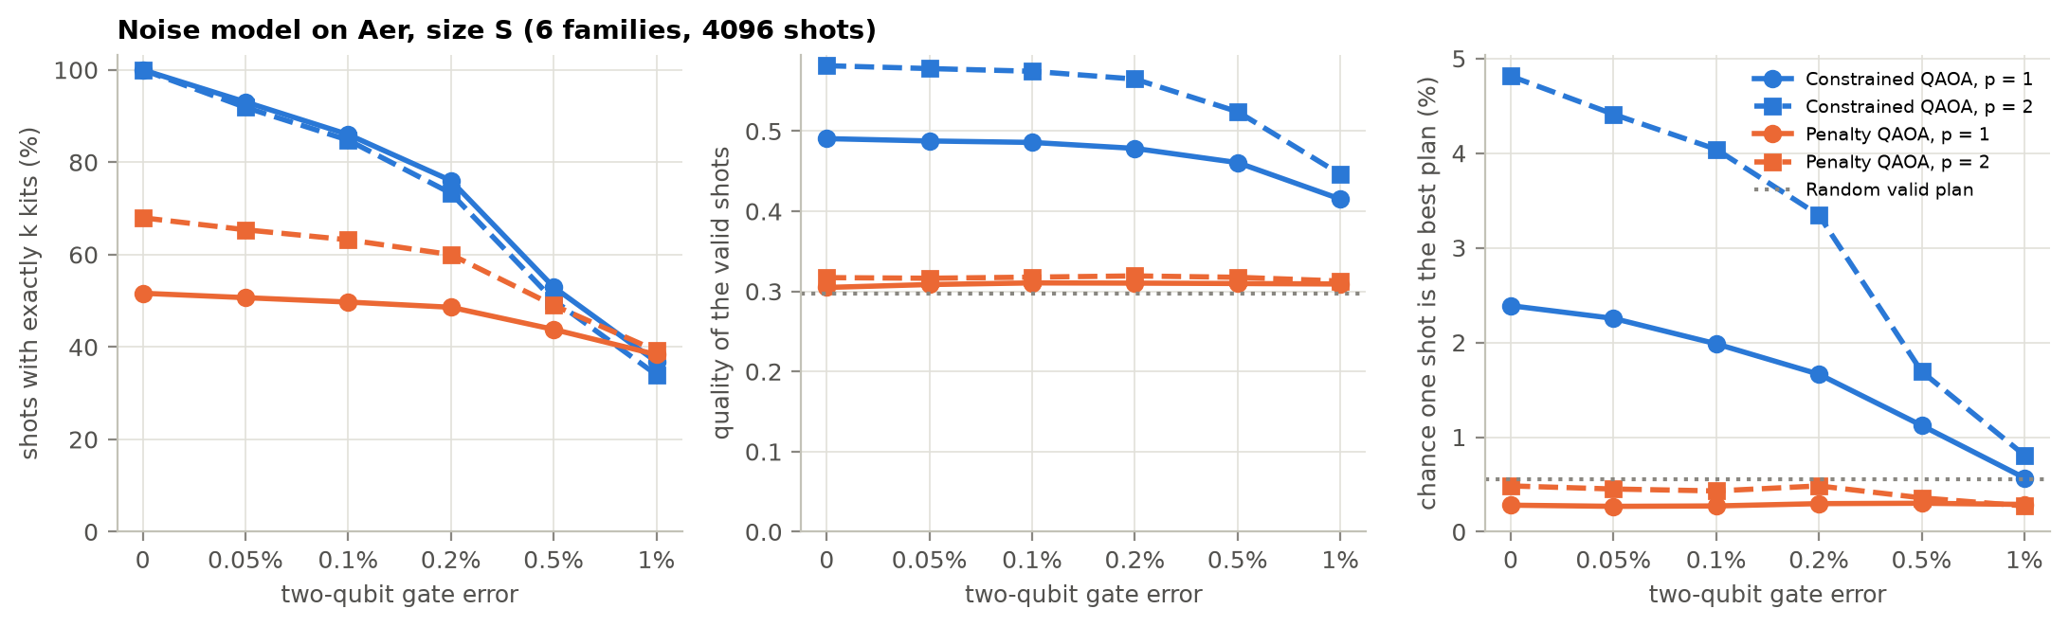
Figure 6. Noise sweep on the 10-qubit instances: valid shots, quality of valid shots, and chance of the best plan.

5.6 Trade-off curve and linked families
Couples against carriers. Sweeping lambda over 8 values trades at-risk couples found against single carriers found. On instance M-01 (chosen by a fixed rule: the largest exact front among the size-M instances) the exact trade-off front has 7 plans. The 2,048 QAOA shots of the sweep contained 7 of them and covered 100.0% of the area under the front; uniform random sampling of valid plans with the same number of shots found 2.8 on average and covered 98.4% (Figure 7). The idea of approximating a front from QAOA samples follows [11]. This is one instance, so it is an illustration and not a general claim.
Linked families. One qubit per relative limits a single circuit to roughly 25 to 30 people on a simulator. People in different connected components of the couple graph interact only through the kit budget, so a large network splits exactly: QAOA solves each component for each budget, and a dynamic programme shares out the kits. On 3 networks of 48 relatives and 12 kits the largest component had 9 people, so no circuit needed more than 9 qubits; QAOA ran 18 times, and every network reached the optimum proven by an integer programme (Figure 8). The field officer's rule reached 24% and greedy 95%. At this component size sampling finds each optimum easily, so the result shows a scaling route and not an advantage.
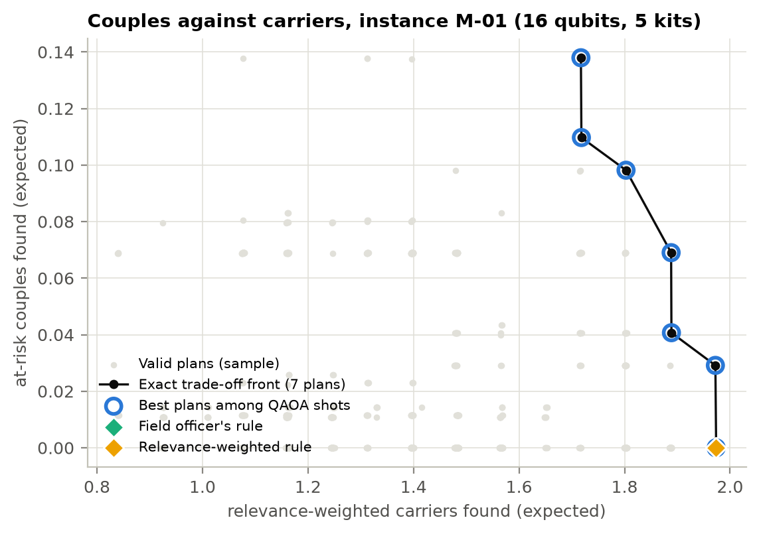  Figure 7. Couples found against carriers found. | 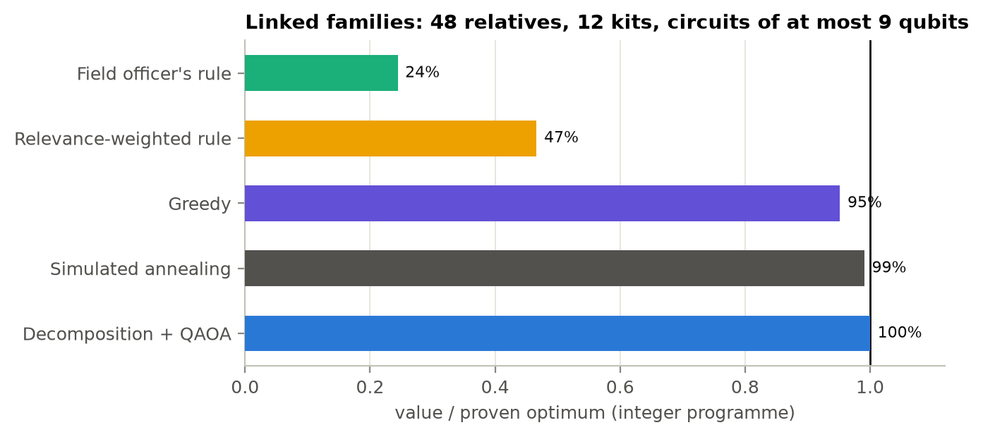  Figure 8. Linked families: value divided by the proven optimum.

6. Limitations and what did not work
- No quantum speedup. Brute force gives the exact answer for the 10- and 16-qubit instances in milliseconds, and simulated annealing found the best plan in 92% of the 16-qubit families. At these sizes a classical solver wins. This is a method study on a new problem.
- Family graphs are sparse. The couple graph splits into small pieces: its largest connected component has 5.2 people on average in the 16-relative families (at most 9). An exact dynamic programme over those pieces solves the problem, so worst-case hardness results for densest-k-subgraph do not apply to these instances. A denser match graph, for example a large group of unmarried cousins, would be harder.
- Expected quality is modest. At depth 3 constrained QAOA reaches 0.50 on 16 qubits while greedy reaches 0.74. QAOA beats the field rule and random picks, not the stronger classical heuristics.
- Penalty QAOA barely beats random. Its valid shots score 0.26 against 0.24 for a random valid plan on 16 qubits, and 39% of its shots break the kit limit at depth 3. We did not tune the penalty weight beyond the principled choice in section 3.
- A cheaper start state failed. Starting from the field officer's plan instead of the Dicke state needs only k X gates, but at depth 3 its chance of the best plan was 0.096% against 5.2% for the Dicke start, and its quality 0.54 against 0.66 (8 size-S instances). The ring mixer cannot spread one basis state far in three layers.
- Noise costs most of the shots. The Dicke start state alone needs 144 CZ gates on 10 qubits. At 1 percent two-qubit error only 37% of constrained shots still use exactly k kits and the chance of the best plan is back at the random level.
- Simulator only, generic noise. No real quantum processor was used. The noise model is a uniform depolarising model with all-to-all connectivity; on a line of qubits the depth-1 circuit grows from 172 to 327 CZ gates.
- Sampling flatters small instances. With 4,096 shots and only 210 or 4,368 valid plans, even uniform sampling usually contains the best plan. We therefore report the chance per shot and the expected quality, not the best of all shots.
- Synthetic families and simple genetics. Families are generated, not observed, and calibrated loosely to one study from 2002 (36% carriers among testable relatives against 31 percent). The model has one gene, standard inheritance and a perfect test. The relevance weights and match probabilities are our assumptions and were not reviewed by a practitioner.
- One visit only. The model chooses everyone before any result is known. Real programmes may test one partner first and the other only if the first is a carrier; step-by-step testing is the natural next model.

7. Ethics
A tool that ranks relatives by genetic risk can stigmatise people, and carrier status is sensitive in a society where it can affect marriage prospects. This project uses synthetic data only. Consent is an input of the model: anyone who declines is fixed to not tested. The tool produces a plan for one visit to support a counsellor, publishes no individual scores, and is not meant to decide who may marry. Any real use would need the approval of the screening programme and of an ethics committee, and data protection for the family trees.

8. Credits and references
Software. Qiskit 2.6.2, Qiskit Aer 0.18.2, NumPy 2.4.6, SciPy 1.17.1 (COBYLA and the HiGHS integer programme), Matplotlib, python-docx, pytest; Python 3.11.0.
Methods. The constrained QAOA design (Dicke start state, XY mixer) follows [5]; the Dicke-state circuit follows [6]; the parity-ordered ring mixer follows [9]; the INTERP warm start follows [10]; the trade-off sweep borrows the idea of [11]. The circuits were written from the papers. No tutorial or third-party code was copied into the repository.
AI assistance. An AI coding assistant was used to help write code and draft text. Every number in this report is produced by running the code in the repository.
[1] Ahmed S, Saleem M, Modell B, Petrou M. Screening extended families for genetic hemoglobin disorders in Pakistan. N Engl J Med. 2002;347(15):1162-1168. doi:10.1056/NEJMsa013234
[2] Ahmed S, Jafri H, Faran M, Ahmed WN, Rashid Y, Ehsan Y, Ahmed M. Cascade screening for beta-thalassaemia in Pakistan: relatives' experiences of a decision support intervention in routine practice. Eur J Hum Genet. 2022;30(4):406-412. doi:10.1038/s41431-021-00974-y
[3] National Institute of Population Studies and ICF. Pakistan Demographic and Health Survey 2017-18. Islamabad and Rockville; 2019. Figures as reported in Iqbal S, Zakar R, Fischer F, Zakar MZ. BMC Women's Health. 2022;22:118. doi:10.1186/s12905-022-01704-2
[4] Dawn, 11 March 2026: report on the National Assembly passing the Islamabad Capital Territory compulsory thalassaemia screening bill, dawn.com/news/1980653. Associated Press of Pakistan, 11 May 2026: report on its passage by the Senate. Presidential assent could not be confirmed at the time of writing.
[5] Cook J, Eidenbenz S, Baertschi A. The Quantum Alternating Operator Ansatz on Maximum k-Vertex Cover. IEEE International Conference on Quantum Computing and Engineering (QCE) 2020, 83-92. arXiv:1910.13483
[6] Baertschi A, Eidenbenz S. Deterministic Preparation of Dicke States. Fundamentals of Computation Theory (FCT) 2019, Lecture Notes in Computer Science, 126-139. arXiv:1904.07358
[7] Farhi E, Goldstone J, Gutmann S. A Quantum Approximate Optimization Algorithm. 2014. arXiv:1411.4028
[8] Hadfield S, Wang Z, O'Gorman B, Rieffel EG, Venturelli D, Biswas R. From the Quantum Approximate Optimization Algorithm to a Quantum Alternating Operator Ansatz. Algorithms. 2019;12(2):34. doi:10.3390/a12020034
[9] Wang Z, Rubin NC, Dominy JM, Rieffel EG. XY mixers: analytical and numerical results for the quantum alternating operator ansatz. Phys Rev A. 2020;101:012320. arXiv:1904.09314
[10] Zhou L, Wang S-T, Choi S, Pichler H, Lukin MD. Quantum Approximate Optimization Algorithm: Performance, Mechanism, and Implementation on Near-Term Devices. Phys Rev X. 2020;10:021067. arXiv:1812.01041
[11] Kotil A, Pelofske E, Riedmueller S, Egger DJ, Eidenbenz S, Koch T, Woerner S. Quantum approximate multi-objective optimization. Nat Comput Sci. 2025;5:1168-1177. arXiv:2503.22797
[12] Bhaskara A, Charikar M, Chlamtac E, Feige U, Vijayaraghavan A. Detecting high log-densities: an O(n^1/4) approximation for densest k-subgraph. STOC 2010, 201-210. arXiv:1001.2891
[13] Manurangsi P. Almost-polynomial ratio ETH-hardness of approximating densest k-subgraph. STOC 2017, 954-961. arXiv:1611.05991 (revised by the author in October 2026 with a weaker assumption).

